Appendix for 2300285 submission

Ethics form: Appendix 1

APPLICATION FOR ETHICAL APPROVAL

RESEARCH STUDENTS
This form is to be completed by the student within SIX months for full-time students and TWELVE months for part time students, after the commencement of the research degree or following progression to Part Two of your course.

Once complete, submit this form via the MyTSD Doctoral College Portal at (https://mytsd.uwtsd.ac.uk).

This document is also available in Welsh.

RESEARCH STAFF ONLY
All communications relating to this application during its processing must be in writing and emailed to pgresearch@uwtsd.ac.uk , with the title ‘Ethical Approval’ followed by your name.

STUDENTS ON UNDERGRADUATE OR TAUGHT MASTERS PROGRAMMES should submit this form (and receive the outcome) via systems explained to you by the supervisor/module leader.

In order for research to result in benefit and minimise risk of harm, it must be conducted ethically. A researcher may not be covered by the University’s insurance if ethical approval has not been obtained prior to commencement.

The University follows the OECD Frascati manual definition of research activity: “creative work undertaken on a systematic basis in order to increase the stock of knowledge, including knowledge of man, culture and society, and the use of this stock of knowledge to devise new applications”. As such this covers activities undertaken by members of staff, postgraduate research students, and both taught postgraduate and undergraduate students working on dissertations/projects.

The individual undertaking the research activity is known as the “principal researcher”.

Ethical approval is not required for routine audits, performance reviews, quality assurance studies, testing within normal educational requirements, and literary or artistic criticism.

Please read the notes for guidance before completing ALL sections of the form.

This form must be completed and approved prior to undertaking any research activity. Please see Checklist for details of process for different categories of application.

SECTION A: About You (Principal Researcher)
1 | Full Name: |  | Isobel Webb
2 | Tick all boxes that apply: |  | Member of staff: | ☐ | Honorary research fellow: | ☐
 | Undergraduate Student | ☐ | Taught Postgraduate Student | X | Postgraduate Research Student | ☐

3 | Institute/Academic Discipline/Centre: | University of Wales Trinity Saint David
4 | Campus: | Swansea
5 | E-mail address: | 2300285@student.uwtsd.ac.uk
6 | Contact Telephone Number: | 07539777125
 | For students:
7 | Student Number: | 2300285
8 | Programme of Study: | Secondary PGCE
9 | Director of Studies/Supervisor: | Ishmael Lewis

SECTION B: Approval for Research Activity
1 | Has the research activity received approval in principle?  (please check the Guidance Notes as to the appropriate approval process for different levels of research by different categories of individual) |  | YES | X | NO | ☐
 |  |  |  |  | Date
2 | If Yes, please indicate source of approval (and date where known): Approval in principle must be obtained from the relevant source prior to seeking ethical approval | Research Degrees Committee |  | ☐
2 |  | Institute Research Committee |  | ☐
2 |  | Other (write in)  Ishmael Lewis |  | X | 14/3/24

SECTION C: Internal and External Ethical Guidance Materials
 | Please list the core ethical guidance documents that have been referred to during the completion of this form (including any discipline-specific codes of research ethics, location-specific codes of research ethics, and also any specific ethical guidance relating to the proposed methodology). Please tick to confirm that your research proposal adheres to these codes and guidelines. You may add rows to this table if needed.
1 | UWTSD Research Ethics & Integrity Code of Practice | X
2 | UWTSD Research Data Management Policy | X
3 | Bera (2018) Ethical Guidelines for Educational Research, fourth edition (2018) | X

SECTION D: External Collaborative Research Activity
If there are external collaborators then you should gain consent from the contact persons to share their personal data with the university. If there are no external collaborators then leave this section blank and continue to section E.
1 | Institution
2 | Contact person name
3 | Contact person e-mail address
4 | Is your research externally funded? |  | YES | ☐ | NO |  | ☐
5 | Are you in receipt of a KESS scholarship? |  | YES | ☐ | NO |  | ☐
6 | Are you specifically employed to undertake this research in either a paid or voluntary capacity? | Voluntary | YES | ☐ | NO | ☐
7 |  | Employed | YES | ☐ | NO | ☐
8 | Is the research being undertaken within an existing UWTSD Athrofa Professional Learning Partnership (APLP)? | If YES then the permission question below does not need to be answered. | YES | ☐ | NO |  | ☐
9 | Has permission to undertake the research has been provided by the partner organisation? | (If YES attach copy)  If NO the application cannot continue | YES | ☐ | NO |  | ☐

Where research activity is carried out in collaboration with an external organisation
10 | Does this organisation have its own ethics approval system? | YES | ☐ | NO | ☐
 | If Yes, please attach a copy of any final approval (or interim approval) from the organisation (this may be a copy of an email if appropriate).

SECTION E: Details of Research Activity
1 | Indicative title: | What impact does mindfulness starter activities have on learners' readiness to learn?
2 | Proposed start date: | 14/3/24 | Proposed end date: | 31/7/23
Introduction to the Research (maximum 300 words per section)
Ensure that you write for a Non-Specialist Audience when outlining your response to the points below:
- Purpose of Research Activity
- Proposed Research Question
- Aims of Research Activity
- Objectives of Research Activity
Demonstrate, briefly, how Existing Research has informed the proposed activity and explain
- What the research activity will add to the body of knowledge
- How it addresses an area of importance.
3 | Purpose of Research Activity  The purpose of this research is to investigate the potential impact / effectiveness of mindfulness starter activities on learners' readiness to learn. This will develop my skills as an evidence based research practitioner.
4 | Research Question  What impact does mindfulness starter activities have on learners' readiness to learn?  (this box should expand as you type)
5 | Aims of Research Activity  - To explore the potential benefits of integrating mindfulness based interventions into the classroom.  - To examine the effectiveness of mindfulness in regulating emotion and promoting readiness to learn.  - To understand perceptions of learners and educators on the use of mindfulness starter activities.  (this box should expand as you type)
6 | Objectives of Research Activity  - Observe learners ‘readiness to learn’ as they enter the classroom and after the activity  - Implement a mindfulness starter activity in the classroom  - Measure changes in learners emotions and readiness to learn by questionnaire  - Collect qualitative data through questionnaires for learner participants and an interview for participant (staff member) to see their perceptions on the impact of mindfulness starter activities.  - Summarise findings of the intervention of mindfulness starter aviticies impact on readiness to learn and offer recommendations for educators.  (this box should expand as you type)
Proposed methods (maximum 600 words)
Provide a brief summary of all the methods that may be used in the research activity, making it clear what specific techniques may be used. If methods other than those listed in this section are deemed appropriate later, additional ethical approval for those methods will be needed. You do not need to justify the methods here, but should instead describe how you intend to collect the data necessary for you to complete your project.
7 | Questionnaire for Learner participants:  - Participants will be provided with a structured questionnaire containing questions related to their experiences with the mindfulness starter activity and their perceived readiness to learn. The questionnaire will include Likert scale items, Lueven scale, multiple-choice questions, closed questions and open-ended questions to gather both quantitative and qualitative data.  2. Interview  - A semi-structured interview with a staff member.  - The interview will consist of a set of structured questions to explore the staff member's perspectives, experiences, and insights regarding the impact of mindfulness activities (and starter activities in general) on learners' readiness to learn. Probing questions / open ended questions will be used to delve deeper into specific areas of interest.  - Answers will be recorded through note taking.  3. Observation of participants  - Participants will be observed when entering the classroom and during mindfulness starter activity to assess their engagement, behaviour, and responses. This will involve overt observation, where learners are aware of being observed. Observational data will be recorded using notes to capture relevant behaviours and interactions. Parental consent will be given, ascent will be given and learners will be debriefed at the end of the study.  (this box should expand as you type)
Location of research activity
Identify all locations where research activity will take place.
8 | A secondary school in South Wales.  (this box should expand as you type)
Research activity outside of the UK
If research activity will take place overseas, you are responsible for ensuring that local ethical considerations are complied with and that the relevant permissions are sought. Specify any local guidelines (e.g. from local professional associations/learned societies/universities) that exist and whether these involve any ethical stipulations beyond those usual in the UK (provide details of any licenses or permissions required). Also specify whether there are any specific ethical issues raised by the local context in which the research activity is taking place, for example, particular cultural and/or legal sensitivities or vulnerabilities of participants. If you live in the country where you will do the research then please state this.
9 | N/A  (this box should expand as you type)

10 | Use of documentation not in the public domain: Are any documents NOT publicly available? | NO | X
10 |  | YES | ☐
11 | If Yes, please provide details here of how you will gain access to specific documentation that is not in the public domain and that this is in accordance with the current data protection law of the country in question and that of England and Wales.  (this box should expand as you type)

 | Does your research relate to one or more of the seven aims of the Well-being of Future Generations (Wales) Act 2015? | YES | NO
12 | A prosperous Wales | ☐ | x
13 | A resilient Wales | ☐ | x
14 | A healthier Wales | X | ☐
15 | A more equal Wales | ☐ | x
16 | A Wales of cohesive communities | ☐ | x
17 | A Wales of vibrant culture and thriving Welsh language | ☐ | x
18 | A globally responsible Wales | ☐ | x
19 | If YES to any of the above, please give details:
This research question is investigating the impact of mindfulness starter activities on readiness to learn. The mindfulness element relates to a ‘healthier Wales’ as it involves mental wellbeing techniques and their impact on learning.

(this box should expand as you type)

SECTION F: Scope of Research Activity
 | Will the research activity include: | YES | NO
1 | Use of a questionnaire or similar research instrument? | X | ☐
2 | Use of interviews? | X | ☐
3 | Use of focus groups? | ☐ | X
4 | Use of participant diaries? | ☐ | X
5 | Use of video or audio recording? | ☐ | X
6 | Use of computer-generated log files? | ☐ | X
7 | Participant observation with their knowledge? | X | ☐
8 | Participant observation without their knowledge? | ☐ | x
9 | Access to personal or confidential information without the participants’ specific consent? | ☐ | X
10 | Administration of any questions, test stimuli, presentation that may be experienced as physically, mentally or emotionally harmful / offensive? | ☐ | x
11 | Performance of any acts which may cause embarrassment or affect self-esteem? | ☐ | x
12 | Investigation of participants involved in illegal activities? | ☐ | x
13 | Use of procedures that involve deception? | ☐ | x
14 | Administration of any substance, agent or placebo? | ☐ | x
15 | Working with live vertebrate animals? | ☐ | x
16 | Procedures that may have a negative impact on the environment? | ☐ | x
17 | Other primary data collection methods. Please indicate the type of data collection method(s) below. | ☐ | x
 | Details of any other primary data collection method:  (this box should expand as you type) | ☐ | x
If NO to every question, then the research activity is (ethically) low risk and may be exempt from some of the following sections (please refer to Guidance Notes).

If YES to any question, then no research activity should be undertaken until full ethical approval has been obtained.

SECTION G: Intended Participants
If there are no participants then do not complete this section, but go directly to section H.

 | Who are the intended participants: | YES | NO
1 | Students or staff at the University? | ☐ | x
2 | Adults (over the age of 18 and competent to give consent)? | x | ☐
3 | Vulnerable adults? | ☐ | x
4 | Children and Young People under the age of 18? (Consent from Parent, Carer or Guardian will be required) | x | ☐
5 | Prisoners? | ☐ | x
6 | Young offenders? | ☐ | x
7 | Those who could be considered to have a particularly dependent relationship with the investigator or a gatekeeper? | ☐ | x
8 | People engaged in illegal activities? | ☐ | x
9 | Others. Please indicate the participants below, and specifically any group who may be unable to give consent. | ☐ | x
 | Details of any other participant groups:  (this box should expand as you type) | ☐ | x

Participant numbers and source
Provide an estimate of the expected number of participants. How will you identify participants and how will they be recruited?
10 | How many participants are expected? | There will be a maximum of 20 learner participants who will be involved in the observation and the questionnaire.  There will be 1 interview conducted with 1 member of staff discussing starter activities and their impact on learners.  (this box should expand as you type)
11 | Who will the participants be? | Learners in KS3 as part of their lesson  1 adult staff member  (this box should expand as you type)
12 | How will you identify the participants? | I will send an invitation (letter of consent) to the parents of around 30 learners. Using an opportunity sample I will select up to 20 learners through an opportunity sample within the class to observe and question at the end. Participants will know their involvement and have the right to withdraw during the questionnaire.  A meeting will be arranged with the member of staff for the interview and a letter of consent will be provided.  (this box should expand as you type)

 | Information for participants: | YES | NO | N/A
13 | Will you describe the main research procedures to participants in advance, so that they are informed about what to expect? | x | ☐ | ☐
14 | Will you tell participants that their participation is voluntary? | x | ☐ | ☐
15 | Will you obtain written consent for participation? | x | ☐ | ☐
16 | Will you explain to participants that refusal to participate in the research will not affect their treatment or education (if relevant)? | x | ☐ | ☐
17 | If the research is observational, will you ask participants for their consent to being observed? | x | ☐ | ☐
18 | Will you tell participants that they may withdraw from the research at any time and for any reason? | x | ☐ | ☐
19 | With questionnaires, will you give participants the option of omitting questions they do not want to answer? | x | ☐ | ☐
20 | Will you tell participants that their data will be treated with full confidentiality and that, if published, it will not be identifiable as theirs? | x | ☐ | ☐
21 | Will you debrief participants at the end of their participation, in a way appropriate to the type of research undertaken? | x | ☐ | ☐
22 | If NO to any of above questions, please give an explanation
 | (this box should expand as you type)

 | Information for participants: | YES | NO | N/A
24 | Will participants be paid? | ☐ | x | ☐
25 | Is specialist electrical or other equipment to be used with participants? | ☐ | x | ☐
26 | Are there any financial or other interests to the investigator or University arising from this study? | ☐ | x | ☐
27 | Will the research activity involve deliberately misleading participants in any way, or the partial or full concealment of the specific study aims? | ☐ | x | ☐
28 | If YES to any question, please provide full details
 | (this box should expand as you type)

SECTION H: Anticipated Risks

Outline any anticipated risks that may adversely affect any of the participants, the researchers and/or the University, and the steps that will be taken to address them.

If you have completed a full risk assessment (for example as required by a laboratory, or external research collaborator) you may append that to this form.
1 | Full risk assessment completed and appended? |  | Yes | ☐
1 |  |  | No | X
2 | Risks to participants  For example: sector-specific health & safety, emotional distress, financial disclosure, physical harm, transfer of personal data, sensitive organisational information
 | Risk to participants:  - Emotional distress  - Possible emotional distress to learners as the questionnaire will ask participants about emotions and how the starter activity made them feel.  - Disturbance to relationship with staff  - May not understand research which causes a breakdown in trust or cause disturbance to their usual routine.  - Risk that participants may feel coerced into giving positive or biassed responses  - Learners may think they have to rate the starter activity positively.  - Safeguarding  - Following appropriate safeguarding procedures if concerns are raised.  - Data - anonymity and confidentiality  - keeping participants' data anonymous and confidential. | How you will mitigate the risk to participants:  - Emotional distress  - Ensure topics are covered in consent from.  - Right to withdraw to be made clear.  - Ensure access to appropriate support if this becomes evident. Links to the ‘Mindful’ website so participants can access wellbeing material.  - Disturbance to relationship with staff  - Ensure clarity with all young people and staff regarding the aims and focus of the research.  - Minimise disturbance of day-to-day activities: research will be conducted like a usual class starter and plenary.  - Ensure confidentiality and anonymity of those participating in the research at all times.  - Risk that participants may feel coerced into giving positive or biassed responses  - Participants will be provided with a participant information sheet where a sent will be given and the right to withdraw made clear.  - To avoid the risk of participants feeling coerced, it will be made clear that answers will stay anonymous.  - Safeguarding  - As my participants consist of KS3 learners I have a duty to keep them safe. If any of their answers indicate a safeguarding concern I will have to follow the schools safeguarding regulations.  - Data - anonymity and confidentiality  - Ensure procedures for data storage are in accordance with university procedures and ethical guidelines.
3 | If research activity may include sensitive, embarrassing or upsetting topics (e.g. sexual activity, drug use) or issues likely to disclose information requiring further action (e.g. criminal activity), give details of the procedures to deal with these issues, including any support/advice (e.g. helpline numbers) to be offered to participants. Note that where applicable, consent procedures should make it clear that if something potentially or actually illegal is discovered in the course of a project, it may need to be disclosed to the proper authorities
If research does cause emotional distress learners can access support within the school (well being) and will be offered links to follow at the end of the questionnaire.
https://www.mindful.org

(this box should expand as you type)
4 | Risks to the investigator  For example: personal health & safety, physical harm, emotional distress, risk of accusation of harm/impropriety, conflict of interest
 | Risk to the investigator:  - Allegations while conducting interviews  - Concerns of coercion  - Risks relating to the possibility of unexpected negative emotions of the participants. | How you will mitigate the risk to the investigator:  - Allegations while conducting interviews  - The interview will be conducted with an adult member of staff. I will ensure access to a suitable space that secures the confidentiality of the of the participant contributions, whilst also being visible to other colleagues.  - Concerns of coercion  - It will be made explicit that participants should answer honestly and are free to withdraw at any point.  - I will reaffirm ascent  - Risks relating to the possibility of unexpected negative emotions of the participants.  - Place of study conducted in the usual classroom.  - Participants are aware of support and can be excused from classroom if they need to access wellbeing support.
5 | University/institutional risks  For example: adverse publicity, financial loss, data protection
 | Risk to the University:  - Reputational damage  - If research is conducted in an unethical way this could cause reputational damage to the university. | How you will mitigate the risk to the University:  - Reputational damage  - Adhering to the UWTSD code of ethics and research standards and continuous professionalism.  - Comply with data storage regulations and university guidelines and security procedures.  - Ensure that research methodology is robust and that methods are appropriate.  - Adhere to the UWTSD code of conduct and EWC code of conduct.  - Work with partners to avoid misunderstandings and manage expectations by them understanding the research project.
6 | Environmental risks  For example: accidental spillage of pollutants, damage to local ecosystems
 | Risk to the environment:  - Use of paper  - For my mindfulness intervention and questionnaire, paper will be used. | How you will mitigate the risk to environment:  - Use of paper  - When it is appropriate to discard data, paper used will be shredded and recycled.

 | Disclosure and Barring Service
 | If the research activity involves children or vulnerable adults, a Disclosure and Barring Service (DBS) certificate must be obtained before any contact with such participants. | YES | NO | N/A
7 | Does your research require you to hold a current DBS Certificate? | X | ☐ | ☐
8 | If YES, please give the certificate number. If the certificate number is not available please write “Pending”; in this case any ethical approval will be subject to providing the appropriate certificate number. | 001816428677

SECTION I: Feedback, Consent and Confidentiality

1 | Feedback  What de-briefing and feedback will be provided to participants, how will this be done and when?
 | On request I will be able to share my title and general findings of my research project.
2 | Informed consent  Describe the arrangements to inform potential participants, before providing consent, of what is involved in participating. Describe the arrangements for participants to provide full consent before data collection begins. If gaining consent in this way is inappropriate, explain how consent will be obtained and recorded in accordance with prevailing data protection legislation.
- Consent will be provided from parents by a letter of consent which describes the research question and descriptions of procedures.
- Verbal ascent will be provided from participants (learners) for observation and verbal/written accent for questionnaire.
- Written consent will be provided from the adult participant in the interview.

3 | Confidentiality / Anonymity  Set out how anonymity of participants and confidentiality will be ensured in any outputs. If anonymity is not being offered, explain why this is the case.
 | No identifiable information will be included in my research to ensure anonymity and confidentiality.

SECTION J: Data Protection and Storage

 | Does the research activity involve personal data (as defined by the General Data Protection Regulation 2016 “GDPR” and the Data Protection Act 2018 “DPA”)? | YES | NO
1 | “Personal data” means any information relating to an identified or identifiable natural person (‘data subject’). An identifiable natural person is one who can be identified, directly or indirectly, in particular by reference to an identifier such as a name, an identification number, location data, an online identifier or to one or more factors specific to the physical, physiological, genetic, mental, economic, cultural or social identity of that natural person. Any video or audio recordings of participants is considered to be personal data. | ☐ | X
 | If YES, provide a description of the data and explain why this data needs to be collected:
2 | (this box should expand as you type)
 | Does it involve special category data (as defined by the GDPR)? | YES | NO
3 | “Special category data” means sensitive personal data consisting of information as to the data subjects’ –  (a) racial or ethnic origin,  (b) political opinions,  (c ) religious beliefs or other beliefs of a similar nature,  (d) membership of a trade union (within the meaning of the Trade Union and Labour Relations (Consolidation) Act 1992),  (e) physical or mental health or condition,  (f) sexual life,  (g) genetics,  (h) biometric data (as used for ID purposes), | ☐ | X
 | If YES, provide a description of the special category data and explain why this data needs to be collected:
4 | (this box should expand as you type)

 | Will data from the research activity (collected data, drafts of the thesis, or materials for publication) be stored in any of the following ways? | YES | NO
5 | Manual files (i.e. in paper form)? | x | ☐
6 | University computers? | ☐ | x
7 | Private company computers? | ☐ | x
8 | Home or other personal computers? | ☐ | x
9 | Laptop computers/ CDs/ Portable disk-drives/ memory sticks? | x | ☐
10 | “Cloud” storage or websites? | x | ☐
11 | Other – specify: | ☐ | x
12 | For all stored data, explain the measures in place to ensure the security of the data collected, data confidentiality, including details of backup procedures, password protection, encryption, anonymisation and pseudonymisation:
All data will be kept in a password protected personal computer. All participants will be given a unique identifier to ensure confidentiality and this list will be kept securely in the password protected folder. If any cloud storage is needed, the University Office 365 system will be used, which will be encrypted and the data in the cloud is anonymised. The data will be stored until receipt of the dissertation result and then deleted. Participants will have the right to ask to see what data is held relating to them and these data will be deleted immediately if the participant requests this, in which case the data will not be
used in the project.

 | Data Protection
 | Will the research activity involve any of the following activities: | YES | NO
13 | Electronic transfer of data in any form? | ☐ | x
14 | Sharing of data with others at the University outside of the immediate research team? | ☐ | x
15 | Sharing of data with other organisations? | ☐ | x
16 | Export of data outside the UK or importing of data from outside the UK? | ☐ | x
17 | Use of personal addresses, postcodes, faxes, emails or telephone numbers? | ☐ | x
18 | Publication of data that might allow identification of individuals? | ☐ | x
19 | Use of data management system? | ☐ | x
20 | Data archiving? | ☐ | x
21 | If YES to any question, please provide full details, explaining how this will be conducted in accordance with the GDPR and Data Protection Act (2018) (and any international equivalents, where appropriate):
 | (this box should expand as you type)
22 | List all who will have access to the data generated by the research activity:
Researcher - Isobel Webb

(this box should expand as you type)
23 | List who will have control of, and act as custodian(s) for, data generated by the research activity:
Researcher - Isobel Webb

(this box should expand as you type)
24 | Give details of data storage arrangements, including security measures in place to protect the data, where data will be stored, how long for, and in what form. Will data be archived – if so how and if not why not.
Each participant’s electronic consent form and data from interviews, class observation and questionnaire will be stored in a secure place in a password protected personal computer or the University Office 365 system which will be encrypted.

All personal identification information will be removed or anonymised during transcription.

Signed informed consent forms in paper form will be kept in a locked file cabinet and will be unavailable to anyone except the researcher.

On receiving the feedback and mark for this piece of work, the signed informed consent forms will be destroyed and audio- and/or video-taped data will be deleted

(this box should expand as you type)
25 | Please indicate if your data will be stored in the UWTSD Research Data Repository (see https://researchdata.uwtsd.ac.uk/ ). If so please explain. (Most relevant to academic staff)
 | (this box should expand as you type)
26 | Confirm that you have read the UWTSD guidance on data management (see https://www.uwtsd.ac.uk/library/research-data-management/) | YES | X
27 | Confirm that you are aware that you need to keep all data until after your research has completed or the end of your funding | YES | X

SECTION K: Declaration
The information which I have provided is correct and complete to the best of my knowledge. I have attempted to identify any risks and issues related to the research activity and acknowledge my obligations and the rights of the participants.

In submitting this application I hereby confirm that I undertake to ensure that the above named research activity will meet the University’s Research Ethics and Integrity Code of Practice which is published on the website: https://www.uwtsd.ac.uk/research/research-ethics/
1 | Signature of applicant: | I.Webb | Date:14/03/24

For STUDENT Submissions:
2 | Director of Studies/Supervisor: | Ishmael Lewis | Date:14/03/24
3 | Signature: | I.Lewis | Date:14/03/24

For STAFF Submissions:
4 | Academic Director/ Assistant Dean: |  | Date:
5 | Signature: |  | Date:

Checklist: Please complete the checklist below to ensure that you have completed the form according to the guidelines and attached any required documentation:
x | I have read the guidance notes supplied before completing the form.
x | I have completed ALL RELEVANT sections of the form in full.
x | I confirm that the research activity has received approval in principle
☐ | I have attached a copy of final/interim approval from external organisation (where appropriate)
☐ | I have attached a full risk assessment (where appropriate) ONLY TICK IF YOU HAVE ATTACHED A FULL RISK ASSESSMENT
x | I understand that it is my responsibility to ensure that the above named research activity will meet the University’s Research Ethics and Integrity Code of Practice.
x | I understand that before commencing data collection all documents aimed at respondents (including information sheets, consent forms, questionnaires, interview schedules etc.) must be confirmed by the DoS/Supervisor, module tutor or Academic Director.

RESEARCH STUDENTS ONLY
Once complete, submit this form via the MyTSD Doctoral College Portal at (https://mytsd.uwtsd.ac.uk).

RESEARCH STAFF ONLY
All communications relating to this application during its processing must be in writing and emailed to pgresearch@uwtsd.ac.uk , with the title ‘Ethical Approval’ followed by your name.

STUDENTS ON UNDERGRADUATE OR TAUGHT MASTERS PROGRAMMES should submit this form (and receive the outcome) via systems explained to you by the supervisor/module leader.

Parental information sheet / consent form: Appendix 2.

(Sent out through the placements schools class charts with a link to a google form)

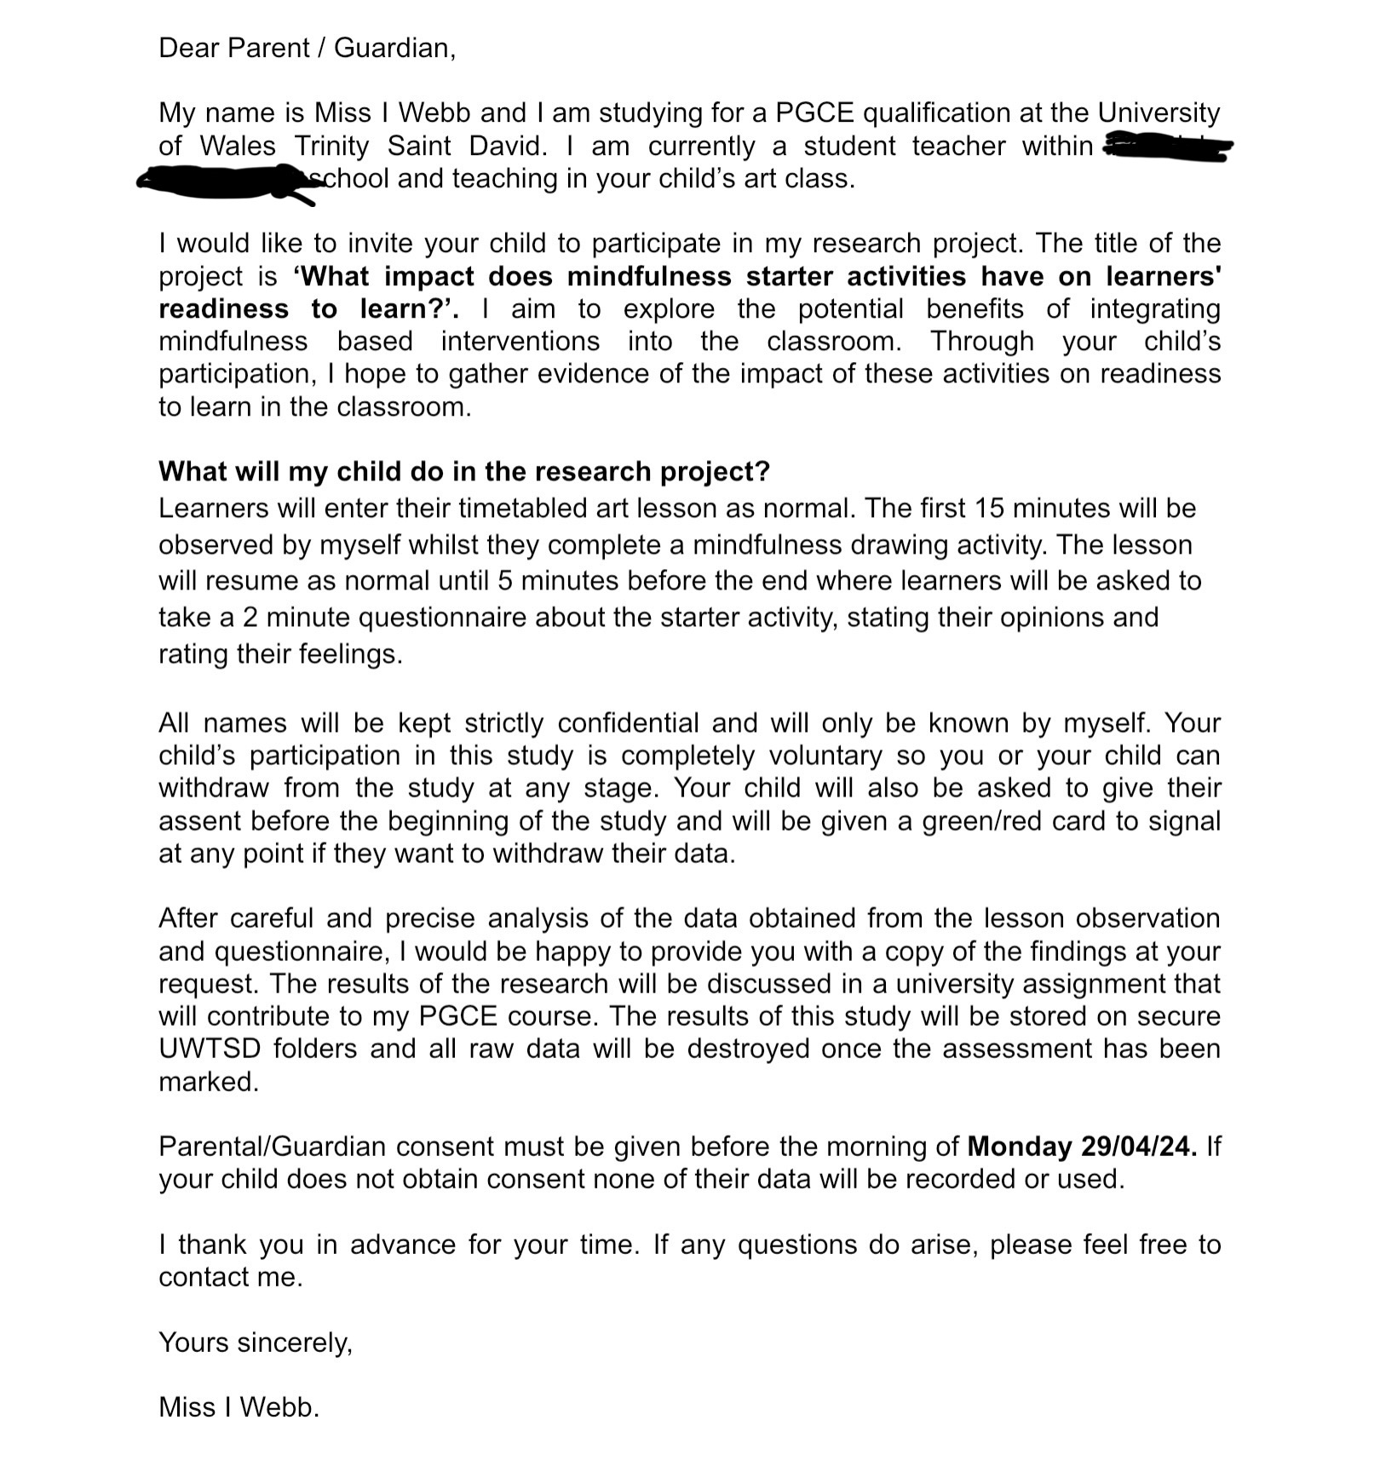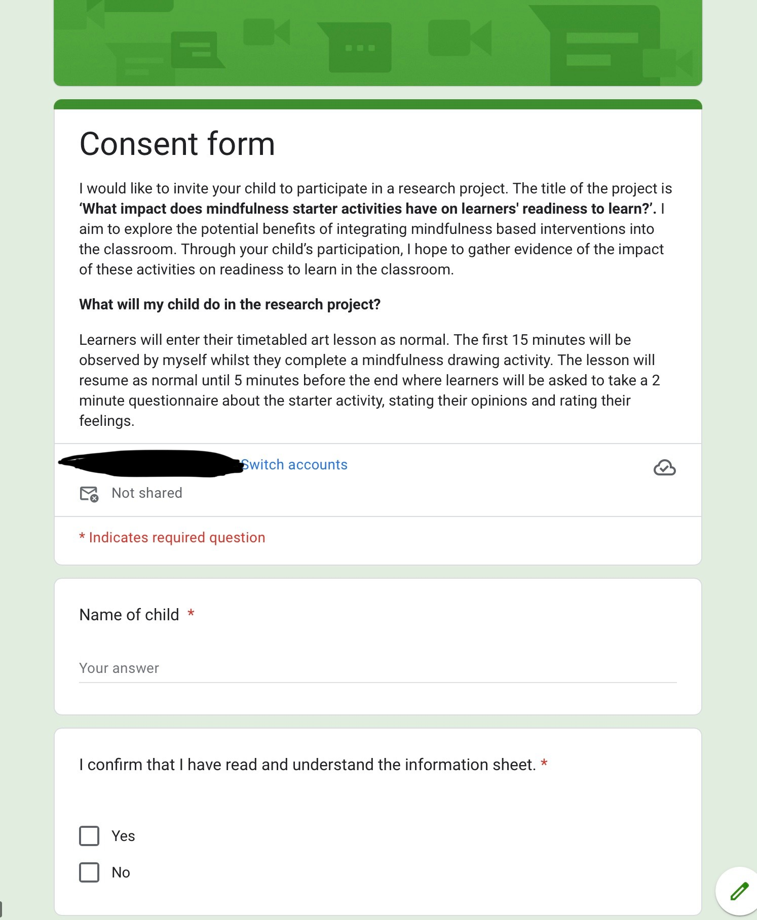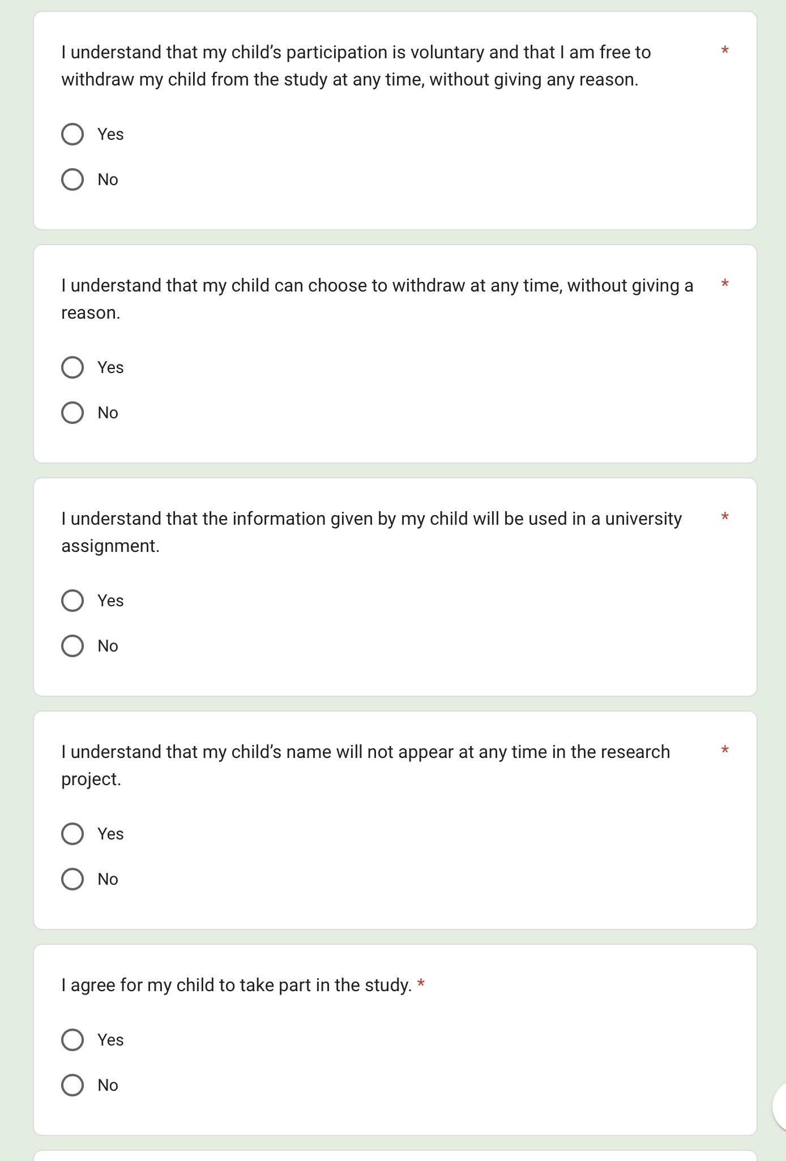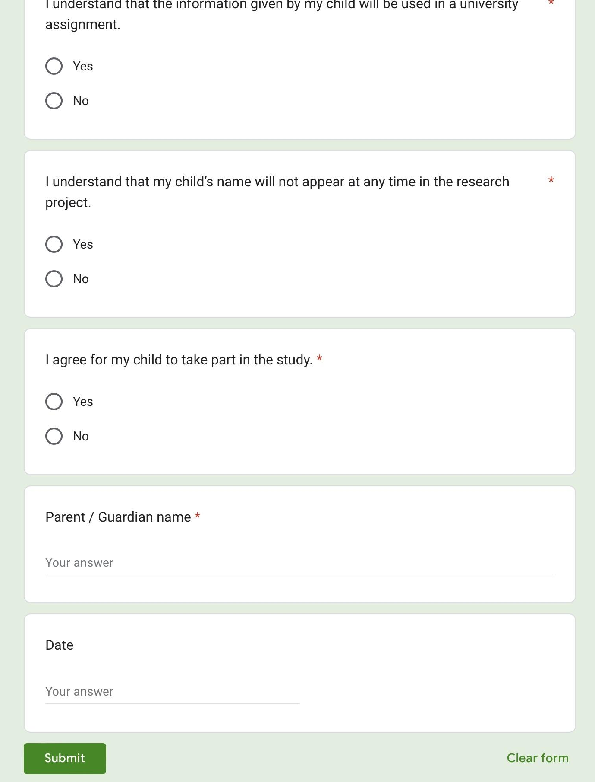

Learner consent form: Appendix 3.

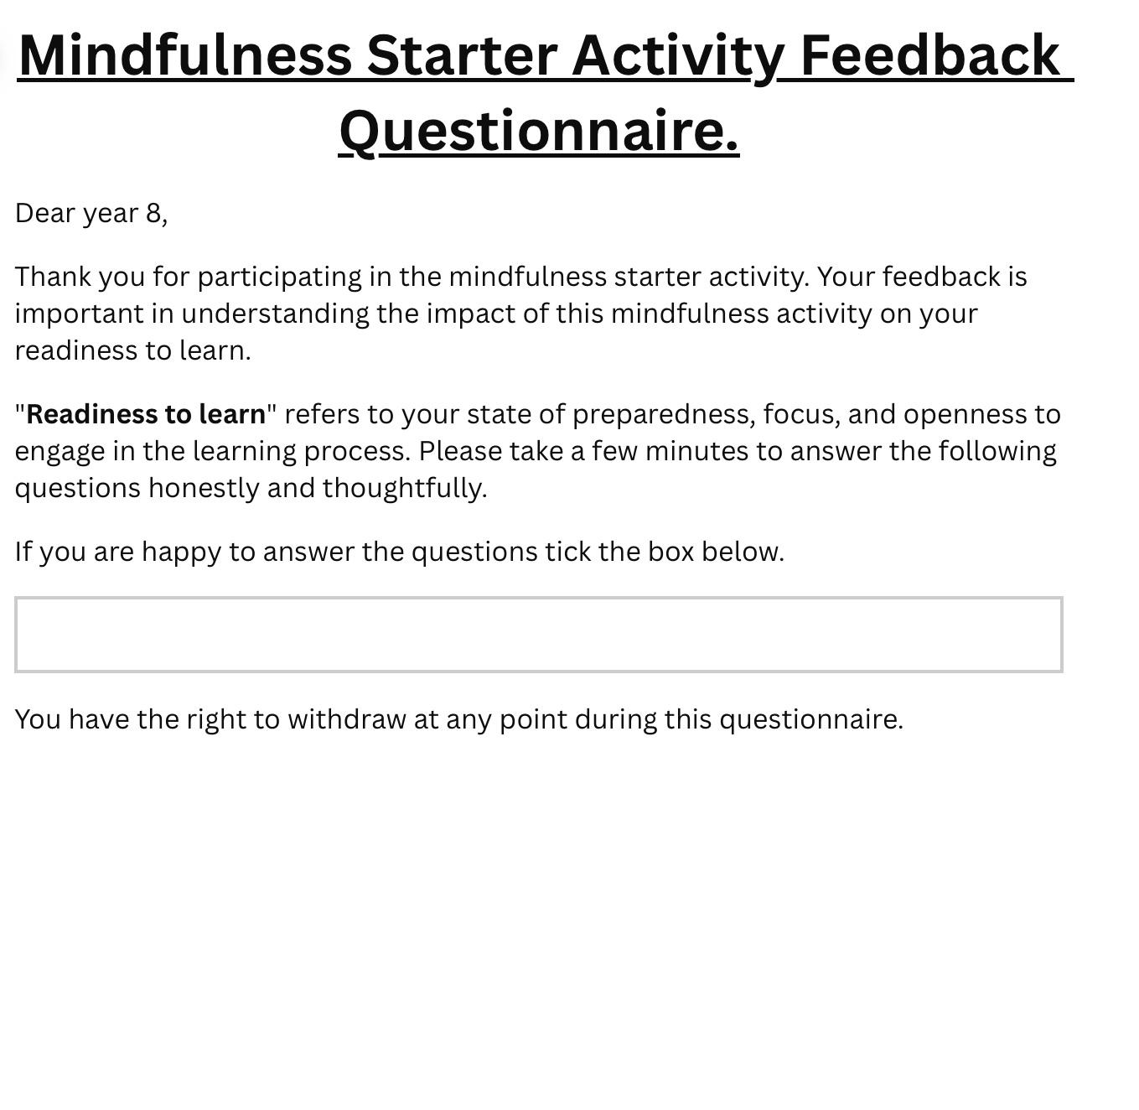Learner participant questionnaire: Appendix 4.
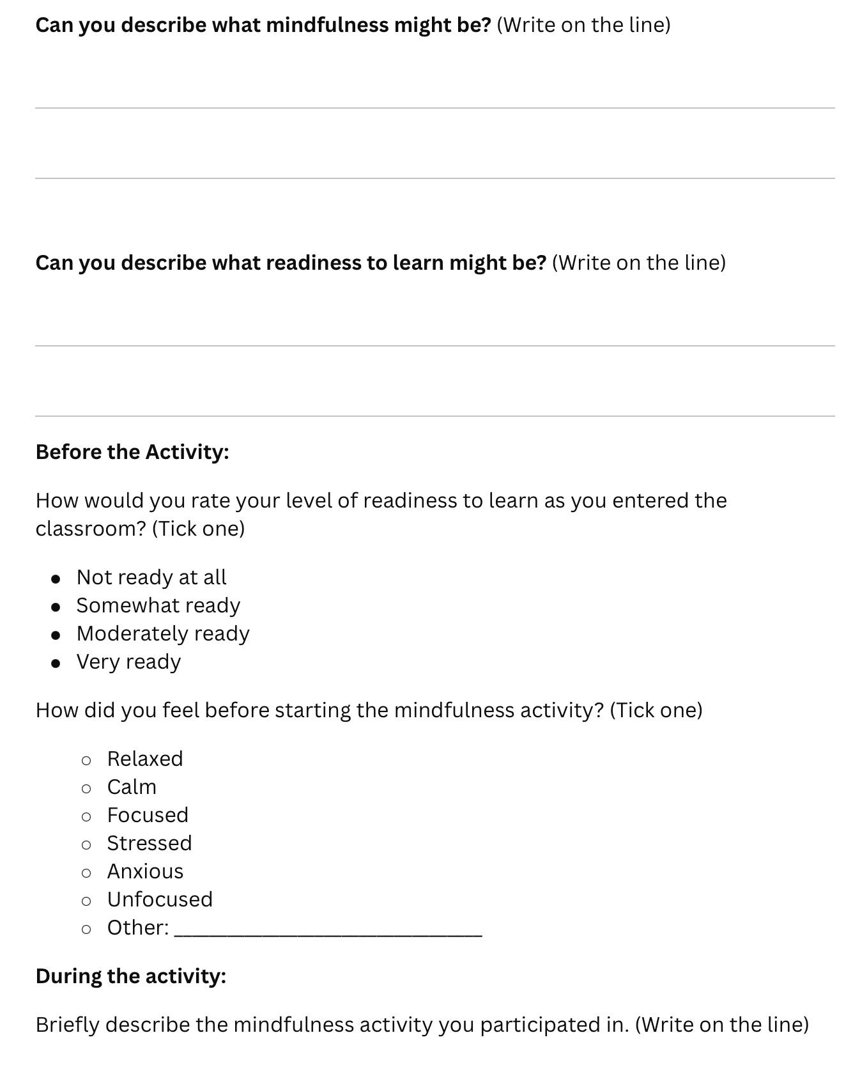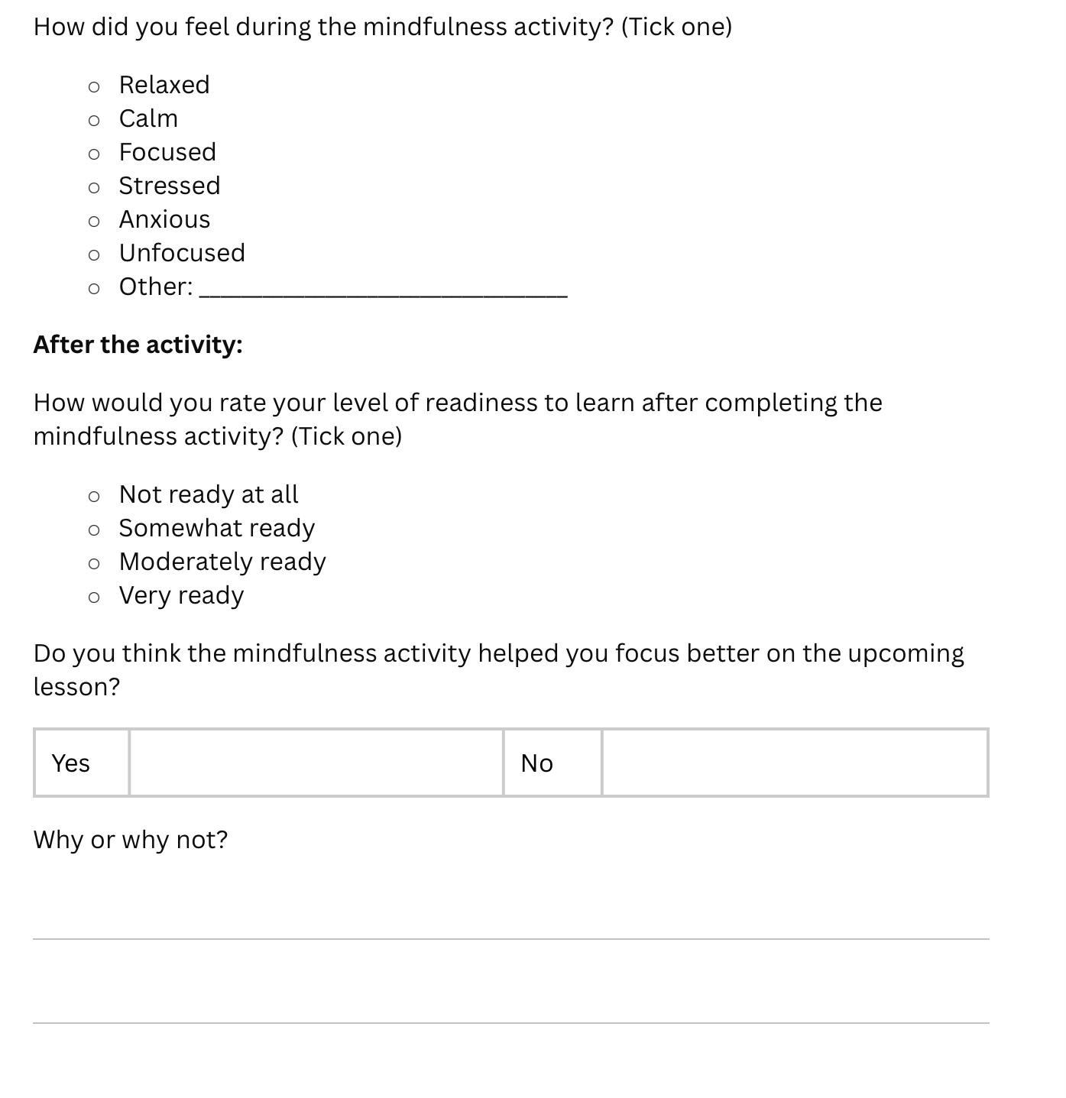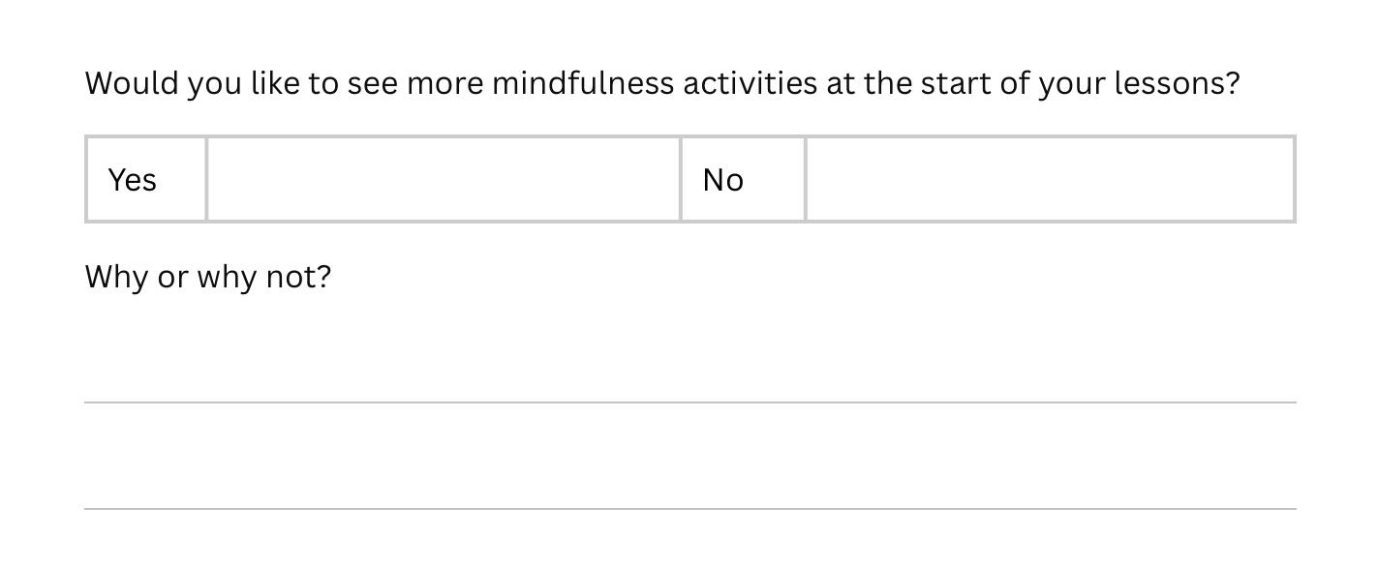

Explanation of assent used: Appendix 5
- Parental consent acquired
- Learner accent acquired by a tick
- Red and green cards given to each learner to Identify withdrawal at any point during the study

Observation schedule: Appendix 6
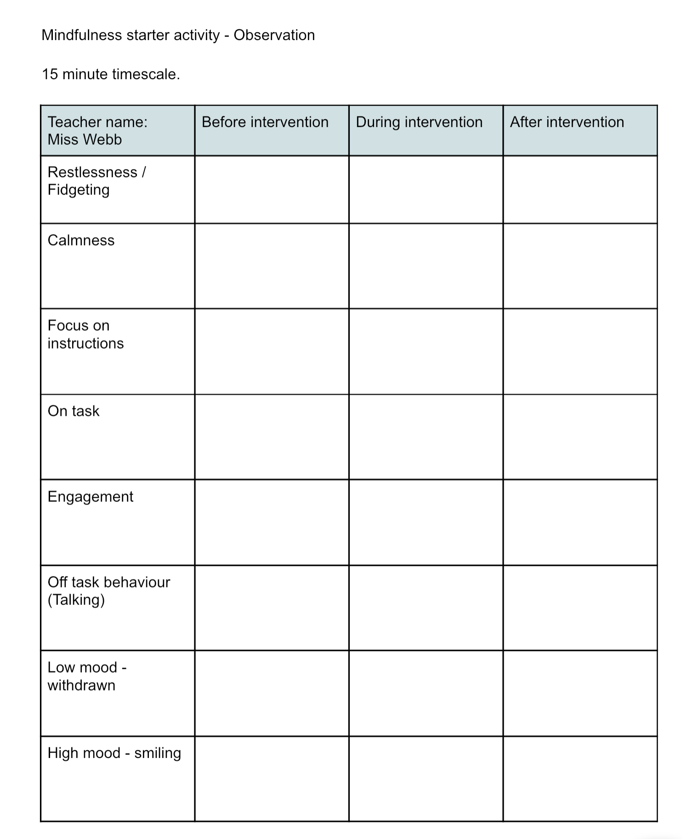
Interview questions used: Appendix 7

An interview was conducted between the researcher and an experienced member of staff in the art classroom.

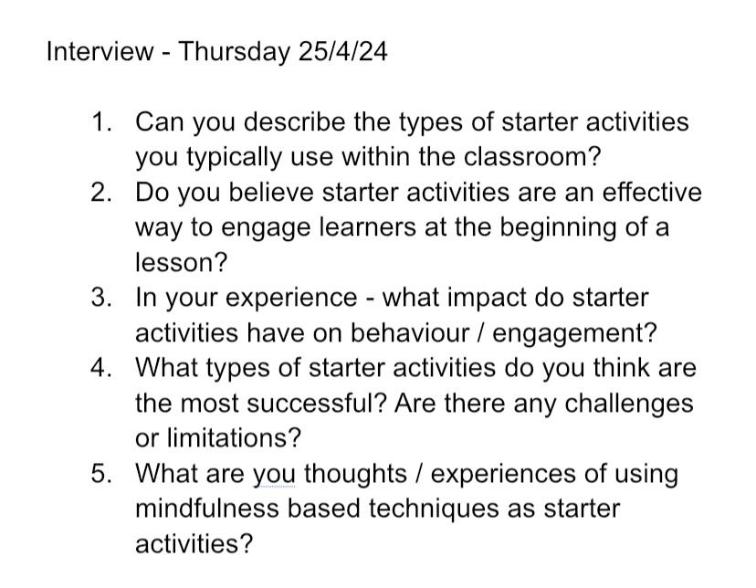

Mindfulness based starter activity used: Appendix 8



