


Marketing plan written for
Bellevue Syrene
__________________________________________

Student Name
Apurba Das
__________________________________________________

Student ID 2107164
___________________

Marketing Essentials BMIH4005

Lecturer
Neil Dyer

________________________________

Introduction

Introduce the geographical area
The Bellevue Syrene was rebuilt on the site of a Roman villa in Sorrento, Italy, in 1750 as a residential space and reopened in 1820 as a hotel (Relais & Châteaux, 2021). Here is a map view of its location.
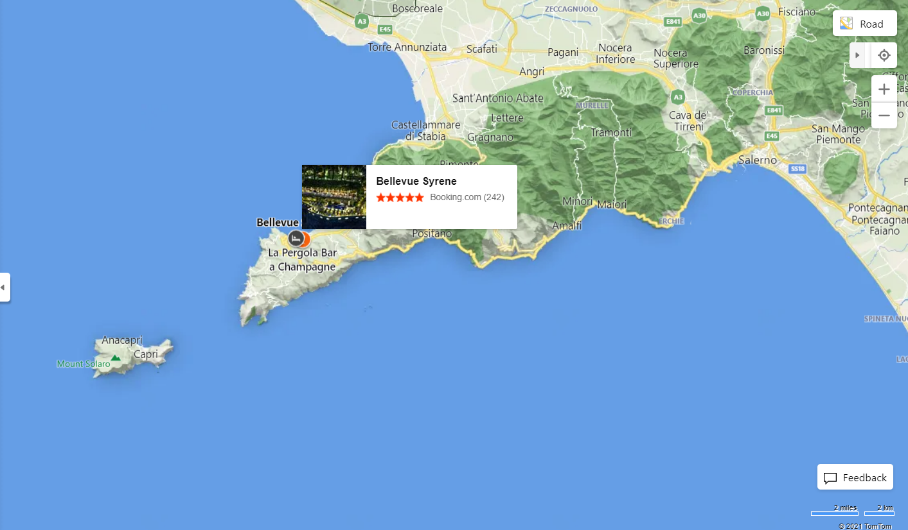
Fig: location of Bellevue Syrene
Source: (Relais & Châteaux, 2021)

The purpose of the marketing plan
The purpose of this marketing plan is to derive a strategic marketing orientation for Bellevue Syrene Hotel.
Fig: Various ratings of the hotel
Source: (Relais & Châteaux, 2021)

Whom is it being prepared for?
The marketing plan is being prepared for the professionals concerned with Bellevue Syrene.

- Marketing Mix

Product- The hotel currently offers a diverse range of rooms and suites, including ocean view, Bridal Suites, Non-smoking rooms, Suites, and Family rooms (Tripadvisor, 2021). The rooms come with amnesties like Blackout curtains, Bathrobes, Air conditioning, Private beach, Housekeeping, Private balcony, Minibar, Flatscreen TV, Room service, Safe, Wake-up service/alarm clock (Tripadvisor, 2021).
Place- The Bellevue Syrene is a 5-star boutique hotel perched on a cliff overlooking the harbour of Sorrento. Sorrento's historic centre is only a few blocks away, adorning the home with antique paintings (U.S. News & World, 2021). Guests can easily book their stay through its well-fledged website. Besides, third-party intermediaries like TripAdvisor offers booking and customer services. Lobby outlets are also available as usual.
Price- The hotel uses a high quality, the high pricing strategy in this area (Henley, Cotter and Herrington, 2004). It, therefore, has products priced at different stages, starting from a starter US$ 452.25 to a premium of US$ 1,889.13 (Relais & Châteaux, 2021). The visitors may scroll through the increasing order of prices along with the accustomed products and services.
Promotion- The company currently promotes itself through its dedicated website, intermediary websites, and social media sites. Its website contains catchy images along with several messages. The images are dynamic and contain user-friendly navigation. These elements are divided into various sections referring to the promotion of various services and capabilities; for example, its award section promotes just how good its services are. It has a separate section called Mailing List, where interested visitors may opt-in for promotional newsletters delivered straight to their email. The hotel maintains customer relationships through these newsletters and a mobile app (Kakeesh, Al-Weshah and Al-Ma’aitah, 2021).

- The Marketing Environment (Micro-SWOT)

Strengths- This hotel's location, design, comfort, and feeling of history make it a unique experience. Customers seem to enjoy its wedding venue and highly recommend its dining experience. Moreover, the hotel has 1474 reviews, generating an impressive 5-star rating (Tripadvisor, 2021). The hotel has been awarded TripAdvisor Travellers’ Choice Best of the Best Awards 2020 and Fodor's Choice (Tripadvisor, 2021).
Weaknesses- The key weakness of the hotel is the value not provides for the money (Trip Advisor, 2021); (booking.com, 2021). For example, in the following figures, two of the stayers in the hotel rated its value proposition way below, along with a few other factors. Also, the hotel does not have adequate staffing (booking.com, 2021). Visitors often have to carry their own luggage and belongings. Some rooms are aged, and some are right next to the wedding hall or party centre. Stayers feel irritated with the noises. The following two customers seem to be dealt with unprofessionally.
Some of its visitors also had issues with room services. They felt the staff were not adequately prepared or trained to serve high profile customers (Nikolskaya, 2021). The hotel is full of resources and capabilities, but it seems unaware of its optimum utilisation.
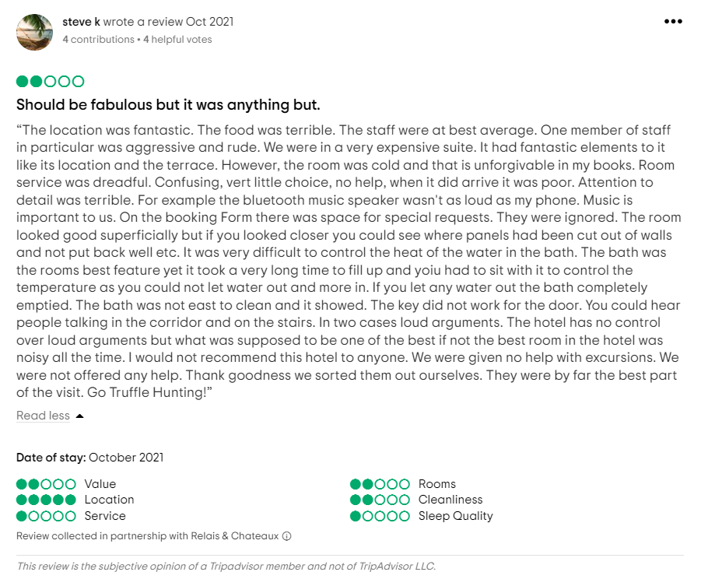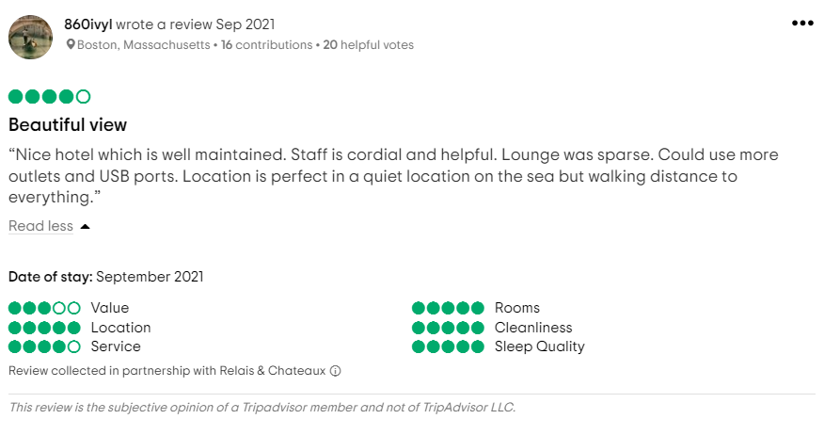

Opportunities- Nowadays, health and hygiene have been critical, sometimes a no-dealer for the customers (Jain, 2020). The hotel can implement and promote its safety measures and show its concern towards its customers. It can implement infrastructural rearrangement to put hygiene corners within its premises. These approaches should result in increased visits after the COVID situation.
Threats- Health and safety measures, if not applied, can be threatening to its business. The competitors are deliberately strategizing the safety issues as the post COVID crises emerge (Gupta and Sahu, 2021). Besides, the hotel, perceived as pricey and overvalued, is falling behind the competition. It is high time the hotel lowered its pricing by collaborating with its suppliers.

- The Marketing environment (Macro) PESTEL

Political- There has been a lot of unrest in the nation recently because of political instabilities such as dissent among the ruling coalition partners and differences over policies and election promises (Mordor Intelligence, 2021). The government tightly controls the hotel business. For example, if the ruling party imposes a travel restriction, this might have an immediate negative impact on the tourist and hotel industries.
Economical- In Italy, one of the world's top 10 economies, hospitality is a major investment area for worldwide investors (Trapani et al., 2019). The desirability of a holiday area may be affected by the strength or weakness of its currency. When the Euro is weaker than other currencies, tourists from outside Italy will be more inclined to come.
Social- In tourist season, hotels frequently run out of rooms, increasing the lodging rates. This is a major concern for hotels, which typically enjoy a significant increase in profits during peak tourist season as accommodations become limited.
Technological- Traditional media like print and television were the only options available to hotels in the past (Khatri, 2019). Still, the internet has opened a whole new world of media to consider. These are the most important instruments that hotel owners may utilise, but they must also be aware of.

- Creating Customer Value & Engagement

Change in human behaviour and corporate reorientation is being triggered by COVID 19 (Roy, 2020). As a result, the influence on consumer involvement might be enormous and long-lasting. Firstly, Bellevue Syrene will focus on its cleanliness and hygiene factors to accommodate post COVID customers who should be wary of sanitation factors. Floor decals for social distancing and front desk dividers may be installed if check-in processes are not self-serve. Hand sanitising stations may be put in place as well. To ensure the safety of their visitors, the hotel will demand their guests to perform temperature checks before or during their stay. The company should promote the hygiene perks that set it out from its competitors.
Besides, a significant portion of the young generation nowadays demands a 'Minimalistic' lifestyle. The pricing factor added to this trend invites the hotel to accommodate 'Minimalistic Suits' for this customer segment.
Finally, tourists in the post-COVID era increasingly depend on convenient services (Hotelivate, 2020). During this age, the tourists want the best services, specially tailored for each visitor (Bowie, 2017). The hotel should reorient dedicated 24/7 chat service for customers query and dealt with complaints. The business already has a mobile app and newsletter services distributed to its existing customers. However, it should incorporate a loyalty program to these customers regularly.

- Effective Use of digital Marketing

For the hotel industry's recovery, engagement with customers will be more critical than ever before. The use of social media platforms by Bellevue Syrene will help the hotel better notify guests about COVID-inspired improvements and enhancements and demonstrate how new procedures contribute to a unique and enjoyable hotel stay (Sampetua Hariandja, 2021). New consumer-focused standards may be shown at the hotel while keeping prioritising the needs of hotel guests (Accenture, 2020). These include things like personalised attention to the needs of the customer, as well as distinctive and memorable experiences. For example, the hotel may use Robotics (Revfine, 2021) to greet its customers and employ self-check-in and self-check-out options (Clock Software, 2019). In the early aftermath of COVID, those that communicate these benefits will be best positioned to catch the recovery surge long-term.
To ensure that the customers are always up to date, it is essential to regularly update and pin contents and materials (Accenture, 2020). A local Facebook or group is a terrific approach to communicating with staff and even getting comments from individuals working on the project. Employee-facing material should not be shared on customer-facing platforms.
There is now an option in Google Ads for booking hotels. The hotel's Facebook and the Instagram following may be boosted via the use of sponsored advertisements. Google Ads, Titktok and youtube video may be powerful tools for hotels to use when it comes to promoting their business on the internet.

Conclusion –

Based on the analysis. It is clear that Bellevue Syrene has a reputation built over the years, which is being threatened by factors like value creation, staffing, room makeovers, and overall services. In this situation, the hotel can implement the following adjustments.
- Those who feel that the hotel does not provide adequate value for the money points out few issues like no courtesy services. They want additional services like contemporary massages, fresh swimming items beside the pool, personalised items that represent the brand. The hotel should consider adding these services to justify its pricing.
- The wedding hall and the party centre must be made noise-proof.
- The hotel should maintain a balanced staff ratio for the rooms so that the visitors do not feel unwelcomed. The staffs must be trained properly to serve the visitors in a five-star way.
- The hotel can place robots to welcome the visitors at the entrances.
- A fully accessible to all bedrooms.

(Words 1550)

References –

Accenture (2020). NOW NEXT A New Era in Customer Engagement Transforming your continuity plan into your continuous plan.
booking.com (2021). Bellevue Syrene, Sorrento, Italy. [online] Booking.com. Available at: https://www.booking.com/hotel/it/bellevue-syrene.en-gb.html#tab-reviews [Accessed 29 Nov. 2021].
Bowie, D. (2017). Hospitality marketing. New York: Routledge.
Clock Software (2019). Hotel Kiosk - Check-In/Out and Self Service | Clock Kiosk. [online] Clock-software.com. Available at: https://www.clock-software.com/hotel-kiosk.html [Accessed 26 Nov. 2021].
Gupta, V. and Sahu, G. (2021). Reviving the Indian hospitality industry after the Covid-19 pandemic: the role of innovation in training. Worldwide Hospitality and Tourism Themes, ahead-of-print(ahead-of-print).
Henley, J.A., Cotter, M.J. and Herrington, J.D. (2004). Quality and Pricing in the Hotel Industry. International Journal of Hospitality & Tourism Administration, 5(4), pp.53–65.
Hotelivate (2020). Hotel marketing strategies for Covid-19 business recovery. [online] Insights. Available at: https://insights.ehotelier.com/insights/2020/09/17/hotel-marketing-strategies-for-covid-19-business-recovery/ [Accessed 16 Nov. 2021].
Jain, Dr.S. (2020). How Can Hotels Survive the Pandemic Using Effective Digital Application/mechanical Strategies? Long Term Solutions to Make Hotels COVID-19 Safe. SSRN Electronic Journal.
Kakeesh, D., Al-Weshah, G. and Al-Ma’aitah, N. (2021). Maintaining Customer Loyalty Using Electronic Customer Relationship Management (E-CRM): Qualitative Evidence from Small Food Businesses in Jordan. Studies of Applied Economics, 39(7).
Khatri, I. (2019). Information Technology in Tourism & Hospitality Industry: A Review of Ten Years’ Publications. Journal of Tourism and Hospitality Education, 9, pp.74–87.
Mordor Intelligence (2021). Hospitality Industry in Italy - Growth, Trends, and Forecasts (2020 - 2025). [Online] www.mordorintelligence.com. Available at: https://www.mordorintelligence.com/industry-reports/hospitality-industry-in-italy [Accessed 16 Nov. 2021].
Nikolskaya, E.Y. (2021). The Influence of Digitization on Staff Training for Tourism and Hospitality Industry. Revista Gestão Inovação e Tecnologias, 11(4), pp.414–423.
Relais & Châteaux (2021). Bellevue Syrene 1820. [online] Available at: https://www.relaischateaux.com/us/italy/syrene-campania-sorrento-na [Accessed 15 Nov. 2021].
Revfine (2021). Hotel Robots: An Overview of Different Robots Used in Hotels. [online] Revfine.com. Available at: https://www.revfine.com/hotel-robots/#:~:text=Robots%20Intended%20to%20Greet%20Guests%20Sometimes%20referred%20to [Accessed 26 Nov. 2021].
Roy, A. (2020). The pandemic is a portal. [online] www.ft.com. Available at: https://www.ft.com/content/10d8f5e8-74eb-11ea-95fe-fcd274e920ca [Accessed 16 Nov. 2021].
Saglie, G. (2020). HOME. [online] Gabe Saglie. Available at: https://gabesaglie.com/ [Accessed 15 Nov. 2021].
Sampetua Hariandja, E. (2021). Customer perspective on dynamic marketing capability in international hotels of Indonesia during Covid-19: Confirmatory factor analysis. Innovative Marketing, 17(3), pp.74–87.
Trapani, D., Presti, L., Editors, S. and Proceedings, B. (2019). New frontiers in the tourism and hospitality industry: digital, social and economic transformations. [online] Available at: https://it.pearson.com/content/dam/region-core/italy/pearson-italy/pdf/Docenti/Universit%C3%A0/pearson-pubblicazione-atti-convegno-ICTDT2020_DT_v2a.pdf [Accessed 15 Nov. 2021].
Tripadvisor (2021). Bellevue Syrene. [online] Available at: https://www.tripadvisor.com/ShowUserReviews-g187782-d235955-r815045784-Bellevue_Syrene-Sorrento_Province_of_Naples_Campania.html [Accessed 15 Nov. 2021].
U.S. News & World (2021). Best Hotels in Amalfi Coast. [online] Available at: https://travel.usnews.com/hotels/Amalfi_Coast_Italy/ [Accessed 15 Nov. 2021].

Five Minutes Supporting Presentation



