Platinum Starlights Ltd.
Managing Enterprise in 21th century

We are
Cem Azizoglu -2030420

Georgi Chorbev -2030330

Lecture Afzal Munna


...and this is our business plan.





About Us
We are a Fashoin Luxury Brand born in the UK and ready to open our Boutique doors in July 2022,
along with the lounch of our first Couture collection for ladies and
gents.
We are passionate about our exclusive products and designs and we invite you to visit our online store and discover our Pret-a-porter collection.
You can find us at : www.platinumstarlightscouture.com
Or you can have a memorable experience in store from the 1st of July, on 13 Bond Street, London, UK.

Our Products & Services
Pret-a-Porter Collection list of products : Ladies Gents
Coats and Jackets Coats and Jackets
Suits Suits
Dresess Blazers and Waistcoats
Skirts Shirts
Tops T-shirts and Polos
Trousers Trousers

Descovery of Exclusive Couture designs and tailoring services available by appointment.

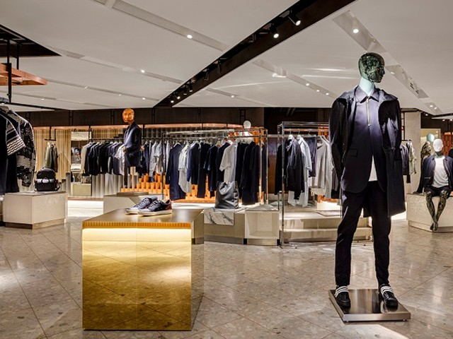

The Market & Competitors

- The market is highly competitive

- The business will be an online start-up company

- The company will address any age group who needs the safest, softest and high quality materials

  - Our business sells luxury organic clothing

- Versace, Chanel and D&G are some of our competitors

Our Marketing & Sales

  - Creating a Loyalty programme to boost our sales

- Using social media for the recognition of our brand

- For example: YouTube and Instagram channels are a great way
for promoting our products

  - Using E-commerce

- Recruiting a film star or a singer for the brand image

Management and Organisation

Management

George R. Terry (1977) defined Management as a distinct process consisting of planning, organising, and controlling, performed to determine and accomplish set of objectives.

Management, in every form, is a dynamic process engaged with getting things done with team work and effort by harnessing human and other resources. (Bhattacharyya, 2008).

The management in any organisation or a company is the particular organ that is the basis for the survival and performance of their respective business.

- Our company will be based on sole proprietorship

Organisational Structure
The organisational structure is a direct representation of their management flow, their organisation’s value and corporate structure strategies, the channels that it adapts to for promotion of new challenges along with its decision making processes.

Organisational structure indicates an enduring configuration of tasks and activities (Skivington and Daft, 1991).

- Our brand will consist of a CEO (President) as a head of every different field and departments working under them.



1 ·· IU
. :r,w.

l\ltsTIIIT

Management Team
The management levels are divided into different teams that can help the overall efficiency of the business by making the members concentrate on their respective areas of expertise.
- President and Chief Executive Officer (CEO)
- Design Director
  - Design Department Staff
- Purchasing Director
  - Textile Buyers
- Quality Assurance
- Sales Director
- Regional Director
- Director of International Development
- Key Account Manager
- Marketing Director

Financial Information

Business plan financials is the section of your business plan that outlines your past, current and projected financial state. This section includes all the numbers and hard data you’ll need to plan for your business’s future, and to make your case to potential investors. You will need to include supporting financial documents and any funding requests in this part of your business plan.

References

Bhattacharyya, Dipak Kumar, 2008. Organisational Systems, Design, Structure and Management. [online] Available at: <https://ebookcentral.proquest.com/lib/anglia/reader.action?docID=3011256> Accessed on 15 Dec 2021]

Birkinshaw,J.,2000, Entrepreneurship in the global firm, Sage publications: London. Burns,T and Stalker, G.M, 2001. The management of Innovation, Oxford University
Skivington, E., J. and Draft L., R., 1991. A STUDY OF ORGANIZATIONAL ‘FRAMEWORK’ AND ‘PROCESS’ MODALITIES FOR THE IMPLEMENTATION OF BUSINESS-LEVEL STRATEGIC DECISIONS*. 28 (1), pp.
45-68 [online] Available at: <https://onlinelibrary.wiley.com/doi/10.1111/j.1467- 6486.1991.tb00270.x> [Accessed on 15 Dec 2021]

https://couturenotebook.com , https://luxurylondon.co.uk

The Market and Competition
It can be argued that the crucial part of any kind of business is the critical market analysis. This plays a key role for a company to be successful. Therefore, this part of the business plan requires us to demonstrate both our expertise in our specific market as well as the attractiveness of the market from the financial point.
It can be said that doing market assessment could be a quantitative and qualitative analysis of a market. This focuses on the size of the market both in numbers as well as in the value perspective. For example; the different customer segments and buying habits since we provide any age group, the competition, and the economic situation in terms of blockages to entry as well as the regulation.

We are well aware about our market and it is highly competitive. In addition to that we strongly believe that the market that we will be entering into is large enough in order to build a sustainable business in the long run. This business will be an online start-up company at first and the company is going to target any age group whoever wants to buy the safest and softest products. And these products will be high quality materials. Our company will be selling luxury organic clothing.

For example, Versace, Channel as well as the D&G brands are the biggest existing brands in terms of our competitors out there in the market for us. We know that It will require us to make a great assessment of the market in order to compete with them successfully and effectively.

Target Market
The target market is the type of clients companies focus within the market they are competing Our company will be addressing at any age group. We do believe that this section is really relevant when the market has specific and clear segments with various aspects of demand.
Market Need
From a strategical perspective, we have found out about our competition and our strengths, weaknesses and market positioning in which we will discover our own market positioning. All we want to achieve is to able to prepare the reader to pay attention and understand our positioning so that they buying from our company.

Competition
To be successful, first of all, we need to be able to find out who our competitors are. We do believe that gathering information as much as possible on our competitors will lead to the great success. Therefore, we can mention that our aim of this section is to be able to give a great fair perspective of whom we will be competing against. We surely need to understand our competitors' well positioning as well as to find out their strengths or either weaknesses. We also argue that the more we understand and discover about our competitors the more profitable our company will be in the future.
For example; as a start-up company we do know that it is not going to be so easy to compete with Channel and Versace which are already in the market for years and years. Social media, newspapers, as well as the magazines could all have data about the businesses we are investigating for our competitive analysis. In addition to that, press releases are another source of investigation about a company.
The main idea here is to assess our competitor's angle in the market in order to find out the weakness so that our company will be able to apply in our own market positioning. We believe that the quality of our products will be the main drivers for our business’ success. These quality products will be helping us to achieve in beating the competition. Nowadays people are well aware of their health. With the help of providing the most luxury organic fabric clothing, customers will be more and more aware of our business in the market.
There also could be some barriers to entry for us, for example;
Initial Investment will be needed in order give a proper start to our company for the project we will be focusing. At first we know that there will be initial expenses.

Technology could be sophisticated sometimes for instance company’s website should be well designed. A complicated website may cause a client to leave the website or either hard to use the website could be another obstacle to our company. Our website must be easy to be used.

Brand name It would indeed be true to say that building a brand name and sustaining it will require us huge marketing costs in order to be able get to a certain level of recognition. Brand image is so important for people nowadays.

Regulation in order to run our business we will need to get kind licenses and certificates. So that, we will be sure that the company will follow the rules and regulations.

Marketing and Sales
It can also be argued that one of the most important sections of any type business plan is the marketing and the sales strategy. Without the successful marketing and sales strategy, there is no single company still exists, in the world, that lasts forever. It is because this strategy well outlines and mentions our plans in order to be able to reach our target market. With the help of our marketing and sales strategy, more and more customers will be hearing about our products and services as well as that they will be more aware of our brand image. So that we could build a great sustainable future for our company. Successful marketing and sales strategy is going to lead us achieve in brand reputation.

While we achieve to keep a wonderful product or provide excellent service, it's all meaning nothing, if we don't have customers and clients. Imagine the company has the best product in the market, however, no one hears about this product so the product mean nothing to the company. Therefore, our marketing plan is the key to effectively discovering those buyers.

Customer Loyalty Programe

Each and every company’s top executives will mention that having loyal clients for the business is the key for a sustainable business success. Loyalty marketing has been an effective strategy that encourages and motivates the customers to come back to your business again and again to do shopping. In addition to that, this strategy involves in building up to boost customer loyalty. Loyalty marketing plays an important role in bringing back as well as the retain the existing and previous clients with incentives, which will be absolutely great for our business.

We as a company will build a loyalty platform and this platform will be named as Starlight. With the help of our loyalty platform, we will be able to see our customers buying habits. Which age group is spending on what specific products will be discovered on what they are spending the most.

Social media

Social media marketing will be one of our most powerful ways for us to reach our customers. We are well aware that our customers are already interacting with various brands with the help of social media. If we are not able to directly to target our audience through the social platforms like Facebook and Twitter as well as Pinterest and Instagram we will be definitely missing out much. This marketing channel has been the use of social media platforms in order to link with our audience to be able to boost our brand image and increasing our revenues and bringing more and more people to our websites. With the help of all these social platforms usage we will be involving and publishing great extensive content on our social media profiles paying attention to our audience to and engaging our followers assessing our outcome and operating our adverts in those platforms. Our product awareness will be boosted through all the channels mentioned above and therefore we believe that this will also importantly help us to promote all of our products. This kind of marketing strategy play a key role in our product awareness since will be a new startup company.

E-commerce Marketing Strategy
Ecommerce marketing strategy allows a business to sell products or services through a website online. It can be seen as an online store. Our products will be physical like clothing. Our company will be selling only our own products through a website. We will be a direct-to-consumer business.
The Covid-19 global pandemic has given an incredible support for companies’ ecommerce strategy to be applied. Moreover, many businesses have really been forced and have to do business digitally online. Therefore, so many businesses regardless of new to selling and questioning themselves whether or not they should be applying ecommerce marketing.
In between choosing to build our own website in order for allowing our customers to easily make purchases or choosing commerce platforms, in order to attempt keep sales coming, it can be difficult to take on one additional strategic task.

Ecommerce marketing strategy will do the followings for our start-up company
- Brings more people to our ecommerce website without the need for phsycial shop
- Brings us in front of our audience
- Makes it possible for people searching for products we sell to discover our website
- New customers will be reachable.
- This will increase the chances for people in order to make purchases again easily
- This will be a discover for the after purchase experience to increase our customer satisfaction and to be able to drive customer loyalty

It is indeed to true to say that as a result of this strategy, without this kind of marketing, we will not be able to make any sales. Therefore, creating and designing our ecommerce website is not enough by itself. People will need to discover us before they think of spending money on our products.

Recruiting a famous person for the brand image

We believe that famous people have usually made the sales increase and supported the business boosts its revenue. People would get affected positively when they see a familiar face on the products they are thinking of buying. These familiar faces will be one of the quickest and easiest techniqies for our company to build brand image and brand reputation in the mind of people.

For example; when a globally loved film star or a singer wears our product, then the product will gain so quick awareness on the eyes of people. There are many reasons on why the companies may need to select in using celebrity marketing strategy. With the help of this marketing strategy our products will be introduced to our target audience when the consumers feel familiar and comfortable with those famous well known faces. The main key to be a successful in the celebrity marketing campaign, we argue that the right marketing celebrity must be done with the right product in connection with famous person.

Management & Organisation of a Luxury Fashion Brand

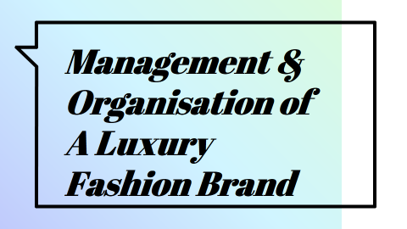

Table of Contents

Management and Organisation 3
Organisational Structure 3
Management Team 4
President and Chief Executive Officer 4
Design Director 4
Design Department Staff 5
Purchasing Director 5
Textile Buyers 5
Quality Assurance 6
Sourcing Manager 6
Sales Director 6
Regional Director 7
Director of International Development 7
Merchandising Manager 7
Key Account Manager 7
Marketing Director 8
References 9

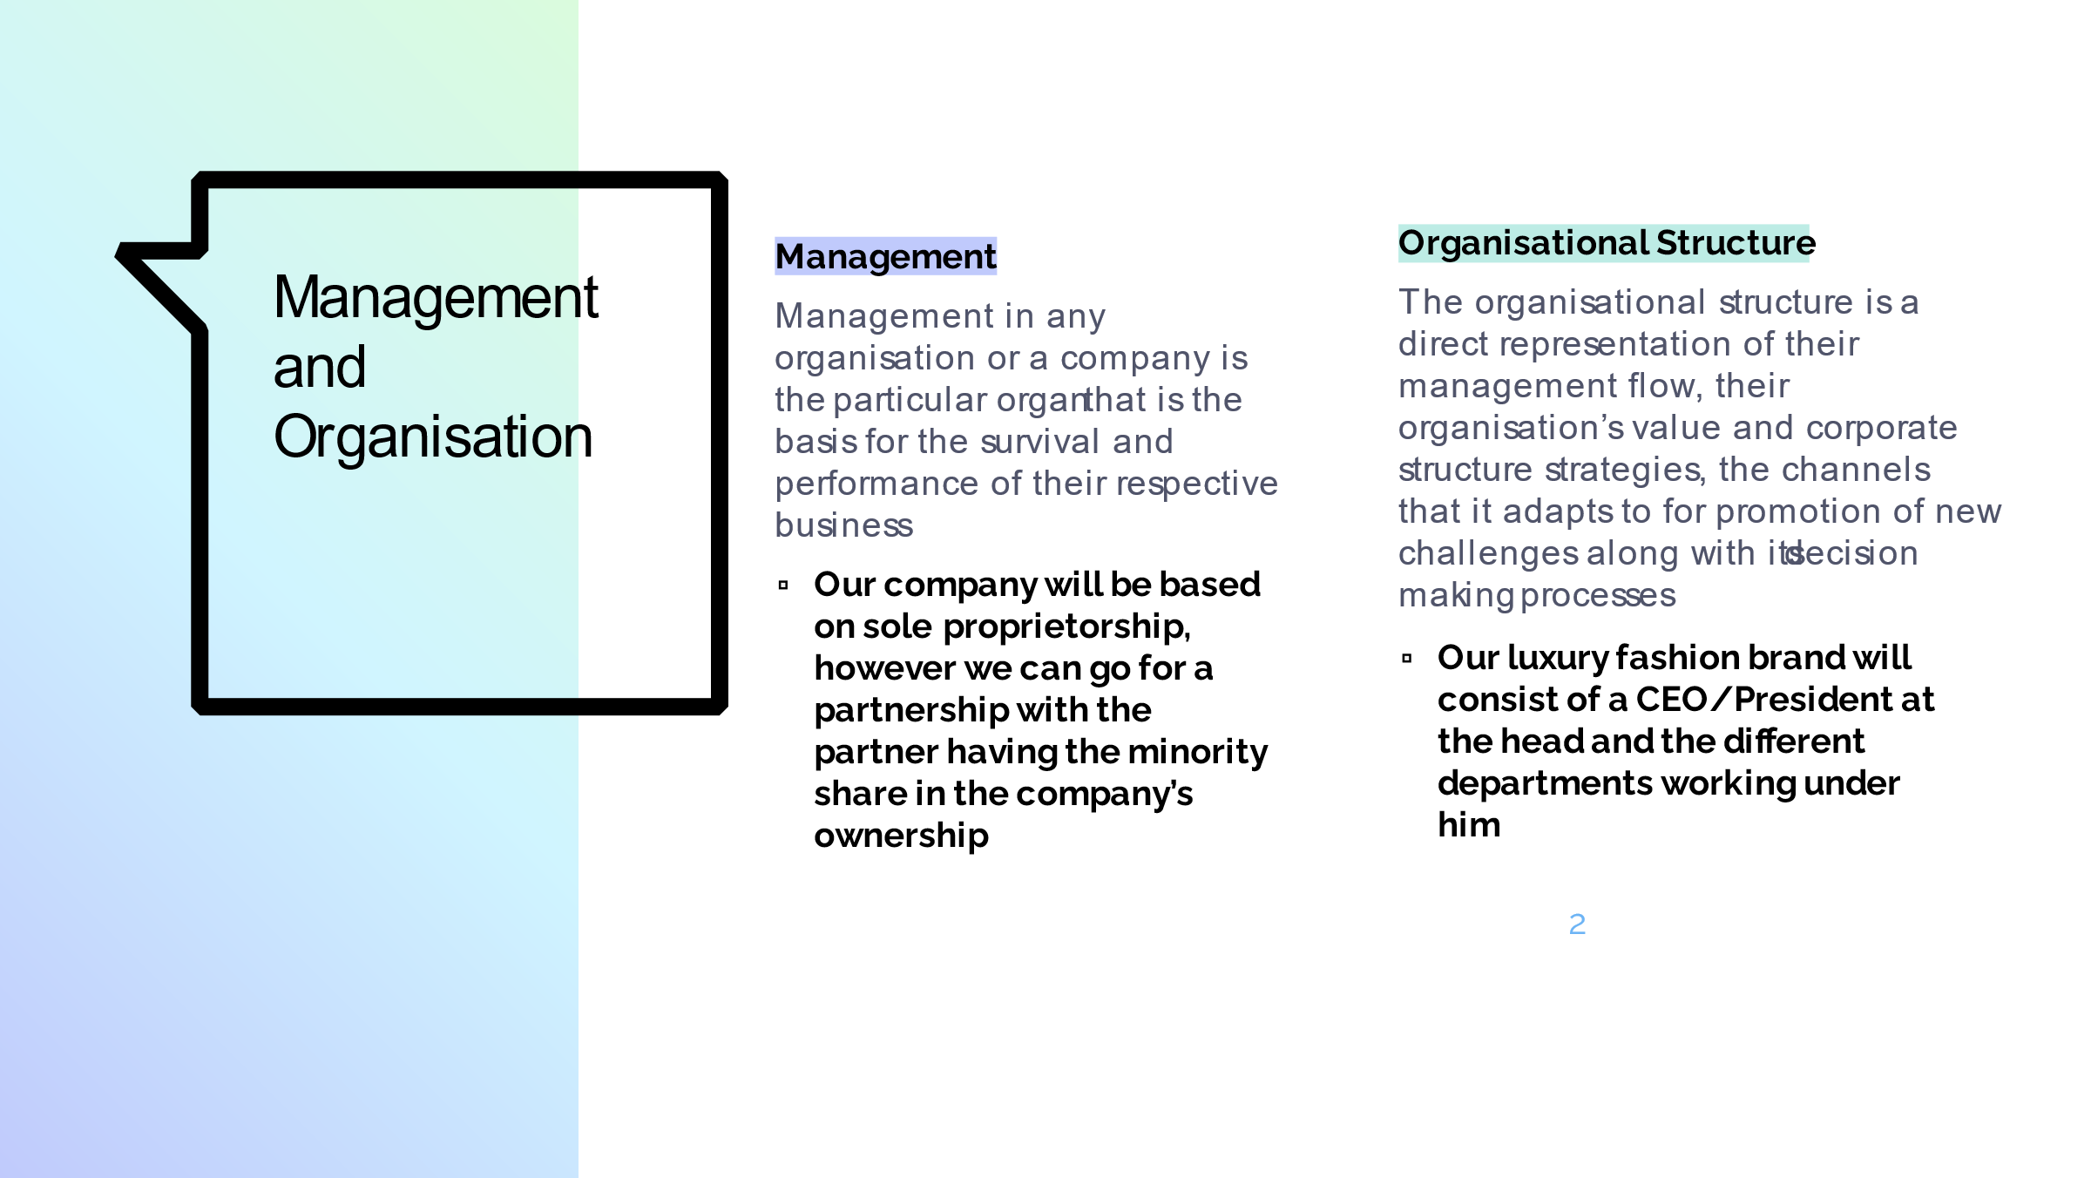

Management and Organisation
Management in any organisation or a company is the particular organ that is the basis for the survival and performance of their respective business (Shoimardonkulovich, 2020).
The management and organisation for our luxury fashion brand, will comprise of a CEO, who would be the principal owner as well. We would not be going for a partnership, however, if the need arises and a suitable partner can be found, the new partner will have a minority share in the company’s ownership. Our Luxury Fashion brand is intended to be launched and then grow for several years ahead in the future. However, in the event of any unfortunate circumstances that require the brand and company to be closed off, or that the investors demand repayment of the original investment amounts along with the return on their investments, the company can follow on two strategies, either finding a partner to buy out the initial investor’s shares, or going for the management buyout option (Gilligan, and Wright, 2020). The suitable options will be decided upon by the co-operation between the initial investors and the company management, before the operations start to take place. However, this seems highly unlikely, as the luxury fashion brand is a really profitable business, and since we will be operating in both men and women apparel categories, the business is forecasted to have a larger appeal for its consumer base.
The rest of the information regarding the company’s organisational structure and the management teams that we will integrate into our business plan, are provided below.

Organisational Structure
All the companies and businesses are partially defined by the organisational structure that they adopt. Their adoption of organisational structure is a direct representation of their management flow, their organisation’s value and corporate structure strategies, the channels that it adapts to for promotion of new challenges along with its decision making processes (Maduenyi et al., 2015).
Regarding our company, whose business products correspond to the luxury fashion industry, the organisational structure would comprise of A CEO (who would be the President as well), and the directors of different departments, such as Design department, purchasing department, sales department, regional department, international development department, marketing department etc. All of these directors will be responsible for managing the staff of their respective departments and would directly be answerable to the CEO/President of the company.

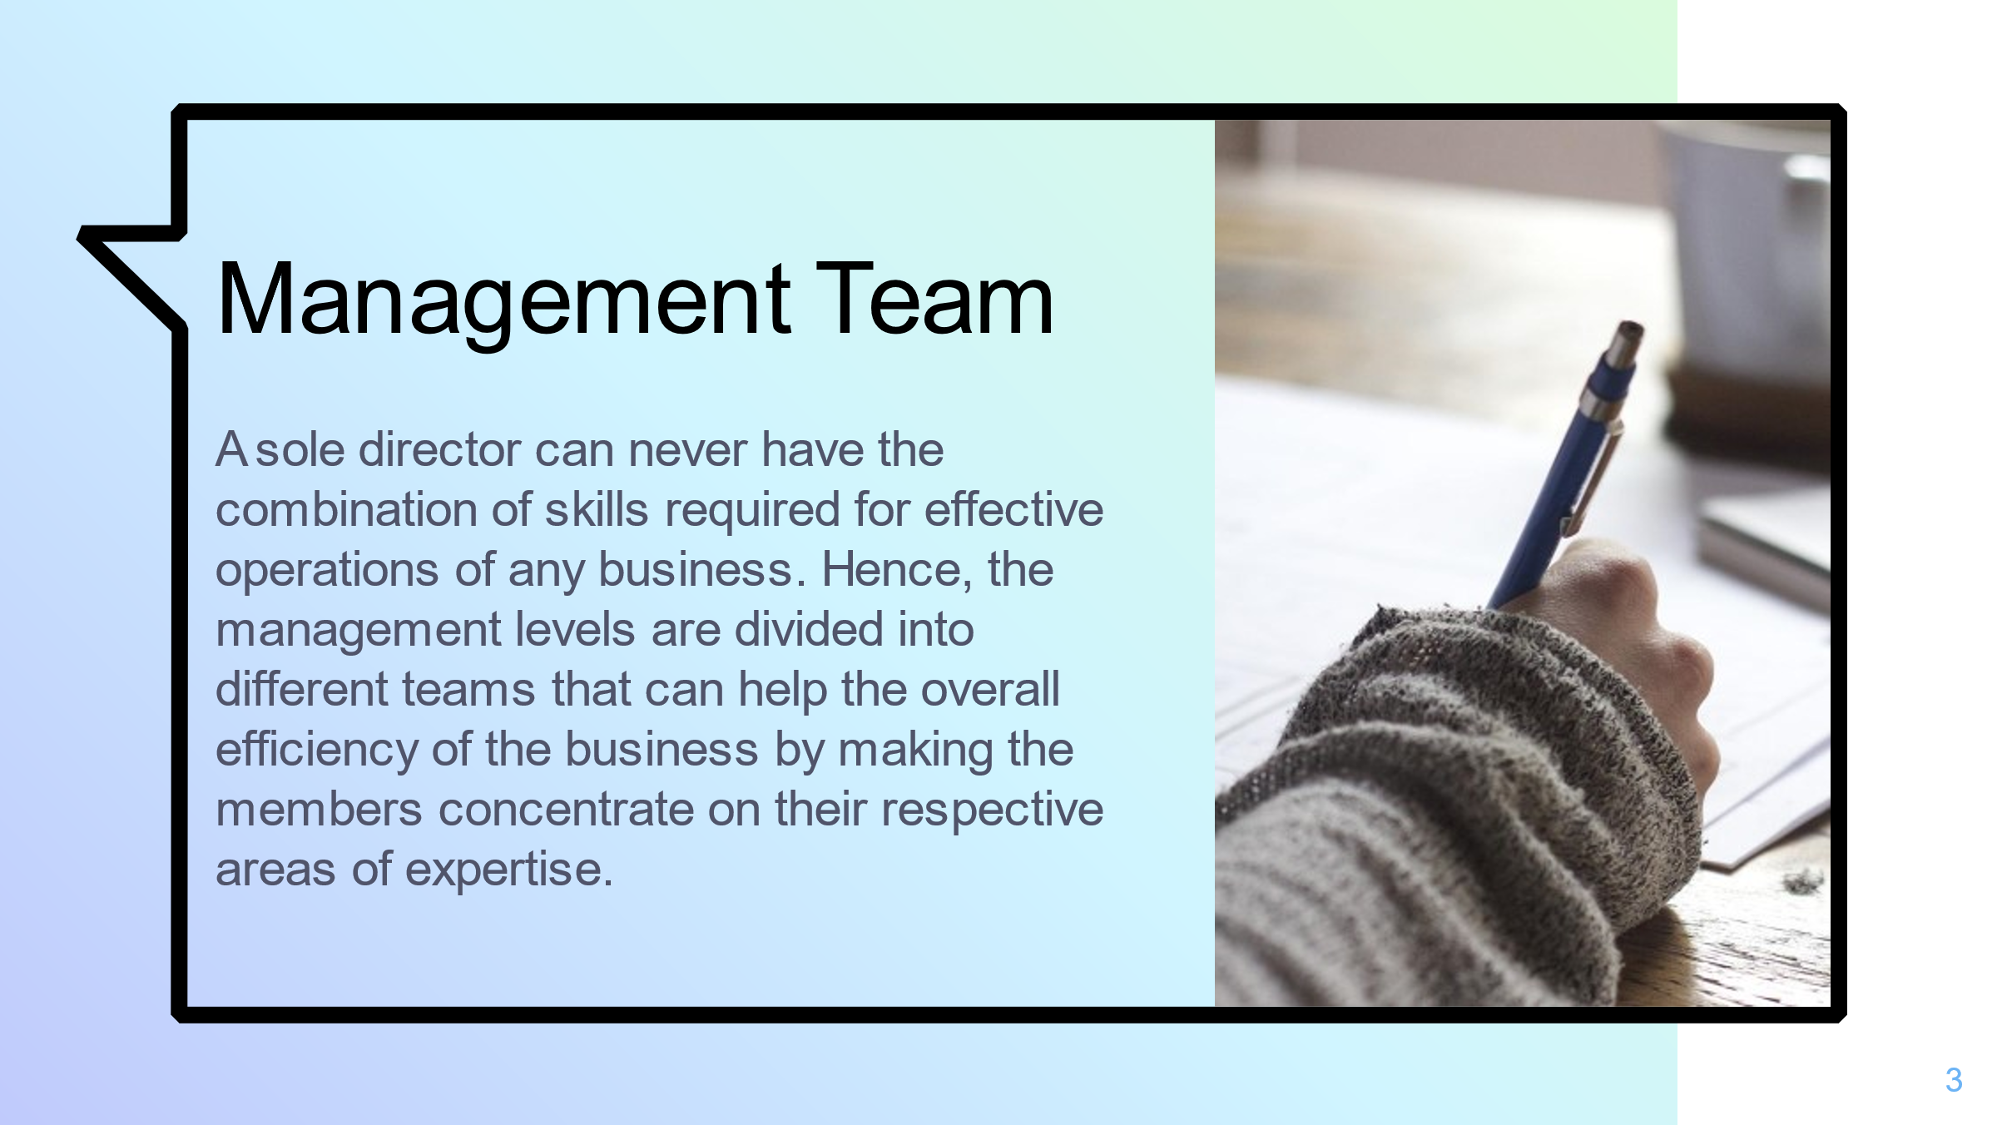

Management Team
A sole director or manager can never have the combination of skills and talents that are required for the effective operations for any business. Hence, the management levels are divided into different teams that can help the overall efficiency of the business by making the members concentrate on their respective areas of expertise. Additionally, this can also help the business, such that its values and goals can be viewed through varying perspectives, hence providing an overall strategic direction (Goworek, et al., 2020). This is the reason, a strong management team is required by every business and organisation.
The Management Team for our business corresponding to the men and women’s luxury fashion brand will comprise skilled and talented management teams. The major positions along with their respective responsibilities that our company will encompass of are explained below:

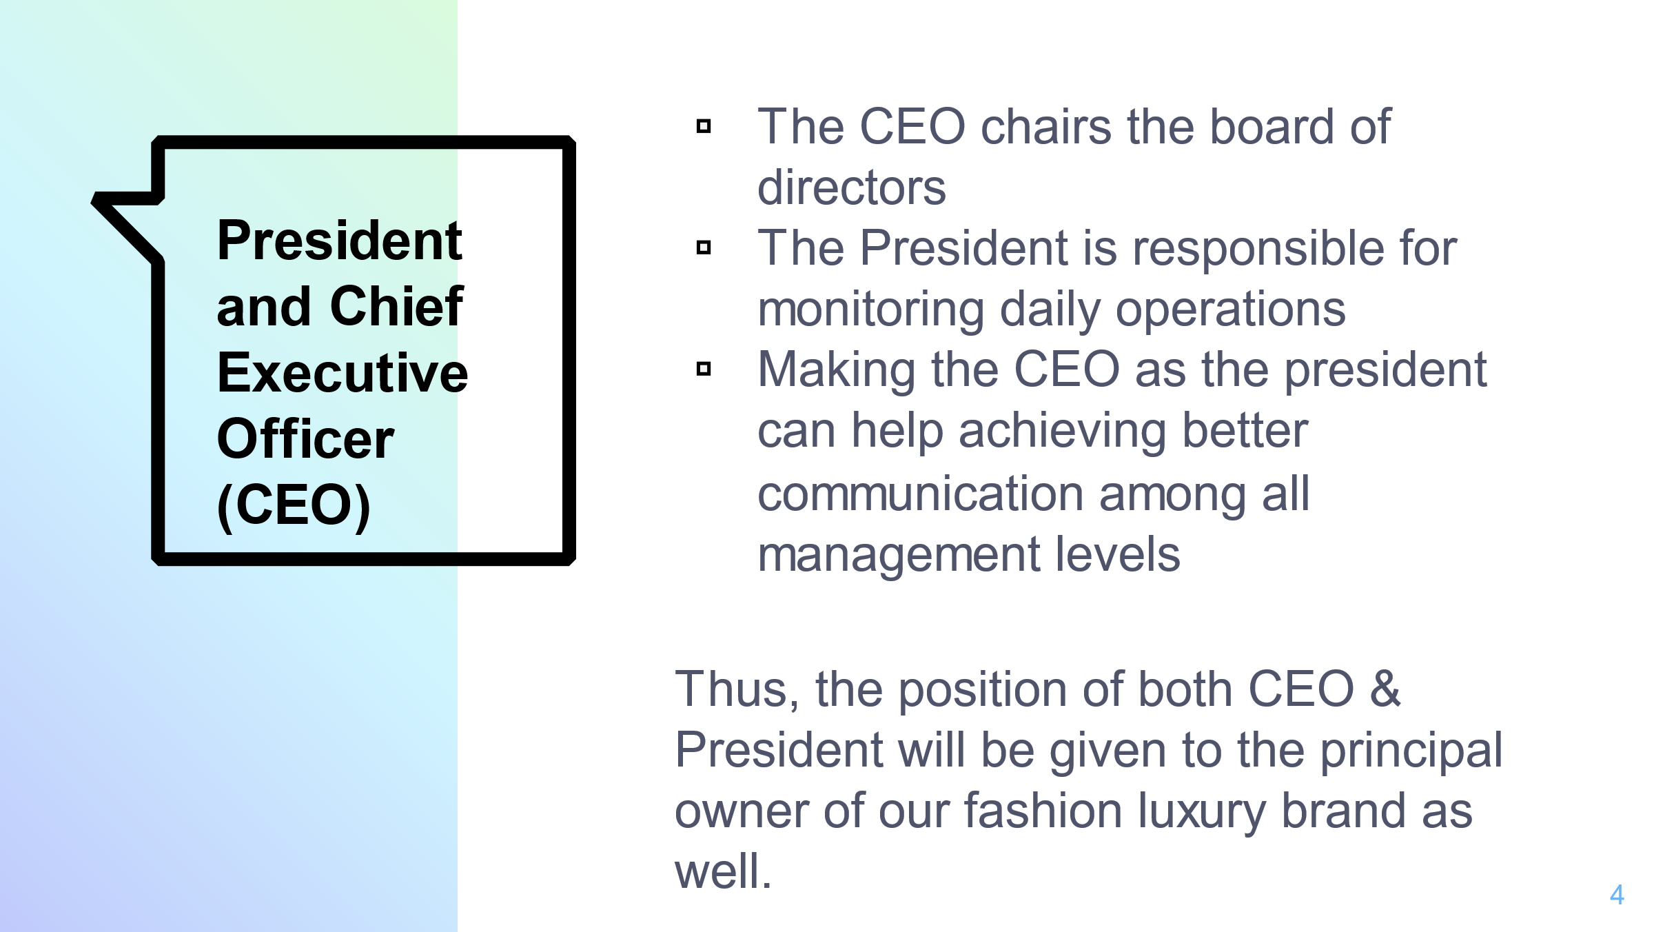

President and Chief Executive Officer
Although pretty unusual, the companies without different subsidiaries can have only one person designated both, as a CEO as well as a President. The basic job responsibility for a CEO is to chair the board of directors that are responsible for the setting of policies for the company, whereas for a president, the basic responsibility is to oversee the daily operations of the business for effective monitoring. In instances, where the CEO and the President are the same person, a better communication between the board of directors (i.e. upper management levels) and the operational management can be achieved (Wheelen, et al., 2017). Regardless of the arrangements, the ultimate objective of corporate governance is the efficient and effective management of the relationships between the decision makers and the owners that results in increasing the shareholder worth (Ansoff, et al., 2018).
Thus, based on our company’s management on this phenomenon, the position of the CEO and the President will be given to the same person, who will essentially be the principal owner of our fashion luxury brand as well.

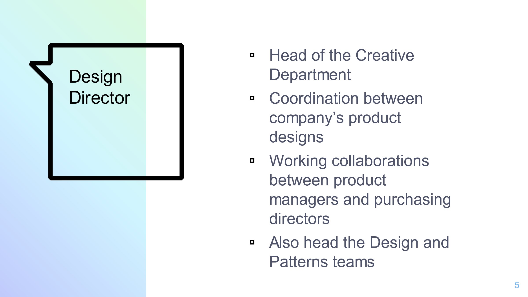

Design Director
The Design Director will be the person who will head the Creative Department. Their main responsibility will correspond to the provision of coordination between the designs of all of the company's products, along with working in collaborations with the purchasing director and the product managers, for achieving this coordination of product designs (Welters, and Hannel, 2015). The design director will also be responsible for overseeing the design and pattern teams of the department. This design director will have to report daily operations of their respective department, directly to the CEO.

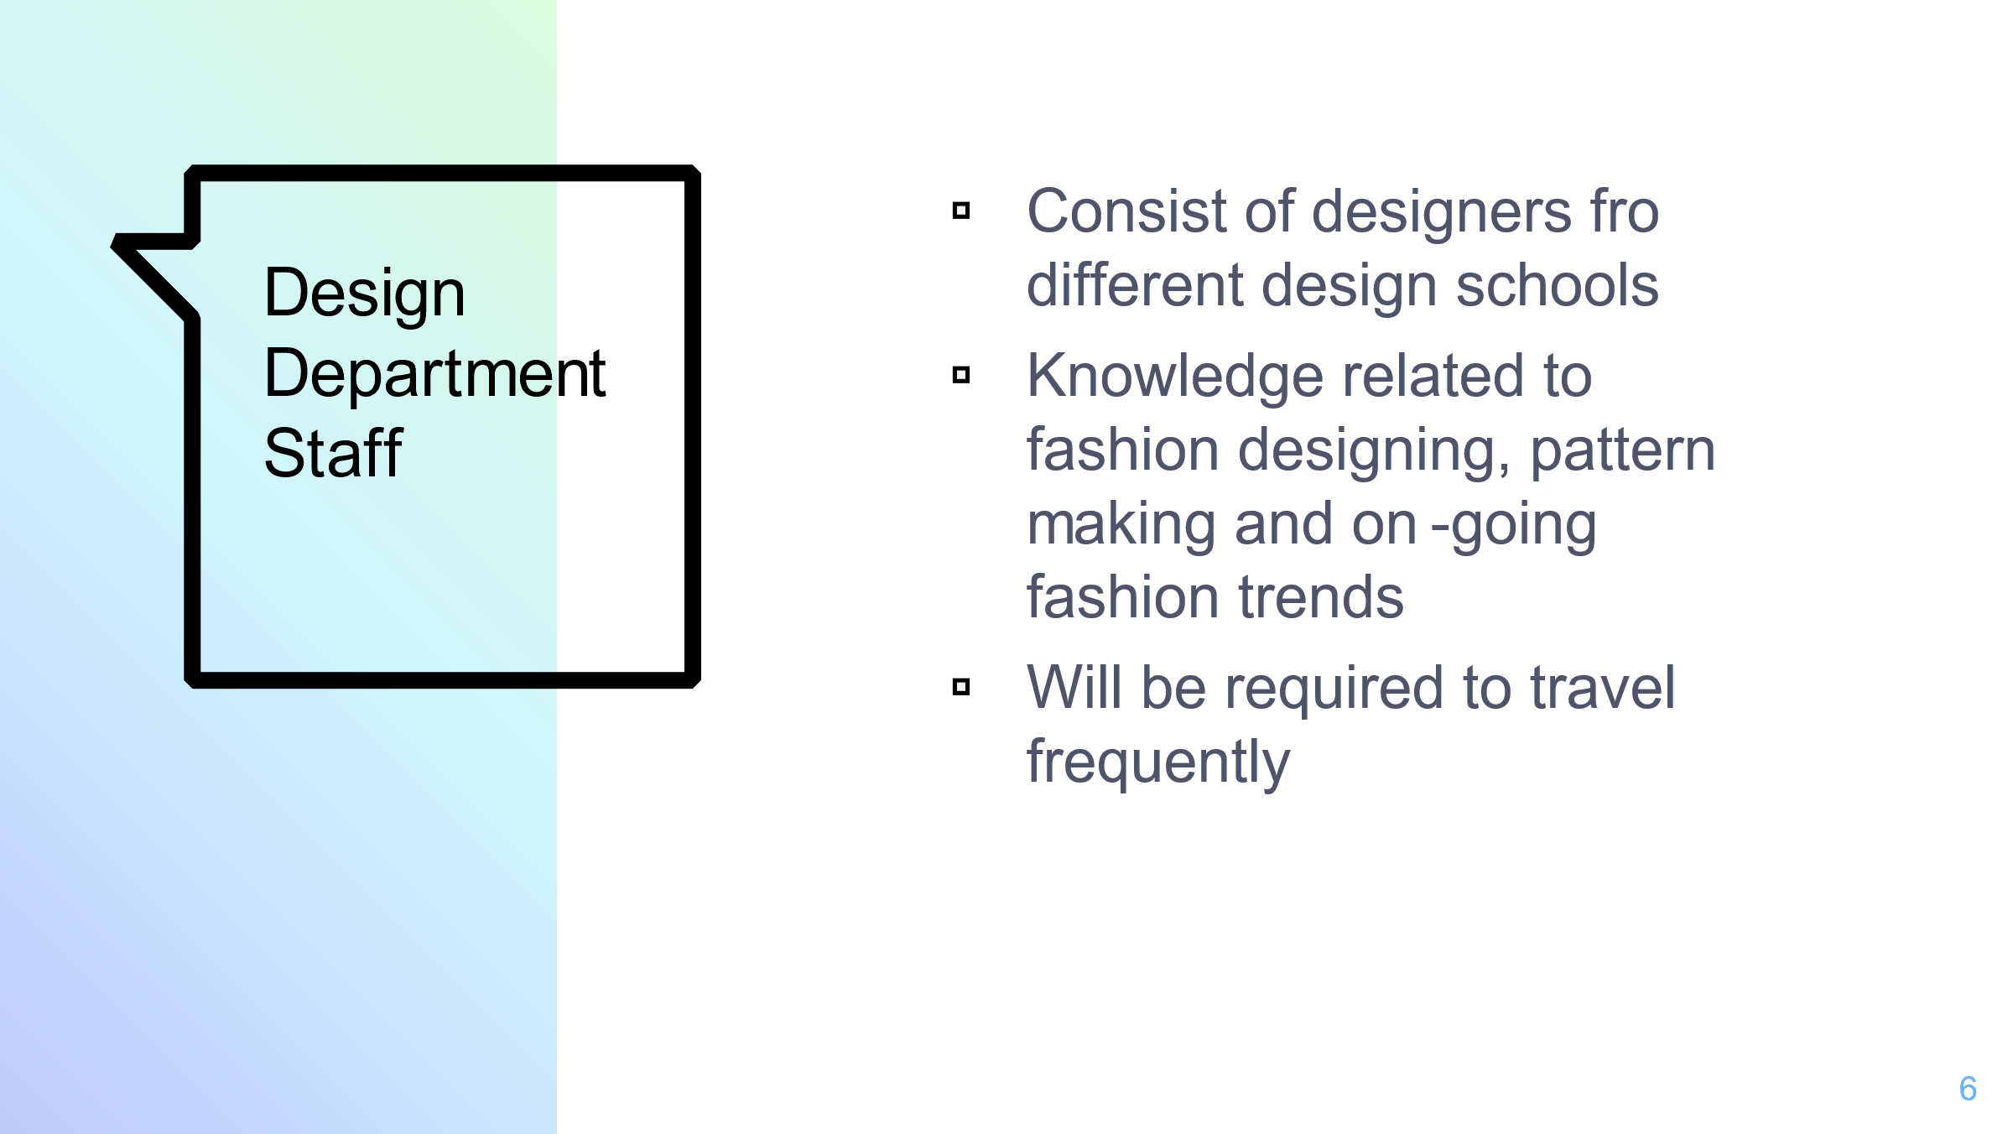

Design Department Staff
The creative teams of the design department will consist of designers who will be hired on the basis of their training from different design schools. They will be required to have extensive knowledge related to pattern making, fashion designing, as well as on-going trends in the fashion industry. Moreover, apart from creation of different styles and trends (Claxton, and Kent, 2017). These designers would also be required to travel frequently, for the purpose of getting inspirations and searching various kinds of markets for different materials. This will help them to interact with different suppliers as well as with their colleagues from other teams such as the patterns team, as well as other departments such as the production department.

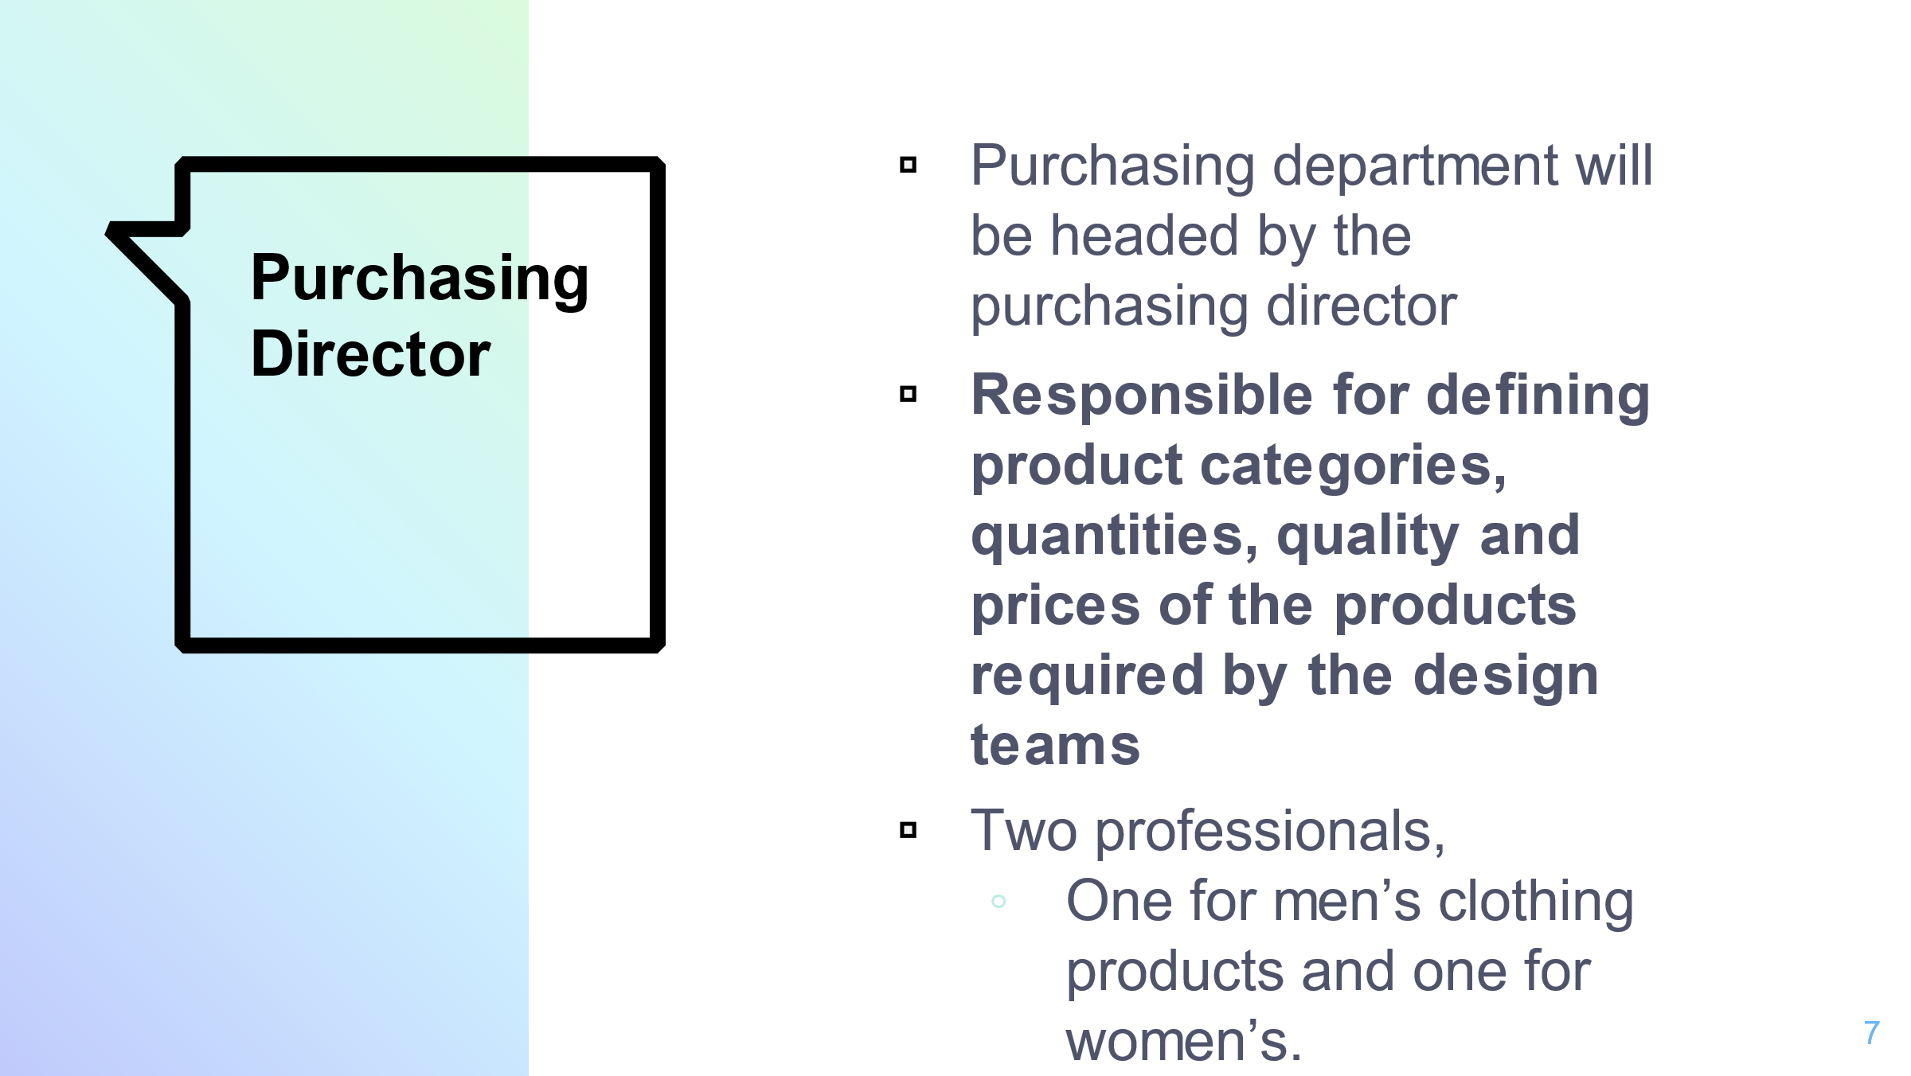

Purchasing Director
Purchasing department will consist of different purchasing teams, and will have strong working collaborations with the design department, and will be headed by the Purchasing Director (Sorger, and Udale, 2017).
The major responsibilities of the Purchasing Director will comprise of defining the exact product categories, the quantities that are required to be purchased for each product design corresponding to their quality, styles and prices, and the precise dates on which the products need to be reached at the brand outlets. Along with all this, the responsibility for managing, updating and improving the supplier network for the brand, will also be the responsibility of the purchasing director, as the suppliers also come under the authority of the purchasing department (Okonkwo, 2016).
Since our luxury fashion brand will be dealing in both men and women’s clothing, the company will be required to hire two professionals for the positions of purchasing directors, one for the women’s clothing products and one for the men’s clothing products.

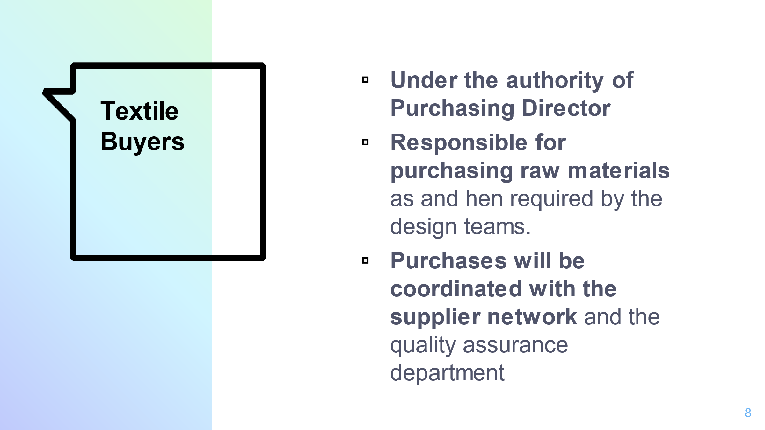

Textile Buyers
The textile buyer teams will come under the purchasing departments as well. The textile buyer will basically be responsible for purchasing of raw materials such as fabrics, beads, sequins etc., as and when required by the design department. These purchases will be coordinated with the supplier network as well as the quality control personnel (Sorger, and Udale, 2017). The textile buyer positions will be filled by professionals who are required to travel abroad frequently and thus should be proficient in English language. This is required, as they will have to manage the negotiations, purchase and production processes with the international suppliers.

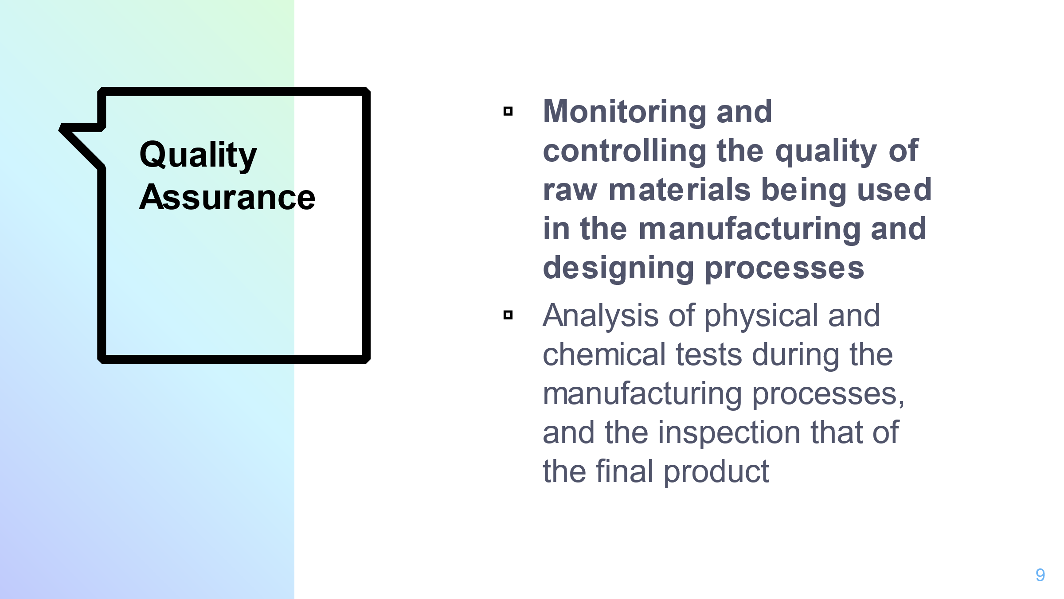

Quality Assurance
The Quality Assurance Manager will work closely with both the purchasing as well as the designer department. The Quality Control department will be tasked with monitoring and controlling the quality of raw materials being used in the manufacturing and designing processes. This monitoring responsibility will be fulfilled through the analysis of physical as well as chemical tests that will be deployed during the manufacturing processes, and the inspection that will be carried out for the final product (Carmignani, 2016).

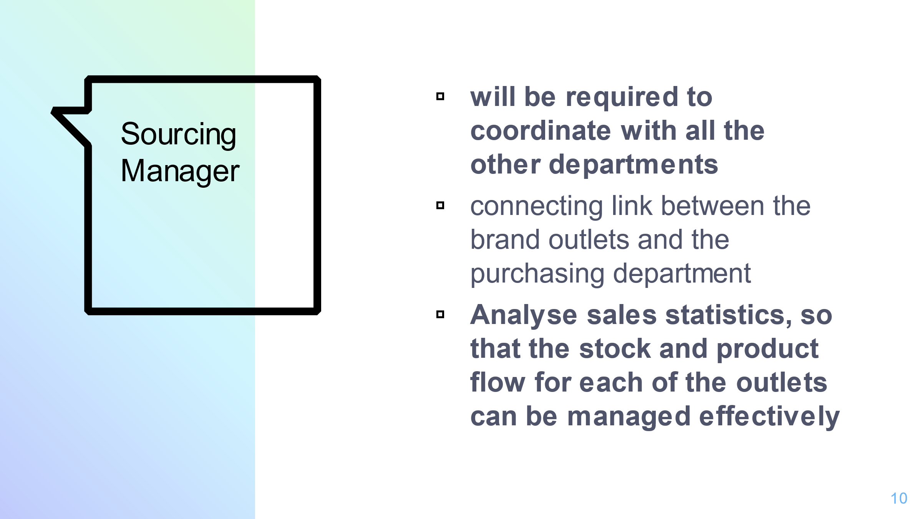

Sourcing Manager
The sourcing Manager will be required to work closely, while coordinating with all the other departments. The basic responsibility of this professional will pertain to the management of product delivery across all of the brand outlets. The sourcing manager will basically work as a connecting link between the brand outlets and the purchasing department, while serving the functions of analysing sales statistics, so that the stock and product flow for each of the outlets can be managed effectively and no store faces the shortage or unavailability of any product or design (Okonkwo, 2016). The person hired for this position will be required to have mastery of analytical skills along with having a strong command on data tables.

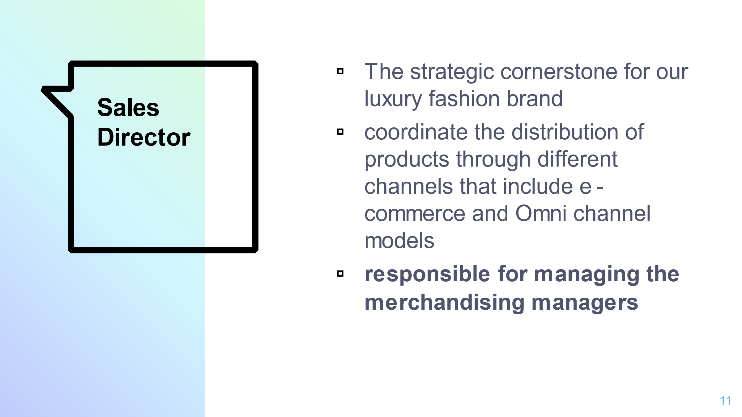

Sales Director
The sales department is one of the strategic cornerstones for any manufacturing business. This is more so for the case of a luxury fashion brand. Hence, a professional with extensive knowledge of the relevant field will be hired for the position of Sales Director, in order to effectively manage the operations of the department.
The main responsibilities of the sales director for our fashion brand would be to coordinate the distribution of products through different channels that include e-commerce and Omni channel models (Claxton, and Kent, 2017). Each of these areas, however, will be the responsibilities of their respective managers, who in turn will be answerable to the sales director.
In addition to all this, the sales director will also be responsible for managing and coordinating the merchandising managers along with providing connections between the directors of stores and international development.
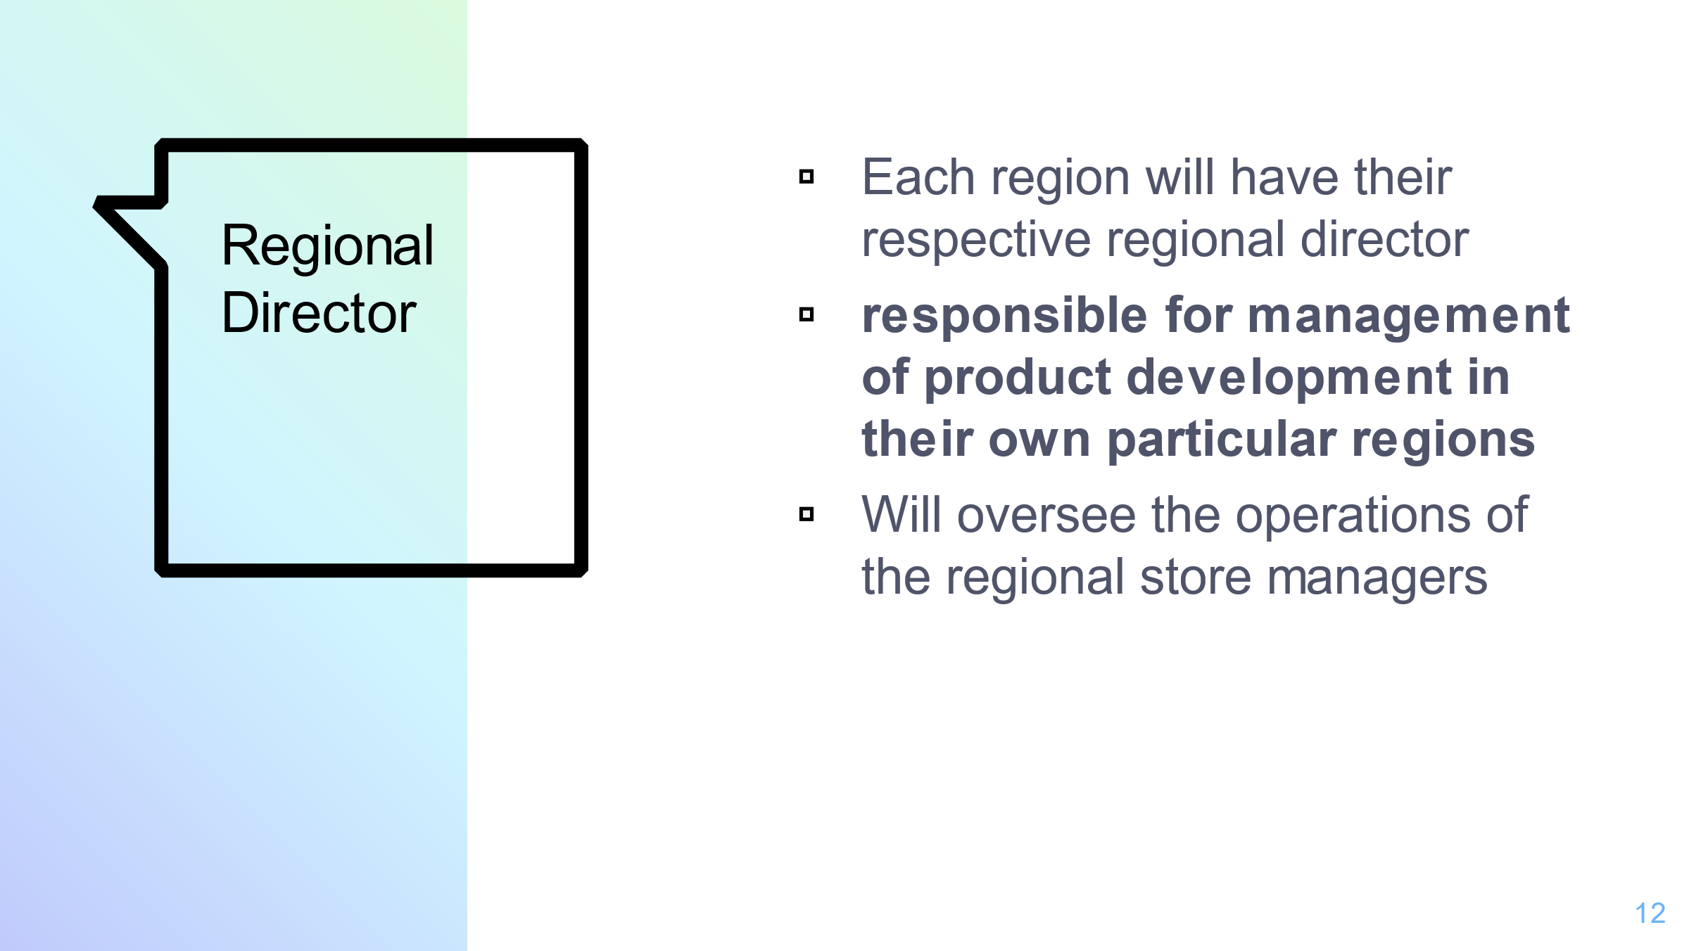

Regional Director
Since, we are aiming to expand our fashion brand into different regional markets, each region will have their respective regional director, who will be responsible for managing the development of our products corresponding to their particular regions (Okonkwo, 2016). The store managers corresponding to the regions they are located in, will be answerable to their respective regional directors.
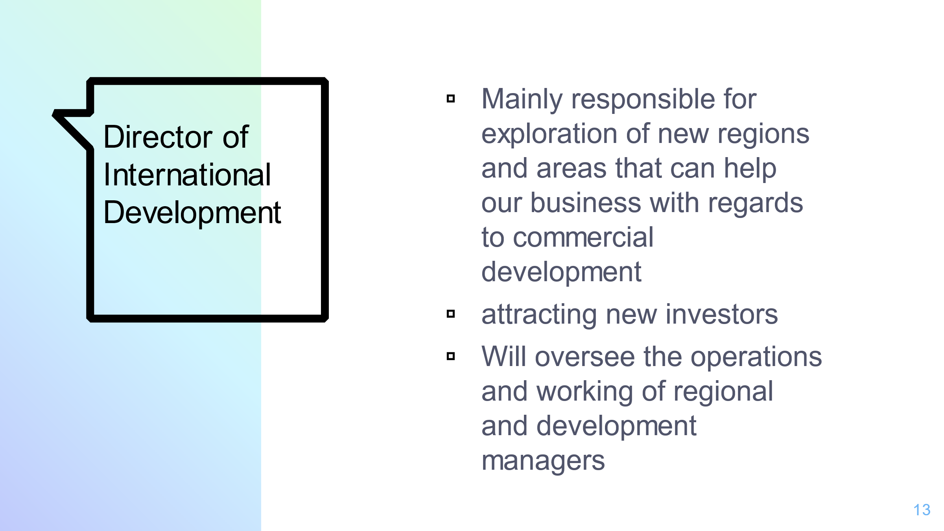

Director of International Development
The person hired for the position of director of international development, will mainly be responsible for exploration of new regions and areas that can help our business with regards to commercial development. They will also be responsible for attracting new investors, to attain the required amount of investments for the purpose of opening these new points of sale and brand outlets in new regions.
The personnel under the authority of the director of international development will include, the regional managers, whose responsibility is to control and monitor the operations of their respective outlets and the development managers, who are chiefly responsible for discovering of new store locations along with completing any of the associated paperwork required for renting or buying out of the new discovered place (Okonkwo, 2016).
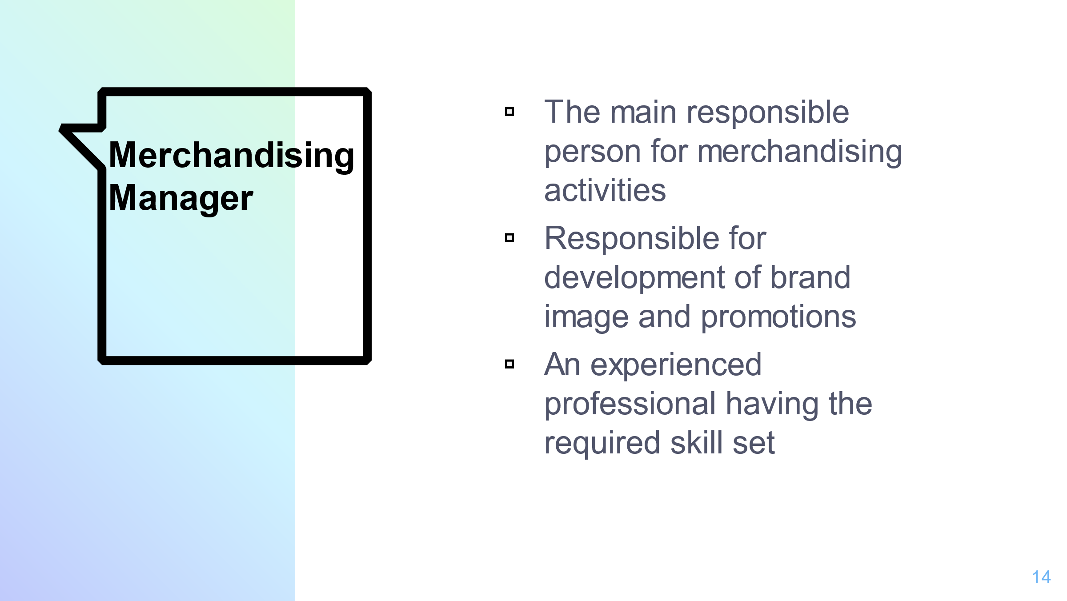

Merchandising Manager
The merchandising manager will be the main responsible person for merchandising activities for our luxury fashion brand. This merchandising manager will remain in close contact with the marketing department (Welters, and Hannel, 2015).
Since this post is also of great importance for effective operations of the fashion company, an experienced professional, having the required skill set will be hired. The main responsibilities that he will be overseeing operations related to the development of brand image, along with replicating and promoting that image across the marketing network.
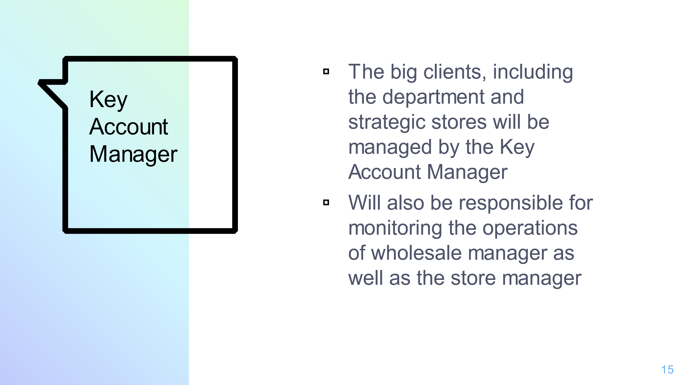

Key Account Manager
Since, we will be aiming for the high class market and will be branding our brand as a luxury item, we will have to secure outlets at several high end places such as the department stores etc. as well. These big clients, including the department and strategic stores will be managed by the Key Account Manager (Okonkwo, 2016).
Apart from this the Key Account Manager will also be responsible for monitoring the operations of the wholesale manager (i.e. the person in charge of proper management of points of sales) as well as the store manager (i.e. the person responsible for management of product supplies to their respective stores).
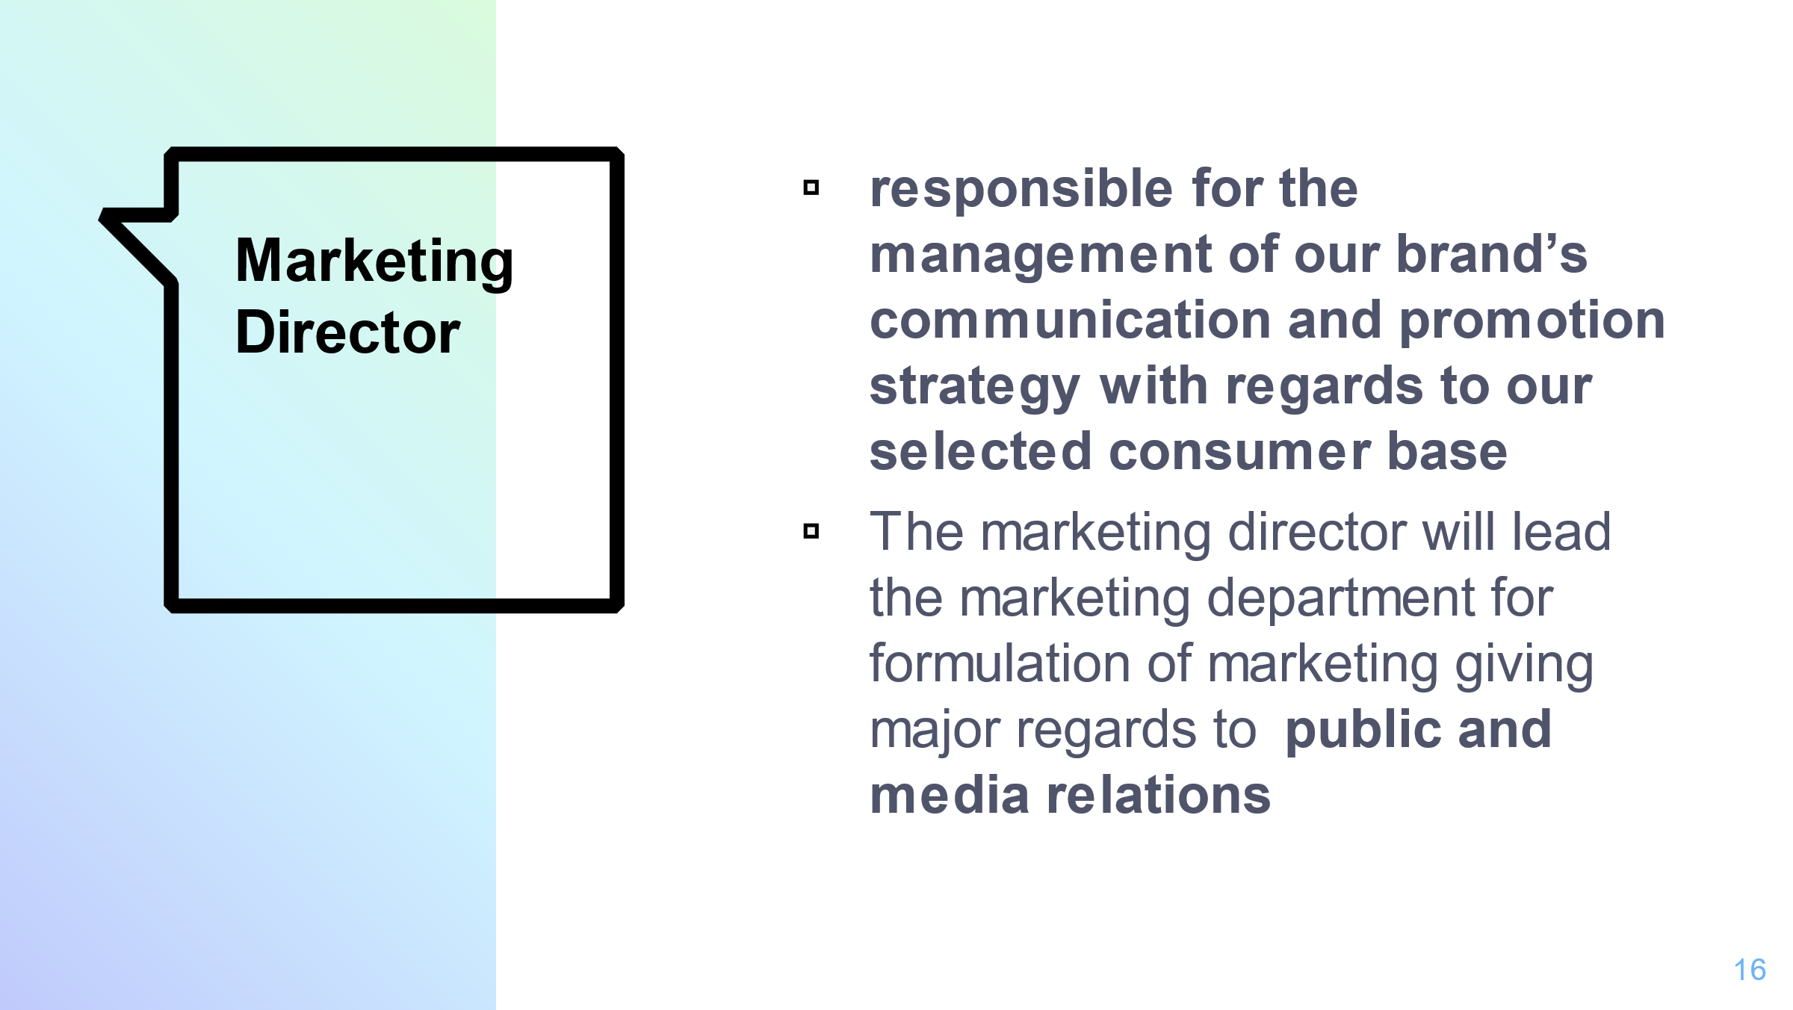

Marketing Director
The Marketing Director will be responsible for the management of our brand’s communication and promotion strategy with regards to our selected consumer base. The marketing director will be responsible for leading the marketing department that will be responsible for the formulation of strategies for the purpose of achieving higher sales volumes giving major regards to public and media relations (Welters, and Hannel, 2015).

References

Adenfelt, M. and Lagerström, K., 2008. The Development and Sharing of Knowledge by Centres of Excellence and Transnational Teams: A Conceptual Framework.

Aldrich, H.E., 2008. Organizations and Environments. Stanford University Press: Stanford.
Ansoff, H.I., Kipley, D., Lewis, A.O., Helm-Stevens, R. and Ansoff, R., 2018. Implanting strategic management. Springer.
Beer, S., 1979. The Heart of Enterprise. John Wiley and Sons: Chichester.

Beer, S., 1995. The Brain of the Firm. 4th ed. John Wiley and Sons: Chichester.
Cooper, D.R. and Schindler, P.S., 1998 (2010). Business Research Methods. 6th (11th) ed. Irwin/ McGraw Hill: Boston.

Corbetta, G., Huhse, M. and Ravasi, D., 2004. Crossroads of Entrepreneurship. Springer Science+Business Media: New York.

Carmignani, G., 2016. Lean supply chain model and application in an Italian fashion luxury company. In Understanding the Lean Enterprise (pp. 203-220). Springer, Cham.
Claxton, S. and Kent, A., 2017. Design management of sustainable fashion.
Gilligan, J. and Wright, M., 2020. Private equity demystified: An explanatory guide. Oxford University Press.
Goworek, H., Oxborrow, L., Claxton, S., McLaren, A., Cooper, T. and Hill, H., 2020. Managing sustainability in the fashion business: Challenges in product development for clothing longevity in the UK. Journal of Business Research, 117, pp.629-641.
Maduenyi, S., Oke, A.O., Fadeyi, O. and Ajagbe, A.M., 2015. Impact of organisational structure on organisational performance.
Okonkwo, U., 2016. Luxury fashion branding: trends, tactics, techniques. Springer.
Shoimardonkulovich, Y.D., 2020. The importance of management in the field of service. Вопросы науки и образования, (14 (98)), pp.16-19.
Sorger, R. and Udale, J., 2017. The fundamentals of fashion design. Bloomsbury Publishing.
Welters, L. and Hannel, S.L., 2015. Careers in Fashion Design.
Wheelen, T.L., Hunger, J.D., Hoffman, A.N. and Bamford, C.E., 2017. Strategic management and business policy (Vol. 55). Boston, MA: pearson.

