

Postgraduate/Distance Learning
Assignment coversheet & feedback form

THIS SHEET MUST BE THE FIRST PAGE OF THE ASSIGNMENT YOU ARE SUBMITTING (DO NOT SEND AS A SEPARATE FILE)

For completion by the student:
Student Name: Brigitte Cobb

Module code: HPCA7015  Module title: Foundations in Cultural Astronomy and Astrology | Student ID number:  2229709 |  |  | Educational support needs:  No
Module tutor: Nick Campion

Assignment due date: 30 November 2023
If your module has multiple submissions please indicate which piece of work this is.

1st 2nd 3rd 4th 5th 6th
I confirm that this is my original work and that I have adhered to the University policy on plagiarism.
Signed …………Brigitte Cobb…………………………………………………
Email submission: if you are submitting this form via email, please tick this box
(as a substitute for your signature) to confirm that you agree to the above declaration.
Assignment Mark
Final Mark | WILL BE GIVEN ON TURNITIN

NB. All marks are provisional until confirmed by the Final Examination Board.

PLEASE NOTE: ALL COMMENTS WIL BE POSTED ON TURNITIN

For completion by Marker 1 :
Comments:

Marker’s signature: |  |  | Date:
For completion by Marker 2/Moderator:

Comments:

Marker’s Signature: |  | Date:
AGREED INTERNAL MARK (where necessary):

Comment on process of arriving at agreed mark:

External Examiner’s comments (if relevant)

External Examiner’s Signature: |  | Date:

Essay based on a Sky Journal

The Moon and its Phases
Word Count: 2,061 words

Introduction
This essay aims to discuss the experience of keeping a sky journal for four weeks in Thames Ditton, Surrey. I chose to focus my sky observations on the phases of the moon and selected a period that mapped to the moon’s monthly cycle starting with the October new moon and ending with the November new moon. As part of this work, I was curious to see how my thoughts and emotions would respond to engaging directly with the natural phenomena of the moon in the sky. My methodology was both qualitative and reflective. I used a phone camera to take pictures of my observations and a computer to record my experiences. I faced challenges as I conducted this experiment which caused me to reflect both logically and emotionally on my experience. Three themes emerged from these reflections: the challenging weather, the direct experience of the moon and a sense of connection. Beginning with the weather, the themes will be explored in the context of Harris’ statement that ‘to think is to walk among the clouds’, a proposition that our thoughts can come to mirror our experience of the weather and by extension, of the natural world.

The Challenging Weather
This section explores how, at first, the dark, cold and cloudy autumn weather reflected my thoughts and emotions and kept me locked in an erroneous understanding of the moon’s cycle. The first 7 entries in my sky journal read roughly the same: it’s cold, dark and wet, the sky is overcast and the moon is nowhere to be seen which I put down to the new moon phase or the frustrating weather. I made the following entries in my sky journal:
17 October 2023: No moon, no stars, lots of rain and clouds. All I can see in the sky is a plane which is not very inspiring (Fig.1). The new moon was 3 days ago which might be why there is nothing there.
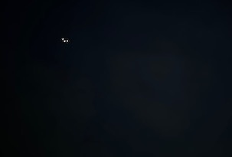
Figure 1. A plane in a dark and cloudy sky. Tuesday 17 October 2023 19:05 - from West facing side of garden. Photo: Brigitte Cobb.

19 October 2023: Still raining and very cloudy (Fig.2). The weather app is predicting more of the same for the next week or so, I’m not sure I’ll ever get to see the moon in this weather.

Figure 2. Cloudy sky. Thursday 19 October 2023 19:22 – from West facing side of garden. Photo: Brigitte Cobb.
Harris is right when she says that our emotions can cloud our vision and prevent us from truly experiencing nature. My focus on the dreary weather is keeping me locked into my thoughts and preventing me from engaging with the sky. As a result, my erroneous understanding of the moon’s cycle stays firmly in place: the moon is invisible because it is new or the clouds are to blame. Psychologists have a concept called a ‘mental model’ which is defined as an internal representation that allows someone to reason about the external world without directly experiencing it. In my case this lack of direct experience has impacted my understanding of the moon’s phases and I find support in Aitkin who agrees that ‘many a famous poet or novelist’ proved to be mistaken about the moon cycle and how easy this could be remedied by simply watching it ‘with seeing eyes’.
Reflecting on this phase of my journey, I draw the following conclusions: my internal world was indeed mirroring the weather and causing the rational part of my mind to literally stay in the dark. The next section discusses how this situation was going to start to change with the appearance of the moon. I find this poem by the Sufi mystic and poet Rumi (c. 1207-1273 CE) a good representation of the power of patient observation:
“A New Moon” by Rumi

A new moon teaches gradualness
and deliberation and how one gives birth
to oneself slowly. Patience with small details
makes perfect a large work, like the universe.

What nine months of attention does for an embryo
forty early mornings will do
for your gradually growing wholeness.

The Appearance of the Moon
This section contemplates how having a direct experience of the moon led me to start questioning my thinking and to gradually start realigning my understanding with reality. In Jones et al.’s opinion, a person’s mental model can be changed through experience which is what the first quarter moon starts to bring. Suddenly one night, I catch the moon and curiosity replaces frustration. On the 22nd of October I write in my sky journal:
The clouds have cleared! The moon is at the first quarter and shining brightly (Fig.3). I wonder why it’s called the first quarter since it looks like a half? Must be a quarter of the whole sphere. I can see shades on the moon and lots of stars in the sky (Fig.4).
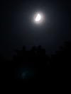 | 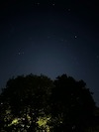
Figure 3. First quarter moon. Sunday 22 October 2023 20:38 - from South facing side Giggs Hill Green. Photo: Brigitte Cobb | Figure 4. Starry sky. Sunday 22 October 2023 20:38 - from West facing side Giggs Hill Green. Photo: Brigitte Cobb.
Realising that the first quarter is really seen as a half picks my curiosity. I find that Brunner describes the moon that appears before the full moon as a half-moon and that the Greek poet Aratus [c.315-240 BCE] writes: ‘Scan her when full and when half-formed on either side of full, as she waxes from or wanes again to crescent form’ . Nasa informs me that it is called a quarter moon because it is a quarter of the way through the lunar month, this makes sense logically but not in terms of what I am seeing. This realisations reinforces the value of direct experience in informing the writings of different authors.
The next full moon is to coincide with a partial lunar eclipse. There are only two lunar eclipses each year and I long for an experience that is free of clouds. Two nights before the full moon, there is a clear sky and I get a good picture. The day after, the clouds are back but rather than be disappointed, this time I get curious. I make the following entries in my sky journal:
On 26 October 2023: Two days to the full moon. Not long until the moon makes a full circle of light and I can see from my picture that only a little bit of the disc is now missing. I like how sharp the light is against the black sky (Fig.5).
On 27 October 2023: The moon is hiding tonight (Fig.6). I wonder why it’s to the left of where it was yesterday? I took the picture an hour earlier but if feels a bit too far East. Must check this out.
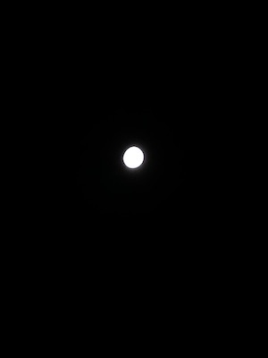 | 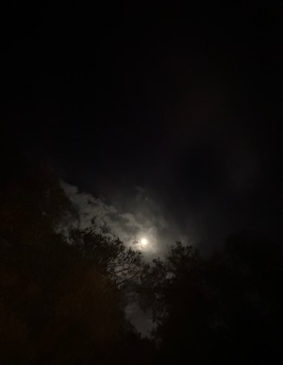
Figure 5. Waxing gibbous. Thursday 26 October 2023 22:37 - facing Southeast from my drive. Photo: Brigitte Cobb. | Figure 6. Waxing gibbous in the clouds. Friday 27 October 2023 21:37 – facing East from my drive. Photo: Brigitte Cobb.
A small chink has appeared in my mental model as I start to question the position of the moon in the sky. The day of the full moon, the clouds are back but I get very lucky and manage to take a picture as the moon emerges for a split second from behind a cloud. I don’t see the eclipse, this is too brief a glimpse but I start to develop a relationship with the moon. On the 28th of October, I wrote in my sky journal:
I wanted to take a picture of the full moon and of the eclipse. I came out around 21:00 but it was raining and the moon wasn’t visbile. I went out on the off chance at 22:00 and got a picture (Fig.7) but a minute later the moon was gone again. Either I got lucky or it knew I was there and came out to meet with me? Maybe it knows I’m watching it?
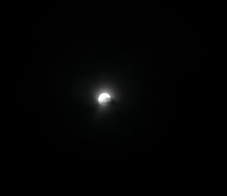
Figure 7. A glimpse of the full moon. Saturday 28 October 2023 22:02 – facing Southeast from my drive. Photo: Brigitte Cobb.
Reflecting on my experience at this stage, I find that the magic of engaging directly with the Moon allowed me to start developing a relationship with it. It was this sense of connection, although not fully developed at this stage, that led to the curiosity required to start questioning why I was seeing it appear in different places. This shift in emotion and perception will be explored next.

A Sense of Connection
Being able to connect with the moon in the real world shifted both my thoughts and my emotions. Interestingly, the rational part of this experience did not stand in the way of a feeling of enchantment. The day of the last quarter, I go out at 19:15. There are no clouds and no moon so I fire up the software Stellarium and track its position under the horizon. This is where I realise for the first time how the moon’s cycle and phases work. The next day, I spend some time learning about the journey of the moon and map where I believe it will be just before lunch when my weather app says the clouds will part from the sky. On the 6th November, I make the following entry in my sky journal:
Wow, it was exactly where I calculated it would be (Fig.8)! I’m looking West which makes sense as the moon will set there soon. This is the first time I’ve understood why I see it in different places, why is dark or full and why it appears during the day. The clouds have lifted in more than one way.
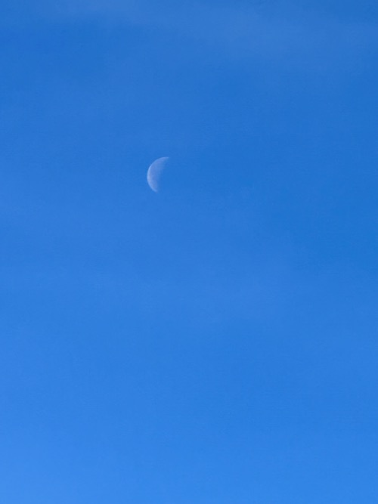
Figure 8. The crescent moon. Monday 6 November 2023 11:49 – facing West from my garden. Photo: Brigitte Cobb.
As my project nears the end, I reflect on the fact that reasoning about the cycle of the moon did not stop a sense of connection and even enchantment from emerging. I find support for this experience in Campion who writes that reason does not preclude enchantment and even that enchantment can be facilitated by technology. In terms of what created this sense of wonder, Curry agrees that relationality can lead to enchantment. I conclude that the direct experience of chasing the moon for a month has given rise to a new relationship which is evidenced in the last two entries in my sky journal:
On the 7th November 2023: Right on cue, the moon and the clouds got together for what I think is a particularly inspiring picture (Fig.9). Isn’t it funny that one of my last pictures is of the darkness and the light. I feel the moon is telling me something.
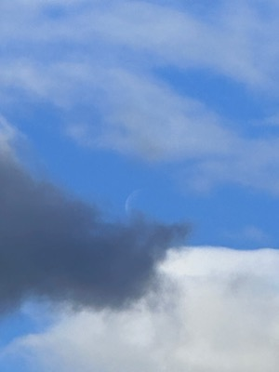
Figure 9. The Crescent Moon and the clouds. Tuesday 7 November 2023 13:25 – facing West from my garden. Photo: Brigitte Cobb.

On the 9th of November 2023: I had to blink and squint a few time to spot the moon but now that I know exactly where to look, I found it (Fig. 10). My phone is really struggling to capture the image. It takes about 5 shots but finally, I get a tiny crescent in the upper right corner. I’m very happy but also a bit sad to see it go. Bye bye moon!

Figure 9. The last moon. Thursday 9 November 2023 9:55 – facing South-West from my garden. Photo: Brigitte Cobb.

Conclusion
The aim of this essay was to observe what would emerge from keeping a sky journal for a period of one month. I chose to focus on the phases of the moon and to situate my experience in the rationale framework presented by Alexandra Harris. Three themes emerged from my observations: the impact of the weather, the direct experience of the moon and a sense of connection. Through my analysis and reflections, I found that these themes built on each other to first challenge how I intellectually understood the phases of the moon which in turn allowed me to understand the moon and as a result connect with it and experience enchantment. This exercise led me to two conclusions: the importance of directly experiencing something to truly understand it and the discovery that reason does not stop enchantment. I found that my thoughts and emotions did come to reflect my experience of nature by becoming more aligned with the moon.

References
Aitken, Roger G., ‘The Moon’, Publications of the Astronomical Society of the Pacific, 169.29 (1917), pp. 121-132
Aratus, ‘Phaenomena’, in Callimachus, Hymns and Epigrams Lycohpron (Cambridge: Harvard University Press, 1989)
Brunner, Bernd. Moon: A Brief History (New Haven and London: Yale University Press, 2010)
Campion, Nick, ‘Enchantment and the Awe of the Heavens’, in Corsini, Enrico (ed.), Proceedings of the sixth conference on the Inspiration of Astronomical Phenomena (Prvo, Utah: Astronomical Society of the Pacific, 2011), pp. 415-22
Curry, Patrick, ‘The Relational Dynamics of Enchantment and Sacralization: Changing the Terms of the Religion Versus Secularity Debate’, Material Religion, 15.1 (2018), pp.126-127
Harris, Alexandra. Weatherland: Writers & Artists under English Skies (London: Thames & Hudson, 2015)
Jones, Natalie A., Helen Ross, Timothy Lynam, Pascal Perez, and Anne Leitch, ‘Mental Models: An Interdisciplinary Synthesis of Theory and Methods’, Ecology and Society, 16.1 (2011), article 46 <https://www.jstor.org/stable/26268859> [accessed 8 November 2023]
Rumi in Suarez, Veronica, ‘3 New Moon Poems to Bring You Hope, Renewal, and Inspiration’, Read Poetry Blog, 13 January 2021. <readpoetry.com/3-new-moon-poems-to-bring-you-hope-renewal-and-inspiration/> [accessed 8 November 2023]
Stellarium software can be found at https://stellarium.org.

Alexandra Harris, Weatherland: Writers & Artists under English Skies (London: Thames & Hudson, 2015) p. 180.
Harris, Weatherland, p. 200.
Natalie A. Jones and others, ‘Mental Models: An Interdisciplinary Synthesis of Theory and Methods’, Ecology and Society, 16.1 (2011), article 46 < https://www.jstor.org/stable/26268859> [accessed 8 November 2023].
Roger G. Aitken, ‘The Moon’, Publications of the Astronomical Society of the Pacific, 169.29 (1917) pp. 121-132 (pp .121-122).
Rumi in Veronica Suarez, ‘3 New Moon Poems to Bring You Hope, Renewal, and Inspiration’, Read Poetry Blog, 13 January 2021. <readpoetry.com/3-new-moon-poems-to-bring-you-hope-renewal-and-inspiration/> [accessed 8 November 2023].
Jones and others, ‘Mental Models’, 2011.
Bernd Brunner, Moon: A Brief History (New Haven and London: Yale University Press, 2010) p. 1 of Chapter One ‘Gazing at the Moon’
Aratus, ‘Phaenomena’, in Callimachus, Hymns and Epigrams Lycohpron, Aratus (Cambridge: Harvard University Press, 1989 [LCL 129 p. 268-269].
Nasa Website <https://starchild.gsfc.nasa.gov/docs/StarChild/questions/question3.html#:~:text=When%20half%20of%20the%20Moon%27s,The%20Moon%20continues%20to%20wax> [accessed 13 November 2023].
For info on lunar eclipses < https://www.timeanddate.com/eclipse/next-lunar-eclipse.html> [accessed 13 November 2023]..
Stellarium software can be found at <https://stellarium.org>.
Nick Campion, ‘Enchantment and the Awe of the Heavens’, in Corsini, Enrico (ed.), Proceedings of the sixth conference on the Inspiration of Astronomical Phenomena, Prvo, Utah: Astronomical Society of the Pacific, 2011, pp. 415-22. (pp. 7-11). [sort out page numbers]
Patrick Curry, ‘The Relational Dynamics of Enchantment and Sacralization: Changing the Terms of the Religion Versus Secularity Debate’, Material Religion, 15.1 (2018), pp.126-127 (p. 126).

