Effective Team Working and Communication Skills
Student Name Tsvetomila Vutova
Student ID 2027746
Lecture: Lloyd Beharry
Module Code:BMSW4002

Table of Contents
Section 1 3
Introduction 3
The Importance of Communication Skills 3
Example of Poor Communication Skills 4
Improving communication Skills 5
Communication Models 5
Shannon and Weaver’s Model 6
Interactional Model 6
Transactional Model 7
Examples of Poor Communication at the Workplace and how to Improve it. 8
Reference List 9

Section 1

Introduction
With the help of communication skills, we can easily understand others and explain ourselves to others. Communication skills are minimal, so people have to implement practical communication ideas. It is also crucial for a person to have active listening skills during a conversation. A person can also improve their conversation skills by working in their public speaking. In order to give and receive different types of knowledge or information, people must make proper use of their communication skills. There are various examples of communication ideas (Back et al., 2020). Various things are crucial to practical communication skills, such as empathizing, observing, speaking, and listening. People can easily communicate and interact with different people through phone conversation, face-to-face, digital communication such as social media and email.

The Importance of Communication Skills
With the help of strong communication skills, people can also become very successful in their lives. Professional and personal life is highly influenced by their communication skills (Back et al., 2020). If we talk about the business point of view, all operations are mainly based on communication skills. Good communication skills help the organization to understand and get information about other people or things.
1. Listen
A person must have good communication skills, and A person should also practice active listening and focus on understanding the point of view of people.
2. Conciseness
By having good communication, a person also can convey his or her message in very few words as few as possible (Back et al., 2020). If a person has good communication skills, then a person does not have to use various filler words. In that way, a person is able to avoid excessive speaking.
3. Body language
In order to become a successful person in life, it is very crucial to practice good body language, using hand gestures, using eye contact, and also ensure that by using a good tone of voice for communication with different people (Back et al., 2020). By using a very friendly tone a person can easily collaborate with different people and for that body language should be relaxed. Communication can also be done through eye contact; by making eye contact, people can focus on their particular conversation. By making eye contact, it is very crucial for a person not to make another person uncomfortable.
4. Confidence
Through an entire communication, a person should also need to be very confident (Back et al., 2020). If a person wants to make good eye contact, then it is very crucial for a person to maintain a confident and relaxed body stance. To be confident, a person can avoid being more aggressive and demeaning.

Example of Poor Communication Skills
Passive Aggressive Communication
The term passive-aggressive communication is not considered a very good practice. This will also create a negative impact on the working environment (Shorey et al., 2020). In the workplace, it is very difficult to maintain a good communication level.
Intimidation in the Workplace
There are various signs of negative communication, which include intimidation tactics. There are various organizations (Shorey et al., 2020) in which people or employees are bullied by their bosses. There are also high chances that intimidation could also occur because of co-workers who are mainly competing for their promotion in the organization.
The Blame Game
The communication link among the employees in the organization is highly disturbed because of the blame game (Shorey et al., 2020). In some cases, the employees of the organization put the blame for their own failure on others.

Improving communication Skills
A person can improve his or her communication skills by practicing. By working on the following particular areas, a person can improve his or her communication skills.
- Ask a close friend or colleague for constructive criticism: To become an effective communicator is not easy for people (Mishra and Mishra, 2020). A trusted friend is very crucial for a person to have their honest opinion and feedback. By working on this particular area, a person can improve his or her communication skills.
- Practice improving communication habits: It is very crucial for a person to keep practicing their communication habits. In order to improve communication skills, a person needs to practice new habits. People can also improve their communication skills by attending several communication workshop classes.
- Seek opportunities to communicate: In order to keep updating and improving their communication skill, it is very crucial for people to seek different types of opportunities in order to communicate with different people.

Section 2

Communication Models

Shannon and Weaver's Model
The model describes the way how a sender transmits a particular message to the receiver. In this model, the sender is the primary source of the message. The message will consist of words or behavior in a proper communication interaction. The message will be effectively transmitted through a particular channel or a communication route. There might be certain obstacles in the communication channel that will be referred to as noises. A case study discusses the limitations of the model, which states that communication only flows in one direction, which is not that effective as communication is more dynamic in nature (Weaver, 2016).
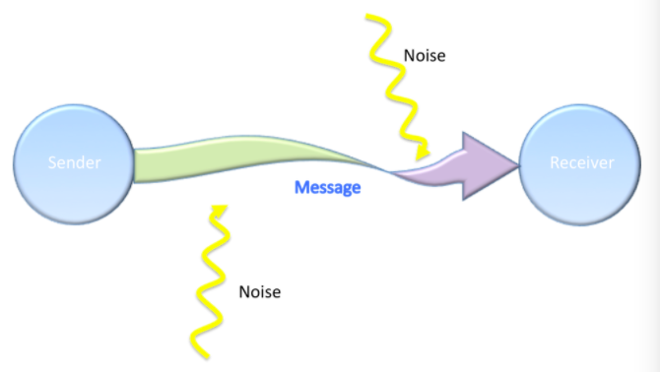


Interactional Model
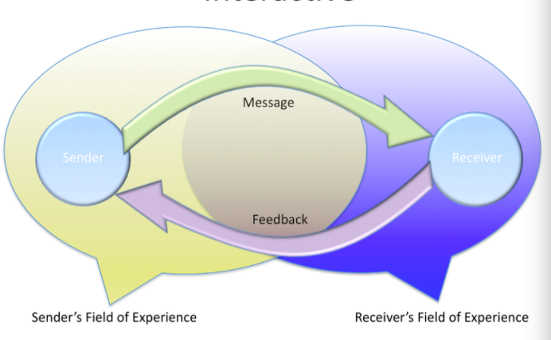

The model follows two-way communication channels, in which there is the flow of effective communication and feedback between the sender and receiver. Feedback is considered as an adequate response that the receiver provides to the sender. Feedback will enable the sender to analyze if the receiver well understood his communication message. Communication will be viewed as an ongoing process by the interactional model. A case study discusses the fact that in real life, the communication roles are not that clearly defined, and instead, they are more fluid (Gumpert & Drucker, 2019).

Transactional Model
In this model, the people that are involved in the communication process are viewed as communicators. Communication is viewed as a transaction through this model, as communication is a practical action in which communicators will tend to co-create the entire process and outcomes of the communication interaction. In the transactional model, the communicators will develop a shared meaning in the overall dynamic communication process. A case study emphasis the basis of the communication theory in which the people are considered as the dynamics communicators and the fact that messages are interdependent (Gumpert & Drucker, 2019).
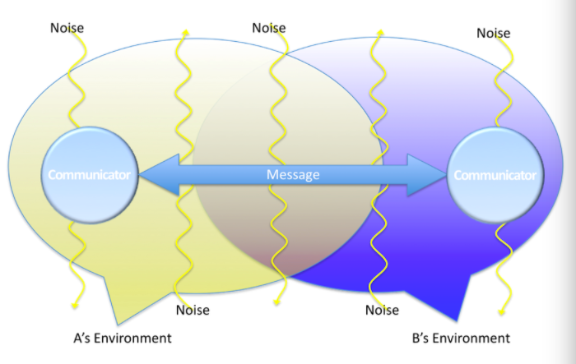


Examples of Poor Communication at the Workplace and how to improve it
Poor communication will drain out the valuable resources of the organization. One-way communication can have a negative impact on the organizational plan and will tend to make the communicator highly frustrated not to receive immediate feedback. This problem can be overcome by providing immediate feedback and practicing active listening. If the word "you" is followed by a directive like "should" and "will" that should demand a particular action, this will indicate that there is poor communication at the workplace. To combat this issue, the word "you" should be followed by a statement like, "I noticed, you were arrived late today" instead of saying, "you should have been here 30 minutes ago" This will make the people feel like they are being communicated to instead of being communication at (Timmins, 2020).

Section 3

Methods of Communication
Verbal
It is characterized as verbal communication if the interaction takes place via words, whether spoken or written. To communicate orally means using the voice, while to communicate by writing means using the pen. There are thus two types of verbal communication:
ORAL COMMUNICATION
Oral communication refers to the process of conveying thoughts and ideas via the use of spoken words (Tongue, 2005). 65% to 75% of an executive's time at work is spent in the form of spoken communication. In both professional and informal settings, managers communicate orally for the majority of their workdays. Formal oral communication settings include meetings, interviews, group discussions, speeches, presentations, and so on. Oral informality is shown by the grapevine. Face-to-face communication may also take place through telephony or a videoconferencing platform such as Skype (Hargie, 2006). The way we express ourselves verbally reveals a great deal about our character, outlook, and level of emotion. In oral communication, nonverbal communication is just as important, if not more so, than the words themselves. Nonverbal communication, on the other hand, complements and enhances vocal communication.
WRITTEN COMMUNICATION
Written communication is a term used to describe communication that is conducted via the use of writing or written language. Written communication is more than just a string of letters and numbers on a page. Only until the recipient receives, decodes, and comprehends the sender's intended meaning can words and phrases have any value. Organizations use written communication in a variety of ways: rules and regulations; instructions, notifications; letters, and reports. Planned, coordinated, and executed projects are impossible without written communication. Structure, hierarchy, and duties are all outlined in this document. In addition, written communication offers improved clarity, precision, validity, dependability, accountability, and a long-term information lifecycle. Communication in writing may be professional or casual (Maguire, 2002).
Non-verbal
Nonverbal communication occurs when ideas, thoughts, sentiments, and emotions are conveyed without the use of words. In addition to words, facial expressions such as a grin, widening of the eyes, a scowl, a seated posture with the legs crossed, or a body cross convey a lot about a person's feelings and thoughts. Nonverbal communication has its origins in culture. Hence it varies greatly from community to community and culture to culture (Tongue, 2005). Nonverbal communication may have a significant influence on a person's life. It is important to maintain eye contact. Even if we do not have to stare, we must maintain eye contact for a few seconds at a time, especially if we are trying to explain yourself or demonstrate the unified focus. Compatibility and trust may be built via eye contact. It is reassuring to the speaker that we are listening if you do not mention it. As a result, remember to sometimes lookup. This also aims to be used in presentations. Scanning the room, focusing on one person for a few seconds, and then moving on (Tongue, 2005). It is going to take some getting used to. It is fine if one uses the hands while speaking, but remember that it might be disturbing to others. When we fold the arms in the middle of a meeting or lean back in the chair to address a colleague, we may be sending a subtle message that we should be aware of. Since invading someone's personal space may quickly and easily cause them distress, it is necessary to follow a few basic politeness principles. When conversing with one person (or even a small group of people), be respectful of their personal space and boundaries (Hargie, 2006).
Listening
Effective listening is one of the most important sets of communication skills that business people can learn in order to be successful, even though it is not generally regarded as a nonverbal type of communication (Hargie, 2006). In addition, listening abilities have a direct influence on a person's psychological and emotional health and well-being. Although many experts dispute the precise number of components that make up an excellent listener, several important factors are widely acknowledged as recommendations to make a listener more successful and improve the quality of communication between the parties involved (Hargie, 2006).

Conclusion
It is impossible to overestimate the value of good communication skills. It has long been known that before the development of language, individuals communicated with one other via hand gestures, body language, etc. The ability to communicate effectively is essential in every facet of life. Personal and professional lives are negatively impacted by a person's inability to communicate effectively. Professionals in every field need to be able to communicate effectively. For instance: This is due to poor communication rather than ineptitude, which prevents doctors from expressing to patients that they have their best interests at heart. For example, a doctor may have a great deal of knowledge and competence in his field of employment. Patients may feel abandoned or disregarded if the doctor lacks appropriate communication skills. A second opinion is another option for the patient who has lost faith in their doctor. When a person is unwell, a simple misunderstanding may cause a lot of distress. If a doctor or nurse has the ability to make patients feel at rest with reassuring words and actions, they are an invaluable addition to any hospital or healthcare facility.

Reference List
Back, A., Tulsky, J.A. and Arnold, R.M., 2020. Communication skills in the age of COVID-19.
Gumpert, G., & Drucker, S. (2019). Models, metaphors, and other scholarly meanderings: Renovating models of communication. New Jersey Journal Of Communication, 7(1), 9-22. https://doi.org/10.1080/15456879909367352
Hargie, O. (Ed.). (2006). The handbook of communication skills.
Maguire, P., & Pitceathly, C. (2002). Key communication skills and how to acquire them. Bmj, 325(7366), 697-700.
Mishra, S.K. and Mishra, P., 2020. Functional Aspects of Communication Skills for Professional Empowerment. Journal of English Language and Literature (JOELL), 7(1), pp.79-85.
Shorey, S., Ang, E., Ng, E.D., Yap, J., Lau, L.S.T. and Chui, C.K., 2020. Communication skills training using virtual reality: A descriptive qualitative study. Nurse Education Today, 94, p.104592.
Timmins, F. (2020). Managers' duty to maintain good workplace communications skills. Nursing Management, 18(3), 30-34. https://doi.org/10.7748/nm2011.06.18.3.30.c8538
Tongue, J. R., Epps, H. R., & Forese, L. L. (2005). Communication skills. Instructional course lectures, 54, 3-9.
Weaver, R. (2016). The Communication Process: Conceptual Models for Research and Teaching. College Composition And Communication, 7(3), 165. https://doi.org/10.2307/355144

