Student name: Gabai GABAI
Student ID number: 2407055
Model: Introduction to Web and Database Concepts
Module code: ACCA4023
Assignment Title: Design and Implementation of a Relational Database System

Table of Contents
Introduction 3
Scenario analysis 3
Entity-Relationship Diagram (ERD) 4
Data structure Development 6
Normalization Compliance 8
Sample Data Population 10
Query Development 12
Validation and Testing 13
References 14

Introduction
The web connects people globally enabling access to info online. It is a network of interconnected resources. Web apps make life convenient allowing users to access stuff anytime. Databases keep data organised and super easy to access. Web apps rely on databases for user info and content. Developers use HTML CSS JavaScript and SQL to build strong apps. This leads to better user experiences. It also drives business growth. Good web-database integration is important. It helps make informed decisions and deliver personalized services. It makes apps dynamic and super responsive to what users need [1]. The report focuses on the database development of the company, MediLink Pharmacy which is a growing community pharmacy chain that currently helps patients in providing prescription medicines, sales and supplies, etc. These are done completely with manual efforts. There is high need of increasing efficiency of the company through designing and implementation of a structured database system capable of managing medicines, suppliers, prescriptions, customers, and sales transactions efficiently. Manual systems often result in data inconsistencies, inventory errors, and inefficient reporting. To address these issues, the CEO has proposed implementing a database management system using Microsoft Access or equivalent software. The database is associated with automating the pharmacy company through advanced operations, stock monitoring and inventory management, and reduce data inconsistency and redundancy, and support in making proper management decisions. It also helps in accurately reporting of data as well.

Scenario analysis
The Pharmacy is of the most rapidly growing one on the community with currently managing its operational information using manual records. This makes the company slow and it cannot provide all the resources well. The detailed operation include medicines, suppliers, prescriptions, customers, and sales transactions. The medicine stocks are also not well-managed due to inefficiencies in the stock records as well. This gives the company a limited report capabilities and create pharmaceutical challenges. To overcome these challenges, the pharmacy’s CEO has proposed the development of a structured database system using Microsoft Access or similar SQL database management systems. The objective of the database that should be formulated here is to centralise pharmacy data and automate the management of medicines, supplier information, customer prescriptions, and sales transactions. It focuses on centralising the pharmacy data for the company. The database should also have regulatory compliance in improving the accuracy and efficiency of the company. Here, a well-designed relational database must be formulated to enhance the company’s operational efficiencies. Monitoring of the system should also be done with proper testing and validation.
In terms of analysing the scenario, several key entities are identified, that forms an integral part of building the Entity Relationship Diagram (ERD). It holds information about suppliers, medicines, staff, etc. The entities store information and provide responsible details about the company. The customer entity, prescription entity, and sales entity work together while queries are also prepared for supplier entity, medicine entity and so on. Based on the scenario, there should be relationship (one to one and one to many) between these entities to ensure data consistency [2]. The supplier can provide multiple medicines, while each medicine is associated with a single supplier. A customer can have multiple prescriptions and may also make multiple purchases. Similarly, a medicine can appear in many sales transactions. Based on the scenario requirement, the database must ensure that the system supports MediLink Pharmacy in managing its daily operations efficiency by organising pharmacy data into a structured format and enable faster access to information.

Entity-Relationship Diagram (ERD)
ERDs display database structure with entities and relationships simply. ERDs display entities attributes and relationships. ERDs serve as visual guides for organizing data effectively. This aids in designing and managing data effectively. Entities are typically represented by rectangle shapes in ERDs. Connecting lines show relationships between entities in the diagram. ERDs help plan database designs cutting redundancy boosting integrity. ERDs simplify scaling and maintenance highlighting relationships. ERD shows customer prescription medication links. This streamlines MediLink Pharmacy's data management process easily. This supports business growth informed decisions making ERDs a key tool [2]
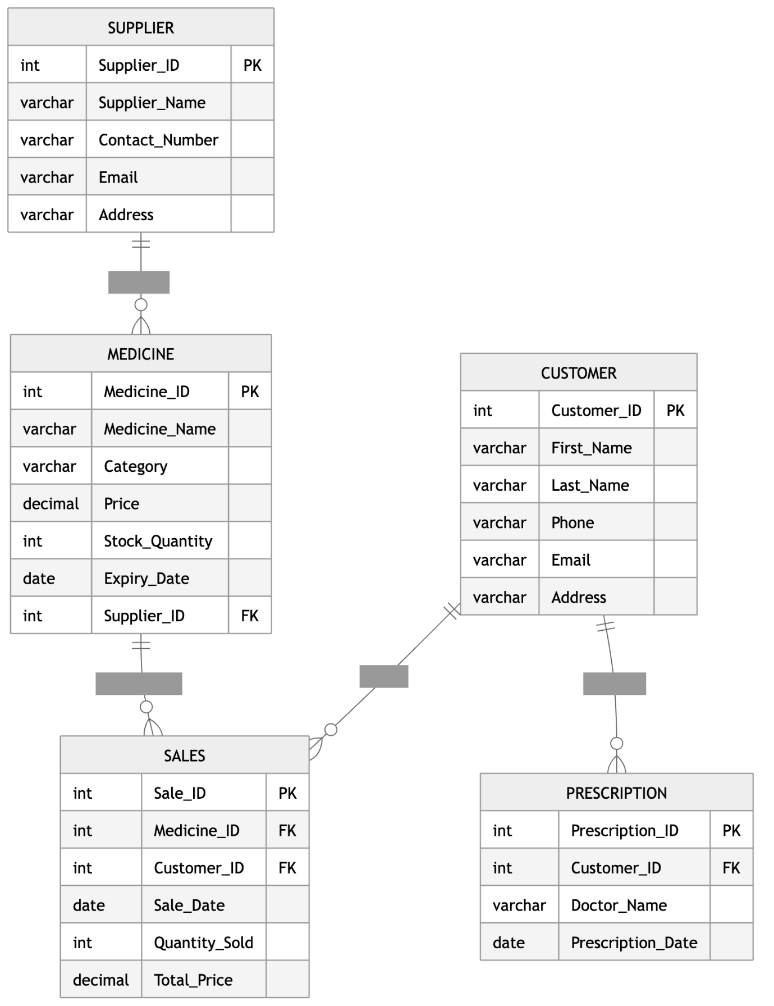
Figure 1. ERD For MediLink Pharmacy
(Source: Self-created by learner)
Explanation of the relationship between the entities and cardinality:
Supplier → Medicine (1:M)
One supplier associated with providing many medicines while each is supplied by one supplier.
Supplier (1) -------- supplies -------- (M) Medicine
Customer → Prescription (1:M)
A customer may have multiple prescriptions, but each prescription belongs to one customer.
Customer (1) -------- receives -------- (M) Prescription
Customer → Sales (1:M)
A customer can make many purchases, but each sale is linked to one customer.
Customer (1) -------- makes -------- (M) Sales
Medicine → Sales (1:M)
One medicine can appear in many sales transactions, but each sale records one medicine.
Medicine (1) -------- included in -------- (M) Sales

Data structure Development
Based on the ERD, the database is designed using SQL where relational database management system is followed. The approach is to manage data efficiently and build relationship between different entities while allocating primary as well as foreign keys properly. There are appropriate constraints applied to ensure data accuracy, consistency, and integrity within the database.
Supplier table:
It stores information about medicine suppliers that are connected to the company. Each supplier has an unique ID for uniquely identifying them. It serves as the primary key that details supplier name, contact number, email and address. The primary key ensures that each supplier is recorded with unique ID and prevents supplication of data.
Attributes:
- Supplier_ID (Primary Key)
- Supplier_Name
- Contact_Number
- Email
- Address
Medicine Table:
It stores details of all medicines available in the pharmacy inventory. Each medicine is uniquely identified as Medicine_ID, which uniquely identifies it and store data for medicine price, supplier name, price, stock and quantity. This relationship ensures that every medicine in the system is associated with a valid supplier.
Attributes:
- Medicine_ID (Primary Key)
- Medicine_Name
- Category
- Price
- Stock_Quantity
- Expiry_Date
- Supplier_ID (Foreign Key referencing Supplier table)
Customer table: it stores details of individuals who basically are customers and purchase medicines. It stores their details like name, reference number, phone number, email and home address. This database table enables the company to maintain records of valuable customers.
Attributes:
- Customer_ID (Primary Key)
- First_Name
- Last_Name
- Phone
- Email
- Address
Prescription table:
The prescription table stores information about prescriptions issues by doctors. Each prescription is stored with an unique ID and acts as the primary key. The Customer_ID attribute serves as a foreign key linking the prescription to a specific customer. This relationship allows the system to track which prescriptions belong to which customers.
Attributes:
- Prescription_ID (Primary Key)
- Customer_ID (Foreign Key referencing Customer table)
- Doctor_Name
- Prescription_Date
Sales table:
It records transaction details for the company and each of them is stored with a primary key sales_id. The table contains foreign keys Medicine_ID and Customer_ID to connect sales records with the respective medicine and customer. These relationships are important for accurately maintaining sales and tracking and reporting of transactions.
Attributes:
- Sale_ID (Primary Key)
- Medicine_ID (Foreign Key referencing Medicine table)
- Customer_ID (Foreign Key referencing Customer table)
- Sale_Date
- Quantity_Sold
- Total_Price

Normalization Compliance
Normalization helps MediLink Pharmacy's database by organizing data to cut errors. It boosts scalability and reliability. All data is stored together in one safe place. All duplicate data and errors are completely wiped out. Data management gets way easier and more straightforward. This supports growth and better decisions. This makes everything way simpler and more straightforward. It gets rid of all the unnecessary extra data. It clears up all the data errors and mistakes. It makes the data more accurate and reliable. First Normal Form means each cell has one value [3]. Records are unique and there are no repeating groups. Non-key attributes depend on the whole primary key in Second Normal Form. This makes data more reliable and easier to manage. MediLink Pharmacy's manual system causes data issues. Normalizing helps by splitting data into separate tables for customers prescriptions and medications. It cuts out repeats and makes the data more accurate. Managing data becomes simpler and fewer mistakes happen. The data becomes way more trustworthy and accurate in the end. This is a good move for MediLink Pharmacy. Data is split into tables like Customers and Prescriptions. A unique ID is assigned to each customer. Prescriptions are connected to the customer's ID number. Medications are stored in a separate table for better management. This makes data storage efficient and cuts errors. It is a clean and smart way to manage data. It really helps to improve things a lot. Data handling gets easier because of this structure. MediLink Pharmacy's system brings clear benefits and big advantages. Managing data is easy now with this setup implemented properly. Decisions are way smarter with accurate information available. The system's efficient and grows easily. It is a solid plan for future business growth actually. It is a great move for MediLink Pharmacy. Data handling's super easy with this new efficient system implemented properly [4].
Normalised to 3NF tables:
Supplier:
Field Name | Key | Description
Supplier_ID | PK | Unique identifier for supplier
Supplier_Name |  | Name of supplier
Contact_Number |  | Supplier contact number
Email |  | Supplier email address
Address |  | Supplier location

Medicine:
Field Name | Key | Description
Medicine_ID | PK | Unique medicine identifier
Medicine_Name |  | Name of medicine
Category |  | Medicine category
Price |  | Price per unit
Stock_Quantity |  | Quantity available in stock
Expiry_Date |  | Expiry date of medicine
Supplier_ID | FK | References Supplier table

Customer:
Field Name | Key | Description
Customer_ID | PK | Unique customer identifier
First_Name |  | Customer first name
Last_Name |  | Customer last name
Phone |  | Contact number
Email |  | Customer email
Address |  | Customer address

Prescription:
Field Name | Key | Description
Prescription_ID | PK | Unique prescription identifier
Customer_ID | FK | References Customer table
Doctor_Name |  | Name of prescribing doctor
Prescription_Date |  | Date prescription issued

Sales:
Field Name | Key | Description
Sale_ID | PK | Unique sales transaction ID
Medicine_ID | FK | References Medicine table
Customer_ID | FK | References Customer table
Sale_Date |  | Date of sale
Quantity_Sold |  | Quantity purchased
Total_Price |  | Total sale amount

Sample Data Population
Each table that is created here in SQL has to be filled with data. For data population, the primary key and foreign keys are identified from the ERD. Based on that, the data population is done as shown below.
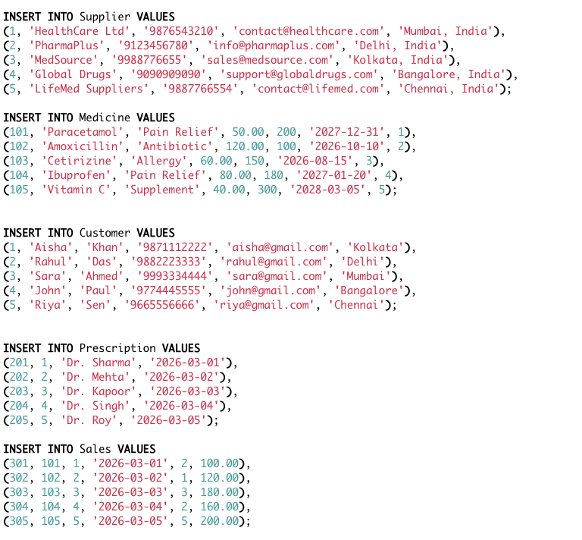
After that, some queries are used to run the database and obtain good results as per company requirements.
SELECT Medicine.Medicine_Name, Supplier.Supplier_Name
FROM Medicine
JOIN Supplier
ON Medicine.Supplier_ID = Supplier.Supplier_ID;

SELECT Medicine_Name, Stock_Quantity
FROM Medicine
WHERE Stock_Quantity < 150;

SELECT Customer.First_Name, Customer.Last_Name, Sales.Total_Price
FROM Customer
JOIN Sales
ON Customer.Customer_ID = Sales.Customer_ID;

SELECT SUM(Total_Price) AS Total_Revenue
FROM Sales;

SELECT Customer.First_Name, Medicine.Medicine_Name, Sales.Quantity_Sold
FROM Sales
JOIN Customer ON Sales.Customer_ID = Customer.Customer_ID
JOIN Medicine ON Sales.Medicine_ID = Medicine.Medicine_ID;

The screenshot of the results are shown as per the query development here.

Query Development
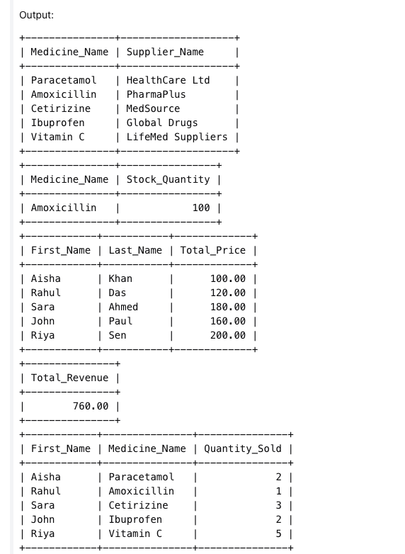

Validation and Testing
The code is developed and queries are formulated. However, it is important to check if the database functions properly and meets operational requirements of the company. The test focuses on evaluating data integrity, relationship constraints and accuracy testing while checking if the code correctly reports and achieve a place for better decision-making [5].
The table below shows the testing process and validation.
Test Case | Test Description | Expected Result | Actual Result | Status
1 | Insert a new supplier record | Supplier record should be added successfully | Supplier record inserted correctly | Pass
2 | Insert a medicine with a valid Supplier_ID | Medicine should be linked to the correct supplier | Medicine added and relationship maintained | Pass
3 | Insert a medicine with an invalid Supplier_ID | System should prevent entry due to referential integrity | System rejected invalid supplier reference | Pass
4 | Add a new customer record | Customer details should be stored correctly | Customer record saved successfully | Pass
5 | Record a sales transaction | Sale should link to valid medicine and customer | Sales record created successfully | Pass
6 | Run low-stock query | Medicines with low stock should be displayed | Query returned correct records | Pass
7 | Run sales report query | System should display customer purchases | Query produced accurate results | Pass

References
[1] Y. Bai and S. Bhalla, “Introduction to databases,” in Oracle Database Programming with Java, Boca Raton, FL, USA: Auerbach Publications, 2022, pp. 9–66. Available: https://www.taylorfrancis.com/chapters/edit/10.1201/9781003304029-2/introduction-databases-ying-bai-satish-bhalla
[2] P. Pornphol and S. Chittayasothorn, “Some practical aspects of the relational database normalization process,” in Proc. 11th Int. Conf. Engineering, Applied Sciences, and Technology (ICEAST), May 2025, pp. 188–192. Available: https://ieeexplore.ieee.org/abstract/document/11088203
[3] M. Pykälistö, “How database normalization and schema versioning improve system efficiency, data integrity, and flexibility in changing business settings,” 2024. Available: https://aaltodoc.aalto.fi/items/a7b0ec3a-10ee-4479-8b69-9cbfd2809796
[4] R. Rashkovits and I. Lavy, “Mapping common errors in entity relationship diagram design of novice designers,” International Journal of Database Management Systems, vol. 13, no. 1, pp. 1–19, 2021.
[5] E. Eessaar, “The database normalization theory and the theory of normalized systems: Finding a common ground,” Baltic Journal of Modern Computing, vol. 4, no. 1, pp. 5–33, 2016.

