Dissertation -LCBB6000

Impact of Social Media Marketing on Consumer Engagement: A Case Study of Gymshark

Student Name: Adelina Camelia Perva
Student ID: 2020310

Acknowledgement
I would like to thank everyone who helped me finish my dissertation. This journey has been both challenging and enlightening thanks to the encouragement and support of various people. First, I would like to express my sincere gratitude to my professors, for all of their support, acceptance, and insightful advice during this research. Their knowledge and commitment were extremely helpful in determining the course of my work. I also want to express my appreciation to everyone who responded to my survey and helped me gather important information for my research. I am appreciative of my friends and family's support, tolerance, and encouragement throughout this academic endeavour.

Abstract
The following research has briefly shed light on the effect of online marketing on consumer engagement for Gymshark. Further, a thorough aim, objectives and rationale have been provided with a background. The research has included various secondary studies to provide more thorough information related to the topic. Additionally, the steps that have been undertaken by the researcher while conducting the study have also been covered. Lastly, a primary analysis has been conducted with the help of a survey to gather new and accurate data to understand the topic thoroughly.

Table of Contents

Chapter One: Introduction 6
1.1 Introduction of the Research 6
1.2 Background of the Study 6
1.3 Problem Statement 6
1.4 Aim, Objectives and Research Questions 7
1.4.1 Aim of the Research 7
1.4.2 Objectives of the Research 7
1.4.3 Research Questions 7
1.5 Rationale of the Research 8
1.6 Methodology of the Research 8
1.7 Scope of the Study 8
1.8 Summary 9
Chapter Two: Literature Review 10
2.1 Introduction 10
2.2 Analyze an organization’s social media marketing strategies 10
2.3 Analyzing relevant content types, frequency of posting and the selection of platforms that are merely utilised and their effectiveness within an organisation 12
2.4 Assessment of the level of consumer engagement within an organisation through social media content 13
2.5 Gaps identified to situate the research project 15
2.6 Summary 15
Chapter Three: Research Methods & Methodologies 16
3.1 Overview 16
3.2 Research Philosophy 16
3.3 Research Paradigm 17
3.4 Research Approach 17
3.5 Research Methods 17
3.6 Research design 18
3.7 Research Strategy 18
3.8 Data Collection Tools 19
3.9 Data Analysis Techniques 19
3.10 Sampling 20
3.11 Ethical Consideration 20
3.12 Summary 21
Chapter Four: Findings and Analysis 22
4.1 Introduction 22
4.2 Findings 22
4.3 Discussions 29
4.4 Summary 31
Chapter Five: Conclusion, Limitations and Recommendations 32
5.1 Introduction 32
5.2 Conclusion on research issues and objectives 32
5.3 Conclusion of the research problem 32
5.4 Summary of the research findings and outcomes 33
5.5 Original contribution of the research 34
5.6 Limitations of the Research 34
5.7 Recommendations 34
5.8 Summary 35
References 36
Appendix One: Questionnaire 41
Appendix Two: Survey Findings 43
Appendix Three: Participant Information Sheet 47
Appendix Four: Google Form 48
Appendix Five: Participation Consent Form 52
Appendix Six: Application for Ethical Approval 54

Chapter One: Introduction

Introduction of the Research
Gymhsark is one of the leading gym garment retailers in the UK that established a prominent presence in the market with its well-maintained service. Considering this the organisation faced some challenges in maintaining their customer loyalty to some extent. Thus this research aims to understand the measures through which social media marketing helps in maintaining the customer loyalty of the firm. Apart from that a detailed literature review will be included in this study that justifies the objective of the study. Moreover, the researcher will follow the ethics of appropriate methodology following gathering necessary data that ensure the success of the study over time.

1.2 Background of the Study
The tough situation of the current market trend brings various complexities for Gymshark to maintain its brand position. Apart from that the market demographics of the present market have also shifted due to the changes in the preferences of the people. Thus, it is essential to understand the present demographics of the current market in the context of holding the brand position in the market. with the utilisation of an effective marketing strategy, the is very effective in overcoming the impact of the market trend to some extent which is the core aspect of this research.

1.3 Problem Statement
The organisation faced several issues in maintaining its customer base due to the emergence of the pandemic. Besides the revenue of the organisation also gets lower which brings several complexities in maintaining their position in the market. Accordance to mitigate the influence of the consequences of a tough market situation it is essential to develop effective measures of marketing to recover the gap of the business.

1.4 Aim, Objectives and Research Questions

1.4.1 Aim of the Research
The proposed aim of this research would be to understand the influence of Gymshark’s social media marketing on consumer engagement and loyalty.

1.4.2 Objectives of the Research
1. To Analyse Gymshark’s social media marketing strategies: To achieve this objective, Gymshark must carefully examine its entire social media marketing strategy. This study examines Gymshark's social media strategies for brand promotion and audience engagement.
2. To analyse GymShark's content types, frequency of posting the platforms that are utilized and its effectiveness: This objective drives Gymshark's social media output. The posting frequency on various social media networks will help us understand Gymshark's content distribution regularity and timeliness. Effectiveness measures how successfully the material connects with its target audience to meet marketing objectives.
3. To assess the level of consumer engagement with Gymshark’s social media content: To keep track of how much interaction Gymshark gets from its social media posts. Interactions, likes, shares, comments, and total interactions are examined from many social media networks. To understand the audience's emotions and involvement in Gymshark's social media activity, qualitative insights may be acquired.

1.4.3 Research Questions
1. How does Gymshark utilise different social media platforms for their marketing strategies?
2. Level of consumer engagement with Gymshark’s social media content?
3. Can consumer engagement on social media translate into brand loyalty for Gymshark?

1.5 Rationale of the Research
This portion will directly elaborate on the implementation of social media platforms and their use cases within the apparel business. During the year 2021, the organisation has almost 5.8 million followers with almost 230 customers worldwide. Though the organisation’s gross profit margin dropped to 65%, the business’s revenue rate will rise to 21% within 2021. Therefore, from evaluating this research, relevant information can be generated through which the business can maintain its profitability rate and continue to gain greater results from the online market.

1.6 Methodology of the Research
The researcher follows the measure of the research onion for the gathering of the necessary data that are required for the success of the research. Following this a survey will be conducted in accordance to collect the primary data through a deductive approach. Considering this the research follows the aspects of simple random sampling to reduce the collection of biased data that enhance the credibility of the study as well. further the cross-sectional time horizon as well as regulation of the Data Protection act assist in developing the research without any hassle.

1.7 Scope of the Study
The scope of the research is to realise the effectiveness of social media platforms through which Gymshark can gain a larger audience within the market field. Here, the primary target for the researcher is to evaluate the boundaries by analysing specific parameters of this portion effectively. Not only that, the unexplored data will also be evaluated through analysing the significance of social media platforms by developing promotional activities for the business. Evaluating all the study gaps can make it easier for the researcher to understand the subject matter and generate key insights from that.

1.8 Summary
This section has devised the justification for the importance of undertaking the study. Apart from that a brief description of how the research gathers the necessary data for the completion of the research has been devised in this section. The problem that is encountered by the firm in maintaining customer loyalty is another core aspect of this section. Further, the scope of the study is shorty described in this section as well.

Chapter Two: Literature Review

2.1 Introduction
The literature review is generally defined as a summary of a subject field, which supports the mere identification of the research questions in an assignment. Literature review in a further note provides an opportunity to observe as well as evaluate the successful and unsuccessful assessment along with the research methods within the academic field. Therefore, this section will reflect the impacts of Instagram, Facebook, X, and other social platforms including YouTube to increase customer engagement within a company’s brand like a cloth manufacturer or a grocery retailer. Additionally, the greater perspective of the researchers for incorporating a literature review in this research project is to convey the social media platform’s beneficial approaches to organizational brand promotion.

2.2 Analyze an organization’s social media marketing strategies
According to Cao et al. (2021), an outline of all the goals an organisation has for the activities that it would like to do on social media is called a social media marketing plan. It guides an organization’s actions and shows them how successful or unsuccessful their organization is. Within this case, the more accurate the plan will be the more effective it will be for the organization’s success. As per Cartwright et al. (2021), a social media marketing strategy should include a list of all existing and future social media accounts as well as specific goals for each platform that an organization uses. These goals should be consistent with the company's overall digital marketing strategy. A strong social media plan should outline the reporting schedule and the responsibilities assigned to each team member. The first step in making an accurate social media strategy is to make clear goals and objectives for the organization. In the view of Rietveld et al. (2020), each of the social media marketing goals needs to be SMART which indicates “Specific, Measurable, Attainable, relevant and Time-bound”. Next, an organization needs to analyze the current social media trends to make relevant advertisements representing the brand showcasing the product or service. According to Pop et al. (2022), a documented plan outlining an organization’s goals on social media, the steps that they take to achieve them, and the metrics they track to evaluate the progress is called a social media strategy. As per the statement of de Oliveira Santini et al. (2020) most renowned organizations are actively marketing on Facebook, Instagram, YouTube, LinkedIn and more. On the contrary, the number of followers and number of likes needs to be tracked to see the social media engagement of the organization. An organization also needs a competitive analysis as well and through the help of a competitive analysis, a company may find out who its opponent is and what they are doing successfully and poorly. This aspect will present a clear understanding of industry standards, which will enable the company to establish its own social media goals. Another important strategy is conducting a social media audit. Pelletier et al. (2020) describe the company's need to be able to see clearly from the audit what function each social media account fulfils. The company needs to Consider if an account is worthwhile to keep if its function is unclear. It does not matter that these imposters are gaining followers that belong to the company rather they can still cause damage to your brand. Setting up social media accounts and profiles is important. The company needs to fix the platforms if it wants to focus on and improve customer engagement through social media insights. In the view of Wibowo et al. (2020), the organization can also take inspiration from other renowned brands on social media. However, the organization needs to avoid imitating other companies positively. As stated by Dwivedi et al. (2021) the company needs to focus on making its advertisements and promotions unique so that it can easily attract the attention of the customers. Additionally, an organization can collaborate with different social media influencers and celebrities along with launching some exciting social media campaigns.

2.3 Analyzing relevant content types, frequency of posting and the selection of platforms that are merely utilised and their effectiveness within an organisation
Within the statement, Effendi et al. (2020) present that the mere content types need to be optimised according to the modern trend of eye-catching colours or brand logos as well as according to the public demands for increasing customer engagement. More than 60% of people are highly concerned about the ongoing fashion and trends as they reflect complex buying behaviour. According to Saura (2021), Modern social media platforms are highly affordable these days as the internet charges and smartphones are more than available in the market. Based on these plus points most of the big brands attain social media brand promotion for greater engagement of the customers. Organisations from the retail sector can create attractive content of daily need products as well as fashionable items to generally attract people and increase the sales figure as well as the revenue area. As stated by Hudders et al. (2021), digital retail giants can use their content in the form of ads within social media platforms to attract a huge public in a very short time. Most smartphone companies are using these technologies to make promotional advertisements within the social media platforms of YouTube, Facebook and X. Except for this, the seasonal product advertisement content associated with great offers and cashback can also be categorised as mere promotional activity of the organisations and brands for bigger customer engagement. Based on the view of Morgan-Thomas et al. (2020) the posting frequency also needs to be observed and provided within suitable times only, as the shorter frequency and irrelative social media endorsement can be harmful to the companies by creating a disturbance aspect. Except for this the posting gap as well as frequency need to be optimised as the seasonal approach of the products and need to be maintained and reflected once or twice in an individual's social media account for remaining an attractive approach. Labrecque et al. (2020) present, that the frequency of posting promotional advertisements or posts needs to be maintained by thinking about the aspects of attractive purpose to the clients or social media users rather than being a disturbance element and being avoided by the users. As per Steffens et al. (2020), the Implementation of these angles as well as the above-mentioned strategies can be highly beneficial for an organisation to generate remarkable customer engagement through social media strategy. The selection of the platforms for conducting these promotional activities and performing an effective social media endorsement is also highly significant. As stated by Li et al. (2021) the maintenance of relevant social media postings like clothing elements on Facebook and Instagram and video material reflecting the brand is beneficial. Additionally, the endorsement of celebrities and other relatable activities on YouTube can be beneficial and appropriate to make logical sense of advertisements. According to Vrontis et al. (2021) implementing these strategies and incorporating a logical sense of social media endorsement for the brand promotion of an organisation as well as to make a popular element of the organisational products can be highly effective within the modern societal aspects.

2.4 Assessment of the level of consumer engagement within an organisation through social media content
According to Massey et al. (2020), social media platforms are the highlighted area in this modern century as people are more associated with social media activities than real-life experiences. Based on this, people desire to copy the uppercase people like celebrities and follow the trend of marketing consciously and sometimes subconsciously. As merely presented by Walter et al. (2021) an organisation should not only focus on making a broad plan that cannot be measured or attainable within the public area, the required thing is to understand the market demand and by presenting effective products to satisfy the people and well-conducting business activities. Valeri and Baggio (2021) also present that an organisation needs to focus on the advertisement and the pictures or videos that they are going to post on social media, which will represent the whole company. Hence, McClure and Seock (2020) have stated that choosing the right technique of advertisement is also necessary to increase customer engagement and make it effective in the market. According to Molinillo et al. (2019), an organisation should also focus on being active on different social media platforms and channels to connect with more customers as well as retain the remote public in comparison to the local public. On the contrary, seasonal advertisement activities of clothes like introducing summer outfits, and attracting people in the pre-summer period through social media platforms can be a significant brand promotional activity to use social media strategies. Apparently, through the help of ‘social media analytics,’ a company can get useful data regarding the demographics, locations, and online behaviours of the followers. As per the statement of Mehmet et al. (2020), this can help in improving audience targeting and strategy with the help of these insights to understand the market trends as well as the customer demands broadly. Based on these activities the engagement of the customers and complex buying customers can be associated through the beneficial approaches of social media strategies and social media content. Vander Schee et al. (2020) also refer to mere procedures to measure the level of engagement through social media brand promotion strategy implementation can be categorised as the evaluation of the sales figure from the previous sales figures in the pre-period of social media utilisation of advertisement. According to Moran et al. (2020), the significant increment of sales within the retail sector of cloth manufacturing organisations and the improved sales area of online retail giant companies are reflected in the result of social media endorsement. Apart from that, in most cases to satisfy the people’s desire to copy celebrities and to copy the exclusive market trend the contribution of social media marketing is impressive. Additionally, Melović et al. (2020) described that the retail giant companies also admitted that the implementation of social media branding and promotional activities has increased their sales figure in comparison to older days. Based on these statements the mere evaluation of the level of accommodation as well as engagement of customers within an organisational selling and buying activities, through social media platforms has been described.

2.5 Gaps identified to situate the research project
Research gap generally presents the gap to conduct research smoothly and by exploring all the probable aspects of the research topic (Klingner and Boardman, 2011). The vital deadline for time highly damaged the quality of the research work as the allocated time was very short to collect all the relevant evidence within this complex research topic. Apart from that, the lack of appropriate evidence as well as relevant information also hinders the research process and creates an obstacle to increasing the quality of the research project to incorporate significant statistics (Snilstveit et al., 2016). Except for this, the selection of the current and modern sources as well as the journals also provided less information, in comparison to the previously published journals regarding this topic.

2.6 Summary
This section has presented a core analysis regarding the impacts of social media campaigns and promotional activities to increase the brand image of an organisation and improve sales to generate more revenue. The significant strategies of social media endorsement as well as how social media can be utilised to make an effective brand promotion has also been discussed. On the contrary, relevant timings of posting the promotional content within social media platforms like Facebook, Instagram and X are also incorporated within this section by exploring the positive impacts and significant effectiveness of social media advertisement strategies for an organisation.

Chapter Three: Research Methods & Methodologies

3.1 Overview
The research methodology section is the most important part of the research chapter as a whole. Methodically, it directs the research through its many stages, acting as its backbone. The complexities of the research process are laid out in this chapter, which provides a structured way to go through the study. The researcher uses Saunders' onion model, a well-known tool for its effectiveness and organisational prowess, to highlight the importance of this methodology. The researcher succinctly yet fully outlines the stages done to conclude the study in the following sections.

3.2 Research Philosophy
The intentional selection of positivism as the guiding research philosophy is based on its unique emphasis on objective and measurable facts. The study's primary objectives are to highlight the need for a systematic approach to gathering and interpreting data in line with this choice. The positivist approach has been used as a research ideology that gives importance to empirical facts and the scientific method. The commitment to a methodical and fair investigation means that the research will be focused on facts rather than personal opinions.
There is a natural link between positivism and quantitative methods that tries to show links between causes and effects and generalise very important results (Thompson, 2022). Adopting this idea could help the research stay objective while using quantitative methods to test theories that give complete and trustworthy outcomes. Positive epistemology is used to examine issues objectively and logically. Positivist ideas can be used to make a list of research questions that can be tried in the real world. This ensures that the philosophy matches the research goals. This part explains how positivism makes sure that true and reliable points of view are found through organised data collection and analysis.

3.3 Research Paradigm
The descriptive method serves as a paradigm for the research. This makes it possible to depict characteristics, deeds, or situations without adding extraneous elements. The selection of this paradigm is crucial for the study's conceptual and methodological aspects, aligning with the research objectives (Webster, 2023). The research employs a descriptive paradigm and provides a methodical way to directly address the existing aims and difficulties. By carefully coordinating, the researcher builds a reliable and efficient strategy, resulting in more substantial and reliable study results.

3.4 Research Approach
The research team decided to use the logical research method, which involves collecting data, evaluating it, and managing the process in a planned way. By employing this approach, one can concentrate exclusively on evaluating hypotheses that are constructed upon prior concepts. The researcher builds a study theory from the hypothesis in the first phase. They will collect and examine data to verify or invalidate the initial notion (Meeker, 2022). This inquiry relied heavily on deduction. First, develop research questions based on existing premises. This method will ensure methodical research. It helps uncover statistically significant factors and check predictions, improving the study's dependability and rigour.

3.5 Research Methods
The study only uses quantitative research methods to look at the details of people's experiences, actions, and events in society. It is important to use study, interviews, notes, and qualitative analysis along with numeric data to look at these complicated problems (Peck et al., 2020). There are a lot of useful results that give a full understanding of the study subject that come from using the quantitative research method. It involves measuring things and carefully looking at and studying them. The reason this approach works is that it can show complicated traits, situations, variables, and factors. Thus, the investigation is more complete. Researchers may prove they're not infringing any regulations by using surveys methodically and following all survey standards. This option was carefully considered. This strategy helps the researcher to gather data impartially and comprehensively, ensuring the study's success.

3.6 Research design
Planning a well-thought-out research design that includes instructions on how to collect and analyse data is necessary for studying. Systematic analysis and ways to test research questions or theories are part of research design (Mcleod, 2020). Today's research uses a descriptive research design to understand the traits and actions of a person or group without adding any new factors. By utilising survey and data analysis, this methodology may effectively identify events. A strong topical base is provided by the detailed design. Trends, patterns, and connections may help experts come up with ideas and keep doing research. A thorough descriptive design improves data quality and dependability while delivering topical insights. The methodical approach to data collection and concentration on finding distinguishing qualities while minimising confusion boosts the research.

3.7 Research Strategy
Data collection, analysis, and interpretation are part of the research methodology. This thorough design used several methods and tools to fulfil the study's goals. Information collecting, sampling, and data sources are included. The approach guides analysis and organises research issues. This research shows how important it is to use an experimental research method when not much is known about the research topic. For this method, gathering qualitative data through focus groups, interviews, or observation is used to yield useful insights, ideas, and theories (Cherry, 2023). Exploratory research gives new ideas, relevant information, and different points of view. This method keeps the analysis process thorough, fresh, and reliable and recognises the value of exploring research in quickly learning about areas that are hard to understand or are new to you. This one-of-a-kind research method helps the researcher collect data figure out what it all means and the study plan more credible. Qualitative data-driven exploratory research improves comprehension and sets the stage for future research.

3.8 Data Collection Tools
Questionnaires are the main data gathering instrument in this research. The toolbox of data gathering methods used in research includes statistical analysis, questionnaires, interviews, polls, and surveys. Surveys are used as a key data collection strategy because they can collect data from many respondents in a systematic way (David, 2022). Interviews, online survey platforms like Google Forms, or more conventional survey methods all provide structured and standardised question formats. The comparison and analysis of replies may be carried out in a way that is both efficient and thorough thanks to this framework.
Google Forms' ethical concerns help the researcher collect quantitative data ethically. Using Google Forms simplifies data collection and ensures that the research remains honest by adhering to ethical standards. Surveys and Google Forms provide a rigorous and modern approach to quantitative data collection. Surveys give a plethora of quantitative data for statistical analysis. Profitable and effective trend, pattern, and relationship identification is possible with this approach. The study's results and informed decision-making benefit from the systematic use of surveys and the ethical usage of Google Forms to collect extensive and trustworthy primary data from the organization's personnel.

3.9 Data Analysis Techniques
The application of data analysis techniques is key to gaining insights from data. This research uses quantitative data analysis techniques to handle and evaluate data. The systematic and methodical approach to data analysis emphasises statistical analysis (Business Research, 2022). Statistics are essential to research because they organise and understand data. The goal is to find useful insights and draw solid conclusions that make a significant contribution to the study's results by using statistical techniques.
Selecting data analysis methods is vital to study. They help academics examine and draw conclusions from data. This step ensures the data is usable for answering research questions and achieving study objectives. Quantitative data analysis helps research direction. The study uses statistical analysis to find patterns, trends, and correlations. Researchers may test ideas, make informed decisions, and get valuable insights into many study topics using the comprehensive process. Thus, focusing on quantitative data analysis strengthens and illuminates research.

3.10 Sampling
Simple random sampling is used in the research's robust sample technique. Bussetto (2020) states that this technique ensures that all population members have an equal probability of getting selected. The study attempts to reduce bias and provide useful findings for the whole population. Careful random selection simplifies data collection.
This method hand-picks respondents at random, so the sample represents the population. This strategy maintains results integrity and provides valuable insights and extrapolation to the wider context. The researcher randomly selected 20 respondents for a Google Forms survey. Simple random sampling makes this study's conclusions more reliable.

3.11 Ethical Consideration
The research framework must highlight ethical considerations, including responsible conduct by participants and researchers. The research satisfies ethical standards for informed consent, confidentiality, and voluntary involvement. These safeguards are essential for participant rights, dignity, and well-being.
Maintaining honesty and integrity throughout research is part of ethical conduct. This dedication protects against adverse effects and boosts research process trust by legitimising and relying on research outcomes. Ethics underpin the research method (Bouchrika, 2022). This principled viewpoint advances research via open and transparent means while adhering to long-standing ethical norms.

3.12 Summary
The chapter opens with an instructive summary to prepare for in-depth research methods discussion. Positive research requires thorough observational evidence and methodical data collecting, thus the various phases of the research process are broken down. The chapter highlights the relevance of research paradigms in aligning research goals and methods to create reliable findings. Quantitative analysis is dominated by deductive analysis, which tests hypotheses systematically.
The talk also covers research methods, particularly qualitative analysis's significance in comprehending complicated variables and experiences. Starting with qualitative technique is crucial when establishing assumptions. The exploratory technique is excellent for exploring new regions. Systematic and transparent data collection is achieved by carefully selecting survey, interview, and observation tools. The explanation of data analysis methodologies highlights methodical data processing. Simple random selection provides population representation, the chapter concludes. This facilitates chapter transitions and keeps research information available.

Chapter Four: Findings and Analysis

4.1 Introduction
This section examines survey data to reveal Gymshark's internal structure and staff devotion and longevity. The research starts by emphasising the diverse views on Gymshark's marketing activities' use of social media to set the tone for a demographic-based evaluation. The multifaceted function of social media in Gymshark's marketing strategy is highlighted, and its effects on brand awareness, targeted advertising, and consumer interaction are thoroughly examined. We need to take a closer look at the aspects that could improve Gymshark's strategy for online advertising activities since, as the investigation progresses, the survey data shows different perspectives of success. Examining Gymshark's strategic focus and adaptability, as well as the interaction strategies deployed, the following sections traverse through the specific social media channels utilised by the organisation.

4.2 Findings
Data Presentation - What is your job designation in Gymshark?
The questionere was sent to 25 people, out of them 20 people participated in the survey. The poll results make it clear that 60% of the people who filled it out are trainers, 15% are bosses, and 25% are managers at Gymshark. The hierarchy that exists inside the organisation is illustrated by this breakdown, which gives insights into the distribution of positions at the organisation. Gaining an understanding of the exact tasks that are associated with each role can provide a more nuanced perspective on the internal structure of Gymshark. If these jobs are investigated further, it may be possible to gain significant insights into the organisational dynamics operating inside the corporation.
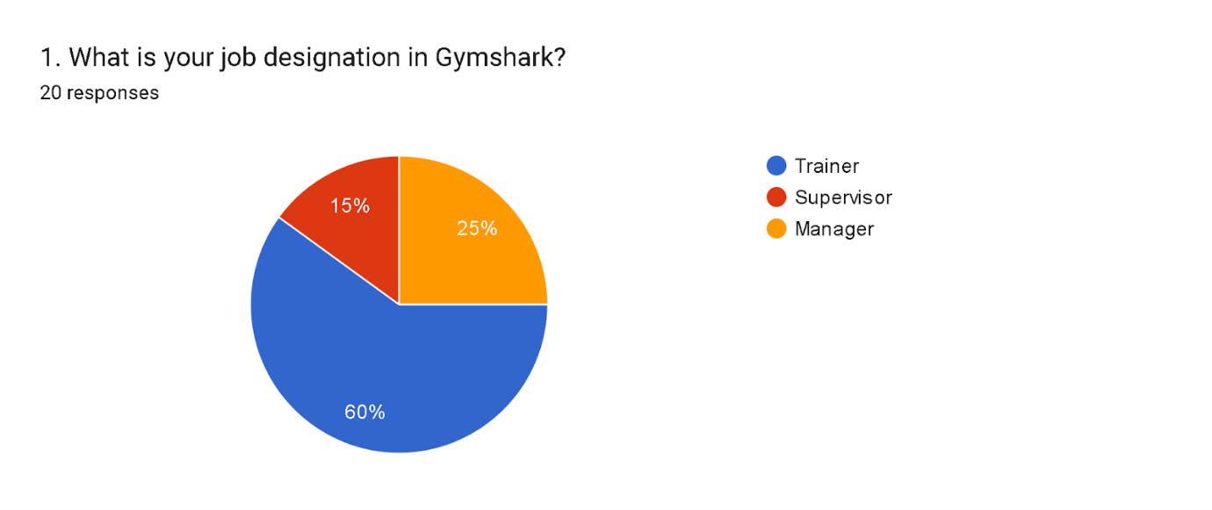

Data Presentation – How long have you been working at Gymshark?
20% of respondents had been with Gymshark for less than a year, 15% for two to three years, and 65% for more than three years, according to the poll results. This long employment period shows employee loyalty and job satisfaction. The extended stay may indicate a good work culture and career progression at Gymshark. Consistent with the study's emphasis on organisational dynamics, more research into the variables affecting employee retention and its effect on firm success could yield useful clues.
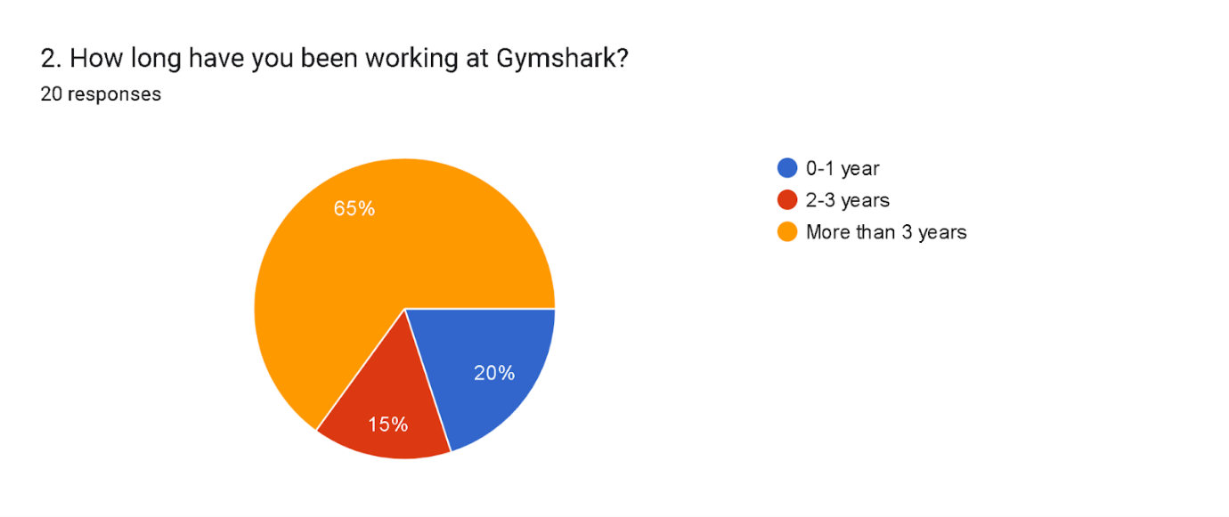

Data Presentation – Do you think social media is important for marketing a product, service or brand?
By looking at the survey responses, it is clear that 35% of people say they agree that social media is important for marketing, 25% say they disagree, and 40% are still not sure. This disagreement exemplifies the fact that people have different views on the value of internet platforms for advertising. A large percentage agrees that it is important, yet many more are either unsure or sceptical. Further research into demographic or experiential criteria like age, job experience, or preferences might illuminate these viewpoints. This fits in with the study's overarching goal of elucidating the range of perspectives on Gymshark's social media marketing.
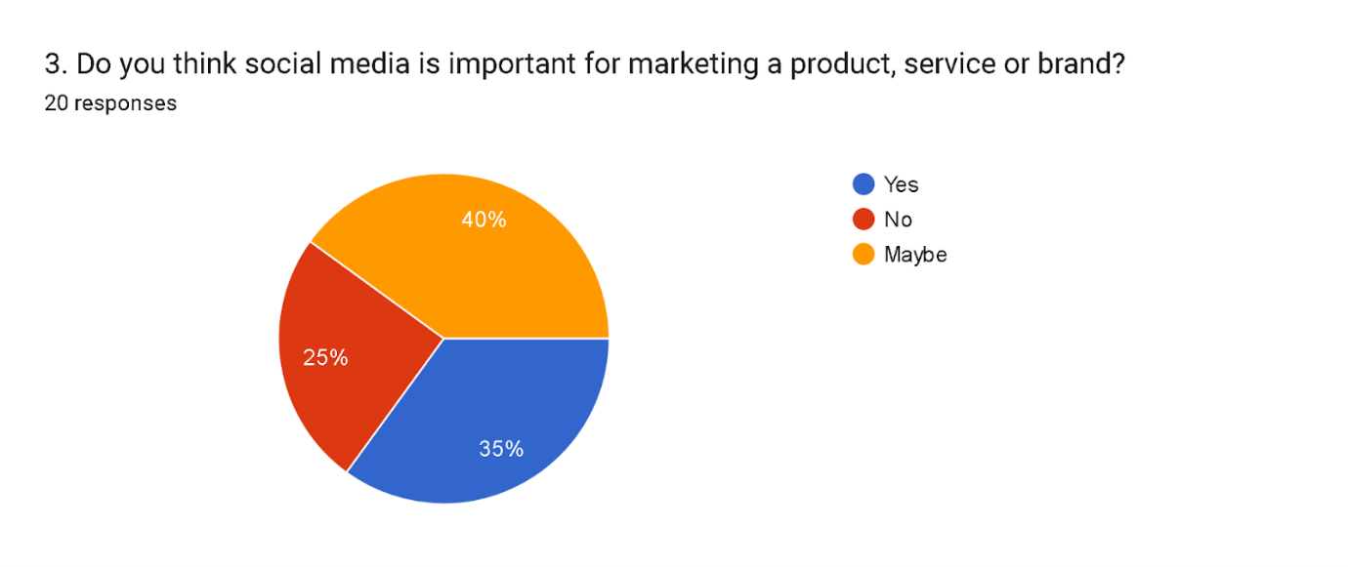
Data Presentation – According to you, how does social media help in marketing?
Based on survey responses, 40% of respondents feel social media boosts brand exposure, whereas the same number emphasises focused advertising. Also, 20% stress the platform's role in getting customers more involved. These findings show that social media aids marketing through interactive customer engagement, personalised messages, and brand visibility. More research into specific strategies and examples of how social media helps with these marketing goals would help us understand its effects better, which fits with the study's main goal of finding out what participants thought about social media's part in Gymshark's marketing plan.
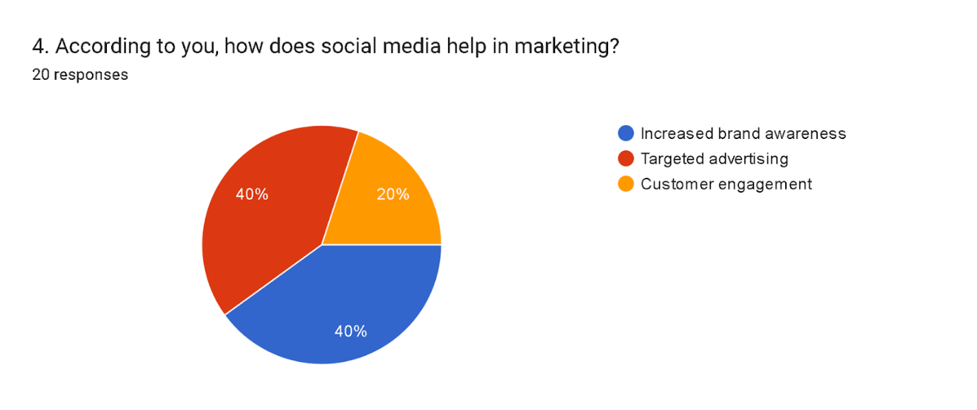
Data Presentation – Rate the effectiveness of such social media marketing strategies
Data analysis shows that 25% of people surveyed gave social media marketing a perfect score of 10, while another 5% gave it a 9. Plus, a quarter of the people who took part in the survey gave it a score of seven or eight. According to these findings, a sizeable percentage of respondents thought social media marketing was very successful. However, a smaller subset of the data showed a little lower degree of effectiveness. Following the research's goal of measuring participant perceptions, more exploration into the elements impacting these evaluations might reveal particular ways in which Gymshark's online promoting efforts could be improved or made more effective.
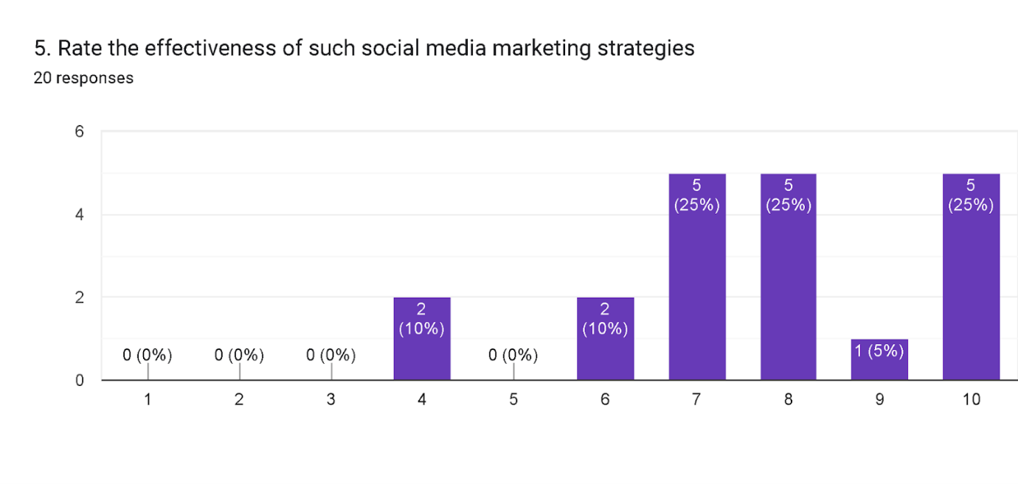

Data Presentation – Do you think Gymshark makes use of various social media channels for its marketing process?
Gymshark uses a variety of social media channels for marketing, according to 60% of respondents, 15% of whom disagreed and 25% of whom were unclear, according to the survey. According to the data, most people think that Gymshark uses a variety of social media platforms for advertising. The level of social media participation by Gymshark is still a matter of some doubt for a sizeable percentage of the population. The research aims to explore participant perceptions of Gymshark's marketing practises; further analysis might explore the platforms used and how effective they are at reaching the target demographic.
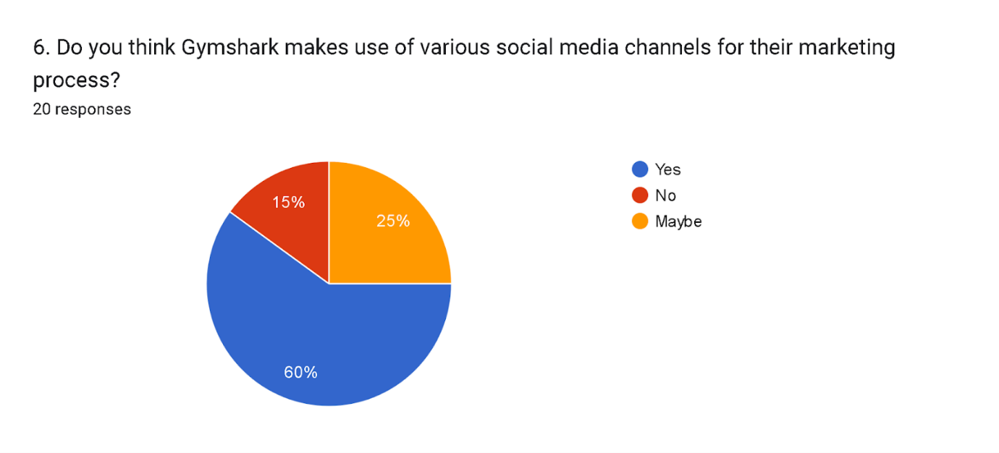

Data Presentation – As per your opinion, how does Gymshark use different social media channels for their marketing process?
Third-party survey responses show that Gymshark's marketing approach focuses on YouTube and Instagram. Furthermore, thirty percent of people think Gymshark uses TikTok in its ads. According to these results, Gymshark is quite active on all the major social media sites, especially the more visually appealing ones like Instagram and YouTube, and it is also looking into the possibilities of newer sites like TikTok. The research aims to examine participant impressions of Gymshark's marketing practises; further analysis might explore the precise techniques and content types implemented by the firm on various platforms to effectively engage its target audience.
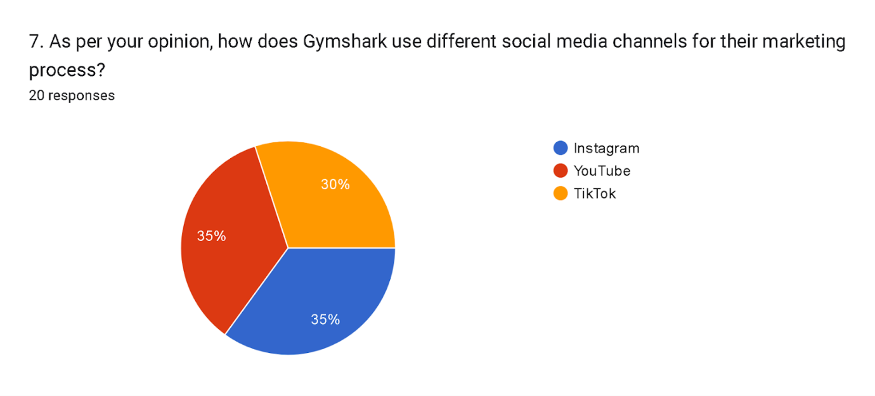

Data Presentation – How does Gymshark maintain its level of consumer engagement with the usage of social media content?
Gymshark uses several social media engagement tactics, according to survey data. 30% think Gymshark does this by continuously producing high-quality material. Also, 45% say that working with influencers has helped the company get customers more involved. Also, 25% talk about how important events and gifts are for keeping customers interested. These results show that Gymshark uses a variety of strategies to effectively engage its target audience on social media, such as regular content updates, partnerships with influencers, and interactive promotions. This is in line with the research's main goal to find out what participants thought about the company's engagement strategies.
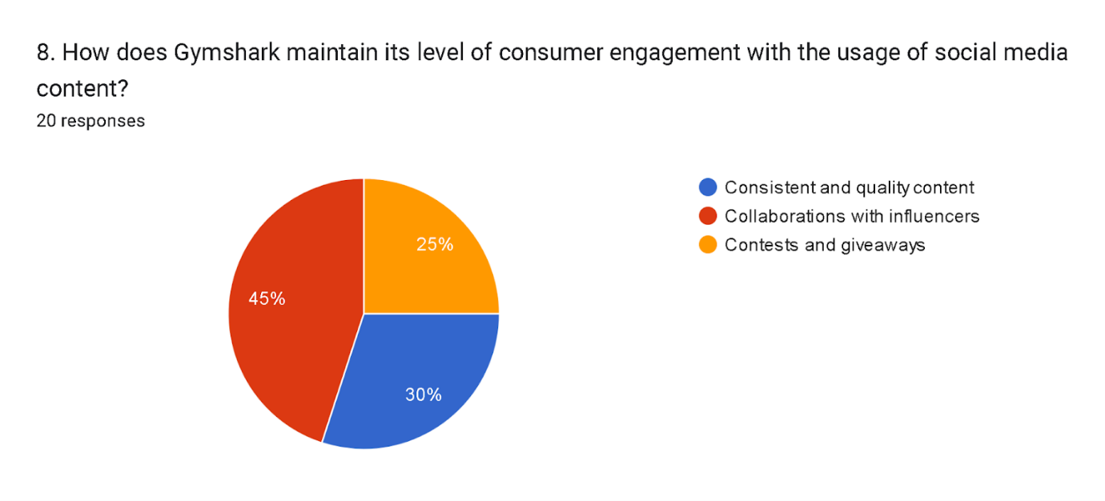
Data Presentation – Do you believe higher customer engagement in social media can translate to brand loyalty?
The survey shows that opinions on whether social media activity increases brand loyalty are mixed. Increased social media interaction, according to 40% of respondents, results in brand commitment. Nevertheless, 15% of people disagree with this statement, and 45% are still unsure. The conflicting viewpoints show that brand loyalty and social media engagement are complex. The study aimed to examine different viewpoints on brand loyalty about Gymshark's social media presence; further research taking demographics and personal experiences into account might shed light on the intricacies of this relationship.
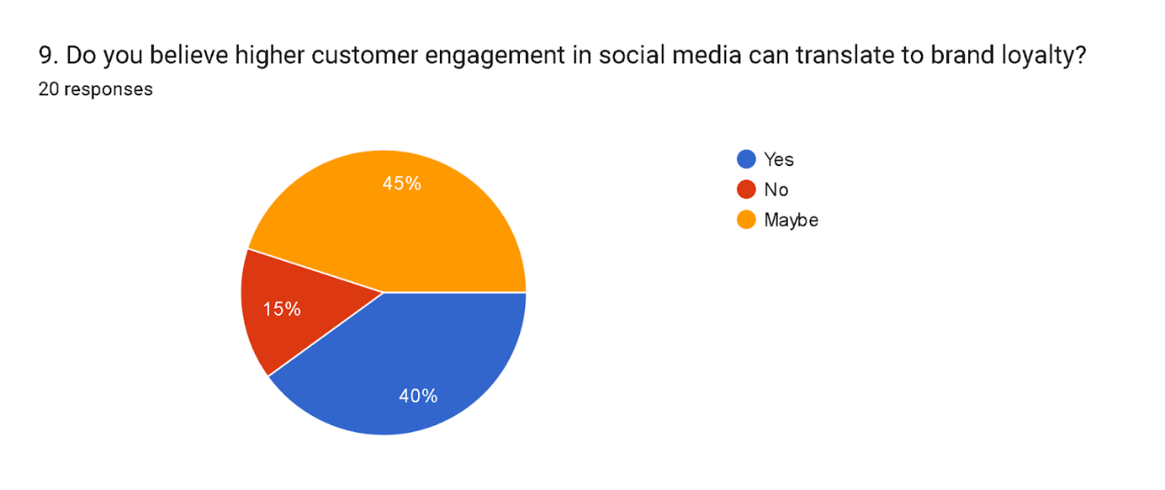
Data Presentation – According to you, in what way higher consumer engagement through social media can lead to brand loyalty for Gymshark?
According to participant responses, Gymshark can build brand loyalty through social media interaction. The survey found that 36.8% value trust and trustworthiness and 31.6% value community development. Also, 31.6% say that brand difference is one of the most important things that makes people loyal to a brand. These results suggest that Gymshark's ability to keep customers coming back online is linked to building a sense of community, earning trust, and showing off what makes the business unique. This is in line with the study's look at the many factors that affect brand loyalty on Gymshark's social media pages.
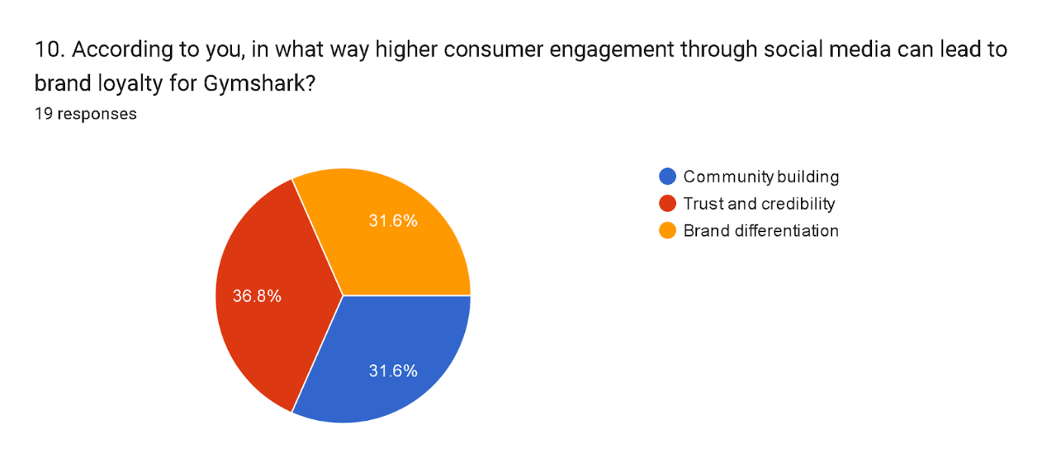

4.3 Discussions
The research on Gymshark's social media marketing and consumer engagement and loyalty provides useful insights into the company's internal dynamics, employee loyalty, and marketing methods. The survey data's main themes are examined below. The survey shows that 60% of Gymshark employees are trainers, 15% bosses, and 25% managers. This breakdown shows the company's role distribution and structure. Further investigation into each role's responsibilities may reveal Gymshark's organisational dynamics. Over 65% of responders have been with Gymshark for more than three years, highlighting employee loyalty. This long tenure reflects a good work culture and career advancement. The findings suggest more research on employee retention and corporate success. The survey found 35% agreeing, 25% disapproving, and 40% undecided about social media's marketing value. This diversity highlights the different views on online advertising platforms.
The survey showed Gymshark's multifaceted social media marketing strategy. Fourty percent think social media boosts brand exposure, while the same number think it helps focus advertising. Additionally, 20% emphasise its role in customer involvement. These studies emphasise social media-enabled interactive customer involvement, personalised messaging, and brand visibility. Further research into specific techniques and instances could help us understand Gymshark's online marketing effects. Gymshark's social media marketing was rated a 10 by 25% and 9 by 5%. Most think it's great, while some think it might be better. Exploring these assessments elements may help Gymshark optimise its internet promotions. Gymshark uses multiple social media channels for marketing, according to data from a survey. 15% disagree and 25% are unsure. The research examines participants' views of Gymshark's marketing strategies, emphasising the necessity to examine the platforms' success in reaching the target audience.
Gymshark's YouTube and Instagram marketing is highlighted, with 30% of respondents using TikTok for advertising. Focusing on visually appealing channels like Instagram and YouTube and examining emerging platforms like TikTok helps the study comprehend participant opinions of Gymshark's marketing strategies. Gymshark uses a variety of social media engagement strategies, with 30% mentioning high-quality content development, 45% mentioning influencer collaborations, and 25% mentioning events and gifts. These findings support the research's main purpose of highlighting Gymshark's different audience engagement techniques. 40% believe increasing social media participation increases brand loyalty, 15% disagree, and 45% are undecided. To understand the complex relationship between social media involvement and brand loyalty, demographic and experiential research is needed.
The discussion ends the main analysis and fills the literature evaluation gaps. The poll revealed how people react to a business's social media and online advertising. Monitoring social media trends, conducting social media audits and competitive research, and understanding digital advertising methods are discussed. The research also examines client loyalty, social media platforms, and consumer interaction. Through this study, the research fills gaps in our knowledge and offers practical advice for firms wishing to better their online marketing.

4.4 Summary
Social media marketing research shows Gymshark's internal structure, staff loyalty, and marketing efficacy. The poll found that 60% of trainers, 15% bosses, and 25% managers at Gymshark. Long tenure (65%) indicates a healthy work culture and professional progression, demonstrating employee commitment. Different views on social media's marketing usefulness demand demographic study. Gymshark's social media approach emphasises brand recognition, targeted advertising, and consumer involvement. The majority views marketing efforts as successful, yet there are suggestions for improvement, suggesting a closer look at affecting elements. Gymshark uses YouTube, Instagram, and TikTok, according to the survey’s social media usage. Content quality, influencer collaborations, and events demonstrate a thorough approach. Disagreements on the relationship between social media engagement and brand loyalty highlight the need for more research into this complex relationship. Trustworthiness, community development, and brand distinction are key to creating brand loyalty through social media involvement, providing Gymshark with marketing insights.

Chapter Five: Conclusion, Limitations and Recommendations

5.1 Introduction
The general findings of the study will be the primary topic of the next chapter. The conclusion of the primary study as well as the identification of research issues will be assessed in this part. We'll also talk about how this research benefits academia, business, and academics. This chapter will conclude by offering some insightful suggestions for enhancing future research and for Gymshark.

5.2 Conclusion on research issues and objectives
The research question that arises from the survey's findings focuses on consumers' differing opinions and views of social media marketing's function in the Gymshark context. The aforementioned findings underscore the significance of investigating and comprehending the complex interrelationships among influencer partnerships, multi-platform tactics, and social media marketing. These partnerships affect Gymshark's brand reputation, trust, and customer engagement. Participants disputed whether the group had numerous social media channels confusing. The majority's remarks concluded the analysis of the findings.

5.3 Conclusion of the research problem
There were some problems and limits that had to be dealt with during the research. First, survey participants may have given false or socially acceptable information about Gymshark's social media marketing. This might have resulted in the main study being somewhat biased. Because of the study's restricted emphasis on Gymshark as a single brand, the results are less transferable to a larger environment than is the case with other studies. Last but not least, even though secondary sources might be useful, there may be problems with ensuring that the information obtained from them is accurate and applicable. It is necessary to overcome these constraints to improve the validity and application of the study.

5.4 Summary of the research findings and outcomes
The examination of secondary sources produces a number of significant conclusions and discoveries on the effective implementation of social media marketing strategies in companies. The selection of relevant social media sites, personalised content kinds, and a well-balanced posting schedule are all important factors in effective customer engagement and retention. Trends are a useful tool for social media plans; they also conduct social media audits, avoid copying, and prioritise unique advertising and partnerships with influencers. The study also found that social media activities greatly impact consumer behaviour and enhance company involvement and sales. Social relationships, Gymshark's social media presence, the purpose of social media marketing, and the impact these aspects have on consumer involvement are just a few of the significant subjects that the survey findings have highlighted. Firstly, a lot of people who answered stress how important social media is becoming in the business world. This shows that Gymshark needs to keep putting money into its social media tactics to get the most out of its marketing. Statistics show that Gymshark is very busy on social media sites like Instagram, TikTok, and YouTube. In line with modern marketing strategies, this shows that the company knows it needs to connect with and interest its target audience in a number of different media. The poll results also show how important it is for well-known influencers to work together to get customers involved. This shows that influencer marketing is a good way to build trust and a good image. Influencers may boost Gymshark's reputation and customer base that makes them worthy brand advocates.

5.5 Original contribution of the research
The study gives us a lot of useful information about how businesses can use social media marketing. If a business is in the exercise or clothes industry, this article is especially helpful for managers. Because it stresses the importance of the use of effective social media marketing strategies to get customers more involved (Mason et al., 2021). Adding a real-life case study that shows how social media and customer habits change over time adds to the large body of academic writing that already exists. Scholars gain information by using particular cases to build and enhance internet marketing and brand-consumer interaction ideas.

5.6 Limitations of the Research
Limited sample
Several constraints must be considered while evaluating the research. At first, the study's poor generalizability may be ascribed to its lack of emphasis on Gymshark. It would have been beneficial to collect a broader array of information and statistical data by augmenting the sample size to enhance its application (Salomon et al., 2019).
Response Bias Risk
The participants were asked to fill out a survey and the study raised the issue of response bias because people could lie about how they interacted with Gymshark's social media marketing. If respondents provided false or inaccurate data, this may compromise the research's results.

5.7 Recommendations
Seasonal advertising
Gymshark might boost its social media marketing by using seasonal patterns and events. Effective seasonal advertising helps attract and retain clients (Chron, 2021). Gymshark may create holiday and fitness event-specific content and promos. This might include special deals, limited-edition items, or themed fitness challenges. Taking advantage of audience passion and interests at these times might help Gymshark build community and excitement.
Collaboration with influencers
Collaboration with fitness and wellness social media influencers may be advantageous. Many times, these influencers have engaged, loyal followers who depend on their counsel (Mathew, 2019). Gymshark and influencers may work together to create content that showcases their products and way of life. By doing this, they may take advantage of the influencer's credentials and reach a wider, more relevant audience. Influencer testimonials and recommendations that are sincere may have more persuasive power than standard commercial language.
Consistent content
Keeping your social media following consistent requires sticking to a posting schedule and content strategy. Gymshark should make a content schedule that outlines the categories, topics, and themes that will be addressed (Lorette, 2023). Regular posting keeps the brand front and centre in the thoughts of followers and helps them build expectations of what to expect from it. Gymshark should include instructional material, exercise advice, success stories, and inspirational posts in addition to product-focused content to further support its fitness-focused philosophy. This will maintain followers' interest while also establishing Gymshark as a reliable source and authority in the fitness industry.

5.8 Summary
A few issues with the study have been discussed in this chapter. These issues include the possibility that the participants would exchange misleading information with one another and the small size of the sample. Furthermore, after doing a study of the data, it has been shown that social media marketing methods have a significant connection to customer management and retention strategies. There is a recommendation that Gymshark should concentrate on seasonal advertising tactics, teamwork, and continual content.

References
Bouchrika, I., (2022). How to Write Research Methodology: Overview, Tips, and Techniques. [Online]Available at: https://research.com/research/how-to-write-research-methodology [Accessed 04 November 2023].
Business Research, (2022). Research Methods. [Online]Available at: https://research-methodology.net/research-methods/ [Accessed 04 November 2023].
Cao, D., Meadows, M., Wong, D. and Xia, S., (2021). Understanding consumers’ social media engagement behaviour: An examination of the moderation effect of social media context. Journal of Business Research, 122, pp.835-846.
Cartwright, S., Liu, H. and Raddats, C., (2021). Strategic use of social media within business-to-business (B2B) marketing: A systematic literature review. Industrial Marketing Management, 97, pp.35-58.
Cherry, K., (2022). What Is Conformity?. [Online]Available at: https://www.verywellmind.com/what-is-conformity-2795889 [Accessed 04 November 2023].
Chron, (2021). Importance of Tone & Feel of Advertising. [Online] Available at: https://smallbusiness.chron.com/importance-tone-feel-advertising-37567.html [Accessed 01 November 2023].
David, H., (2022). Ethical Considerations. [Online]Available at: https://research-methodology.net/research-methodology/ethical-considerations/ [Accessed 04 November 2023].
de Oliveira Santini, F., Ladeira, W.J., Pinto, D.C., Herter, M.M., Sampaio, C.H. and Babin, B.J., (2020). Customer engagement in social media: a framework and meta-analysis. Journal of the Academy of Marketing Science, 48, pp.1211-1228.
Dwivedi, Y.K., Ismagilova, E., Rana, N.P. and Raman, R., (2021). Social media adoption, usage and impact in business-to-business (B2B) context: A state-of-the-art literature review. Information Systems Frontiers, pp.1-23.
Effendi, M.I., Sugandini, D. and Istanto, Y., (2020). Social media adoption in SMEs impacted by COVID-19: The TOE model. The Journal of Asian Finance, Economics and Business (JAFEB), 7(11), pp.915-925.
Hudders, L., De Jans, S. and De Veirman, M., (2021). The commercialization of social media stars: a literature review and conceptual framework on the strategic use of social media influencers. International Journal of Advertising, 40(3), pp.327-375.
Labrecque, L.I., Swani, K. and Stephen, A.T., (2020). The impact of pronoun choices on consumer engagement actions: Exploring top global brands' social media communications. Psychology & Marketing, 37(6), pp.796-814.
Li, F., Larimo, J. and Leonidou, L.C., (2021). Social media marketing strategy: definition, conceptualization, taxonomy, validation, and future agenda. Journal of the Academy of Marketing Science, 49, pp.51-70.
Lorette, K., (2023). Importance of Consistent Email Marketing Schedule. [Online] Available at: https://smallbusiness.chron.com/importance-consistent-email-marketing-schedule-3303.html [Accessed 02 November 2023].
Mason, A.N., Narcum, J. and Mason, K., (2021). Social media marketing gains importance after Covid-19. Cogent Business & Management, 8(1), p.1870797.
Massey, P.M., Kearney, M.D., Hauer, M.K., Selvan, P., Koku, E. and Leader, A.E., (2020). Dimensions of misinformation about the HPV vaccine on Instagram: Content and network analysis of social media characteristics. Journal of medical Internet research, 22(12), p.e21451.
Mathew, J., (2019). Understanding Influencer Marketing And Why It Is So Effective. [Online] Available at: https://www.forbes.com/sites/theyec/2018/07/30/understanding-influencer-marketing-and-why-it-is-so-effective/?sh=6f2d141f71a9 [Accessed 01 November 2023].
McClure, C. and Seock, Y.K., (2020). The role of involvement: Investigating the effect of brand's social media pages on consumer purchase intention. Journal of retailing and consumer services, 53, p.101975.
Mcleod, S., (2023). Sampling Methods In Reseach: Types, Techniques, &amp; Examples. [Online]Available at: https://www.simplypsychology.org/sampling.html [Accessed 04 November 2023].
Meeker, W.Q., Escobar, L.A. and Pascual, F.G., (2022). Statistical methods for reliability data. John Wiley & Sons.
Mehmet, M., Roberts, R. and Nayeem, T., (2020). Using digital and social media for health promotion: A social marketing approach for addressing co‐morbid physical and mental health. Australian Journal of Rural Health, 28(2), pp.149-158.
Melović, B., Jocović, M., Dabić, M., Vulić, T.B. and Dudic, B., (2020). The impact of digital transformation and digital marketing on the brand promotion, positioning and electronic business in Montenegro. Technology in Society, 63, p.101425.
Molinillo, S., Anaya-Sánchez, R., Morrison, A.M. and Coca-Stefaniak, J.A., (2019). Smart city communication via social media: Analysing residents' and visitors' engagement. Cities, 94, pp.247-255.
Moran, G., Muzellec, L. and Johnson, D., (2020). Message content features and social media engagement: evidence from the media industry. Journal of Product & Brand Management, 29(5), pp.533-545.
Morgan-Thomas, A., Dessart, L. and Veloutsou, C., (2020). Digital ecosystem and consumer engagement: A socio-technical perspective. Journal of Business Research, 121, pp.713-723.
Peck, R., Short, T. and Olsen, C., (2020). Introduction to statistics and data analysis. Cengage Learning.
Pelletier, M.J., Krallman, A., Adams, F.G. and Hancock, T., (2020). One size doesn’t fit all: a uses and gratifications analysis of social media platforms. Journal of Research in Interactive Marketing, 14(2), pp.269-284.
Pop, R.A., Săplăcan, Z., Dabija, D.C. and Alt, M.A., (2022). The impact of social media influencers on travel decisions: The role of trust in consumer decision journey. Current Issues in Tourism, 25(5), pp.823-843.
Rietveld, R., Van Dolen, W., Mazloom, M. and Worring, M., (2020). What you feel, is what you like influence of message appeals on customer engagement on Instagram. Journal of Interactive Marketing, 49, pp.20-53.
Salomon, L.J., Sotiriadis, A., Wulff, C.B., Odibo, A. and Akolekar, R., (2019). Risk of miscarriage following amniocentesis or chorionic villus sampling: systematic review of literature and updated meta‐analysis. Ultrasound in Obstetrics & Gynecology, 54(4), pp.442-451.
Saura, J.R., (2021). Using data sciences in digital marketing: Framework, methods, and performance metrics. Journal of Innovation & Knowledge, 6(2), pp.92-102.
Steffens, M.S., Dunn, A.G., Leask, J. and Wiley, K.E., (2020). Using social media for vaccination promotion: Practices and challenges. Digital Health, 6, p.2055207620970785.
Thompson, S.K. (2022). Sampling. 3rd ed. Hoboken: J. Wiley, Cop.
Valeri, M. and Baggio, R., (2021). Social network analysis: Organizational implications in tourism management. International Journal of Organizational Analysis, 29(2), pp.342-353.
Vander Schee, B.A., Peltier, J. and Dahl, A.J., (2020). Antecedent consumer factors, consequential branding outcomes and measures of online consumer engagement: current research and future directions. Journal of Research in Interactive Marketing, 14(2), pp.239-268.
Vrontis, D., Makrides, A., Christofi, M. and Thrassou, A., (2021). Social media influencer marketing: A systematic review, integrative framework and future research agenda. International Journal of Consumer Studies, 45(4), pp.617-644.
Walter, N., Brooks, J.J., Saucier, C.J. and Suresh, S., (2021). Evaluating the impact of attempts to correct health misinformation on social media: A meta-analysis. Health communication, 36(13), pp.1776-1784.
Webster, J., (2023). How Ethical Business Tactics Can Improve Research. [Online]Available at: https://www.forbes.com/sites/forbesfinancecouncil/2023/02/14/how-ethical-business tactics-can-improve-research/?sh=2b34b5381ddf [Accessed 4 November, 2023].
Wibowo, A., Chen, S.C., Wiangin, U., Ma, Y. and Ruangkanjanases, A., (2020). Customer behavior as an outcome of social media marketing: The role of social media marketing activity and customer experience. Sustainability, 13(1), p.189.

Appendix One: Questionnaire
1. What is your job designation in Gymshark?
Trainer
Supervisor
Manager
2. How long have you been working at Gymshark?
0-1 year
2-3 years
More than 3 years
3. Do you think social media is important for marketing a product, service or brand?
Yes
No
Maybe
4. According to you, how does social media help in marketing?
Increased brand awareness
Targeted advertising
Customer engagement
5. Rate the effectiveness of such social media marketing strategies
6. Do you think Gymshark makes use of various social media channels for their marketing process?
Yes
No
Maybe
7. As per your opinion, how does Gymshark use different social media channels for their marketing process?
Instagram
YouTube
TikTok
8. How does Gymshark maintain its level of consumer engagement with the usage of social media content?
Consistent and quality content
Collaborations with influencers
Contests and giveaways
9. Do you believe higher customer engagement in social media can translate to brand loyalty?
Yes
No
Maybe
10. According to you, in what way higher consumer engagement through social media can lead to brand loyalty for Gymshark?
Community building
Trust and credibility
Brand differentiation

Appendix Two: Survey Findings
Figures

Appendix Three: Participant Information Sheet
Participant Information Sheet
University of Wales Trinity Saint David (London Campus)
Winchester House
11 Cranmer Road
London – SW9 6EJ
Tel: +442075667600
Email: info.london@tsd.ac.uk
londonstudentservice@tsd.ac.uk

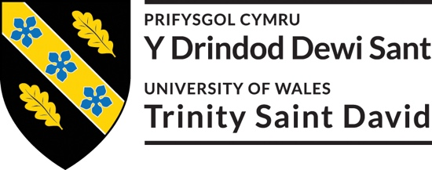
Rhif Adnabod Cyfranogwr:
Participant Identification Number:
FFURFLEN GANIATÂD CYFRANOGIAD | SAMPLE PARTICIPANT INFORMATION SHEET
Project Title: Impact of Social Media Marketing on Consumer Engagement: A Case Study of Gymshark

Dear Sir/Madam,

My name is Adelina Camelia Perva and I am a student in the School of Business, and Management (London Campus), Faculty of Business and Management in University of Wales Trinity Saint David, United Kingdom. At present, I am conducting a research on Impact of Social Media Marketing on Consumer Engagement: A Case Study of Gymshark The purpose of this research is to understand the influence of Gymshark’s social media marketing on consumer engagement and loyalty.

I would like to invite you to participate in my research project by answering the attached short questions developed by the researchers. Those questions will assess your opinions, experiences, knowledge, suggestions and views. Through your participation in the interviews, I hope to ascertain my research purpose to get the best opinion from you. I believe your opinion will be extremely helpful to me to carry out this research.

All questions will be kept strictly confidential to the researchers involved and at NO time will individual questions will be released to the general public. This gives you a chance to express your views on your programme a confidential and anonymous forum and still be able to make a difference. Your participation in this study is completely voluntary so you can withdraw from the questionnaire at any stage.

Please note, questionnaire should take no more than 30 minutes to complete but however, there is no time constraint. There are also no right or wrong answers. Attached to this letter along with the questionnaire there is a consent form where you will better understand researchers intension As this is a new project, your feedback is also important to me and I would be much obliged if you could also complete the feedback sheet along with the questionnaire. I understand that your time is at a premium, but your opinions are very valuable to me.
After careful and precise analysis of the data obtained from this questionnaires/interviews, I will be happy to provide you with a copy of the findings at your request. The results of this questionnaire will hopefully enhance my understanding of current level of knowledge and future findings. The results of the research will be feedback to Director of Studies, Supervisor, University and British Library.

I thank you in advance for your time and participation. If any questions do arise, feel free to contact me at your convenience.

NAME & ADDRESS OF RESEARCHER
Adelina Camelia Perva
University of Wales Trinity Saint David (London Campus)
Winchester House
11 Cranmer Road
London – SW9 6EJ
Tel: +442075667600
Email: info.london@tsd.ac.uk
londonstudentservice@tsd.ac.uk

Appendix Four: Google Form
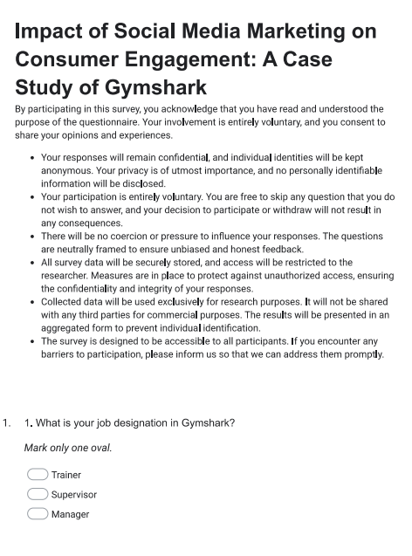
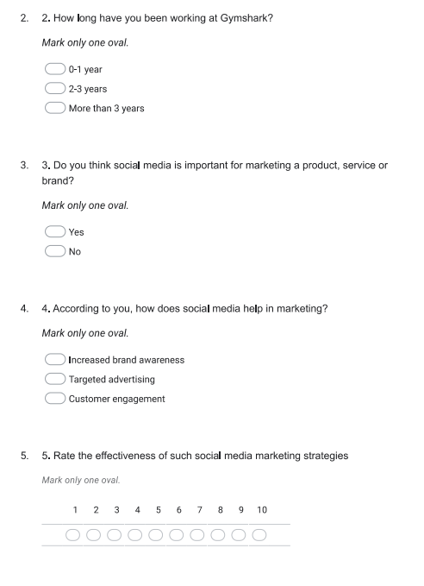

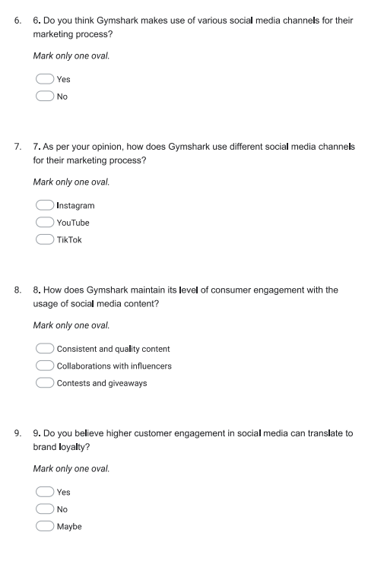
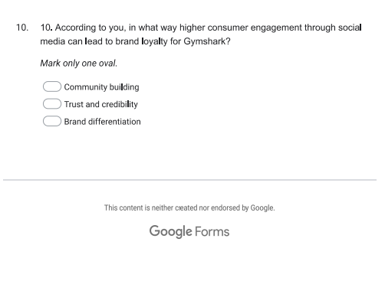

Appendix Five: Participation Consent Form
Participation Consent Form
University of Wales Trinity Saint David (London Campus)
Winchester House
11 Cranmer Road
London – SW9 6EJ
Tel: +442075667600
Email: info.london@uwtsd.ac.uk
londonstudentservice@uwtsd.ac.uk

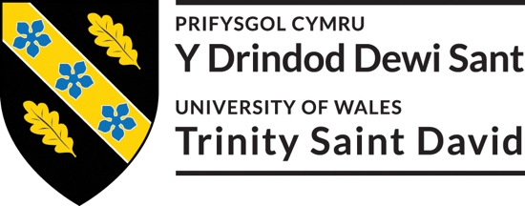

Rhif Adnabod Cyfranogwr:
Participant Identification Number:
FFURFLEN GANIATÂD CYFRANOGIAD | PARTICIPATION CONSENT FORM
Teitl Y Prosiect: / Project Title:
Impact of Social Media Marketing on Consumer Engagement: A Case Study of Gymshark
Enw'r Ymchwilydd / Name of Researcher: Adelina Perva

1 | I confirm that I have read and understand the information sheet dated _________ for the above study. I have had the opportunity to consider the information, ask questions and have had these answered satisfactorily.
2 | I understand that my participation is voluntary and that I am free to withdraw at any time, without giving any reason.
3 | I understand that any information given by me may be used in future reports, articles or presentations by the research team.
4 | I understand that my name will not appear in any reports, articles or presentations.
5 | I agree to take part in the above study.
Name of Participant |  |  | Signature
Researcher |  | Adelina Camelia Perva | Signature  

You may decline to participate in this study. You may end your participation in this study at any time. If you decide to remain anonymous, maintaining your anonymity will be a priority and every practical precaution will be taken to disguise your identity. If you prefer anonymity, there will not be any identifying information on audiotapes or transcripts of this or any interview. No one will hear any audiotapes or see any transcripts without your prior consent. All materials generated from this or any interview will remain confidential.
When completed please return in the envelope provided. One copy will be given to you and the original to be kept on the file of the research team at:

NAME & ADDRESS OF RESEARCHER

University of Wales Trinity Saint David (London Campus)
Winchester House
11 Cranmer Road
London – SW9 6EJ
Tel: +442075667600
Email: info.london@uwtsd.ac.uk
: londonstudentservice@uwtsd.ac.uk

Appendix Six: Application for Ethical Approval
APPLICATION FOR ETHICAL APPROVAL

In order for research to result in benefit and minimise risk of harm, it must be conducted ethically. A researcher may not be covered by the University’s insurance if ethical approval has not been obtained prior to commencement.

The University follows the OECD Frascati manual definition of research activity: “creative work undertaken on a systematic basis in order to increase the stock of knowledge, including knowledge of man, culture and society, and the use of this stock of knowledge to devise new applications”. As such this covers activities undertaken by members of staff, postgraduate research students, and both taught postgraduate and undergraduate students working on dissertations/projects.

The individual undertaking the research activity is known as the “principal researcher”.

Ethical approval is not required for routine audits, performance reviews, quality assurance studies, testing within normal educational requirements, and literary or artistic criticism.

Please read the notes for guidance before completing ALL sections of the form.

This form must be completed and approved prior to undertaking any research activity. Please see Checklist for details of process for different categories of application.

SECTION A: About You (Principal Researcher)
1 | Full Name: |  | Adelina Camelia Perva
2 | Tick all boxes that apply: |  | Member of staff: | ☐ | Honorary research fellow: | ☐
 | Undergraduate Student | ☒ | Taught Postgraduate Student | ☐ | Postgraduate Research Student | ☐

3 | Institute/Academic Discipline/Centre: | University of Wales Trinity Saint David
4 | Campus: | London, SW9 6EJ
5 | E-mail address: | Londonreception@uwtsd.ac.uk
6 | Contact Telephone Number: | (0044) 270 127 7400
 | For students:
7 | Student Number: | 2020310
8 | Programme of Study: | BA-Business Management
9 | Director of Studies/Supervisor: | Dudley Ofori

SECTION B: Approval for Research Activity
1 | Has the research activity received approval in principle?  (please check the Guidance Notes as to the appropriate approval process for different levels of research by different categories of individual) |  | YES | ☒ | NO | ☐
 |  |  |  |  | Date
2 | If Yes, please indicate source of approval (and date where known): Approval in principle must be obtained from the relevant source prior to seeking ethical approval | Research Degrees Committee |  | ☒
2 |  | Institute Research Committee |  | ☐
2 |  | Other (write in) |  | ☐

SECTION C: Internal and External Ethical Guidance Materials
 | Please list the core ethical guidance documents that have been referred to during the completion of this form (including any discipline-specific codes of research ethics, location-specific codes of research ethics, and also any specific ethical guidance relating to the proposed methodology). Please tick to confirm that your research proposal adheres to these codes and guidelines. You may add rows to this table if needed.
1 | UWTSD Research Ethics & Integrity Code of Practice | ☒
2 | UWTSD Research Data Management Policy | ☐
3 | [List any other relevant documents here] | ☐

SECTION D: External Collaborative Research Activity
If there are external collaborators then you should gain consent from the contact persons to share their personal data with the university. If there are no external collaborators then leave this section blank and continue to section E.
1 | Institution
2 | Contact person name
3 | Contact person e-mail address
4 | Is your research externally funded? |  | YES | ☐ | NO |  | ☒
5 | Are you in receipt of a KESS scholarship? |  | YES | ☐ | NO |  | ☒
6 | Are you specifically employed to undertake this research in either a paid or voluntary capacity? | Voluntary | YES | ☒ | NO | ☐
7 |  | Employed | YES | ☐ | NO | ☒
8 | Is the research being undertaken within an existing UWTSD Athrofa Professional Learning Partnership (APLP)? | If YES then the permission question below does not need to be answered. | YES | ☐ | NO |  | ☒
9 | Has permission to undertake the research has been provided by the partner organisation? | (If YES attach copy)  If NO the application cannot continue | YES | ☐ | NO |  | ☒

Where research activity is carried out in collaboration with an external organisation
10 | Does this organisation have its own ethics approval system? | YES | ☐ | NO | ☐
 | If Yes, please attach a copy of any final approval (or interim approval) from the organisation (this may be a copy of an email if appropriate).

SECTION E: Details of Research Activity
1 | Indicative title: | Impact of Social Media Marketing on Consumer Engagement: A Case Study of Gymshark
2 | Proposed start date: | 01 September 2023 | Proposed end date: | 27 December 2023
Introduction to the Research (maximum 300 words per section)
Ensure that you write for a Non-Specialist Audience when outlining your response to the points below:
- Purpose of Research Activity
- Proposed Research Question
- Aims of Research Activity
- Objectives of Research Activity
Demonstrate, briefly, how Existing Research has informed the proposed activity and explain
- What the research activity will add to the body of knowledge
- How it addresses an area of importance.
3 | Purpose of Research Activity  The purpose of this research would be to understand the influence of Gymshark’s social media marketing on consumer engagement and loyalty.
4 | Research Question  1. How does Gymshark utilise different social media platforms for their marketing strategies?  2. Level of consumer engagement with Gymshark’s social media content?  3. Can consumer engagement on social media translate into brand loyalty for Gymshark?
5 | Aims of Research Activity  The proposed aim of this research would be to understand the influence of Gymshark’s social media marketing on consumer engagement and loyalty.
6 | Objectives of Research Activity  1. To Analyse Gymshark’s social media marketing strategies.  2. To analyse GymSharks content types, frequency of posting the platforms that are utilized and its effectiveness.  3. To assess the level of consumer engagement with Gymshark’s social media content
7 | Proposed methods (maximum 600 words)  The research methodology section is the most important part of the research chapter as a whole. Methodically, it directs the research through its many stages, acting as its backbone. The complexities of the research process are laid out in this chapter, which provides a structured way to go through the study. The researcher uses Saunders' onion model, a well-known tool for its effectiveness and organisational prowess, to highlight the importance of this methodology. The phases undertaken by the researcher to culminate the study are concisely but comprehensively outlined in the following parts

10 | Use of documentation not in the public domain: Are any documents NOT publicly available? | NO | ☒
10 |  | YES | ☐
11 | If Yes, please provide details here of how you will gain access to specific documentation that is not in the public domain and that this is in accordance with the current data protection law of the country in question and that of England and Wales.

 | Does your research relate to one or more of the seven aims of the Well-being of Future Generations (Wales) Act 2015? | YES | NO
12 | A prosperous Wales | ☐ | ☒
13 | A resilient Wales | ☐ | ☒
14 | A healthier Wales | ☐ | ☒
15 | A more equal Wales | ☐ | ☒
16 | A Wales of cohesive communities | ☐ | ☒
17 | A Wales of vibrant culture and thriving Welsh language | ☐ | ☒
18 | A globally responsible Wales | ☐ | ☒
19 | If YES to any of the above, please give details:

SECTION F: Scope of Research Activity
 | Will the research activity include: | YES | NO
1 | Use of a questionnaire or similar research instrument? | ☒ | ☐
2 | Use of interviews? | ☐ | ☒
3 | Use of focus groups? | ☒ | ☐
4 | Use of participant diaries? | ☐ | ☒
5 | Use of video or audio recording? | ☐ | ☒
6 | Use of computer-generated log files? | ☒ | ☐
7 | Participant observation with their knowledge? | ☒ | ☐
8 | Participant observation without their knowledge? | ☐ | ☒
9 | Access to personal or confidential information without the participants’ specific consent? | ☐ | ☒
10 | Administration of any questions, test stimuli, presentation that may be experienced as physically, mentally or emotionally harmful / offensive? | ☐ | ☒
11 | Performance of any acts which may cause embarrassment or affect self-esteem? | ☐ | ☒
12 | Investigation of participants involved in illegal activities? | ☐ | ☒
13 | Use of procedures that involve deception? | ☐ | ☒
14 | Administration of any substance, agent or placebo? | ☐ | ☒
15 | Working with live vertebrate animals? | ☐ | ☒
16 | Procedures that may have a negative impact on the environment? | ☐ | ☒
17 | Other primary data collection methods. Please indicate the type of data collection method(s) below. | ☐ | ☒
 | Details of any other primary data collection method: | ☐ | ☒
If NO to every question, then the research activity is (ethically) low risk and may be exempt from some of the following sections (please refer to Guidance Notes).

If YES to any question, then no research activity should be undertaken until full ethical approval has been obtained.

SECTION G: Intended Participants
If there are no participants then do not complete this section, but go directly to section H.

 | Who are the intended participants: | YES | NO
1 | Students or staff at the University? | ☐ | ☒
2 | Adults (over the age of 18 and competent to give consent)? | ☒ | ☐
3 | Vulnerable adults? | ☒ | ☐
4 | Children and Young People under the age of 18? (Consent from Parent, Carer or Guardian will be required) | ☐ | ☒
5 | Prisoners? | ☐ | ☒
6 | Young offenders? | ☐ | ☒
7 | Those who could be considered to have a particularly dependent relationship with the investigator or a gatekeeper? | ☐ | ☒
8 | People engaged in illegal activities? | ☐ | ☒
9 | Others. Please indicate the participants below, and specifically any group who may be unable to give consent. | ☐ | ☒
 | Details of any other participant groups: | ☐ | ☒

Participant numbers and source
Provide an estimate of the expected number of participants. How will you identify participants and how will they be recruited?
10 | How many participants are expected? | 20
11 | Who will the participants be? | Employees of Gymshark
12 | How will you identify the participants? | Randomly

 | Information for participants: | YES | NO | N/A
13 | Will you describe the main research procedures to participants in advance, so that they are informed about what to expect? | ☒ | ☐ | ☐
14 | Will you tell participants that their participation is voluntary? | ☒ | ☐ | ☐
15 | Will you obtain written consent for participation? | ☒ | ☐ | ☐
16 | Will you explain to participants that refusal to participate in the research will not affect their treatment or education (if relevant)? | ☒ | ☐ | ☐
17 | If the research is observational, will you ask participants for their consent to being observed? | ☐ | ☒ | ☒
18 | Will you tell participants that they may withdraw from the research at any time and for any reason? | ☐ | ☐ | ☒
19 | With questionnaires, will you give participants the option of omitting questions they do not want to answer? | ☐ | ☒ | ☐
20 | Will you tell participants that their data will be treated with full confidentiality and that, if published, it will not be identifiable as theirs? | ☒ | ☐ | ☐
21 | Will you debrief participants at the end of their participation, in a way appropriate to the type of research undertaken? | ☒ | ☐ | ☐
22 | If NO to any of above questions, please give an explanation

 | Information for participants: | YES | NO | N/A
24 | Will participants be paid? | ☐ | ☒ | ☐
25 | Is specialist electrical or other equipment to be used with participants? | ☐ | ☒ | ☐
26 | Are there any financial or other interests to the investigator or University arising from this study? | ☐ | ☒ | ☐
27 | Will the research activity involve deliberately misleading participants in any way, or the partial or full concealment of the specific study aims? | ☐ | ☒ | ☐
28 | If YES to any question, please provide full details

SECTION H: Anticipated Risks

Outline any anticipated risks that may adversely affect any of the participants, the researchers and/or the University, and the steps that will be taken to address them.

If you have completed a full risk assessment (for example as required by a laboratory, or external research collaborator) you may append that to this form.
1 | Full risk assessment completed and appended? |  | Yes | ☒
1 |  |  | No | ☐
2 | Risks to participants  For example: sector-specific health & safety, emotional distress, financial disclosure, physical harm, transfer of personal data, sensitive organisational information
 | Risk to participants:  (this box should expand as you type) | How you will mitigate the risk to participants:  (this box should expand as you type)
3 | If research activity may include sensitive, embarrassing or upsetting topics (e.g. sexual activity, drug use) or issues likely to disclose information requiring further action (e.g. criminal activity), give details of the procedures to deal with these issues, including any support/advice (e.g. helpline numbers) to be offered to participants. Note that where applicable, consent procedures should make it clear that if something potentially or actually illegal is discovered in the course of a project, it may need to be disclosed to the proper authorities
 | (this box should expand as you type)
4 | Risks to the investigator  For example: personal health & safety, physical harm, emotional distress, risk of accusation of harm/impropriety, conflict of interest
 | Risk to the investigator:  (this box should expand as you type) | How you will mitigate the risk to the investigator:  (this box should expand as you type)
5 | University/institutional risks  For example: adverse publicity, financial loss, data protection
 | Risk to the University:  (this box should expand as you type) | How you will mitigate the risk to the University:  (this box should expand as you type)
6 | Environmental risks  For example: accidental spillage of pollutants, damage to local ecosystems
 | Risk to the environment:  (this box should expand as you type) | How you will mitigate the risk to environment:  (this box should expand as you type)

 | Disclosure and Barring Service
 | If the research activity involves children or vulnerable adults, a Disclosure and Barring Service (DBS) certificate must be obtained before any contact with such participants. | YES | NO | N/A
7 | Does your research require you to hold a current DBS Certificate? | ☐ | ☒ | ☐
8 | If YES, please give the certificate number. If the certificate number is not available please write “Pending”; in this case any ethical approval will be subject to providing the appropriate certificate number.

SECTION I: Feedback, Consent and Confidentiality

1 | Feedback  What de-briefing and feedback will be provided to participants, how will this be done and when?
The outcome of the research will be emailed to the participants if they want initially while participating in the research.
(this box should expand as you type)
2 | Informed consent  Describe the arrangements to inform potential participants, before providing consent, of what is involved in participating. Describe the arrangements for participants to provide full consent before data collection begins. If gaining consent in this way is inappropriate, explain how consent will be obtained and recorded in accordance with prevailing data protection legislation.
The consent of the participants will be collected by the informed consent form.
(this box should expand as you type)
3 | Confidentiality / Anonymity  Set out how anonymity of participants and confidentiality will be ensured in any outputs. If anonymity is not being offered, explain why this is the case.
The data of the participants will be confidential and will not be published in any circumstances.
(this box should expand as you type)

SECTION J: Data Protection and Storage

 | Does the research activity involve personal data (as defined by the General Data Protection Regulation 2016 “GDPR” and the Data Protection Act 2018 “DPA”)? | YES | NO
1 | “Personal data” means any information relating to an identified or identifiable natural person (‘data subject’). An identifiable natural person is one who can be identified, directly or indirectly, in particular by reference to an identifier such as a name, an identification number, location data, an online identifier or to one or more factors specific to the physical, physiological, genetic, mental, economic, cultural or social identity of that natural person. Any video or audio recordings of participants is considered to be personal data. | ☐ | √
 | If YES, provide a description of the data and explain why this data needs to be collected:
2 | (this box should expand as you type)
 | Does it involve special category data (as defined by the GDPR)? | YES | NO
3 | “Special category data” means sensitive personal data consisting of information as to the data subjects’ –  (a) racial or ethnic origin,  (b) political opinions,  (c ) religious beliefs or other beliefs of a similar nature,  (d) membership of a trade union (within the meaning of the Trade Union and Labour Relations (Consolidation) Act 1992),  (e) physical or mental health or condition,  (f) sexual life,  (g) genetics,  (h) biometric data (as used for ID purposes), | ☐ | √
 | If YES, provide a description of the special category data and explain why this data needs to be collected:
4 | (this box should expand as you type)

 | Will data from the research activity (collected data, drafts of the thesis, or materials for publication) be stored in any of the following ways? | YES | NO
5 | Manual files (i.e. in paper form)? | ☐ | ☒
6 | University computers? | ☐ | ☒
7 | Private company computers? | ☐ | ☒
8 | Home or other personal computers? | ☐ | ☒
9 | Laptop computers/ CDs/ Portable disk-drives/ memory sticks? | ☒ | ☐
10 | “Cloud” storage or websites? | ☐ | ☒
11 | Other – specify: | ☐ | ☒
12 | For all stored data, explain the measures in place to ensure the security of the data collected, data confidentiality, including details of backup procedures, password protection, encryption, anonymisation and pseudonymisation:
The data will be stored in a password protected laptop of the researcher and after 6 months of the completion of the research, the data will be deleted.

(this box should expand as you type)

 | Data Protection
 | Will the research activity involve any of the following activities: | YES | NO
13 | Electronic transfer of data in any form? | ☒ | ☐
14 | Sharing of data with others at the University outside of the immediate research team? | ☐ | ☒
15 | Sharing of data with other organisations? | ☐ | ☒
16 | Export of data outside the UK or importing of data from outside the UK? | ☐ | ☒
17 | Use of personal addresses, postcodes, faxes, emails or telephone numbers? | ☐ | ☒
18 | Publication of data that might allow identification of individuals? | ☐ | ☒
19 | Use of data management system? | ☐ | ☒
20 | Data archiving? | ☐ | ☒
21 | If YES to any question, please provide full details, explaining how this will be conducted in accordance with the GDPR and Data Protection Act (2018) (and any international equivalents, where appropriate):
The data will be transferred from google sheet to my personal laptop in excel file.
(this box should expand as you type)
22 | List all who will have access to the data generated by the research activity:
Only the researcher.

(this box should expand as you type)
23 | List who will have control of, and act as custodian(s) for, data generated by the research activity:
The researcher will be the custodian.

(this box should expand as you type)
24 | Give details of data storage arrangements, including security measures in place to protect the data, where data will be stored, how long for, and in what form. Will data be archived – if so how and if not why not.
The data will be stored in a password protected devices which can only be accessed by the researcher.

(this box should expand as you type)
25 | Please indicate if your data will be stored in the UWTSD Research Data Repository (see https://researchdata.uwtsd.ac.uk/ ). If so please explain. (Most relevant to academic staff)
No, it will not be.

(this box should expand as you type)
26 | Confirm that you have read the UWTSD guidance on data management (see https://www.uwtsd.ac.uk/library/research-data-management/) | YES | ☒
27 | Confirm that you are aware that you need to keep all data until after your research has completed or the end of your funding | YES | ☒

SECTION K: Declaration
The information which I have provided is correct and complete to the best of my knowledge. I have attempted to identify any risks and issues related to the research activity and acknowledge my obligations and the rights of the participants.

In submitting this application I hereby confirm that I undertake to ensure that the above named research activity will meet the University’s Research Ethics and Integrity Code of Practice which is published on the website: https://www.uwtsd.ac.uk/research/research-ethics/
1 | Signature of applicant: | Adelina Camelia Perva | Date:  18 December 2023

For STUDENT Submissions:
2 | Director of Studies/Supervisor: |  | Date: 18 December 2023
3 | Signature: | Dudley Ofori | Date: 18 December 2023

For STAFF Submissions:
4 | Academic Director/ Assistant Dean: |  | Date:18 December 2023
5 | Signature: | Anupam Mazumdar | Date:18 December 2023

Checklist: Please complete the checklist below to ensure that you have completed the form according to the guidelines and attached any required documentation:
☒ | I have read the guidance notes supplied before completing the form.
☒ | I have completed ALL RELEVANT sections of the form in full.
☒ | I confirm that the research activity has received approval in principle
☒ | I have attached a copy of final/interim approval from external organisation (where appropriate)
☒ | I have attached a full risk assessment (where appropriate) ONLY TICK IF YOU HAVE ATTACHED A FULL RISK ASSESSMENT
☒ | I understand that it is my responsibility to ensure that the above named research activity will meet the University’s Research Ethics and Integrity Code of Practice.
☒ | I understand that before commencing data collection all documents aimed at respondents (including information sheets, consent forms, questionnaires, interview schedules etc.) must be confirmed by the DoS/Supervisor, module tutor or Academic Director.

RESEARCH STUDENTS AND STAFF ONLY
All communications relating to this application during its processing must be in writing and emailed to pgresearch@uwtsd.ac.uk , with the title ‘Ethical Approval’ followed by your name.
You will be informed of the outcome of your claim by email; therefore it is important that you check your University and personal email accounts regularly.
STUDENTS ON UNDERGRADUATE OR TAUGHT MASTERS PROGRAMMES should submit this form (and receive the outcome) via systems explained to you by the supervisor/module leader.

This form is available electronically from the Academic Office web pages: https://www.uwtsd.ac.uk/academic-office/appendices-and-forms/

