DS 1 Template

My Screenshots/Photos
- Please add 4–6 screenshots or photos of your digital life.
- You can use your phone or laptop.
- For each screenshot, write one or two sentences explaining what it shows.

Screenshot/Photo 1
[Insert Photo/Screenshot below]
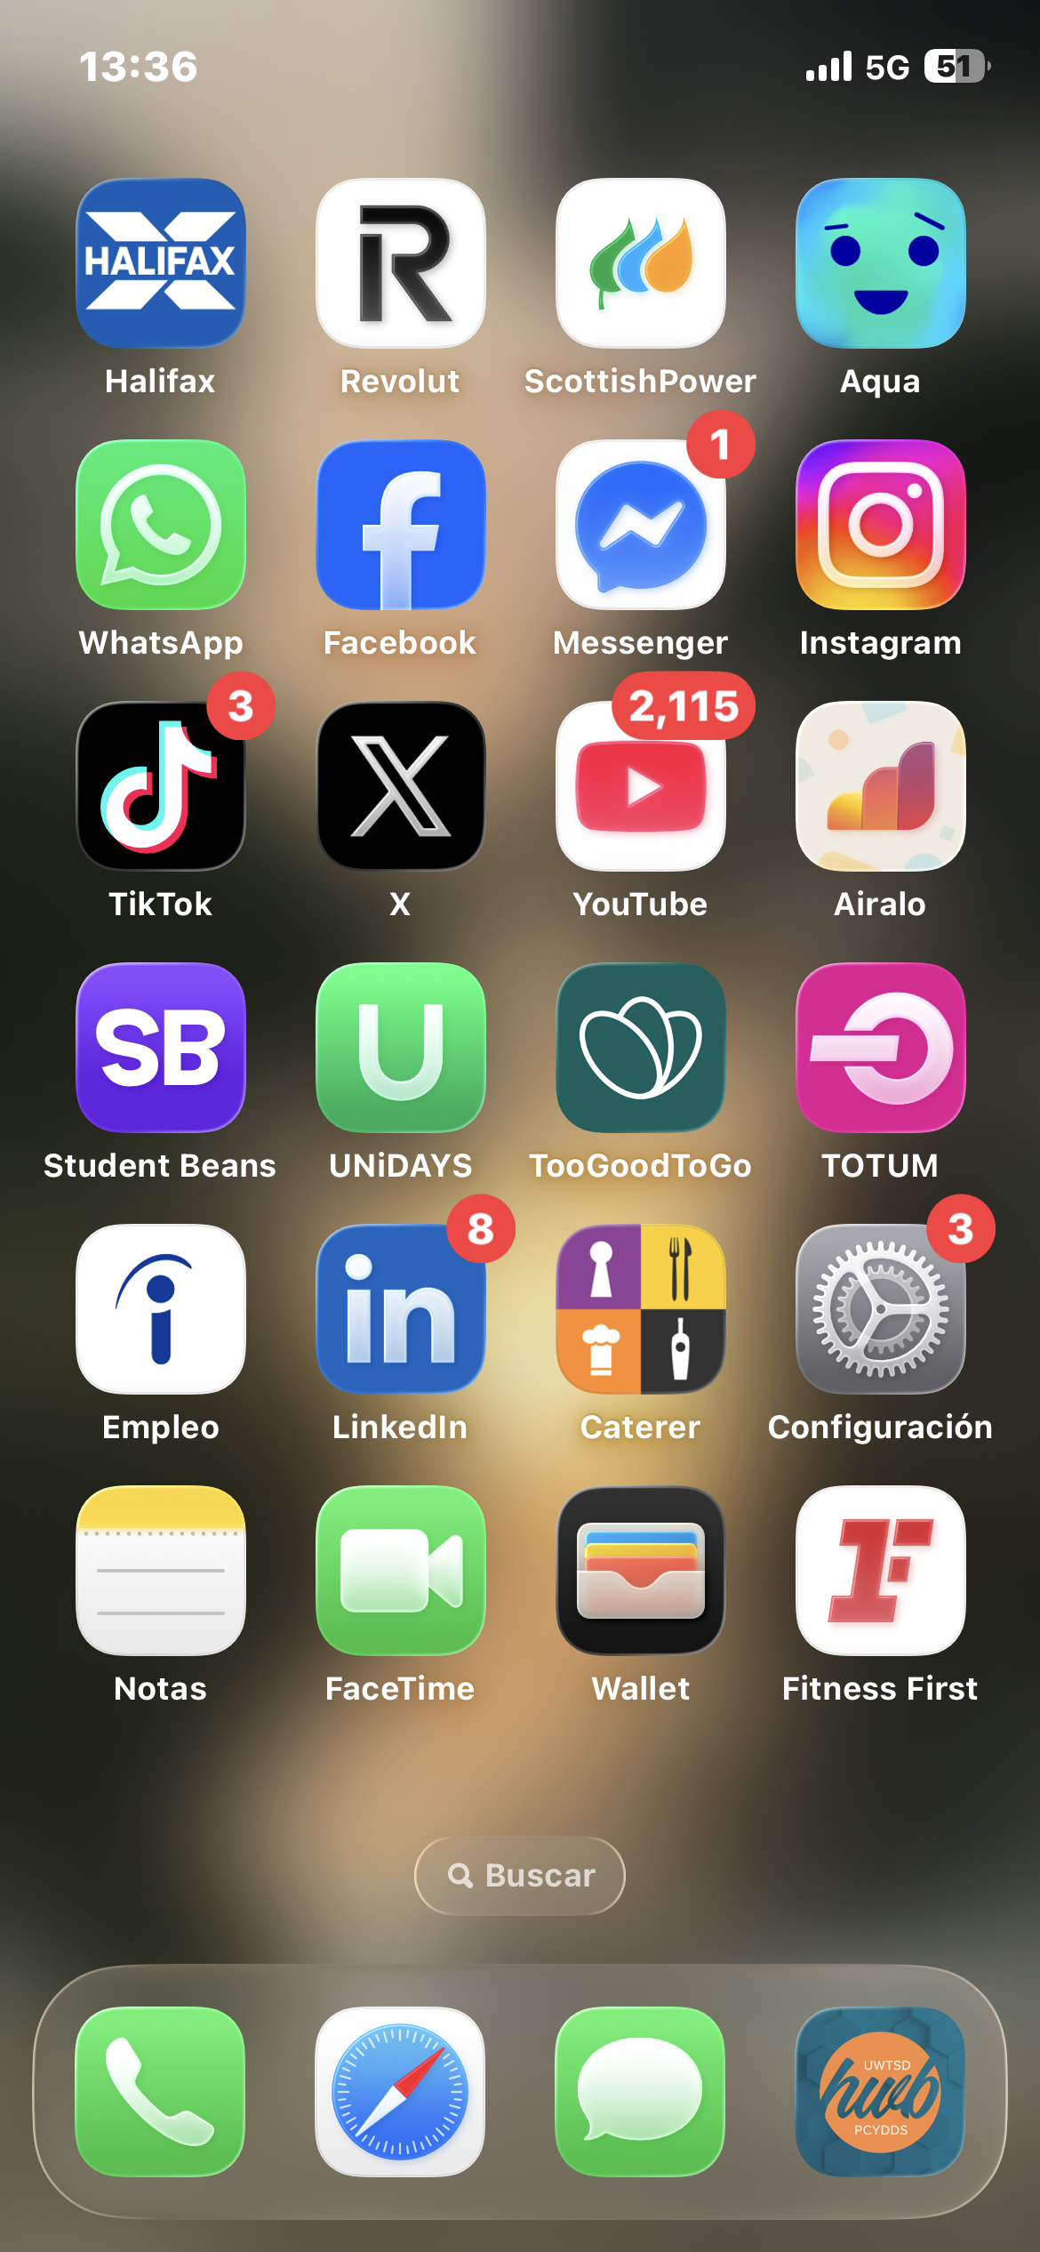
This Screenshot shows the apps I use to communicate and get information.

Screenshot/Photo 2
[Insert Photo/Screenshot below]
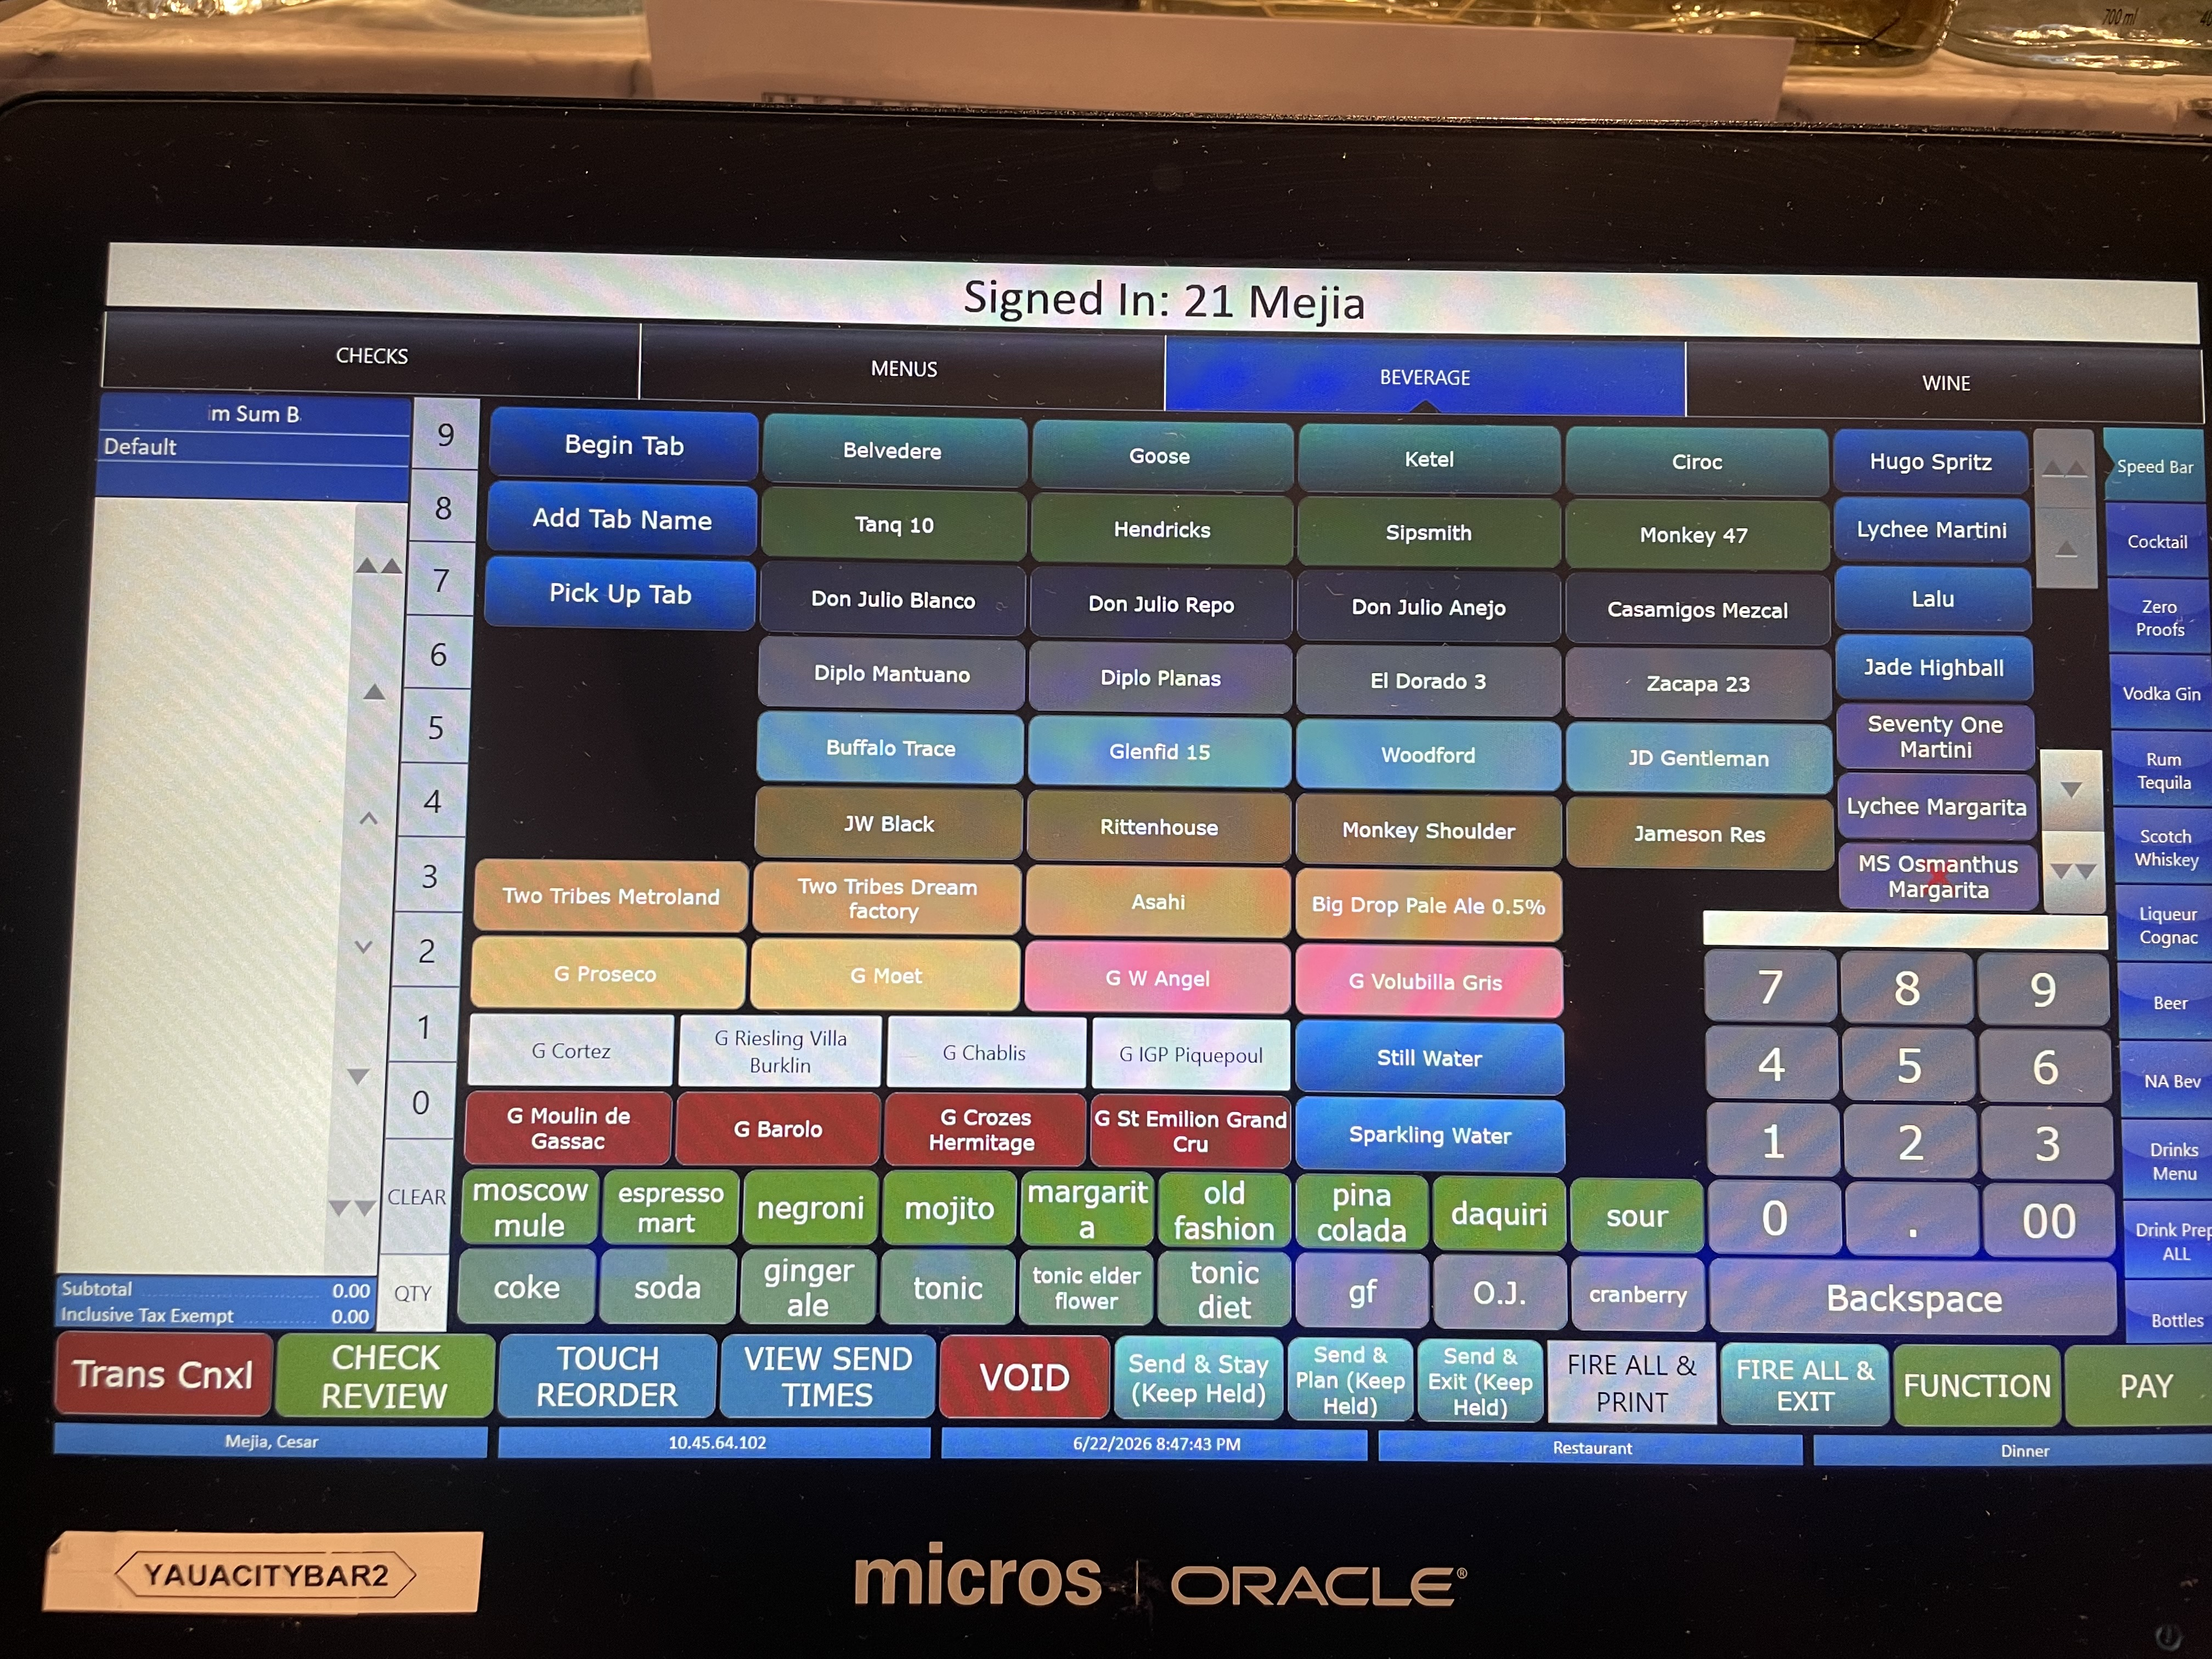
In this Photo I show the screen of the till and the system that I use to send the orders in my workplace.

Screenshot/Photo 3
[Insert Photo/Screenshot below

Screenshot/Photo 4
[Insert Photo/Screenshot below]
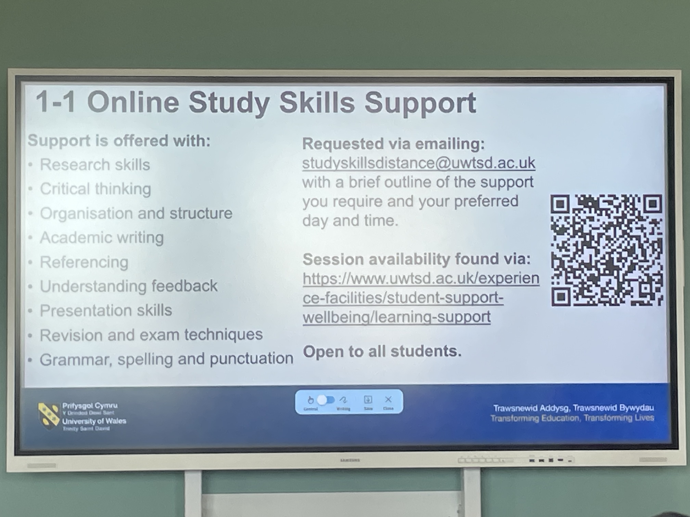
A screen that I use in class to read important information provided by the lecture.

Screenshot/Photo 5
[Insert Photo/Screenshot below]
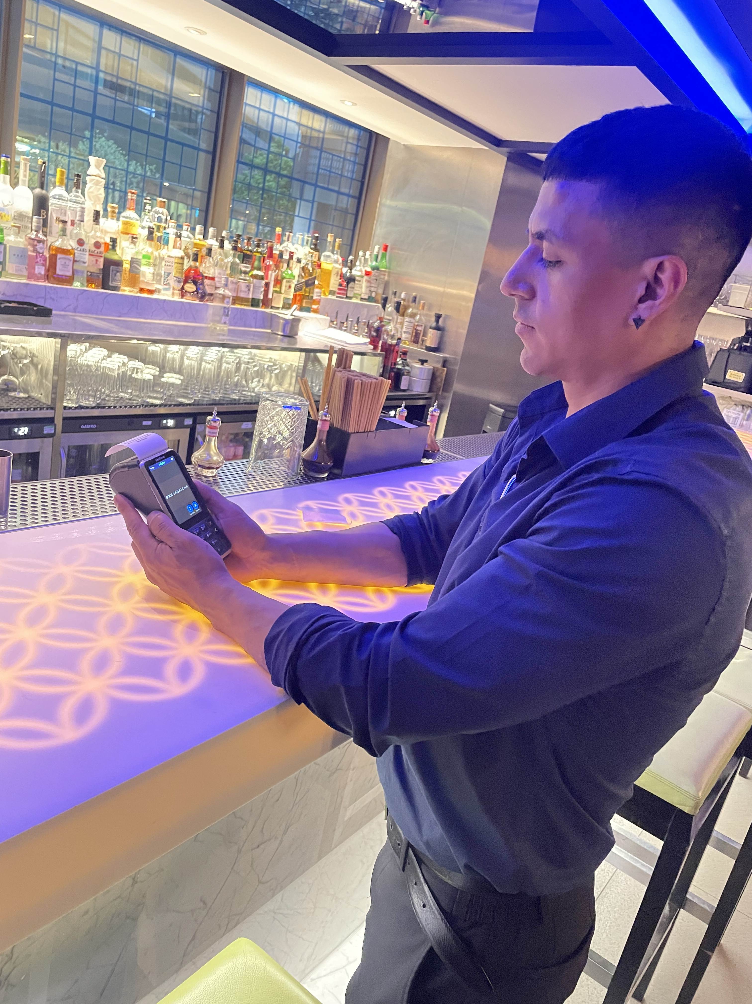
In this Photo I’m using a PDQ machine to take a payment from a costumer.

Screenshot/Photo 6
[Insert Photo/Screenshot below]
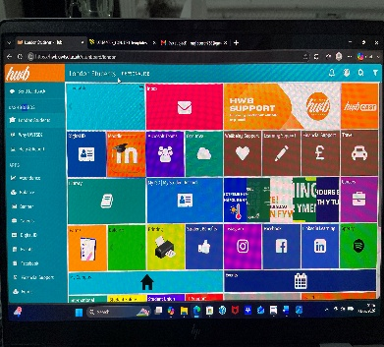
The hub App from the UWSTD this app I use to submit my assessments and study from the modules.

My Short Reflection
- Write 5–8 simple sentences about your digital life.
- You can use the sentence starters below if helpful.
I feel confident when I’m using digital devices it helps to save time and make live more easy.

Sentence starters
- I use digital tools to …
- I feel confident when I …
- I want to improve …
- I often use these tools: …
- I sometimes feel nervous about …
- I hope this module will help me …
- Digital skills are important for me because …
You can write more if you want.

Submission Checklist
Before you submit, please check:
​​​ ☒ I added 4–6 screenshots
☒ I wrote short sentences for each screenshot
☒ I wrote my short reflection
☒ My work is my own
☒ My file opens correctly
​​☒ My file opens correctly

