

LOCATION: Swansea | LLEOLIAD: abertawe
LEVEL 4 | LEFEL 4
EXAMINATION PERIOD | CYFNOD ARHOLIADAU
may 2020 | mai 2020

MODULE CODE: ACDB4002 & ACDA4006
Electrical and Electronic Principles
TIME: 2 HOURS + 30 mins upload time
answer all questions

Equipment or materials required – Calculator, Graph paper
Adnoddau neu ddefnyddiau sydd eu hangen – cyfrifiannell, papur graff

Formula sheet and graph paper are after questions

Detach graph paper and place in your Answer book write your student number and question number on any graph paper used

you will have 30 mins following the exam to photograph and upload your answers. your answers can be handwritten and do not have to be typed.

ANSWER ALL QUESTIONS

- An oscilloscope display shows the above voltage waveform. The oscilloscope settings are shown in the box next to the waveform.

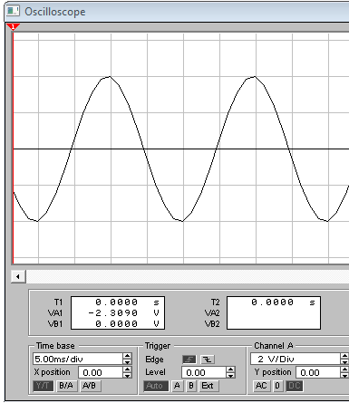
Oscilloscope settings:
5V/div
25ms/div

- Estimate the period of the waveform
[1 Mark]
4 div x 25 ms/div = 100 ms
- From the estimated period, determine its frequency
[1 Mark]
f = 1/t = 1/0.1 = 10 Hz
- Determine its peak to peak amplitude
[1 Mark]
Vpk-pk = 4 div x 5 V = 20 V
- Determine the RMS value of the waveform
[2 Marks]
VRMS = Vpk x 0.7071 = 20/2 x 0.7071 = 7.071 V

- The discharging equation for a series resistor/capacitor network is given by:
$$V_{C}=V_{0}\left(e^{{-t}/τ}\right)$$
Where V_{c} is the voltage across the capacitor and V₀ is the initial capacitor voltage.
Assuming the following: R = 80k, C = 10µF and V₀ = 10V:
- Calculate V_{c} at time t = 1.6 seconds.
[3 Marks]
$$τ=RC$$
$$τ=80×{10}^{3}×10×{10}^{-6}=0.8 Seconds$$
$$V_{C}=V_{0}\left(e^{{-t}/τ}\right)$$
$$V_{C}=10\left(e^{{-1.6}/{0.8}}\right)=1.353 V$$

- Sketch a labelled graph that would represent the discharging curve.
[5 Marks]

t (seconds) | Vc Volts
0 | 10
0.8 | 3.679
1.6 | 1.353
2.4 | 0.498
3.2 | 0.183
4.0 | 0.067

- What is the stored energy within the capacitor before it is discharged?
[3 Marks]
$$E=\frac{1}{2}CV^{2}$$
$$E=\frac{1}{2}×10×{10}^{-6}×{10}^{2}=500×{10}^{-6}J$$

- Calculate the time taken for the stored energy within the capacitor to reach 0.1mJ
[4 Marks]

$$E=\frac{1}{2}CV^{2}$$

$$V=\sqrt{\frac{E}{\frac{1}{2}C}}=\sqrt{\frac{0.1×{10}^{-3}}{\frac{1}{2}10×{10}^{-6}}}=4.4721 V$$

$$V_{C}=V_{0}\left(e^{{-t}/τ}\right)$$
$$-\ln\left(\frac{V_{C}}{V_{O}}\right)×τ=t$$
$$-\ln\left(\frac{4.4721}{10}\right)×0.8=0.64378 Seconds$$

- Design a logic circuit to fulfil the behaviour shown in the truth table in Fig Q3.
[7 Marks]
A | B | C | X
0 | 0 | 0 | 1
0 | 0 | 1 | 0
0 | 1 | 0 | 1
0 | 1 | 1 | 1
1 | 0 | 0 | 1
1 | 0 | 1 | 0
1 | 1 | 0 | 0
1 | 1 | 1 | 1

Fig Q3

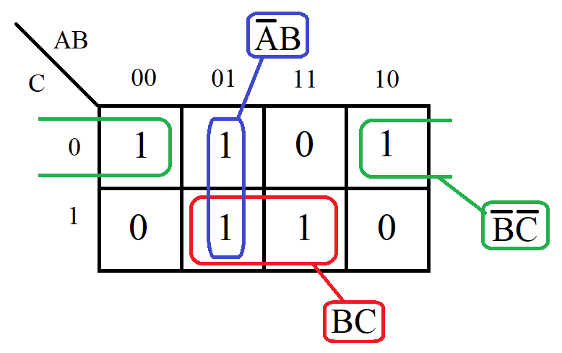
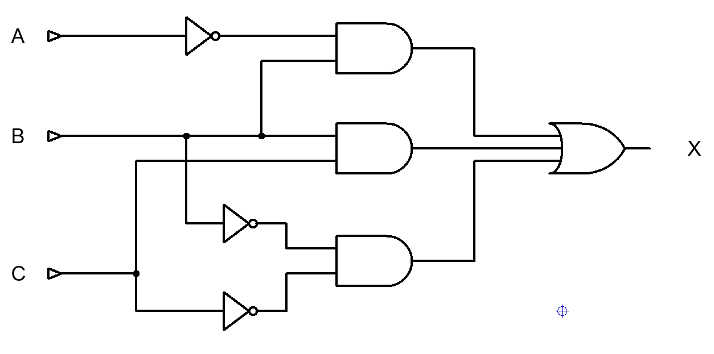

- For the circuit shown in Fig Q4. Determine the following:
  - Total circuit resistance
[4 Marks]
$$\frac{1}{R_{T}}=\frac{1}{R_{1}}+\frac{1}{R_{2}}+…+\frac{1}{R_{n}}$$
$$R_{T}=\frac{1}{\frac{1}{4000+2000}+\frac{1}{2000+1000}}=2 kΩ$$

  - Total circuit current
[2 Marks]
$$I=\frac{V}{R}=\frac{12}{2000}=6 mA$$
  - Current flowing through R4
[2 Marks]
$$I=6×{10}^{-3}×\frac{4000+2000}{4000+2000+2000+1000}=4 mA$$
  - Total power delivered by the battery
[2 Marks]
$$P=IV=6×{10}^{-3}×12=72 mW$$
  - Power dissipated by R1
[4 Marks]
$$I_{R1}=6 mA-4 mA=2 mA$$
$$P=I^{2}R={2×{10}^{-3}}^{2}×4×{10}^{-3}=16 mW$$
  - R4 is replaced by a wire link. What is the new circuit current?
[4 Marks]
$$\frac{1}{R_{T}}=\frac{1}{R_{1}}+\frac{1}{R_{2}}+…+\frac{1}{R_{n}}$$
$$R_{T}=\frac{1}{\frac{1}{4000+2000}+\frac{1}{2000}}=1500 Ω$$
$$I=\frac{V}{R}=\frac{12}{1500}=8 mA$$

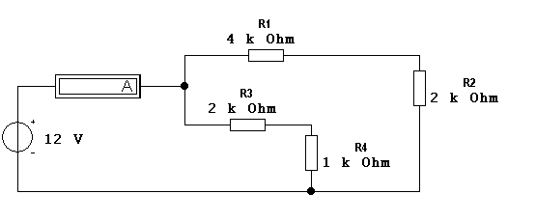
Fig. Q4

- For the circuit shown in Fig Q5, calculate the current flowing through the all resistors given V1=5V, V2=10V, R1=10Ω, R2=15Ω, R3=5Ω.
[5 Marks]
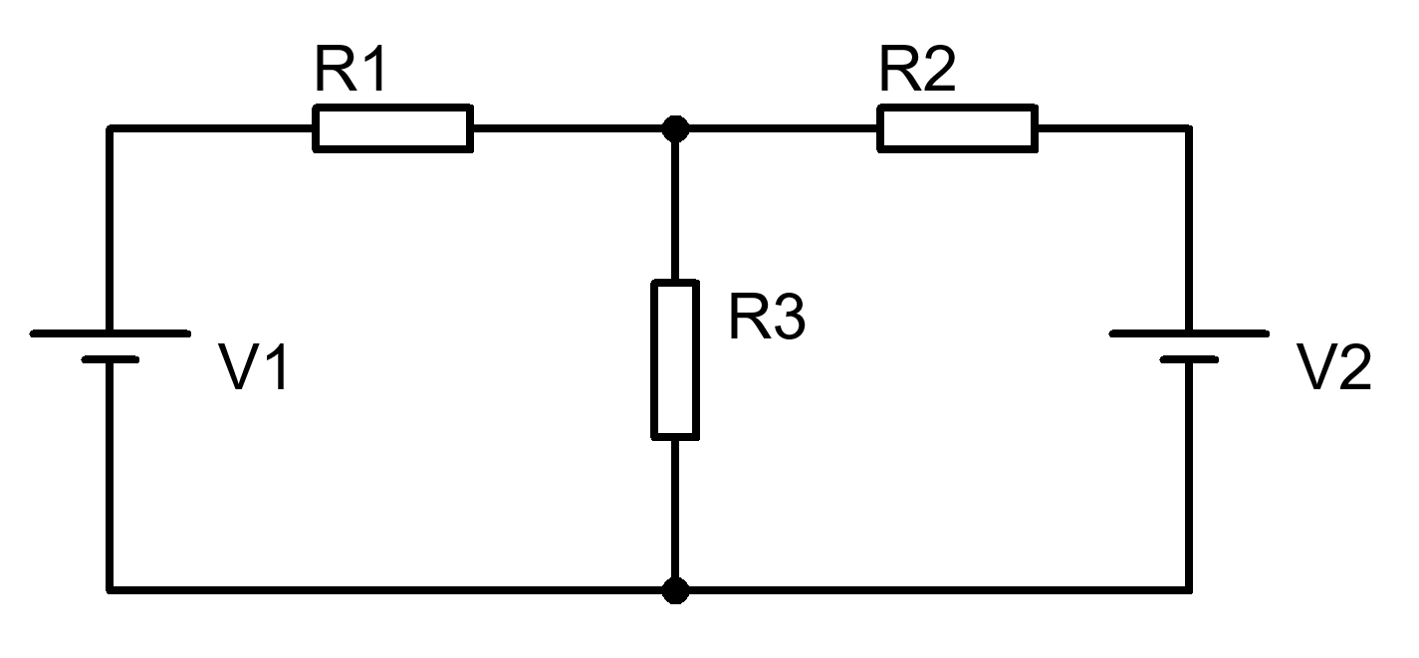

Fig. Q5

By nodal analysis:
$$I_{1}+I_{2}=I_{3}$$

$$I_{1}=\frac{{5-V}_{X}}{10}$$

$$I_{2}=\frac{10-V_{X}}{15}$$

$$I_{3}=\frac{V_{X}}{5}$$

$$\frac{V_{X}}{5}=\frac{{5-V}_{X}}{10}+\frac{10-V_{X}}{15}$$

Multiply by 15

$$3V_{X}=1.5\left(5-V_{X}\right)+10-V_{X}$$

$$3V_{X}=7.5-1.5V_{X}+10-V_{X}$$

$$5.5V_{X}=17.5$$

$$V_{X}=\frac{17.5}{5.5}=3.1818 V$$

$$I_{1}=\frac{5-3.1818}{10}=0.1818 A$$

$$I_{3}=\frac{10-3.1818}{15}=0.4545 A$$

$$I_{3}=\frac{3.1818}{5}=0.6363 A$$

Diwedd/End

Formulae Sheet
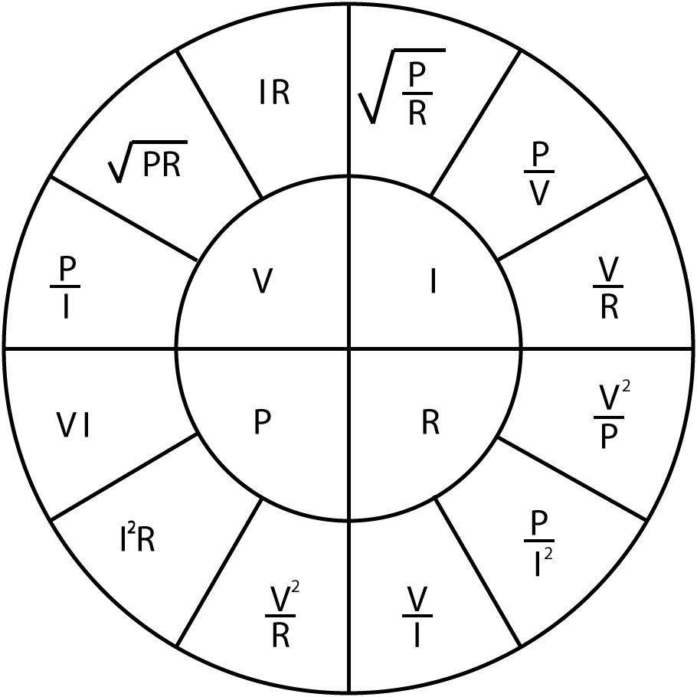 |  | $$R_{T}=R_{1}+R_{2}+…+R_{n}$$  $$\frac{1}{R_{T}}=\frac{1}{R_{1}}+\frac{1}{R_{2}}+…+\frac{1}{R_{n}}$$  $$\frac{1}{C_{T}}=\frac{1}{C_{1}}+\frac{1}{C_{2}}+…+\frac{1}{C_{n}}$$  $$C_{T}=C_{1}+C_{2}+…+C_{n}$$  $$L_{T}=L_{1}+L_{2}+…+L_{n}$$  $$\frac{1}{L_{T}}=\frac{1}{L_{1}}+\frac{1}{L_{2}}+…+\frac{1}{L_{n}}$$ | $$V_{Out}=V_{in}\frac{R_{B}}{R_{A}+R_{B}}$$  $$I=I_{in}\frac{R_{B}}{R_{A}+R_{B}}$$
$$X_{C}=\frac{1}{2πfC}$$
$$X_{C}=-j\frac{1}{ωC}$$

$$X_{L}=2πfL$$
$$X_{L}=jωL$$

$$Z=R+j\left(X_{L}-X_{C}\right)$$  $$\left|Z\right|=\sqrt{R^{2}+{\left(X_{L}-X_{C}\right)}^{2}}$$ | $$ω=2πf$$  $$X_{T}=X_{L}-X_{C}$$ | $$φ=\tan^{-1}{\frac{X_{T}}{R}}$$  $$pf=\cos{φ}$$ | $$f_{res}=\frac{1}{2π\sqrt{LC}}$$
$$V_{C}=V_{s}\left(1-e^{{-t}/τ}\right)$$  $$I_{C}=\frac{V}{R}\left(e^{{-t}/{RC}}\right)$$  $$V_{C}=V_{0}\left(e^{{-t}/τ}\right)$$  $$I_{C}=-\frac{V}{R}\left(e^{{-t}/{RC}}\right)$$  $$τ=RC$$ | $$τ=\frac{L}{R}$$  $$V_{L}=V\left(e^{{-Rt}/L}\right)$$  $$V_{L}=-V\left(e^{{-Rt}/L}\right)$$  $$I_{L}=\frac{V}{R}\left(1-e^{{-Rt}/L}\right)$$  $$I_{L}=\frac{V}{R}\left(e^{{-Rt}/L}\right)$$ | $$f=\frac{1}{2πRC}$$  $$A_{V}=20\log{\frac{V_{out}}{V_{in}}}$$  $$A_{P}=10\log{\frac{P_{out}}{P_{in}}}$$ | $$Q=\frac{X_{L}}{R}$$  $$Q=\frac{X_{C}}{R}$$  $$Q=\frac{f_{R}}{f_{U}-f_{L}}$$  $$Q=\frac{1}{R}\sqrt{\frac{L}{C}}$$
$$E=\frac{1}{2}CV^{2}$$
$$E=\frac{1}{2}LI^{2}$$
$$V_{B} \text{=}\frac{\text{RB2}}{\text{(}\text{RB}\text{1 + }\text{RB}\text{2)}}\text{×} V_{CC}$$  $$V_{E}=V_{B}-0.7$$  $$I_{C}=I_{E}$$  $$V_{C}=V_{CC}-\left(I_{C}×R_{C}\right)$$  $$Av=\frac{v_{c}}{v_{b}}$$  $$V_{E}=10\%V_{CC}$$  $$R_{IN}=\frac{1}{\frac{1}{{RB}_{1}}+\frac{1}{{RB}_{2}}+\frac{1}{\left(h_{FE}×R_{E}\right)}}$$  $$R_{OUT}=R_{C}$$  $$A_{V}≈-\frac{R_{C}}{R_{E}}$$ |  | $$V_{out}=-\frac{R2}{R1}×V_{in}$$  $$V_{out}=\left[1+\frac{R2}{R1}\right]×V_{in}$$  $$V_{out}=\frac{R2}{R1}×\left[V_{2}-V_{1}\right]$$  $$V_{out}=-\frac{R2}{R1}×\left[V_{1}+V_{2}\right]$$  $$V_{out}=-\left[\frac{R}{R1}×V_{1}+\frac{R}{R2}×V_{2}+…+\frac{R}{Rn}×V_{n}\right]$$

Detach this page and place in answer book

Student Number …………………………. Question Number ……………………….



