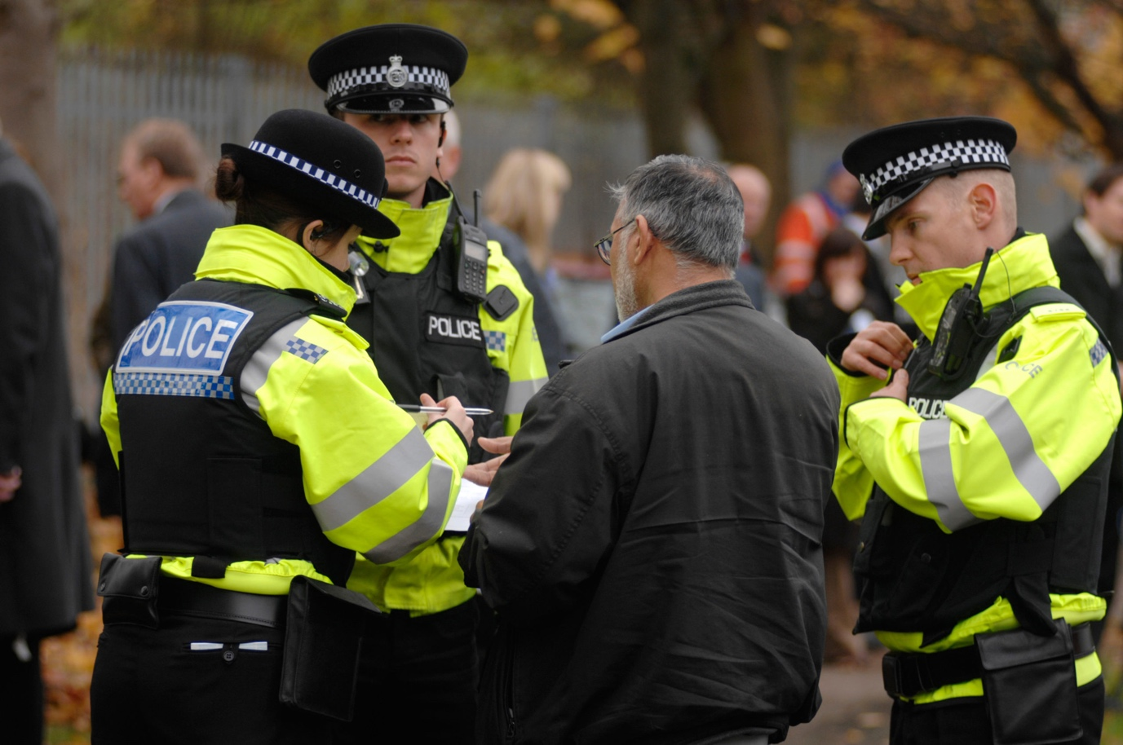

Procedural Justice
Assignment 1- Police, Policing and Society


“What is policing by consent? Critically evaluate why police and community relations are important in the Uk”

In modern society, the Police force are a crucial organisation in maintain order, and enacting justice on those who do not comply to the laws and rules of this modern era. It has been this way for hundreds of years. However, this does not diminish the importance of the people they are protecting, and how they are perceived by them. The term ‘Policing by Consent’, (Home Office, 2012), refers to “a long standing philosophy of British policing”. It directly links to Robert Peel’s 9 principles of policing, which help create an image, of how a police force should be perceived by a community. But why are good community relations important in for the police in the UK?

To answer this question, this essay will discuss and evaluate Policing foundations, what their role and purpose is, what their main goals are, and what strategies they use to uphold the law and protect the communities they serve. This essay will also be delving into Policing history, looking at early policing, and how it has developed from then to now. This essay will be looking at legal issues and their procedures, enforcement, and their liabilities, to show weaknesses within the system, and also its strengths. Policing strategies will get a closer look, to show specific developments, improvements over the years, and investigations. Also, Police administration will be investigated, to see how the organisation has changed. How policing accountability is changing, revolving around the ethics and morals behind an officer’s behaviour, and mis-behaviour. Finally, this essay will further investigate the relationship between society, what impact it makes, and how collaboration between both groups can make society safer. This essay will also use and refer to social divisions such as class, race and gender, to fully understand majority, and minority groups relationships with the police, and organisation that work together with the police.

To start off, it is important to understand the historical context of policing, and how policing has got to this point in modern society in the 21st century. Nowadays, rational choice is a well-known theory when discussing criminology, and is vital part when policing and protecting a community and upholding the law. Thomas Hobbes, an English philosopher from the 17th century, created a theory which eventually evolved into rational choice theory. The theory was called (Stanford Encyclodpedia of Philosphy, 2022) ‘social contract theory’ and was “the method of justifying political principles or arrangements by appeal to the agreement that would be made among suitably situated rational, free and equal persons”. This means a person’s morals, opinions and actions, are dependent on an agreement in the society they live in. this means based on how a community, or promises and decisions a government make, will determine whether they will conform to the rules of that society or not. This then compares with rational choice theory in criminology, as rational choice theory refers to the fact that people won’t randomly start committing a crime, and external factors such as class, racism and any kind of discrimination, and now health and living conditions can all lead to a person’s motivation act out a crime. With this information, and more modern practices of criminology, and crime reduction, we now know that human behaviour can be controlled or modified by fear of punishment. Individuals are responsible for choices, so only they can be blamed for their criminality.

Theories of crime deterrence have also been prevalent in the history of policing and criminology, and have shaped the way the criminal justice systems view on criminals and their crimes, and crime prevention. Notable classical criminology theorists in history also include Cesare Beccaria and Jeremy Bentham. These two theorists work “radicalized the understanding of crime and punishment” (West, 2017). They believed in a pain pleasure principle, insinuating crime can have a negative effect on the moral of an area and community. This then can relate back to Hobbe’s theory, as radical choice and calculation can come into it, as moral will have an effect on their decision making. Through the 18th century, theorists such as Beccaria and Bentham, believed the introduction of a legal system, like the one we have today, would deter crime, as people would know the consequences of committing minor, and serious examples of crime such as theft, rape and murder. This is the pain pleasure principle, created by Bentham. This principle means in terms of classical criminology, as everyone has free will, and can make these decisions, having a deterrent, such as prison time, or a death sentence, world deter people from committing crime. “people act in ways that maximize pleasure and minimize pain” (United Nations Office on Drugs and Crime, 2022). This means people would instinctively, want to minimize the threat of punishment by acting in a lawful way. Before the legal system, a lot of crime and disorder either went unpunished, or punishment was too harsh, or to lenient. Crime Deterrent was not effective in making areas safe before an overhaul in the legal justice system. Other theorists, who believed in positivist criminology which says people do not have free will. They believe only “internal or external influences” on a person are “the primary cause of criminal behaviour” (United Nations Office on Drugs and Crime, 2022). Cesare Lombroso, an Italian criminologist, believed “criminals could be identified through general characteristics”. This means he believed that people were born criminals.

In the 21st century, we rely on more modern biological theories, such as from Cohn and Rotton in 1997 and 2012, who believed temperature had a direct impact on assault rates. “Both temperature and assault rates were recorded at 3- hr daily intervals” to prove that “assault as a function of temperature” (Bushman, et al., 2005). Other theories include the introduction of bio-chemical reasons for increased criminality, such poor diet and poor mental health.

From the context of methods of policing, and the evolution of people with authority, there have been many different groups and organisation, who acted as police before their inception in the 1800s. Before that, in pre-Roman times, people called Vigiles Urbani, also know as watchmen, were an example of police, and the “first organised fire brigade” (Windsor Fire & Rescue Services, 2006). Another example of a form of police include Sheriffs in the 5th century, and the Bow Street Runners 1749, the “first professional police force” of six people in London in 1749 (Brain, 2023). In 1829, the Metropolitan Police Act 1829 was created, which is the birth of modern-day policing, and policing by consent

it is important to understand what Policing by consent actually means. As referenced before, it is based from Robert Peel’s 9 principles of policing. Referring back to the Home Office, these principles can be identified as, to “prevent crime and disorder” as an alternative to ‘military repression’ as was the case before 1829, when these principles were set out; to “recognise always that power of the police to fulfil their function” relies on the approval of the public, and their respect and trust in their abilities to protect them; to “recognise always that to secure and maintain the respect and approval of the public” is also to maintain the co-operation of the public in the “securing of laws; to recognise the more an officer co-operates with people, lessens “the necessity of the use of force”; to preserve public favour by “constantly demonstrating absolutely impartial service by law” and offer service to anyone “without regard to their “wealth or social standing”; to use physical force, only when persuasion, advance and warning is insufficient; to maintain a constant positive relationship with the public with respect to historical policing tradition; to always recognise the need “for strict adherence to police-executive functions, and to refrain from even seeming to usurp the powers of the judiciary of avenging individuals or the State”; and to recognise that policing correctly should result in the ‘absence in crime’ (Home Office, 2012).

The 3 core ideas behind policing by consent is to, prevent crime, not to apprehend it, to earn public support by preventing crime, and to respect the principles of every community. After the passing of the act, 1,000 men were hired immediately, and by 1830 they had 3,000 officers, known as Bobbies, and Peelers. The results of this act included robbery decreasing by 40% and there being a significant decrease in violent and property crime which lead to more charges in property crime. However, there were issues with this new police force including threat to civil liberties of the people and fear of potential abuse went up. This was partly down to a lot of the 3000 officers not being police material, and abusing their power and authority. A newspaper page from Aberystwyth in 1850 shows the overall perception of the metropolitan police, stating “The state of the Town for the last Month has proved to the satisfaction of the most timid and incredulous” (People's Collection Wales, 2020). The reason a lot of these forces didn’t work, is due to the fact they couldn’t respect the importance of policing by consent, and the distrust from the public, made it so officers were unable to do their jobs and protect the community, as at time in history, communities and their police were at war at times and didn’t feel respected due to their different cultures, and conditions they lived in

In the 21st century, policing is a lot different to what it was almost 200 years ago. They have different procedures, and foundations, as well as a more diverse amount of people working for them. On top of that, the communities they serve are a lot more diverse, with new communities and cultures being emigrated into the UK, and all over the world. This means that police forces are having to compensate for that by making their own forces diverse. On top of that we are in an era, where social media exists, which further hinder, and also help forces. So, what is modern policing, and how policing by consent used in modern policing, and how do they maintain relationships with communities?

Egon Bittner (Rowe, 2013) said “the police service was one of the ‘best known but least understood’ of public institutions”. This summarises the current state of policing within the UK. Although policing by consent is a vital part of modern community policing, and policing in general, minority groups such as the poor, emigrants, and some youth, along with other majority groups, such as white adults, still find distrust for the police in the UK, so to earn back that trust, to show the public they are capable of doing their jobs, they have to follow the code of ethics Traditionally, modern policing, under current legislation can be seen as a force working within the governments rules to uphold social regulation and order. The code of ethics, is used in the police “sets and defines the exemplary standards of behaviour for everyone who works in policing” (College of Policing, 2023). This means it is a guideline for officers to follow when doing their job, when policing by consent. It also shows, officers can be held accountable for if they go against these ethics. People have discussed whether this is enough for a long time. The Home office states, (Home Office, 2010) reconnecting police and the public is “the key priority is to cut crime”. However, issues the police face to accomplish this are, the law is under-enforced, constant law changes, and the fact that a small proportion of police time is spent on law enforcement.
With the development, and enhancement of technology in the 21st century, it has further created more benefits and problems for police when policing by consent. For example, police deal with a lot more calls from the public to, report crimes, report their own problems, and other matters regarding their welfare. The development of phones at this time can benefit the police, when tackling crime, and furthering their footprint, when connecting with the public. In USA, “95.6% of calls to police don’t involve crime” (Breen, 2020). This shows that forces are having to compensate for this by distributing staff to be dispatchers, to distribute officers to crime, and to deal with people calling because of other issues, such as mental health. In 2017 in the UK “there were 97,796 crimes and 431,060 incidents flagged as mental health” (Her Majesty's Inspectorate of Constabulary, 2017).
Social Media is also another kind of technology, and influence, Police forces now need to engage with. In terms of influence it can have, Leishman and Mason state, according to Stenson and Croal, “the institutional arrangements that organise the media and the rhetorical forms through which crime is represented can play a vital role in shaping and reflecting our deepest personal and cultural fears about crime and insecurity” (Leishman & Mason, 2003). This shows that through different outlets of media, including social media apps such as Facebook, Instagram and Twitter, is a great way of expressing fear and crime for the public. It also means that police forces can see worries, and opinions on how they deal with crime, and also use social media, and other media outlets, to share information with everyone, to improve policing by consent, as the relationship with the public improves. However, social media also has its issues. For example, in the case of the death of George Floyd, in which a video went viral of an officer who ‘pinned’ George to the ground, with his knee on the back of his neck, which you can see in the video. The video clearly shows George stating to the officer “I can’t breathe”, however the officer does nothing and keeps his knee where it is (NBC News, 2021). This ended up killing him, and was viewed by the online public as an act of discrimination, as George was a black man, and the officers on the scene were white. This created massive backlash for the police all over the world, as the public had lost faith in them, which resulted in riots all over the USA.
Neighbourhood policing is a crucial part of modern policing by consent. The term is used to “describe the teams of police officers, police staff and PCSOs (police community support officers) that police or support policing within the local community” (College of Policing, 2023). Using this style of policing helps contributing to improve relations with police, as it helps engaging communities, solving problems, and promoting a more inclusive culture into communities that aren’t close.
Policing by consent is a vital part in ensuring and maintaining, a trust worthy, and respectful relationship between the police, and the communities they serve. Without this relationship, as seen by events such as the Brixton riots in 1981 where “rumours of police brutality against a black man resulted in an angry crowd confronting police for a few hours before the protests were contained” (BBC, 2021), or the aftermath of the death of George Floyd, where any riots, and looting took place all over the USA. As Robert Peel said, the priority of the police is to ‘prevent’ crime, and not to ‘apprehend’ it. If there is all out anarchy, and chaos, police services across the UK, and all over the world cannot live up to their duties as officers.

Bibliography
BBC, 2021. What were the Brixton riots?. [Online]
Available at: https://www.bbc.co.uk/newsround/50035769
[Accessed 7 March 2023].
Brain, J., 2023. Bow Street Runners. [Online]
Available at: https://www.historic-uk.com/HistoryUK/HistoryofBritain/Bow-Street-Runners/
[Accessed 5 March 2023].
Breen, T., 2020. 95.6% Of Cops’ Calls Don’t Involve Violence. [Online]
Available at: https://www.newhavenindependent.org/article/police_dispatch_stats
[Accessed 7 March 2023].
Bushman, B. J., Wang, M. C. & Anderson, C. A., 2005. Cohn and Rotton’s (1997) Study. Is the Curve Relating Temperature to Aggression Linear or Curvilinear? Assaults and Temperature in Minneapolis Reexamined, 1(1), p. 63.
College of Policing, 2023. Code of Ethics. [Online]
Available at: https://www.college.police.uk/ethics/code-of-ethics
[Accessed 6 March 2023].
College of Policing, 2023. Neighbourhood policing career pathway. [Online]
Available at: https://www.college.police.uk/career-learning/career-development/career-pathways/neighbourhood-policing
[Accessed 8 March 2023].
Her Majesty's Inspectorate of Constabulary, 2017. Polcing and Mental Health. [Online]
Available at: https://www.justiceinspectorates.gov.uk/hmicfrs/wp-content/uploads/policing-and-mental-health-picking-up-the-pieces.pdf
[Accessed 7 March 2023].
Home Office, 2010. Policing in the 21st Century: Reconnecting police and the people , London: United Kingdom Government.
Home Office, 2012. Definition of policing by consent. [Online]
Available at: https://www.gov.uk/government/publications/policing-by-consent/definition-of-policing-by-consent
[Accessed 4 March 2023].
Leishman, F. & Mason, P., 2003. Policing and the Media. 1 ed. Devon: Willian Publishing.
NBC News, 2021. Watch A Minute-To-Minute Breakdown Leading Up To George Floyd's Deadly Arrest | NBC News NOW. [Online]
Available at: https://www.youtube.com/watch?v=kiSm0Nuqomg
[Accessed 7 March 2023].
People's Collection Wales, 2020. No Police!! Well Done Aberystwyth Boys 1850. [Online]
Available at: https://www.peoplescollection.wales/items/489951#?xywh=-322%2C-16%2C1188%2C806
[Accessed 5 March 2023].
Rowe, M., 2013. Introduction to Policing. 2 ed. London: Sage Publications.
Stanford Encyclodpedia of Philosphy, 2022. Hobbes’s Moral and Political Philosophy. [Online]
Available at: https://plato.stanford.edu/entries/hobbes-moral/
[Accessed 4 March 2023].
United Nations Office on Drugs and Crime, 2022. Classical: pain-pleasure decisions. [Online]
Available at: https://www.unodc.org/e4j/en/organized-crime/module-6/key-issues/classical-pain-pleasure-decisions.html
[Accessed 5 March 2023].
United Nations Office on Drugs and Crime, 2022. Positivism: environmental influences. [Online]
Available at: https://www.unodc.org/e4j/zh/organized-crime/module-6/key-issues/positivism-environmental-influences.html
[Accessed 5 March 2023].
West, R., 2017. Classical Criminology. 1 ed. Essex: Ashgate.
Windsor Fire & Rescue Services, 2006. A Brief History of Firefighting. [Online]
Available at: https://www.windsorfire.com/a-brief-history-of-firefighting/
[Accessed 5 March 2023].

