

Module : LCBB6015

Lecturer : Dr Nerys Dosseh

Strategic Management &

Sustainability

By Georgiana Piticas 2315601

1. Executive Summary
Ford of Britain is one of the big players in the UK automotive sector that is a subsidiary of Ford Motor Company. Strategic management is needed in fast evolving automobile business environment to enable organisations to respond adequately to technological perturbations alongside environmental policies and changing customer preferences. The sector is confronting some of the most critical issues such as the shift to the electric vehicle mode, sustainability demands, digital mobility innovations and severe competition at the global level.
The current report examines the strategic standing of Ford by analysis of the external environment using the PESTLE and Porters Five Forces analysis. Value Chain analysis and the Resource Based View and the VRIO framework are used to measure internal capabilities. SWOT analysis is used to synthesise findings so as to come up with strategic priorities. These findings have enabled this report to suggest that to improve the competitiveness of Ford in the long term, it needs to invest in electric vehicles faster, enhance strategic alliances and sustainable manufacturing processes.

Table of Contents
1. Executive Summary 2
2. Introduction 4
3. Strategy Analysis 5
3.1 External Environment Audit 5
3.1.1 PESTLE Analysis 5
3.1.2 Porter’s Five Forces Analysis 7
3.2 Internal Environment Audit 8
3.2.1 Value Chain Analysis 8
3.2.2 Resource Based View (RBV) 9
3.2.3 VRIO Framework 9
3.3 SWOT Analysis 9
4. Strategy Formulation 10
Strategy 1 – Accelerate Electric Vehicle Development 10
Strategy 2 – Strategic Partnerships and Innovation 11
Strategy 3 – Sustainable Manufacturing 11
Strategy 4 – Digital Mobility and Customer Experience 11
5. Conclusion and Recommendations 11
6. References 13

List of Figures
Figure 1: Ford 4
Figure 2: Growth Trend of Electric Vehicle Adoption 6
Figure 3: Ford UK PESTEL Analysis 7
Figure 4: VRIO Analysis 9

2. Introduction
Strategic management is an orderly process, whereby organisations consider their internal strengths and external surroundings in a bid to come up with strategies which would enable them to remain competitive over the long term and successful in the organisation. In modern industries that are technologically inclined and subjected to regulatory pressures, strategic management permits organisations to react to the dynamics in the market in an effective way (Porters, 2023). In the automotive sector, strategic planning is especially critical because the manufacturers have to react to technological newness, environmental regulation, and emerging consumer preferences and maintain the level of competitiveness at the same time.
The automotive industry in the UK is an important part of the national economy as it contributes to employment, manufacturing export and output. Nonetheless, the industry is in the process of massive transformation as it is shifting towards electric cars, tougher environmental regulations and growing competition around the globe (Mu, 2023). The industry is also changing due to technological innovation as well as shifting consumer expectations about sustainable mobility.
Ford of Britain is a significant player in the UK automotive market that began its existence over one hundred years ago. The company has manufacturing and engineering plants and has a very extensive range of passenger and commercial cars. The strategy vision of Ford focuses on electrification, sustainable mobility, and digital technologies of vehicles.
This report identifies the strategic environment used by Ford of Britain and suggests an approach that can help improve its competitiveness and sustainability in the long term.

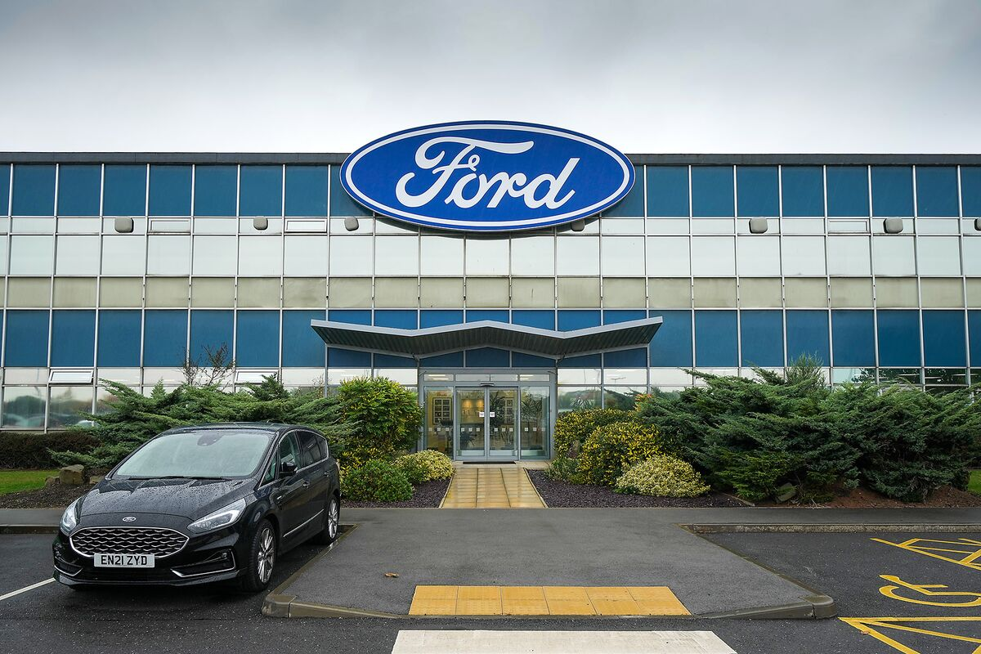
Figure 1: Ford
Source: (Nicola, 2022)

3. Strategy Analysis
Strategic analysis assists organisations to comprehend things that determine the level of their competitiveness and long-term performance. In the case of Ford of Britain, the external environmental factors as well as internal organisational strengths significantly contribute towards the strategic decisions (Fedotov, 2022). Tremendous transformation in terms of electrification, environmental regulation, technological advancement and shifting consumerisms are now playing out in the UK automotive industry as a sector. Hence, businesses should evaluate the macro-environment and competition within the industry to determine the opportunities and threats that may arise and analyse the resources of the business, which may be used in creating competitive advantage. This part of the paper will review the strategic position of Ford based on PESTLE analysis, Five Forces analysis of Porter, and finally internal ability analysis based on the Value Chain analysis, Resource based View (RBV) and VRIO model.

3.1 External Environment Audit

3.1.1 PESTLE Analysis
Political Factors
The political decisions are influential in determining the strategic climate of the car industry. The UK government is stimulating the adoption of electric vehicle with the help of subsidies, the charge infrastructure development, and environmental policies. The commitment among countries to attain net-zero carbon emissions by 2050 motivates the manufacturers to invest in low-emission technologies (Magnusson and Werner, 2022). Moreover, the exit of the European Union has changed rules of the trade, and it affects the automotive supply chains, tariffs, and the logistics processes in the UK. Such political environment demands that Ford will have to change its production planning and supply chain strategies to remain efficient and competitive in the UK market.
Economic Factors
The economic factors have a significant impact on the aggregate demand and output in the automotive industry. The increasing inflation and the escalating energy cost and raw material prices have greatly become a burden to manufacturing vehicle at high costs. Meanwhile, changes in the income levels of consumers are likely to influence consumer buying behaviour and demand of the new cars. The automotive industry is an economic powerhouse to the UK economy, with or without economic uncertainties, which is evidenced by employment, exports and industrial productivity. These are the economic factors which have direct effects on the investment choices of Ford, the pricing policies as well as long term planning to produce.
Social Factors
Consumer behaviour is getting affected by social attitudes towards environmental responsibility and sustainability (Sharanabasappa and Soumya, 2024). The increasing awareness of people about the problem of climate change has stimulated consumers to use more eco-friendly means of transportation like electric and hybrid cars. Therefore, it is necessary that automotive companies react to it by creating sustainable vehicle technology and promoting the mobility patterns that are eco-friendly.

Technological Factors
The automotive industry is still being redesigned due to technological advancement. The design of the vehicle and the experience of using it is changing with innovative battery technology, autonomous driving systems and digital connectivity. The greater the investments made by the manufacturers in research and development, the higher the chances of the manufacturer keeping up the technological frontline and competition.
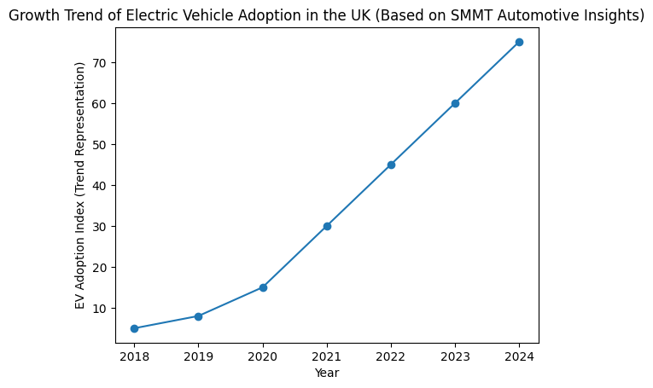
Figure 2: Growth Trend of Electric Vehicle Adoption
Source: (SMMT, 2025)
Legal Factors
Legal acts, especially the ones concerned with emissions and automobile safety standards, have an important impact on the process of producing automotive (Susanto and Wibowo, 2025). To bring down the levels of environmental pollution, governments are also imposing tougher laws that would bring about road safety. To meet such legal regulations, automotive companies have to keep evolving the designs and technologies of cars.
Environmental Factors
The environmental sustainability has become a critical matter in the automotive industry. International response to the problem of climate change demands the manufacturers to decrease carbon emissions and implement cleaner modes of productions. Consequently, the firms are putting more investment in electric vehicles and environment-friendly production technology to deliver what is expected of them regarding the environment.

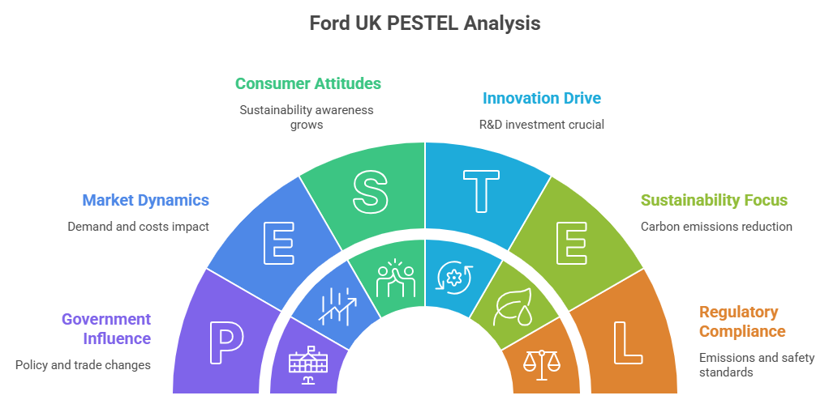
Figure 3: Ford UK PESTEL Analysis
Source: Self-made (Adapted from: (Susanto and Wibowo, 2025))

3.1.2 Porter’s Five Forces Analysis
Threat of New Entrants
The automotive industry has a medium potential entry threat. To set up automobile manufacturing requires large scale capital investments, high level of technological skills and well-developed distribution system. This is because, due to these high barriers of entry, new competitors are little. Nevertheless, due to the introduction of electric vehicle startups, there has been a slight potential of new companies entering the market and especially those focusing on novel EV technologies (Zhu, 2025).
Bargaining Power of Suppliers
Supplier power is also relatively high in automotive industry since demand relies on such specific components as semiconductor chips and lithium-ion batteries. The scarcity of suppliers of these important parts may affect price and supply levels which will impact the efficiency of production and cost of operation.
Bargaining Power of Buyers
The buyer power is rising because consumers are offered with a great number of automotive brands and vehicle models (Cho et al., 2025). Their power to negotiate is enhanced because the customers can easily compare the prices, product features and environmental performance.

Threat of Substitutes
There are alternatives to owning the private cars and these include substitutes like the public transport, ride-sharing services, and mobility platforms.

Competitive Rivalry
The competition in the industry is also very fierce given the intense global competition among the large automotive manufacturing companies.

3.2 Internal Environment Audit

3.2.1 Value Chain Analysis
Value Chain analysis elaborates on how Ford is able to establish value by its operation and support activities. The inbound logistics of global supplier networks, manufacturing processes in the assembly plants, marketing and selling processes with high brand coverage and dealerships, and post-selling services like maintenance and customer support are the primary activities (Shu, 2022). These processes are reinforced by support activities which include technology development, procurement management and the human resource competency. Electric vehicle technology and good supply chain management can help Ford provide efficient product delivery without impacting the proper operation and the industry performance of the company.

3.2.2 Resource Based View (RBV)
Resource Based View clarifies the competitive advantage brought about by organisational resources. Manufacturing infrastructure, production plant and good financial ability are important tangible assets that Ford has which contribute towards mass-production of vehicles. Also, the company enjoys intangible benefits such as world brand recognition, engineering skills and innovation ability. The other organisational capabilities that also exemplified by Ford is research and development, supply chain management and product design. These resources and capabilities enable Ford to be innovative and to enhance the efficiency in operations and stay competitive in the global automotive industry.

3.2.3 VRIO Framework
The VRIO model determines the existence of sustainable competitive advantage in the resources of a firm (Sun and Yang, 2025). Ford has useful resources that include a good brand name and technology innovation that will help it gain customer loyalty and product differentiation. Other resources are scarce such as the global manufacturing network and engineering experience by Ford. The competitors would also find it hard to repeat such capabilities as they are both costly to invest in and time-consuming in their development. Moreover, the organisational structure and strategic partnerships can allow Ford to fully leverage these resources to sustain the long-term competitive advantage.
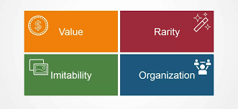
Figure 4: VRIO Analysis
Source: (Francis, 2024)

3.3 SWOT Analysis
Strengths
Ford enjoys a good brand awareness around the world, long history of manufacturing, and there is the superior technological expertise. It has established distribution networks and engineering skills that facilitate the product innovations as well as market penetration in the international automotive market (Jagani, Marsillac and Hong, 2024).
Weaknesses
Though these are its strengths, Ford also experiences some weaknesses like comparatively high production costs and lack of capability to accelerate transition to electric vehicles as most of the competitors of its nature in the quickly changing automobile industries.
Opportunities
The expanding market of electric vehicles is a significant opportunity to Ford. Depending on incentives by the government, environmental sustainability programs and the increasing consumer interest in environmentally friendly cars provide opportunities to innovate and expand into a larger market.
Threats
Other threats that face Ford are intensive competition in the global economy, the shocks and accidents in the supply chain and the growing stringency of the environmental rules on the automotive manufacturing.
Strategic Implication
These aspects suggest that Ford has to move faster on electrification and technological development to be competitive.

4. Strategy Formulation
Strategic formulation is vital to facilitating Ford of Britain to react to the fast-changing automotive business. According to the above strategic analysis, a number of strategic options can be adopted to promote the competitive position of Ford and enhance the long run sustainability.

Strategy 1 – Accelerate Electric Vehicle Development
Ford must focus on growth of electric vehicle (EV) offering by investing more in battery technology, electric power trains and charging infrastructure (Hong, 2024). The introduction of more electric passenger cars and commercial vans would enable the company to address the increased consumer demand and meet environmental requirements. The fast-tracked development of EVs would also make Ford competitive with the makers of major electric vehicles.

Strategy 2 – Strategic Partnerships and Innovation
The strategic alliances should be formed with the battery organizations and the technological companies which will contribute to the enhancement of the Ford technology. Battery performance self-driving systems and technologies involved in connected vehicles may be an innovative development that can be enabled through collaboration. This type of partnership enables Ford to spread research expense, get specialised knowledge, and other research product development.

Strategy 3 – Sustainable Manufacturing
Ford will also need to go more sustainable in its manufacturing process by investing in energy efficiency in its production systems and environmentally friendly supply chains (Gouveia et al., 2025). The introduction of carbon emission reduction through the manufacturing process and logistics chains would allow achieving regulatory compliance and a positive corporate image.

Strategy 4 – Digital Mobility and Customer Experience
The engagement and delivery of customer services and services can be enhanced by investing in digital mobility platforms and connected vehicle technologies (Gouveia et al., 2025). Remote vehicle monitoring, mobility applications and personalised customer experiences are some of the digital services that can boost brand loyalty and generate new sources of revenue.
All these measures will enhance the competitiveness of Ford in the long run, innovativeness and environmental sustainability.

5. Conclusion and Recommendations
The analysis of the strategic position of Ford of Britain conducted in this report was based on external and internal environmental analysis. The results show that the company is involved in the very active automotive market which is conditioned by explosive technological development, introduction of electric cars and much stricter environmental laws. All these bring major strategic issues but also open up the opportunities of innovation and market growth.
Analysis further reflects the main strengths of Ford as it has good global brand image, technological skills and wide knowledge in manufacturing. Nevertheless, to sustain a competitive edge, one must be able to adjust the strategy on a regular basis in accordance with industry change.
Ford could intensify its investment in the development of electric vehicles and increase its product portfolio by investing in car electric vehicles to cement its presence in the market. The business entity must also enhance technological innovation via strategic alliances and advanced sustainable production processes via the same. Besides, the establishment of digital mobility services and the improved interaction with customers through advanced digital platforms can support a long-term competitive advantage.
The active strategic management will all round ensure that Ford experiences a sustainable growth in the transforming UK automobile market.

6. References
Cho, M., Bae, K., Byun, J. and Shin, J. (2025) ‘Expanding the identification of key resource combinations for mid- to long-term growth in electric vehicle market entry’, PLOS One, (1). https://doi.org/10.1371/journal.pone.0328563
Fedotov, P. (2022) ‘Critical analysis of the electric vehicle industry’, Exchanges: The Interdisciplinary Research Journal. https://doi.org/10.31273/eirj.v10i1.362
Francis, A. (2024) VRIO Analysis - Meaning, Components, Advantages, and Disadvantages - MBA Knowledge Base, MBA Knowledge Base. Available at: https://www.mbaknol.com/strategic-management/vrio-analysis/.
Gouveia, S., de la Iglesia, D.H., Abrantes, J.L., López Rivero, A.J., Silva, E., Gouveia, E. and Santos, V. (2025) ‘Creating value through strategic management: Sustainable mobility for family-owned small- and medium-sized enterprises with electric vehicles in the digital era’, Sustainability, (1). https://doi.org/10.3390/su17051785
Gouveia, S., de la Iglesia, D.H., Abrantes, J.L., López Rivero, A.J. and Gouveia, E. (2025) ‘Fuzzy-based decision support for strategic management: Evaluating electric vehicle attractiveness in the digital era’, Eng, 2. https://doi.org/10.3390/eng6050086
Hong, J. (2024) ‘Competitive strategies and market positions of global automotive giants: Toyota, Tesla, and BMW’, Modern Management Science & Engineering. https://doi.org/10.22158/mmse.v6n2p53
Jagani, S., Marsillac, E. and Hong, P.C. (2024) ‘The electric vehicle supply chain ecosystem: Changing roles of automotive suppliers’, Sustainability, (1). https://doi.org/10.3390/su16041570
Magnusson, T. and Werner, V. (2022) ‘Conceptualisations of incumbent firms in sustainability transitions: Insights from organisation theory and a systematic literature review’, Business Strategy and the Environment, (1). https://doi.org/10.1002/bse.3081
Mu, Y. (2023) ‘Research on sustainable competitive advantage strategy of leading electric vehicle enterprises’, Frontiers in Business, Economics and Management. https://doi.org/10.54097/fbem.v9i3.9654
Nicola, S. (2022) Ford Invests £150 Million to Boost EV Parts Output From UK Plant, Bloomberg.com. Available at: https://www.bloomberg.com/news/articles/2022-12-01/ford-invests-150-million-to-boost-ev-parts-output-from-uk-plant
Porters, M.W. (2023) ‘Strategic innovation management in U.S. automobile manufacturing: Electric vehicles and competitive advantage’, Journal of Strategic Management. https://doi.org/10.53819/81018102t4189

Sharanabasappa, S. and Soumya, S. (2024) ‘A strategic examination of the electric vehicle (EV) industry: Unveiling opportunities and challenges for Tesla’s continued dominance’, Journal of Scientific Research and Technology. https://doi.org/10.61808/jsrt105
Shu, J. (2022) ‘Analysing on external environment and industrial competition of high-tech companies’, Proceedings of the 2022 7th International Conference on Social Sciences and Economic Development (ICSSED 2022) https://doi.org/10.2991/aebmr.k.220405.015
SMMT (2025) Automotive Insights - SMMT. [online] SMMT. Available at: https://www.smmt.co.uk/automotive-insights/.
Sun, L. and Yang, Q. (2025) ‘Strategic synergy between financial leverage and technological innovation: Analysing BYD's competitive edge in the global EV market: A mixed-methods study integrating Porter’s Five Forces analysis with a financial strategy matrix (2018–2024) Financial Economics Research. https://doi.org/10.70267/fer.250201.5767
Susanto, F. and Wibowo, S.G. (2025) ‘The influence of innovation capability, digital transformation, and supply chain integration on competitive advantage in the automotive industry in Indonesia’, International Journal of Business, Law, and Education. https://doi.org/10.56442/ijble.v6i2.1248
Zhu, L. (2025) ‘Analysis of technological innovation and competitive advantage in new energy vehicle industry: BYD as an example’, SHS Web of Conferences. https://doi.org/10.1051/shsconf/202521801031

