Edward Ellis Archive Project: 1909
As another year draws to a close, a duty to reflect on our past draws us. This year has been one filled with trials and tribulations as well as ups and downs. It truly has been a year filled with new beginnings as well as sad goodbyes. This last year has also seen Saint Davids College Lampeter endure struggles and tribulations.
One of the more notable positives of this past year comes to us in the form of the opening of a new cricket pavilion on the rugby field. The building was opened by the sportsman, Member of Parliament and longtime supporter of Saint David's College Lampeter: Sir John Llewellyn. The opening of our new pavilion has been heralded as an architectural triumph by many architectural peers. With this in mind, I’m sure that the pavilion will fit nicely into the surrounding area and keep with the overall feel of our humble Saint David's College Lampeter.
On the subject of buildings we must now take a moment to mourn the tragic fire that sadly destroyed our beloved canterbury building. In the May of this past year smoke was seen rising from the eastern wing. Unfortunately the damage to the building done by the fire was considerable but fortunately no sustained any injuries. It is at this point that the actions of many members of staff and students of our fine institution must be praised. Firstly, we must commend the actions of one Herbert Evans, an attendant in the employ of Saint David's College Lampeter, and was the man who made the discovery of the fire at quarter to 8 in the morning. The actions undertaken by Mr Herbert Evans doubtlessly saved the lives of many of the students lodging in the Canterbury building. At this point it is also necessary to commend the actions of the many undergraduate students that were lodging in the Canterbury building at the time of the fire. Once the alarm had been raised some of the students were able to organise themselves into the placement of large ladders for the use of the local Fire Brigade. Besides the heroic actions of both the students and staff of Saint David’s College Lampeter we must also acknowledge the diligent work of Captain Richard John and his brave men in the local Fire Brigade. Without the swift response and brave actions of these local heroes the damage could have been much more severe. Besides the actions of the local Fire Brigade we must also thank the Messrs J D Owen and W M Jones, a pair of local builders who valiantly climbed the ladders prepared by the undergraduate students of Saint David’s College Lampeter to remove tiles from the roof of the Canterbury Building so that the water pumped by the manual engine of the fire brigade from the tank in the quadrangle in the main building. The brave heroics of Messrs J D Owen and W M Jones, the Fire Brigade of Captain Richard John as well as the quick thinking and hard work of the students lodging in The Canterbury Building can be seen in the image attached overleaf.
As mentioned earlier in this address we have been fortunate enough to have been visited by the MP and Sportsman Sir John Llewllyn. However Sir John Llewllyn was far from the only dignitary to visit Saint David’s College lampeter. This year has seen three separate bishops visiting our humble college. During the Michaelmas term we were visited by the Bishop of Saint Davids and former Principal of Saint David’s College Lampeter: John Owen. As always it was a delight to see the Right Reverend Owen returning to our humble college. Besides the Right Reverend Owen, we at Saint David's College Lampeter have also been blessed and honoured with the presence of the Right Reverend Joshua Hughes, the Bishop of Llandaff during our Lent term. Even with these remarkable visitors to our humble Saint David's College Lampeter, we were further blessed with a one day visitation to our college by the Bishop of Liverpool during our summer term.
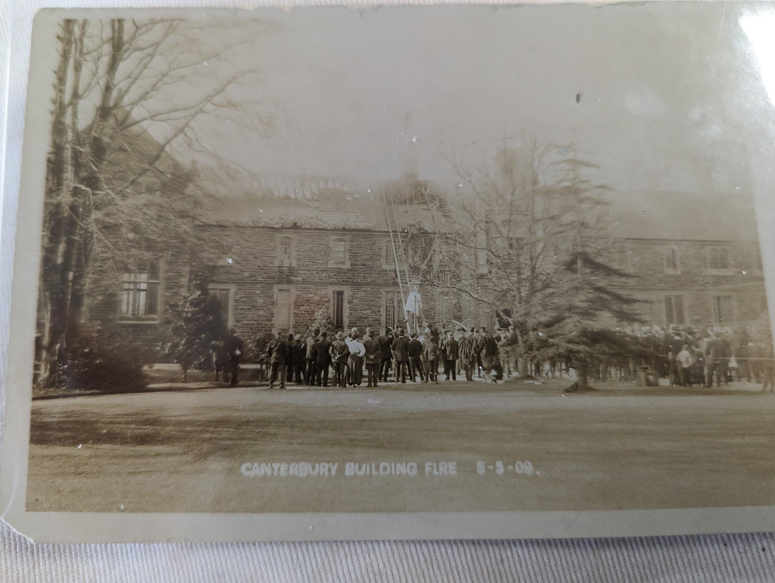
Following on from these happy visits to our humble college, we must now turn out attention to more business oriented matters of Saint David’s College Lampeter. I am pleased to announce that some our academic members of staff were fortunate enough to be invited to a conference in Geneva Switzerland. This past year there I am also pleased to announce that we held our annual degree day in the july of this year and it was, without a doubt, a spectacular way to close out an academic year that, on the whole and for the most part, has been positive.
Figure 1: The Fire at Canterbury Building
However, in this past year I am displeased to report that there were legal charges made towards the college totalling £69.
Besides the above mentioned charges, doubtless you have heard various rumours about the issues currently surrounding Saint David’s College Lampeter and I am here to put these rumours to rest. I will admit that there have been certain issues we have been working on regarding the matriculating class of 1908, Form IVB but those issues have now been resolved through correspondence with various members of the Board of Education.
On top of this now resolved issues with the board of education, there are also the fundamental attacks that Saint David’s College Lampeter as an institution have come under. These attacks have shaken myself and other members of staff at Saint David's College Lampeter to the core and I would like to apologise if these issues have negatively impacted the teaching that students have received this past year. The attacks in question have come in the form of revisions to the Statues of Saint David's College Lampeter. With this, I am able to report that in the September of this past year there was a meeting chaired by the Right Reverend John Owen, the bishop of Saint Davids in shrewsbury. Also in attendance at this meeting was the Bishop of Saint Asaph, The Bishop of Chester, the Archdeacon of Carmarthen, the Archdeacon of Bangor as well as numerous academics from both Saint David’s College Lampeter, Jesus College Oxford and Aberwyswrth. I am pleased to announce that myself and the other academics present made significant amounts of progress in regards to the revision of the statues of Saint David’s College Lampeter. This comes after many turbulent months about the future of our institution. Saint David’s College Lampeter has endured many attacks from numerous detractors who claim that there is simply no need for a Welsh theological college anymore. At this point in time, Saint David’s College Lampeter is in a perilous state of change. As mentioned above, myself and various other parties involved with Saint David’s College Lampeter have recently met in Shrewsbury to discuss changes to the statues of the college. This is because it is the feeling of some involved that Saint David’s College Lampeter must adapt and grow with the time and we are seeking to change the statues of the college to better allow this. The proposed changes would see Saint David’s College Lampeter transition from the theological training college Thomas Burgess envisioned Saint David’s College was founded as, to a modern University College. While there are some detractors to this idea that state Saint David’s College Lampeter can never hope to compete with larger, more endowed University Colleges nearby such as Aberystwyth. However, I truly believe that Saint David’s College Lampeter has every strength and ability to not only survive but thrive as its own University College.
In other, sadder news, I am saddened to announce that this past year we at Saint David’s college Lampeter have lost a dear friend this past year in the form of Mr A.G.P Lewis, a long time member of the Saint David's College Lampeter Council. He will surely be missed and we will cherish his memory and fondly remember the work he did at Saint David’s College Lampeter as a member of our college council.
I would like to thank the many students and staff of Saint David's College Lampeter for their continuous hard work and dedication to our humble college.

Bibliography
‘DILLWYN DILLWYN-LLEWELYN, (DILLWYN) VENABLES-LLEWELYN,’ https://biography.wales/article/s-DILL-DIL-1650 [ last accessed 22.10.23]

‘ Joshua Pritchard Huges (1847-1938) Bishop’ https://biography.wales/article/s-HUGH-JOS-1807 [last accessed 26.10.23]

‘Owen, John (1854-1926), Bishop’ https://biography.wales/article/s-OWEN-JOH-1854#?c=0&m=0&s=0&cv=193&manifest=https%3A%2F%2Fdamsssl.llgc.org.uk%2Fiiif%2F2.0%2F5905457%2Fmanifest.json&xywh=1044%2C1436%2C2041%2C1761 [last accessed 25.10.23]

Roderic Bowen Library and Archives: University Archives, UA/SDS/16, Account of Legal Charges

Roderic Bowen Library and Archives: University Archives, UA/SDS/17, Correspondence with the Board of Education.

Roderic Bowen Library and Archives: University Archives, UA/SP/1/8. St Davids College Magazine (bound Vol.) 1908-12

Roderic Bowen Library and Archives: University Archives, P/365

Roderic Bowen Library and Archives: University Archives, UA/X/132/11. Scrapbook of Newspaper cuttings, 1903-09

Roderic Bowen Library and Archives: University Archives, UA/SP/1/8. St Davids College Magazine (bound Vol.) 1908-12
‘DILLWYN DILLWYN-LLEWELYN, (DILLWYN) VENABLES-LLEWELYN,’ https://biography.wales/article/s-DILL-DIL-1650 [accessed 22.10.23]
RBLA: University Archives, UA/SP/1/8. St Davids College Magazine (bound Vol.) 1908-12
Roderic Bowen Library and Archives: University Archives, UA/X/132/11. Scrapbook of Newspaper cuttings, 1903-09
Ibid
Ibid
Ibid
Ibid
Roderic Bowen Library and Archives: University Archives, P/365
RBLA: University Archives, UA/SP/1/8. St Davids College Magazine (bound Vol.) 1908-12
Ibid
‘Owen, John (1854-1926), Bishop’ https://biography.wales/article/s-OWEN-JOH-1854#?c=0&m=0&s=0&cv=193&manifest=https%3A%2F%2Fdamsssl.llgc.org.uk%2Fiiif%2F2.0%2F5905457%2Fmanifest.json&xywh=1044%2C1436%2C2041%2C1761 [accessed 25.10.23]
‘ Joshua Pritchard Huges (1847-1938) Bishop’ https://biography.wales/article/s-HUGH-JOS-1807 [accessed 26.10.23]
RBLA: University Archives, UA/SP/1/8. St Davids College Magazine (bound Vol.) 1908-12
RBLA: University Archives, UA/X/132/11. Scrapbook of Newspaper cuttings, 1903-09
RBLA: University Archives, UA/SP/1/8. St Davids College Magazine (bound Vol.) 1908-12
Roderic Bowen Library and Archives: University Archives, UA/SDS/16, Account of Legal Charges
Roderic Bowen Library and Archives: University Archives, UA/SDS/17, Correspondence with the Board of Education.
RBLA: University Archives, UA/X/132/11. Scrapbook of Newspaper cuttings, 1903-09
Ibid
Ibid
Ibid
Ibid
RBLA: University Archives, UA/SP/1/8. St Davids College Magazine (bound Vol.) 1908-12

