EXECUTIVE SUMMARY

CREATIVITY AND INNOVATION
FOR BUSINESS ADVANTAGE
NEURALINK TECHNOLOGY
INTERFACING WITH THE BRAIN

INNOVATION PUSHING THE BOUNDARIES OF NEURAL ENGINEERING

INNOVATION PUSHING THE BOUNDARIES OF NEURAL ENGINEERING
University of Wales Trinity Saint David (UWTSD)
Student: Leighton Pedro Fernandes/1915091
Lecturer: Davina Wyn Evans
Module: BMSW6102
December 16th, 2022
This report highlights the importance of creativity and innovation in the workplace. Organisations who fail to innovate will simply go stagnant or in decline. Creative ideas are what fuel innovation and innovation improves products, services, and internal processes. Therefore, it is important to understand the processes involved with innovation. This report draws upon innovation models which can help organisations to categorise and prioritise creative thinking. This report concludes that there is no doubt that Neuralink is a revolutionary technological advancement and has many benefits to mankind. However, it can be argued that this new technology has the potential to cause more harm than good due to the complexity of the superhuman intelligence. Nevertheless, until they demonstrate the use of the link in human beings, it will just remain another contributor in the field of brain-computer interface research.

Table of Contents
1.0 INTRODUCTION 3
2.0 WHAT IS CREATIVITY 4
3.0 WHAT IS INNOVATION 5
4.0 MODELS OF INNOVATION 6
4.1 Innovation Matrix ‘Four Types of Innovation’ 7
4.2 Open and Closed Innovation 8
4.3 Four Ps of Innovation 9
4.4 Tidd and Bessant Innovation Model 10
4.5 Kurt Lewin Force Field Analysis 11
5.0 LEADERSHIP & MANAGEMENT 12
6.0 CONCLUSION 13
7.0 REFERENCES 14
8.0 APPENDICES 15

INTRODUCTION
Creativity and innovation involve the process of creating and applying new knowledge which are essential in the sector of knowledge management Cambridge International (2014). Creativity is the ability to think of new solutions to existing problems and innovation is a term used for the implementation of new creative ideas that can be applied to existing problems Peek (2022). The Leadership and management that employees encounter at a company is a key predictor of individual, team and organisational creativity and innovation. The importance of leadership in the innovation processes of the organisation is essential – for creativity to arise leaders/managers must encourage and actively implement strategies to new business ideas to support it Fleenor (2006). In essence, to achieve persistent innovation within a company, leaders need to create an organisational culture to nurture unorthodox thinking and its application. As organisations seek growth, they need to remain competitive and above all, they must innovate to avoid stagnation and decline. For example, customers in modern times expect a constant flow of new products and services. Therefore, organisations need to be aware of customer behaviour to deal with the shortening innovation cycle. Innovation is key for business advantage in the increasingly dynamic and competitive marketplace as when organisations innovate, it is possible to improve the products, services, procedures, and business strategies at present, or it can create new and improved ones from the ground up Purcell (2021). This report will explore the Neuralink corporation, co-founded by Elon Musk – a neurotechnology company (who has revolutionised technological innovation) that develops implantable brain-computer interfaces (BCIs) or brain to machine interface (B2M) to treat serious brain diseases and restore full-body functionality to a person who has severe spinal cord injuries Neuralink (2022a). To form this report, the writer will draw upon a variety of recognised creativity and innovation processes using varies models, tools, and techniques within the main findings to highlight the innovation opportunity that has been adopted by the Neuralink corporation with an examination of the appropriate leadership and management style that advocates the creative idea behind Neuralinks identified innovation opportunity. The models include, Innovation Matrix, Open and Closed Innovation, Model of Innovation, 4P’s to Innovation, Force Field Analysis. This report will conclude on why ‘Innovation is Essential for Business Success.’

2.0 WHAT IS CREATIVITY
Oxford (2022) defines creativity as a production of original or worthwhile ideas that is useful meaningful or correct. Therefore, creative is something you are or can be. To innovate is something you can do, but not necessarily through your own creativity. Forbes. (2017) highlights creativity and innovation are what makes good organisations great. Creativity and innovation allow organisations to use their creativity and innovative to accomplish long-term success. Roth (2020) states creativity and innovation play a crucial major role in corporate organisations as in the process of creativity and innovation on decision-making plays a significant role. For example, companies need to learn and analyse past experiences before deciding on the best possible idea so that the idea can be successfully implemented after creative analysis. According to Boyles (2022) if the implementation of ideas through creative analysis are done correctly business can stay ahead in a dynamic marketplace. Therefore, in the modern times, creativity and innovation is a major factor behind achieving business goals. According to Global Innovative Leadership (2015) Sadly, a lot of corporate companies today are more focused on intelligence instead of creative thinking and innovation and fail to understand that creativity plays an important part in the success of an organisation. Business Academia (2021) state a successful implementation of an idea is always possible after creative analysis as an in-depth analysis enables an organisation to find the best solution to complicated problems through creative thinking. This way organisation can improve products, services, and processes to stay above other organisations in the same field.

3.0 WHAT IS INNOVATION
Innovation means to create something new or to make change. The definition of innovation can be described as creating value from ideas. According to a Harvard Business review Pisano (2015) argues if a company fails to innovate, they will simply not survive and grow as when organisations innovate it allows them to gain a competitive edge, leading to better opportunities like improving products, services, performance, and efficiency in turn, will help build long lasting relationships with stakeholders. Forbes (2022) highlights that innovation provides people with an outlet for their creativity- a chance to put their ideas into practice. Davila et al (2006a) organisations who provide an outlet for creativity it will create an innovative culture where employees will possibly experiment and expand, making scientific and technological steps forward in the process. This concept does not only benefit the organisation but also the industry in which they operate and the wider economy through employment. More importantly, it can enhance the existing products and services to help maintain or enhance a company’s market share. Mullins (2016a) argues that all businesses must have a successful innovation strategy that advocates a creative thinking culture as the creative thinking process increases the chances of a business succeeding and by doing this will help create more efficient processes which will result in improved productivity and performance. Therefore, organisations need creativity and innovation to find new and improved ways of doing things as creating new ideas and implementing those ideas will help then grow beyond their competition. Mullins (2016b) highlight that when carrying out a something new and that has not been done before may seem risky. Although, it is a much bigger risk in fact is to not innovate as if an organisation fails to improve their products or services this will leave them unable to compete or simply nor operate.

4.0 MODELS OF INNOVATION
The next section will piece together an overview of the Neuralink corporation and the innovation opportunity using models of creativity and innovation which are applied in the following order: Innovation Matrix, Open and Closed Innovation, Model of Innovation, 4P’s to Innovation, Force Field Analysis.

4.1 Innovation Matrix ‘Four Types of Innovation’
An innovation matrix is a tactical tool that can be used to help corporate business leaders recognise and concentrate on opportunities for innovation in their organisations Miro (2022). It provides a structure to examine and assess potential opportunities and to focus on the best approach for growth. Davila et al (2006b) suggests that there are four types of innovation approaches available to organisations, these are Technology innovation, radical, Business Model Innovation, and incremental, each carrying different levels of risk and reward. The ‘Innovation Matrix’ can be seen in (Appendix 1). Using the Innovation Matrix - it was easy to distinguish the innovation opportunity and what type of innovation has been identified within NUERALINK. The company is a RADICAL INNOVATION as it is a new edge digital transformation. Although, it is disrupting more operation areas in their business processes, slowly becoming disruptive innovation. NEURALINK is a start-up company cofounded by Elon Musk in 2016. Neuralink as a company aims to “understand and treat brainly disorders and preserve and enhance our brain,” Neuralink corporation seeks to develop implantable brain-machine interfaces to connect humans and artificial intelligence (AI) allowing patients who are mobility-impaired to use technology with their minds Neuralink (2022b). It could be said that the design of Neuralink is revolutionary. Nevertheless, until they demonstrate the use of the link in human beings, it will just remain another contributor in the field of brain-computer interface research.
BENEFITS OF THE INNOVATION MATRIX- The innovation matrix allows organisations to direct and concentrate on ideas via visualisation tools and to collect ideas and decide the ones that are worth pursuing, dependant on the organisational objectives. It is ideas that drive the innovation process. Although, corporate business leaders find it difficult sorting through the most appropriate ideas from different concepts, teams, and products. Therefore, this model will he to categorise and prioritise these ideas to help focus on innovations with the highest potential of success.
DISADVANTAGES- The disadvantages of the ‘Innovation Matrix’ are that stakeholders are ignored. For example, this matrix only shows a strategy for keeping in mind the organisations product and market.

4.2 Open and Closed Innovation
The difference between ‘Open and Closed Innovation’ depends on the way the innovation occurs. Organisations that become involved in closed innovation execute work in a closed environment. On the other hand, organisations who become involved in open innovation methods rely on external knowledge resources for innovation management strategies. Closed innovation is built on the opinion that innovation is solely down to internal staff along every step of the innovation process. Yet, organisations using open innovation strategies are concerned with outside knowledge and resources and expanding their innovative potential by strategically using the world around them. For example, they are open to combining internal and external creative ideas, technologies, and their corporate strategies to find solutions to problems and bring ideas into fruition Fried (2022). There are many important external factors that that influence the innovation process, which includes competition, customer, stakeholders, suppliers and most importantly the employees Panagopoulos (2016). The open and closed ‘Innovation Matrix’ can be seen in (Appendix 2). Neuralink started as closed innovation (behind closed doors so to speak) however, external knowledge was required for part of the process. Therefore, Neuralink can be described as Open innovation. Since the company launched, they have hired several high-profile neuroscientists from various universities. On the Neuralink website they are always looking to hire a wide range of people with diverse engineering, scientific, and operations expertise and has doubled its workforce since its launch in 2016. Also, Neuralink has a variety of institutional and corporate investors such as Vy Capital, Google Smith. (2020). Elon Musk has always tried to attract new talent to his Neuralink ever since the company has launched. Elon Musk states he has always encouraged creative thinking within his companies and highlights that he tries to do things differently. Although only if they are better. You should not do things differently just because they are different, they need to be better. Musk tries to attract a workforce where employees ‘think out of the box’ beyond the normal stuff and he promotes a working environment where that sort of thinking is encouraged and rewarded and where it is ok to fail Neuralink (2022c).
Benefits of Closed Innovation- Management are in full control of ideas and innovation strategies and all information inside the company about innovative developments stay inside the company. Which means that an idea can be implemented and innovated before it spreads to the outside world giving them a competitive advantage that is unique to the market.
Disadvantages of Closed Innovation- Corporate innovation processes are developed with limited corporate resources. Employees within the company no matter how talented they are, cannot endlessly generate new ideas.
Benefits of Open Innovation - The process of developing innovations assists organisations in becoming more efficient.
Disadvantages of Open Innovation- When organisations bring openness to the market it creates many risk factors in terms of information leakage.

4.3 Four Ps of Innovation
The four Ps or the innovation mix is a model that was developed by John Bessant & Joe Tidd (2013). The ‘4Ps Model of Innovation’ can be seen in (Appendix 3). According to Michigan State University (2019) the four Ps is a model that can be used to make clear how comprehensive innovation is. The Four Ps Model focuses on four broad categories of innovation: The PRODUCT or service – That the organisation supply. The PROCESS – The way organisations create and deliver the product or service. The POSITION – Who the company offer the product or service to and the story the company talks about it. The PARADIGM – The company’s corporate image. The paradigm is sometimes called” the business model”.
PRODUCT  Neuralink are aiming to instal a fully implantable, cosmetically brain-computer interface that will allow human beings to control a computer or mobile device with just thoughts. Once installed Neuralink (2022d). Elon Musk – a neurotechnology company (who has revolutionised technological innovation) that develops implantable brain-computer interfaces (BCIs) or brain to machine interface (B2M) to treat serious brain diseases and restore full-body functionality to a person who has severe spinal cord injuries Neuralink (2022a). | PROCESS  Neuralink changed the innovation process within the company in terms of their innovation processes as they went from close innovation to open innovation as stated in the previous model. Neuralink has built partnership with other companies. Through cooperation with these companies, Neuralink has been successful on open innovation with their product and technology such as Tesla and Space X. At the same time, through process of innovation, Neural link has gained more resources and help from outside of the company Neuralink (2022e)
POSITIONING  Via Elon Musk’s star power and on social media (not common for medical devices) 47.3 million followers across all platforms. Bypassing doctors via robotics. Direct-to-consumer marketing on Neuralink website Kent (2019). | PARADIGM  Elon Musk is the founder and CEO of Tesla and SpaceX and is well-known charismatic leader who has achieved a great deal of success in his career. However, Musk has been known to reconsider important company decisions last minute Which has caused confusion and unsureness amongst stakeholders and employees. This can damage the company corporate image and make it an unreliable business model. This behaviour could have an adverse effect on the corporate image and brand credibility. Some people may no longer trust Neuralink as a reliable and responsible company because of Elon’s actions. This could have consequences for the company, such as a loss in sales or investment Gregersen (2022).

Advantages- The good thing about the ‘Four Ps Model’ is that it continuously forces you to discuss where your innovation takes place and how much to innovate.
Limitations- The simplicity of this model makes it only a jumping off point as it lacks guidance for further steps that must be taken.

4.4 Tidd and Bessant Innovation Model
Tidd and Basset (2013) identify innovation happens in 4 stages – 1. Recognising the Opportunity, 2. Finding the Resources, 3. Developing the Idea, and 4. Capturing Value. The ‘Innovation Model’ can be seen in (Appendix 4). According to Indeed (2021) the innovation processes describe the process of translating new or existing knowledge to help with solution to problems. Companies that adapt innovation processes help them to gain a competitive advantage over other organisations. Musk (2021) states “when you are looking for an opportunity it's important not to focus on just disruption for the sake of it. But rather where there is an industry either stagnant or in decline. Where the product or service has stayed the same or maybe even gotten worse over time. Also, it is worth looking at industries that you think are impossible and you think you will not succeed in are usually where there is opportunity.” Finding the resources is easy for The SpaceX and Tesla CEO as his net worth is estimated to be around (£120bn), according to the Bloomberg Billionaires Index, ranking him just below Amazon founder Jeff Bezos on the world’s rich list. Elon Musk also has many investors that are interested in his revolutionary products like Google, to name one of note. Capturing Value – Elon musk Creates brand value on his social media platforms with his 17 million-strong followers. Companies like Tesla, Space X, and Neuralink are available on the stock market where anyone can buy shares Cuthbertson (2022).
Disadvantages of process innovation- It is time consuming and costly – Organisations may possibly run out of financial resources if they invest too much time and do not get products to market quickly enough or developing something that do-not sell.
Advantages of process innovation- Innovations in processes, if done correctly can add value to existing products / services.

4.5 Kurt Lewin Force Field Analysis
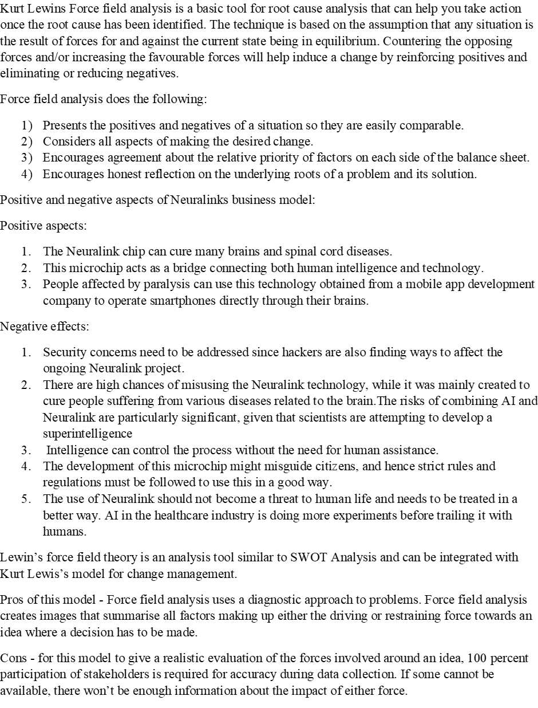
Lewin’s ‘Force Field Analyses Model’ can be seen in (Appendix 5)
Lewin (2013), Goshko et al (2022).

5.0 LEADERSHIP & MANAGEMENT
Mullin (2008c) highlights the relationship between social norms and values that are specific to an organisation has its effect on economic performance. Further, that knowledge development and innovation strategies are closely linked - The knowledge basis of the organisation and innovation depends on innovation strategies and social relationships between management and employees, influencing innovation and economic growth. Innovation by definition: The launch of a new product, service, or process and as that launch of something new frequently involves change, and change is often not well received. It is great to introduce something new into a company but, on the flip side it is another story to get that new thing fully accepted and adopted Drucker (2012). The process requires leadership and most importantly a leadership role that fits the innovative process- this leadership style that should be adopted within this process is ‘Laissez-faire’ which is a term used for 'Let it be' or 'Leave it alone.' A laissez-faire style of leadership is suitable for employees who like to work independently. Leaders are hands-off in their approach; employees have a chance to be hands-on. This leadership style creates an environment that facilitates growth and development. Leaders who use a laissez-faire leadership leave it up to employees to decide how to complete tasks and reach organisational objectives. Mullin (2008d) highlights the characteristics of organisational knowledge and organisational knowing. He explains the social norms and values that are specific to an organisation has its effect on economic performance and that knowledge development and innovation strategies are closely linked - The knowledge basis of the organisation and innovation depends on innovation strategies and social relationships between management and employees thus influencing innovation and economic growth. Forbes (2022) Tacit knowledge is a crucial driver in the innovation process and its application has a massive impact on the innovation process and, therefore, plays a important role as a company resource and success factor. It is important that leaders understand the power of knowledge and how it can be leveraged and managed to drive more innovation in the organisation.

6.0 CONCLUSION
Creativity and innovation allow organisations to use their creativity and innovative to accomplish long-term success. If the implementation of ideas through creative analysis are done correctly business can stay ahead in a dynamic marketplace. Therefore, in the modern times, creativity and innovation is a major factor behind achieving business goals. This way organisation can improve products, services, and processes to stay above other organisations in the same field. If a company fails to innovate, they will simply not survive and grow as when organisations innovate it allows them to gain a competitive edge, leading to better opportunities. For example, improving products, services, performance, and efficiency. In turn, this will help build long lasting relationships with stakeholders. Innovation provides people with an outlet for their creativity- a chance to put their ideas into practice. organisations who provide an outlet for creativity can create an innovative culture where employees will possibly experiment and expand, making scientific and technological steps forward in the process. This concept does not only benefit the organisation but also the industry in which they operate and the wider economy through employment. More importantly, it can enhance the existing products and services to help maintain or enhance market share. All businesses must have a successful innovation strategy that advocates a creative thinking culture as the creative thinking process increases the chances of a business succeeding and by doing so this will help create more efficient processes which will result in improved productivity and performance. Therefore, organisations need creativity and innovation to find new and improved ways of doing things as creating new ideas and implementing those ideas will help them grow beyond their competition. If organisations did not innovate, they simply would not progress go stagnant or in decline. For organisations, to be successful they must innovate to stay competitive or face extinction. Therefore, it is crucial that creativity is encouraged. A successful implementation of a creative idea can lead to innovation. When employees get the chance to be creative, they can come up with creative solution to problems. A successful implementation of a creative idea can lead to innovation. It is important that we foster and nurture creativity in the workplace as it not only improves products, services, processes and will lead to new discoveries and innovations. It also, creates a work environment where people are happy, motivated, and engaged which will lead to more productivity and with that productivity will improve Efficiency and with that efficiency will improve profits and relationships with customers stakeholder increase. With those relationship will bring more opportunities to provide the organisation with a competitive advantage. Innovation models can help corporate business leaders sort through the most appropriate ideas from different concepts, teams, and products. Therefore, using innovation processes will he to categorise and prioritise these ideas to help focus on innovations with the highest potential of success. There is no doubt that Neuralink is a revolutionary technological advancement and has many benefits to mankind. Although, it can be argued that this new technology has the potential to cause more hard than good due to the complexity of the superhuman intelligence. Nevertheless, until they demonstrate the use of the link in human beings, it will just remain another contributor in the field of brain-computer interface research.

7.0 REFERENCES

A Cuthbertson. (2022). Elon Musk says he is ‘accumulating resources to extend the light of consciousness to the stars. [Online]. Independent.co.uk. Last Updated: 22 March 2022. Available at: https://www.independent.co.uk/space/elon-musk-net-worth-space-b1820466.html [Accessed 04 December 2022].
A Panagopoulos. (2016). Closed vs Open Innovation. [Online]. Researchgate.net. Last Updated: 01 January 2016. Available at: https://www.researchgate.net/publication/311908120_Closed_Vs_Open_Innovation [Accessed 11 December 2022].
B Fried. (2022). Open Innovation vs. Closed Innovation. [Online]. Lead-innovation.com. Last Updated: 16 August 2022. Available at: https://www.lead-innovation.com/en/insights/english-blog/open-innovation-vs.-closed-innovation [Accessed 10 December 2022].
Business Academia. (2021). 5 Key Reasons Why Creativity Is Crucial for Business Success. [Online]. Business Academia. Last Updated: 08 February 2021. Available at: https://businessacademia.co/creativity-is-crucial-for-business-success/ [Accessed 2 December 2022].
C Kent. (2019). Neuralink: unpacking the hype around Elon Musk’s brain-computer interface. [Online]. Medicaldevice-network.com. Last Updated: 12 August 2019. Available at: https://www.medicaldevice-network.com/features/neuralink-fact-fiction/ [Accessed 08 December 2022]
Cambridge International. (2014). Chapter 4: Innovation and Creativity. [Online]. Cambridge International. Last Updated: 2014. Available at: https://www.cambridgeinternational.org/Images/426483-chapter-4-innovation-and-creativity.pdf [Accessed 2 December 2022].
Cambridge. (2022). Meaning of innovation in English. [Online]. Dictionary of Cambridge. Last Updated: 2022. Available at: https://dictionary.cambridge.org/dictionary/english/innovation [Accessed 16 November 2022].
E Gregersen. (2022). Elon Musk American entrepreneur. [Online]. Britannica.com. Last Updated: 14 December 2022. Available at: https://www.britannica.com/biography/Elon-Musk [Accessed 14 December 2022].
E Musk. (2021). Elon Musk on Founding SpaceX. [Online]. bigthink.com. Last Updated: 2021. Available at: https://bigthink.com/videos/elon-musk-on-founding-spacex/ [Accessed 04 December 2022].
Forbes. (2017a). Why Innovation Is Crucial To Your Organization's Long-Term Success. [Online]. Forbes. Last Updated: 8 May 2017. Available at: https://www.forbes.com/sites/forbescoachescouncil/2017/05/08/why-innovation-is-crucial-to-your-organ [Accessed 2 December 2022].
Forbes. (2017b). Why Innovation Is Crucial To Your Organization's Long-Term Success. [Online]. Forbes. Last Updated: 8 May 2017. Available at: https://www.forbes.com/sites/forbescoachescouncil/2017/05/08/why-innovation-is-crucial-to-your-organ [Accessed 2 December 2022].
Forbes. (2022). Four Ways to Cultivate Innovation. [Online]. Forbes. Last Updated: 11 Oct 2022. Available at: https://www.forbes.com/sites/forbestechcouncil/2022/10/11/four-ways-to-cultivate-innovation/?sh=320b [Accessed 1 December 2022].
G Pisano. (2015). You Need an Innovation Strategy. [Online]. Harvard Business Review Home. Last Updated: 1 June 2015. Available at: https://hbr.org/2015/06/you-need-an-innovation-strategy [Accessed 1 December 2022].
Global Innovative Leadership. (2015). COMPETITION AND INNOVATION. [Online]. Europa.eu. Last Updated: 2015. Available at: https://ec.europa.eu/programmes/erasmus-plus/project-result-content/13f220f8-936f-46d8-8697-03e468a7 [Accessed 2 December 2022].
Indeed Editorial Team. (2021). A guide to the innovation process and how to develop one. [Online]. Uk.indeed.com. Last Updated: 30 November 2021. Available at: https://uk.indeed.com/career-advice/career-development/innovation-process [Accessed 06 December 2022].
J B Am, L Furstenthal, F Jorge, and E Roth. (2020). Innovation in a crisis: Why it is more critical than ever. [Online]. Mckinsey. Last Updated: 17 June 2020. Available at: https://www.mckinsey.com/capabilities/strategy-and-corporate-finance/our-insights/innovation-in-a-cr [Accessed 2 December 2022].
J Tidd and J Bessant. (2013). Managing Innovation. 5th ed. United Kingdom: John Wiley. pp.7-27.
J W Fleenor. (2006). TRAIT APPROACH TO LEADERSHIP. United States: Sage. pp.810-821.
K Dalida and K Goshko. (2022). Evaluating the pros and cons of Elon Musk’s Neuralink. [Online]. Summitpsnews.org. Last Updated: 25 July 2022. Available at: https://summitpsnews.org/2022/07/25/evaluating-the-pros-and-cons-of-elon-musks-neuralink/ [Accessed 13 December 2022].
K Lewin. (2013). The Conceptual Representation and the Measurement of Psychological Forces. United States: Martino Fine Books. pp.70-90.
L J Mullins. (2016a). Management and Organisational Behaviour. 11th ed. London: Pearson Education. pp.10-22.
L J Mullins. (2016b). Management and Organisational Behaviour. 11th ed. London: Pearson Education. pp.33-42.
L J Mullins. (2016c). Management and Organisational Behaviour. 11th ed. London: Pearson Education. pp.15-29.
L J Mullins. (2016d). Management and Organisational Behaviour. 11th ed. London: Pearson Education. pp.45-51.
M Boyles. (2022). INNOVATION IN BUSINESS: WHAT IT IS & WHY IT’S SO IMPORTANT. [Online]. Harvard Business School Online. Last Updated: 08 MAR 2022. Available at: https://online.hbs.edu/blog/post/importance-of-innovation-in-business [Accessed 2 December 2022].
Michigan State University. (2019). Implementing the 4 “Ps” for Healthcare Innovation. [Online]. Michiganstateuniversityonline.com. Last Updated: 30 August 2019. Available at: https://www.michiganstateuniversityonline.com/resources/healthcare-management/applying-4-ps-for-heal [Accessed 11 December 2022].
Miro. (2022). Innovation Matrix: How to elevate product development within your company. [Online]. Boardofinnovation.com. Last Updated: 15 July 2022. Available at: https://miro.com/blog/innovation-matrix/ [Accessed 6 December 2022].
Neuralink. (2022a). Breakthrough Technology for the Brain. [Online]. Neuralink.com. Last Updated: 2022. Available at: https://neuralink.com/ [Accessed 6 December 2022].
Neuralink. (2022b). Breakthrough Technology for the Brain. [Online]. Neuralink.com. Last Updated: 2022. Available at: https://neuralink.com/ [Accessed 6 December 2022].
Neuralink. (2022c). Expanding Our World. [Online]. Neuralink.com. Last Updated: 2022. Available at: https://neuralink.com/about/ [Accessed 13 December 2022].
Neuralink. (2022d). Innovation pushing the boundaries of neural engineering. [Online]. neuralink.com. Last Updated: 2022. Available at: https://neuralink.com/approach/ [Accessed 09 December 2022].
Neuralink. (2022e). A Direct Link Between the Brain & Everyday Technology. [Online]. Neuralink.com. Last Updated: 2022. Available at: https://neuralink.com/applications/ [Accessed 07 December 2022].
Oxford. (2022). OVERVIEW Creativity. [Online]. Oxford Reference. Last Updated: 2022. Available at: https://www.oxfordreference.com/display/10.1093/oi/authority.20110803095646664;jsessionid=C9EA78204C [Accessed 2 December 2022].
Peter Drucker. (2012). The Practice of Management. Great Britton: Taylor & Francis. pp.252-272.
S Peek. (2022). Creativity Is Not Innovation (But You Need Both). [Online]. Business News Daily. Last Updated: 03 August 2022. Available at: https://www.businessnewsdaily.com/6848-creativity-vs-innovation.html [Accessed 4 December 2022].
T Davila, M Epstein, R Shelton. (2006b). Making Innovation Work How to Manage It, Measure It, and Profit from It. United States: Tim Moore. pp.12-22.
T Davila, M Epstein, R Shelton; Wharton School. (2006a). Making Innovation Work: How to Manage It, Measure It, From It, and Profit. [Online]. Moodle.uwtsd.ac.uk. Last Updated: 2006. Available at: https://moodle.uwtsd.ac.uk/pluginfile.php/374351/mod_resource/content/0/Davila%20et%20al%2C%20%28200 [Accessed 1 December 2022].
T Smith. (2020). A Scientist and Engineer Explain Everything Elon Musk’s Neuralink Can (and Can’t) Do. [Online]. onezero.medium.com. Last Updated: 17 September 2020. Available at: https://onezero.medium.com/a-scientist-and-engineer-explain-everything-elon-musks-neuralink-can-and- [Accessed 12 December 2022].
W Purcell. (2021). The Importance of Innovation in Business. [Online]. Northeastern.edu. Last Updated: 31 October 2021. Available at: https://www.northeastern.edu/graduate/blog/importance-of-innovation/ [Accessed 6 December 2022].

8.0 APPENDICES

Appendix 1 – Innovation Matrix
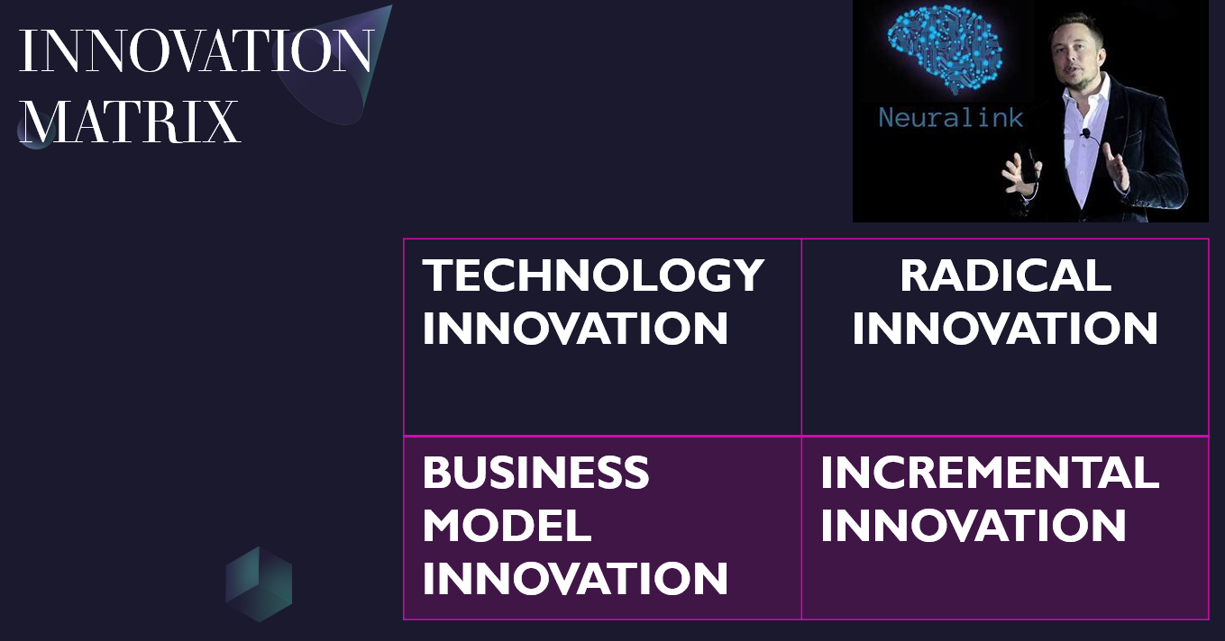

Appendix 2 – Open and Closed Innovation
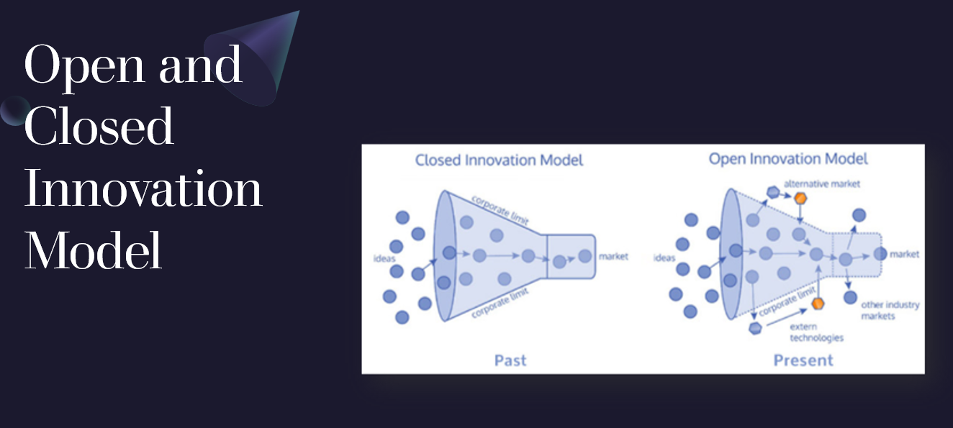

Appendix 3 – Model of Innovation
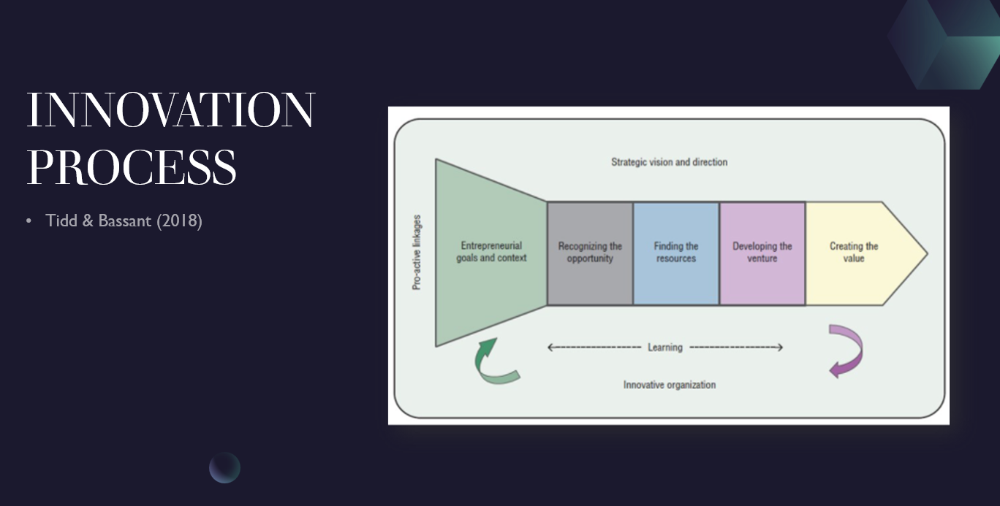

Appendix 4 – 4P’s to Innovation
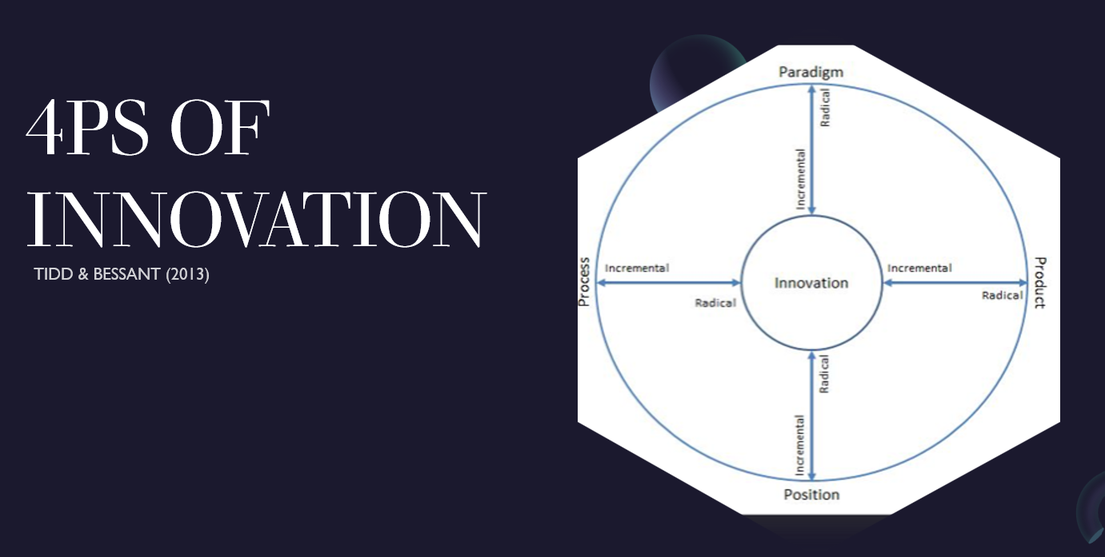

Appendix 5 – Force Field Analysis


