Palaeoenvironmental archaeology is multi-disciplinary in nature

Palaeoenvironmental archaeology is a method of archaeology which uses carefully selected recovery techniques on archaeological sites in order to put these sites into their environmental context, as well as providing us with information and evidence on economy, diet and living conditions. This is also most usually required as a part of most site investigations. There is a wide range of different sub-fields that are practiced within palaeoenvironmental archaeology, including archaeobotany, zooarchaeology, geoarchaeology, bioarchaeology, archaeopedology, sedimentology and micromorphology.
The field of palaeoenvironmental archaeology is clearly multidisciplinary, as it would see environmental archaeologists working alongside palaeoecologists, archaeologists and anthropologists. This is due to the fact that it allows for a more holistic understanding of human and environmental interactions for all disciplines that are involved. Different focuses within environmental archaeology and palaeoenvironmental archaeology gather information about different aspects of humans and their relation to and interactions with their environmental surroundings. Amassing these components together and also with the use of the methods that are used by the other disciplines that are involved in the project such as the anthropologists, all of the information can be combined in order to fully understand a past societies interactions with each other and their environment, as well as their particular lifestyle. A lot of what we can learn from these past societies and their interactions with the environment around them can be applied both current as well as future human environment interactions; this can be done by looking at the various uses that past societies had for their land, their food production, their use of tools as well as their various occupation patterns.
In palaeoenvironmental archaeology there are numerous scientific methods that are used by a number of different disciplines. Environmental archaeologists can learn a lot from investigating an archaeological site, however, due to the broad nature of palaeoenvironmental archaeology, an environmental archaeologist on their own would not be able to successfully investigate an archaeological site effectively and would not be able to learn as much about humans interaction with the environment as is required. Due to this other specialists from different disciplines would be required to work on the site in order to provide the research and information that is required for the project.
The first archaeological site that I have been looking at is the Azraq project in Jordan. The near east is widely regarded as being the home of the earliest farming centre in the world. This particular project took place at the Azraq Basin which is located in north central Jordan and is currently a dry steppe and a sub desert region which also has an oasis at its centre. There were eighteen sites found at the Asraq Basin, five of which investigations were undertaken at. Many of these sights represented small scale encampments which showed signs of activity from highly mobile groups and some other areas have signs of being repeatedly occupied by a number of different groups. However, one site in particular was on a considerably larger scale and is believed to have been the permanent home for many people, as well as a stopover point for many more mobile groups. There also appears to be evidence for the introduction of both domestic sheep and domestic goats, dating as far back as 5000 BC.
Much of the interest in this area was to find to what extent that this area was involved in the initial beginnings of farming. There were even remnants of what appears to be of a floor of what is believed to have been a structure that was built within the Palaeolithic times. The size of this camp is very substantial and is one of only two camps that was built to the same scale as this one within this time period in the Near East. Excavations at this site also revealed that there was a cluster of human burials, containing the remains of three adults and six children of varying ages. Recent analysis that has been done upon the remains of the bodies found discovered that two of the adult bodies found had ochre pigment applied to their skulls before their burial, which is one of the earliest examples of this practice that has ever been found or documented about in the Near East. There were also a number of tools found at this site, along with many small stone figurines that were discovered in many of the dwellings at this site. There was also found that there is a lot of evidence of a stone bead building industry, and it was found that these stone beads were likely traded over large distances, from the Jordan valley to the very eastern most point of Jordan.
Many scientific methods have been used on this project from a number of different professionals. Zooarchaeology played a large part in this project in the examination of the faunal remains that were found. From looking at the animal remains that was left behind at this site, the investigators found large numbers of animal bones, hair, hides, proteins and DNA. From their investigations into these remains that were found they discovered that around eighty per cent of the hunted fauna was found to be that of gazelle, however, also well represented in their findings was remains of many other animals, such as onager, hare, tortoise and birds. They also found that the fauna found here was rather different to the fauna that was described in earlier periods, with this site containing the remains of large numbers of wild cattle. There were also studies conducted on the human remains that was found at this site and tests were taken on the material that was found on two of the adult bodies skulls, revealing that there was an ochre pigment that was applied to their skulls, which shows this to be possibly the first ever account of this practice being used in the Near East. The study of archaeobotany was also used at this site, helping to reveal the way in which these people lived and ate. There were many tests taken on the remains of plants that were found at the site and they found that this site was home to a rather successful farming community, with many other smaller farming communities in the surrounding area. This site very quickly gained the interest of not only archaeologists and environmental archaeologists, but of anthropologists and palaeocologists as well, with many people from each discipline aiding in the excavation, examination and research processes.
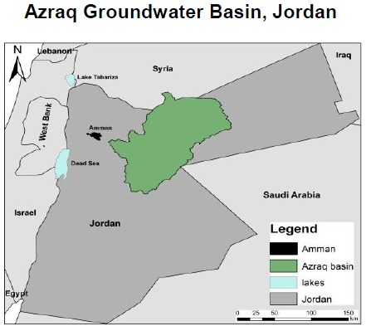
The second site that I have chosen to look at is the Boxgrove project, which is locates in West Sussex in England. From looking at the gravel pits at this site, they have provided a rather detailed insight into the lives of some of the earliest ever colonisers of Northern Europe. There have been a large number of objects and remains found at this site that can provide us with much insight into the lives of these colonisers that lived here. Part of this site contains a number of fresh water deposits, with many of them containing and preserving the remains of butchered animal bones, found alongside a number of different flint tools and waste flakes. It is believed that there were large numbers of herbivores that would have frequented this area of fresh water, including deer, horses and even rhinoceros, making it a very popular location for early hominids to hunt for game. To support this there were also large numbers of cut marks found on the bones of the animal remains that were found, leading archaeologists to believe that this was due to human interaction with these animals, and with the discovery of the flint tools and the waste flakes at this site there is no doubt that this site was regularly visited and exploited by early hominids.
Much like the Azraq project in Jordan, this site at Boxgrove required the use of zooarchaeology in order to examine the faunal remains that were found at this site. There were a number of calcium carbonate rich deposits discovered at this site, which is ideal for the preservation of faunal remains. There were many bones and teeth of various animal species found here, which allows for the reconstruction of the palaeocology of this environment as well as to accurately date the site along with the faunal remains found here. Due to the numerous cut marks that were found on the animal bones we have been able to discover the hunting and butchery techniques and behaviour of the early hominids that lived on this site. This site has also been of particular interest to not only archaeologists and environmental archaeologists, but has also required the attention on anthropologists to look into the behaviour of the hominids at this site and how they behaved with their environment, and palaeocologists were also both interested in the project and needed for the research and examination of the site and its remains. This is yet another example of a palaeoenvironmental archaeological site that has required a multi-disciplinary approach in order to fully understand what this site has to offer and to fully examine the site to discover what had really happened here thousands of years ago.
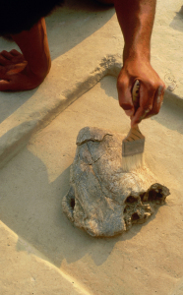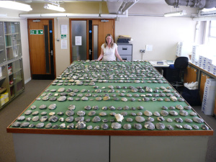
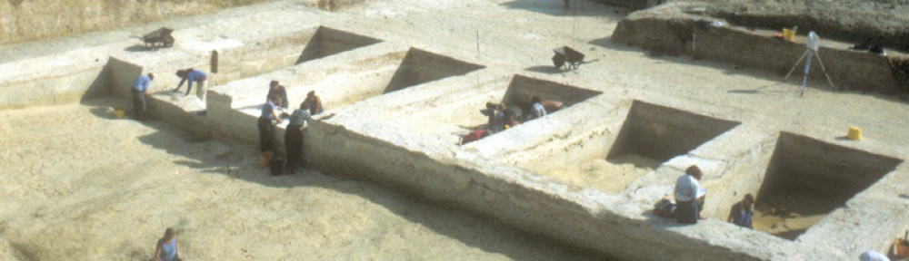
Both of these sites that I have chosen to examine share a lot in common as well as differing from each other in a number of ways. Both of these sites required a multi-disciplinary approach to correctly examine and understand the site and its history, and both sites used very similar techniques and professionals in order to accomplish this task. Neither one of these sites could have been fully examined to the extent that they have been now if it wasn’t for the variety of professionals from a number of different disciplines having input on the projects. However, there is a lot that these two sites do not have in common. These two sites have been found in two completely different parts of the earth with vastly different weather conditions, environments and animal life. As well as this, the Azraq project was looking into the evidence of farming in the Near East, whereas there was no sign of farming being implemented at Boxgrove, rather the use of hunting. The site at Boxgrove depicts a slightly more primitive people that that at the Azraq project, as the Boxgrove hominids appear to have been simple hunter gatherers, whilst the Azraq hominids appear to have developed a farming society.
Through the examination of both the site at Azraq in Jordan and the site at Boxgrove in England, it is clearer than ever that palaeoenvironmental archaeology is at its very core a multi-disciplinary subject. It can also be said that without the input from professionals such as archaeologists, environmental archaeologists, anthropologists and palaeocologists the research that was conducted would not have been at all a possible feat.

Bibliography

Albarella, U. 2001. Environmental Archaeology: Meaning and Purpose. Dordrecht, Kluwer Academic Publishers.
Branch, N. et al. 2005. Environmental Archaeology Theoretical and Practical Approaches. London, Hodder Education.
Dincauze, D. 2000. Environmental Archaeology Principles and Practice. Cambridge, Cambridge University Press.

