1.Basic Configuration
    - a. Configure hostname on all devices as per the Addressing table
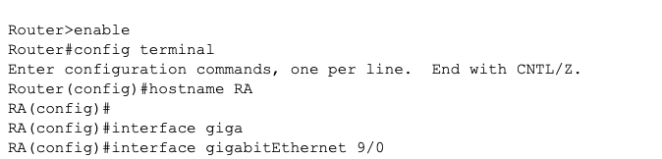
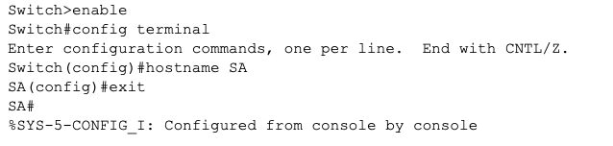
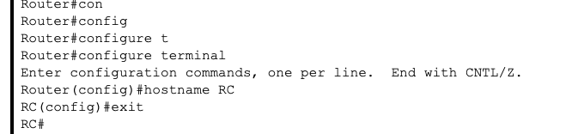
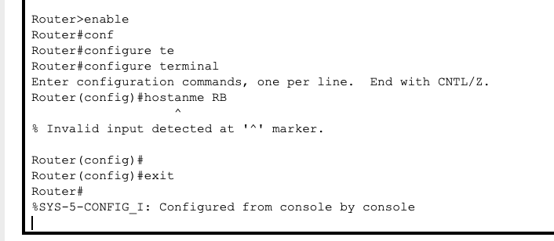
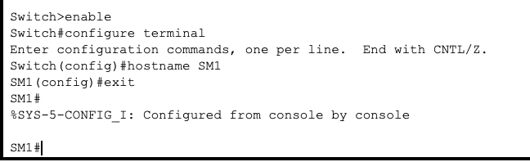
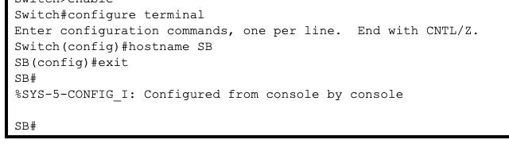
    - Disable DNS Lookup
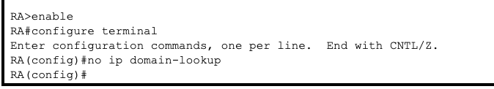
    - Configure all devices IP addresses shown in the tables and network topology
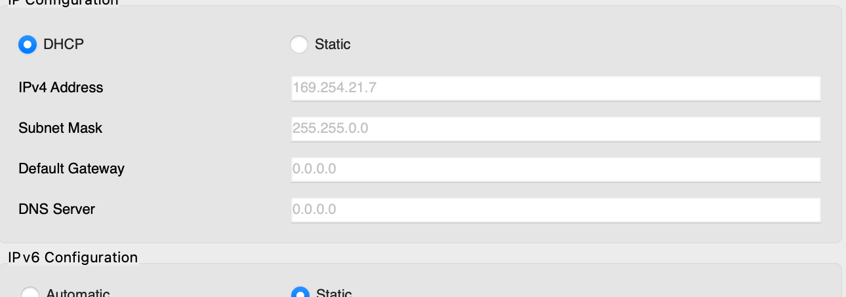

2.a. Configure EIGRP with AS 12 on RA, RB & RC. Advertise directly connected Networks.
Disable automatic summarization. Use the Network IDs and Wild-card masks
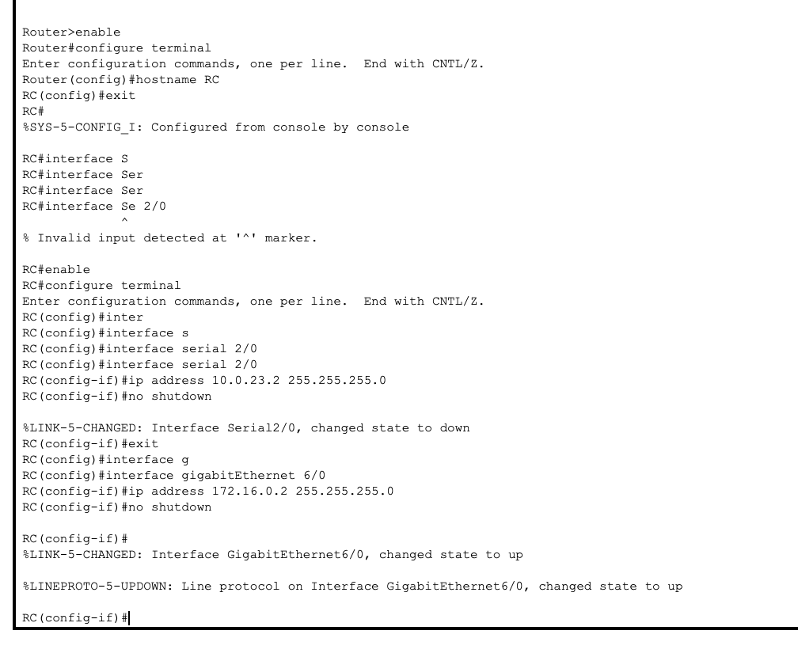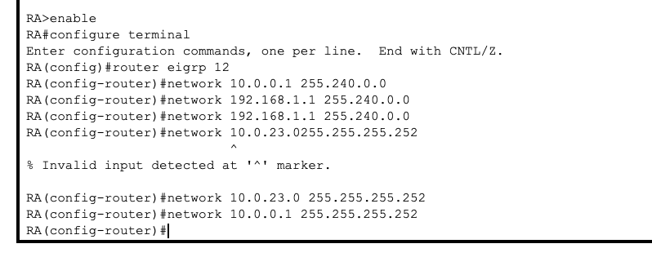
b. Set Router ID, 1.1.1.1 on RA, 2.2.2.2 on RB and 3.3.3.3 on RC.

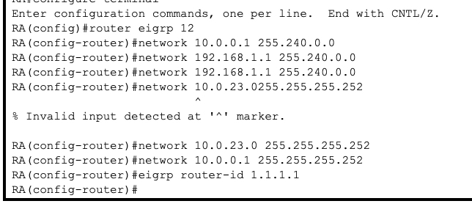
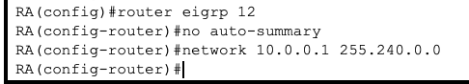

C. Set LAN interfaces to Passive.

- a. Configure VLANs as shown in the table 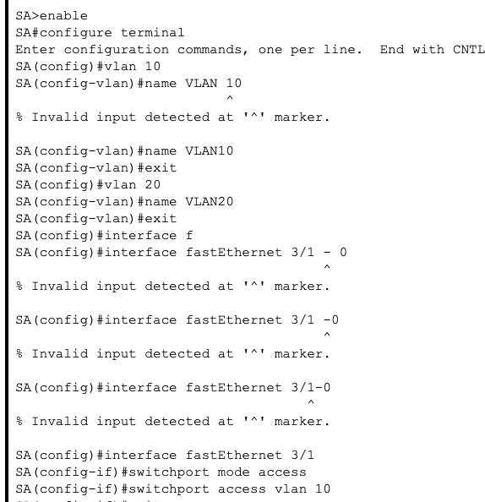

b. Set Switch Interfaces appropriately as Trunk and Access ports as per the scenario enabling a successful and feasible network connectivity.
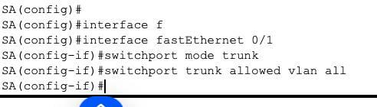

c. On switches SA and SB, configure Rapid PVST+ as spanning tree mode 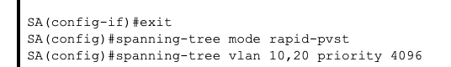

d. Configure PortFast and BPDU Guard on the interfaces connected to PCs. Shutdown all unused ports.
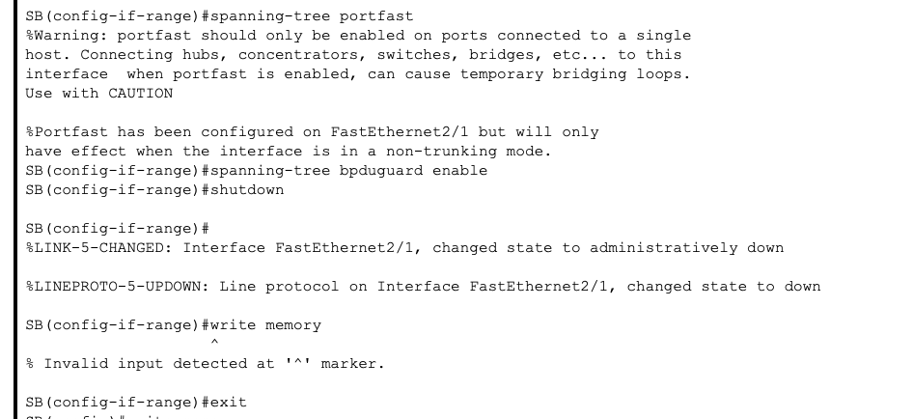

4. a. On SM1, configure a PAgP EtherChannel on interfaces connected to SM2. Use group 1 and desirable mode

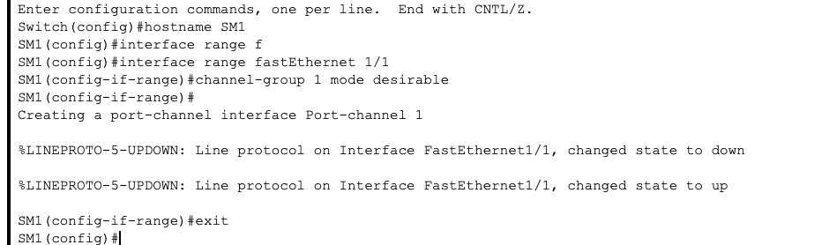

b. On SM2, configure an PAgP EtherChannel on interfaces connected to SM1. Use group 1 and desirable mode.
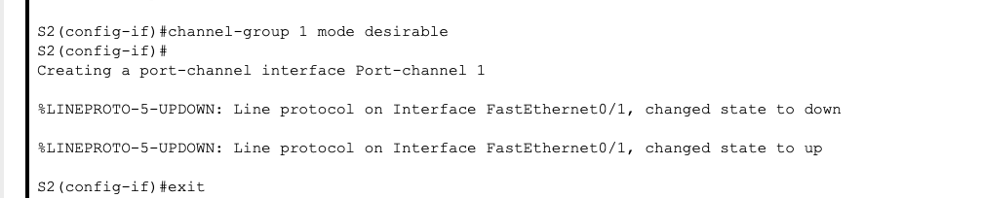

5. Configure HSRP on RB and RC. Group: 1, Virtual IP address: 172.16.0.3. Make RB as the Active router with priority 110
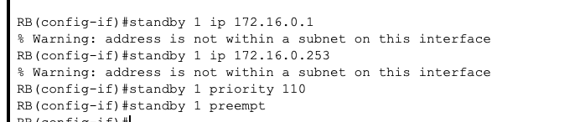

6. a. 

