Is Britain a Nation of Lazy Scroungers?
(Ramesh, 2013)

The headline above is one of many headlines that the media publish to indicate that lazy individuals who scrounge benefits usually choose not to work as they prefer to live a life courtesy of the state (Garthwaite, 2012). But according to recent research by Teeside University, Garthwaite (2012) claims that ‘the scrounger myth is leading to great suffering for increasing numbers of people.’ She argues in the conclusion that the participants shifted in and out of unemployment and low wages for a number of years, and that most felt a lasting obligation to work. Yet, this commitment to work failed to deliver routes away from poverty, mainly due to the lack of job opportunities available locally. Their resilient enthusiasm to work along with the uncertainty of the low wage job and poor quality work available, was the basis for why moving between benefits and jobs was the experience of working life for the participants (Garthwaite, 2012).
The welfare state is a huge part of family life in the UK, there are 20.3 million families in receipt of benefits, that equates to 64% of all families and around 8.7 million of them are pensioners. For 9.6 million families, benefits form above half of their income. Research carried out by The Joseph Rowntree Foundation observed whether there were three generations of the same family that had never worked (The Guardian, 2013). Despite searching, the researchers could not find such families. There was no indication of a culture of not wanting to work, it was a result of complex issues, particularly with health that associated them living in long term poverty (The Guardian, 2013).
Traditionally poverty has been defined in one of two ways, either as absolute or relative. Absolute poverty is described as ‘a fixed standard below which individuals and families experience complete destitution and so cannot meet minimum needs for food and shelter’ (Pierson, 2010). Relative poverty on the other hand is defined as
‘a lack of resources needed to obtain the kinds of diet, participate in activities and have the living conditions and amenities that are widely approved and generally obtained by most people in society’
(Pierson, 2010)
The Gini Coefficient measures the income inequality of countries. It reduces the ‘income distribution of a country into a number between 0 and 1. The higher the number, the larger the quantity of income inequality’ (Equality Trust, 2017). The graph below exemplifies the rise in inequality in the UK between 1961 and 2016 (Equality Trust, 2017).

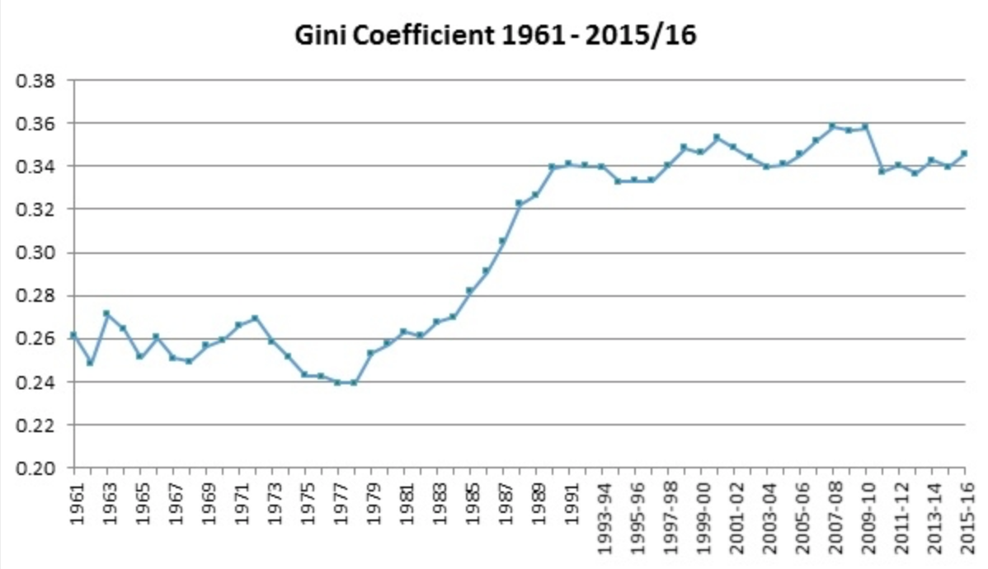
(Equality Trust, 2017)
This rise in inequality has seen a huge growth in the distribution of income going to the top, a deterioration in the distribution at the bottom and in recent years a stagnation of incomes among the middle (Equality Trust, 2017). The graph below clarifies that in 2010, while the top 10% receive 31% of all income, the bottom received just 1%. ‘In 2010 45% of all the wealth in the country was held in the richest 10%. The poorest 10% held just 1%’ (Equality Trust, 2017).
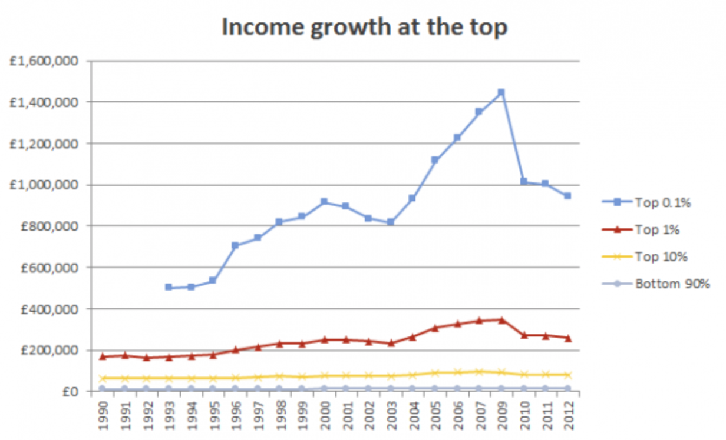
(Equality Trust, 2017)

The inequalities are powered by a neoliberal ideology, mostly due to outsourcing production to poorer countries where it is easy to abuse cheap labour, and environmental laws are non-existent. ‘These features all combine great increases to the companies’ profits, along with the insecurities of the workforce with regards to poverty and bleak futures’ (The Economist, 2017). Turnbull (2017) states that
‘A recent report by the OECD found that, in its mostly-rich members, the average productivity gap between the most productive 10% of regions and the bottom 75% widened by nearly 60% over the past 20 years.’

This is not the first time that the UK has been set apart for its inequalities. In 2016 the BBC News reported that
‘The richest 1% of the UK population owns more than 20 times the wealth of the poorest fifth, according to Oxfam. Its analysis found that about 634,000 Britons were worth 20 times as much as the poorest 13 million people.’

According to Turnbull (2017) in reality it is the rage, desolation and sorrow inflicted on many by neoliberalism that has also directed them to turning to ‘buffoons like Trump, and voting for Brexit, even though neither of these movements provide any real solutions to the problems people are facing.’ The results of neoliberalism are unpleasant in a number of ways, and they are harmful for society. The Joseph Rowntree Foundation (JRF) (2015) concur
‘that there were 700,000 people in poverty in Wales between 2011 and 2014, this was around 23% of the population. The graph below illustrates the number of people in poverty by age in Wales from 2002/03 to 2012/13.’
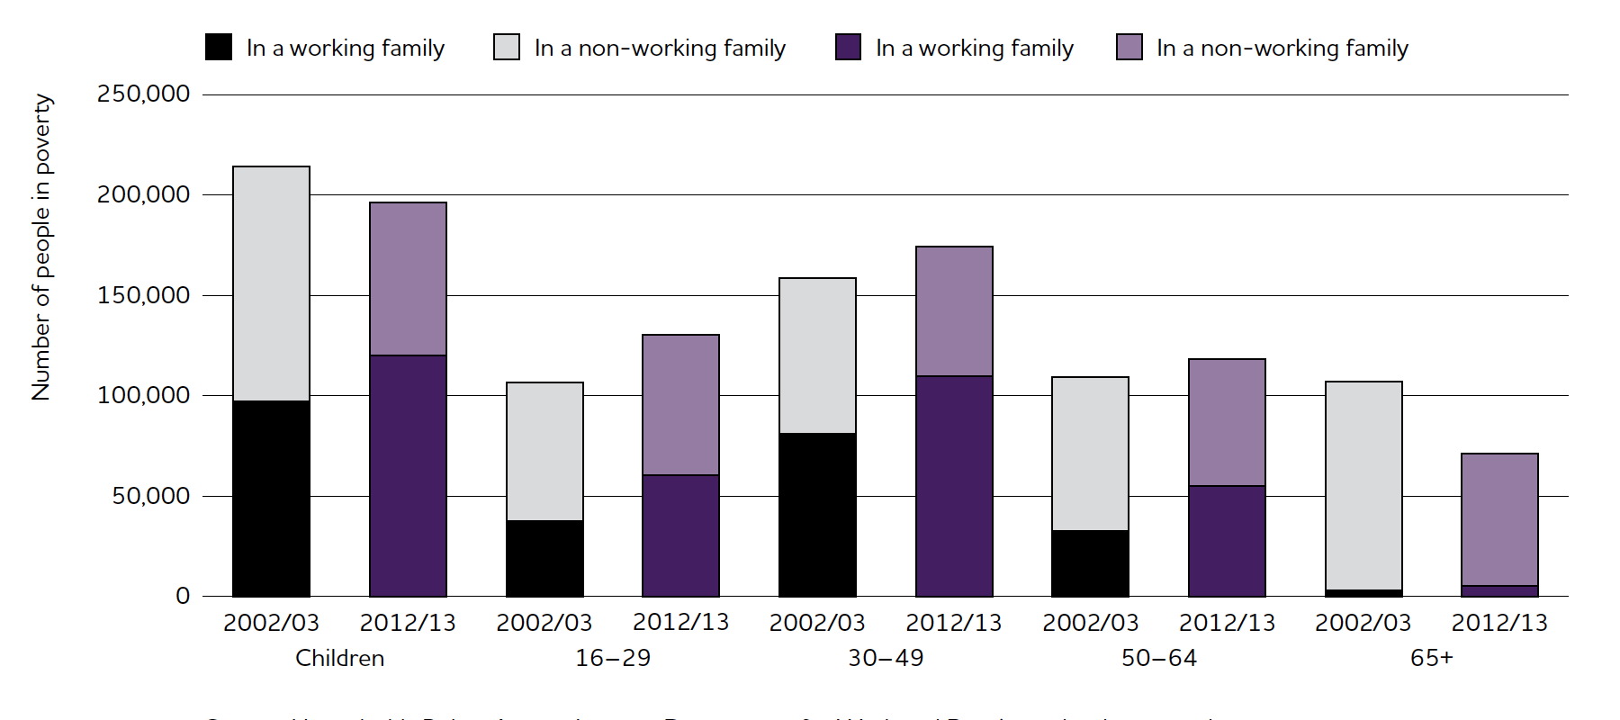

(JRF, 2015)
The 16-29 and 30-49 age group saw a surge in poverty over the past ten years. Children and pensioner numbers in poverty have equally tumbled by around 40,000 and 20,000 (The JRF, 2015).
The effect of poverty on children is huge, it not only affects them but it also affects their families and the entire country. Children facing poverty and social exclusion usually face it throughout their lives (Pierson, 2010). The social problems that the government’s Social Exclusion Task Force (2004) relate with social exclusion are, poor prospects for employment, the absence of opportunities to obtain an
‘education and work related skills, childhood deprivation, families disrupted through high levels of conflict, separation or divorce, barriers to older people living active lives, inequalities in health, poor housing, poor neighbourhoods, fear of crime, groups, disadvantaged through poverty.’

The Children Act 1989 ensures that local authorities provide an extensive variety of provision for families with children in need (DoH, 1991). The act distinguishes that parenting is a difficult task.
‘The support services mentioned in the Children Act include day nurseries and child-minding, holiday activities and help with travel, as well as cash payments under Section 17 to cover monetary difficulties and short term local authority supported accommodation for children’
(DoH, 1991).
According to Pierson (2010) research indicates that children’s need for inspiration is broader and more complex than it was in the 1980’s when the act was passed and that services need to be reconstructed to indorse the wellbeing of families in order to guarantee the healthy ecology for the child.
During 2003 a green paper was published by the government, Every Child Matters was intended to develop children’s wellbeing regardless of the provision that they were involved in (Pierson, 2010). The five outcomes of Every Child Matters aim ‘that every child stays healthy, stays safe, achieves economically, contributes to society and enjoys life’ (Every Child Matters, 2018). All local authorities guaranteed that they would collaborate with multi-agency partners in order to establish the most effective result for children and young people in that area. It required practitioners working with children find out what suited them best, and continually assess them to ensure that the procedures were working. Asking the children was absolutely fundamental (Pierson, 2010). Labour’s 2010 Child Poverty Act placed a legal obligation for the abolition of child poverty by 2020, although the Conservative-Liberal Democrat coalition government (2010-15) verified this as a policy goal, in practice it was not followed through (Lansley & Mack, 2015). Research carried out by the New Policy Institute (NPI) suggested that since 2013m poverty has increased and child poverty has rocketed by around 300,000, with 29% of UK children living in poverty (Aldridge et al, 2015). It is forecasted that child poverty is likely to increase to around 25.7% by 2020-1 (Browne and Hood, 2016).
When the Conservative-Liberal Democrat coalition came to power in 2010 they implemented a severe kind of neoliberal austerity. It was during their time in government that inequalities increased within UK and the rich became richer (Springer& Birch, 2016) Businesses such as Amazon, Starbucks, Vodaphone were confronted with trifling taxation on astoundingly huge profits (Springer & Birch, 2016). Astonishingly the government turned a blind eye to wealthy individuals hiding money in Swiss banks to evade income tax. However, the very same government executed ruthless attacks on welfare expenditure, and cut the benefits of the most exposed members in society. The significances have remained severe. Whereas the fortune of the UK’s wealthiest families has doubled in five years, half a million children have limited access to sufficient nutrition (Springer & Birch, 2016). Neoliberalization has proceeded by government led approaches, that strove to accuse the victims of the neoliberal policies that they were accountable for the desolation caused by the policies. The Prime Minister at the time, David Cameron urged individuals from low socio-economic backgrounds to oppose against the lazy scroungers rather than against the super-wealthy in a speech in 2010 (Springer & Birch, 2016).
The most industrialised countries today are welfare states, this suggests that the government has a dominant position in the distribution of welfare. This is completed by a structure that proposes welfares in order to meet the requirements of people in society. An additional function of the structure comprises of dealing with the threats people face during their lives’ (Giddens, 2017). Numerous theories have developed over the years to justify the growth of the welfare state. Marxists perceive that benefits are crucial for sustaining a ‘capitalistic market’ grounded society, by verifying the ‘reproduction of a healthy, well-educated workforce, while functionalists believe that welfare systems aided in interrogating society in an arranged manner under conditions of industrial development’ (Giddens, 2017). Functionalists consider that we live in a meritocratic society. ‘Meritocracy is the notion that people should and are duly awarded by society for their hard work and efforts’ (Thompson, 2008).
According to the JRF (2014) the solution towards a more equal society is to follow the lead of countries such as France, Finland and Japan whose economies are wealthy. Finland does have
‘a reputation for egalitarianism, but it is in fact the least disproportionate society of the three before taxes. It is only after taxation and paying benefits that Finland transfers’ to being the most equal.’
JRF (2014)
also add that poverty and inequality are observed to be extensive problems in society, and can be tackled through getting numerous basics right, such as providing schools with high quality teachers, keeping deprived neighbourhoods safe at night, sustaining public transport so that communities are not cut off from where the jobs are, or maintaining childcare settings for pre-school children (JRF, 2014).
Research by the University of Kent studied the ‘impact of stigma and other social influences on applying for benefits’ (Turn2us, 2018). One of the crucial discoveries included that a considerable amount of people had miscalculated the amount of people deceptively claiming benefits. They believed that 1 in 5 people were falsely claiming. Statistics released by the government indicate that the actual fraud rate was around 1%. The research found that
‘the public now see claimants less deserving than they did 20 years ago. Evidence was found that confirmed the notion that negative media coverage is linked to stigma’
(Turn2Us, 2018)

Copious amounts of individuals have put applying for benefits on the back burner due to the apparent stigma that is generated by false media portrayals of ‘scroungers’, in turn relinquishing essentials such as food and fuel (Ramesh, 2012). The newspaper headlines below exemplify the types of headlines that are published on a daily basis with in the UK.
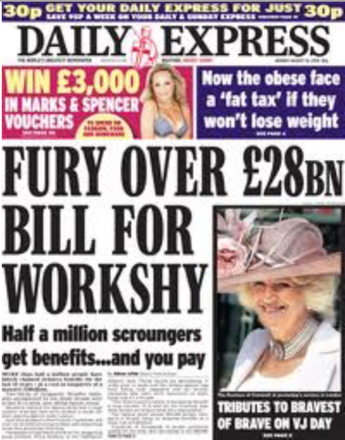
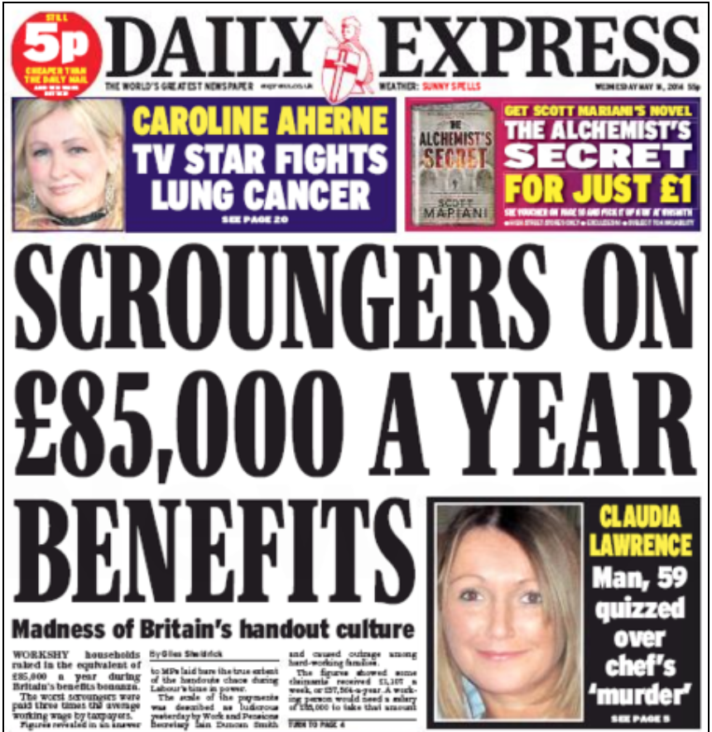
(English Blog, 2014) (Hawkes, 2010)
A google search of headlines regarding benefit scroungers display hundreds of images from the Daily Mail, Daily Express, Sunday Express, The Sun and Daily Mail newspapers. Unsurprisingly, these newspapers all sit to the right wing of the political spectrum. Currently within the UK, we only have a minority of CEO’s and owners of the media, hence the political affiliation of the newspapers. The graph below shows how left or right winged UK newspapers are.
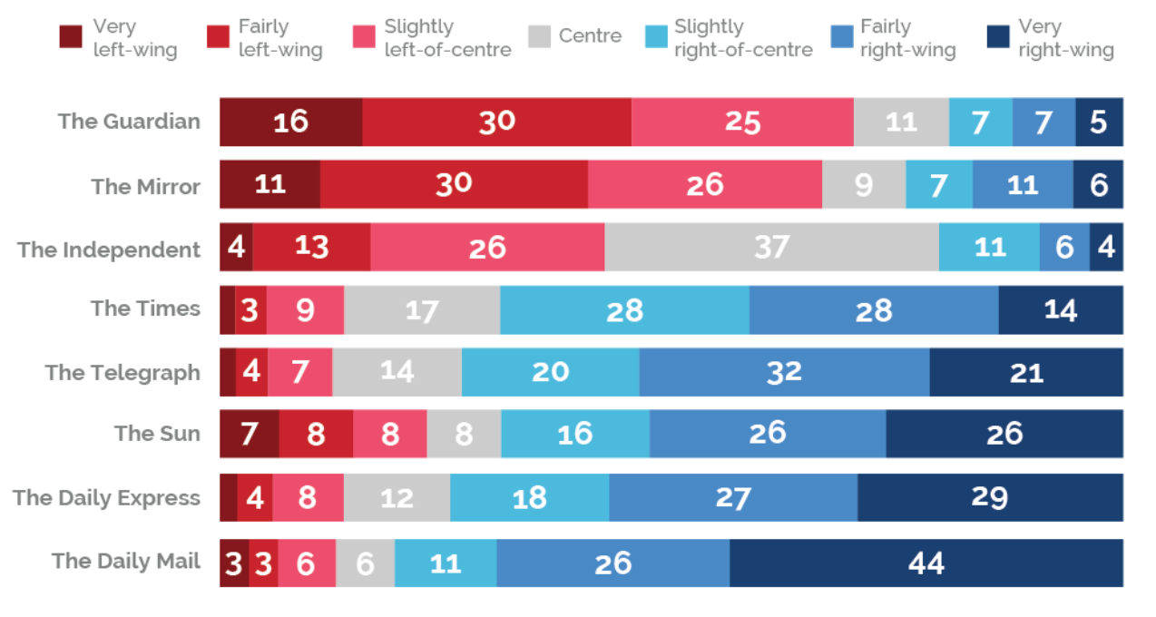
(Yougov, 2017)
The Conservative party are well known for ‘sitting together’, and Theresa May and her cabinet of millionaires sit there swimming in cash whilst there are millions of children in Britain living in poverty (Hussain, 2013). ‘Under the Conservatives, the rich get richer and the poor get poorer’ (Hussain, 2013). Democratically elected governments are selected into power in order to be the voice of the views and interests of the greater part of Britain (Hussain, 2013).Yet, it seems that it is on rule for them and another for the Conservative party. They have levied a tax on bedrooms in the homes of millions of vulnerable people, and forgot to introduce mansion tax, this would support the people of this country and contribute to challenging the cost of living crisis. Their policies need to benefit everyone in society not only the fortunate few (Hussain, 2013).
In conclusion, people that claim benefits are not all lazy scroungers as the government portrays. It is neoliberal austerity that has caused inequalities to rise within UK and in turn compelling vulnerable people to claim benefits. In order to tackle the issue by providing schools with high quality teachers, keeping deprived neighbourhoods safe at night, sustaining public transport so that communities are not cut off from where the jobs are, or maintaining childcare settings for pre-school children. It is simple to overlook policy improvements and observe the graphs of rising inequality, but the truth is that the answers begin with facts.

Reference List

Aldride, H. Kenway, P,. and Born, T.B. (2015) What happened to poverty under the coalition? Available: http://npi.org.uk/files/5214/3031/5186/. (Accessed 23rd May 2018).

BBC News. (2016) UK one of the most unequal countries, says Oxfam. Available: http://www.bbc.co.uk/news/business-37341095. (Accessed: 23rd May 2018).

Browne, J. & Hood, A. (2016) Living Standards, Poverty and Inequality in the UK: 2015-16 to 2020-21. London. Institute of Fiscal Studies.

Department of Health (1991) The Children Act Guidance and Regulations. London: The Stationary Office.

Emaze. (2018) Bronfenbrenner’s Theory. Available: https://www.emaze.com/@AFOZFQQW. (Accessed: 23rd May 2018).

English Blog (2014) Words in the news: Scrounger. Available: http://www.englishblog.com/2014/05/words-in-the-news-scrounger.html#.WwRtmy-ZPOQ. (Accessed: 22nd May 2018).

Equality Trust. (2017) How has Inequality Changed? Available: https://www.equalitytrust.org.uk/how-has-inequality-changed. (Accessed: 23rd May 2018).

Every Child Matters. (2018) Aims And Outcomes. Available: http://www.everychildmatters.co.uk/aims/. (Accessed: 21st May 2018).

Hawkes, N (2010). Modest savings from targeting the "workshy". Available: http://straightstatistics.fullfact.org/article/modest-savings-targeting-workshy. (Accessed: 22nd May 2018).

Hussain, K. (2013). Tories make the rich richer and the poor poorer. Available: https://www.huffingtonpost.co.uk/kamran-hussain/david-cameron-austerity_b_4310611.html?guccounter=1. (Accessed: May 23rd 2018).

Joseph Rowntree Foundation. (2014) Three ways to reduce inequality in Britain. Available: https://www.jrf.org.uk/blog/three-ways-reduce-inequality-britain. (Accessed: 23rd May 2018).

Kelly, D.M. (1998) 'Stigma Stories. Four Discourses About Teen Mothers, Welfare, and Poverty' Available on [doi://dx.doi.org/10.1177/0044118X96027004002]. (Accessed: 20th May 2018).

Lansley, S. & Mack, J. (2015) Breadline Britain: The rise of mass poverty. London. Oneworld.

Pierson, J. (2010) Tackling Social Exclusion. Oxon. Routledge.

Ramesh, R. (2012). ‘Scrounger’ stigma puts poor people off applying for essential benefits. Available: https://www.theguardian.com/society/2012/nov/20/scrounger-stigma-poor-people-benefits. (Accessed: 23rd May 2018).

Ramesh, R. (2013). Is Britain a Nation of Lazy Scroungers? Available: https://www.theguardian.com/politics/reality-check/2013/apr/24/benefits. (Accessed: 20th May 2018).

Social Exclusion Task Force. (2004) Tackling Social Exclusion: Taking Stock and Looking at the Future. London. Office of the Deputy Prime Minister.

Springer, S. & Birch , K. (2016) The Handbook of Neoliberalism (Routledge International Handbooks). Oxon. Routledge

The Guardian. (2013) Benefits in Britain: separating the facts from fiction. Available: https://www.theguardian.com/politics/2013/apr/06/welfare-britain-facts-myths. (Accessed: 23rd May 2018).

Thompson, C. (2008) What is the point of education? A functionalist perspective. Available: https://sociologytwynham.com/2008/12/20/what-is-the-point-of-education/. (Accessed: 23rd May 2018).

Turn2US. (2018). Benefits Stigma in Britain. Available: https://www.turn2us.org.uk/About-Us/Research-and-Insights/Benefits-Stigma-in-Britain. (Accessed: 23rd May 2018).

Welsh Assembly Government. (2014) Welsh Index of Multiple Deprivation 2014. Available: https://gov.wales/docs/statistics/2015/150812-wimd-2014-summary-revised-en.pdf. (Accessed 21st May 2018).

Williamson, D. (2018) Nearly a quarter of people in Wales are living in poverty – the highest rate in the UK. Available: https://www.walesonline.co.uk/news/politics/nearly-quarter-people-wales-living-14374552. (Accessed: 21st May 2018).

Yougov. (2017) How left or right-wing are the UK’s newapapers? Available: https://yougov.co.uk/news/2017/03/07/how-left-or-right-wing-are-uks-newspapers/. (Accessed: 23rd May 2018).

