Phase One Preliminary Study for New Hotel
Section 1 – History & Recommendations
Historically, this site has been used for over 150 years, as stated by WalesOnline, dating back to around 1841 where it was used primarily as a gas light company by burning coal. It stayed this way, making gas, for many years until around 1922 where it then switched to gas distribution and changed once more as a gas operations centre around 1949 to roughly 1999. In 1999-2000, construction of the Tesco superstore took place and was then completed around a year later. The sites ground may have been investigated prior to this construction however with more advanced technology and updated procedures we have today it is possible that things may have been missed. Furthermore, although the area where the Tesco superstore was constructed may have had some extensive ground investigation, the car park area may have had significantly less focus apart from near the surface as nothing of extreme weight, like a building, would be built on the surface. Therefore, this section should have extensive ground investigation too. A picture of the said gas facility is pictured below:
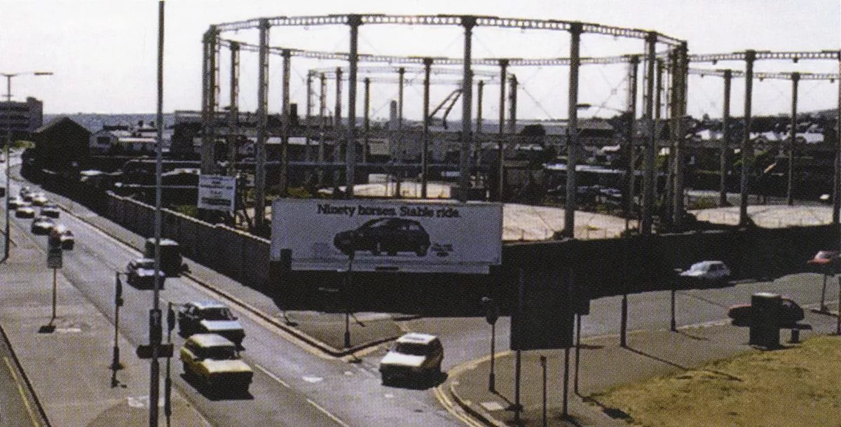
As you can see from the above image, there are some large structures built on the site, which would have had their own foundation type that may not be suitable for future structures. As well as this, gas facilities would commonly have some storage and equipment placed within the ground near the surface which may have been left or simply covered over after being demolished which would cause ground issues for future builds.
Source: Wales Online (2020)
In the surrounding area, just two streets over, there have been recordings of boreholes during site ground investigations prior to a construction. A borehole being in such proximity to the new construction is significant as there may be a high likelihood that there would be more, especially in our proposed construction site. It shows the borehole reaching around 20.25 metres deep and starting at around 3.5 metres, making it around 16.65 metres deep, a cause for concern as this can cause a dangerous collapse if the walls were to cave in.
This borehole can also help to ensure we check deep areas for boreholes when we conduct a borehole investigation, as it proves that the boreholes around this area can be quite deep under the surface.

Section 2 – Recommendations
Boreholes
Given the historical background of the surrounding area, a thorough investigation for boreholes should be of most significance considering the existence of boreholes in the surrounding area. The reason for this, as stated by BDWater, is that sealing boreholes correctly is essential to protecting ground water quality, by negative the fact that they could become contaminated and effect underground water. Part of the recorded information regarding the nearby borehole can be seen below:
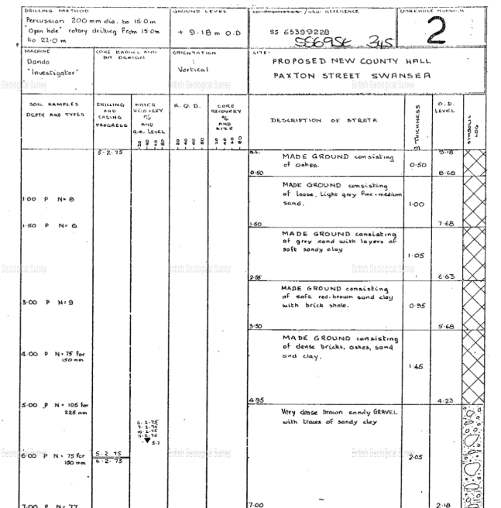
As you can see from the image, the borehole was found quite deep underneath surface, which should be considered when conducting the borehole investigation. If any boreholes are uncovered, they should be reported, recorded and then dealt with correctly. To fix the boreholes, as stated by Boreholes Solutions, an outer casing should be removed from the borehole and backfilled with a material, protect the outer wall from caving and to fill the hole in, and then finally capped off and sealed appropriately.

Causes from Previous Structures
Source: provided for assignment
Again, given the history of the site, we know a gas facility used to operate on this site. Gas facilities at that time would usually have some storage and equipment places under the surface, but close enough to the surface for access. After the demolition of the structure, as proven by Thomas, R, there may have been remnants from these underground gas work items that either may have been left or would have been removed and not dealt with after. Ultimately leaving holes dotted around the site hence the significance of investigating this. These could cause issues with the foundation of the site so should be investigated and dealt with. To amend these holes, if any, they should be filled with suitable soil or grout and tested after amendment to ensure it is stable for construction.
Ground Conditions
Going back to the borehole log above, it also shows that there was some loose soil, sand and clay under the surface but shallower under the surface. This should be investigated as it is nearby and could also apply to the soil on the site, this could result in instability in the foundation of the site during or after construction resulting in extreme issues and complicated amendments. The soil should be tested for stability prior to construction and should be sampled for research. If this issue was to occur, the soil should be compressed using a roller, and then more soil should be placed and compressed until the surface is level. A test should then be conducted to ensure the soil can handle extreme weight.
As well as this, the site is also located near a dock and the sea, this could have an impact on the soil of our site. A test on the water contents of the soil should be conducted to get a reading of the soils water content, this is significant as it can affect the properties of the soil. Soil with high water content can decrease its strength and as proved by British Geological Survey, can cause the soil to contract when it dries which can cause heaving to the building, causing issues to the foundations. If the soil water content is high, it can be amended with better drainage which would have to be installed.
Additionally, as the site used to be a gas facility it is entirely possible that the soil may be contaminated. This should also be tested to check, as this could cause several issues. It can be a big risk to human health, as mentioned by Ashfield Solutions Group who state that if any was to get into a water system or if inhaled or consumed in some capacity it can cause serious health problems. As well as this, it can create a dangerous work environment by being a massive hazard to those working on construction and especially ground investigation. It can also affect the stability of the foundation, as some types of contamination can affect the properties of the soil. To fix this issue if was to arise, I would suggest completely excavating the soil and replacing it with new and contaminated soil.

Underground Pipes and Cables
Historically, with the site once being a gas distribution site it is entirely possible that there may be pipes underground related to this. Not only this, but the location of this site is in a high traffic area with a high density of surrounding buildings. This means there is a possibility that there is pipe and cable work underground which would need to be avoided. Accidentally affecting any of these pipes could cause issues to a large surrounding area, whether that be water or gas shut off due to broken pipes. Forge Property state that water penetration from pipe leaks can be catastrophic for foundations as it can lead to erosion overtime. As it was once a gas distribution site there is a possibility of gas pipes being present below the surface, this would have to be identified and countered. These would either be avoided completely if possible, or other companies would have to be used to rework the pipe so that it is out of the way.

Social and Environmental issues
An issue for construction at this site is that it is in a very high traffic area, being close to a busy main road and especially close to nearby residents. Noise pollution could be a massive factor for the nearby residents, along with the workers, and with the lengthy investigation and building time it is likely to be of some issue to those living close by. I recommend noise pollution regulations should be checked beforehand to ensure they are being met, and as proven by GMT Rubber, most common noise pollution on a site are vehicles and machinery, therefore I recommend that as little machinery is used at one time to ensure there is no combined build-up of noise pollution to ensure these regulations are met, and for work to be carried out within busy days and hours.
In addition, the construction can be an eyesore for both residents and to those passing by on the main road. Given that there are not many solutions to this, I recommend advertising the construction online, so residents are educated about the construction. As well as this, I also suggest that a temporary wall is placed around the site so the public cannot see the works, and to also advertise on this wall what the construction is for. Also, adding an estimated date the construction is likely to end on the temporary wall could also help.
Furthermore, public transport could be affected as roads and pavements have a possibility of being temporarily closed due to the works being done. This would have to be identified before construction, so the public have this knowledge, but to also prevent any issue in this area occurring while the roads and pavements are busy. Additionally, there is a nearby bus depot that has heavy traffic, as well as a multistorey car park next door. I recommend both to be informed of the construction beforehand so that alternative routes can be identified and created before construction if needed, and to ensure that the car park can still operate as normal during the construction. Not only this, but if there is a concern for public safety and then results in the pause of construction, this could affect any contractors financially as it would extend construction time. Hence the significance of ensuring that there are alternative routes for the public to ensure they are safe if this was to arise.

Health and Safety
Health and safety is of upmost importance, so any issues that could arise during the ground investigation, such as dust, emissions of machinery, and pollutants should be accounted for beforehand. As this is a high traffic area, if any of these issues were to arise it would have a big impact on the public especially if the affect is large enough to reach the nearby bus depot, possibly affecting the public from travelling elsewhere as well as the financial effect it would have if the busses were unable to run. To prevent this, it is essential the soil is tested for any of these issues as well as informing the nearby facilities as well as a road works company in case there still may be an issue, as proven by Technics Group who state that coring provides insights into the structures, and allows for soil sample collection for laboratory testing to inform about the strength of material used.

Building Regulations & Codes of Practise
The building regulations and codes of practise must be covered beforehand the ensure all requirements are being met while constructing. Building regulations in Wales have several different parts, however some of the more significant areas, as proven by Gov.Wales include Site preparation and resistance to contaminants and moisture, Drainage and waste disposal, conservation of fuel and power and access to and use of buildings. We must ensure all requirements are met before the process of site investigation and construction begins.
Same goes with the codes of practise, they must be covered to ensure they are being met and are classified into the correct level in correspondence with our building size. These codes apply types of standards and procedures for the project, as proven by Designing Buildings who state that it sets out requirements to matters like working hours, liaison with neighbours, noise monitoring, waste management and traffic and transport. As we are located directly next to a main road, it is extremely important we keep a close eye on the traffic and transport.

Section 3 – Advised Building Foundation
As for the foundations of this site, I advise upon using a pile foundation. Pile foundations consist of concrete columns within the ground, at various points, for stability and to evenly spread the weight evenly throughout the surface. The columns can be of any length, as mentioned by Civil today who state that foundations can be as shallow and as deep as necessary. They are more stable the deeper they are, but all must be the same length, and any number of piles can be added. As well as this, if boreholes are uncovered during the site investigation, they can even be used for the pile foundations, given they are in the right place. This can save time and money as less soil would need to be excavated for the pile foundations. Furthermore, as the piles will need to be deep into the surface to provide the stability needed for such a large structure, other types of foundation would be difficult to successfully produce as it would need to be deep under the surface. As the foundations would have to be deep under the surface, other types of foundations would be difficult to do as materials would become more specific as the depth increases, making pile foundations the most cost-effective method for foundations on large buildings. An example of pile foundations can be seen below:
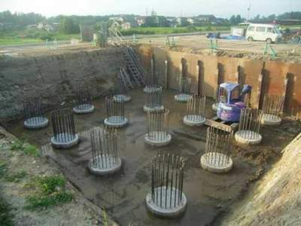
I recommend pile foundations as they work extremely well with loose or unsteady soil as they are placed deep under the surface. Referring to the borehole report earlier in this study, the existence of loose soil in the surrounding area and the existence of the gas facility that was present on this site, there is a high probability that loose soil is present within the site, making pile foundations the most effective foundation for this structure. Furthermore, steel beams can also be added for increased support if needed, further increasing stability if the situation calls for it.
Source: Civil Today (no date)
Additionally, given the surrounding area being very high traffic being next to a busy main road, the vibrations cause by the cars passing by, as well as the number of vehicles that would be using this structure after construction, could influence the stability of the soil, and causing it to become loose overtime. This is a further example of why pile foundations would be the best fit for a building of this height and weight as well as the very heavy nearby traffic, hence why I believe a foundation that works well with loose soil would be the best choice in this situation.

References
Ashfield Solutions Group (2024) Contaminated Land Risk Assessments: A Beginners Guide. Available at: https://www.ashfieldsolutions.com/blog/contaminated-land-risk-assessment-beginners-guide/#:~:text=Contamination%20in%20shallow%20soil%20could,occupants%20and%20an%20explosion%20risk. (Accessed on 10th January 2025)

BD Water (NO Date) Bores, Decommissioning. Available at: https://bdwater.com.au/bores/decommissioning

Borehole Solutions (2023) How are Boreholes Decommissioned after Geotechnical Testing? Available at: https://www.boreholesolutions.co.uk/blog/how-are-boreholes-decommissioned-after-geotechnical-testing/ (Accessed on: 11th January 2025)

British Geological Survey (No Date) Swelling and Shrinking Soils. Available at: https://www.bgs.ac.uk/geology-projects/shallow-geohazards/clay-shrink-swell/#:~:text=For%20example%2C%20if%20there%20is,the%20centre%20of%20a%20building. (Accessed on: 10th January 2025)

Civil today (No Date) What is Pile Foundation? Types of Pile Foundation. Available at: What is Pile Foundation? Types of Pile Foundation - Civil Engineering (Accessed 10th January 2025) (Photo 2)

Designing Buildings (2020) Code of Construction Practise. Available at: https://www.designingbuildings.co.uk/wiki/Code_of_construction_practice#:~:text=A%20code%20of%20construction%20practice,environmental%20impacts%20of%20construction%20works. (Accessed on: 10th January 2025)

Forge Property Consultants (2021) Going Underground – Foundation Movement and What it Could Mean. Available at: https://www.forgeproperty.co.uk/blog/going-underground-foundation-movement-and-what-it-could-mean/110#:~:text=Water%20penetration%20in%20general%20is,and%20brickwork%20in%20the%20vicinity. (Accessed on: 11th January 2025)

GMT Rubber (No Date) What is Noise Pollution in Construction? Available at: https://www.gmtrubber.com/what-is-noise-pollution-in-construction/#:~:text=Construction%20site%20noise%20is%20classed,as%20hammering%2C%20drilling%20or%20digging. (Accessed on: 10th January 2025)

Gov.Wales (No Date) Quick Guide to the Building Regulations. Available at: https://www.gov.wales/sites/default/files/publications/2021-12/quick-guide-to-the-building-regulations.pdf (Accessed on: 9th January 2025)

Technics Group (2023) Everything You Need to Know About Ground Investigation. Available at: https://www.technicsgroup.com/2023/10/everything-you-need-to-know-about-ground-investigations/ (Accessed on: 10th January 2025)

Thomas, R. (No Date) Regeneration & Development of Former Gasworks Sites. Available at: Pneumatic Chemistry & the Gasholder (Accessed 9th January 2025)

Wales Online (2020) What was there before these giant Swansea supermarkets arrived? Available at: What was there before these giant Swansea supermarkets arrived - Wales Online (Accessed on 9th January 2025) (Photo 1)

