Part 1: Create a reflective personal development plan (PDP) that includes personal and professional aims to help develop your skills as a professional practioner.

The purpose of this personal development plan is to help provide me with a self-reflective tool to help me achieve my vision and goals.
I am currently a first-year university student and working as a teaching assistant in a primary school. My long-term goal is to be a primary school teacher as whilst working at the primary school I have realised that this is a career I really enjoy and want to further myself in. Some of the strengths and personal qualities I possess is reliability, empathic, resilient, trustworthy and enthusiastic. I am a very friendly and approachable person. I have recently achieved my level three diploma in specialist supporting teaching and learning.
At the moment the weaknesses I have which I believe would hold me back in my career development is that, even though I truly believe I have all the practical quality and skills to become a teacher, I think my weakness right now is my academic knowledge and I also know I have to work on my self-belief. I believe the only obstacle stopping me from achieving my vision would be academic work.
To help me achieve better academic skills I have used the SMART goal framework.
- S (specific) Better academic skills within the year
- M (measurable) I will measure this by passing assignments
- A (attainable) I believe with the study resources available to me this is attainable
- R (relevant) This is extremely relevant to my career development
- T (time) My deadline is one year
My action plan to get me where I want to be will consist of setting objectives to help me improve my study skills.
My first objective will be: - Enhance academic research. The action this requires is to use online tools and attend thy library or online tutorials to help me enhance my research. The resources needed would be university library, google and online resources made available to me via my university hub. My target date for this would be by the end of the year. My success criteria would be to pass my assignments and for grades to increase each module.
Another objective to help me achieve my target is to improve note taking on what I learn from lectures. To do this I will use selective note taking and write down key concepts. I will also go over the lecture slides before the lecture so I can be aware of the key concepts of the lecture. I will also rephrase the lecture into my own words to help me understand better and not miss key points. My success criteria would be when I have a full set of organised notes for each module.
The support I will actively look for to help me achieve these is engaging with tutors when I receive my first academic feedback. I will also dedicate time to review my academic progress once available and organise all my lecture notes. Peer support is also available as we have a class group chat where we could share academic resources.
This plan will be a document that I review monthly when I receive assignment grades so that I can evaluate my progress. I will reflect on any feedback from my tutors to see if my new study habits from my pdp are working. If I find they are not successful and I am failing my academic studies, I will consult my lecturers to help me find a way to adapt my approach and update my plan.

Part 2: Design a briefing paper that explores the importance of reflective practise within the early years and analyses different reflective models.
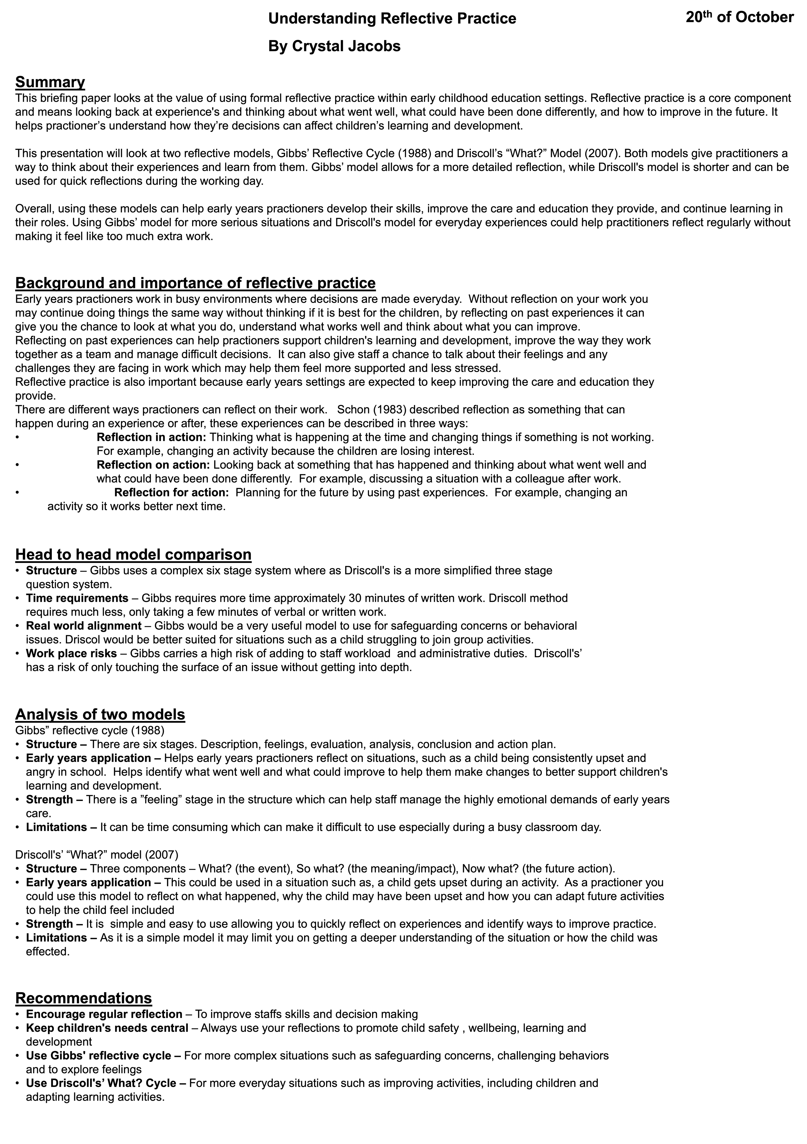
Part 3: Written piece – Recognise and analyse the significance of different aspects of professional practise and why these are important in meeting the individual and inclusive needs of children, including professional values, communication, multiagency work, observations, planning and the UNCRC.
In early years education and childcare, professional practice helps form the foundation of a child’s development, safety and well-being. To meet the needs of every child requires an individual structured approach that includes ethical principles, communication and action. This written essay will look at the importance of these different aspects of practise and focus on why they are important for childcare to work. It will also look at how the professional values work alongside the UNCRC (united nations convention on the rights of a child) to protect children’s rights. Every child is different and it is important that all children are treated fairly. To do this practioners must follow laws and guidance, communicate with parents and other professionals to provide the best possible support. This essay will explain how all this is used to help work together to meet children’s individual needs and provide a safe, supportive and inclusive learning environment.
Professional values, such as respect, inclusion, equality and fairness, are important in early years education because they provide care and learning opportunities for children. Practioners should make sure that every child has the opportunity to learn and develop, no matter what their background, culture or abilities. This could mean adapting activities so that all children could take part, for example, if a child had religious beliefs which could stop them attending a Christmas or easter event then adaptations could be made so that all children could be included.

The UNCRC (united nations convention on the rights of a child) is a legally binding human rights treaty that states the civil, political, economical, social and cultural rights of every child and young person under the age of eighteen. It is made up of fifty-four articles; I will be focusing on two articles to show how the UNCRC works alongside professional values. Article three states that the best interests of a child must be the main consideration when making decisions that affect them. In a primary school setting an example of this could be creating inclusive learning environments for children with neurodiversity such as sensory spaces and arranging table and chairs to account for their additional needs. Article twelve states that children have the right to express their views and have them taken seriously. This can be achieved by listening to children and allowing them to make age-appropriate descions, for example, in a primary school setting you could have a school council made up of pupils, allowing them to come up with ideas on how things in the school could be planned, such as school events, school trips etc.
By applying these values, you can create an environment where children feel valued, respected and safe and seen as individuals with their own thoughts rather than just being taught and looked after. You should adapt environments to meet the children’s rights instead of expecting every child to learn the same way such as providing different resources and offering additional support. Overall, using the professional values and the UNCRC articles helps create a supportive learning environment where every child is given the opportunity to reach their full potential.
Professional practise includes communication and working with other professionals if you recognise they are needed for the child’s best interest, such as, social services or occupational therapists. Communication skills are very important as it helps practioners understand and meet the child’s needs. Examples of good communication can include listening, sharing information clearly and building good relationships, not just with the children but also with the parents/carers as they can make you aware of any difficulties that they think the child can be facing. Multi agency practise is when different professionals work together to meet the child’s needs. These are professionals such as teachers, health visitors, speech and language therapists and social workers. By working together, they can help to provide a more complete understanding of the child’s needs as each profession has a different set of skills and knowledge. For example, if a primary school teacher had concerns that a child was struggling with their speech, they would then use their communication to discuss concerns with the child’s parents/carer. With the parents’ consent the school could then work with a speech and language therapist to find out any support they could offer the child in the school setting to develop their communication skills, this is an example of how different professions can work together to meet the needs of a child. However, multi-agency work can have its challenges, different professions may have different goals or priorities, for example, a GP would be more focused on the health of a child whilst a social worker would look at child safety in the family setting and this could result in a disagreement on what issue to focus on first. Another barrier which would need careful handling is confidentiality which is a very important factor for the child’s best interests. Sharing information about a child must always be done in accordance with the Dat protection act 2018, although in some circumstances, safeguarding would require you to break confidentiality where there is a concern a child is suffering, or is likely to suffer, significant harm, neglect, or emotional, physical or sexual abuse. Clear records and communication between professions can help to reduce any challenges. Overall, communication and multi-agency practice helps to make sure that children receive support that meets their individual needs. To make children feel supported, included and able to reach full potential, professional and families need to work together effectively.
There is a process that can help early years practioners support the child’s learning and development, The Pedagogical cycle. This process helps to understand how children learn and then identify ways to support individual needs by observing children, assessing their needs, planning activities and putting these plans into practice and then reviewing the results. Observation is the important part of the process, it allows you to see what the child enjoys, what they can and cannot do and observe if they need extra support. For example, you may have observed that the child enjoys playing and interacting with children but struggles to do things independently. Observation allows you to better understand the child’s interests and developments. The next step in the process would be assessment, where you use your observations to understand the child’s progress and plan the next steps for their learning and development. For example, if a child was finding it difficult to share you could organise a group activity that encourages taking turns, such as a game where they roll a ball back and fore, by putting this activity into practise you can then review how well it works. If an activity does not help the child to share the practioner can then change their approach. This is why the Pedagogical cycle is important, as planning should be based on a child’s needs rather than use the same approach for every child as every child develops differently at different stages, you should not expect them to learn at the same pace. Overall, the pedagogical cycle helps practioners make decisions for the child’s development by observing, assessing, planning, acting and reviewing to help the child reach their full potential.
In conclusion, professional practise in early years and primary education is important for supporting every child’s learning, development and wellbeing. Practioners should always show their professional values, such as equality, fairness, respect and inclusion to ensure that all children feel safe and valued. The UNCRC highlights the importance of protecting children’s rights, putting their best interests’ firsts and listening to their views. Good communication and multi-agency working are also essential because they allow different professions and parents to use their different knowledge sets to work together to meet the child’s needs and ensure they are receiving the right support. The pedagogical is also important as it allows you to observe children, assess development, plan activities and review progress which in turn helps to recognise strengths and identify areas where support may be needed. Overall, these areas work together to help create a positive, safe and inclusive learning environment so all children have the opportunity to learn, develop and reach their full potential.

Referencing list
Children’s Commissioner for Wales. (2019). Home - Children’s Commissioner for Wales. [online] Available at: https://www.childcomwales.org.uk/ [Accessed 25 Oct. 2026].
early-education.org.uk. (n.d.). Home | early education. [online] Available at: https://early-education.org.uk [Accessed 25 Oct. 2026].
help-for-early-years-providers.education.gov.uk. (2021). Help for early years providers - Department for Education. [online] Available at: https://help-for-early-years-providers.education.gov.uk [Accessed 25 Oct. 2026].
Legislation.gov.uk. (2020). Rights of children and young persons (Wales) measure 2011. [online] Available at: https://www.legislation.gov.uk/mwa/2011/2 [Accessed 25 Oct. 2026].
NSPCC (2020). NSPCC learning home. [online] NSPCC Learning. Available at: https://learning.nspcc.org.uk [Accessed 25 Oct. 2026].
Safeguarding Network - confidence in safeguarding. (n.d.). Safeguarding network - confidence in safeguarding. [online] Available at: https://safeguarding.network [Accessed 25 Oct. 2026].
Unicef UK. (n.d.). UNICEF UK - children’s charity - for every child in danger. [online] Available at: https://unicef.org.uk [Accessed 25 Oct. 2026].
Wales Safeguarding Procedures (2023). Safeguarding Wales. [online] www.safeguarding.wales. Available at: https://www.safeguarding.wales/en/ [Accessed 25 Oct. 2026].
Welsh Government (2023). Early childhood play, learning and care in Wales - HWB. [online] hwb.gov.wales. Available at: https://hwb.gov.wales/curriculum-for-wales/early-childhood-play-learning-and-care-in-wales [Accessed 25 Oct. 2026].
www.careinspectorate.wales. (n.d.). Home | care inspectorate wales. [online] Available at: https://www.careinspectorate.wales [Accessed 25 Oct. 2026].

Poster reference list
Department for education (DfE), 2024. Statutory framework for the early years foundation stage. London: HM Government.
Driscoll,J. ed., 2007. Practising clinical supervision. 2nd ed. Edingburgh: Elsevier.
Early years coalition, 2021. Birth to 5 Matters. London: Early Education.
Gibbs, G., 1988. Learning by doing. London: Further Education Unit

