  Component One:  What are the key skills required when working in the housekeeping team? 750 words (+/- 10%)  Contribution to Overall Module Assessment: 25% | Student No: | Gergana Nikolova  2125766
 | Module Title: | BMIH
 | Module Code: | 4006
 | Lecturer: | Laurence Blake
In order to work efficiently as a housekeeping member within the hospitality sector, it is important for the member to attain both soft skills and hard skills. Time management skill is a mandatory skill required to be possessed by housekeeping members (Quick, 2020). Time management skill is a soft skill that supports individuals to complete their responsibilities on time along with completing tasks in an organized way. Hence, it has been identified as a key skill for housekeeping members within the hospitality sector as it supports delivering services like cleaning, vacuuming, and dusting on time. Hence, it supports the organisations to ensure overall satisfactory quality of service delivery to the guests and to manage the cleanliness in the service areas as well as in the rooms (Bridger 2018).
Working diligently and independently is another key skill that is required to be possessed by the people working in housekeeping services. Working diligently supports the people working in the housekeeping department to ensure delivering housekeeping services to the guests in an empathetic manner (Raghubalan and Raghubalan, 2009). Hence, it supports creating mutual trust and satisfaction among the guests resulting in the better success of the organisations to retain customers. Furthermore, working independently supports the housekeeping services to stay prepared to meet the personalized needs of the guests (Sharma, Chaudhary and Singh (2019). It creates an opportunity for them not to wait for the instructions of the team leaders and to offer independent solutions to any cleanliness-related urgent concern of the guests, Hence, it enhances the quality of staying experience of the guests resulting in a better chance for the employee retention rate (Mullins and Dossor, 2013). For example, Marriot, a renowned hotel in the UK and across the international hospitality industry has implemented a housekeeping principle that encourages the housekeeping members to work independently. Moreover, focusing on the operational excellence in the department the firm has encouraged the housekeeping member to stay diligent and punctual in their job responsibilities so that the guests stay satisfied during their stay regarding the cleanliness and staff behaviour. This policy and principle of the hotel chain have been a key reason for the success it enjoys in the international hotel industry (Marriott, 2023).
Prioritization is another key skill that is required for a housekeeping employee. Attaining this skill supports the individuals to deliver performance based on the sequence of customer needs and priority if the concern is related to cleanliness. Therefore, having these skills creates an opportunity for businesses to improve the overall organisation of the housekeeping job and to ensure elevated customer satisfaction (Ferdinand and Kitchin 2017). Being customer-centric is another soft skill that is required to become an efficient housekeeping member. Delivering friendly behaviour within the responsibilities of a housekeeping system elevates the quality of experience of the customers and increases the feasibility of success within the hospitality industry (Rogers, 2008).
For example, Premier Inn is another renowned hotel chain in the UK that is focused on delivering premium quality customer service to its guests in the housekeeping department. The management expects the housekeeping service providers will maintain their work ethics along with having the confidence to communicate with the guests and resolve their queries or service requests as soon as possible (Whit Bread Careers, 2023). This focus of the management has supported the development of a workforce focused on delivering the best possible customer-centric housekeeping services, which has been a key and critical success factor for the firm in delivering satisfactory customer services.
In order to work with efficiency as a housekeeping worker, along with the soft skills mentioned above, some key hard skills also are required. Other than personal characteristics professional expertise is another key need for being able to work as a successful housekeeping service provider in the hospitality sector. Ability to deep clean has been identified as a key requirement for housekeeping service providers (Rogers 2008). The individuals working in the housekeeping services are responsible for cleaning the surface areas, even the areas hard to reach. Having this ability the individuals can ensure cleanliness in the hotel premises resulting in higher guest satisfaction. Mopping is another key skill for housekeeping service providers, which has been identified as increasing in terms of requirement after the emergence of the Covid-19 pandemic. Mopping supports the housekeeping employees to ensure better sanitization on the surface area of the hotels. Therefore, it ensures better performance of the employees to ensure customer satisfaction in terms of securing their safety whilst staying at the hotels. Vacuuming and dusting are the other key hard skills that are mandatory for housekeeping service providers. It ensures efficient cleaning of the surface, furniture and carpet of the hotels resulting in an elevated staying experience for the guests.

Word Count | 750

Component Two:
Contribution to Overall Module Assessment: 25%
In this scenario – You have just been promoted to team leader for a floor within the hotel. A guest complains that on their arrival, their room had not been properly cleaned. Create an action plan and answer the following questions.

Problem | Why did it happen? | What are you going to do? | How will you prevent this from happening in the future? | What measures would you introduce to improve team effectiveness?
The cleanliness in the hotel room was not properly maintained | Lack of employees in the housekeeping department along with lack of expertise in time management among the housekeeping employees | Asking for an apology from the guests | Delivering personalized training to the guilty housekeeping employees regarding time management skills and expertise in cleaning the rooms | Monitoring each room personally 10 minutes before the guests enter the room
Guests experiencing the uncleanliness situation in the room resulting dissatisfied staying experience | As the cleanliness of the rooms was not as per the desired standard of the customers, it created customer dissatisfaction | Assuring customers that the cleanliness of the room will be maintained as soon as possible | Delivering knowledge to the housekeeping member regarding the standard of cleanliness needed to be maintained and delivering strict yet achievable targets for the cleaning employees | Developing per-day goal sheets for each housekeeping employee and monitoring them minutely
Guests becoming irritated and want to lodge a complaint against the quality of housekeeping services to the top management | As the guests did not expect the room not being cleaned on their arrival at the hotel room they became agitated with the housekeeping services | Guests will be offered to stay at any other room, which is cleaned if they want so that they do not have to wait at the lobby | Employees will be strictly delivered notice that any delay will not be entertained especially in cleaning the rooms further | Checking the employees in the housekeeping services through CCTV cameras while they enter
Guests asking to cancel the booking and seeking the return of their advance booking | Guests being late in entering the rooms they have booked | Heartiest apologies will be asked from the guests and they will be offered to choose any other room for their stay | Rooms will be monitored personally by the managers before the check.in time of the guests and any gap in the cleanliness will be taken care of as early as possible | Checking the check-in times each day will be required to ensure guests are welcome following a standardized manner for each booking
Guests threatened to complain in the consumer forum regarding the uncleanliness of the hotel rooms on time | As the standards of cleanliness and punctuality have not been maintained the guests became dissatisfied | Guests will be promised that no such incident will take place in the future. | Guests will be welcome to maintain all the necessary standards in the housekeeping department | Personalized training will be delivered to the employees every week, and a review of their performance will be done

Component Three:
Contribution to Overall Module Assessment: 50%
Your task is to create and prepare a presentation following the detailed scenario provided below.

As the floor housekeeping manager and given the recent guest complaints you need to put together a basic training presentation for your colleagues within the housekeeping team to get the best out of them, ensure that brand standard is being achieved and that Health and Safety procedures are also being followed.

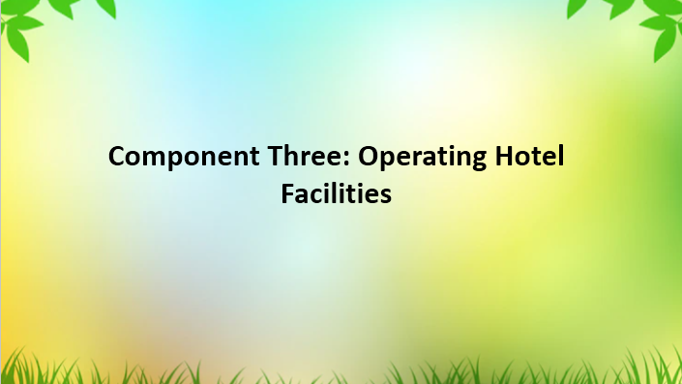

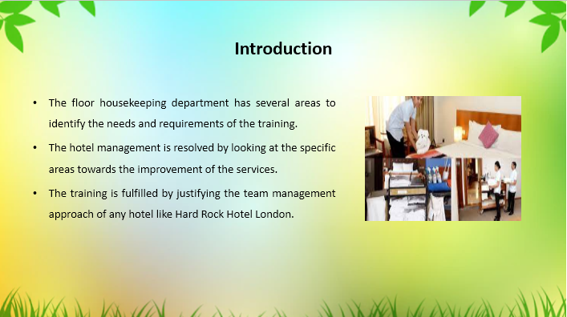

Training Notes: The floor housekeeping department has the key areas to identify the needs for training that improve the business values in maintaining the activities (Bridger, 2018). The hotel management activities are executed by the housekeepers with improving the services that enhance the chance to determine the team. It is seen that the specific areas are evaluated in determining the services that are needed towards the hotel management. It is seen that Hard Rock Hotel practices the training I UK to develop the business by following the areas like cleaning, equipment using, food presenting, communication and guest etiquette consideration.
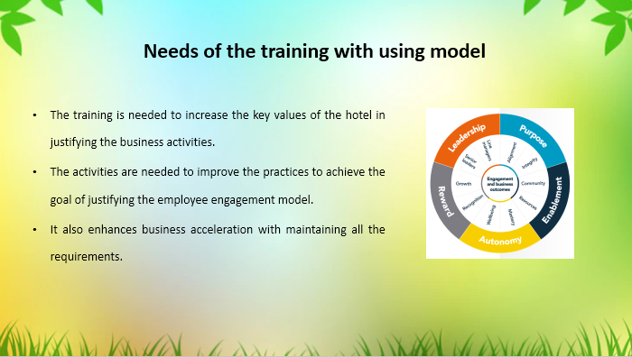

Training Notes: The training is required to provide effective knowledge in order to justify the key business practices. The manager is involved in justifying the managerial approaches for developing the system. The activities are evaluated in demonstrating the business goal by providing the best practices. It enhances the business values and increases the performance to earn more profits than before in the UK. The employee engagement model is used to train the employees in the hotel where the Purpose, enablement, autonomy, reward and leadership skill are justified. The model identifies the workplace maintenance practice with the team management in the working environment (Abdurrahman, et al., 2023).

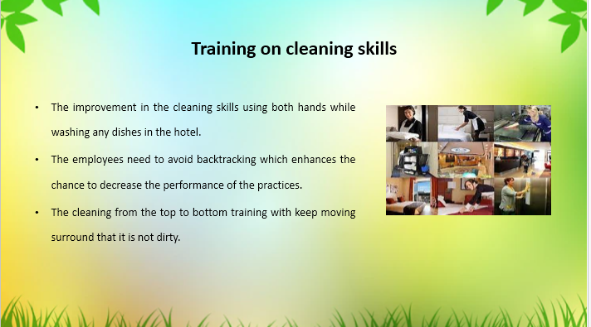

Training Notes: The training on the cleaning skill is improved by following the key areas that investigate the chance to determine the business. Hard Rock Hotel London is also involved in providing training in the UK to avoid mistakes that decrease the cleaning performance. It is seen that the training program is accomplished by determining the work clockwise keep moving surroundings to check the dirt.

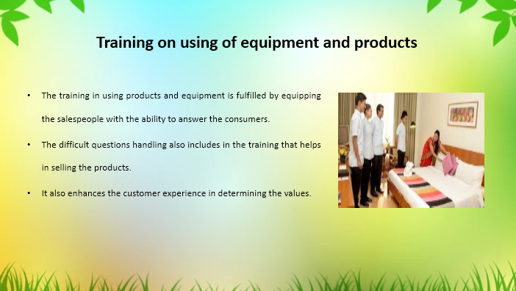

Training Notes: The training on the use of the equipment and products using is based on the internal servicing system to determine the team management. It is seen that Hard Rock Hotel also practise training to improve the business activities that increase the valuation of the business. it enhances the customer's experience in the organisation by justifying the management system of the servicing while handling equipment and products to sell.

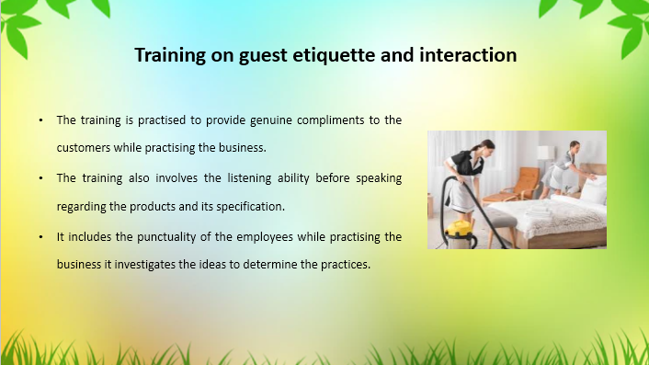

Training Notes: The training programme is executed by managers of the hotel with providing proper justification to accomplish the service ideas. It is seen that the organisation has the chance to identify the valuation towards the training practices in the UK. It is also seen that punctuality also enhances the behaviours among the employees towards proper handling of the customers while getting services.

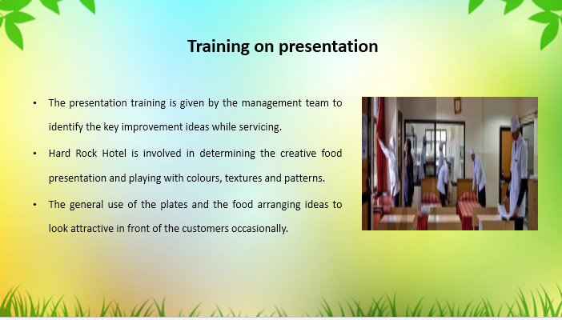

Training Notes: The food presentation training is also given by the managers in case of occasion handling like wedding or ceremony. Team management provides the basic presentation skills development ideas with specific design playing with the colours (Leiter, et al., 2010). The team also arranges the justification on which the development of the training is fulfilled. The general use of plate arranging and food presenting was also done by Hard Rock Hotel in the UK to maintain its status in the hospitality industry.

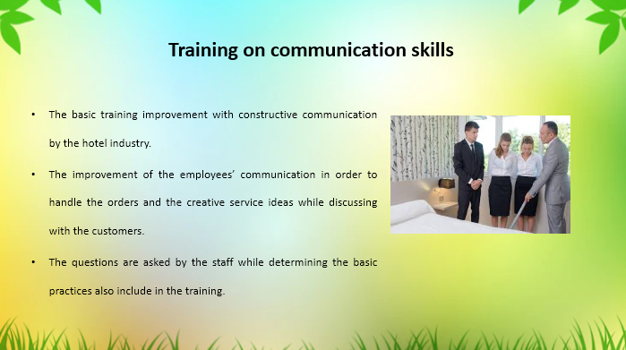

Training Notes: Training in communication skills is required for improving the basic knowledge of the English language in the UK. Hard Rock Hotel is also involved in providing training to the customers while justifying the practices in food servicing (Tavitiyaman, et al., 2022). The training benefits the business to take orders and understand the actual service area to identify the business justification
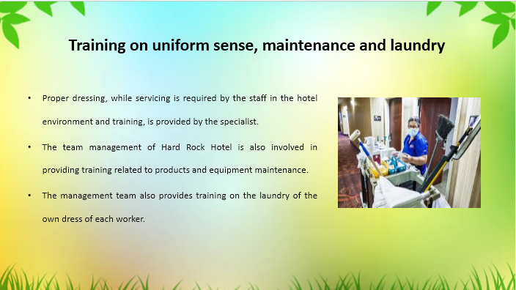

Training Notes: The business is improved by determining the proper valuation, where the management investigates the ideas regarding the improvement of the uniform and dressing sense to present in front of customers (Lashley, 2022). The maintenance training is also given by the team in order to justify the business effectiveness in the UK.

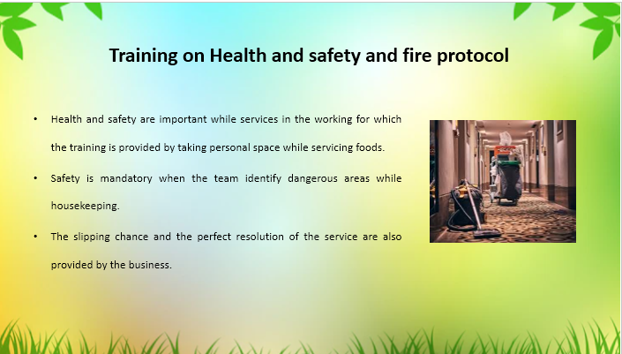

Training Notes: Training on health and safety is needed to determine the value of the business and it is seen that the organisation improve the key areas by determining the values of the training process (Cottrell, 2019). The team has identified mandating the servicing challenges and safety to protect from dangerous situations like slipping. Hard Rock is involved in providing the training while the business has the chance to determine the workplace.

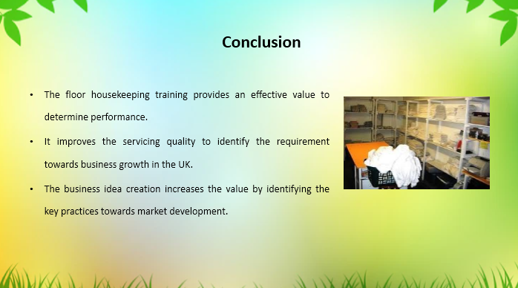

Training Notes: The training session improve the employees with basic needs fulfilment that enhance the chance to justify the market effectiveness. It is seen that the Hard Rock hotel also involve in providing the following training to improve the business.
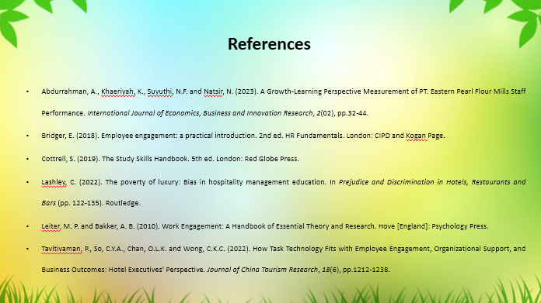


References
Quick, L. (2020). Managing events: Real challenges, real outcomes. Managing Events, pp.1-480.
Raghubalan, G. and Raghubalan, S. (2009). Hotel housekeeping: Operations and management. Oxford University Press.
Mullins, L. and Dossor, P. (2013) Hospitality Management and Organisational Behaviour. 5th ed. Harlow: Pearson.
Sharma, N., Chaudhary, N. and Singh, V. (2019) Management Techniques For Employee Engagement In Contemporary Organizations. Hershey, Pennsylvania: IGI Global.
Rogers, T. (2008) Conferences and conventions a global industry (2nd ed., Events management series). Oxford ; Boston: Butterworth-Heinemann.
Ferdinand, N. and Kitchin, P. (2017) Events Management - An International Approach. 2nd ed. London: SAGE Publications Ltd.
Abdurrahman, A., Khaeriyah, K., Suyuthi, N.F. and Natsir, N. (2023). A Growth-Learning Perspective Measurement of PT. Eastern Pearl Flour Mills Staff Performance. International Journal of Economics, Business and Innovation Research, 2(02), pp.32-44.
Bridger, E. (2018). Employee engagement: a practical introduction. 2nd ed. HR Fundamentals. London: CIPD and Kogan Page.
Cottrell, S. (2019). The Study Skills Handbook. 5th ed. London: Red Globe Press.
Lashley, C. (2022). The poverty of luxury: Bias in hospitality management education. In Prejudice and Discrimination in Hotels, Restaurants and Bars (pp. 122-135). Routledge.
Leiter, M. P. and Bakker, A. B. (2010). Work Engagement: A Handbook of Essential Theory and Research. Hove [England]: Psychology Press.
Tavitiyaman, P., So, C.Y.A., Chan, O.L.K. and Wong, C.K.C. (2022). How Task Technology Fits with Employee Engagement, Organizational Support, and Business Outcomes: Hotel Executives’ Perspective. Journal of China Tourism Research, 18(6), pp.1212-1238

