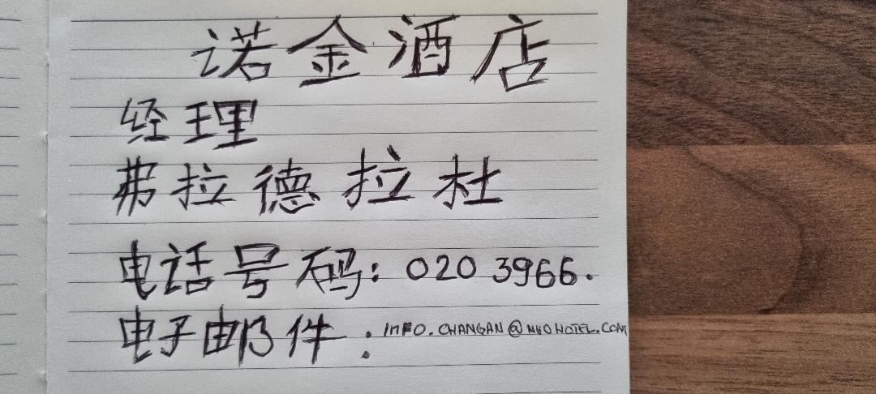

Mandarin business card, Vlad Alexandru Radu 2111633 for the first assignment due on the 4th of November. Hope it is all good.

