Ibrahim Balogun
Network Programmability assignment 2

Contents
Introduction 1
Part 1 1
Part 2 1
Part 3 1
Part 4 3
Part 5 4
Part 6 5
Problems 5
Conclusion 6

Introduction
The pursue of my code is to create a programme that will display the Premier Leagues fixtures for each week of the season. Additionally, when the matches are over the programme automatically updates and display the score and the programme will show the upcoming fixtures for the following week. The programme will perform throughout the entire Premier League season and onwards. My aim for my programme is to get it working, to a high standard so matches can be displayed.

Part 1
The first thing I did was to make sure my python programme works, and my get requests work as well, as shown in figure 1, I had to find where my Python programme is stored and enable the request, once finding where the requests are stored, I entered the command “pip install requests.” this installed files that would allow my computer system to enable the requests as shown in figure 1.

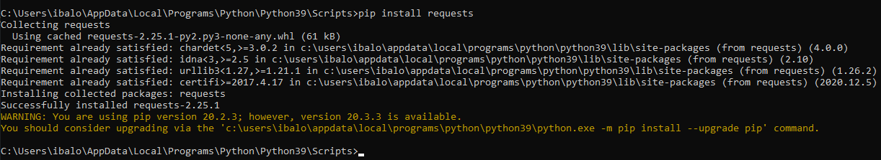
Figure 1

Part 2
Then to test that all my libraries are working I ran a hello world test, I typed in code that when run displays “hello world” when run in figure 2. My test results can be seen in figure 3; this shows that all my libraries are working.
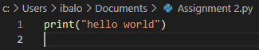
Figure 2

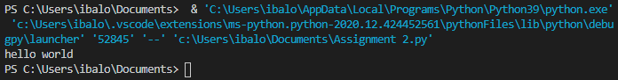
Figure 3

Part 3
Next, I processed to create the programme, as shown in figure 5. Figure 5 shows my first attempt at creating the programme; I started by finding out where my authentication token is I used the website (https://www.football-data.org/) to find my token, once I was on the site I signed in, and it gave me an application programming interface token, this can be seen in figure 4. Once I have got the application programming interface token and the destination for my request, I can start writing the programme, as shown in figure 5. The reason I need to add these details in my code is so when executing the code; I can gain access to the content from the API link by using the token. Figure 6 show the results of the code, as you can see it is puzzling to read, as unnecessary information is being displayed and the way the text is has been laid out is not that help to read, the reason this has happed is that I have not given my code instruction on how I would like my text to be formatted.
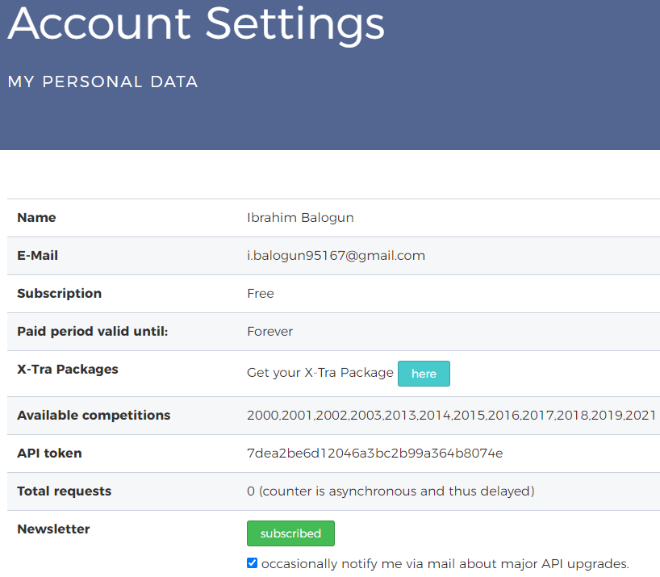
Figure 4

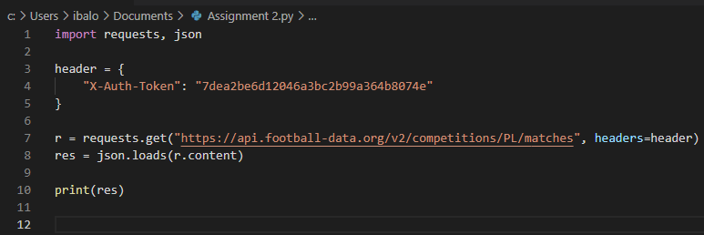
Figure 5

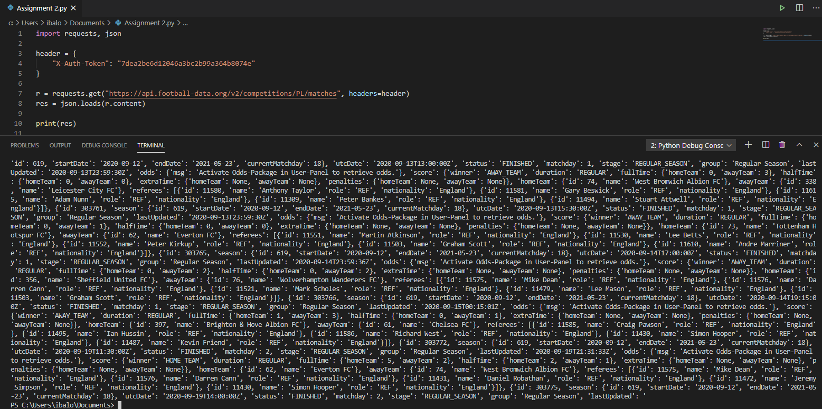
Figure 6

Part 4
To ensure that the formatting problem I had would not happen again, I add code that would take information about the matches, seasons, and the current match day. This can be seen in figure 7. The way I decided to let my code to work is by looping the present match day, as this can be found on the API and returning the information into the function. Once I got this, I was able to pull the match days in the URL to allow me to see the matchday. My code results can be seen in figure 8, as match details can be seen a lot clearer, without having lots of unnecessary text; however, removing the id’s from the test will make it a lot cleaner, and that is what I will do next.
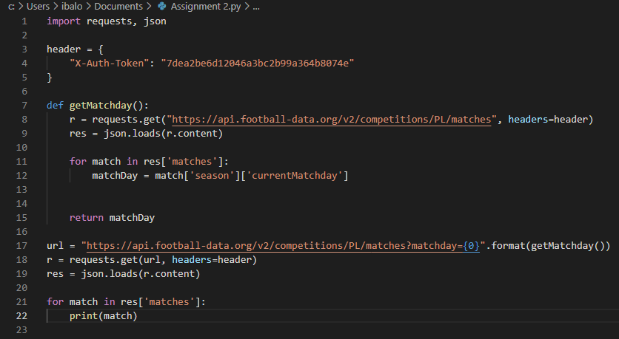
Figure 7

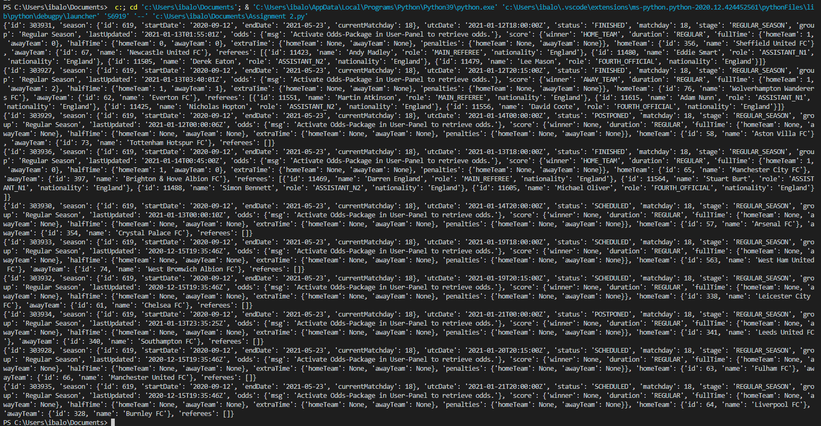
Figure 8

Part 5
In figure 9, I decided to create a way that matches would be displayed clearly with only the correct information available, which is who is playing the score and the match. I also add a system where if a match is over the scores will be displayed. I did this by creating an IF statement, so if the football matches are finished, the scores will be displayed; I used format function, as this allowed me to arrange the output from the API. Figure 10 shows the outcome of using the formatting function and the IF statement, as some games are over, yet others are still scheduled to be healed, even the time and date are shown in the displayed.
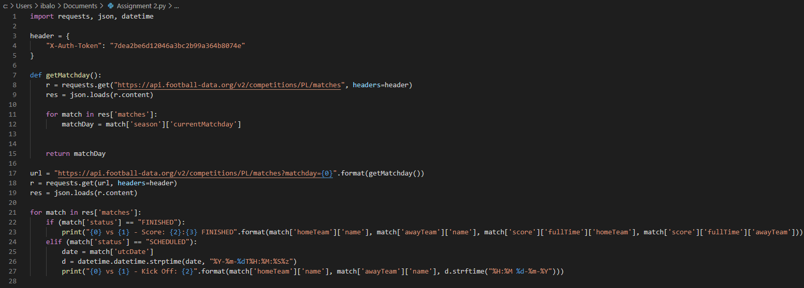
Figure 9

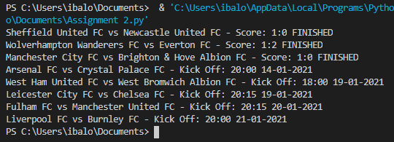
Figure 10

Part 6
The last stage of the programme contains typically content that will have the end-user of the software; this content can be found in a “.txt” format and consists of basic instructions for the end-user. Figure 11 shows my vision of this.
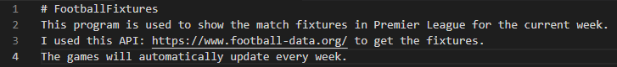
Figure 11

Problems
When creating my programme, there were lots of problems I encountered many of them where basic syntax errors that were quickly corrected, some were a lot more troublesome to fix. Figure 12 shows one of the outcomes of my code, as you can see, the formatting is acceptable; however, it is a bit difficult to read, changes will need to be made to this format. Figure 13 shows another updated/ fixed version of my I made during testing to try and figure out the optimal way I would like to set out my code but still needs to be changed.
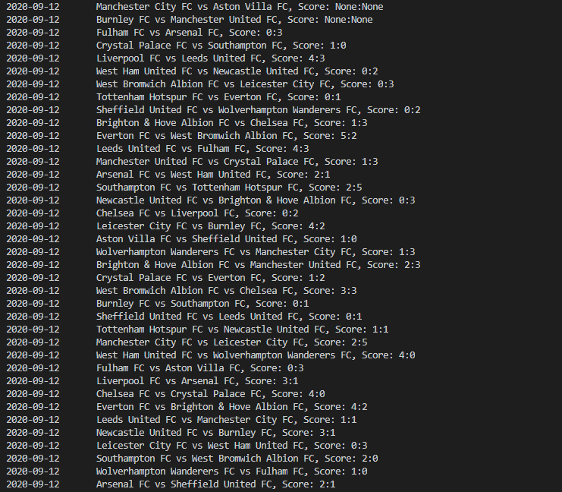
Figure 12

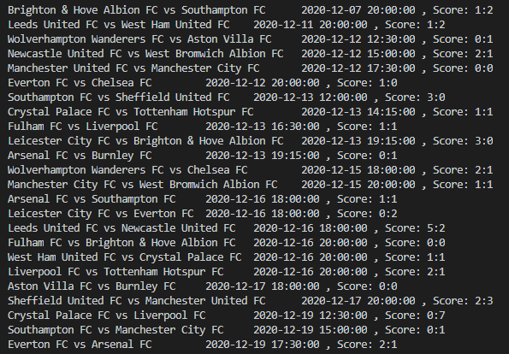
Figure 13

Conclusion
My aim of having a fully functional code was achieved; however, I felt there was more I could have added more to streamline the experience for the end-user. What I could do in the future with the code, is add a feature whereby entering a team name would bring up their previous, current and upcoming matches for the season, additionally adding what day the matches are played on is it a Monday or Tuesday and I would like to add a winnability rating to teams that match up with each other, the way this would work is from all the past matchups which team won or lost, then a percentage will be given of the probability of a team to lose or win.

