

Academic Skill
Student name: Roselyn Bunda
Student ID: 2414716
Module Code: LCLM4001
Lecturer: Timothy Hopkins

Date

11/12/2024

Table of Contents

1 Introduction 3
2 Notetaking 3
3 Paraphrasing 5
4 Gibbs model 6
5 Reflection 8
6 Reference 9
7 Appendix 10

1.INTRODUCTION
This is all about my self-experience learning about academic skills: note-taking; paraphrasing; reflection. This will use Gibbs model to help me explain my experience. To make this report I did the following: I went back to my notes, picked out some details I wanted to talk about.

2 Notetaking
Description
For example, in a week 2, I learned about NOTE- TAKING.
I have learned five note-taking methods, for example: Linear notes; Cornell notes; Diagrammatic, mind-map and tabular notes.
We learned for example that Linear note is a normal note for daily use like a grocery note, when you need to make list what are you going to buy at the supermarket. Cornell notes are two types of CUES and Note. This gives you space to say what you think what been told. [See appendix 3]

Feelings
During the class I felt quite interested. But I feel a bit confused after.
And, even I understand but, in my mind, not still confidence.
Some of the topic I find too easy and some hard.
Homework I always feel frustrated if I cannot answer.
I wanted to be my homework done after the end of the day after class that make me feel happy.

Evaluation
This note is very useful, and I never know about it. But know I am more knowledgeable about this.
It is useful if I can remember everything after, and always looking my note.
Analysis
Because I find it difficult to understand. I am struggling to understand what my lecturer explaining because it to fast.
Conclusion
I would say I cannot make it own my own without asking for help. In my point of view its hard. I need to improve my learning process.
Action
I need to practice hearing information quickly and writing notes from it at the same time.
I could listen to a 5-minute radio news programme and try to write notes from it as I listen.
I can use my note taking skills in other classes.

PARAPHARASING
Gibbs Model
Description
We looked at paraphrasing in Week 4.
We wrote a sentence about our lives in our own words. We needed to change the first sentence using different techniques. We used synonyms, we changed word order, and changing word class.[see appendix 5]
Feelings
At first, I felt hard after I found not really that hard what I thought.
Evaluation
This note is very useful, and I never know about it. But know I am more knowledgeable about this.
Analysis
I have problems with this because my use of English is not as good as I would like. When I came to England my English is not good enough and it was very basic.
The first thing that I was thinking when I came to England is learned how to properly speak in English that is the time that I decided to go to school.
Conclusion
I have difficulty my English speaking and also my paraphrasing understanding.
Action Plan
I need to practice my English, and I need to practice my paraphrasing.

Gibbs
Reflection Cycle
(The University of Edinburgh, 2024 [Adapted by the Author])
Description
Note Taking

Action plan
I wanted to be challenged myself in a new area for thregrowth
Feelings
Nervous at the same time excited

Conclusion
It has been a great moment to develop my knowledge and understanding
Evaluation
I am determined to focus my learning

Analysis
The module is unfamiliar to me beacouse I do not have this in my previous learning

(Source: the Author)

Conclusion
I have learned from my previous/experience I progress my learnings, expanded my knowledge made all things possible to pursue dreams my accomplishments my gaols in life more over I will continue to share my learnings to other people who has the same experience in my experience.
In this time in my life, I will eam to developer my learnings to pursue, to finish my study to
get my high-level certificate.

REFLECTION
For example, in a week 6, I learn about Reflection.
It is useful if I can remember everything after in class and always looking my notes. I felt a bit confused after; I would say I can’t make its own.
In my point of view its hard. I need more time to learned.
Feelings During the class I felt quite interested. But I feel a bit confused after.
And, even I understand but, in my mind, not still confidence.
Some of the topic I find too easy and some hard.
Homework, I always feel frustrated if I cannot answer.
I wanted to be my homework done after the end of the day after class that make me feel happy.[see appendix 8]

Conclusion
Its not easy for me the paraphrasing I am struggling now.
Action plan
I need more practice paraphrasing to improve it.

Reference
‌Sewell, C. (n.d.). LibGuides: Reflective Practice Toolkit: Introduction. [online] libguides.cam.ac.uk. Available at: https://libguides.cam.ac.uk/reflectivepracticetoolkit.
‌[Accessed: 14 Dec 2024]
The University of Edinburgh (2024). Gibbs’ Reflective Cycle. [online] The University of Edinburgh. Available at: https://reflection.ed.ac.uk/reflectors-toolkit/reflecting-on-experience/gibbs-reflective-cycle. [Accessed: 11 Dec 2024]

Appendices
Appendix 1 - Notetaking

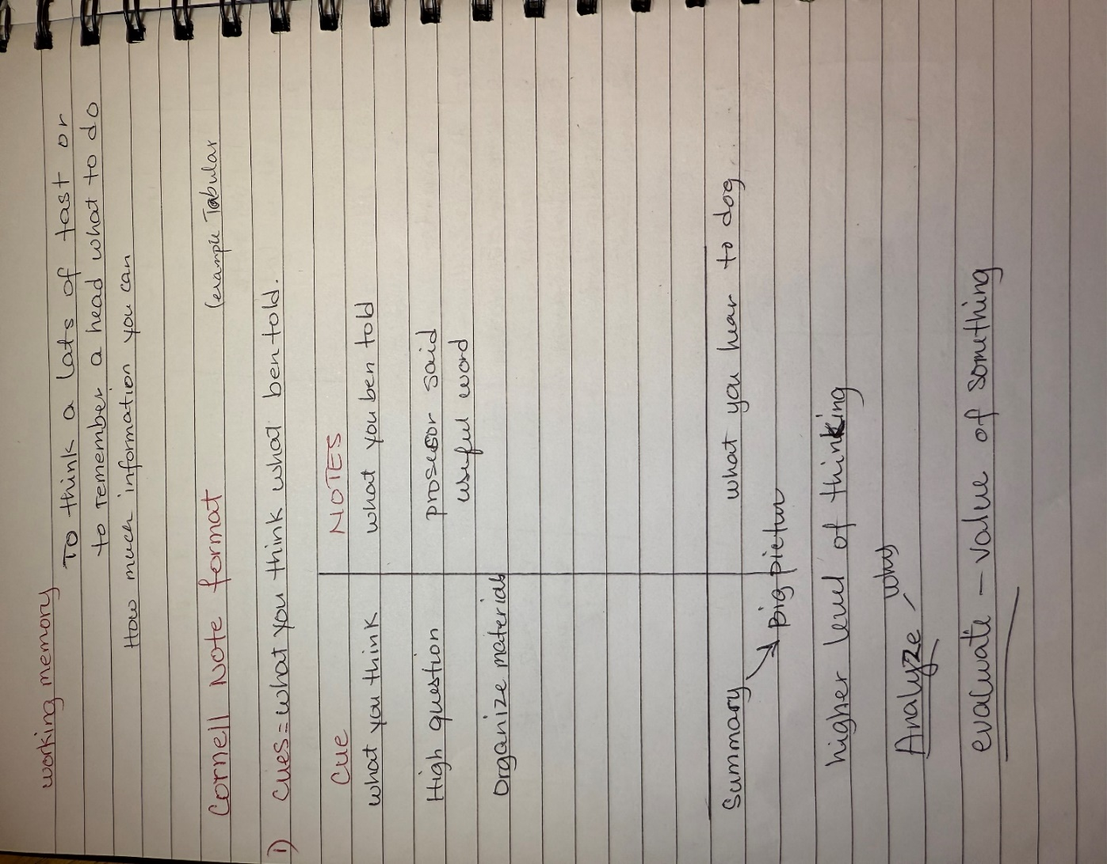

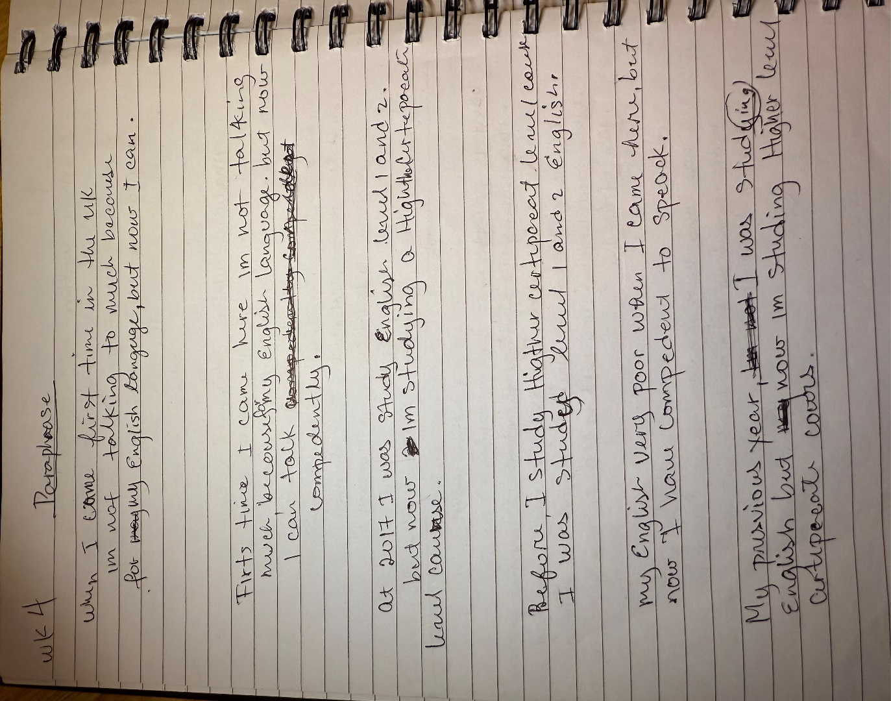
Appendix 2 Paraphrasing

Appendix 3 Reflection 

