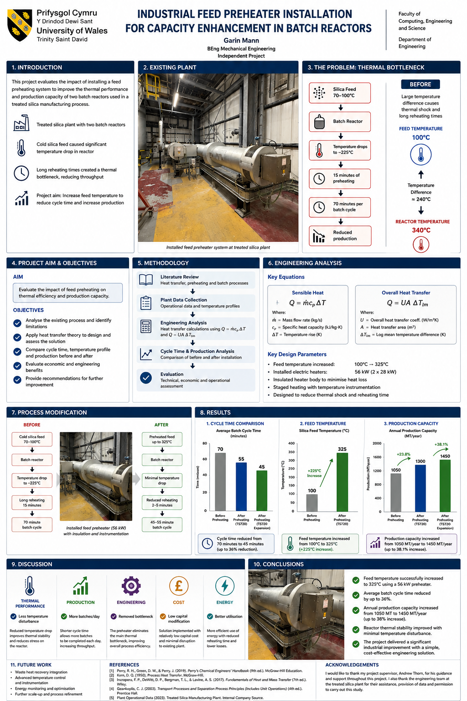
C c c c c c c c c c c c c c c c c c c cc

