Network Operating Systems and Services (NOSS) ACCA5023
Routing and Packet Filtering within Core TCP/IP Services and Critical Failover/Redundancy Practices

Worksheet Four

Network Operating Systems and Services – ACCA5023
Sarah Rule - 1810755

Worksheet Two

Task One: Utilising ARP and Routing Tables

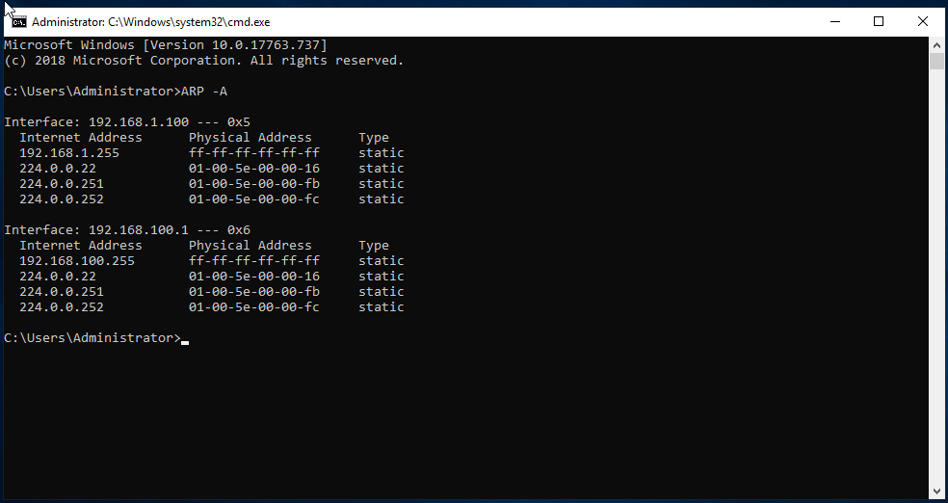
Figure 1
The user has produced an ARP table using the command prompt of the PC.

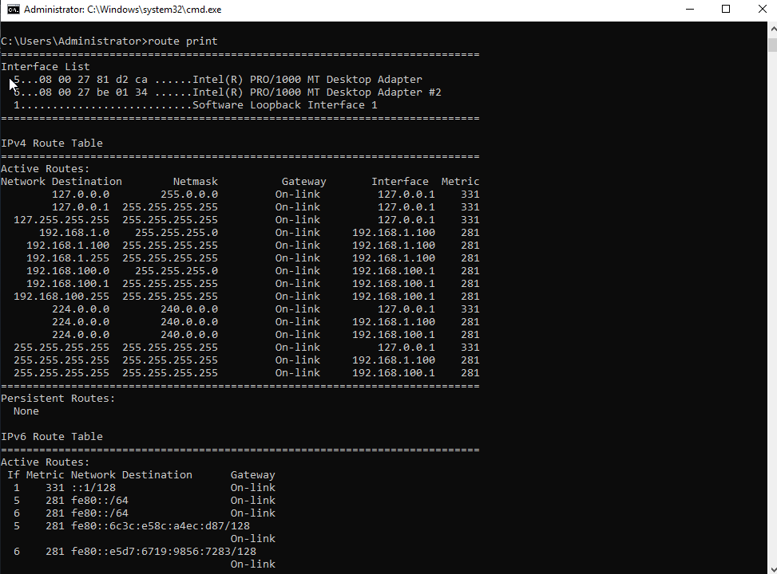
Figure 2
Figure 2 shows the IPv4 Route Table.

Task Two: Deploy core services (FTP Server)

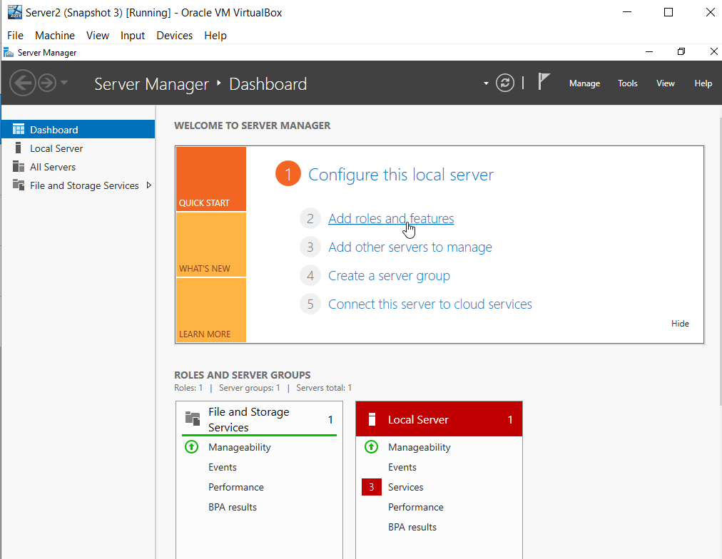
Figure 3
Server 2 dashboard showing the user adding Roles and Features as previously done in Server 1.

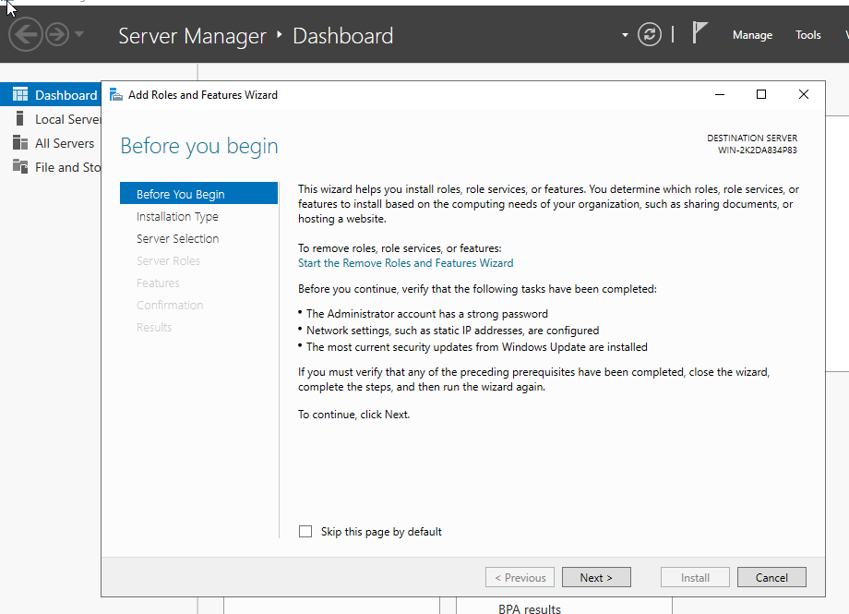
Figure 4
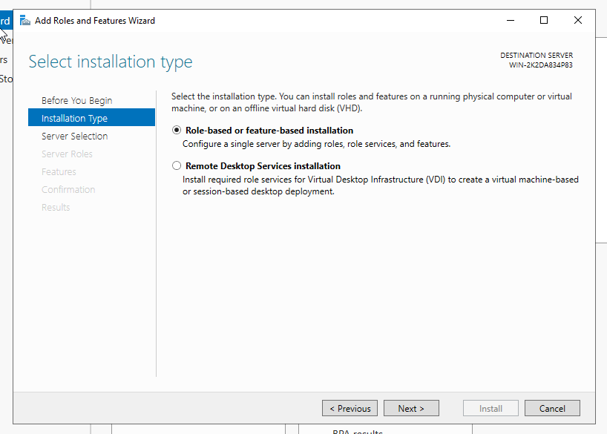
Figure 5
Selecting the installation type within the Add Roles and Features page on the Server Manager Dashboard.

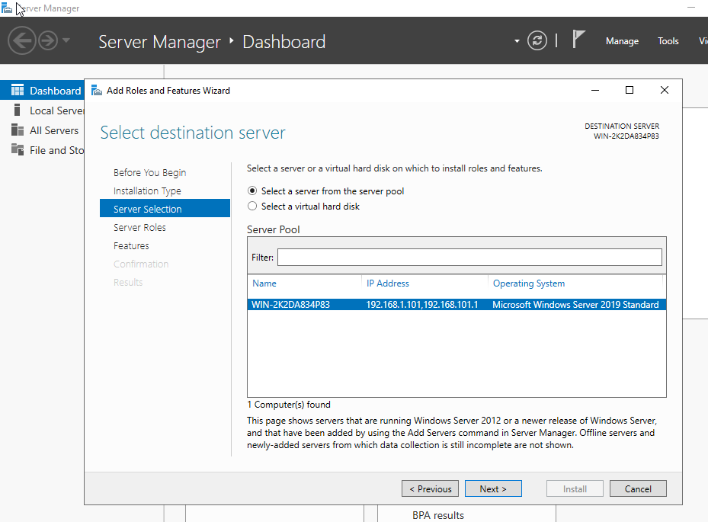
Figure 6
Selecting the Server required to make the additional changes too. The image itself also shows the IP address linked to this server.

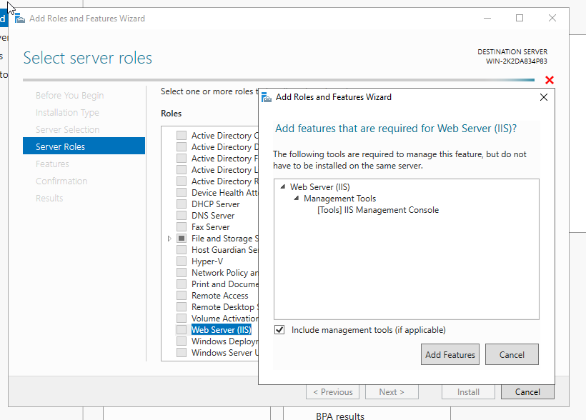
Figure 7

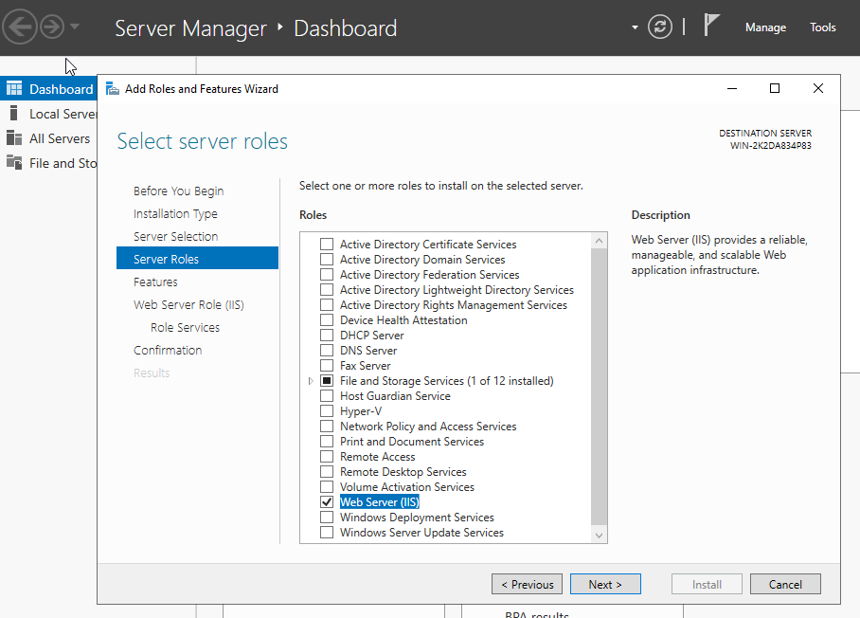
Figure 8
Figure 7 and 8 shows that the user has added the Web Server (IIS) as a feature to the Server.

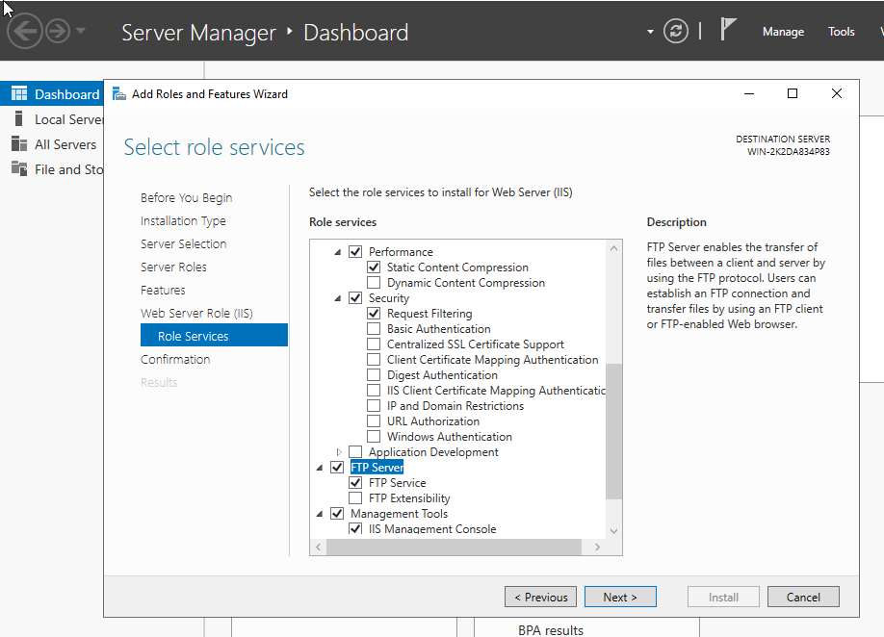
Figure 9
The user has chosen the following Role Services to be enabled:
- Performance
  - Static Content Compression
- Security
  - Request Filtering
- FTP Server
  - FTP Service
- Management Tools
  - IIS Management Console

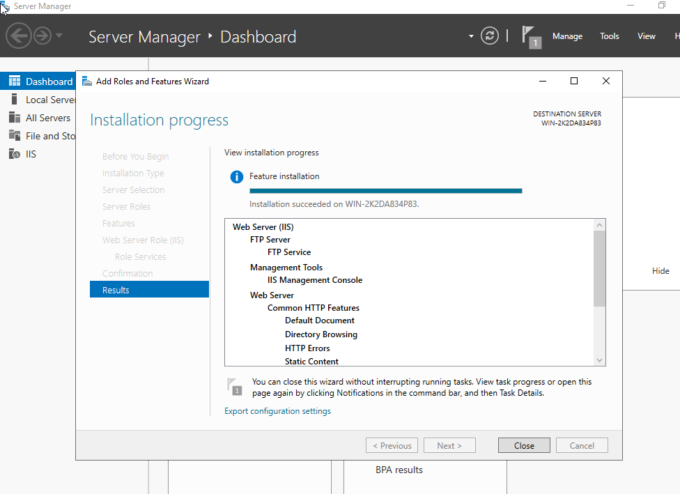
Figure 10
While the installation process is taking place, the dashboard allows the user to see an overview of their previous choices.

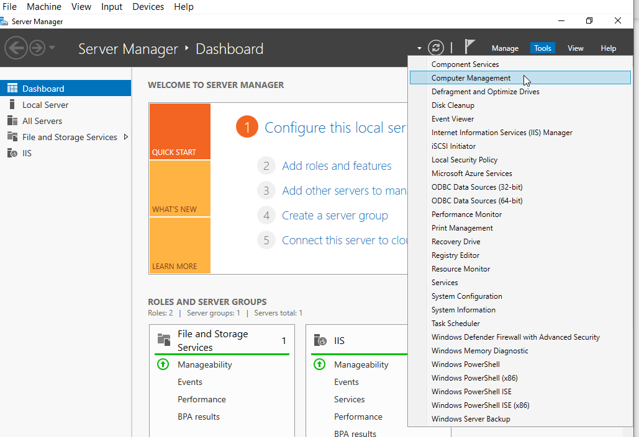
Figure 11
Right click ‘Tools’, then ‘Computer Management’.

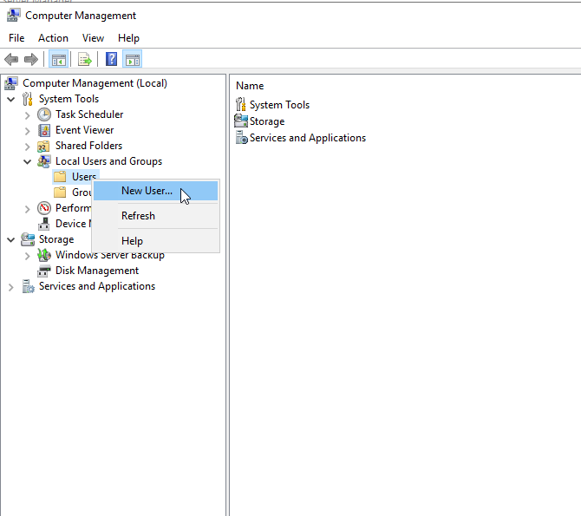
Figure 12
Adding a New User to the Local Users and Groups Folder.

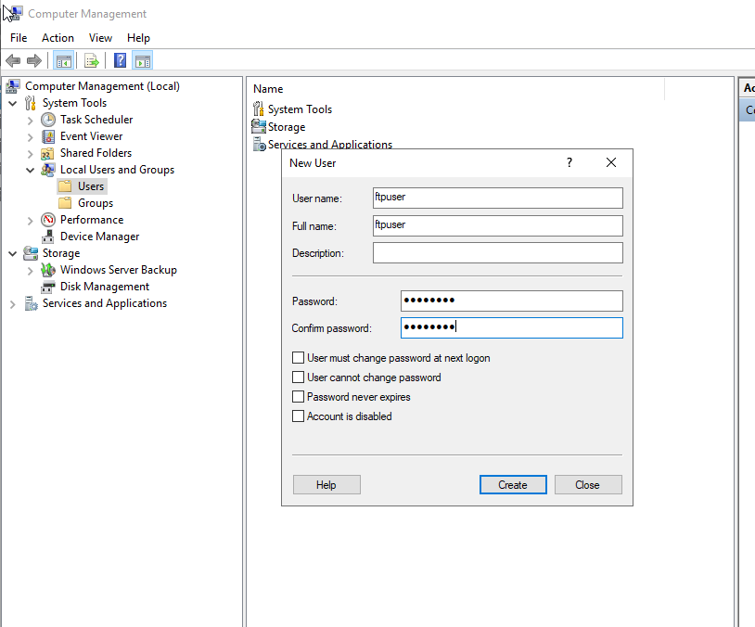
Figure 13
Creating the user, and allocating a secure password.

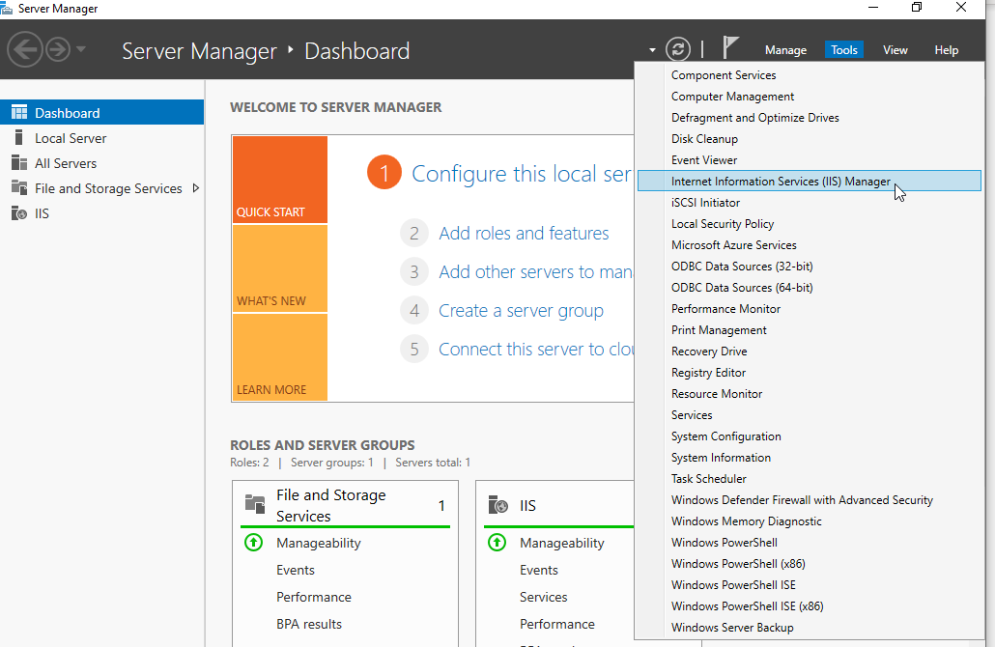
Figure 14
The user will make changes in the Internet Information Service (IIS) Manager.

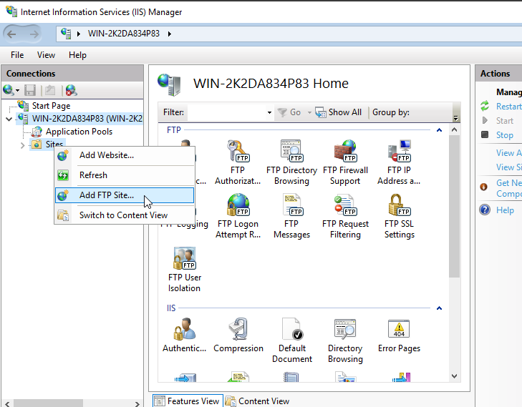
Figure 15
An FTP Site is going to be added to the WIN-2K2DA834P83 Server.

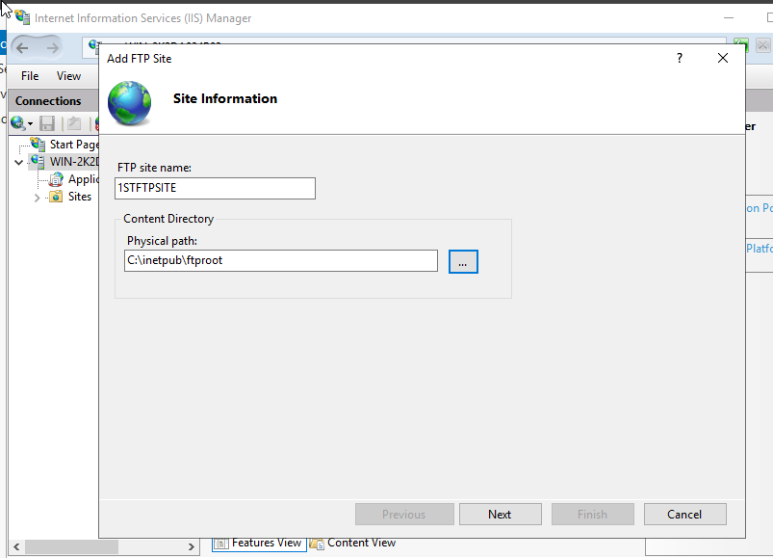
Figure 16
The FTP Site Information Name and Physical Path is required.

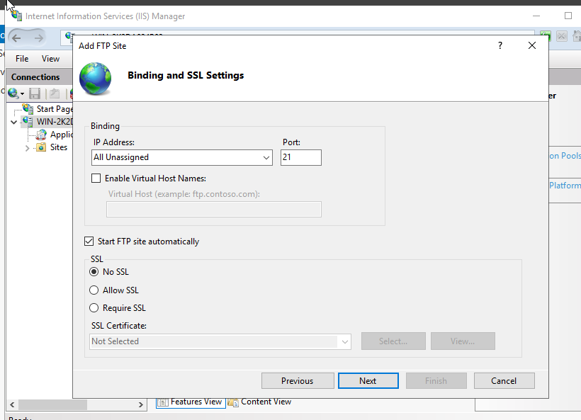
Figure 17
The user has selected ‘All Unassigned’ IP addresses and Port 21, with no SSL for the Binding and SSL Settings page.

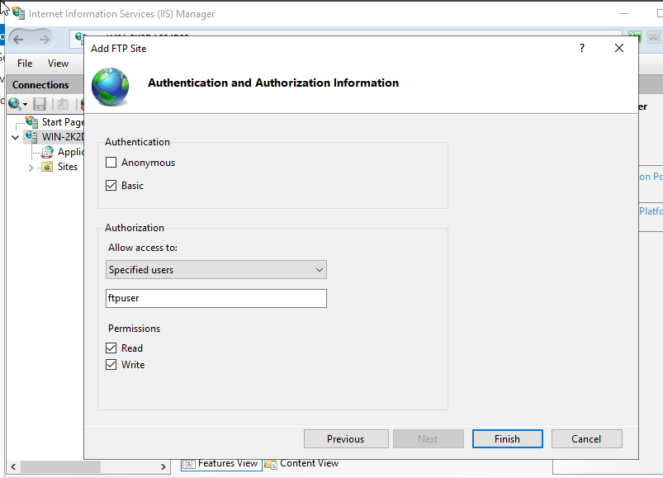
Figure 18
Basic Authentication for specified users has been selected. These users will only have Read and Write permissions.

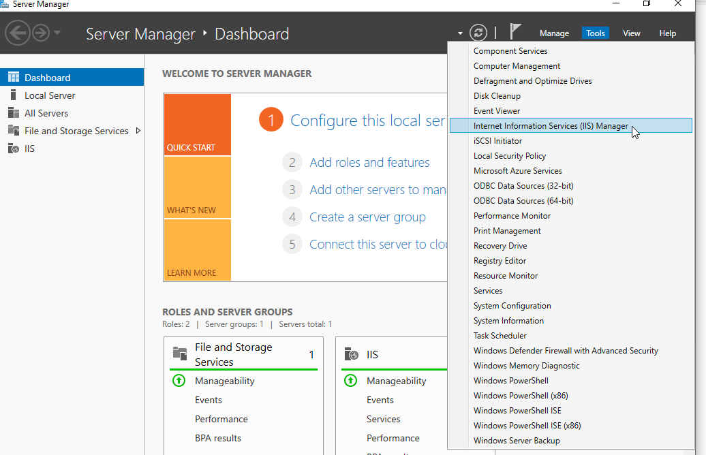
Figure 19

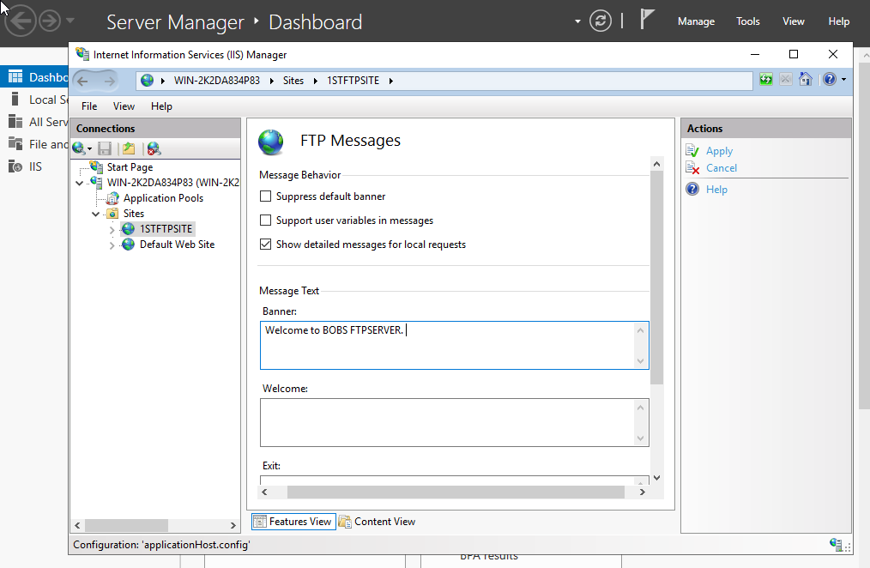
Figure 20
A Banner message has been input for the first FTP Site.

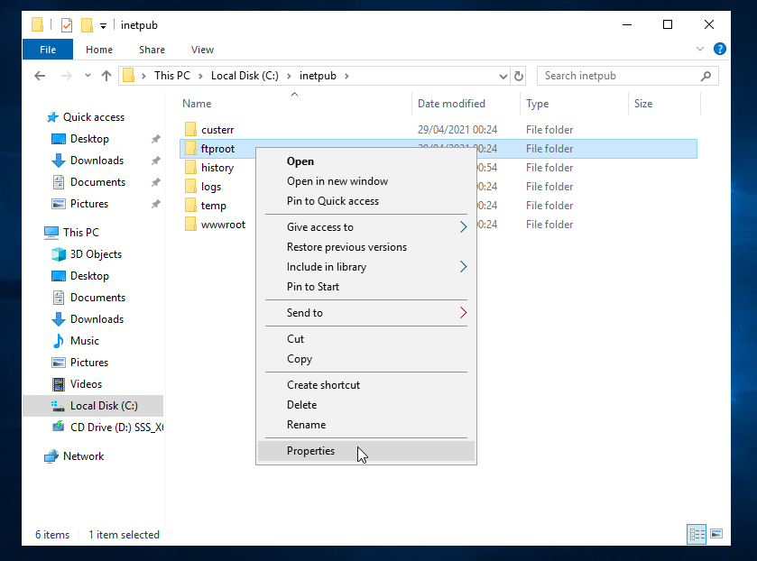
Figure 21
Editing the properties of the ftproot folder in the Local Disk (C:) Drive.

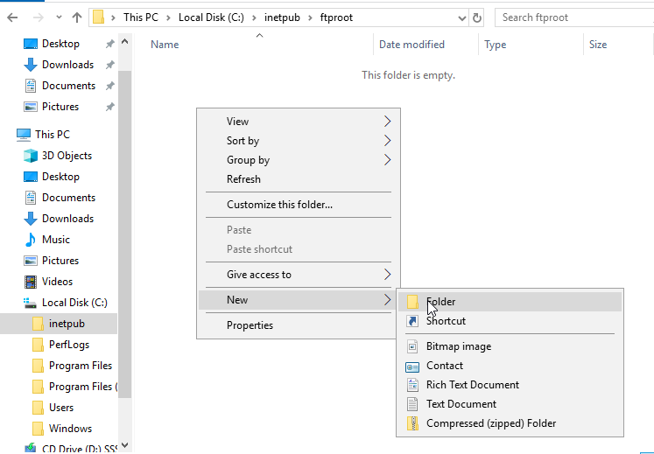
Figure 22
Creating a new folder within the ‘ftproot’ folder.

On Client 2 VM:
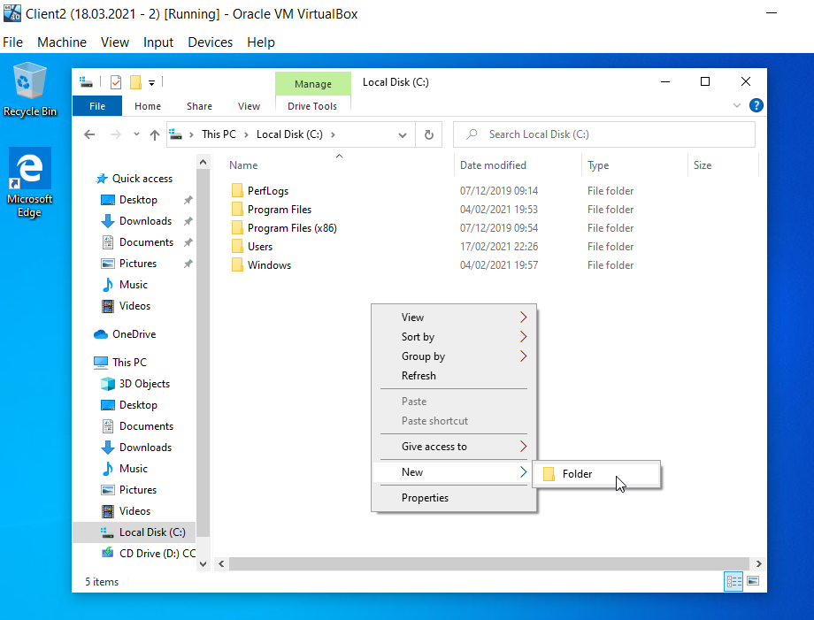
Figure 23
The user has created a new folder within the Local Disk (C:) Drive on the Client 2 machine.

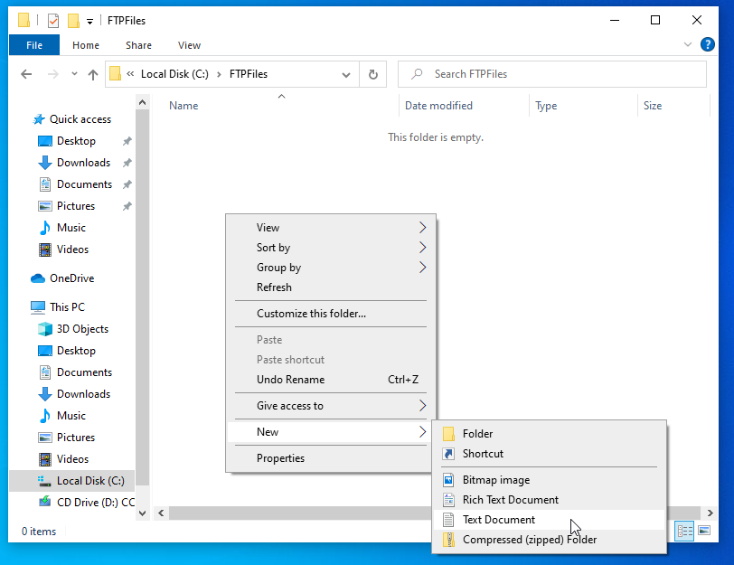
Figure 24
Within that folder, now called FTPFiles, she has created a text document.

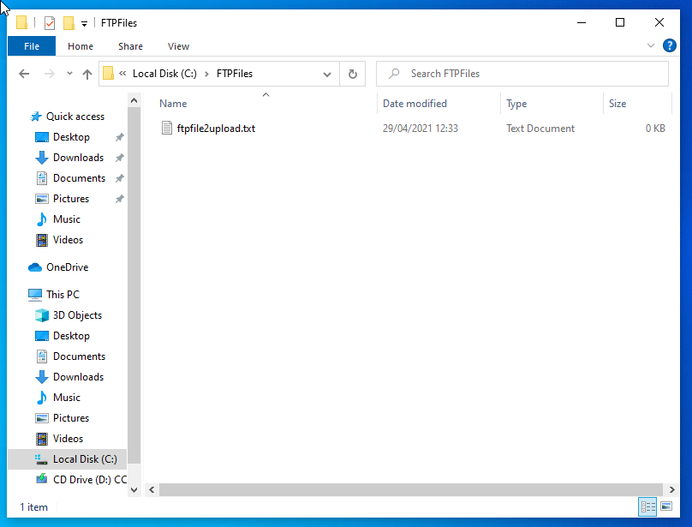
Figure 25
The text document created has been called ‘ftpfile2upload.txt’.

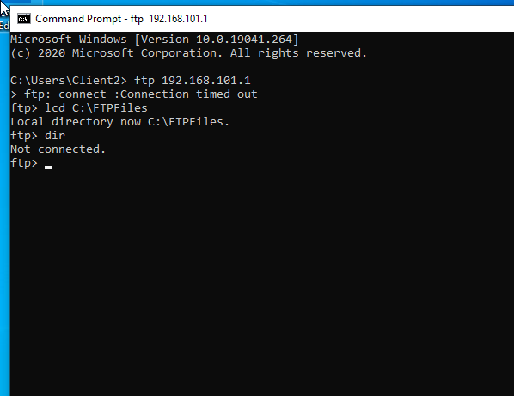
Figure 26
The client 2 machine, which has an IP of 192.168.101.1 now has the Local Directory in the following file path C:\FTPFiles. The command prompt in Figure 26 gives the user this information.

Task Three: Installing and Configuring the Routing and Remote Access Service

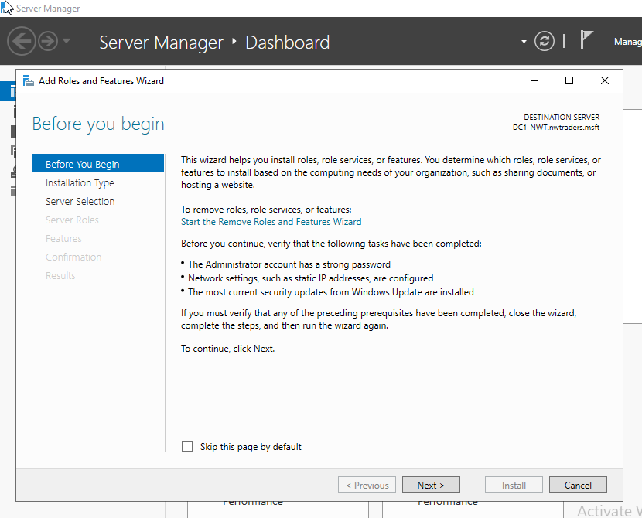
Figure 27

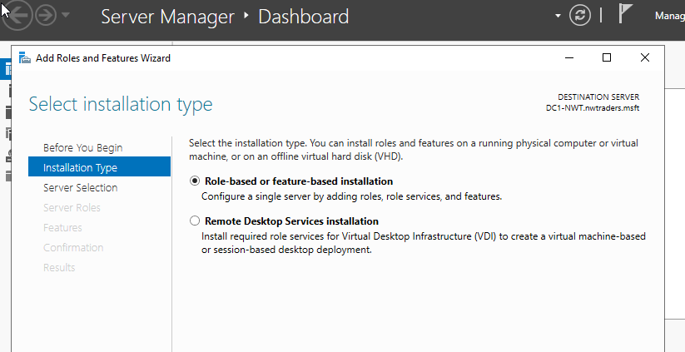
Figure 28
Installing more Role-based or Feature-based add-ons.

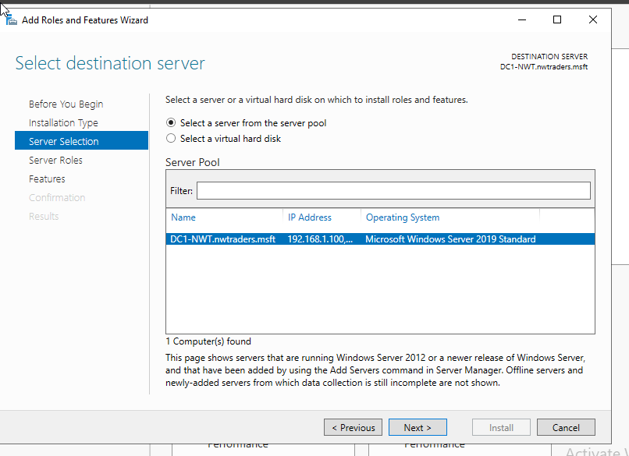
Figure 29
The user has selected a different server from before, this server is called DC1-NWT.nwtraders.msft.

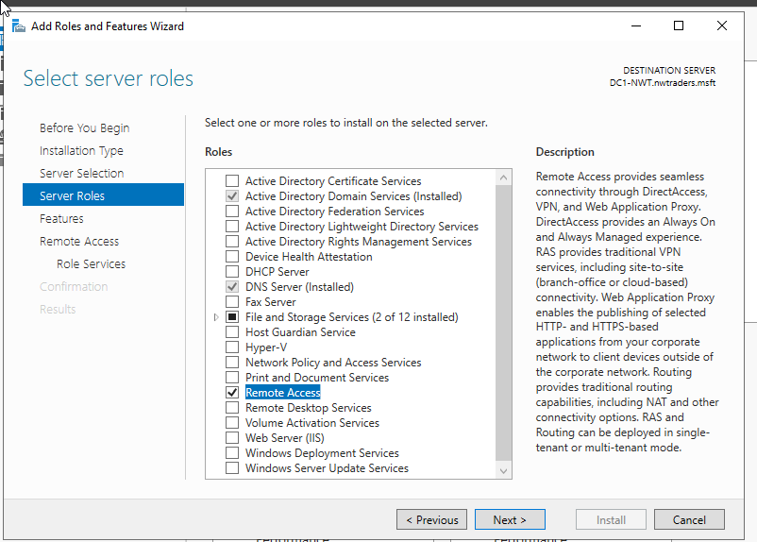
Figure 30
The server roles that she is choosing to install herself are:
- Active Directory Domain Service (Installed)
- DNS Server (Installed)
- Remote Access

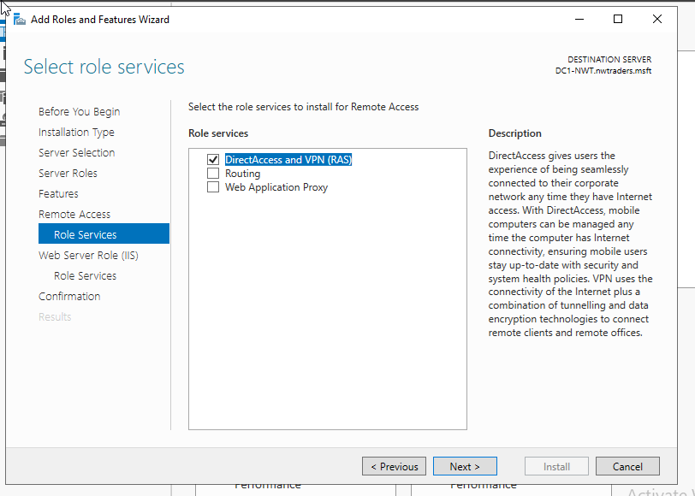
Figure 31
DirectAccess and VPN (RAS) has been selected under role services.

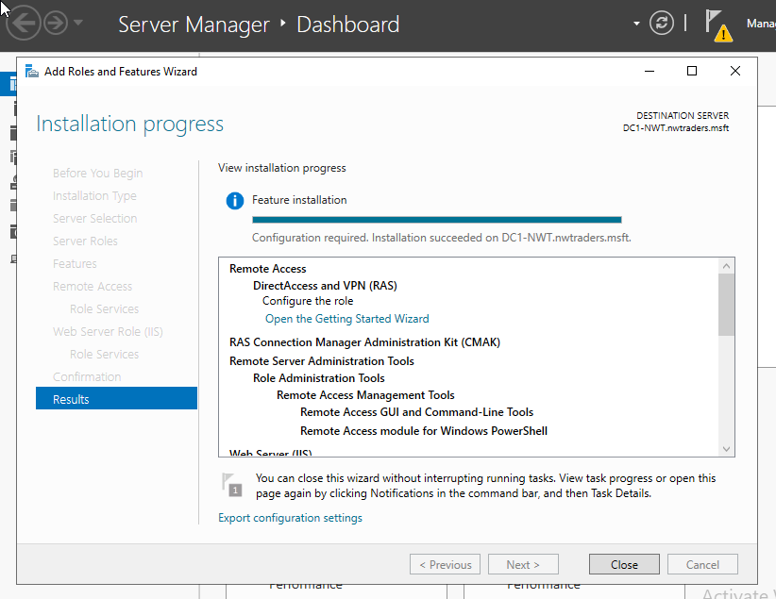
Figure 32
An overview of the installation progress.

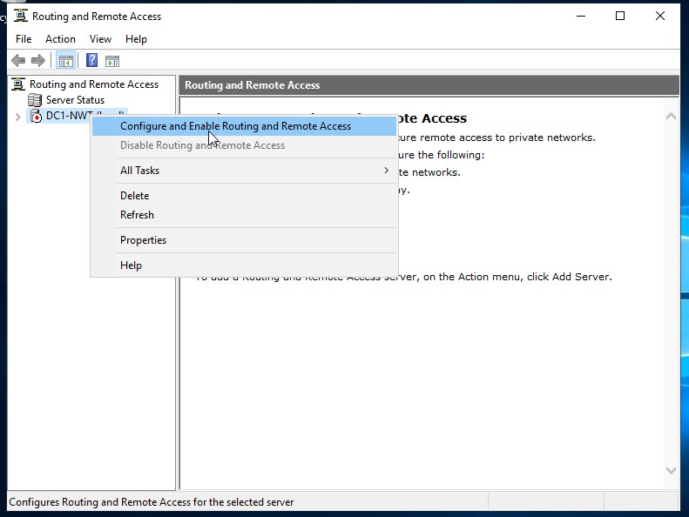
Figure 33
Here the user is going to configure and enable Routing and Remote Access on the selected server from Figure 29.

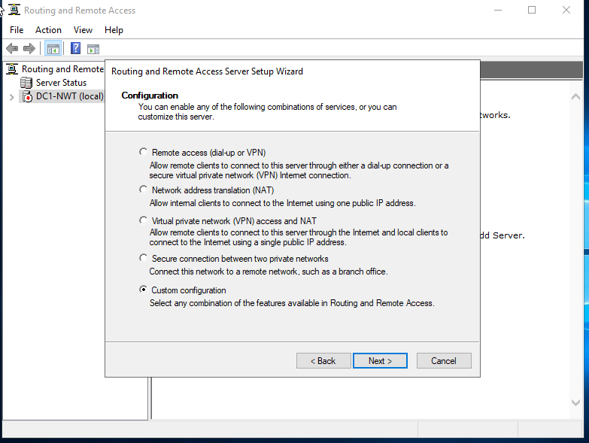
Figure 34
A custom configuration will be used.

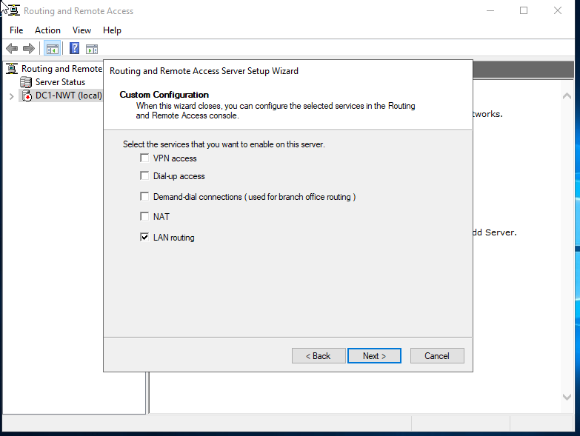
Figure 35
LAN Routing has been selected as one of the services to be enabled.

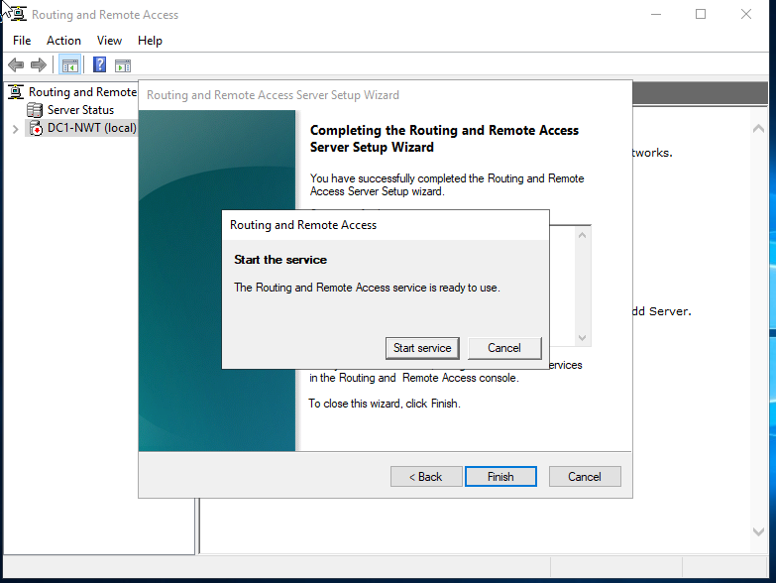
Figure 36
Once completed, the user has the option to start the service.

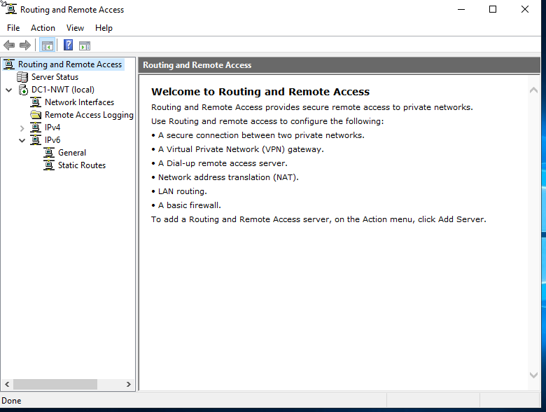
Figure 37
The Green arrow next to the DC1-NWT Server Status in Figure 37, shows that the Server is running.

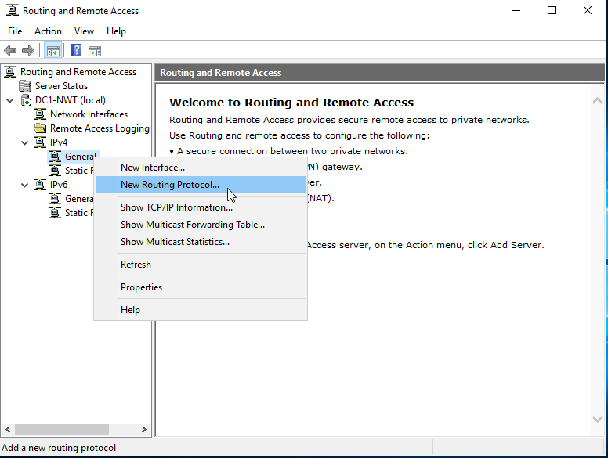
Figure 38
A new IPv4 protocol will be created.

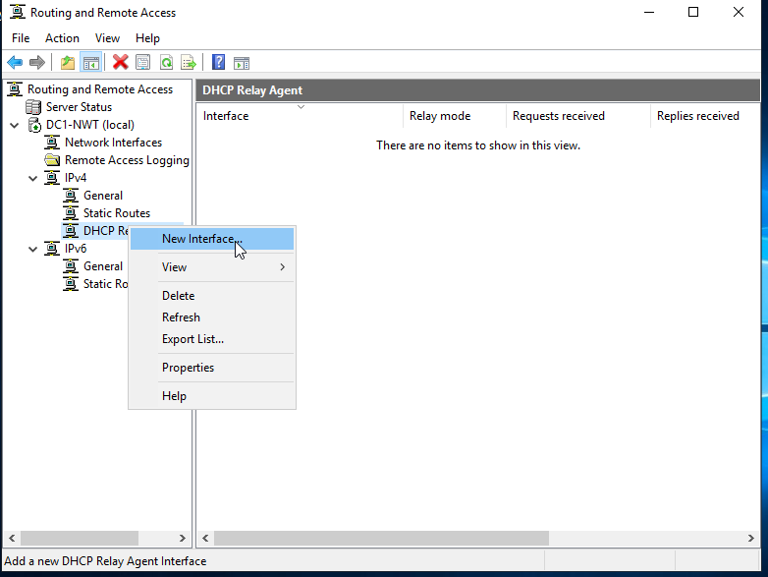
Figure 39
A new interface will be created within the IPv4 settings.

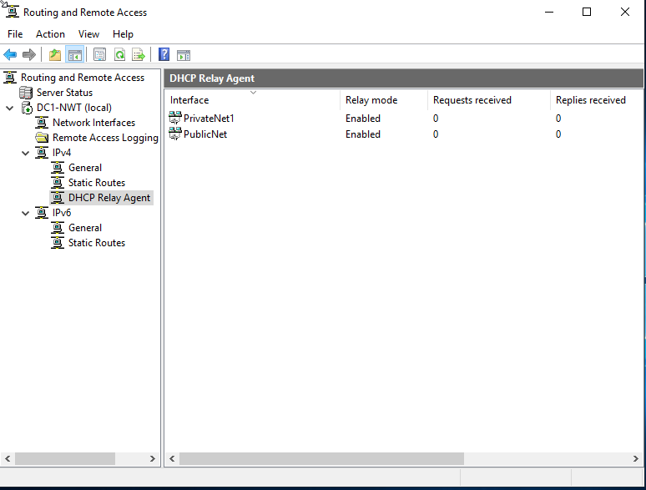
Figure 40

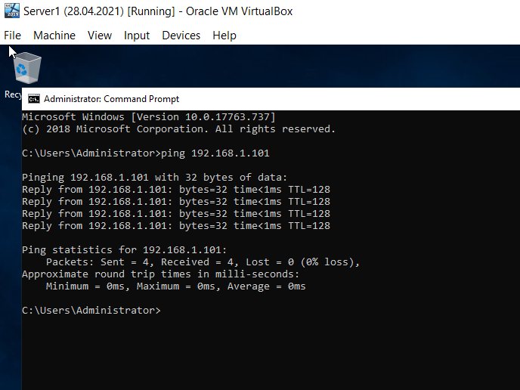
Figure 41
The user has used the command prompt to show Server 1 pinging Server 2 on it's PublicNet IP. The command prompt shows that there were 4 packets sent, and 4 packets received meaning the Ping between the two servers was successful and they can communicate with each other.

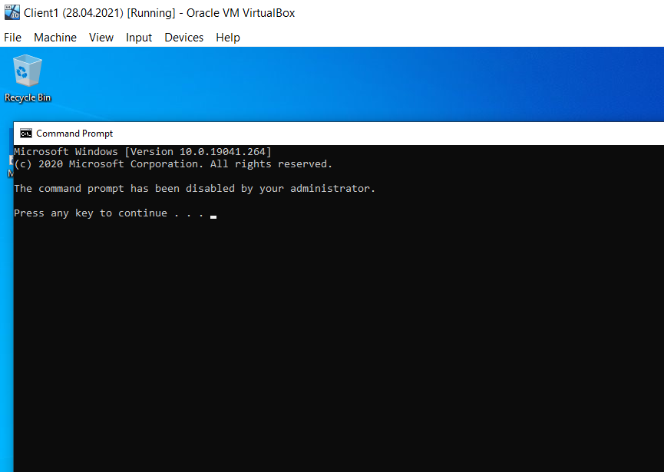
Figure 42
The user is unable to ping from Client 1 as this function has been restricted.
The author realised she was pinging from the restricted account and when she changed the account to the Admin one, it worked successfully.

Task Four: IP Packet Filtering

Filter One: Stopping ‘anyone’ in PrivateNet 1 from Pinging the Router Firewall Service

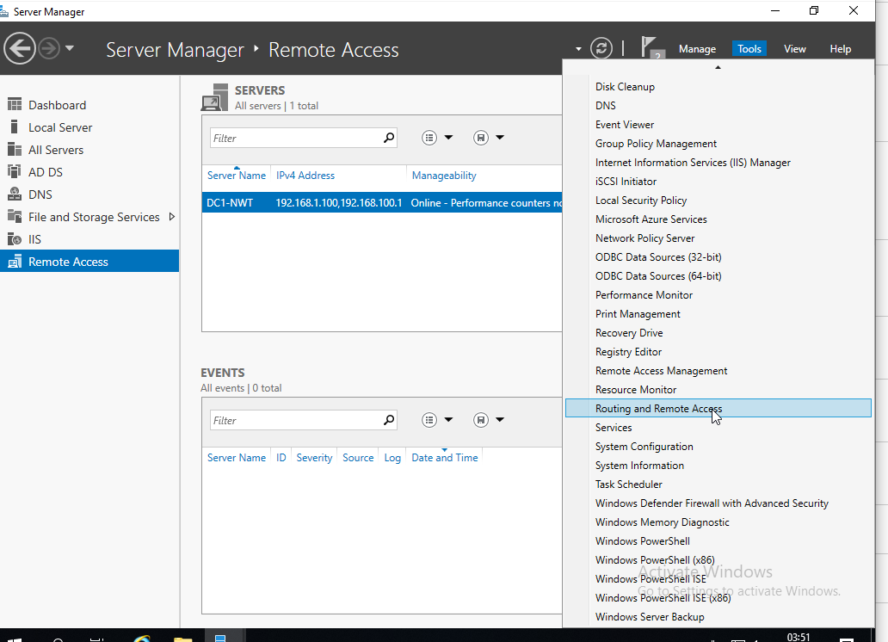
Figure 43
Accessing the Routing and Remote Access settings so the user can alter the settings to prevent ‘anyone’ in PrivateNet1from pinging the Router Firewall Service.

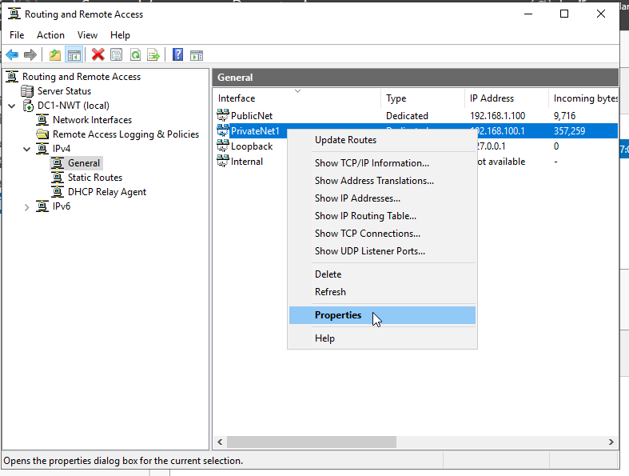
Figure 44
Editing the properties of PrivateNet1 to make the necessary changes.

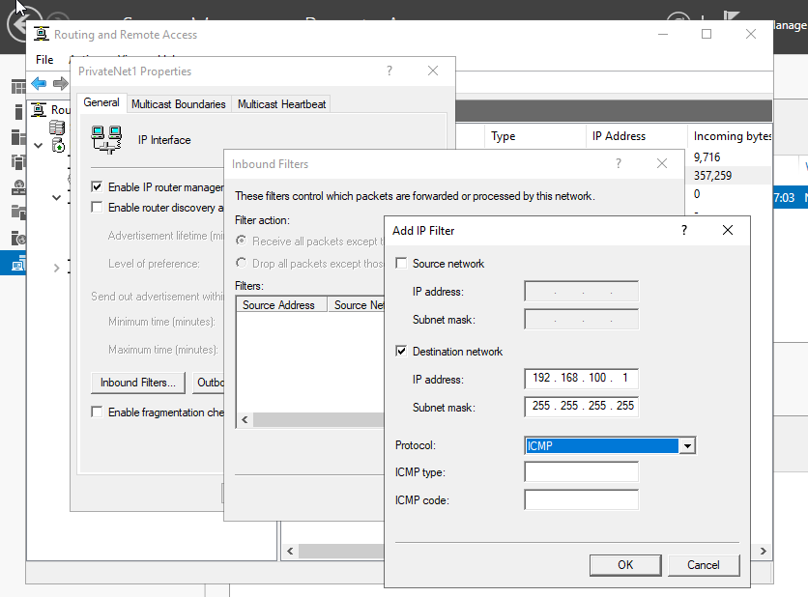
Figure 45
Adding an IP Filter within PrivateNet1. Adding ICMP to the protocol.

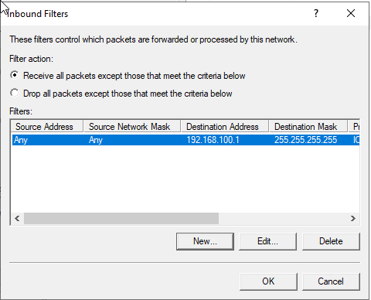
Figure 46
Inbound Filters from the PrivateNet1 Network.

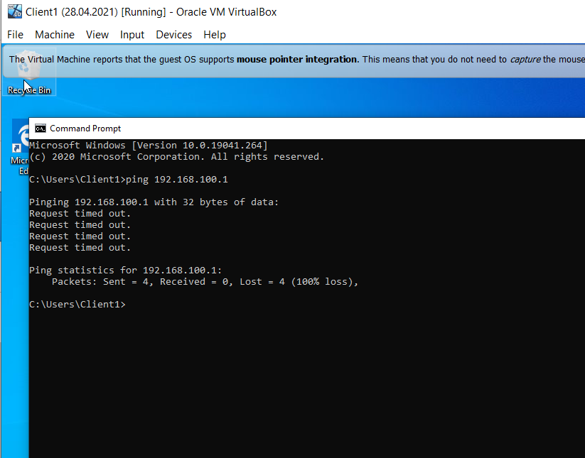
Figure 47
On the Client 1 Virtual Machine, the user has performed a Ping request using the command prompt as before. The ‘ping’ request has failed due to the restrictions that she has just put in place.

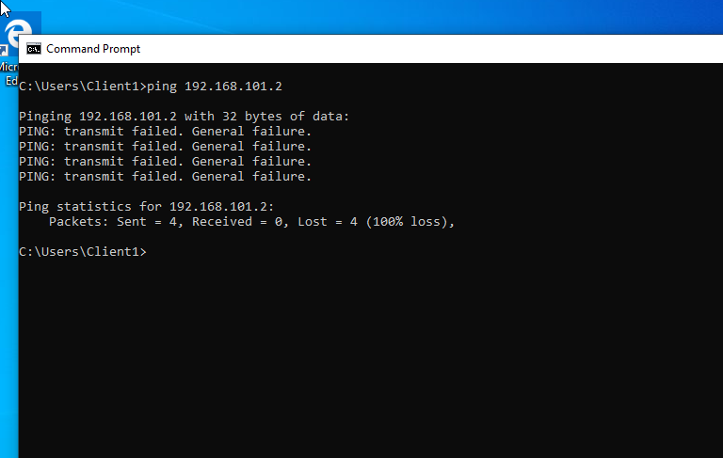
Figure 48
The Ping request has also failed on the Client 2 machine.

Filter Two: Restrict Access to FTP Service running on Server 2 to only hosts in PrivateNet2.

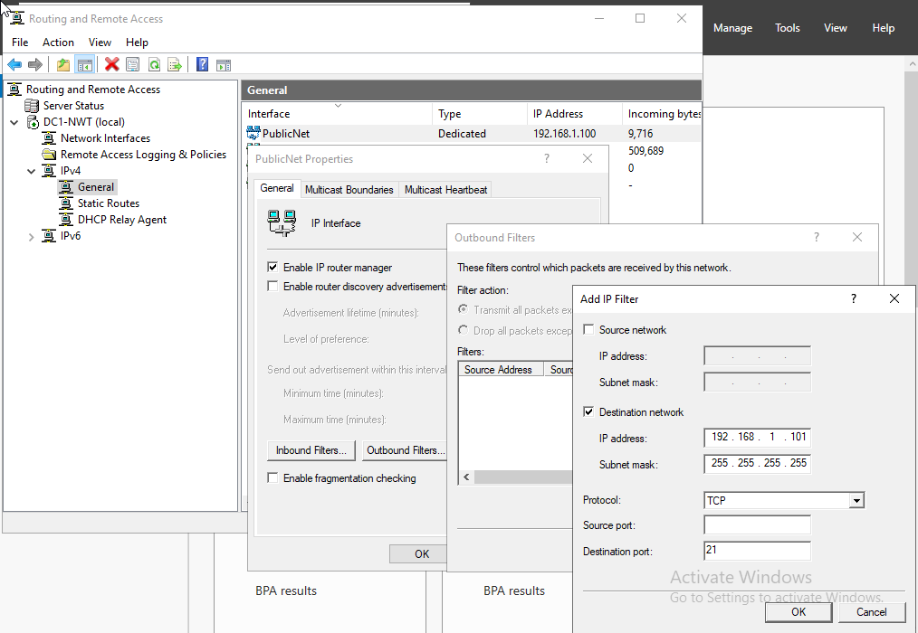
Figure 49
The user has added in a restriction for the FTP Port, 21, to be disabled on Server 2 for only hosts within PrivateNet2.
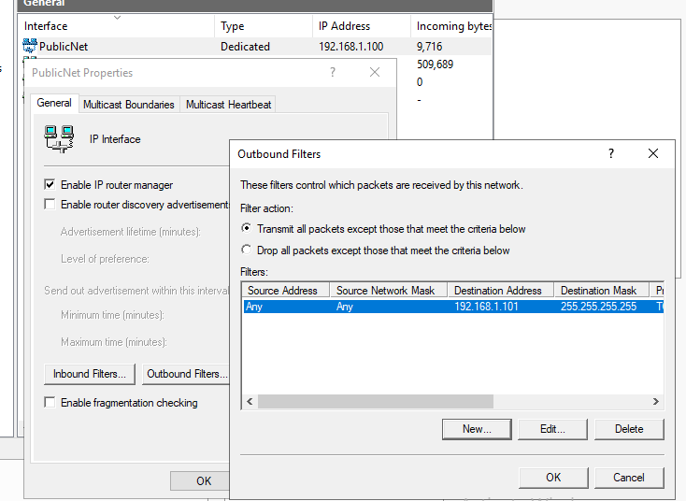
Figure 50
An overview of the Outbound Filters that the user has just put in place.

