
Applied Leadership and Management Outreach
Module Assignment Submission
Student Name: | Jeri Derrick
Student Number: | 2525457
Module No: | BMSK4014
Module Title: | Problem Solving and Decision Making

Statement of Confirmation of Authenticity
By the act of making this submission, the student declares that this is the work of the student named above. The work has not, in whole or in part, been knowingly presented elsewhere for assessment, or where assessment has been built on a previous assessment, this has been identified. Where materials have been used from other sources it has been properly acknowledged. If this statement is untrue, the student acknowledges that an assessment offence has been committed.
Attention is drawn to the plagiarism and unfair practice policies of UWTSD.

Table of Contents
1.Introduction 3
3. Analysis of the Problem 4
3.1 Tool 1: Brainstorming (Osborn, 1953) 4
3.2 Tool 2: Mind Mapping (Buzan & Buzan, 1993) 5
3.3 Tool 3: Fishbone (Ishikawa, 1985) 6
3.4 Tool 4: 5 Whys (Ohno, 1988) 7
4. Possible Solutions 8
5. Decision Making 9
5.1 Weighted Grid Analysis 10
6. Cost- Benefit Analysis (Boardman et al., 2018) 11
6.1 Figure 7 – Annual cost 11
6.3 Figure 9 – Monetary Benefits 12
6.4 Figure 10 – 3 Year Financial Benefit 13
6.5 Benefit–Cost Ratio 13
7. Net Annual Benefit and Payback Period 14
7.1 Figure 11 - Net Annual Benefit 14
7.2 Figure 12 – Payback period 14
7.3 Return on Investment (ROI) 15
7.4 Sensitivity Analysis 15
8. Non-Monetary Benefits 16
9. Implementation Plan 18
9.1 Implementation Plan Table 18
9.2 Gantt Chart 20
10. Stakeholder Analysis (Mitchell et al., 1997) 21
11. Communication 24
12. Monitor and review implementation 25
12.1 Figure 16 Measure and Baseline Table 26
12.2 - Review Point Table 27
13. Conclusion 29
References 30

1.Introduction
The service provides community-based support for individuals with complex needs, and staff rely on individualised care plans to deliver safe, predictable, person-centred routines. Recent evidence shows these plans are not followed consistently across shifts, creating variability in practice and affecting safety, therapeutic progress, and family confidence.
Inconsistent adherence matters because the child’s routines, communication approaches, and risk-management strategies depend on reliable implementation (Adams et al., 2013). In this report, I will explore why care plans are not always followed consistently and use four problem-solving tools to understand the main causes. I will then consider possible solutions, compare them using a weighted decision grid and financial analysis, and explain how my chosen solution could be implemented and monitored within the service.
2. Problem Definition
The problem in this report is the inconsistent adherence to individualised care plans by support workers. Care-plan adherence refers to staff reliably following the routines, communication strategies, risk-management instructions and daily support procedures outlined in each client’s plan. These plans are central to safe, predictable and person-centred practice, yet current evidence shows they are not being implemented consistently across shifts and environments.
Over the last quarter, the service received six family complaints relating to inconsistent routines, missed activities and changes in support that did not align with the care plan. MDT professionals have reported occasions where staff used approaches that differed from agreed strategies. Observations and incident reports also show discrepancies between planned and delivered care, demonstrating that inconsistent adherence is occurring regularly and affecting the quality, reliability and safety of support (World Health Organization, 2003).
In practice, staff do not always work in the same way. This appears to be linked to differences in their experience, confidence, competency and understanding of the information within the care plan. Some workers struggle to locate the correct version of the plan, while others rely on verbal information rather than documented guidance. When this happens, the child may not receive the same support from one shift to another. This can affect progress and make routines less predictable. It can also reduce the confidence that families and MDT professionals have in the service. The desired condition is a stable, competent workforce that implements care plans accurately and consistently across all shifts, ensuring predictable routines, safe practice and effective multidisciplinary collaboration (Sjöberg et al., 2021).
The scope of the problem is affecting the child, support workers, families, MDT professionals and the organisation; it links with daily care delivery, communication processes, documentation systems, supervision quality and operational pressures. The impact extends beyond frontline practice, influencing organisational performance, regulatory compliance, safeguarding reliability and family confidence.
As Team Leader, I am responsible for overseeing staff practice, ensuring documentation is accessible and up to date, and supporting workers to meet organisational expectations. However, several restrictions limit full resolution, including staffing shortages, limited training time, high turnover, workload pressures and organisational constraints such as budget and regulatory requirements.
This is a complex problem and not a simple one, because it arises from multiple people, organisational, communication and documentation factors (Dörner & Funke, 2017). Because there are several different factors involved, I do not think the problem can be resolved by making one change alone. The solution needs to consider staff, supervision, documentation and the pressures within the service

3. Analysis of the Problem
To understand why support workers are not consistently following individualised care plans, four analytical tools were applied. Each tool provided a different perspective on the problem and contributed unique evidence to support decision-making.

3.1 Tool 1: Brainstorming (Osborn, 1953)
Brainstorming generates a wide range of possible causes without judgement (Osborn, 1953). In this workplace, it revealed numerous contributing factors including rushed inductions, unclear documentation, inconsistent supervision, staff fatigue, high turnover and communication gaps. This made me consider that the problem was not simply down to individual staff members. There were also wider pressures within the service that could be affecting how care plans were followed. Brainstorming does not prioritise causes because it established the breadth of the problem and prevented premature assumptions about staff performance.

Figure 1 shows the initial brainstorming list
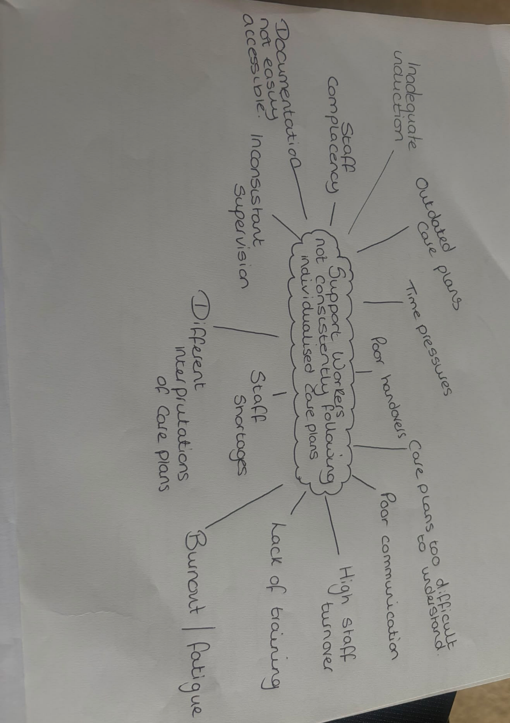

3.2 Tool 2: Mind Mapping (Buzan & Buzan, 1993)

Mind mapping visually organises information around a central issue and highlights connections between factors (Buzan & Buzan 1993). It showed how documentation accessibility, communication quality, staffing pressures and supervision practices interact to create inconsistency. For instance, issues like difficulty locating the correct care plan version were directly linked to poor handovers and inconsistent documentation updates. Because this type of analysis relies heavily on individual interpretation, the findings remain partly subjective. This highlighted that focusing on only one part of the problem was unlikely to be enough. The main causes were connected, particularly staffing pressures, communication, documentation and supervision

Figure 2 shows the mind map created during analysis.
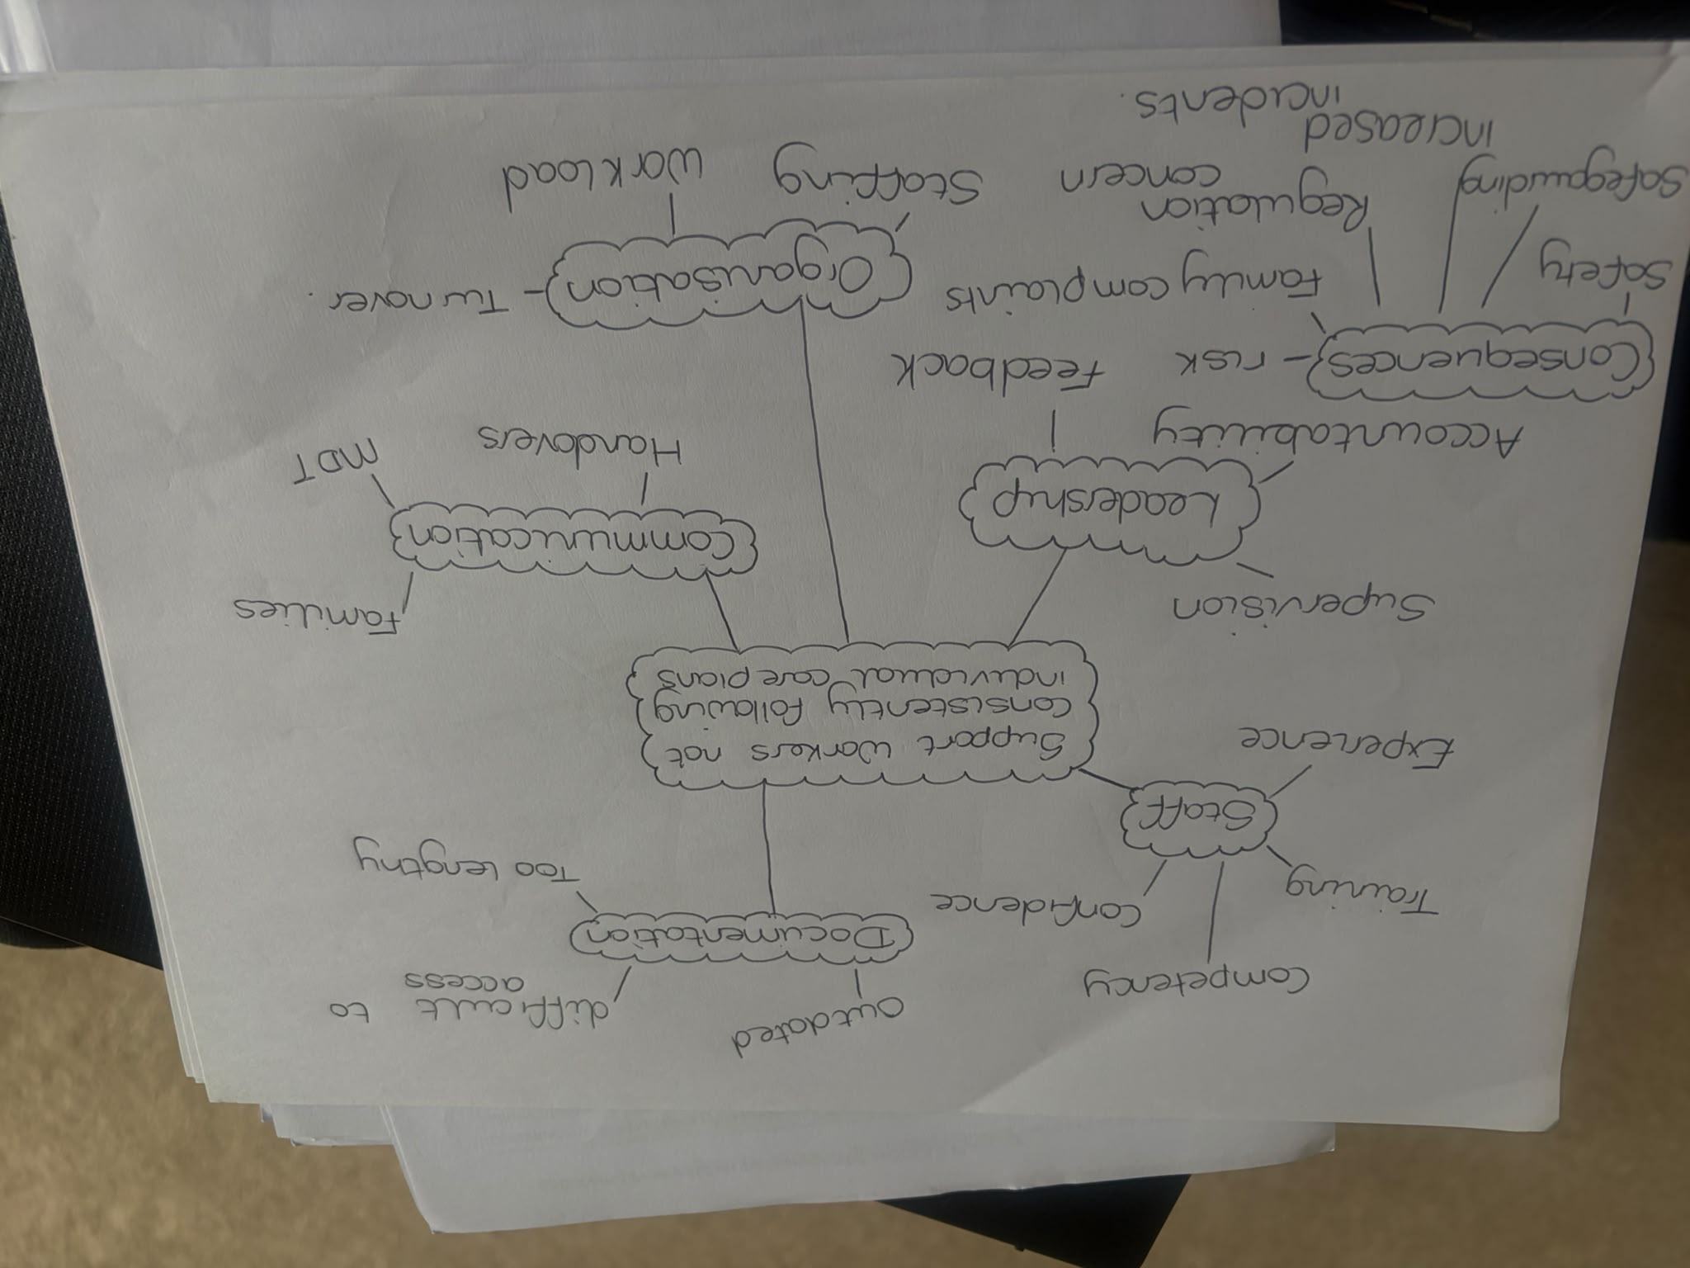

3.3 Tool 3: Fishbone (Ishikawa, 1985)
The fishbone diagram categorises causes under structured headings such as People, Process, Documentation, Communication, Environment and Management. It organised the brainstorming ideas into clear categories, identifying rushed inductions, low confidence, outdated plans, unclear processes, poor handovers, inaccessible documentation and workload pressures as key contributors. The disadvantage is that it does not prioritise causes, because it provides structure to the problem, showing that documentation, communication and human-factor issues are central and must be addressed together.
Figure 3 shows the fishbone diagram.
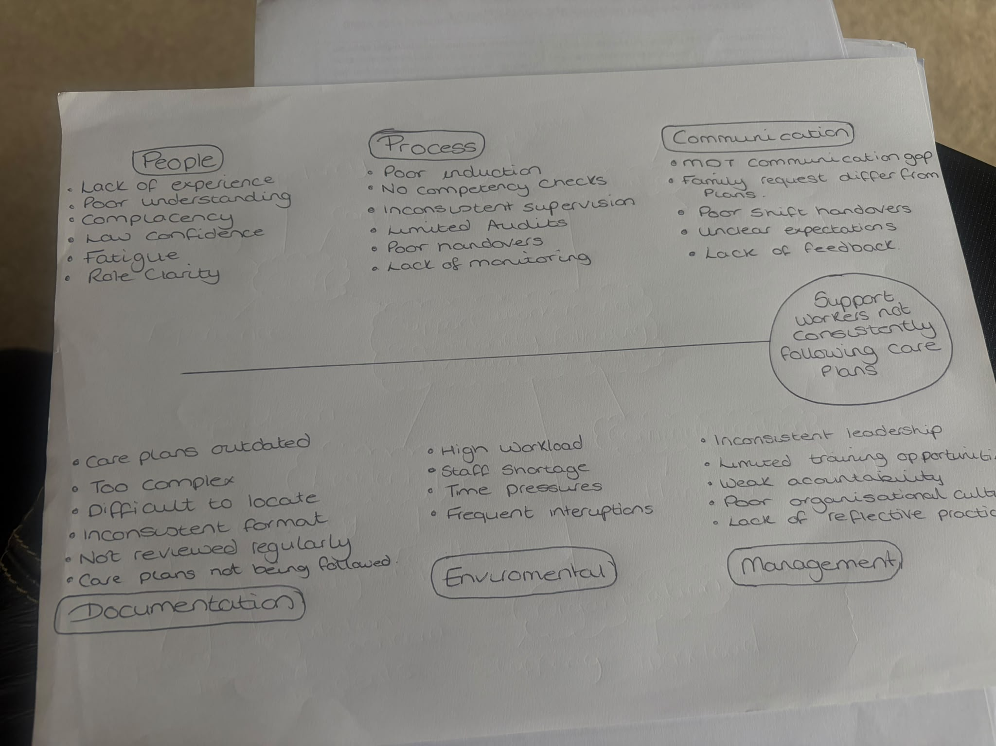

3.4 Tool 4: 5 Whys (Ohno, 1988)
The 5 Whys model identifies deeper root causes by repeatedly asking “why?” along a single causal pathway. It revealed that operational pressures, staffing shortages and limited administrative capacity result in reactive rather than proactive documentation management. This leads to outdated, unclear or inaccessible care plans, reducing staff confidence and consistency. It focuses on one pathway and may overlook others, which can lead to missing other concerns. This was useful because it linked the documentation problems back to wider operational pressures. It helped explain why staff may be working from information that is unclear, out of date or difficult to access.
Figure 4 shows the 5 Whys chain.
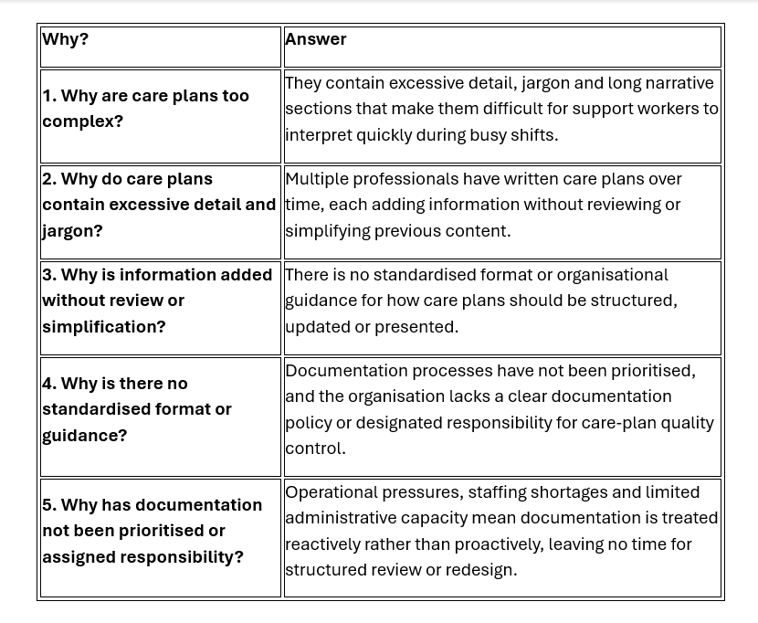
Looking at the findings from all four tools together, it became clear that there was no single cause of the problem. The same issues kept appearing around staff competency, supervision and the accessibility and quality of documentation. Brainstorming generated breadth, mind mapping revealed connections, the fishbone diagram provided structure and the 5 Whys identified deeper operational causes. Across all tools, three dominant themes came to light: variable staff competency and confidence, inconsistent supervision and accountability, and documentation that is difficult to access, update or interpret. These findings shaped the development of alternative solutions and provide the foundation for selecting an intervention that addresses human-factor, communication and documentation issues simultaneously.
4. Possible Solutions
The four alternative solutions were developed directly from the root causes identified through the analysis tools. Together, they provide a balanced range of options targeting documentation quality, accessibility, staff competency, supervision consistency and organisational processes.
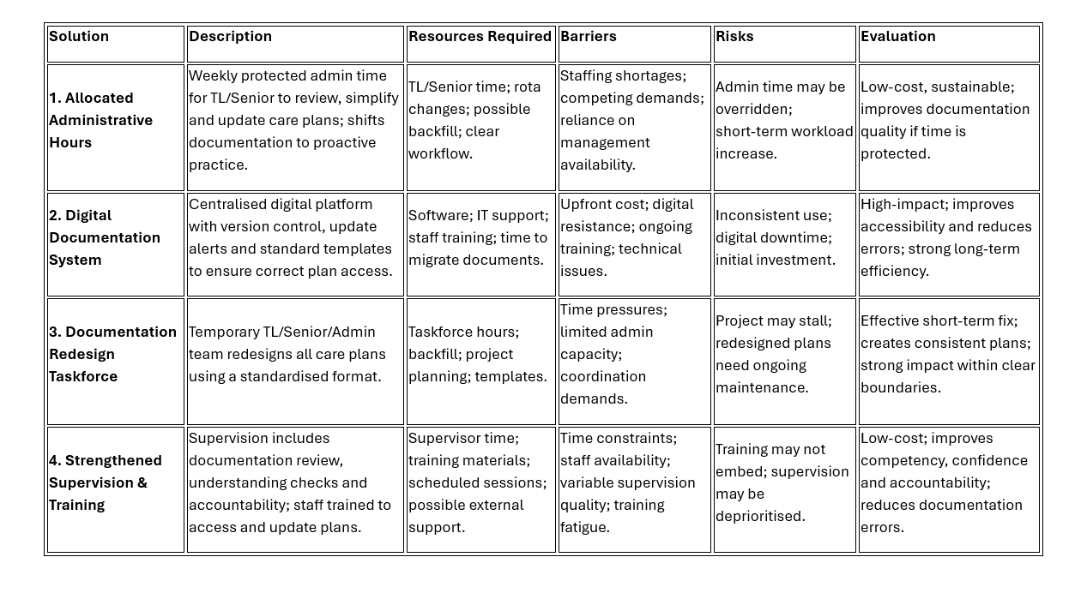
Figure 5 shows the identified solutions table
Solution 1 focuses on proactive documentation management; Solution 2 addresses accessibility and version-control issues; Solution 3 provides a short-term structural redesign of care plans; and Solution 4 targets human-factor causes through strengthened supervision and documentation-focused training. These options address different parts of the problem. This gave me four realistic alternatives to compare before deciding which would be most suitable for the service.
5. Decision Making
A structured decision-making process was used to compare the four solutions and identify which would most effectively address inconsistent care-plan adherence. A weighted decision grid was completed first, followed by financial analysis. Criteria were selected to reflect workplace restrictions: effectiveness and sustainability were weighted highest (5) because safe, predictable care requires long-term consistency; cost was weighted at 4 due to budget limits; and ease of implementation and speed of impact were weighted at 3 because staffing pressures require a feasible, timely intervention.
The grid is worked out by scoring each solution against every criterion (1–5), multiplying each score by its weight, and then adding the totals. The scores provided an initial comparison between the four options. However, I did not rely on the score alone, as the practical restrictions within the service also needed to be considered (Németh et al., 2019).
5.1 Weighted Grid Analysis
Figure 6: Weighted Grid Analysis
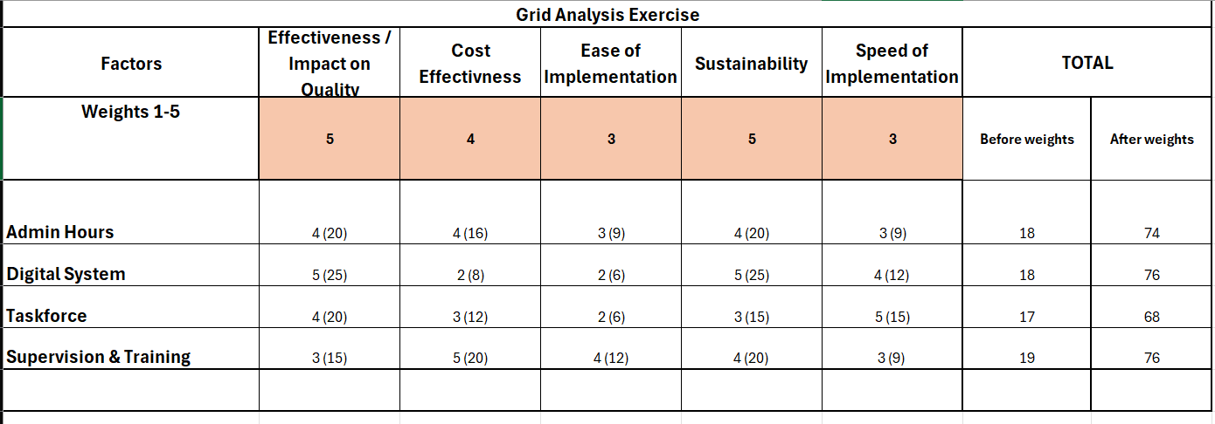

Although the weighted grid produced a joint outcome between Solution 2 and Solution 4, the final decision required qualitative interpretation based on root-cause evidence and workplace constraints. I selected Solution 4 because it was the option that most closely matched the main causes identified during my analysis. In particular, it addressed the gaps I had identified in supervision, staff confidence and understanding of documentation. Increasing supervision would give staff more opportunities to discuss problems and receive feedback, while the additional training would focus specifically on understanding and following care plans. I considered this more realistic than introducing a completely new system, particularly given the current staffing and budget pressures.
Solution 1 was rejected because protected admin time is unlikely to be sustained during staffing shortages. Solution 2 was rejected because, despite its potential impact, it requires digital readiness, IT infrastructure and upfront investment the organisation cannot currently support. Solution 3 was rejected because it provides only a short-term fix and does not address ongoing competency or supervision needs.

6. Cost- Benefit Analysis (Boardman et al., 2018)

6.1 Figure 7 – Annual cost
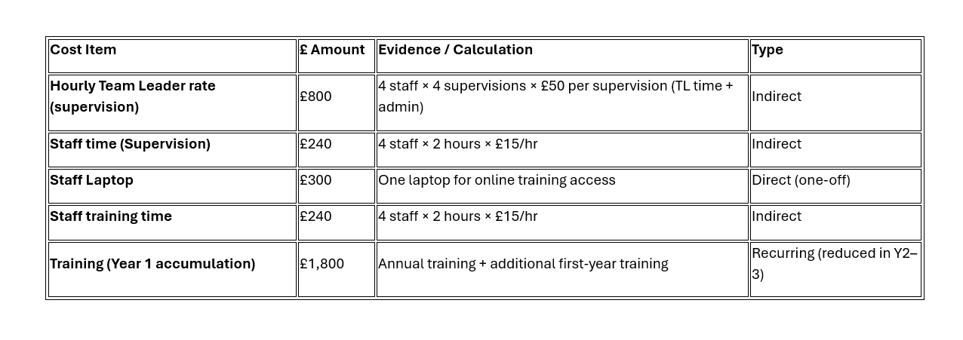
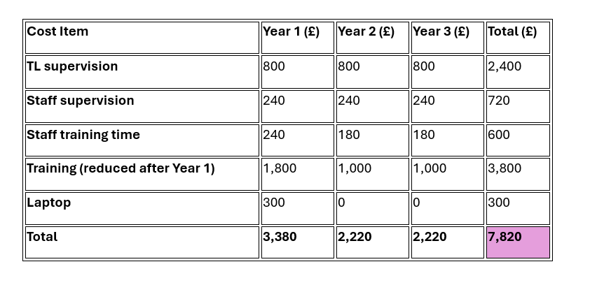
The costs include the training itself as well as the staff time needed to deliver supervision and complete the training. Direct costs are the immediate, out-of-pocket expenses such as training delivery and equipment. Indirect costs relate to staff time, supervision hours and operational impact. Recurring (annual) costs are those that continue each year, such as ongoing training and regular supervision. This breakdown shows the overall financial commitment and highlights where the organisation will face upfront investment versus ongoing expenditure.
6.2 Figure 8 – Three-year projection
This table shows how costs change over time. This helps identify where initial investment is higher in Year 1 and how costs reduce once training materials and staff competency improve.

6.3 Figure 9 – Monetary Benefits
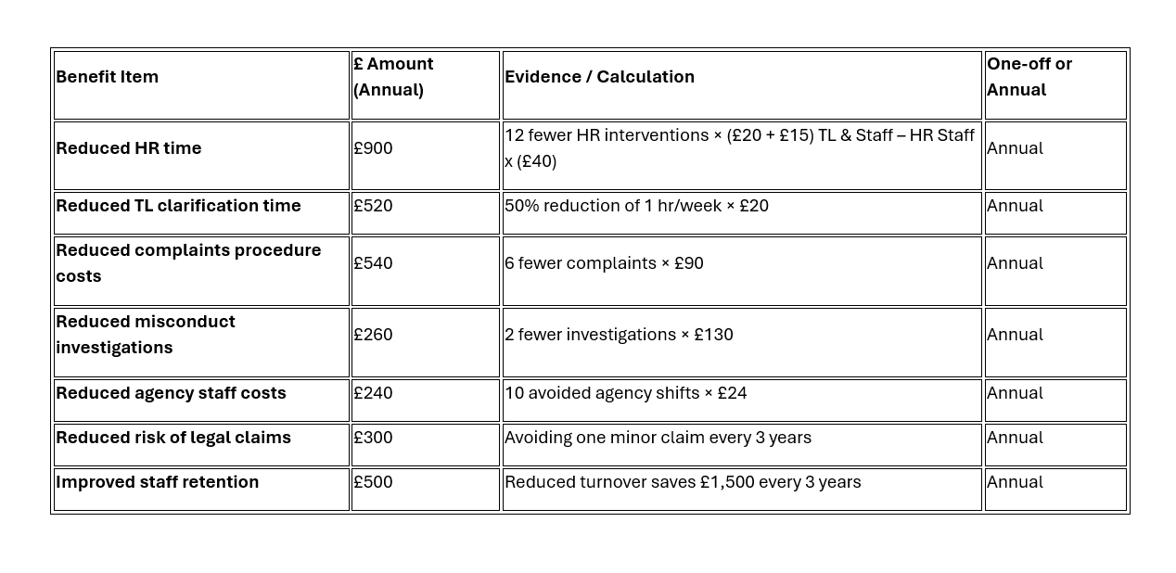
Monetary benefits are the financial gains the organisation receives as a direct result of the intervention.

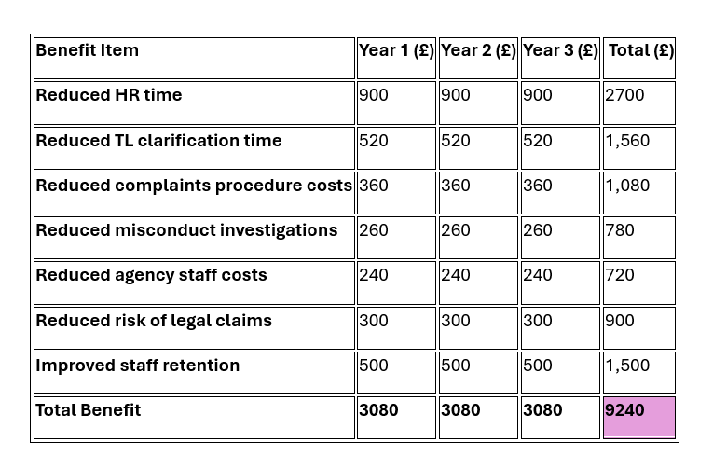
6.4 Figure 10 – 3 Year Financial Benefit
This table shows how benefits accumulate over time. It allows me to compare long-term gains against long-term costs.

6.5 Benefit–Cost Ratio
The benefit-cost ratio provides a useful way of showing whether the expected financial benefits outweigh the cost of the intervention. The three-year projection is useful because the highest costs occur during the initial implementation, while some costs reduce in later years.
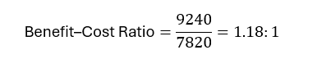
Over a three-year period, total costs were £7,820 and total benefits were £9,240, producing a positive benefit–cost ratio of 1.18:1. This means that for every £1 spent, the organisation receives £1.18 in benefit.

7. Net Annual Benefit and Payback Period
7.1 Figure 11 - Net Annual Benefit
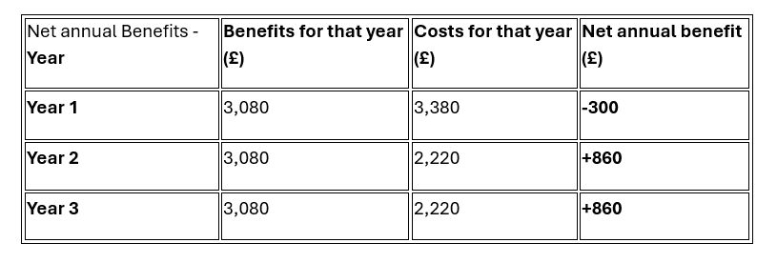

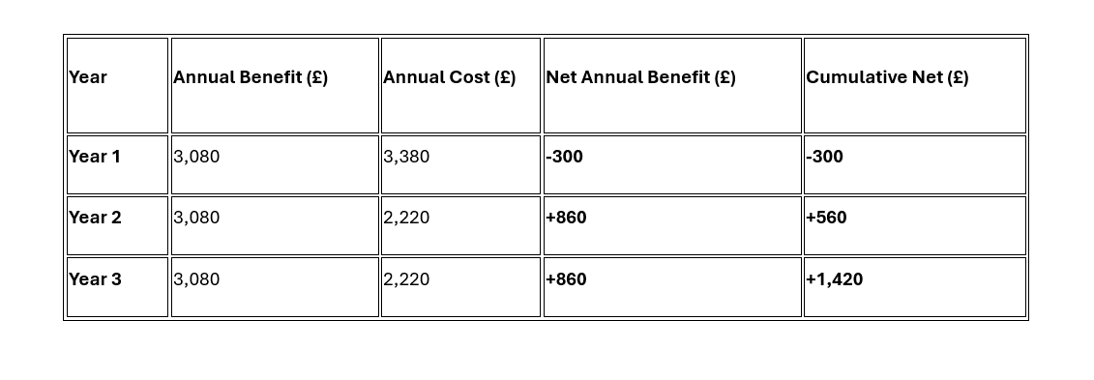
7.2 Figure 12 – Payback period

Net annual benefit calculations showed a small loss in Year 1 (–£300), followed by gains of £860 in Years 2 and 3. The payback period model shows that the intervention recovers its initial investment after approximately 1.35 years, or around Month 4 of Year 2. This is a key decision-making indicator because it shows how quickly the organisation will see a return, reducing financial risk and supporting confident investment.

7.3 Return on Investment (ROI)
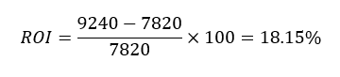
The ROI calculation produced a return of 18.15% over three years. This indicates that the intervention delivers more value than it costs and contributes positively to organisational efficiency. ROI is particularly useful for senior management because it shows measurable financial value linked directly to improved practice.

7.4 Sensitivity Analysis
A sensitivity analysis was used to assess how changes in the estimated costs and benefits could affect the financial outcome of the proposed intervention. This is important because the costs and benefits used in the analysis are estimates and may change during implementation.
First, I considered a 30% reduction in the expected benefits. The original benefit of £9,240 was multiplied by 0.7, giving £6,468. Dividing this by the original cost of £7,820 gives a benefit–cost ratio of approximately 0.83:1. This means that if the expected benefits were 30% lower than estimated, the intervention would no longer provide a positive financial return.
I then considered a 20% increase in costs while keeping the original benefits unchanged. The original cost of £7,820 was multiplied by 1.2, giving £9,384. Dividing the original benefits of £9,240 by £9,384 gives a benefit–cost ratio of approximately 0.98:1. This would bring the intervention close to break-even.
Finally, I considered a worst-case scenario where both changes occurred at the same time: benefits reduced by 30% and costs increased by 20%. The reduced benefit of £6,468 divided by the increased cost of £9,384 gives a benefit–cost ratio of approximately 0.69:1. This would result in the financial costs exceeding the estimated benefits.
These results show that the financial case is sensitive to changes in both costs and benefits. This reinforces the importance of monitoring implementation, staff competency and outcomes throughout the intervention. If the expected benefits are not being achieved, the service would need to review the intervention and consider whether changes are required.

8. Non-Monetary Benefits
Factor | Why it matters to this decision | Supports or counts against the option
Improved quality of service | Clearer documentation and better staff understanding of care plans lead to more consistent, accurate, and person-centred support. | Supports – strengthens service delivery and organisational reliability.
Increased safety of the child | Accurate care-plan adherence reduces risk of errors, safeguarding concerns, and inconsistent practice. | Supports – enhances safeguarding and reduces risk.
Higher staff job satisfaction | Staff feel more confident, supported, and competent when supervision and training are structured and meaningful. | Supports – improves morale and reduces turnover.
Better communication within the team | Regular supervision encourages reflective practice, shared understanding, and clearer communication pathways. | Supports – improves team cohesion and reduces misunderstandings.
Consistency of care delivery | Training ensures all staff follow the same procedures, reducing variability in care. | Supports – improves reliability and predictability of support.
Professional development for staff | Staff gain skills, confidence, and competence, supporting long-term workforce development. | Supports – aligns with organisational development goals.
Reduced emotional stress for staff | Clear care plans and better supervision reduce uncertainty, conflict, and pressure. | Supports – improves wellbeing and reduces burnout.
Improved family confidence and trust | Families feel reassured when staff demonstrate competence and consistency in following care plans. | Supports – strengthens relationships and reduces complaints.
Enhanced organisational reputation | High-quality documentation and safe practice contribute to positive external perception (regulators, families, MDT). | Supports – improves credibility and compliance.
Potential resistance to change | Some staff may initially feel anxious or resistant to increased supervision or training demands. | Counts against – may require additional support or phased implementation.
Increased short-term workload | Introducing new training and supervision structures may temporarily increase workload for TLs and staff. | Counts against – short-term pressure before long-term benefits emerge.

Non-monetary benefits reflect improvements in safety, service quality, staff wellbeing and organisational reputation that cannot be measured financially but still influence long-term outcomes. The table shows that strengthened supervision and documentation training support more consistent practice, clearer communication, greater staff confidence and stronger safeguarding, while also improving family trust and organisational credibility. These benefits demonstrate the wider value of the intervention for the child, staff and the service. The model also recognises realistic drawbacks, including initial resistance and short-term increases in workload, providing a balanced view of the option.

9. Implementation Plan

9.1 Implementation Plan Table
Task | Owner | Start / Finish | Resources Required | Milestone / Success Indicator
Develop updated supervision structure | Team Leader (Senior Support Worker) | Week 1–2 | Existing supervision templates; organisational policies | New supervision format approved and ready for use
Liaise with external training company to confirm training content | Team Leader & Training Company Lead Trainer | Week 1–2 | Contract agreement; training outline; communication meetings | Training content finalised and scheduled
Create documentation-focused training materials | Team Leader, Training Company, Online Training Provider | Week 1–3 | Laptop; online training platform; care-plan examples; training software | Training pack completed and uploaded to online platform
Deliver additional Year 1 training (face-to-face) | External Training Company & Team Leader | Week 3–6 | Training room; laptop; printed materials; attendance register | All staff complete initial training session
Deliver online training modules | Online Training Provider & Team Leader | Week 3–6 | Online training portal; staff log-ins; digital resources | Staff complete online modules and pass competency checks
Schedule monthly supervision sessions | Team Leader | Week 2 onwards | Staff rota; supervision templates; booking system | Supervision timetable published and adhered to
Monitor staff competency and care-plan adherence | Team Leader | Week 4 onwards | Observation tools; supervision notes; competency checklist | Improvement in documentation accuracy recorded
Review complaints, HR interventions, and incident data | Team Leader & HR Department | Monthly | HR logs; incident reports; supervision records | Reduction in documentation-related issues
Gather staff feedback on training and supervision | Team Leader | Quarterly | Staff surveys; supervision discussions; feedback forms | Positive feedback trends and increased confidence
Provide refresher training (Years 2–3) | Training Company & Online Training Provider | Annual | Updated training materials; online modules; training room | Staff complete refresher training with improved competency
Evaluate financial impact (annual review) | Team Leader & Manager | End of each year | Cost/benefit tables; HR data; supervision records | Positive net benefit achieved in Years 2 and 3
Adjust training or supervision based on findings | Team Leader & Manager | Ongoing | Feedback reports; updated materials; revised supervision structure | Continuous improvement demonstrated

The implementation plan table sets out the specific tasks, responsibilities, timescales, resources and success indicators required to deliver the chosen intervention. It provides a structured overview of what needs to happen, who is responsible, when each activity will occur and how progress will be measured.

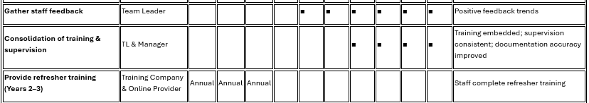
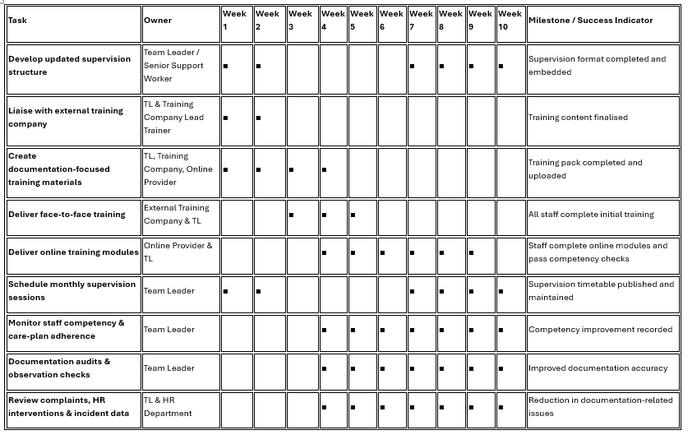
9.2 Gantt Chart

A Gantt chart provides a visual timeline of tasks, showing when each activity starts, finishes, and how tasks overlap. For a Team Leader, this model is particularly useful because it supports planning, coordination, and monitoring progress across multiple staff and responsibilities. It also highlights dependencies between tasks, ensuring that
The implementation plan introduces strengthened supervision and documentation-focused training through a structured 10-week schedule. The plan combines face-to-face training, online modules, updated supervision structures and competency monitoring to ensure staff understand, access and apply care-plan content consistently. Tasks are assigned to the Team Leader, Senior Support Worker, external training company and online training provider, with clear milestones and measurable success indicators to support accountability. The plan begins with developing updated supervision formats and finalising training content, followed by delivery of training sessions and online modules. Monthly supervision is embedded from Week 2 onwards, supported by competency checks, documentation audits and observation records. Consolidation occurs in Weeks 7–10, ensuring training is embedded, supervision is consistent and documentation accuracy improves. This structured approach ensures the intervention is feasible within staffing and organisational constraints and provides clear evidence of progress.

10. Stakeholder Analysis (Mitchell et al., 1997)
The stakeholder analysis identifies all individuals and groups affected by strengthened supervision and documentation-focused training, including internal staff, families, MDT professionals, external training providers and organisational departments such as HR and management. Stakeholders vary in power and interest, managers, HR and regulators hold high power due to their influence on policy, compliance and resource allocation, while support workers and families hold high interest because the intervention directly affects daily practice and the child’s experience.
10.1 Figure 14 – Interests and Influence Matrix
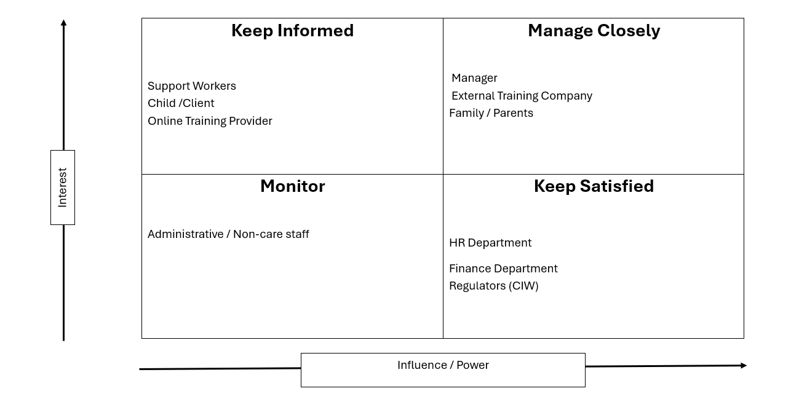

The analysis shows that support workers may require additional reassurance and structured communication to reduce resistance, while external providers need clear expectations and timelines to deliver training effectively. High-power stakeholders require regular, evidence-based updates, whereas high-interest stakeholders benefit from accessible communication and opportunities to provide feedback. This ensures engagement approaches are proportionate, targeted and aligned with each stakeholder’s role in the implementation process.
10.2 Figure 15 – Stakeholder table
Stakeholder | Power | Interest | Why / Stakeholder Expectation | Support or Resistance | Engagement Approach
Team Leader (Senior Support Worker) | High | High | Expects clearer supervision structure, improved staff competency, and reduced documentation errors. Responsible for delivery and monitoring. | Strong Support | Involve closely in planning, decision-making, and evaluation. Provide autonomy and resources.
Support Workers | Medium | High | Expect clear guidance, manageable workload, and training that improves confidence and competence. | Mostly Support (some initial resistance) | Provide regular communication, reassurance, and opportunities for feedback. Offer practical, accessible training.
Manager | High | Medium | Expects improved service quality, reduced incidents, and financial justification for investment. | Strong Support | Provide regular progress updates, financial reports, and evidence of improved outcomes.
HR Department | Medium | Medium | Expects fewer HR interventions, clearer documentation, and reduced complaints/misconduct cases. | Support | Share data trends, involve in monitoring improvements, collaborate on incident reviews.
External Training Company | Medium | High | Expects clear communication, timely scheduling, and access to staff for training delivery. | Strong Support | Maintain structured communication, confirm timelines early, provide care-plan context.
Online Training Provider | Low | Medium | Expects staff engagement with online modules and timely completion. | Support | Ensure staff have access, log-ins, and time allocated for online learning.
Child / Client | Low | High | Expects safer, more consistent care and accurate adherence to the care plan. | Support | Ensure training aligns with care-plan needs; monitor improvements in practice.
Family / Parents | Medium | High | Expect safe, consistent care, competent staff, and reduced errors or concerns. | Strong Support | Provide reassurance through communication, show improvements in documentation and practice.
Regulators / Inspectors (e.g., CIW) | High | Medium | Expect compliance, accurate documentation, and evidence of safe practice. | Support | Provide evidence of training, supervision records, and competency improvements.
Finance Department | Medium | Low | Expect cost-effective implementation and clear financial justification. | Conditional Support | Share cost–benefit analysis, ROI, and payback period to demonstrate financial viability.

The communication plan outlines how information will be shared throughout the intervention. Messages focus on purpose, expectations, progress and evidence of improvement, delivered through appropriate methods such as supervision sessions, team meetings, email updates, training briefings and family communication channels. Frequency varies according to stakeholder needs, with weekly updates for staff during initial implementation, monthly reports for management and HR, and scheduled feedback opportunities for families and MDT professionals. Communication responsibilities are assigned to the Team Leader, Manager and training providers, ensuring accountability and consistency. Evidence of effective communication will be gathered through supervision records, attendance logs, feedback forms, incident trends and documentation audits. The communication plan gives each stakeholder a clear role and makes sure they receive information at the point they need it. Staff receive more frequent updates during implementation, while management, families and other stakeholders receive information appropriate to their involvement.

11. Communication
11.1 – Communication Table
Stakeholder | Purpose / Message | Method | Timing / Frequency | Owner | Feedback / Evidence
Support Workers | Explain training requirements, supervision changes, expectations, and benefits | Team meetings, email updates, supervision sessions | Weekly during rollout; monthly thereafter | Team Leader (Senior Support Worker) | Staff feedback forms, supervision notes, attendance records
Manager | Provide progress updates, financial impact, risks, and outcomes | Formal reports, email summaries, review meetings | Monthly | Team Leader | Manager approval, meeting minutes, performance data
HR Department | Share improvements in documentation, complaints, and misconduct trends | Email updates, HR review meetings | Monthly | Team Leader | HR data trends, incident logs
Finance Department | Communicate cost–benefit outcomes, ROI, and payback period | Financial reports, email summaries | Quarterly | Team Leader | Financial review notes, approval for continued funding
External Training Company | Confirm training content, scheduling, staff attendance, and expectations | Email, scheduled planning calls, shared training documents | Weeks 1–6; annual refresher planning | Team Leader | Training completion certificates, attendance logs
Online Training Provider | Ensure access to modules, monitor completion, resolve technical issues | Email, online platform notifications | Weeks 3–6; annual refresher | Team Leader | Module completion reports, platform analytics
Child / Client | Ensure care-plan accuracy and safe practice improvements | Indirect communication through staff practice | Ongoing | Team Leader | Improved care-plan adherence, reduced errors
Family / Parents | Reassure families about improved documentation, safety, and staff competency | Email updates, review meetings, informal communication | Quarterly or as needed | Team Leader | Family feedback, reduced concerns or complaints
Regulators (CIW) | Demonstrate compliance, training evidence, supervision structure | Formal documentation, inspection reports | Annual or during inspections | Manager & Team Leader | Inspection outcomes, compliance reports
Admin / Non-care Staff | Awareness of training schedule and any operational changes | Email updates | As needed | Team Leader | Confirmation of understanding, smooth operational support
12. Monitor and review implementation
Monitoring and review processes are essential to determine whether strengthened supervision and documentation-focused training improve care-plan adherence. The monitoring framework uses objective, measurable indicators that directly reflect the problem identified earlier. Baselines have been standardised to ensure consistency, including six complaints per quarter, which aligns with the evidence presented in the problem-definition section. Targets focus on documentation accuracy, staff competency, complaint reduction, incident trends and supervision quality.

12.1 Figure 16 Measure and Baseline Table
Measure | Baseline | Target | Frequency | Owner | Evidence | Corrective Action
Staff documentation accuracy | Inconsistent documentation; errors noted in care-plan adherence | 90% accuracy within 3 months | Monthly | Team Leader | Supervision notes; documentation audits | Provide refresher training; increase supervision frequency
HR interventions related to documentation | 12 interventions per year | Reduce by 50% within first year | Quarterly | HR & Team Leader | HR logs; incident reports | Additional coaching; targeted training sessions
Complaints relating to care-plan clarity | 6 complaints per quarter | Reduce to 1–2 per year | Quarterly | Manager & Team Leader | Complaints records | Review care-plan clarity; adjust training content
Staff training completion rate | No structured training completed | 100% completion of face-to-face and online modules | During rollout; annually | Training Company & Online Provider | Attendance logs; module completion reports | Follow-up sessions; individual support
Staff competency in supervision sessions | Varied competency; inconsistent understanding | All staff demonstrate competency by Week 6 | Monthly | Team Leader | Competency checklists; supervision feedback | Additional supervision; targeted skill development
Family confidence and satisfaction | Mixed feedback; concerns about documentation | Positive feedback from families; reduced concerns | Quarterly | Team Leader | Family feedback forms; communication logs | Provide reassurance; adjust training focus
Training company performance | No baseline | Training delivered on schedule and to agreed standard | During rollout | Team Leader | Training evaluations; attendance data | Address delays; revise contract expectations
Online training engagement | No baseline | All staff complete modules within timeframe | During rollout | Team Leader & Online Provider | Platform analytics | Provide additional time; resolve technical issues

12.2 - Review Point Table
Review Point | When | Decision to Be Made | Who Participates
Initial rollout review | End of Week 2 | Confirm readiness for training delivery; approve training materials | Team Leader, Manager, Training Company
Mid-training review | Week 4 | Assess staff engagement; identify any barriers; adjust schedule if needed | Team Leader, Support Workers, Training Company
Post-training review | Week 6 | Evaluate training effectiveness; confirm competency improvements | Team Leader, Manager, HR, Training Company
Quarterly supervision review | Every 3 months | Review documentation accuracy, complaints, HR trends | Team Leader, HR, Manager
Annual financial review | End of Year 1, 2, 3 | Assess cost–benefit outcomes, ROI, payback progress | Team Leader, Manager, Finance Department
Family feedback review | Quarterly | Review family satisfaction and concerns | Team Leader, Families
Regulatory compliance review | Annually or during inspection | Confirm compliance with CIW expectations | Manager, Team Leader
Training provider review | Annually | Evaluate external and online training provider performance | Team Leader, Manager
Continuous improvement review | Ongoing | Adjust supervision structure, training content, or communication | Team Leader, Manager
Documentation accuracy will be checked through monthly audits using a structured checklist to confirm whether staff follow care-plan routines, communication approaches and risk-management instructions correctly. Complaint reduction will be monitored through quarterly reviews of family feedback and formal complaints, with a target of reducing documentation-related complaints from six per quarter to two by the end of Year 1. Incident trends will be reviewed monthly to identify whether inconsistent care-plan adherence continues to contribute to errors or safeguarding concerns. Supervision quality will be assessed through supervision records, attendance logs and evidence of reflective practice to ensure strengthened supervision is delivered consistently.
Review points are set for Weeks 2, 4 and 6 to assess early progress, followed by quarterly reviews to monitor sustained improvement. Annual financial reviews will check whether expected benefits such as reduced HR involvement, fewer agency shifts and improved staff retention are being achieved. Feedback from families, MDT professionals and support workers will be gathered through surveys, supervision discussions and routine communication to ensure the intervention remains responsive to need. Where targets are not met, corrective actions such as refresher training, additional supervision or updates to documentation will be put in place.
Regular monitoring will allow the service to see whether the changes are actually improving practice. If the targets are not being met, the findings can be used to decide whether further training, supervision or changes to the care plans are needed. It provides clear evidence of whether strengthened supervision and training are improving care-plan adherence and supports ongoing improvement across the service.

13. Conclusion
This report examined the problem of inconsistent care-plan adherence, drawing on workplace evidence and four analytical tools to identify the human, documentation and organisational factors contributing to variability in practice. Four alternative solutions were developed and evaluated using a weighted decision grid and financial analysis. Although the grid produced a joint outcome, strengthened supervision and documentation-focused training was selected because it aligns most closely with the dominant root causes and is feasible within current organisational constraints. The implementation plan outlines a structured 10-week schedule supported by targeted communication and stakeholder engagement. Monitoring and review processes provide measurable indicators of progress, ensuring improvements in documentation accuracy, staff competency and complaint reduction. Overall, I believe increased supervision alongside documentation-focused training is the most realistic option for this service. It addresses the main causes identified during the analysis without requiring major changes to the existing system. Its success will depend on staff engagement, consistent supervision and regular review of the results.

References
Adams, S., Cohen, E., Mahant, S., Friedman, J. N., MacCulloch, R., & Nicholas, D. B. (2013). Exploring the usefulness of comprehensive care plans for children with medical complexity (CMC): a qualitative study. BMC Pediatrics, 13(1). https://doi.org/10.1186/1471-2431-13-10
Boardman, A. E., Greenberg, D. H., Vining, A. R., & Weimer, D. L. (2018). Cost-benefit analysis: Concepts and practice (5th ed.). Cambridge University Press.
Buzan, T., & Buzan, B. (1993). The mind map book: How to use radiant thinking to maximize your brain’s untapped potential. BBC Books.
Dörner, D., & Funke, J. (2017). Complex Problem Solving: What It Is and What It Is Not. Frontiers in Psychology, 8. https://doi.org/10.3389/fpsyg.2017.01153
Ishikawa, K. (1985). What is total quality control? The Japanese way (D. J. Lu, Trans.). Prentice-Hall.
Mitchell, R. K., Agle, B. R., & Wood, D. J. (1997). Toward a theory of stakeholder identification and salience: Defining the principle of who and what really counts. Academy of Management Review, 22(4), 853-886. https://doi.org/10.2307/259247
Németh, B., Molnár, A., Bozóki, S., Wijaya, K., Inotai, A., Campbell, J. D, & Kaló, Z. (2019). Comparison of weighting methods used in multicriteria decision analysis frameworks in healthcare with focus on low- and middle-income countries. Journal of Comparative Effectiveness Research, 8(4), 195–204. https://doi.org/10.2217/cer-2018-0102
Ohno, T. (1988). Toyota production system: Beyond large-scale production. Productivity Press.
‌Osborn, A. F. (1953). Applied imagination: Principles and procedures of creative problem-solving. Charles Scribner’s Sons.
Sjöberg, M., Edberg, A., Rasmussen, B., & Beck, I. (2021). Documentation of older people’s end-of-life care in the context of specialised palliative care: a retrospective review of patient records. BMC Palliative Care, 20. https://doi.org/10.1186/s12904-021-00771-w
‌World Health Organization (2003). Adherence to long-term therapies : evidence for action. World Health Organization. https://iris.who.int/handle/10665/42682

‌

