- You are required to use appropriate analytical tools and models such as PESTEL, Porter’s 5 Forces, SWOT, TOWS, QUEST, Porter’s diamond, etc. When assessing the current environmental forces to see where the company currently sits within its current environment and how that the firm has interpreted these findings in terms of the decisions it has made on a Microeconomic level.
- Then utilise the findings from the current position in terms of SWOT (talked about in my last paragraph) and talk about the potential of the organisation taking up any of the opportunities or nullifying any of the threats identified (with the implications this has in terms of your organisation's weaknesses and strengths in doing so) and also the knock on effects there would be in terms of the decisions it would have to make at a Microeconomic level when doing so.

Nuclear sector plus engergy services (hinkley projects C)
Cultural difference APAC Americas and EMEA

******************************************************

Introduction

This report will focus on IMI PLC a British global leader in providing complex engineering solutions across a wide range of leading industrial companies. The business currently positions itself within the FTSE250 with an adjusted revenue of 1.873 billion GBP in 2019 (IMI PLC, 2020). The focus of this report will be to analysis the current environmental factors, micro (internal) and macro (external) influencing the business.

An evaluation of the position of the company along with future strategic direction based on micro and macro factors will also be critically discussed. Industry relevant figures will be used as supporting evidence to measure the performance of IMI PLC in relation to its current market position. The future planning of IMI PLC’s strategic plan will also be explored.

IMI PLC Divisions
IMI PLC operates across three divisions: IMI Precision Engineering, IMI Critical Engineering and IMI Hydronic Engineering. The three different divisions currently operate across fifty countries and employ approximately eleven thousand people globally. Below is a brief introduction to each divisional department:
- Precision consists of seven core brands and specialise in the control of motion and fluid control application systems. The unique selling point is precision, speed and reliability. Precision contributed an adjusted revenue of £907million in 2019. This division of the business employs five thousand eight hundred, accounting for fifty-four percent of IMI PLC staff.
- Critical consists of sixteen core brands and specialise in valves and actuators which regulate the control of gas and liquids within a range a harsh environmental conditions. Critical contributed an adjusted revenue of £651million in 2019. This division employs three thousand two hundred staff, accounting for thirty percent of IMI PLC staff.
- Hydronic consists of five core brands and specialise in hydronic distribution systems which provide heating and cooling systems whilst delivering optimal energy efficient performance. Hydronic contributed an adjusted revenue of £315million in 2019. This division employs one thousand eight hundred staff, accounting for sixteen percent of IMI PLC staff.

PESTEL Analysis

Political:

The main political issue facing the UK currently are trade deal negotiations. The UK under the EU operated under forty different trade deals with over seventy countries. As a percentage in 2018 this accounted for eleven percent of UK trade (BBC,2020). In 2019 the EU was the UK’s largest trading partner with exports valuing £374 billion, whilst the UK imported £294 billion from the EU. This accounted for forty-three percent of all UK exports and fifty-two percent of all UK imports (The UK in Changing Europe, 2020).

In October 2020 the UK secured its first trade deal as an independent trading partner with Japan. Japan is the worlds third largest economy and responsible for (?????). The UK-Japan Comprehensive Economic Partnership Agreement (CEPA) will result in tailored benefits that were previously unavailable to the UK whilst constrained by EU agreements. These benefits focus on digital trade, data, and financial services, food & drink and creative industries. The UKs trade with Japan is estimated to increase by £15billion (British Embassy, 2020).

The second significant trade discussion is with Canada who have extended the Comprehensive Economic and Trade Agreement (CETA) which means that the UK will remain trading with Canada under the same conditions as when it was a member of the EU. This will remove ninety-eight percent of potential tariffs being applied to exports. It also gives the UK the opportunity in 2021 (After leaving the EU) to negotiate a personalised trade deal as witnessed between Japan and the UK.

This also strengthens the UK’s position in entering the Comprehensive Trans-Pacific Partnership(CPTPP) as Japan and Canada are already members. This would grant access to its eleven members all trading with reduced tariffs on over ninety-five percent of goods. The CPTPP covers thirteen percent of the global economy and is of the biggest free trade agreements in the world. In 2019 CPTPP was responsible for £110 billion of trade (Department for International Trade,2020).

There is also the political issue of the trade war between America and China. The trade war has seen traifs of ?? applied to US & China imports and exports. This has repercussion from a political aspect for the UK as it peruses its strategic plan of building a free trading global nation. The UK could be under political pressure from the US to excluded China from trade talks however recent protectionist tactics applied by the USA ask the question is this the best nation to become heavily involved in trade deals with? In recent years the US has withdrawn from trade agreements such as the Trans-Pacific Partnership (TPP) which has recently been superseded by the Comprehensive Trans-Pacific Partnership (CPTPP). By becoming a US close trading partner the UK could potentially be restricted on trading partners and negotiations. One of the very why reasons the UK left the EU!
(LINK all Political to IMI)

Economic:

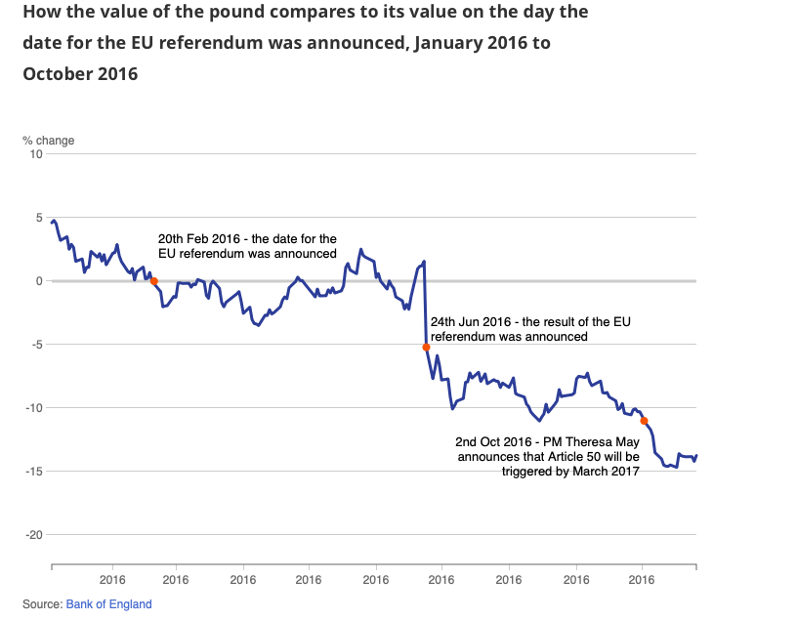
A Major factor effecting the IMI PLC a British based business is the decision by the UK June 2016 to leave the EU. The result to the leave resulted in the fall of the pound, this fall occurred at the significant points. The first being on the 20th February 2020 when the EU referendum date was announced. The pound was already declining in value from the beginning of 2016 due to political uncertainty. The second took place on the 24th June 2016 when the referendum result to leave was announced, resulting in a five percent decline in the value of the pound. A further five percent drop in value took place on the 2nd October 2016 when the announcement date for Article 50 (The formal process of leaving the EU) would be triggered.

(ONS,2016)

Moving to November 2020 and the recovery of the pound has been slow further exacerbated by the Covid19 pandemic resulting in the pound falling a further three percent in March 2020.
HIGH COST imports expand

Social:

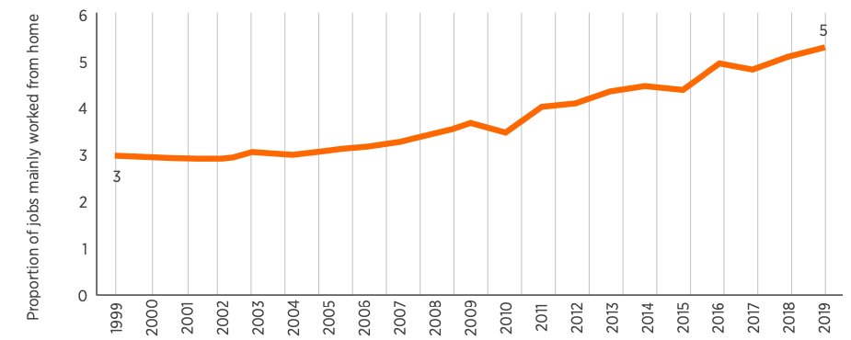
The way in which employees conduct their working business has evolved, with a rise of eighty percent in employees working from home over the last two decade (CIPD, 2020). As shown by the chart below from CIPD (2020):

Figure 1: Home as the main place of work is on the rise (%) (proportion of jobs worked mainly from home, 1999–2019

The world has been massively impacted by the COVID19 pandemic, how the human race socialise, works and exists has completely changed. The trend in homework was steadily increasing before the effects from the COVID19 in 2020 however the pandemic will rapidly accelerate this growth.

Social attitudes of workers and business are also adapting to the pandemic. A culture of trust is being developed between employees and businesses relinquishing the barriers of “fixed working days” and “set working hours”. There is a strong argument that if an employee can preform the same level of work to the same standard regardless of working location why not offer the option of remote working? The argument also goes one step further by asking the question do employees need to be confined to set working hours if business objectives are achieved with flexible working hours?

This social attitude towards remote and flexible working are moving further towards it favour as the pandemic has caused social challenges to all level of employees in UK business, such as:

- Employees requiring to shield from COVID19.
- The disruption to the childcare system relied upon by parents when the school’s closed in early 2020 and nurseries were only accepting child from key workers.
- The reduction in gatherings of people commuting to work
(few more data facts)

British based IMI PLC has been following the UK governments advice of home working where possible. This has resulted in the physical separation of the majority of its employees rendering its three UK sites operating with only essential staff. IMI PLC has embraced the remote and flexible working environment throughout 2020 something that the company had been discussing since 2018.

The pandemic gave the IMI PLC the forced option: stop trading or adapt. Choosing the second option has seen a significant cultural change in a short time period. This cultural change has embraced trust and individuality of employees, accepting different needs of employees and giving managers of departments across all of its sites the ability to judge employees performances on measurable objectives and not how long has been spent in the workplace. Particularly focusing on working parents and supporting their needs the best it can.

IMI PLC is currently heavily investing in its infrastructure to ensure employees remain connected regardless of location. This infrastructure upgrade is currently completed under the “ONE TEAM” initiative. It has pledged to support diversity and individualism covering remote and flexible working (where possibly) in order to ensure all employees can work to their best ability by reducing the everyday working pressure. The CEO of IMI PLC Roy Twite (2020) acknowledges the ONE TEAM initiatives potential by stating:

“I firmly believe that our differences make us stronger. Inclusion and diversity are both vital if we are going to maximise innovation to solve industry problems.”

Technological Advancements:

IMI PLC relies heavily on supplying engineering systems to the defence industry globally.
The value of the pound falling since Brexit and COVID19 pandemic has had little impact on defence industry spending. The Ministry of Defence has pledging a defence budget of £41.5billion for 2020/2021. This is an increase of £2.5 billion from 2019. This places the UK as the third highest for defence expenditure equating to around two percent of national GDP.

In 2019 The UK Ministry of Defence also unveiled its ten year military plan with its highest spending of £46.7 billion from 2019-2029 within the advancement of the nuclear submarine industry an industry in which IMI PLC specialise within (Ministry Of Defence, 2019).

Global spending on defence projects has also increased, positioning Greece as the second largest spender in NATO behind the US.

Renewable energy sources
Rolls royce nuclear program plus hickley power station

DEFO mention coves opportunity for Life sciences cvid opportunity
covid pushing companies automation juts acquired Bimba good position

In March 2020, the Department of Business, Energy and Industrial Energy (BEIS) and Natural Resources Canada (NRCan) signed the UK-Canada Nuclear Cooperation Action Plan. This bilateral framework enables collaboration between BEIS and NRCan, with both governments and nuclear industry stakeholders working together to support advanced nuclear development and deployment, and share best practice and knowledge.

The advanced nuclear sector has the potential to play an important part in the UK’s Industrial Strategy building on our existing economic strengths and competitive advantages in nuclear whilst shaping new advanced nuclear markets and contributing to tackling the Clean Growth Grand Challenge.

Environmental:
Petroleum

Petroleum is a liquid fossil fuel. It is also called oil or crude oil.

Petroleum is trapped by underground rock formations. In some places, oil bubbles right out of the ground. At the LaBrea Tar Pits, in Los Angeles, California, big pools of thick oil bubble up through the ground. Remains of animals that got trapped there thousands of years ago are still preserved in the tar!

Most of the world’s oil is still deep under the ground. We drill through the earth to access the oil. Some deposits are on land, and others are under the ocean floor.

Once oil companies begin drilling with a “drill rig,” they can extract petroleum 24 hours a day, seven days a week, 365 days a year. Many successful oil sites produce oil for about 30 years. Sometimes they can produce oil for much longer.

When oil is under the ocean floor, companies drill offshore. They must build an oil platform. Oil platforms are some of the biggest manmade structures in the world!

Once the oil has been drilled, it must be refined. Oil contains many chemicals besides carbon, and refining the oil takes some of these chemicals out.

We use oil for many things. About half of the world’s petroleum is converted into gasoline. The rest can be processed and used in liquid products such as nail polish and rubbing alcohol, or solid products such as water pipes, shoes, crayons, roofing, vitamin capsules, and thousands of other items.

Advantages and Disadvantages
There are advantages to drilling for oil. It is relatively inexpensive to extract. It is also a reliable and dependable source of energy and money for the local community.

Oil provides us with thousands of conveniences. In the form of gasoline, it is a portable source of energy that gives us the power to drive places. Petroleum is also an ingredient in many items that we depend on.

However, burning gasoline is harmful to the environment. It releases hazardous gases and fumes into the air that we breathe. There is also the possibility of an oil spill. If there is a problem with the drilling machinery, the oil can explode out of the well and spill into the ocean or surrounding land. Oil spills are environmental disasters, especially offshore spills. Oil floats on water, so it can look like food to fish and ruin birds’ feathers.

Legal:

SWOT & TOWS (Internal)

Strength
Strength milirty contracts guaranteed money for orders see nots from one of MBA weeks on securing money as a business.

work with greece government defence show graph spending intracom.

Weakness

reduction in pound more cost more to import into mterials UK

new to nuclear valve industry

Oppertunity
The agreement also includes a strong commitment from Japan to support UK joining the Trans-Pacific Partnership (TPP), one of the world’s biggest free trade areas, covering 13% of the global economy and more than £110 billion of trade in 2019. This will help strengthen trade ties between the UK and 11 Pacific countries and set new standards for global trade.

he deal is tailored to both economies and has secured that goes beyond existing EU deals, with big benefits for digital and data, financial services, food and drink, and creative industries. The deal brings together 2 of the world’s most technologically advanced nations, placing the UK at the forefront of shaping new global standards on digital trade. The estimated boost to trade between the UK and Japan is over £15 billion, with long term economic benefits that are crucial to ‘build back better’ from Covid-19, reshaping the UK economy so it is fit for the future.

submarine rolls royce gold partner could lead to nuclear development smaller reactors!

connect remote working inosturucture link resources globally and deal with customer needs globally

So what is the difference between SWOT and TOWS analysis? ... Within a strategy-making process, you would first use SWOT to identify your strengths, weaknesses, opportunities and threats, and then use TOWS to work out how your SWOT findings can be applied to future strategy.

Threat:

What are the potential consequences of these outcomes?

The imposition of tariffs on trade with the EU would increase costs for both UK importers (and hence
consumers) and exporters. The average EU tariff rate is low - around 1.5%. However, at a sectoral level,
the impacts would be much larger: for example, for cars and car parts the tariff rate is 10%. Since most UK-
based car production is exported, and uses imported parts, the impacts would be magnified. The impacts
would also be large on agriculture, where EU tariffs and quotas remain high; this would result in significant food price inflation for British consumers.

Porters five why’s - pick on strategic decision

While they both help in assessing your company's strengths and weaknesses relative to industry opportunities and challenges, a primary difference is that SWOT focuses more on company-specific elements while Five Forces involves a look at five important competitive factors when making a strategic decision

Macro-Analysis - Critical assessment of a range of national and international macro-economic performance indicators.

Above analysis, derive a comprehensive conclusion, which evaluates the current position of the chosen organisation within the international market and provide an outlook/ scenario

uk strategic plan be hub for free trade.

China nfrastructure China also plays an increasingly important role in the UK's infrastructure, including its nuclear power capabilities. China General Nuclear Power (CGN) is partly financing the building of the £20bn Hinkley Point nuclear power station in Somerset.

future organisational decisions and/ or developments. This should include analysis and discussion on the thinking behind the microeconomic decisions taken by the company previously and also on how these decisions may change if the organisation decides to take up any potential new ways of moving forward in the future.

**Automation big driver currently IMI creating automation ready products moving with technology!

***rebranding to Norgren brand strength as currently IMI different sub sections power one brand.

vaccine production covid 19 social and economic value solution as porter said video week 5

Future trends will magnify the challenges. The world population is on a trajectory to grow from seven billion today to more than nine billion by 2050. And with today's consumption of resources already equivalent to more than 1.5 Earths, we are on an unsustainable path to meet the demands of this growing population.
But multinational corporations that lead the way recognize that finding solutions to economic, social, and environmental challenges will help them grow their companies' value, while also building a better world for all.
https://www.theguardian.com/sustainable-business/business-government-world-problems-davos-multinational business solve world challenges

Conclusion

**The power of three remain specialist but part of word wide resources.s

Despite being a global organisation, we want to remain specialist and expert. We’re spilt into three business divisions – IMI Precision Engineering, IMI Critical Engineering and IMI Hydronic Engineering. Each is set up to solve our customers’ problems and allow us to expand our fluid engineering capabilities. It’s about being agile, responsive and solutions-led.

It seems that China are partial opening up to the world on they terms but the Us is withdrawing from international trade through protectionism activities, but as the government changes the
America and protectionism again free trade, and also pulling out of CPTPP trade deal

References:

https://www.mckinsey.com/business-functions/operations/our-insights/industry-40-reimagining-manufacturing-operations-after-covid-19
Covid advanced automations

https://www.google.com/amp/s/blog.midaxo.com/project/growth-through-acquisition-a-powerful-strategy-in-capable-hands%3fhs_amp=true
Growth by m&a

https://www.ukessays.com/essays/economics/macroeconomic-indicators-and-their-importance-to-performance-economics-essay.php#:~:text=The%20aspects%20include%20performance%20of%20the%20country%2C%20its,economic%20growth%2C%20interest%20rate%20and%20balance%20of%20payment.
Macroeconomic indicators and their importance to performance

https://www.mageplaza.com/blog/micro-and-macro-factors-affect-your-business.html Understanding Of Micro And Macro Factors That Affect Your Business — How

https://data.oecd.org/gdp/gross-domestic-product-gdp.htm facts GDP the world due to covid

https://tradingeconomics.com/united-kingdom/manufacturing-pmi imi measurement manufacturing

https://uk.investing.com/economic-calendar/manufacturing-pmi-204 imi facts

https://www.unicef.org/knowledge-exchange/files/SWOT_and_PESTEL_production.pdf SWOTS PESTLE HELP REF

*********************

Political

https://www.annualreports.com/HostedData/AnnualReports/PDF/LSE_IMI_2019.pdf
(intro 1.83billion annual revenue)

https://www.ons.gov.uk/economy/inflationandpriceindices/articles/whyhasthevalueofthepoundbeenfallingandwhatcouldthismeanforpeopleintheuk/2016-10-28 (2016 cost £ ons picture)

https://tradingeconomics.com/united-kingdom/currency pound tracking value pestle political

https://www.gov.uk/government/news/uk-and-japan-sign-free-trade-agreement japan trad agreement 2020 Pestle

https://www.gov.uk/government/news/uk-secures-vital-rollover-trade-deal-with-canada-and-agrees-to-start-negotiating-more-advanced-deal-next-year (canada trade deal)

https://www.gov.uk/government/publications/uk-approach-to-joining-the-cptpp-trade-agreement/an-update-on-the-uks-position-on-accession-to-the-comprehensive-and-progressive-agreement-for-trans-pacific-partnership-cptpp pestle political

https://www.bruegel.org/wp-content/uploads/2016/10/PC_18_16-1.pdf china back door to the EU

https://www.bbc.co.uk/news/uk-47213842 bbc facts pestle Tom Edgington 2020

https://commonslibrary.parliament.uk/research-briefings/cbp-7851/ (figures uk exports eu pestle)

https://ukandeu.ac.uk/wp-content/uploads/2017/09/No-Deal-The-WTO-Option-Fact-sheet-1.pdf value imports pestle

https://assets.publishing.service.gov.uk/government/uploads/system/uploads/attachment_data/file/919361/20200227_CH_UK_Defence_in_Numbers_2019.pdf (submarine spending 2019).

https://www.gov.uk/government/news/uk-and-japan-sign-free-trade-agreement (British embassy, 2020)

social https://www.cipd.co.uk/Images/working-from-home-1_tcm18-74230.pdf home working facts

https://www.imiplc.com/esg/people roy says one team initative

https://www.nationalgeographic.org/encyclopedia/non-renewable-energy/ petroleum enviromental

