Component 2 - Research Report
Student Name: Khatemnara Begum
Student Number: 2211901
Lecturer Name: Chuen Leung
LCHS4002_BIRM
Digital Skills and Research Methods.

Contents
1. Introduction 3
2. Research design 3
2.1. Research Question 4
2.2. Method 6
2.3. Ethical Considerations 6
3. Results 6
4. Discussion 7
5. Conclusion 9
6. Reference List 10
7. Appendix A – A blank copy questionnaire. 11

Introduction
The purpose of this presentation is to determine whether training on how to use technology to facilitate collaboration at UWTSD is required. We will learn how quantitative and qualitative research findings moderate the relationship between university collaboration and technology throughout this research we have conducted.
Based on resources, the more knowledge you gain about technology usage, the better collaboration skills you will have at UWTSD, allowing social interactions with educational activities and tools.
The most critical scientific issues or innovative technologies are frequently solved by collaborating with a team of researchers from various backgrounds. The combination of different fields can allow for the achievement of incredible goals. Collaborative research can thus be defined as research involving coordination among researchers, institutions, organisations, and/or communities (Medhi, B et al, 2019).
Medhi, B et al, (2019) suggests this collaboration can bring distinct expertise to a project. Collaboration can be voluntary, consortia, federation, affiliation, or merger, and it can occur at five different levels: within disciplinary, interdisciplinary, multi-disciplinary, trans-disciplinary, or national vs international.
Collaborative research allows for the exchange of ideas across disciplines, the acquisition of new skills, access to funding, higher quality results, radical benefits, and personal factors such as fun and pleasure (Medhi, B et al, 2019).

Research design
In accordance with our presentation, we are going to talk about the concept behind our research design. To prepare for this, we conducted an investigation into the nature of the idea and type of collaboration that exists at UWTSD, and as a result, we devised a method of data collection that is centred on the questions that are listed below.
Do you give consent for data collection? Yes or No?
How confident are you in using technology to collaborate? Yes no No?
Are you aware of any technical support being provided at UWTSD? Yes or No
What do you think will help you be more confident in using technology to collaborate? Comments?
As a result of the conversation that has just taken place, we have realized that the ethical consideration for the topic at hand will be attained in order to put into action and carry out the various sessions of technology that will assist in collaborating with UWTSD institution.
You will need to adapt the ways in which you collaborate if some or all of your team is working remotely. This will guarantee that everyone on the team feels involved in the process. When a remote workforce relies only on online communication sessions and project management tools, it may lead to feelings of alienation and a decline in employee motivation.
However, these technologies are important to the success of a remote workforce. In order to cultivate a robust university culture among distant workers or students, it is necessary to conduct frequent check-ins using methods other than email and chat. Put forth the effort to plan weekly meetings through video conferencing to give everyone the impression that they are an integral member of the team. Not only does this enhance mood, but it may also assist members of the team feel more collaborative when working at UWTSD.

Research Question
Is There A Need To Provide Training On How To Use Technology To Collaborate At UWTSD?
Collaboration promotes effective communication and partnerships while also providing equal opportunities to team members. It recognises and values each individual and organisational style. Collaboration improves ethical behaviour by promoting honesty, integrity, justice, transparency, and confidentiality (Calderón, C.E.J. (2008).
Conducting online Session for collaboration at UWTSD:
You will need to adapt the ways in which you collaborate if some or all of your team is working remotely. This will guarantee that everyone on the team feels involved in the process. When a remote workforce relies only on online communication sessions and project management tools, it may lead to feelings of alienation and a decline in employee motivation. However, these technologies are important to the success of a remote workforce. In order to cultivate a robust university culture among distant workers or students, it is necessary to conduct frequent check-ins using methods other than email and chat. Put forth the effort to plan weekly meetings through video conferencing to give everyone the impression that they are an integral member of the team. Not only does this enhance mood, but it may also assist members of the team feel more collaborative when working at UWTSD.
Study skills at UWTSD:
According to a body of academic research, students report greater retention of information after participating in educational activities that emphasize active, social, contextual, and engaged learning. The following are some of the advantages of learning via collaboration:

The cultivation of higher-level abilities in areas such as thinking, oral communication, self-management, and leadership.
Encouragement of interactions between students and teachers.
An increase in students who continue their education, their self-esteem, and their sense of responsibility.
Preparation for the social and professional circumstances that will be encountered in real life.
Being exposed to a variety of points of view and gaining a deeper comprehension of them.

1-2-1 Session at UWTSD:
The teacher will ask a question that requires either analysis, assessment, or synthesis of information.
After a brief period of reflection, students are required to formulate a suitable answer.
During the subsequent discussion, student replies may be discussed either within bigger groups of students or with the full class.
In-class preparation • Immediately actionable feedback and unambiguous clarity
Have the students discuss their answers with a partner (or in small groups) and then turn to them. To take this a step further, encourage students to identify a partner who arrived at a different answer than they did and try to persuade their companion to alter their opinion about the correct answer
Peer Learning:
You should establish clear communication standards regardless of the platforms you choose to use. This will ensure that students are aware of the kind of talks that are fruitful online and those that should be saved for in-person meetings, emails, or phone calls. For instance, you may establish standards for the anticipated response timeframes and alternate follow-up routes in the event that a colleague does not answer after the allotted period of time has passed. It is also crucial to educate workers that they should never use a professional communication tool for personal talks. This is something that should never be done.

Allow for training and adaptation time for new forms of collaborative software:
Expecting your team to feel instantly comfortable utilising a new collaboration technology for work is unrealistic, even if some of your employees are younger students who have grown up with instant messaging and internet chat. Because humans are creatures of habit, it may take some time for any of us to get used to new procedures or technology implemented in the workplace. Even if you are certain that your students will profit from the change in the long term, you should still anticipate some resistance when you introduce a new tool and be open to hearing their concerns about it.
Methods:
This experiment included a total of twenty-five (n = 25) participants from two different educational institutions. In order to be ready for their student teaching, each participant was enrolled in a class that covered various educational strategies. Over one-third of the participants were male, making up 39% of the total, while 56.5% of the participants were female. One person, making up 4.5% of the total, did not state their gender. Ages ranging from 20 to 42 years old were represented among the participants.

Measure:
We collected data by using both qualitative and quantitative research methods independently. The Technology Integration Confidence Scale (TICS) version 1 (Browne, 2009) was completed by the participants both as a pre-test and a post-test so that quantitative data could be collected. This survey is aligned with the National Educational Technology Standards for Teachers, which were developed by the International Society for Technology in Education (ISTE). It examines participants' levels of self-efficacy for utilizing technology in educational settings (NETS-T).
At the beginning of the study, participants were given open-ended questions that they were required to answer in order to produce qualitative data. The issue had previously been discussed at the study design session, so participants were given the opportunity to submit as much comprehensive information as they want on their experiences.

Ethical Consideration:
The exponential growth of human knowledge and the potential of technological advancement are both accompanied by the creation of an increasing corpus of ethical problems. It is possible that an essential part of the technological engagement with UWTSD is the process of bringing these concerns to the attention of the students. It also has the potential to aid us in the development and maturity of our students via their connection with UWTSD, which would be a direct result of this opportunity.
In the course of putting the study design into action in our research and carrying out the survey with participants of varying ages and genders, our primary goal is to increase productivity in the area of technology in order to improve our capacity to collaborate with UWTSD. This will be accomplished by increasing the number of participants in the survey. While we are striving to make improvements to the technology, there are a few holes that need to be addressed. As a result, in order to boost system collaboration, we have done an examination of the protocols for data collecting.

Results
As was said in the previous debate, we have come to the conclusion, which can be seen in the image below:
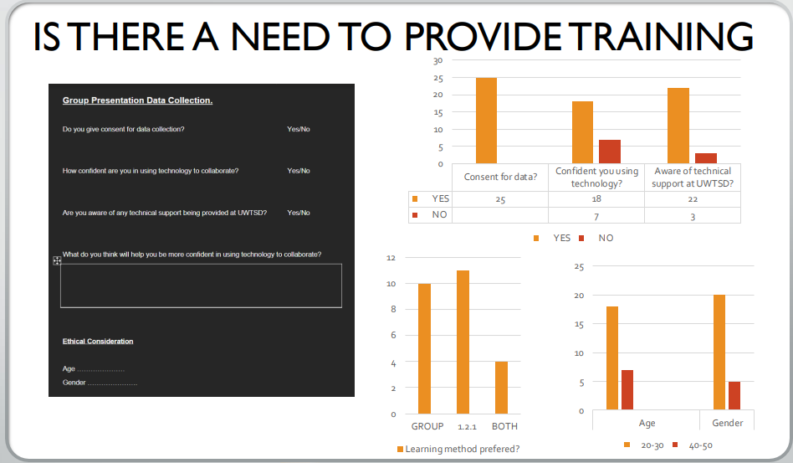
Discussion
The goal of this research was to evaluate the perspectives of students, faculty, and staff at UWTSD University on the collaborative processes made possible by educational technology. We devised activities for group lesson preparation in order to make participant participation easier to achieve via the use of instructional technology. Our primary goal was to improve the participant’s ability to apply their theoretical and procedural knowledge in authentic, technology-based, and collaborative learning environments in order to better serve the educational needs of elementary school students.

They were able to build their self-assurance in the areas of planning and developing chances for collaboration and the creation of learning environments. To be more precise, they learnt how to adjust their teaching methods, lesson plans, and assessments so that they are in line with the standards and the curriculum.

The qualitative component of this research provided some interesting insights into how the participants evaluated the group effort to create lessons. Participants felt at ease making decisions on the kinds of technologies they would use during the course of the project. They tended to gravitate toward asynchronous approaches, which allowed them to participate online at times of their own choice. However, several participants thought that the collaborative process was hindered by the use of asynchronous technologies since they prevented them from communicating with other group members in real time. Concerning additional difficulties, participants mentioned the high degree of communication that was necessary, which was not easily provided by the technology that was available online. The responses from participants indicated a growing sense of exasperation with the process of finding an agreement on the material and preparing the lesson plans.
The majority of participants felt that this project assisted them in the development of abilities that would be useful to them in their future teaching environments. Many were more receptive to the idea of using technology in their future classrooms as a means of facilitating communication and learning. They acknowledged the importance of communication in terms of both content and the overall efficacy of teaching, and they understood the benefits of working together online to better their lesson preparation.

Conculsion
The findings of this research demonstrate how important it is to build skills for working collaboratively with UWTSD. The requirements that students work in collaborative teams and apply principles are aligned with these expectations, which are congruent with the standards. Other conclusions of this research pertinent to 1-2-1 learning that may be useful and advantageous as most students' education and online cooperation include the discovery of generally applicable tactics to educate, motivate, and for a better comprehension. These results are important because they show that 1-2-1 learning has the potential to be effective and beneficial. For instance, the findings provide support for the use of collaborative learning in order to encourage lifetime professional growth among students. Because of this, students will have a more hopeful experience when utilizing advanced technology to interact, as the training that was offered to them will have helped them enhance their grasp of how technology is used.
Language, financial commitment, inadequate regulatory frameworks, and diverse interests are among the potential challenges in collaborative research, based on a thorough understanding of collaboration.
This can be successful if the collaborators respect each other and are willing to give and receive constructive criticism without becoming defensive. To summarise, the outcomes of these collaborations will be visible not only in specific work completed during the collaboration period, but also throughout the professional lifetimes of scholarship and publication.
Technology is the accumulation of knowledge that enables people to create artifacts or processes by modifying the environment to create welfare and satisfy human needs.
These findings appear to imply that in order for collaborative learning across distances to occur, students must learn collaboration principles in addition to the technology, and that a variety of technologies are required to accommodate cultural and individual differences among students.

Reference List
Browne, J. (2009). Assessing pre-service teacher attitudes and skills with the technology integration confidence scale. Computers in the Schools, 26(1), 4–20.

Calderón, C.E.J. (2008). Technology Research Methodology. [online] gestiopolis. Available at: https://www.gestiopolis.com/technology-research-methodology/ [Accessed 1 Nov. 2022].
Chu, S. K.-W., & Kennedy, D. M. (2011). Using online collaborative tools for groups to co-construct knowledge. Online Information Review.

Lee, D., Huh, Y., & Reigeluth, C. M. (2015). Collaboration, intragroup conflict, and social skills in project-based learning. Instructional Science, 43(5), 561–590.

Medhi, B., Bansal, S., Mahendiratta, S., Kumar, S., Sarma, P. and Prakash, A. (2019). Collaborative research in modern era: Need and challenges. Indian Journal of Pharmacology, 51(3), p.137. doi:10.4103/ijp.ijp_394_19.
​

Appendix A – A blank copy questionnaire.


