PSYCHOLOGY FOR HEALTH AND SOCIAL CARE

Student Name: Alexandra Bizga
Student number: 2018352
Module code: Psychology for health and social care/BMHP4019_BIRM, BMHP4003_BIRM
Lecturer’s name: Chloe Harries

Executive Summary
Social Psychology refers to a diagnostic and therapeutic approach through policies, demonstration of social standards and education regarding social ethics. A 15-year-old boy was strictly instructed to follow the rules where the boy swore toward a 58-year-old woman. The social exchange theory postulates aspects of critical explanation in this report. The report will discuss theoretical aspects and justification of the incident. The report will finally recommend if the complaint needs to be withheld or dismissed against the staff.

Table of Contents
PSYCHOLOGY FOR HEALTH AND SOCIAL CARE 1
Executive Summary 2
Introduction 4
Demonstration of the Misbehaviour of Staff and Service User 4
Explanation of the Theoretical Background of Human Behaviour to understand the Situation 5
Attribution Theory 5
Frustration Aggression Hypothesis (FAE) 5
Social Identity Theory (SIT) 6
Data Related to Suicide rates 7
Service User’s Condition 8
The Impact of Counselling for Individuals 8
Recommendations regarding the Upholding or Dismissal of the Staff for the Complaint 9
Conclusions 9
References 10
Books & Journals 10
Webpages 10

Introduction
Psychological analysis for health and social care is emergent in any situation where the right of one individual is getting prioritised over others. A person can serve with limited adjustment and still get rights to act on his/her own. Customers can question any action or system, but cannot misbehave with people for personal complexity. The study will contrast and analyse the following incident to understand company policy and social psychological norms. The study will also discuss whether it will be right to uphold or dismiss staff if taken the right step against a misbehaving customer.

Demonstration of the Misbehaviour of Staff and Service User
A 58-year-old woman as a receptionist was recruited in a store and she was informed to deliver the instruction of post-CoVID norms to the customers regarding social distancing, wearing masks etc. The staff member was generally considered to be polite and welcoming to the customers while mentioning to follow the pandemic norms. A 15-year-old boy suffering from depression and anxiety swore multiple times to the staff telling him to wear a mask and sit down in the waiting room. The boy was recently diagnosed with Emery-Dreifuss Muscular Dystrophy and was suffering from respiratory dysfunction, depression and anxiety.
As mentioned by Kissah-Korsah (2020, p. 159), this situation calls for critical analysis of which action was wrong apart from swearing to the staff member. The boy was right to not wear a mask and walk in the waiting room for his medical condition. On the other hand, the staff was right to tell the boy to follow the CoVID instructions thoroughly. The critical understanding and argument raise on the reasoning of why the boy did not mention his condition and why the staff did not ask the problem in the first place. The verbal communication and interchange could fix the problem, but it did not.

Explanation of the Theoretical Background of Human Behaviour to understand the Situation
The theoretical explanation for behavioural approaches is required to analyse the situation and its criticality. As mentioned by Sullivan (2021, p. 18), the contradiction of the behavioural approaches of the staff and the service user has a relatively justified background. The service user in this case was as appropriate as the staff. However, there are some critical arguments for the company policy and rules in a retail store to follow.

Attribution Theory
Attribution theory suggests that the behavioural approaches and expressions of anger or decency are influenced by two fundamental factors which are disposition (internal cause) and situation (external cause). As mentioned by Ginder et al. (2021, p. 361), the behavioural approach of a person is sometimes determined by the internal cause, and sometimes it is triggered by an external cause. The service user is suffering from depression and anxiety. According to the medical report, the service user is facing difficulty in breathing. On the other hand, CoVID 19 situation is the mass population issue going on. As mentioned by Ginder et al. (2021, p. 361), the appreciative interpretation of the situation can resolve the misbehaviour issue significantly.

Frustration Aggression Hypothesis (FAE)
As mentioned by Molnar et al. (2020, p. 127), the frustration aggression hypothesis postulates that the resource of aggressive activities can sometimes be frustrating for social acceptance, structure, medical condition or economic condition of the individual. This theory is appropriate and compatible for the mentioned situation as the service user was diagnosed by Emery-Dreifuss Muscular Dystrophy recently and was facing short-breathing dysfunction. The proper acknowledgement of the customer’s condition could mitigate the situation in the first place whereas the depressive condition and anxiety of the customer probably did not allow him to demonstrate the condition to the staff. The staff was also required to ask the service user about his problem and then take any ultimate step or verbal action.

Social Identity Theory (SIT)
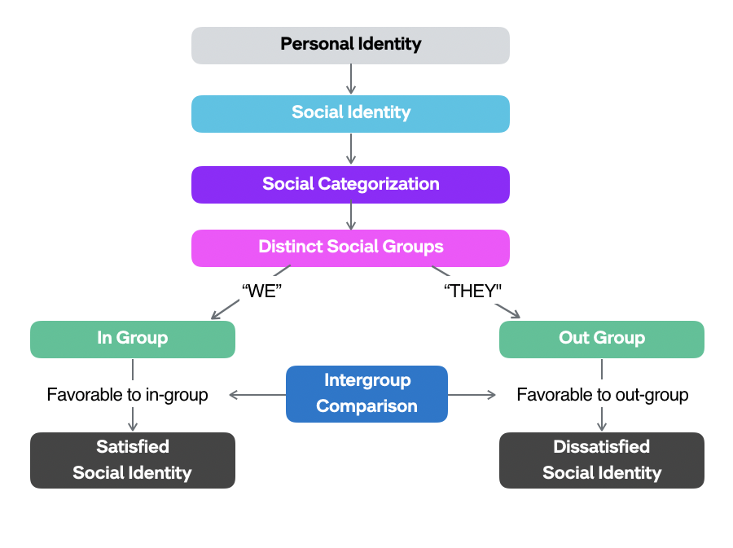
Figure 1: The Development of Social Identity
(Source: Hogg, 2020, p. 114)
Social identity theory suggests that the perceived position of a person in a group, society or culture contemplates his/her action and aids the characteristics of being kind, respected, aggressive, authoritative, humble or silent. As mentioned by Hogg (2020, p. 114), the 15-year-old boy was triggered to be instructed by the staff as he was suffering from the depression of having physiological incapabilities at this moment. The staff was older and her perceived position in the society made her reconsider the position in the store. This is why the staff was psychologically forced to instruct the boy to do the right thing. As mentioned by Hogg (2020, p. 114), the service user on the other hand was struggling with breathing issues, but the perceived position as a customer made him oppose the instruction and not show any cause for the effect of not wearing a mask or sitting.

Data Related to Suicide rates
The exaggerating rates of suicide among teenagers, especially 15 - 19 years are significantly rising every year. More than 700,000 people die due to suicidal causes (World Health Organization: WHO, 2021)‌. The psychological epidemic of suicide influences other people to attempt death volunteer. According to the World Health Organisation, suicide is the fourth most leading cause of death for people from the 15 - 19 age group for various reasons (World Health Organization: WHO, 2021)‌. These reasons are suicide idealisation and interpretation as a solution, physical activity, physical fight, being bullied, serious injury, lack of social exposure, parental understanding etc.
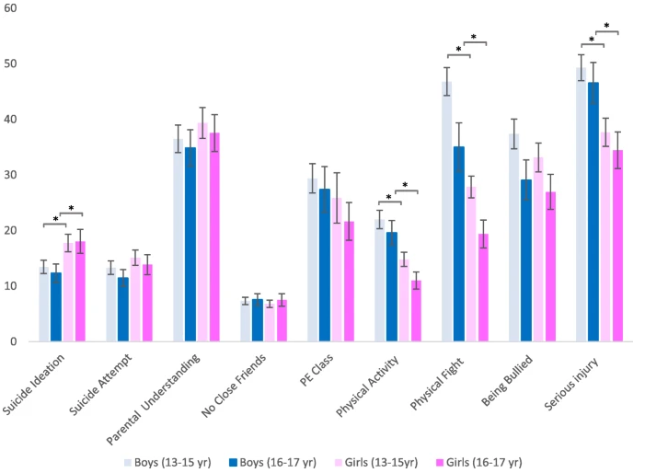
Figure 2: Prevalence Estimates of Suicidal Behaviours, risk and protective factors by sex and Age Group
(Source: Campisi et al., 2020, p. 4)
As mentioned by Campisi et al. (2020, p. 4), the random effect meta-analysis of Confidence Interval (CI) allowed to disclose the exposure of suicidal tendency among teenagers in two groups, wherein the CI varies significantly. These age groups are 13 - 15 years and 16 - 17 years (World Health Organization: WHO, 2021)‌. The prevalence of Head Injury Criterion (HIC) and Low to Middle Income Country (LMIC) population data extemplates the reason behind these psychological phenomena differently where it is reported that the suicidal attempt for physical serious injury obtains the highest rate of suicidal tendency.

Service User’s Condition
The condition of the service user plays an important role in the case. The service user was diagnosed with Emery-Dreifuss Muscular Dystrophy recently and the physical toll was significantly difficult for the service user. This caused him depression, anxiety. The surgical reduction of adipose tissues caused respiratory dysfunction and the physiological changes caused depression and anxiety in the boy’s mind (World Health Organization: WHO, 2021)‌. This caused the behavioural outburst to the staff in the store. The behavioural approach can be explained by the medical condition, but the disagreement of demonstrating the condition earlier in the conversation can be explained with social identity theory. According to this theory, the service user was misunderstood by the perceived position of him as a customer and misbehaved to the staff for having the authority of questioning.

The Impact of Counselling for Individuals
The impact of counselling is based on the importance of counselling. Counselling allows a person to express the influencing perspectives, decision making, reasoning, emotions, identity analysis etc. the belief, behavioural bases and patterns need to be introspective for the improvement of social approaches (Csuci, 2021)‌. The 15-year-old boy needs to be counselled for his depression and anxiety. The boy must be diagnosed with breathing issues. On the other hand, the staff requires to be counselled for being overly instructive to the customer.
As mentioned by Riggs and Bartholomaeus (2020, p. 952), a staff needs to be understood if there are any misbehaviour perspectives while delivering the instruction and rules inside the store. Counselling can help a person understand how his/her perspectives can influence others in a positive or negative manner and can make them capable of controlling, sustaining their expressions accordingly (Csuci, 2021)‌.

Recommendations regarding the Upholding or Dismissal of the Staff for the Complaint
The 58 years woman did her work according to what she was instructed to do. According to her perspective of social identity, she tried to forbid the 15 years old boy to disobey the instructions. The boy on the other hand was suffering from depression and anxiety, which was reflected in his aggressive behaviour and cursing. This misbehaviour can never be appreciated and sustained under customer policy. A person does not get the right to misbehave with someone if he/she is a service user in a situation. The boy should have explained his situation and then reacted to her. This concluded that the staff should not be dismissed for the complaint against her. However, she could have asked the reason for not wearing a mask or walking to the service user

Conclusions
From the explanation in the study, it can be contemplated that the proper behavioural approach is required to be followed by both service users and staff in a company. The misbehaviour of the staff and service user were both misguided wherein the service user manipulated the authority of a customer more than the service provider. The proper adjustment of such a situation can be achieved through documented posters in the entry and proper company policies where the organisation can demonstrate the policy to its customer about the standard behaviour in the store premises.

References

Books & Journals
Campisi, S.C., Carducci, B., Akseer, N., Zasowski, C., Szatmari, P. and Bhutta, Z.A., 2020. Suicidal behaviours among adolescents from 90 countries: a pooled analysis of the global school-based student health survey. BMC public health, 20(1), pp.1-11.
Ginder, W., Kwon, W.S. and Byun, S.E., 2021. Effects of internal–external congruence-based CSR positioning: an attribution theory approach. Journal of business ethics, 169(2), pp.355-369.
Hogg, M.A., 2020. Social identity theory (pp. 112-138). Stanford University Press.
Molnár, B., Pisoni, G. and Tarcsi, Á., 2020. Data Lakes for Insurance Industry: Exploring Challenges and Opportunities for Customer Behaviour Analytics, Risk Assessment, and Industry , 31(7), pp.813-864
Riggs, D.W. and Bartholomaeus, C., 2020. Formal and informal support and counselling for embryo donation and receipt: An Australian qualitative study. Health & social care in the community, 28(3), pp.950-957.
Seidu, A.A., Amu, H., Dadzie, L.K., Amoah, A., Ahinkorah, B.O., Ameyaw, E.K., Acheampong, H.Y. and Kissah-Korsah, K., 2020. Suicidal behaviours among in-school adolescents in Mozambique: Cross-sectional evidence of the prevalence and predictors using the Global School-Based Health Survey data. PloS one, 15(7), p.e0236448.
Sullivan, D., 2021. The Effects of High Stress on Workplace Incivility in High Aggression Employees (Doctoral dissertation, Southeastern Louisiana University).

Webpages
Csuci. (2021). Individual Counseling - Counseling and Psychological Services - CSU Channel Islands. [online] Available from: https://www.csuci.edu/caps/individual-counseling.htm [Accessed 28 Oct. 2021].
World Health Organization: WHO (2021). Suicide. [online] Available from: https://www.who.int/news-room/fact-sheets/detail/suicide [Accessed 28 Oct. 2021].

