

LEVEL 6 ASSESSMENT SPECIFICATION
Student name: | Elise Turner | Student ID number: | 1922450
Programme: | Graduate Diploma in Policing (GDIP)
Module: | Operational Policing Practice 3
Module code: | BMP6005D | Contribution to Overall Module Assessment (%): | 100%
Lecturer: | Jane Thomas | Internal Verifier:
Assignment Title: | See below | Word count (or equivalent): | Essay 5000 Words
Submission deadline: | 28th February 2022 | Return date of provisional marks & written feedback:

TASK 1
Understanding the role of Constable/Maintaining Professional Standards

Policing has advanced significantly over the years, this is due to ever changing society needs and the need for policing grew with this over the years where new crimes began to emerge and resolution was sought after. In the 1700s the role was a part-time volunteering model however, following the industrial revolution there became a greater need for policing and therefore it soon became a full-time profession endorsed by the government (Longley, 2020).

Policing had been recognised as important in the community and an aid of preventing crime, in 1829 it was passed as a profession by Sir Robert Peel. Peel recognised an inadequacy of the system pre 1829 to meet the needs of the communities (Cotton, 2020). Therefore, the Metropolitan Police Act was passed where permanently appointed constables were paid to protect the capital (Johnson, 2019).

Policing today is diverse and brings new challenges as society continues to develop, for example, new technologies and cybercrimes emerge continuously. Policing is forever evolving with these growing demands and South Wales police (SWP), the largest force in Wales has set priorities to work towards as set out by the Police and Crime Commissioner (PCC) in the Police and Crime Plan 2021-2025. This plan is a form of a strategic plan set up to focus on current priorities within policing in SWP. The plan has six main aims, this being to reduce and prevent crime, involve and empower the communities, protecting the most vulnerable, making the local criminal justice system efficient and ensuring that SWP is a high performing force (commissioner.south-wales.police.uk, n.d.). The Police and Crime plan is set for 2021-2025 as the plan will be required to change and adapt as time goes on. The need for change is due to a number of factors such as globalisation and new challenges such as new crimes i.e. child sexual exploitation. Alongside this staff skills need to be adapted to continue the high standard of work carried out, this can be done through new training and refresher courses. A policing reform was sought after for the professionalization of the police following a recruitment drive, known as ‘Be a force for all’ was announced in September 2019 by the government for 20’000 new police constables to join the police with government funding (Home Office, 2019). With this, the College of Policing developed a new entry programme into the police to allow a consistent high standard of training, known as the Policing Education Qualifications framework (PEQF). The benefit of this framework is to allow all forces learning to become standardised and for the expectation of the Policing Vision 2025 to be met (College of Policing, n.d.). This new professional entry route is set to provide consistent national education for policing roles, which is also hoped to provide reassurance to the public regarding the level of training police officers now receive (Strong, 2019).

Following the professionalization of policing a long-term direction was needed within forces to allow a uniform approach across the forces and the UK in order to maintain professional standards. The need for a consistent high standard across the training of officers was required in order to be able to deliver an equal and professional service to the communities and members of the public. The college of policing (COP) is not just responsible for the development of new recruits, it is a professional body that was established in 2012 to take over a number of development and training roles. The COP is responsible for all persons working across policing and is an independent organisation that gives a voice to professional policing and sets standards for key policing areas (College of Policing, 2021).

Public confidence is deemed as critical for a force to function successfully. Being able to retain this and good community relations is important to police forces being reliant on members of the public as they are key sources of information (Warwick.ac.uk, 2015). Public confidence can be affected through incidents not being dealt with correctly which are in turn broadcast for the public to see, for example, the Hillsborough disaster. Following this incident in 1989 the police were heavily scrutinised and have been for a number of years since for the handling of the incident, in turn decreasing the confidence in police.

There are professional bodies in place that are responsible for maintaining professional standards within police and investigate complaints that arise. One example is Her Majesty’s Inspectorate of Constabulary (HMIC), this is an independent body that inspects and reports on the effectiveness and efficiency of police forces (HMICFRS, 2011). The aim is to encourage improvement of forces by publishing reports of the findings and providing high quality professional advice, this allows transparency among the public and other forces. This is a means of ensuring that police forces nationally are working at an equal standard to provide the same professional service to the public and investigations. There are two bodies that are responsible for investigations of complaints reported, these being the Independent Office for Police Conduct (IOPC) and Professional Standards Department (PSD). The IOPC is a body that oversees the complaints systems for forces across England and Wales and are responsible for investigating the most serious cases such as death following police contact (Policeconduct.gov.uk, 2020). The body is responsible for setting the standards for forces to use when handling complaints, this is continuously developed and influenced through learning from previous work. The PSD are unique to each force, however, they all play the same role of receiving, recording, investigating and resolving public complaints and by doing so help play a part in instilling public confidence in forces operating without corruption and misconduct.

Performance and effectiveness of policing today is difficult to measure however, they are considered a drive for a police force and help set goals and policies. Performance can be measured differently dependant on the key priorities, for the force itself it could be detection of crimes, whereas, for the public, it could be increased visibility and patrols. Effectiveness is difficult to measure with no set definition, however, based on the PEEL principles the effectiveness of a police force can be based on the mission of police preventing crime and disorder (The Crime Prevention Website, 2013). However, this is a very wide context to base the notion of effectiveness on. Since the Peelian model, a new model by Stephen Savage has been prepared to reflect the evolving nature of policing. The model designed by Savage has incorporated the fact that policing is evolving and needs to involve a wide array of skills in order to tackle problems and conflict.

WORD COUNT - 1096

TASK 2
Community/Response Policing/Policing roads/Conducting Investigations /Digital Policing

Response policing is unique and demanding. When an individual joins a police force such as South Wales Police (SWP) they initially complete six months training before beginning their career as a response officer. As a response officer, the main aspect is to provide frontline response to a wide range of incidents that can include complex and confrontational situations (College of Policing, n.d.). Response officers need to possess skills and characteristics to be able to assess threat, take control of incidents and engage with members of the public.

A response officer needs to be able to understand human behaviour and how this can affect the response received when interacting with members of the public (MOP). Human behaviour is described as a person’s actions and conduct (Study.com, 2019). There factors that influence a person behaviour, attitude, perception, emotions, social norms, ethics, cohesion and influence of authority (Reference.com, 2015). As front line officers it is important to understand how MOP are dealt with in a policing view can have an impact on how they react to police presence and action. Therefore, it is key that officers are experienced and knowledgeable of how to deal with incidents/situations to ensure that they don’t escalate from our response. This can be explained through the Betari Box Model. The Betari model is set to help understand how attitudes and behaviours impact on the attitudes and behaviour on the people around us (MindTools, 2019). A response officer’s attitude and behaviour, both voluntary and involuntary can if positive and helpful on arrival of an incident result in the person being dealt with replicating the response and cooperating with the officer. See figure.1 below for an example.
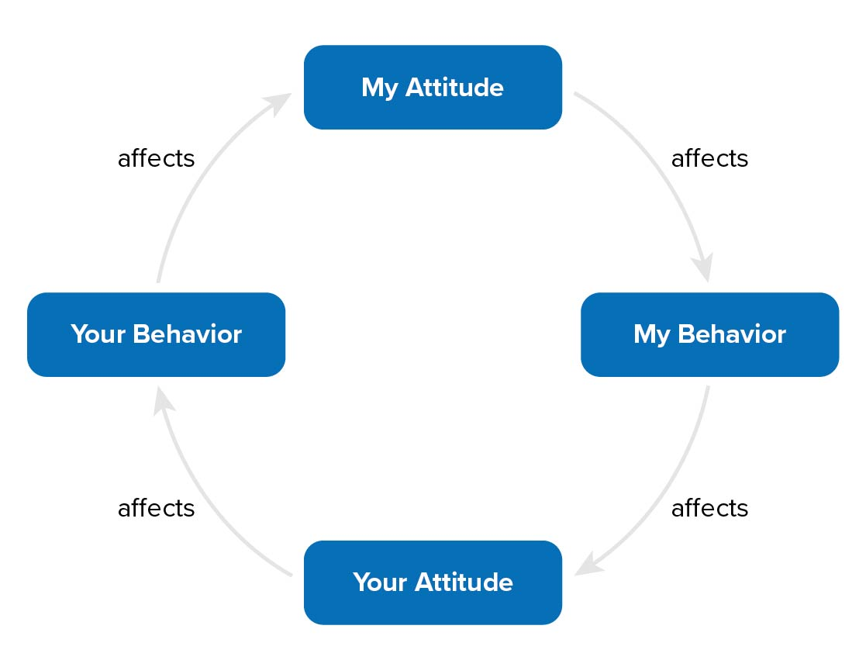

Figure.1 The Betari Box Model (MindTools, 2019).

An officer’s role is to be a role model to the MOP and provide reassurance and a professional service, so on attending incidents, no matter what attitudes or behaviour they may be met with. Officers are to demonstrate a positive, polite and professional response irrespective of the opposing person’s conduct, this falls in line with the Code of Ethics (College of Policing, 2014).

Emotional intelligence (EI) is important within an officer’s skillset. According to Cherry, 2020, EI is described as the ability to perceive, control and evaluate emotions. It is important for officers to be able to not only understand and control their own emotions but to be able to recognise the emotions of others. This is important when interacting with the public and for victims and witnesses of incidents. There are three main skills linked with EI, the first being emotional awareness, a person with higher EI usually is self-aware and able understand the emotions they are feeling. This can be important for officers after dealing with a difficult incident and being able to digest and understand how that particular experience made them feel. The second skill of EI is emotional management, this is the ability to be able to control emotions/impulses and self-regulate feelings and not make careless decisions. This is a vital skill for response officers as they can be challenged and tested daily with incidents they attend. Thirdly is empathy, this is the ability to identify the needs/wants of others around you (Mind Tools Content Team, 2009), and therefore, an important skill to have for an officer as the role is massively public facing.

As part of the role on response, officers are required to attend incidents that are critical or major incidents. A major incident is defined as an event or situation that requires the response under of one or more emergency services’ major incident plan and it usually involves a large number of people involved (www.app.college.police.uk, n.d.). An example where a major incident could be declared could be a multiple injury/fatality road traffic collision. An incident of such a nature where a larger number of people become involved would require a Joint Emergency Service Interoperability Programme (JESIP) response, this consists of multiple emergency services responding to provide their services with the goal of working together to save lives and reduce harm. See Figure 2. for the JESIP joint decision model. The sole purpose of JESIP is to ensure that the multi-agency initial response is structured, organised and practised to provide the best possible response to an incident.
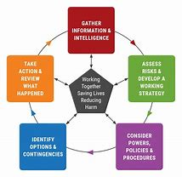

Figure 2. The Joint Emergency Service Interoperability Programme (JESIP) Joint decision model (JESIP, 2017)

A critical incident is classed as any incident where the effectiveness of the police response is likely to have an impact on the confidence of the victim, their family and members of the public (www.app.college.police.uk, n.d.). A critical incident has the ability to derive from any incident attended, an example could be a hate crime incident or anti-social behaviour. If deemed that the response provided by police is likely to have such a significant impact on the matter, then it’s classed as critical. It is vital that as an officer is able to manage the incident and provide positive action and restore public confidence. A critical incident management (CIM) is intended to provide such a response to the victim, family and community as well as being able to efficiently and effectively provide a proportionate response to the incident itself (College of Policing, 2010). There are three main parts to responding to a critical incident that response officers need to be aware of, see Figure 3. For the CIM.
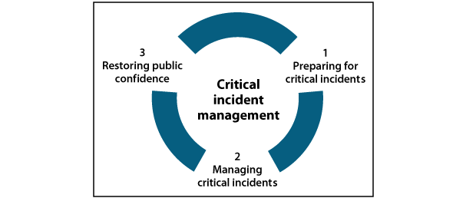

Figure 3. The Critical Incident Management (College of Policing, 2010)

Being a response officer brings much responsibility and daily challenges with the role, it is a unique role which requires certain attributes of a person to succeed among with a vast array of skills. Whilst out in the communities during duty response officers are faced with dealing with a vast range of public all with different background, beliefs and attributes. A response officer needs to understand and respect cross cultural differences within communities. Cross-cultural policing can be seen as the effective use of law enforcement aimed at understanding and responding to the needs of cultural, racial and ethical communities in a way that upholds human rights and dignity (Badges2Bridges, 2018). If an officer is unable to understand and integrate this into their service then it can lead to barriers and mistrust between the police and the communities.

The role of a response officer is never ending and therefore important that officers are well equipped with experiences and skills to be able to deal with the incidents faced with, whether minor or more serious, the role is very diverse with challenges daily that will continue to be experienced with the forever changing social challenges.

WORD COUNT - 1092

TASK 3
Information and Intelligence/Communication Skills

Policing and investigations rely heavily upon gathering of information and processing of intelligence. Collection of such information can aid a force to make decisions and set priorities and tactics in line with what is known regarding current issues. Many, if not all investigations rely upon information gathering and processing of intelligence. Majority of the serious and organised crime (SOC) investigations that are carried out, depend upon the intelligence identified, without this a lot of police work would be less effective and successful and would lead to less prosecutions (Bryant and Bryant, 2019, p.522). It is important for police to have a tool available that helps maintain public safety in the communities, intelligence is the tool that can be used to achieve this (Palmieri, n.d.). Within this assignment the processes of gathering information and intelligence will be discussed along with how this aids coordination of police work.

Collection of information is a constant process where there is usually an interest or purpose behind the need for that information. Police collect information that is only required for a policing purpose, this provides the basis for the process and retention of that information and can include the purpose of protecting life/property, preserving order, preventing offences, bringing offenders to justice and any duty arising from law (College of Policing, 2019). Collection can be carried out in one of three ways, routine collection, tasked information and volunteered information from MOP.

Intelligence is received in many formats, this being open and closed sources of intelligence. Open sources are readily and widely available, however, the reliability and validity of these can be questioned, this is because an open source is publically available and could be accessed by any means (Panlogic, n.d.). A closed source is one that has restricted access such as police national databases, and is assessed to be reliable information without the need for the intelligence report process. Prison intelligence is classed as a closed source example. According to Ayedoo, 2020, is it evaluated information that enhances the safekeeping of offenders and assists in proper crime analysis and prosecution. Types of information, especially linked to crime can aid police to tackle prevalent problems such as SOC. Legislation such as the Proceeds of Crime Act 2002 allows for information to be obtained and sets an obligation on agencies/partners such as banks and solicitors to report any suspicion of criminal activity, overall helping crimes to become linked and identifying a wider picture of organised crimes (Bryant and Bryant, 2019, p.523).

When it comes to information received that is of an open source nature, a process is required to validate that information and deem it as intelligence. A process occurs which is known as the Intelligence Report (IR) evaluation. The IR is used to evaluate and submit information and then handle the dissemination of the intelligence (College of Policing, 2015). It is standard guidance that is used across police forces and it is a method demonstrated as the 3x5x2 process which can be seen below in figure.4.
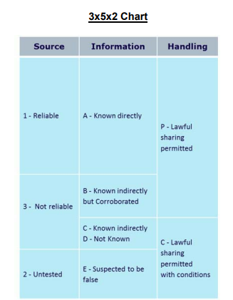

Figure.4 – The Intelligence Report 3x5x2 Chart (3x5x2 Format Source Evaluation Explanation, n.d.)

The first section of the chart is based on ‘Source’ and the evaluation of this is made by the person submitting the information and whether or not it is deemed reliable, not reliable or untested. Information assessment forms the next part of the 3x5x2 chart. There are five elements to this section consisting of, known directly, known indirectly but corroborated, known indirectly, not known and suspected to be false. This section focuses on how the information has become known to the source and assesses its reliability. The final aspect of the 3x5x2 model is dissemination of the intelligence, otherwise known as handling codes. There are two codes, known as, lawful sharing permitted (P), for this there has to be a policing purpose for sharing the information. And lawful sharing permitted with conditions (C) this is where the originator of the intelligence has set up specific conditions of how the information can be viewed, for example, covert use, where action can be taken on the intelligence provided. These handling codes are seen as a control mechanism for intelligence sharing (College of Policing, 2015).

The process of information gathering and the process it takes to become intelligence can be demonstrated below in Figure.5 as already discussed in depth.

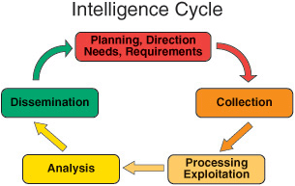

Figure .5 – The Intelligence Cycle (Psu.edu, 2014)

The national intelligence model (NIM) is used to help determine the policing priorities based off intelligence received. According to the Home Office, the NIM can be seen as a model to validate policing, representing the best practice for the use of intelligence to fight crime (Home Office, 2001, p.45.). This is further supported where the model is described as enabling law enforcement agencies to review intelligence systems and as a result introduce more rigour into the decision-making processes for strategic and tactical commitments (National Intelligence Model, 2000). At the heart of the NIM is the tasking and coordinating process, this process alone helps aid the response that will be taken against crime and disorder and can further help prioritise the requirement of intelligence and structure this collection. In my opinion the model is well designed and user friendly as it allows for specific levels of crime to be incorporated into it so that it can be used nationally. The three levels of this model are split between local BCU level (1), force and regional level (2) and national level (3). Bryant and Bryant, 2019 explain how important the classification of crime is for resourcing, this is due to a single BCU not having the resources to cope with large scale group criminal activities. This is why I believe the structuring of this model helps disseminate crime to the proportionate level to allow for it to be dealt with successfully and with prosecution perspectives. Larger scale crimes that sit within level three of the model require a national approach and greater resources and usually incorporate national agencies, this is where Interpol and Europol agencies can be used. For example, Europol helps set up and coordinate cross border operations of larger scales and dangerous activities as well as facilitating communication between investigators and countries (Eurpol, n.d.).

From my own experience, I have only witnessed tasking and coordinating being completed at level one due to my current allocation on response and level of service, however, from viewing tasking and coordinating documents and how they help focus a BCU on their proactive work is massively beneficial, even on smaller crimes and prolific offenders.

WORD COUNT - 1083

TASK 4
Public Protection
Public protection is a very broad term when considered within a policing context. Police officers attend numerous incidents daily whilst also always having to consider public protection for the MOP they come into contact with. When a police officer joins the job they get attested into the role and swear an oath to the country to serve within that role and take on the duties, one of which being ‘protecting life and property’ (www.app.college.police.uk, n.d.), this forms part of the policing core principles. As a police officer you are challenged with protecting vulnerable people, as well as younger people who are unable to protect themselves and MOP who may lack mental capacity and as such are unable to look after themselves and prevent harm forthcoming. A person is classed as vulnerable, according to the National Vulnerability Action Plan, 2020 as ‘if, as a result of their situation or circumstances, they are unable to take care of or protect themselves or others from harm or exploitation’. A person can be classed as vulnerable for a number of reasons, these can be known as personal factors, for example age, disability, religion and sexual orientation and situational factors, such as language barriers, lack of support and adverse family circumstances. Within this writing we will explore the forms of public protection that police can offer to the public along with multi-agency approaches and the link between SOC and the issues surrounding public protection.

Mentally vulnerable people are people that at the time of the incident or contact with the police are suffering with mental ill health. This is a broad term to describe mental illness and in line with GOV.UK, n.d., this applies to any person who, because of a mental health condition or mental disorder, may have difficulty understanding or communicating effectively. As officers it is important to be aware of the signs of mental ill health to treat the person fairly and implement safeguarding as required. Police officers have the power under the Mental Health Act 1983 (MHA) to take action if they suspect that a person is suffering with mental ill health, and as a result of it is unable to protect themselves and could be a danger to themselves or others. Under Section.136 of the MHA a constable who has concerns for another in respect to their mental health can, remove the person to a place of safety or if the person is already at a place of safety, keep them there or remove them to another place of safety (GOV, 2017). This power is essential for officers to safeguard a person who is suffering with their MH and this can assist in getting them to the medical professionals for help and support. In my opinion this power within the MHA is very useful and is used frequently to protect persons from harm especially those who are threatening their life. From personal experiences it is especially important to be aware of how you communicate with a person suffering with their MH as a negative or dismissive approach can lead to escalation of the situation and make that person feel neglected and disinterested in what options you have to offer them. This is supported by Bryant and Bryant, 2019, where they state that good communication can be difficult but is essential when dealing with person with mental ill health, a calm-low pitched voice and reassurance is the best way to deal with any situation such as this.

Family/domestic violence and abuse covers a range of offences that occur between anyone aged sixteen or over who are or have been intimate partners or are family members (Bryant and Bryant, 2019, p.283). Officers are faced with challenges when dealing with victims of such crimes and sometimes victims do not wish to engage with police, in this instances it makes it challenging for officers and the investigation. It is important that officers are aware of information to pass onto such victims of steps that they could take personally if they didn’t wish for police involvement, legislation under The Family Law Act 1996 (FLA) can provide persons with the powers to apply for orders such as a non-molestation order which is an order to refrain another molesting that named person (Legislation.gov.uk, 2020). However, there are steps that officers can take to safeguard a victim of this nature. In 2014 Domestic Violence Protection Orders (DVPOs) and Domestic Violence Protection Notices (DVPNs) were brought into place under the Crime and Security Act 2010 (Legislation.gov.uk, 2011). This allows officers and courts to imply a civil order for protection for a domestic violence victim and give time for the investigation to be carried out and them a chance to decide on how they wish to move forward whilst having protection.

Officers will also ensure that the relevant information from the incident is shared on with multi-agencies to allow further support, this is done usually via a document known as a Public Protection Notification Report (PPN). A PPN is filled out by initial attending officers and done so for any incident that carries risk. A PPN covers the incident, officer’s observations and what support they feel would benefit the individual. This is then sent with consent to multi-agencies to allow the person to gain the support needed. This can result in the individual being contacted by an Independent Domestic Violence Advisor (IDVA) or being subject to a Multi-agency Risk Assessment Conference (MARAC) to allow that individuals needs to be assessed further and the proportionate support given.

SOC is a massive problem within the UK, there is no individual agency that deals with it, this is the responsibility of governments and law enforcement bodies e.g. police forces. There are a wide variety of SOC such as cybercrime, fraud, modern slavery and human trafficking and child sexual abuse (Liberal Briefing, n.d.). The issues surrounding SOC and being able to provide public protection is that a great amount of this type of crime remains hidden and unreported (National Audit Office, 2019, p.5). Therefore, this provides a barrier to those victims receiving protection from further risk or harm if not known to forces.

In conclusion, public protection is an important aspect and the strategies mentioned are just touching on the realms of the support available. If used correctly they really help lessen the impact of the overall experience on the victims. However, there can be barriers to police being able to provide public protection successfully and this is linked to the under reporting of crimes, without a victim identified, safeguarding simply cannot be addressed.

WORD COUNT - 1090

TASK 5
Evidence based policing/criminology and crime prevention/criminal Justice

Evidence based policing (EBP) is a favoured and used notion towards shaping the way policing is run today and helps towards preventing crimes within the UK. In summary EBP means that the best available evidence is used to inform and challenge policing policies, practices and decisions (College of Policing, 2022). Therefore, by conducting research around policing work carried out, this helps forces learn what aspects work well and what do not and as a result form a better working strategy towards that particular issues. Overall, according to Bryant and Bryant 2019, EBP is in place to support decision-making and policy-making by the police and partnership organisations. This writing will discuss EBP in further detail along with this put into practice in the real policing world.

EBP was brought about in 1998 in a policing lecture where the idea was brought forward by Lawrence W. Sherman. Sherman proposed the idea that police practice could be made more effective if its elements were tested by repeated controlled experiments (www.liquisearch.com, n.d.). EBP is widely accepted across police forces to aid decision making and best practice. It defines that policing is not just about having the correct equipment and knowledge on law to carry out the role, but to be informed of what tactics and strategies work best when dealing with and investigating crimes in order to better the decisions made when on duty (Grieco, 2014). This forms the basis of amendments that have been made to policing over the years as a result of research and learning from previous challenges. The below diagram, figure 6. demonstrates how EBP works from start to finish and how it can help form better practice to be shared for all police forces. The first aspect of the model is Ask, this is about asking questions surrounding a particular problem in order to understand it fully, by doing so a hypothesis can be formed to recognise how doing things differently will be of benefit. The second is Test, this stage helps gain an understanding if the intervention chosen will achieve the desired outcome. Learn is next and this looks at measuring the outcome of the chosen intervention on the problem, in order to gain knowledge on how effective it has been or not. Adapt is the end point of the model, if successful, at this point the response is adapted to reflect the findings. At all points throughout the model the Share aspect should be taken into consideration.
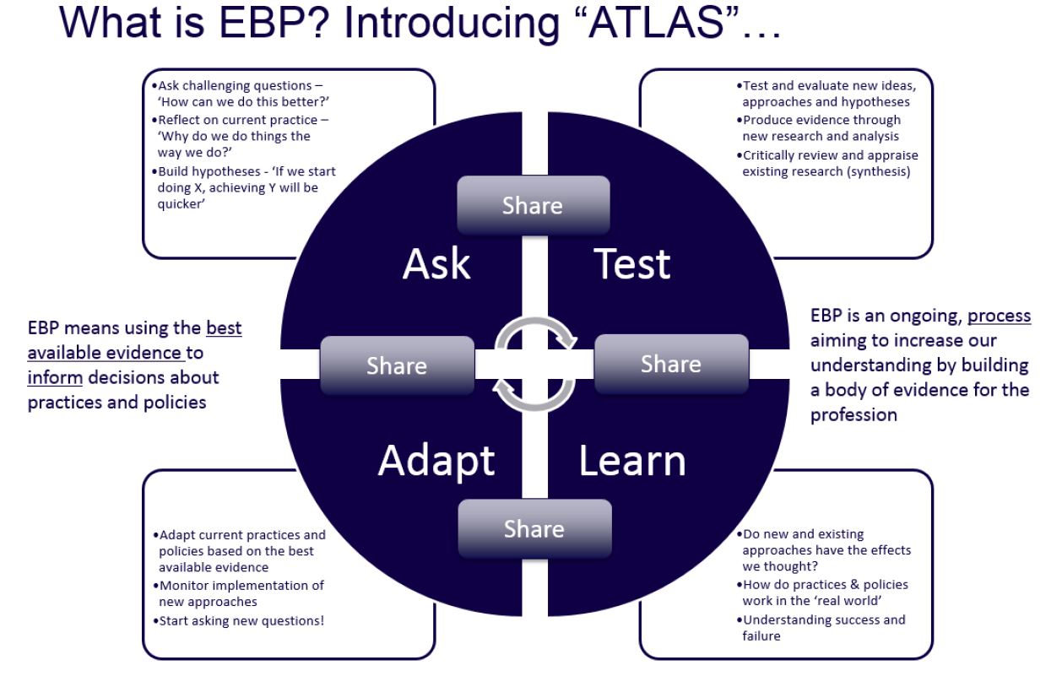

Figure 6. – Evidence Based Policing ATLAS model (whatworks.college.police.uk, n.d.)

It is important that the findings and learning get shared across all levels, this should be done across professional bodies e.g. national policing curriculum, as well as policing forces for processes such as taking on new applicants e.g. training and assessment.

Interventions developed can be used for policing issues and developing working strategies to work towards early-preventative methods. For example, these can be used for issues such as gangs, anti-social behaviour, youth violence, vulnerability and violent crime, and knife crime. Within South Wales Police, set out in one of the priorities is to reduce and prevent crime and anti-social behaviour (ASB) in order to help keep people safe and confident in their own homes and communities (www.south-wales.police.uk, n.d.). Therefore South Wales Police by using EBP that has been developed and shared across forces in the UK promotes the use of early and informal interventions for tackling issues such as ASB. ASB can be defined as behaviour which has caused or is likely to cause harassment, alarm or distress to any persons (Legislation.gov.uk, 2014). According to the Local Government Association, if ASB is left un-tackled it can have a devastating effect on communities and individuals and make the lives of those they target a misery (www.local.gov.uk, n.d.). This is why it is crucial for early intervention to be utilised in areas with common ASB problems, with doing so, helping to maintain public safety and confidence in the service. Early interventions such as verbal/written warnings can be used. These have to include specific information to ensure the individual is aware of the effect their behaviour is having on victims and the community. The next step of early intervention that can be used is restorative justice (RJ), this is defined as a process through which parties with a stake collectively resolve how to deal with the aftermath of the offence and the implications moving forward (The Crown Prosecution Service, 2019) . This is an agreement between both parties involved and gives the victim a chance to express the effects the incident has had on their lives. The Restorative Justice Council states that there is compelling evidence that RJ can be very effective in meeting victim’s needs (restorativejustice.org.uk, n.d.). In my own experience, using RJ’s are a very effective way in dealing with a matter that is suitable for this resolution, it means that the subject takes responsibility for their actions, which gives a lot of reassurance and positive outcome for the victim. There are other forms of interventions used to prevent the matter becoming out of hand, however, if it does get to the point where more is required, the Anti-social Behaviour, Crime and Policing At 2014 does provide powers and injunctions to help police and local authorities address ASB issues (Bryant and Bryant, 2019, P.302). These powers allow for measures to be put into place such as a civil injunction, this is used to stop individuals engaging in ASB and include prohibitions and positive requirements and are issues by the courts. And lastly, for more persistent offending by an individual, a criminal behaviour order (CBOs) can be used, this order can include requirements for the offender to address their behaviour and attend courses such as anger management (Bryant and Bryant, 2019). All of these interventions have been brought about through the use of EBP and sharing of findings of what works best to tackle certain issues within policing.

In conclusion, EBP helps shape policing strategies and responses to incidents, it allows officers to have the best evidence to carry out their role behind and as a result, provide the best service possible when dealing with any incident. Due to the nature of policing continuously changing, EBP is a perfect fit to ensure that as police officers are approaches to new and emerging crimes are continuously being adapted by knowledgeable research. From my own experience, this instils confidence in the way I work and helps reassure me that I am dealing with incidents to the best of my abilities, especially with having only a short amount of service behind me.

WORD COUNT – 1096

BIBLIOGRPAHY
Ayedoo, L. (2020). Utilizing Prison Intelligence in Security Boardrooms By Luka Ayedoo. [online] Emergency Digest. Available at: https://emergencydigest.com/2020/04/18/prison-intelligence-security-boardrooms-luka-ayedoo/#:~:text=Prision%20intelligence%20is%20one%20type%20out%20of%20the [Accessed 22 Feb. 2022].

Badges2Bridges. (2018). What is Effective Cross-Cultural Policing? [online] Available at: https://badges2brdiges.com/effective-cross-cultural-policing/[Accessed 20 Feb. 2022].

Bryant, R and Bryant, S. (2019). Blackstone’s handbook for policing students 2020. 14th ed. Oxford: Oxford University Press, p.268

Bryant, R and Bryant, S. (2019). Blackstone’s handbook for policing students 2020. 14th ed. Oxford: Oxford University Press, p.283

Bryant, R and Bryant, S. (2019). Blackstone’s handbook for policing students 2020. 14th ed. Oxford: Oxford University Press, p.302.

Bryant, R. and Bryant, S. (2019). Blackstone’s handbook for policing student 2020. 14th ed. Oxford: Oxford University Press, p.522.

Bryant, R. and Bryant, S. (2019). Blackstone’s handbook for policing student 2020. 14th ed. Oxford: Oxford University Press, p.523.

Cambridge Dictionary (2022). Crowd. [online] @CambrdigeWords. Available at: https://dictionary.cambridge.org/dictionary/english/crowd.

Commissioner.south-wales.police.uk (n.d.). Police & Crime Plan 2021-2025. [online] Available at: https://Commissioner.south-wales.police.uk/en/your-commissioner/police-crime-plan-2021-2025/[Accessed 25 Jan. 2022].

Cotton, W.B. (2020). The Professionalisation of Policing. [online] WB Global Parnters. Available at: https://www.wbglobalpartners.com/post/the-professionalisation-of-policing [Accessed 25 Jan. 2022].

College of Policing. (n.d.). Policing education qualifications framework (PEQF). [online] Available at: https://www.college.police.uk/guidance/policing-education-qualifications-framework-peqf.

College of Policing (2021). About us. [online] College of Policing. Available at: https://www.college.police.uk/about.

College of Policing. (n.d.). Response Constable. [online] Available at: https://profdev.college.police.uk/professional-profile/test-9/.

College of Policing (2014). CODE OF ETHICS. [Online] Available at: https://assets.college.police.uk/s3fs-public/2021-02/code_of_ethics.pdf.

College of Policing (2010). Introduction. [online] Police.uk. Available at: https://www.app.college.police.uk/app-content/critical-incident-management/types-of-critical-incident/.

College of Policing (2019). Intelligence cycle. [online] Police.uk. Available at: https://www.app.college.police.uk/app-content/intelligence-management/intelligence-cycle/.

College Of Policing (2015). Intelligence report. [online] Police.uk. Available at: https://www.app.college.police.uk/app-content/intelligence-management/intelligence-report/.

College of Policing. (n.d.). Evidence-based policing. [online] Available at: https://www.college.police.uk/research/evidence-based-policing-EBP [Accessed 25 Feb. 2022].

Europol (n.d.). About Europol. [online] Europol. Available at: https://www.europol.europa.eu/about-europol.

‌GOV.UK. (n.d.). PACE Code C 2019 (accessible). [online] Available at: https://www.gov.uk/government/publications/pace-code-c-2019/pace-code-c-2019-accessible.

‌GOV (2017). Mental Health Act 1983. [online] Legislation.gov.uk. Available at: https://www.legislation.gov.uk/ukpga/1983/20/section/136.

Home Officer (2019). National campaign to recruit 20,000 police officers launches today. [online] GOV.UK. Available at: https://www.gov.uk/governments/news/national-campaign-to-recruit-20000-police-officers-launches-today.

HMICFRS (2011). What we do – HMICFRS. [online] HMICFRS. Available at: https://www.justiceinpectorates.gov.uk/hmicfrs/about-us/what-we-do/.

Longley R. (2020). The History of Modern Policing and How It Has Evolved. [online] ThoughtCo. Available at https://www.thoughtco.com/the-history-of-modern-policing-974587.

Johnson, B. (2019). Sir Robert Peel and his “bobbies.” [online] Historic UK. Available at: https://www.historic-uk.com/HistoryUK/HistoryofEngland/Sit-Robert-Peel/.

JESIP (2017). JESIP – Working together, Saving Lives. [online] Jesip.org.uk. Available at: https://www.jesip.org.uk/joint-decision-model.

‌Legislation.gov.uk. (2014). Anti-social Behaviour, Crime and Policing Act 2014. [online] Available at: https://www.legislation.gov.uk/ukpga/2014/12/section/2.

Legislation.gov.uk. (2021). Proceeds of Crime Act 2002. [online] Available at: https://www.legislation.gov.uk/ukpga/2002/29/introduction [Accessed 22 Feb. 2022].

Library Briefing. (n.d.). [online] Available at: https://researchbriefings.files.parliament.uk/documents/LLN-2020-0016/LLN-2020-0016.pdf.

MindTools (2019). The Betari Box: Linking Attitude and Behaviour. [online] Mindtools.com. Available at: https://www.mindtools.com/pages/article/newCS_82.htm.

Mind Tools Content Team (2009). Emotional Intelligence Developing Strong “People Skills.” [online] Mindtools.com. Available at: https://www.mindtools.com/pages/article/newCDV_59.htm.

National Intelligence Model. (2000). [online] Available at: http://www.intelligenceanalysis.net/National%20Intelligence%20Model.pdf#:~:text=The%20National%20Intelligence%20Model%20is%20the%20product%20of.
‌
National Audit Office, Tackling Serious and Organised Crime, 28 June 2019, HC 2219 of Session 2017-19, p.5.
Grieco, J. (2014). EVIDENCE-BASED POLICING: THE BASICS STUDY GUIDE. [online] Available at: http://cebcp.org/wp-content/evidence-based-policing/EBP-Guide.pdf.

Palmieri, L. (n.d.). Information vs. Intelligence: What Police Executives Need to Know. [online] Available at: https://www.ialeia.org/docs/InformationvsIntelligence.pdf.

Panlogic (n.d.). Intelligence: enhancing the picture of serious organised crime affecting the UK. [online] nationalcrimeagency.gob.uk. Available at: https://nationalcrimeagency.gov.uk/what-we-do/how-we-work/intelligence-enhancing-the-picture-of-serious-organised-crime-affecting-the-uk.

Policeconduct.gov.uk. (2020). StackPath. [online] Available at: https://policeconduct.gov.uk/who-we-are.

Psu.edu. (2014). Intelligence Cycle and Process / The Learner’s Guide to Geospatial Analysis. [online] Available at: https://www.e-education.psu.edu/sgam/node/15.

restorativejustice.org.uk. (n.d.). Community resolution and restorative justice | Restorative Justice Council. [online] Available at: https://restorativejustice.org.uk/news/community-resolution-and-restorative-justice.

Reference.com (2015). What Are the Factors That Affect Human Behaviour? – Reference.com. [online] Reference. Available at: https://www.reference.com/science/factors-affect-human-behaviour-3512986d01e403d4.

Study.com. (2019). What is Human Behaviour? – Definition & Explanation – Video & Lesson Transcript / Study.com. [online] Available at: https://study.com/academy/lesson/what-is-human-behaviour-definition-lesson-quiz.html.

Strong, J. (2019). Policing Education Qualifications Framework (PEQF) implementation Frequently Asked Questions. [online] Available at: https://www.polfed.org/Wilts/media/1580/policing-education-qualifications-framework-faws.pdf.

The Crime Prevention Website (2013). The Peelian Principles / The Crime Prevention Website. [online] Thecrimepreventionwebsite.com. Available at: https://thecrimepreventionwebsite.com/police-crime-prevention-service---a-short-history/744/the-pelian-principles/.

‌The Crown Prosecution Service (2019). Restorative Justice. [online] Cps.gov.uk. Available at: https://www.cps.gov.uk/legal-guidance/restorative-justice.

Warwick.ac.uk. (2015). What is “Public Confidence.” [online] Available at: https://warwick.ac.uk/fac/soc/wbs/projects/public-confidence-in-policing/what-is-confidence/.

www.app.college.police.uk. (n.d.). Definitions. [online] Available at: https://www.app.college.police.uk/app-content/civil-emergencies/disaster-victim-identification/definitions/#major-incident.

www.intelligence1010.com. (2016). Information vs Intelligence / Intelligence 101. [online] Available at: https://www.intelligence101.com/information-vs-intelligence/.

www.app.college.police.uk. (n.d.). Intelligence cycle. [online] Available at: https://www.app.college.police.uk/app-content/intelligence-management/intelligence-cycle/#tasked-infromation.

‌www.app.college.police.uk. (n.d.). Core principles. [online] Available at: https://www.app.college.police.uk/app-content/operations/operational-planning/core-principles/#:~:text=The%20police%20have%20core%20operational%20duties%20which%20include%3A.

‌ www.liquisearch.com. (n.d.). Lawrence W. Sherman - Evidence-Based Policing. [online] Available at: https://www.liquisearch.com/lawrence_w_sherman/evidence-based_policing#:~:text=Evidence-Based%20Policing%20In%20a%201998%20Police%20Foundation%20lecture%2C.

‌ Whatworks.college.police.uk. (n.d.). Analyst_day | What Works Centre for Crime Reduction. [online] Available at: https://whatworks.college.police.uk/About/News/Pages/Analyst_day.aspx.

‌www.south-wales.police.uk. (n.d.). Performance and priorities. [online] Available at: https://www.south-wales.police.uk/police-forces/south-wales-police/areas/about-us/about-us/performance-priorities/.

‌www.local.gov.uk. (n.d.). Tackling anti-social behaviour: case studies | Local Government Association. [online] Available at: https://www.local.gov.uk/tackling-anti-social-behaviour-case-studies.

3x5x2 Format Source Evaluation Explanation. (n.d.). [online] Available at: http://nyp-learn.com/IntroductionIntelligence/docs/3x5x2/pdf/

