Summary
With the possibility of crossing geopolitical boundaries easily, the importance of integration as well as of the knowledge of other languages beyond the mother tongue is greater as in the case of subjects concerning technology knowing how to communicate in different languages is important.
Not long ago the EU believed that knowledge of languages ​​was only an opening to intercultural exchange, today the EU itself believes that educating people with a language other than their native language allows not only intercultural exchange but also job exchange, possibility of affiliation with foreign companies, etc. This change of way of thinking is intend to fight against the unemployment rate that back in 2013 reached 23.8%
That’s why I moved in England. I come from south Italy and lived for ten years in Roma, the capital of my country. I see how hard is to find a job with only the knowledge of one or two languages different from native, if you have only the degree is hard as well. When I move I start thinking to join in some courses in IT, to have opportunity to learn the language of technology and after try to learn another language. The important of knowledge more than two languages is explained for me in some articles and book reported below.
Some of the autors that I’ll consider reporting the example from the study done in Switzerland from Grin et al (2009,2010)[1] [2] that had studied the relationship between employment and the importance of knowledge English, French, and German. The results show that demand for monolingual workers decreases by 8.7% but the demand for the workers that knowmore than one language decreases only by 3.7%.
It should be added that in the modern job market, statistics have shown that often the only basic knowledge of a non-native language does not lead to the maintenance of the job obtained. Since according to the European government, the definition of employment opportunities also depends on the ability to support the workload, evolve and improve one's skills
The results show off the difference between Germany and Italy with Spain, in fact, in Germany and Italy, the possibility for a woman to find a job is 5.6% and 5.7%. In Spain, women have less possibility. Instead for a man is 3.4% and 4.3% in Germany and Italy and 5.2% in Spain[3][4][5].

Tables

Tab.1
Table 1 Foreign languages known by natives aged 25–64 in Germany, Italy and Spain

 | Germany | Italy | Spain
Languages
English | 72.0 | 46.2 | 31.2
French | 19.8 | 23.2 | 13.0
German | 0.6 | 4.9 | 2.0
Spanish | 6.9 | 4.4 | 5.6
Italian | 4.7 | 0.4 | 2.1

Tab.2
Share of people able to have a conversation in English or German in the EU-27 and the V4

 | English | German
EU-27 | 38% | 11%
Czech Republic | 27% | 15%
Hungary | 20% | 18%
Poland | 33% | 19%
Slovakia | 26% | 22%

Tab.3
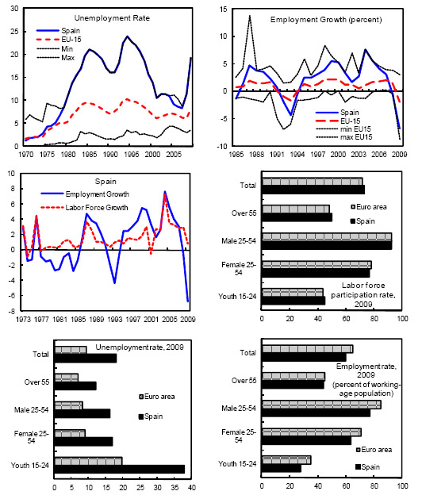

Tab.4
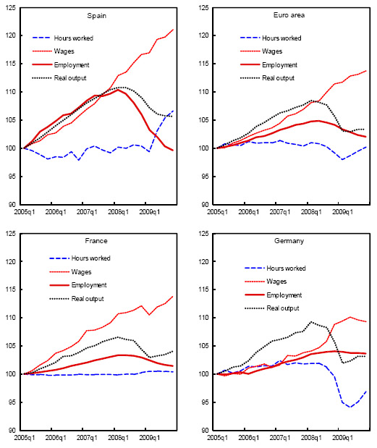

Bibliography
[1]
F. Grin, “Langues étrangères dans l’activité professionnelle (‘LEAP’),” 2009. [Online]. Available: https://www.unige.ch/fti/elf/files/7414/5865/9202/LEAP-RF-7logos.pdf.
[2]
F. Grin, C. Sfreddo, and F. Vaillancourt, The Economics of the Multilingual Workplace. Routledge, 2011.
[3]
florence Jaumotte, “IMF Working Papers Volume 2011 Issue 011: The Spanish Labor Market in a Cross-Country Perspective (2011),” imfsg, 2011. https://www.elibrary.imf.org/view/journals/001/2011/011/001.2011.issue-011-en.xml (accessed Jul. 13, 2021).
[4]
B. Fabo, M. Beblavý, and K. Lenaerts, “The importance of foreign language skills in the labour markets of Central and Eastern Europe: assessment based on data from online job portals,” Empirica, vol. 44, no. 3, pp. 487–508, Apr. 2017, doi: 10.1007/s10663-017-9374-6.
[5]
hartmut esser, “Google Scholar,” scholar.google.com, 2006. https://scholar.google.com/scholar_lookup?title=Sprache%20und%20integration%3A%20die%20sozialen%20bedingungen%20und%20folgen%20des%20spracherwerbs%20von%20migranten&publication_year=2006&author=Esser%2CH (accessed Jul. 13, 2021).

