

LEVEL 4

SEMESTER 2

MODULE CODE: SHSS4078
Adventure: A Risk worth Taking

aSSESSMENT TYPE: aSSIGNMENT
Assessment/Component: 1 (Part A)
COMPONENT WEIGHTING: 55 %
WORD COUNT: 2000 WORDS
MODULE TUTOR: Denise leonard

Assignment:

With reference to a critical incident case study that we have examined, identify one key contributing hazard. In relation to this hazard, evaluate your own personal logged experiences from the module.

As appendices to this submission you should include a logbook recording every activity session you complete during this module and a synopsis of the critical incident case study you have referred to in your essay.

SUBMISSION DETAILS:

Deadline:
Date: 1st May 2020
Time: 3.00pm
Portal: Turnitin

School of Sport, Health & Outdoor Education

Assessment Feedback Sheet

Student No./Name:
Module: SHSS4078
Module Code: Adventure: A Risk Worth Taking

Personal Evaluation – to support your academic progress please complete the section below BEFORE submitting your work.
What do you consider to be the best aspects of this work?
Which aspects do you consider could have been improved in this piece of work?
What have you found most satisfying whilst undertaking this submission?
ASSESSMENT CRITERIA | Learning  Outcomes |  | GRADE
ASSESSMENT CRITERIA |  |  | Poor  0 – 25% | Unsatisfactory  26-39% |  | Satisfactory  40 – 49% | Good  50 – 59% | Very Good  60 – 69% | Excellent  70 – 85% |  | Exceptional  86– 100% | %
Complete logbook for each session | All |  |  |  |  |  |  |  |  |  |  | 15%
Provide a synopsis of a critical incident case study | All |  |  |  |  |  |  |  |  |  |  | 15%
Identify a specific significant hazard and the risk it poses to undertaking adventurous outdoor activities | 1,2,3,5 |  |  |  |  |  |  |  |  |  |  | 30%
Discuss a range of appropriate measures that might effectively control the identified hazard and consequent risks. | 1,2,3,5 |  |  |  |  |  |  |  |  |  |  | 30%
Appropriate references used and correctly formatted | All |  |  |  |  |  |  |  |  |  |  | 10%
It is expected that students will present work that is proof read, correctly referenced and adheres to the Assessment Checklist. Therefore a range of 0 – 10 marks will be deducted for non-completion of any of the points on the checklist below.
TUTOR COMMENTS:

Submission date:  via Turnitin |  | Return date:  (at least within 4 weeks) |  |  | Tutor: Denise Leonard |  |  |  |  | Mark:

Assignment Checklist

- Please complete the Personal Evaluation section of the Assessment Feedback sheet, add your name and details, and paste the whole of this assignment document into the front of your assignment

- Submission is a single word file, clearly labelled with your name and module code
- Font style - Times New Roman, size -12 for text and 14 for headings
- Ink colour – black only
- Line spacing – 1.5 line spacing and 2cm- 2.5cm page margins
- Quotations more than three lines to be indented 1 line spacing
- One line space between paragraphs, paragraphs must be left aligned
- Pagination (your assignment should have page numbers)
- All tables and figures are internally referenced and have a title
- Word count checked and written at end of text (before references and any appendix)
- Assignment is within 10% of the word limit (excluding references and any appendices)
- All references in the text are included in the reference list
- Correct referencing following the Harvard style, as described in the Palgrave study skills book ‘Cite them Right’.
- Correct spelling using UK English
- Correct use of punctuation
- Grammar and syntax correct- double check anything that has a green line under it
- I have read my assignment out loud to myself and it makes sense and is easy to read
- Somebody else has read my work and it makes sense to him or her!
- I have checked and I have not plagiarised
Failure to follow these guidelines will cost you marks!
The hazard that will be discussed during this assignment is the weather and what effec it has on adventurous outdoor activities. Reference will also be made to a case study throughout this assignment, namely GlenRidden Beck. There will also be a logbook from a couple activities that I took part in and reference to these will be made throughout the assignment so that I can show the impact that the weather has on the activities I participated in.

The weather impacts all activities differently; strong winds can cause rivers to flow more quickly and make climbing harder to undertake. The impacts of the weather can determine what activities can take place due to health and safety, for example, rivers can be particularly harsh and cold. “The stream was in spate and the water very cold” (Glenridden Beck 2002, p1.). High river levels and cold weather were the reasons for Max Palmer’s fate along with other factors, but due to the fact the weather had changed the conditions of the river, the conditions had become too dangerous to carry out the activity.

Leading up to the week of the activity it had been wet and rained heavily en route to Glenridden on the Friday night. “The beck outside the hostel was fast-flowing and noisy” (Glenridden Beck, p.20)
This tragedy could have been avoided if there were some health and safety measures in place. Wearing a buoyancy aid would have helped Max stay afloat despite the fact he was in shock “the Glenridden tragedy would have been interrupted at an early stage had the existing guidance been followed.” Adventure Activities Licensing Authority (AALA)
This states that if the leader had followed these guidelines then they would have been better prepared for the activity, from this they would have been more likely to have the proper safety equipment and better safety for the children involved with equipment like buoyancy aids.

The weather conditions may have been too harsh for the plunge pooling activity, although this would not have helped with the fact that the weather was cold which made the water temperature cold in the progress, the cold water put Max Palmer into shock which is why he panicked before the eventual tragedy, but there was also other members of the group who got hyperthermia including Max’s mother,
Immersion in cold waters below 16°C can be particularly hazardous, especially for those who do not wear wetsuits/drysuits, and those who jump or fully enter the water quickly. A key adverse effect of this is “cold water shock”, which is the body’s physiological response following immersion in cold water. In summary, a person can temporarily lose the ability to control breathing, suffer a spike in heart rate and blood pressure. These responses can be a precursor to sudden heart attack, loss of swimming capacity and drowning through inhalation of small amounts of water.
(The Royal Society for the Prevention of Accidents (RSPA), 2015, p.15)

This quotation shows that jumping into cold waters could send someone into shock making it too difficult to be able to swim. So, during activities such as plunge pooling it is very important for health and safety reason that participants should be wearing wetsuits to help lower the risk of going into shock. The group were warned by another group that the activity should not have gone ahead, this should have been warning enough that the weather conditions had been too harsh.

This was also the case with one of my trips to Llandysul, the weather was particularly cold, the air temperature was 0-2 degrees with the water being at -4 degrees, meaning everyone had tp wear wetsuits to help avoid any members of the group getting hyperthermia. This experience showed me how difficult it can be to swim in these conditions, during the day we had to get out the kayaks to practice getting back on the kayak if you had fallen, in participating this, I felt the shock of getting in to the water and found it difficult to start swimming initially, this showed me the importance of the safety equipment, the buoyance aid helping me stay afloat and the wet suit helping keep me warm. After that I was able to continue, from this experience I could see how Max Palmer would have ended up in shock and from diving into the cold water. seeing how the wet suit would have been a helpful control measure alongside the use of the buoyance aid.

A party of similarly - aged children from another school (which had also used the plunge pool on previous occasions) was staying at a neighbouring hostel. Their teachers had decided not to use the pool that day because of the weather and water conditions” (Glenridden Beck Report, p.21)

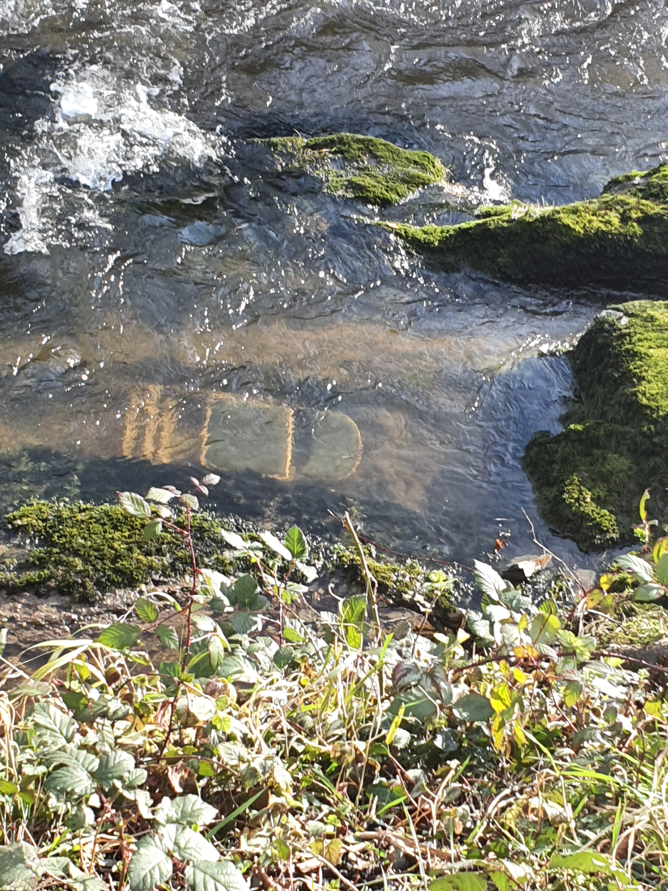
The weather can impact different areas and outdoor activity centres differently, for example for my logbook, when at Llandysul paddlers, I found a lot of debris from the floods that they have had there in the past,
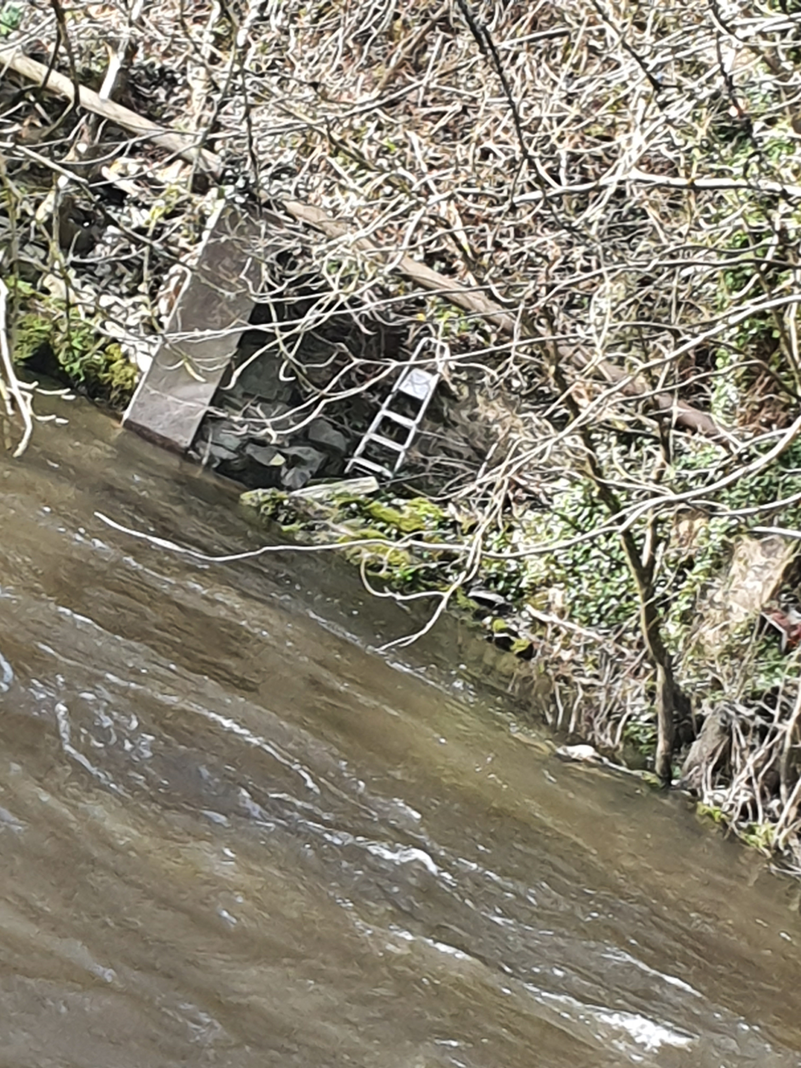

As shown in the images that I had taken myself there has been a lot of impact of different things being washed into the river, this a site specific hazard, the risk with this is the fact that kayaks or rafts going down on the river could hit them, this could be an issue while undertaking an activity because of the fact that there is a possibility of hitting the debris in the water. This could cause the person in the kayak to fall out, or even damage the kayak making it not possible to continue and would be incredibly tricky in some parts of the river. Depending on the skill level of the person who would be on the kayak, this could cause serious issues that could potentially cause harm to the people involved. A lot of the debris is in the eddies along the river which could be cleared which would help solve some of the issue. Items such as chairs have been dragged in through the floods caused by the poor weather conditions that impacted Llandysul. This is one demonstration of the impact poor weather can have. I spotted most of this debris while walking alongside the river. Although a lot of the debris was not in the water and mainly alongside the far bank this does not mean that if the weather was to cause flooding again then these items could be washed into the river
as well. One way to control this is by having someone who works on the site or hiring someone to go alongside the bank and clean up as much as they can to help prevent the amount of things that could cause issues, this may not completely stop the problem but it would help.

The weather can impact a lot of aspects of the activity. Weather that has some wind and strong rain can really increase the speed of rivers and make climbing activities more difficult also; during an activity kayak at Llandysul paddlers, the river was particularly high and the river speed was quick which meant there was also more stoppers and recirculated, which proved an issue when one of the members of the group fell off his kayak due to the fact the he could not control his speed going down the river. This ended up causing an issue during the activity itself, as the kayak ended up going downstream, meaning everyone had to wait in the eddie while one of the instructors went after the kayak. Had the weather conditions been better during the week prior and the winds on the day have been calmer, the incident may have been avoided. there was a discussion prior to the activity and brief dynamic assessment before the activity had taken place and the group had agreed the activity can go ahead.

The weather is something that should be checked before every activity that is undertaken, this is something that is done before the activities that we had taken part in because the weather is always a hazard and something that can alter plans made for the activities and it can also be very unpredictable. So, it is necessary to make sure that as much preparation has been done.

During the climbing session the winds made things difficult to communicate between each other, this could cause issues as there was a possibility that members of the group would not be able to understand what the task was. I f there was a miscommunication and members of the group attempted to climb too soon, it could cause massive health and safety issues. One of the control measures for this is understand the signals from leader, the day was clear and had good visibility meaning if the group were aware of some key signals that would make a better understand for the group.

The weather is an important factor when it comes to the climbing activity, if the weather had been wet with heavy rain this could make the surface very difficult to climb as it would be difficult to get a grip on the wet surface, making incidents more probable. Heavy winds can become an issue as well as they could blow lose rocks off the surface increasing the risk of falling. Heavy winds could also make the climbing ropes blow around and get tangled causing issues with the safety equipment and this could prove fatal.

Conclusion.
The tragedy in Glenridden beck could have been easily avoided if the leader of the group took the health and safety seriously, he should have been able to see how much the weather leading up throughout the week to the activity would have affect the conditions, the water was too cold for the activity to take place, from personal experience during an activity, I know how difficult it can be to start swimming after jumping straight into freezing water. the weather is a key factor in all outdoor activities, as mentioned in activity 3 of the log book, when the weather is windy it can make communication between the group and leaders difficult, as on the climbing trip, the group found it difficult to communicate between at the top and bottom off the slab.
the weather also has the ability to lower people confidence, some people may lose confidence in their ability because of worry of how the wind and rain are going to play affect. As I said in my log book about confidence in ability, members lose confidence then there perceived risk may be higher which could put them in a state of panic putting people in danger so this shows that the weather can have a phycological impact as well.
There are control measures and safety equipment that can be used, one of the points from the Glenridden beck is the fact that the AALA had advise on what would have been needed online, and shows the importance of the making sure you are fully prepared, he would have been able to check online what the weather would have been and the warning from the other group shows the situation the weather had coursed, if they had followed these signs and instructions the tragedy could have been avoided.
Word count 1867.

Appendix.

LOGBOOK
Llandysul paddlers week 1

Site specific hazards –
Risk - multiple and large groups.
Hazard – some groups getting mixed when in the lake together or the instructors getting confused to who is in his group and could try teaching a kid to do stuff he isn’t supposed to be doing in his group.
Risk 2 – steep wet banks.
Hazard – it is difficult to get out of the lake from the banks meaning someone could fall into the banks.
Risk 3 – Electric poles.
Hazard – there’s a possibility of a wet throw line hitting the electrical wire which would shock someone if this was to happen.
Risk 4 - Slalom poles
Hazard – this could course a head injury if you were to hit your head on the poles as you travelled down the river.
On the day – When we went to Llandysul paddlers the weather was calm, some small showers, but mostly dry and low winds. We went paddle boarding on the lake as well as practising our paddling techniques in kayaks, after some time we were taught how to rescue people, tying another padder’s boat to our own so we can pull the other to safety. After we had been taught that we then learned how to flip another person’s boat back up right whilst getting them back on the boat. We had the opportunity to try this on a few different things we had been provided with, white water kayaks, canoes and some stand up paddle boards.

During the activities we were doing I found out that one of the site specific risks I found out for my self, while I was attempting to get the kayak out of the lake, I found the banks are very easy to slip on but they didn’t have any proper control measures for this to be solved.
Some of the control measures for the site specific were fairly simple. For the slalom poles they are able to pull them out of the river from the ropes on the side, as well as wearing a helmet that should make the impact hurt a lot less if you were to hit your head on the way down.

Llandysul paddlers week 2
Day risk assessment – strong North/North Westerly winds. The water levels are high, a lot of rain over the few previous days. Because of this, the water has more stoppers and recirculated stoppers which has also affected the speed of the river making it go a lot quicker. The temperature was also fairly low on the day, the air temperature only being between 0-2 degrees whhilst the water temperature was below freezing at -4 degrees.

A site-specific hazard that I found while at Llandysul that I had not seen the during the first week was the debris in the river, the risk of this is the t fact I could damage the kayaks and rafts being used and depending on the skill level of the participant this could cause a big problem.

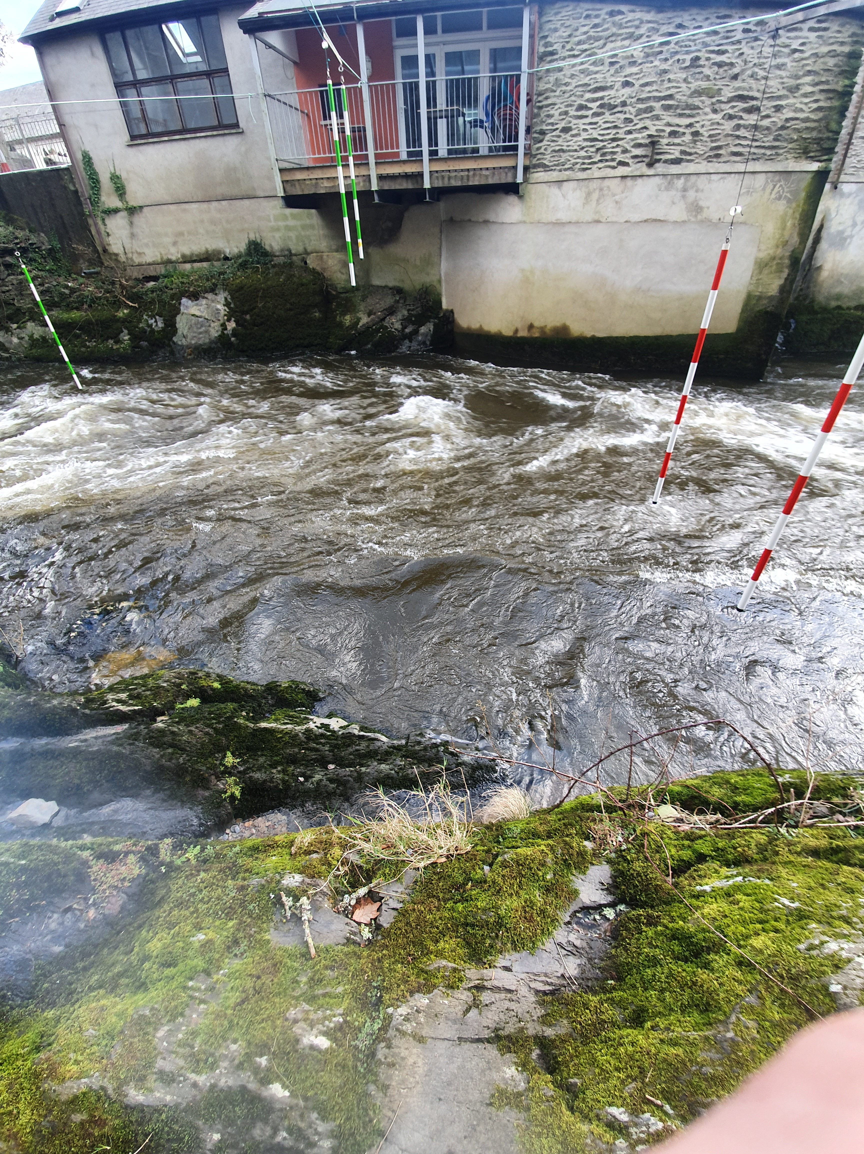
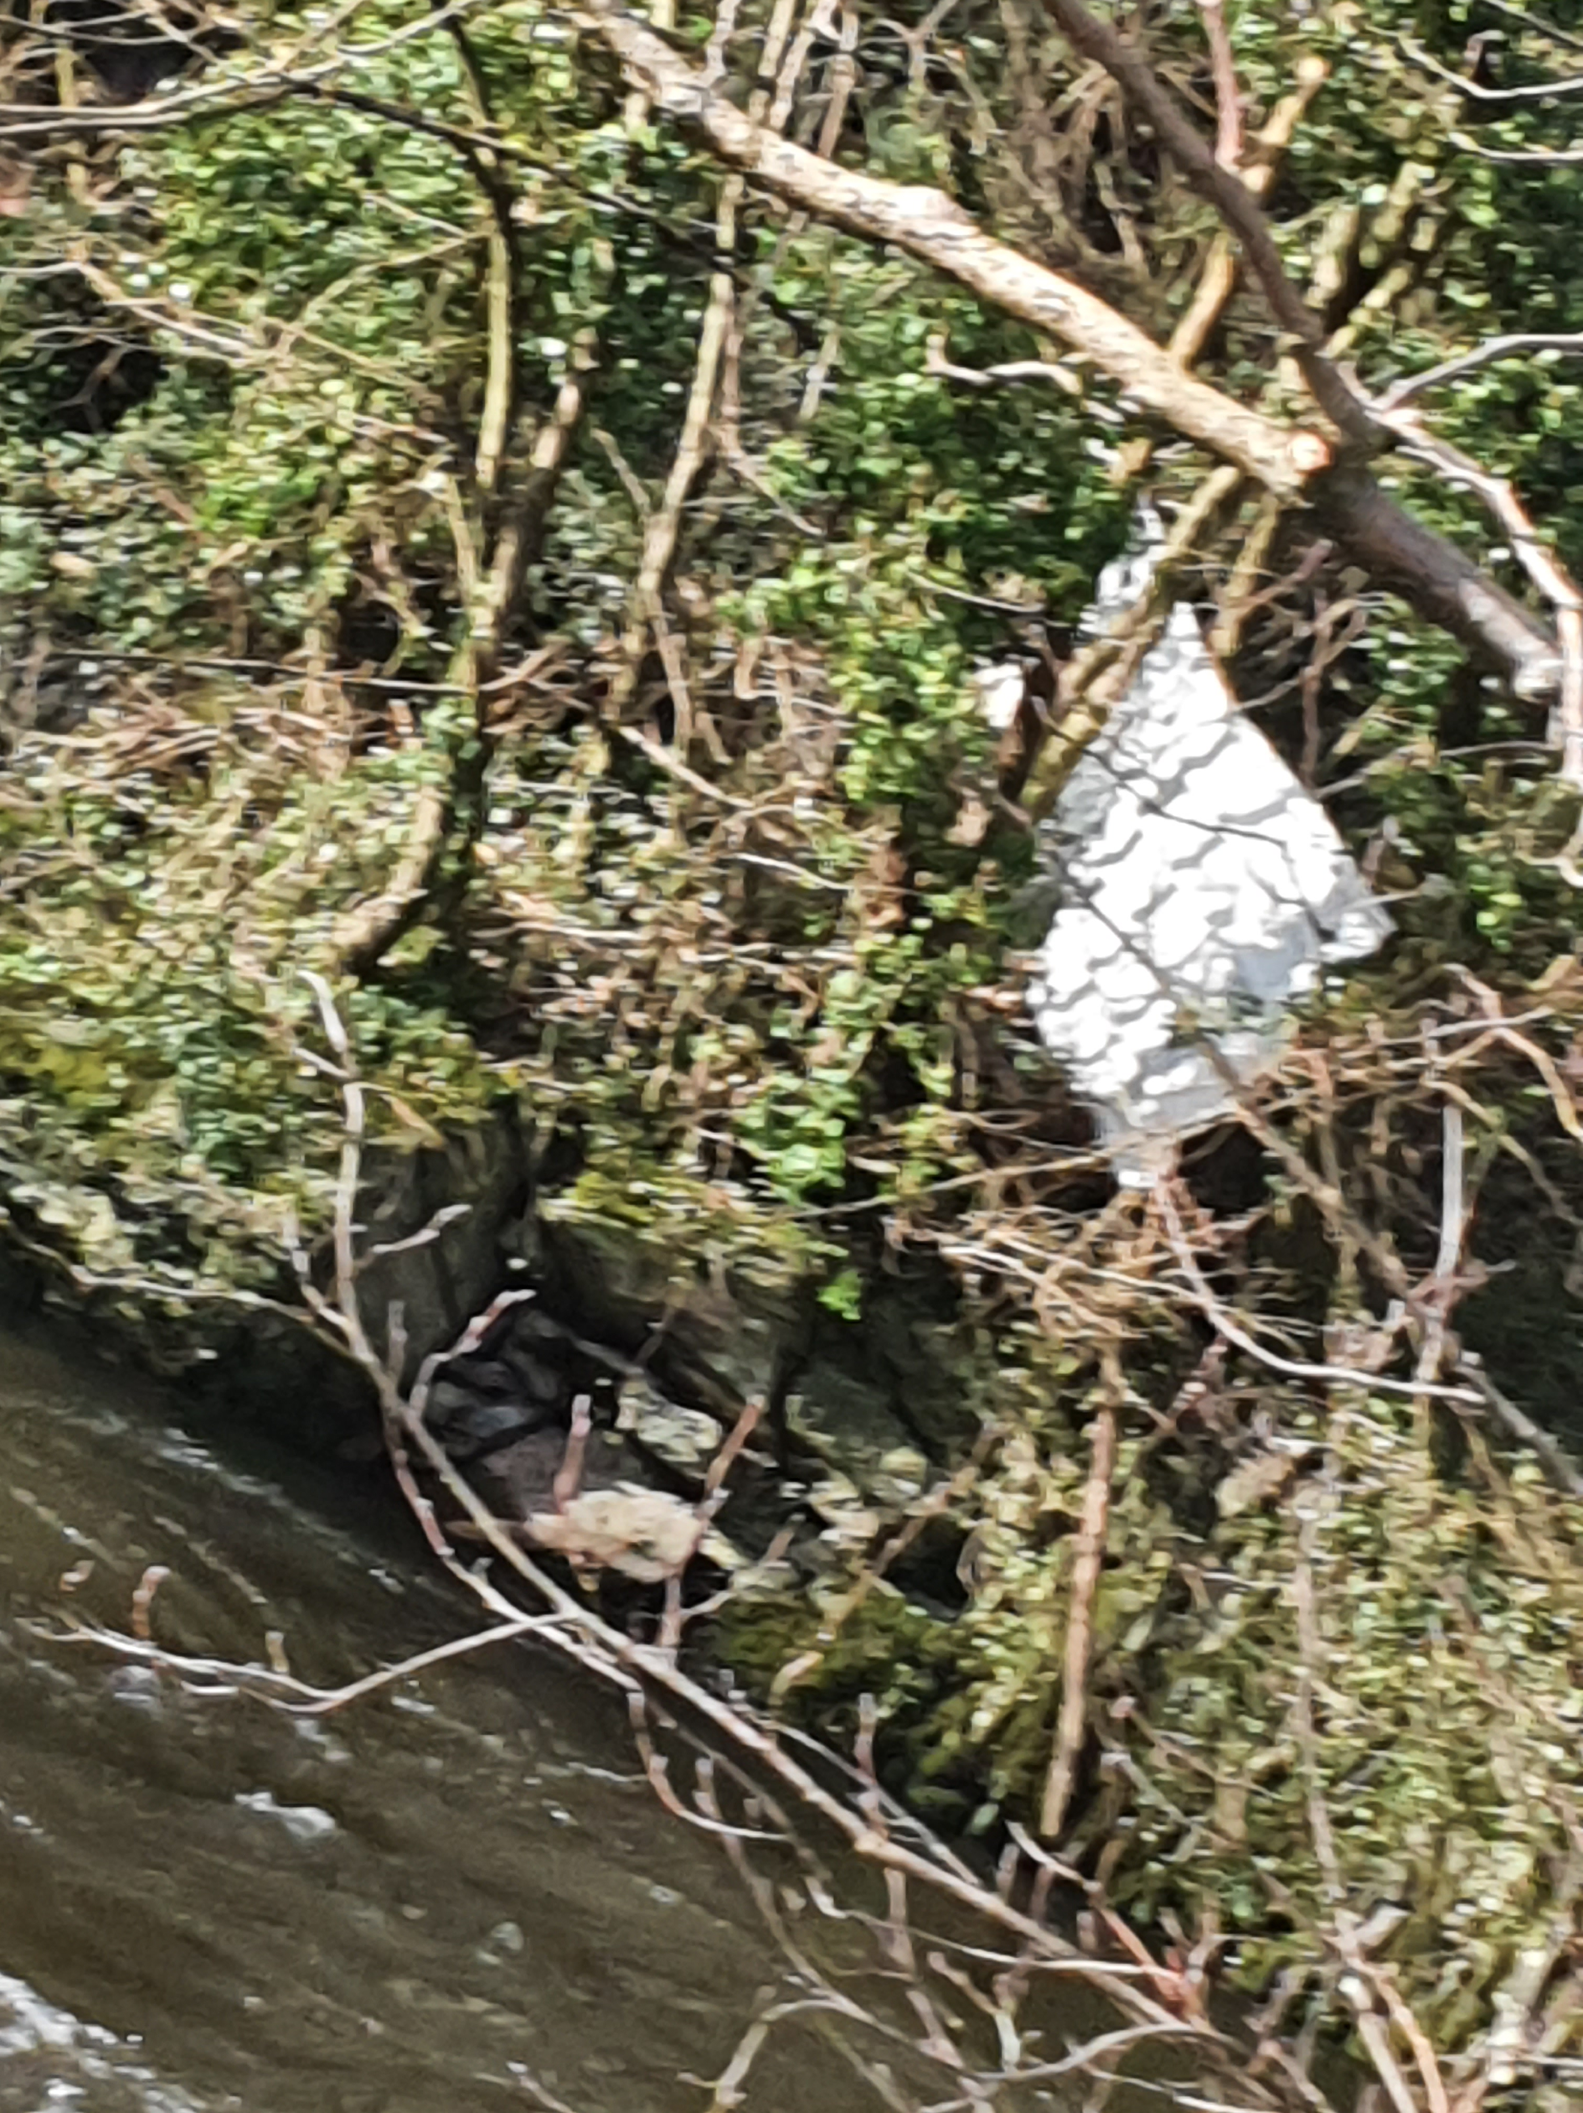

The tutors taught the group when they were on the lake how to control the speed while in the kayaks, some of the group had sit on top kayaks and others where in normal kayaks. They taught the group to “lean and edge” (J.Haylock, 2009) this is to put in to practise how to be able to use your body to be able to control the kayaks. As the group went down the river at higher speeds this proved to be difficult, on the first rapid going down to the first eddy, one of the members of the group struggled to make the eddy which caused them to fall off the sit on top kayak, and they also lost the kayak meaning one the of the leaders of the group had to go and rescue the kayak, causing some issues due to the lack of ability to communicate. This meant the group had to wait in the eddy until there was a way of communicating that the situation was resolved.

Week 3 Boiler Slab at Port Eynon on the Gower. Climbing and abseiling

This activity was climbing and abseiling, the weather on the day was fairly clear, warmer than on the pervious activities but the wind speeds where high with the wind speeds forecasted to be around 17mphs. This isn’t too high as previous weeks had been higher, but this did make communication an issue when trying to talk from the top of the wall to the bottom.
Risk 1 – falling rocks
Hazard – this could cause issues for climbers as it could either fall from above causingvpossible head injury which is why you must wear a helmet, but could make a climber attempt to get out the way making them slip whilst climbing which could course further injuries.
This could be hazard also if the rock is to give way from under your grip making the rocks fall and possibly making the climber fall also.
Risk 2 ability
Hazard - if the person climbing has lower ability or low confidence in their ability then they could cause themselves harm as the perceived risk could be much higher than the actual risk meaning they may make a bad decision due to their ability and confidence
Risk 3 – other climbers
Other climbers could be at risk by other members of the group relating to the last risk having other people struggling near you. One control measure we were taught for this was to stay in the line of sight.
Risk 4 – weather
The weather can make the wall slippery and difficult to climb and well as strong winds blowing lose rocks and other things which prove to dangerous. This can also have a psychological impact as well. As briefly mentioned In another risk this could course people to other think and have very high perceived risk which could end up having more issues
Glen ridden beck
What happened was a young boy by the name of Max Palmer drowned back on May 26th 2002. There was a party of 12 students who had 3 members staff from their school from Lancashire High School. The group also contained 3 primary school kids which included Max Palmer, his mother also came on the field trip. One of the issues that were of concern is the fact that they never made the mother’s role clear, if she knew what her role was in the group this may have helped in the later situation. “It is good practice to ensure that roles are clear in order to avoid misunderstandings and gaps in provision.”(Glenridden Beck, p.34)
They activity the group was going to participate in was plunge pooling. In doing the activity Max drowned and his mother as well as another student got hyperthermia.
The police stated that “the main course of the tragedy were the serious errors of judgement in the leader(teacher) in the planning and leading of the group.
“the significance of a number of variables (hazards) which could give rise to danger (risk). These include: Water depth Water flow Water temperature Water currents Air temperature Rocks and other physical features the ability/make-up of the group.” (Glen ridden beck report, p.5) this is a list of risks that leaders should be aware of, showing the number of things that could go wrong while being under prepared.

The temperature of the day and the water was particularly cold due the weather the week before.The water levels would also have been higher. “It had been wet for much of the week and rained heavily en route to Glenridding on the Friday night. The beck outside the hostel was fast-flowing and noisy” (Glenridden Beck,p.20) and the report states that the weather had been poor leading up to the trip and had made the water levels higher, the stream quicker and colder as well.
Then on the day they passed another group on the way to the activity; the group warned them that it was too dangerous to do the activity, but the leader of the group decided to ignore these warnings and procced with the activity regardless. “A party of similarly - aged children from another school (which had also used the plunge pool on previous occasions) was staying at a neighbouring hostel. Their teachers had decided not to use the pool that day because of the weather and water conditions” (Glenridden Beck report, p.21)

That should have also led to the instructor doing a dynamic risk assessment. The group went out on this in the morning. Around 10 am They also failed to test any of the students on their swimming ability to make sure they were able to swim at a required level. The trip also had no educational benefit or purpose, so the trip was not necessary and did not have be held. The report feels that the leader could have found everything he would have needed to know on the Adventure Activities Licensing Authority (AALA) website (Para A 2)

The instructor did not need to have qualifications because it was a hybrid activity it meant there was no need for NGB’. Two of the leaders did not have any experience in outdoor adventure education. about half of the group did not want to do the activity at the time, they also did not have any equipment on them when at the event. If they had the correct equipment on them, they could have done the activity fairly easily.
“There are National Governing Bodies (NGBs) for sports/activities such as mountaineering, caving and canoeing. They have structured programmes for the training and assessment of instructors. There are no such programmes in respect of hybrid activities, mainly because of the range of possible combinations of activity” (Glenridden beck report, p.4)
The leader of the group did send a letter to the parents of the student, however, there was no consent or medical form for them to fill out which is against the LCC procedure “The leader sent out a brief letter to parents, but no consent/medical information form. This was in contravention of LCC procedures” (Glenridden beck report, p.15) In addition, the leader has claimed he had some qualifications, “Neither the school (under the tenure of a previous head teacher) nor the LEA checked with the Mountain Leader Training Board that the leader held the claimed qualifications.” (Glenridden beck report, p.8)
“NGB qualifications was helpful for schools in matching qualifications to the proposed activities. However, it did not cover situations where schools might provide activities outside the scope of the NGB qualifications.” (Glenridden beck report, p.11) this shows that despite the leader not having the NGB’s he had claimed to have, NGB’s did not completely cover all the activities that they would have taken part in including the plunge pooling which shows the grey area of the activity.
The only clothing participants had to wear to keep warm were swimming shorts. They also didn’t bring a throwline, they attempted to use towels that they had tied together in attempt to make a throw line to help get Max out while they sent someone else back to get the rope, they also used what survival equipment they did have incorrectly, from this it shows they clearly had no plans in place in case of an emergency.

References

Adventure Activities Licensing Authority (AALA) (2020) Glenridding Beck investigation. Available at: https://www.hse.gov.uk/aala/glenridding-beck-investigation.htm
(Accessed: 8 May 2020).
The Royal Society for the Prevention of Accidents (RSPA) (2015) Managing...
Safety at Inland Waters. Available at: https://www.aspli.com/_uploads/pdfs/managing-safety-at-inland-waters.pdf. (Accessed: 8 May 2020).

