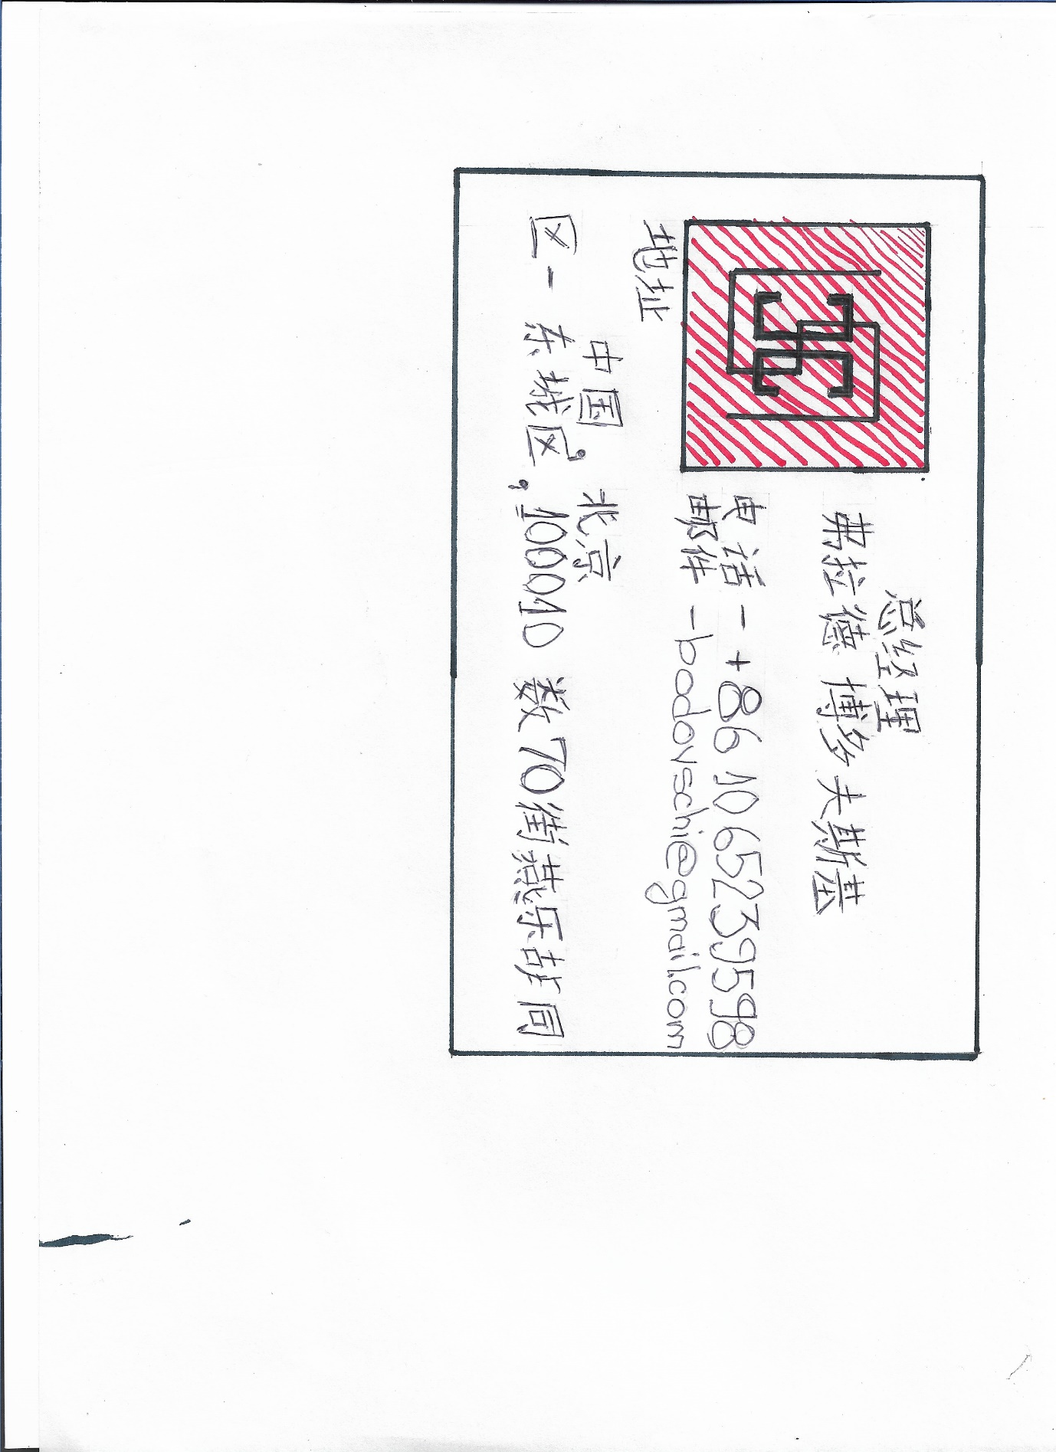

It is a visit card for the general manager of the hotel Core Cour from Beijing with name, address and phone number.

