Research Title: The Impact of Electronic Health Records (EHRs), Primary and Secondary Data on Patient Care in Hospitals

Table of Contents
Abstract 1
Introduction 1
Rationale 3
Research Methodology 4
Literature Review Analysis and Discussion: 5
Conclusion and Recommendation 6
References 7

Abstract
This research proposal explores the impact of electronic health records (EHRs) and primary and secondary data on hospital service user care. The study used a mixed-methods approach, including qualitative interviews and surveys with families, friends, and healthcare professionals. The secondary source will include industry reports, government reports, and academic articles.
In addition, this research analysis will portray the overview of the significance of electronic health records (EHRs) and primary and secondary data in modern healthcare (Fitchburg State University, n.d.). It also discusses the potential benefits of data-driven health and social care strategies and the impact of the Health, Care Bill, and the Wade-Gery review in transforming healthcare.
Data analysis will be used, which involves using thematic analysis, standard deviations, means, inferential statistics, and finding trends and patterns in the data. The study's findings will contribute to the existing knowledge on the impact of EHRs in healthcare services and supply recommendations for policymakers and healthcare professionals. The research will supply a comprehensive analysis of the advantages and disadvantages of using EHRs in hospitals which will contribute to the understanding of factors that influence the successful implementation of EHRs in the healthcare industry.

Introduction
Electronic health record has transformed the way healthcare professionals manage documents and users' information (EHRs) has been abused by healthcare organization worldwide and hospitals to improve patient quality care and to conduct the accurate method of sharing and storing service users' information which enables more informed and coordinated decision-making among other health care professionals. EHRs have eased the collection of primary and secondary data, which can analyse and better understand the impact of these records on patients' care and promote their needs. There are also potential drawbacks to using EHRs (Walker et., 2017 this research proposal aims to investigate the impact on patient care in hospitals, examining both advantages and disadvantages.

Rationale
EHRs in health care are becoming famous all over healthcare settings, and there is still a need to evaluate the impact on patients' care. Many studies have examined the benefits of EHRs as there needs to be more consensus on how much they improve users' health outcomes (Kruse et al., 2018). Additionally, there are potentially set back associated with the use of EHRs, such as the impact of health care information workload and risk of information breaches, which should be addressed to ensure their successful implementation (Adler-Milstein et al., 2017).

This research will address the following questions.
1. What factors influence the success of EHRs implementation in hospitals?
2. What are the advantages and disadvantages of using EHRs in hospitals?
3. How do EHRs impact patient care in hospitals?
Research objectives:
To identify the factors that influence the success of EHRs in hospital implementation.
To Identify and analyse the advantages and disadvantages of using EHRs in the hospital.
To investigate the impact of EHRs on patient care in hospitals.

Research Methodology
The research proposal method will be data-driven tools and data analysis techniques. It highlights how data can support outpatient users, reduce waiting times for treatments and diagnosis, and help the NHS find inequalities and faults in the system (NHS England, 2022). Moreover, this section also emphasizes the importance of the effective use of data for improvements in quality, finding poor care services to patients, and evaluating efforts to integrate care.
The research method used will affect service innovation and the significance of quality data in implementing evidence for long-term funding plans (Enonge et al., 2021). Additionally, it highlights the impact of EHRs on care coordination, clinical decision support tools, and efficiency in hospitals, and the challenges associated with their implementation, such as the first cost and concerns about data privacy and security (HealthIT, 2019).
Impact of Electronic Health Records (EHRs), Primary and Secondary Data on Patient Care in Hospitals
In the healthcare industry, primary and secondary data in patient care, EHRs has s primary and secondary data on hospital patient care. It discusses how EHRs give healthcare professionals full authority over individuals with a complete health history, enabling providers to make correct and informed conclusions in diagnosis and treatment (Upadhyay & Hu, 2022).
EHRs improve care coordination between health promoters and minimize medical errors due to real-time user data access. It enables healthcare professionals to be aware of potential risks and supply proper support to users.
Additionally, EHRs increase efficiency in hospitals by reducing points for time-consuming data entry and duplicate effort and how primary and secondary data can be used in acknowledging patterns in individuals' care, enabling hospitals to optimize arrangements and improve performance (Kose et al., 2020).

Literature Review Analysis and Discussion
The adoption of EHRs has improved care coordination, which is essential in promoting patient-quality care; it ensures users receive the high-quality care possible, according to the study by Poon et al. (2010), which acknowledged that EHRs resulted in a significant improvement in the promotion of care to patients with chronic health conditions.
In addition to improving care coordination, using EHRs increases service user safety by supplying access to real-time patient information to providers, essential for identifying health and safety risks and potential barriers to patient health to present medical errors (Ammenwerth et al., 2018). Hospitals promoting care to critically ill patients with heart complications, cancer, and HIV are complex, as healthcare providers will need correct and timely information to deliver quality care.
Moreover, EHRs have shown increased effectiveness by reducing the time spent on manual data entry and retrieval. They are enabling healthcare professionals to spend more time with users' thus improving the quality of care.
EHRs can reduce the cost of healthcare by using fewer paper records and streamlining administrative processes (Koppel et al., 2018); even with all the benefits of EHRs, there are barriers associated with their adoption and implementation. These barriers can include concern about patients' privacy, resistance to change by healthcare promoters, data security, and the cost of implementation (Gunter et al., 2012), which may affect in delivery of quality care to patients; therefore, all healthcare practice should evaluate as to ensure EHRs are being used effectively in all health care sectors.
Population and Sample
The sample based on hospitals will Provide information on EHR adoption.be decided using a stratified random sampling technique, stratified by hospital size, healthcare provider type, and region. It will be four hundred respondents, including two hundred service users and two hundred healthcare professionals.
Data Collection
Data Collection for this study will involve two methods interviews and a survey; this will be conducted using an online questionnaire; the questionnaire will include both open-ended and closed questions to collect qualitative and quantitative data, which will be administered to healthcare professionals and service users with experience with using EHRs in their respective health sectors.
The interview will be via video conference or face-to-face with semi-structured interview instruction. The interview will be based on the research aim and literature review, including a purposive sample of healthcare professionals and service users with considerable experience with EHRs.
Secondary Data analysis
Quantitative data collected from the survey will use descriptive statistics Example, inferential statistics such as SPSS, frequency distribution, and measures of central tendency such as chi-square tests and ANOVA to evaluate hypotheses and determine relationships between variables. The data will be coded based on themes and categories that appear from the data.

Increased efficiency
EHRs streamline workflows, reducing the time required for
charting and order entry, better communication, EHRs ease information sharing, enabling effective communication between patients and health care professionals. EHRs provide an accurate view of every patient's information, reducing the risk of medical errors (Ammenwerth et al., 2011). EHRs increased efficiency in streamlining workflows and enhanced patient safety.
Disadvantages of EHR
The disadvantage of the EHR is the cost of the system; the
the initial cost of using EHRs may have increased. Maintenance and upgrades can cost more (Lau et al., 2020), including concerns of deviation of patients' privacy as EHRs contain vital information about user's personal life and health history information which must be protected from unauthorized access, according to Human Right Act 1998, Privacy Act 1988 & Data Protection Act 1998 which states that all individuals must be treated fairly with respect regardless of their background, race, or health problems; however, In the case of individuals being a threat to themselves or others is when confidentiality can be breached for health and safety.

Modern services for primary and secondary Data collection and traditional Secondary data collection methods
Health care includes medical records and administrative.
Databases supply access to exact information about patients and healthcare workers (Broom, 2005).
The advantage of modern primary is that its quick and efficient use as digital technologies allows for more efficient data analysis and gathering, helping reduce the time and cost of digital data collection. Online surveys are less expensive than traditional methods due to reducing travel expenses and cutting the need or use of paper surveys (Alkhaldi et al., 2016).
Traditional paper-based data collection methods can be time-consuming, resulting in errors; however, modern approaches to data collection, such as electronic health records and other digital technologies, can be exact and faster, although they require more resources to implement and train.

Advantages and disadvantages of traditional and modern service for primary and Secondary data
Traditional strategies for detailing in-depth information, such as vital data, cannot be obtained through other methods (Creswell, 2014). In health and social care, the traditional way is more effective because it is more formal and shows concern in having face-to-face communication; this enables one to express and see the experience closely. Enabling more understanding of the patient's health and well-being and effective communication, healthcare workers can foster trust and a more personalized experience (Hsleh & Shannon, 2005). online surveys and digital data collection methods can be less expensive than that traditional methods by dropping the use of paper surveys. Control over data collection enables the researchers to control the data collection process, enabling greater precision and accuracy (Creswell, 2014). Traditional methods can be time-consuming and require a larger workforce to collect and process data (Creswell, 2014). Due to collecting data from interviewer and respondent characteristics, there may be biases in the data collection, which means the accuracy of the data may be compromised (Hsieh & Shannon, 2005). Likewise, traditional data collection can be expensive when extensive travel is essential to reach participants.
The disadvantage of secondary data is due to limited scope.

Traditional secondary data sources may give information on a specific healthcare system or population. However, lack of quality control as traditional secondary data sources may have quality control issues such as inaccurate or incomplete data (Broom, 2005).
Another disadvantage is the need for more widespread access it grants. Digital data collection and online survey methods help researchers reach more diverse populations than traditional methods (Alkhaldi et al., 2016).
Limited depth of information and little distinctive touch: Digital services lack the delicate touch of face-face interactions, and digital surveys may not supply the same level of depth information as face-face interviews and observation could have brought, which may reduce response rates and trust from participants (Alkhaldi et al., 2016).

Conclusion and Recommendation
In conclusion, the impact of EHRs and primary and secondary data on hospital patient care highlights their significant contribution to improving service user safety, reducing medical errors, increasing efficiency, improving care coordination. Despite the challenges associated with their implementation, the benefits of EHRs and data outweigh the cost. They are essential tools for modern healthcare and need continuous staff training for improvement.
The recommendation is to continue to use and improve EHRs and data-driven strategies in health and social care.

Investigations:
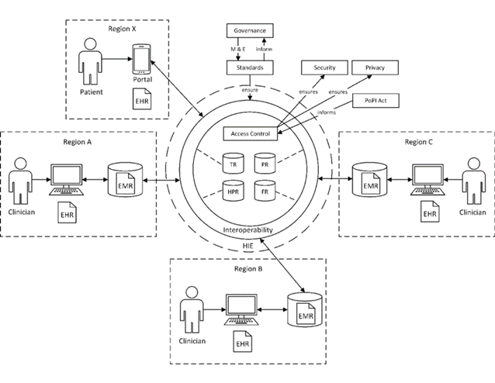
Further research areas related to the impact of EHRs and data on patient care in hospitals (Moher et al., 2009).

Figure 1 - uploaded by Tamir Tsegaye
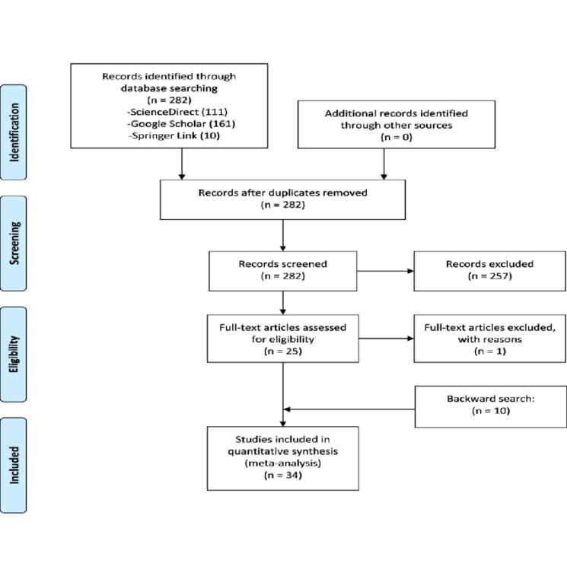
Figure 4 - uploaded by Tamir Tsegaye

Reference

- Adler-Milstein, J., DesRoches, C. M., Furukawa, M. F., & Jha, A. K. (2014). The impact of electronic health records on ambulatory physician productivity. American Journal of Managed Care
- Ahmadian, L., Khajouei, R., & Jebraeily, M. (2014). The impact of computerized provider order entry system on clinical outcomes in
- Ammenwerth, E., Schnell-Inderst, P., & Hoerbst, A.
- Berg, M. (2018). Patient care and the use of electronic health records: ethical and practical considerations. Journal of Healthcare Information Management, 32(1), 28-34.
- Blumenthal D, Tavenner M. The "meaningful use" regulation for electronic health records. N Engl J Med. 2010 Jul 13;363(3):202-3. Doi: 10.1056/NEJMp1006114. PMID: 20514146.
- De Waal, B., van Outvorst, F., & Ravesteyn, P. (2016). Digital Leadership: The Objective-Subjective Dichotomy of Technology Revisited. European Conference on Management, Leadership & Governance, 52.
- Enonge, E. et al. (2021) Primary data vs secondary data: Definition, sources, advantages, Blog for Data-Driven Business. Available at: https://www.intellspot.com/primary-data-vs-secondary-data/ (Accessed: April 13, 2023).
- Fitchburg State University (n.d) Research help: NURS 3710 (RN to BS): Evidence-based practice in nursing: Primary research vs. Secondary Research (n.d.) Primary Research vs. Secondary Research - NURS 3710 (RN to BS): Evidence-based Practice in Nursing - Research Help at Fitchburg State University. Available at: https://fitchburgstate.libguides.com/c.php?g=841815&p=6015293 (Accessed: April 13, 2023).
- HealthIT (2019) What is an electronic health record (EHR)? | HealthIT.gov. Available at: https://www.healthit.gov/faq/what-electronic-health-record-ehr (Accessed: April 13, 2023).
- HealthIT.gov. (2021). What is an Electronic Health Record (EHR). Available at: https://www.healthit.gov/topic/health-it (Accessed: April 13, 2023).
- Institute of Medicine. (2015). Improving diagnosis in health care. National Academies Press (US).
- Jha AK, DesRoches CM, Campbell EG, Donelan K, Rao SR, Ferris TG, Shields A, Rosenbaum S, Blumenthal D. Use of electronic health records in US hospitals. N Engl J Med. 2009 Apr 16;360(16):1628-38. doi: 10.1056/NEJMsa0900592. PMID: 19321858.
- Jones SS, Rudin RS, Perry T, Shekelle PG. Health information technology: an updated systematic review with a focus on meaningful use. Ann Intern Med. 2014 Sep 16;160(6): 48-54. doi: 10.7326/M13-1531. PMID: 25222388.
- Kose, I. et al (2020) Adoption rates of electronic health records in Turkish hospitals and the relation with hospital sizes. Available at: https://www.researchgate.net/publication/344860229_Adoption_rates_of_electronic_health_records_in_Turkish_Hospitals_and_the_relation_with_hospital_sizes (Accessed: April 13, 2023).
- Li, Q., & Li, Y. (2018). A comparative study of patient care using electronic health records versus paper records. Journal of Medical Systems, 42(2), 31.
- Moher, D. et al. (2009) Preferred reporting items for systematic reviews and meta-analyses: The Prisma statement, BMJ (Clinical research ed.). U.S. National Library of Medicine. Available at: https://www.ncbi.nlm.nih.gov/pmc/articles/PMC2714657/ (Accessed: April 13, 2023).
- Nguyen et al. (2014) Electronic Health Records implementation: An evaluation of information system impact and contingency factors, International Journal of Medical Informatics. Elsevier. Available at: https://www.sciencedirect.com/science/article/pii/S1386505614001233?casa_token=njKyri7kByEAAAAA%3A0i_SZeLxwF80a7m3HU0pV88MhVHKLhE_T4WFcZnQIm0sTqPTwsly6aqMGGDfQ32xLD3tLAVr9QUM (Accessed: April 13, 2023).
- NHS England (2022). NHS England. (online) England.nhs.uk. Available at: https://www.england.nhs.uk/ (Accessed 20 Apr. 2023).
- Papanicolas I, Woskie LR, Jha AK. Health care spending in the United States and other high-income countries. JAMA. 2018 Mar 13;319(10):1024-1039. Doi: 10.1001/jama.2018.1150. PMID: 29536101.
- Upadhyay, S. and Hu, H. (2022). A Qualitative Analysis of the Impact of Electronic Health Records (EHR) on Healthcare Quality and safety: Clinicians’ Lived Experiences. Health Services Insights, 15, pp.1–7. doi: https://doi.org/10.1177/11786329211070722

