Annotated bibliography;

Dillwyn, L.J. (1852). St Fagans before restoration, negative. National Museum Wales. Available at: https://museum.wales/collections/online/object/5f704389-a461-3752-8e31-5c1670d6ad4b/St-Fagans-Castle-before-restoration-negative/?field0=with_images&value0=1&field1=string&value1=St%20Fagans%20castle&index=6 [Accessed 2 Mar. 2021].
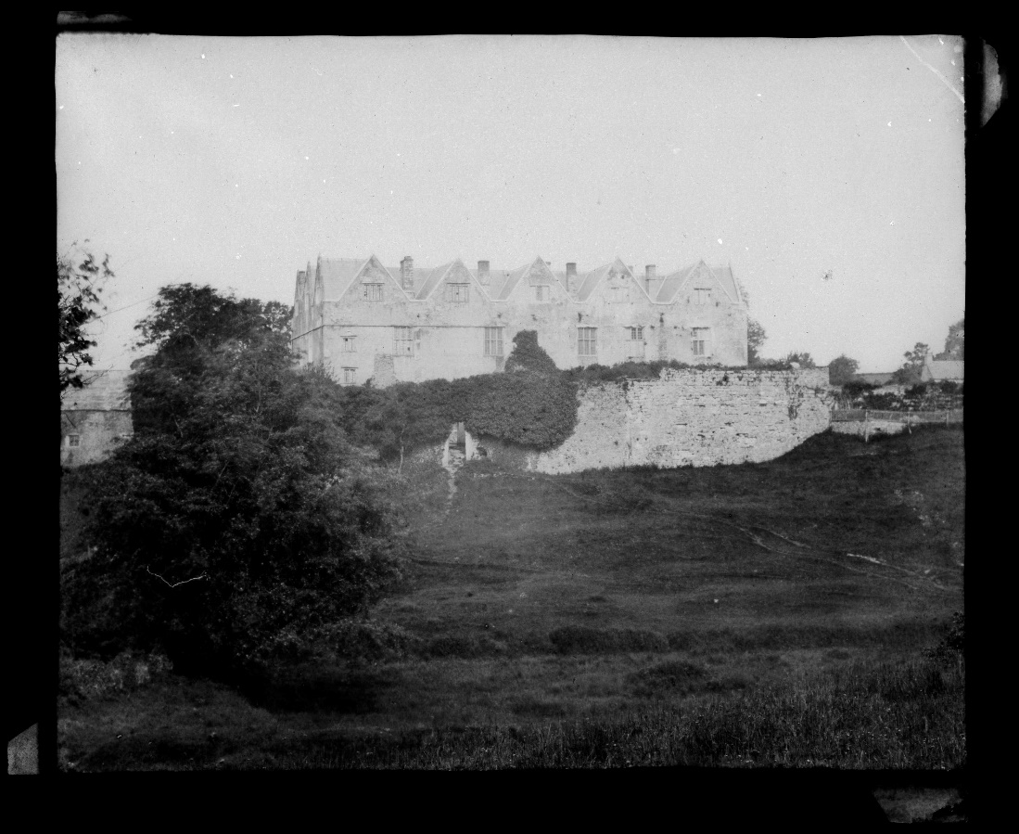
(Figure 1, St Fagans before restoration)
St Fagans Castle was one of the first exhibitions presented at the museum; the photograph was taken (shown above in Figure 1) in 1852 was restored to its original format. The photograph presents the Castle in an authentic environment before the land was donated and encouraged at the beginning of the Welsh Folk Museum, with St Fagans Castle at the museum's forefront in 1946.
The Castle itself is of historical significance, with the grounds and land surrounding the Castle was the focus of St Fagans' battle. Due to the historical significance of the grounds, the Castle's use for the Welsh Folk Museum indicates that Welsh history and heritage are essential features of the museum and ensure the buildings are protected.

National Museum Wales (Welsh Folk Museum) (1951). Festival of Britain 1951. National Museum Wales Online Collection. Available at: https://museum.wales/collections/online/object/15180d12-b033-3c0b-907b-723dfe510da4/Certificate/?field0=string&value0=St%20fagans&field1=with_images&value1=1&page=5&index=50 [Accessed 24 Feb. 2021].
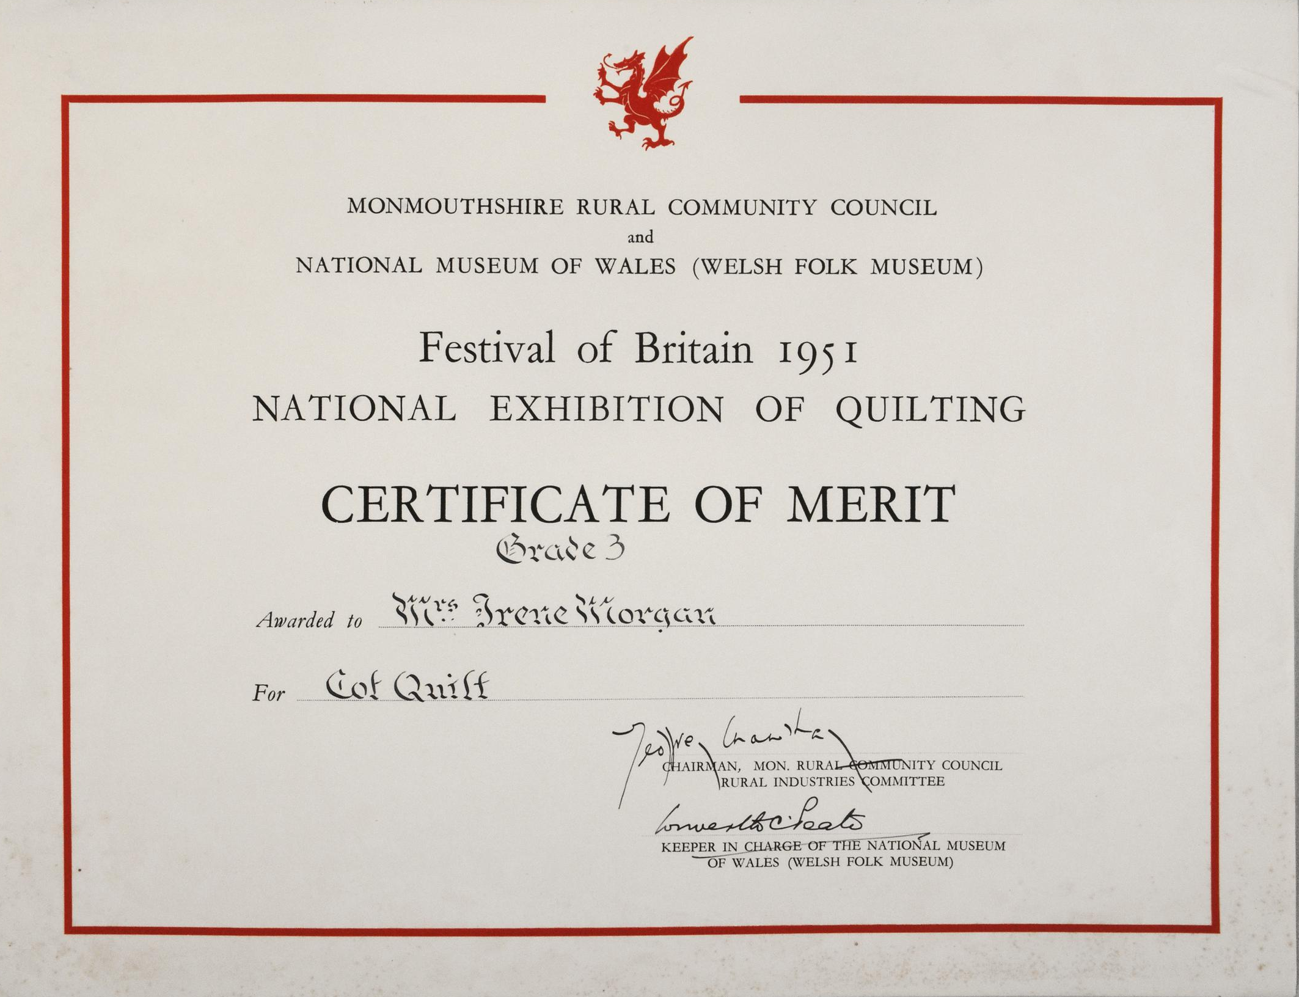
(Festival of Britain, 1951; National Museum Exhibition of Quilting)
The Welsh Folk Museum contributed to the Festival of Britain. As part of Wales' contribution, the museum constructed the large-scale exhibition of National Quilting with 60 modern quilters situated near historical examples of quilting held by either the museum or private owners. This quilting exhibition involves local communities in the museums' competition, which encourages them to add to the museum's vast collection of heritage with this intangible experience of making a quilted blanket displayed for new visitors to experience.
The photograph above presents a Merit certificate for the Festival of Britain in 1951, which brought hope and relief for the nation after the war period presenting the best of Wales. The Festival of Britain committee was a massive support to the museum. They contributed to funding for some of the reconstructed buildings (mentioned below in the 1964 handbook) to celebrate Welsh folk history and recognise the different communities that make up these aspects of Welsh heritage through visitors actively engaging with the museum.

Peate, I. (1965). The Welsh Folk Museum. [online] Indiana University Press, pp.314–316. Available at: https://www.jstor.org/stable/3814151 [Accessed 24 Feb. 2021].
Peate introduces the reader to Artur Hazelius (who introduced a folk museum concept in 1891) with the Skansen open-air museum in Sweden. Hazelius wanted to illustrate the living culture of a nation, "this imaginative leap in technique was probably the most important ever in the history of museum development" (pp 1)
Peate focuses on the different departments within the museum and staff members who worked at the museum in 1965. St Fagans was/is a research institution with publications made by staff from different areas such as houses, welsh folk customs, rural crafts.
This article by Peate distinctly contributes to representing Welsh heritage through the active research departments continuously discovering different aspects of Welsh heritage which deserve the recognition of being presented at the museum and should be taught to others through lectures at the museum.
The St Fagans motto distinctively underlines Welsh heritage's importance and demonstrates how important the museum is when discussing Welsh heritage.
"To teach the world about Wales, and the Welsh people about their fatherland" – (Peate 1965)
St Fagans' history begins with the Battle of St Fagans, which is an aspect of the grounds' local Welsh history. St Fagans Castle is an essential factor to the Battle of St Fagans will frequently be discussed in the negative photograph of St Fagans Castle (Shown above in Figure 1)

Peate, I. (1933). Welsh Folk Industries. ed. [online] Taylor and Francis Ltd for Folklore Enterprises, p.pp 176-188. Available at: https://www.jstor.org/stable/1255817 [Accessed 24 Feb. 2021].
In the introduction to this article, Peate refers to his friend Mr Middleton Murry who wrote an essay on William Morris in The Great Victorians who said: " living art can only arise out of surrounding living crafts".
Peate draws attention to the National Museum of Wales as a place trying to preserve those crafts that are in danger of going extinction if industrialisation continues. Peate explores the exhibits and other reconstructions of some village workshops and the village factories' machinery in the museums' Gallery of Folk Industries.
This article focuses on Welsh rural life's essential aspects. The introduction to Village Smithies, which are infrequently used now in modern life. Peate presents a few examples of well-known ironwork of the 18th&19th centuries, Mr D. J. Williams of Caernarvon, who made the ironwork for the Unknown Warrior's coffin. Rural potteries; found in the north and the south in Wales, specifically in the Buckley district of Flintshire in the north, Monmouthshire and the south in the Vale of Glamorgan.
Peate discusses the Welsh rural communities through the traditional crafts; well-known examples are the woodturner who is significant in Welsh Folk's history; initially, the woodturning craft found in every county in Wales, the number has decreased since. The tradition of the Central European lake-dwellings prolonged in the work of Welsh turners. Peate describes the practice as having a primitive character with their machinery and tools static that have a strong family tradition of craftsmanship, like Artur Hazelius, who invented the first Folk Museum celebrating all that is Sweden. The National Museum now (1933) houses the small woollen yarn factory from Llanrhystyd in Cardiganshire; the Woollen industry was a distinguished aspect of industrial Wales.
Peate highlights the loss of the Welsh language in the 19th century, more particularly in Radnorshire and its community's evolution. The Welsh language or loss of it has become damaging to the community members living in Wales currently, and it is an individual element of Welsh life.
Peate concludes the article by quoting D. H. Lawrence;
'There is no point in work unless it absorbs you like an absorbing game'.
This article helps discuss what constitutes Welsh history and heritage. Each craft symbolises Welsh Folklife's importance and how the Welsh Folk museum is organised and presented to represent the traditional Welsh Folklife.

Welsh Folk Museum (1949). S.T. Fagans Castle& other exhibits Illustrated handbook National Museum of Wales Cardiff pp 1-19
At the beginning of the 1949 handbook, it discusses 'What is a folk museum' that underlines the museum's premise, introducing different examples such as; crafts, etc. and the influence that Scandinavian museums have had on the Welsh Folk Museum. The recurrence of craft activities heavily constitutes Welsh identity and a vast aspect of Welsh culture through exhibits at the museum. Crafts are not just personal memorabilia through the craft maker; they are aspects of Welsh national identity. It was popular, sustainable and affordable during the 1940s and previous decades to hand-made tools and crafts with the resources available.
With the following discussion topic being 'St Fagans Castle; History, that focuses on the history of the Castle and surrounding land, the land was occupied by the Plymouth family from 1730- 1947 until the remaining land was a gift to the museum to encourage the idea of a Welsh Folk Museum.
The handbook is very informative, thoroughly describing the museum to the visitor with a few photographs. The museum's various exhibits each originate from different geographical parts of Wales, representing the variety of Welsh history and heritage. The different exhibits include; The HOUSE; the Ground floor; the kitchen; the back hall, the hall, the withdrawing room, the staircase. The first floor; the 18th-century bedroom, the parlour, the library, the 17th-century bedroom, the long galleries. The GROUNDS and GARDENS. CRAFTS; the Wood-turner, the Basket-maker. Along with; SYSTEMATIC Case Exhibits.
There are other aspects of information mentioned for the visitors in this handbook; this handbook's exciting aspect is the different visitor accounts to the Castle during the 1500s. It stresses the historical importance of St. Fagans Castle.
St Fagans village, also known as Y Cwm, is a significant aspect of Welsh history and heritage, as the memory of the village continues to live on through the museum in these early days of the museum.
The museum in 1948 is still in the early development stages with smaller and less tourist infrastructure; however, there are tea rooms that are an addition to the handbook and offer only a selected amount of products to the visitors. Compared to the other handbook mentioned, the 1949 handbook is detailed yet short, and its indefinity enables reflection on the museum in 2021 and the museum's development since then.

Welsh Folk Museum (1964) St Fagans National Museum of Wales Cardiff pp 1-32

At the beginning of the 1964 handbook, Peate introduced the reader to the museum's evolution from the beginning in 1948. The handbook is like that of the handbook in 1949, just after the museum's start-up, emphasising 'what is a folk museum' before presenting the exhibits.
The handbooks appear to be referenced closely; however, the 1964 handbook is shorter in length. The museum introduced the Folklife gallery, which was revolutionary in the museum's development as the objects project the new Folk Museum building's intentions, which will be elements of material culture in Wales. These exhibits only constituted a small portion of Welsh culture featured in the museum.
In comparison to the 1949 handbook, the museum had reconstructed more buildings in 1964 than before with the introduction of The Stryt Lydan Barn timber-framed barn from Stryt Lydan near Penley that the museum re-enacted with the financial support from the Welsh Committee of the Festival of Britain in 1951 (The barn is still there today!). The barn presents an actual example of the museum actively involving local communities to experience an event that remembers the famous Welsh crafts and their makers.
Another reconstructed building is, The Esgair Moel Woollen Factory, financed by the Welsh Committee of the Festival of Britain.

There are four newer (1964) additions of reconstructed farmhouses, Abernodwydd Farmhouse, Kennixton farmhouse, Hendre'r-ywdd Uchaf Farmhouse and Cilewent Farmhouse. These farmhouses are all aspects of different Welsh geographical life; it is a theme within the handbook to emphasise the exhibits' geographical aspects. They represent different periods in Welsh history that is important to remember. Cilewent farmhouse is significant as it is a distinct representation of typical Welsh longhouses that once spread among the Welsh moorland holding both families and its cattle. Visitors who have lived or live in long-houses will experience a sense of familiarity when viewing Cilewent Farmhouse as, like the other exhibits at the museum, it is a portion of Welsh life that more than one Welsh family ancestrally may have experienced.
Capel Pen-rhiw is a distinct exemplar of the typical Welsh nonconformist chapel building; this chapel is Unitarian, a religious denomination with a long and prestigious tradition in Wales that believes in learning tolerance. The chapel is known for the religious symbolism that it represents. However, the objects found through the chapel's dismantling were ink bottles, quill-pens, and a Welsh Not, which presents the chapel's use before a chapel as it was an elementary school and a grammar school at different periods of its lifeline.
A few other exhibits were not an aspect of the museum in 1948; however, they are beginning to complete the museum's aims for a folk museum. Through the display of a Gipsy Caravan, the Welsh Folk Museum can represent the Welsh culture communities that are not an aspect of the mainstream exhibits in more prominent museums today. This exhibit is an essential feature of the museum as these gipsy families have been crucial members of Welsh traditional society, especially in South Wales.
The milestones markers are two Glamorgan milestones, one in cast iron dated 1841 and 1862, are both visible for visitors to follow. These milestones lead from the Museum block to the Kennixton farmhouse and highlight the significant use of physical milestones in Welsh history as a sense of direction before the advanced technology in contemporary society today. These markers could symbolise how Welsh life has significantly changed from 1841 to the present day; however, this is unclear in the handbook.

