Programmes

Project Planning for Construction ACBA5001


January 2022

Prepared for: Dr Deborah Hughes
Authored by: Jon Phillip Langstone
Student Number: 2006738

Table of Contents
1.0 Introduction & Summary 2
2.0 Proposed Development 2
3.0 Programme of work 3
4.0 Gantt charts 4
6.0 Method statements 6
7.0 References 16

Figure 1 Proposed FOG 2 & 3 (Architects, 2017) 2
Figure 2 FOG Cost Report Graph 4
Figure 3 FOG Resource timescale overview 4

1.0 Introduction & Summary

This report aims to identify how a programme of work is used to aid in the construction of three proposed new-build FOGs (Flats over garages) on a proposed piece of land in Swansea, United Kingdom. It will also show an attached Gantt Chart and three method statements which are essential components for programme of works for general construction best practice.

2.0 Proposed Development
On Langdon road In the marine area of Swansea, known as SA1, Langstone Homes has received planning consent for 3 new-build FOG’s. Each FOG (Flat over garage) comprises of a 2 double bedroom flat that is structurally supported to sit on top of a garage/parking space.
FOG 1 is a singular building, but FOG’s 2 and 3 are joined into one structure.

Langstone Homes now must formulate a programme as part of the procurement stage of the constriction project. This will allow the principle contractor to organize material, labour, and other resources into a structured plan before the initial construction phase begins.
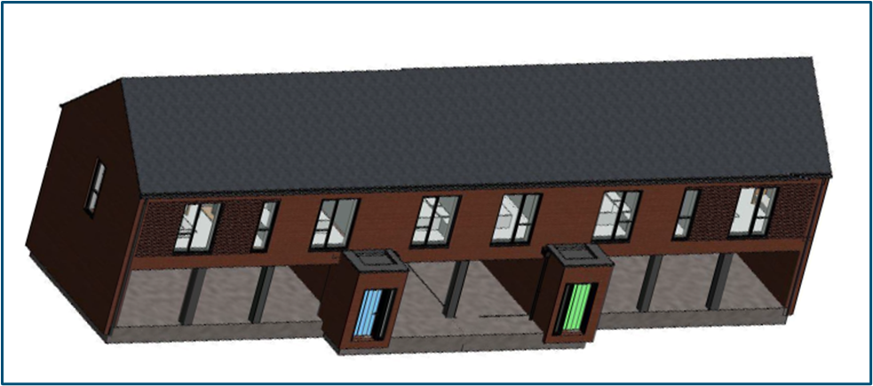
The figure below is an illustration for the proposed FOG 2 & 3:
Figure 1 Proposed FOG 2 & 3 (Architects, 2017)

3.0 Programme of work
What is a programme of work for?

- Primarily a management tool.
- For programming the works involved inside a project.
- For monitoring progress.
- Cost analysis.
- The basis for making or defending a claim if one were to arise (Brian Cooke, 2009).
- Health and safety reviewing.

Programmes can allow teams based on construction sites to monitor and review project progress, plan resource allocation, and ensure that the project can be completed efficiently and ultimately on time. A quote from GoConstruct.org helps further explain a programme:

“As well as being a contractual requirement, a construction programme is an essential management tool, enabling forward-planning to ensure projects are delivered on time, within budget and to a high quality.”
(Goconstruct.org, n.d.)

Construction Programmes are now becoming more intelligent, where construction professionals can access the software to edit or analyze the programme in real-time, to suit their needs, and then inform others involved of their changes. This will allow for a more collaborative way of planning and conducting a construction project.

4.0 Gantt charts
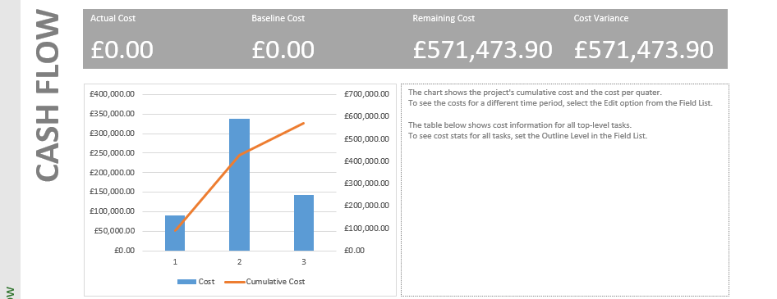
A construction programme is often presented in the form of a Gantt chart. The Gantt chart will have a list of grouped activities or tasks shown as a bar to represent its duration, which will then show a time scale to indicate what sequence the task or activity is in. Gantt charts can also show the cost of resources such as materials, labour or rented equipment. For example, the figure below represents the cost of the project throughout three stages of the full duration: The figures below show graphs from the Microsoft Project software used to identify the number of resources being used and the cost of the operations, on the proposed FOG project:
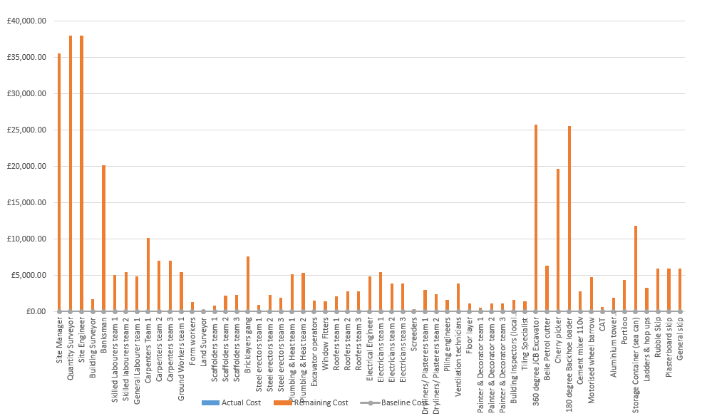

Figure 2 FOG Cost Report Graph
Fig.2 identifies how much each operation costs compared to other operations in the project.

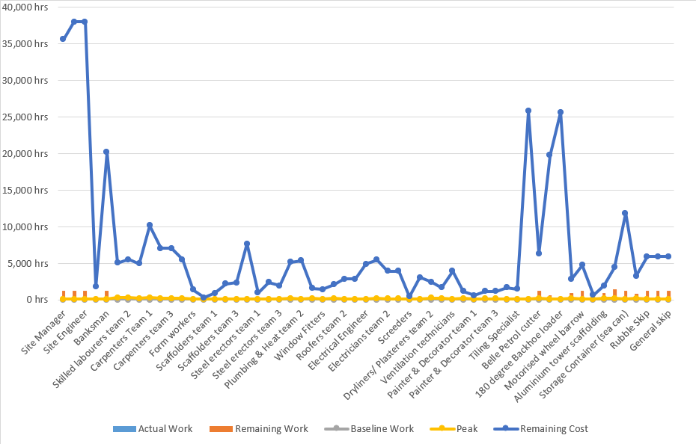
Figure 3 FOG Resource timescale overview
Fig.3 clearly demonstrates how Microsoft projects can produce a graph that shows the duration of each operation on the specific project. The Chartered institute of building outline the importance of using cost control integrated reports in construction programmes: “the aim of cost control is to produce the best possible building within the budget” (CIOB, 2014).

This programming software, Microsoft projects (as well as other closely related software packages) comes as one integrated package that can undertake the whole range of project-planning requirements needed. The full Gantt chart of the three FOG new-builds to coincide with this report is attached to the document for observation.

There are many advantages to using Gantt charts to porgramme for construction projects.
Below is a list of those advantages:
- Gantt charts help keep fluid communication within a team or organization.
- Help to plan by the hour, day, week, month, or even annually.
- Gives a simple representation of the tasks, sub-tasks, and achieved goals on the graph.
- Project progress and peer review can be easily viewed and edited.

Although Gannt charts have a lot of benefits, there are some disadvantages. They are as follows:
- Using the software can take some time to learn and not all construction professionals are software savvy.
- Regular updates to a graph are a complex process.
- Singular views of the process do not give enough room to elaborate on specific tasks.

6.0 Method statements
A method statement is an explanation of the sequence of operations and resources required for the job, described inside a formal document (Lester, 2021). Method statements are usually prepared by the contractor and sub-contractors at various stages of projects. They are an essential component that outlines the task and the health and safety risks, which are also accompanied by a risk assessment, which will then go further to identify the risk in any given task or activity on site.

The CITB also help highlight how important method statements are regarding health and safety, and identifying risks before a project starts, in the following quote:

“Well written method statements provide an ideal means of communicating vital health and safety information to those who will be doing the work and others (such as contractors) who have an interest in how the job will be carried out”
(CITB, 2021).

following are three method statements that identify 3 areas of the relevant FOG construction project:

6.1 Method statement 1 – Piling operations
Langstone Homes
14 sketty avenue,
Sketty,
SA20TE
07395102478

Written by: Jonathan Langstone
Date: 23/12/21

Project: Langdon Road FOG Project
Project number: 899
Site address:
Plot E3b
South Of Fabian Way
Langdon Road
Swansea Docks
Swansea SA1 8QY

Date of works: Start: 8th Feb 2022 Finish: 12th Feb 2022

Description of activity

Piling for FOG No.1

The Piling operation Involves:

- Construction Area fenced off barriers and signage to the work area in place.
- Compacted Stone Piling mat installed in advance by others with CBR tests to prove suitability for the piling rigs.
- Piling rigs will be directed to the position of erecting which should be firm and level and sufficient.
- In this instance, the piling platform/works area shall be the area for rigs erection (the working area).
- Continuous Flight Auger Piles will be utilised cast in situ to avoid noise and vibration of a driven pile solution.
- Selection of piles will be in the order of preference by the supervising site engineer, client, or pile designer
- If necessary, pile sides will be exposed to 1 m from the pile head.
- At no time is the pile engineer to be in exclusion zone 5m from RIGS unless operations have ceased, and explicit authorisation has been given by the piling engineer foreman.

Supervision and personnel
- Powerful Piling LTD. - 01792 888880

Training

All operatives are adequately trained to carry out required tasks.
All site operatives hold current certification and have the following training:

- CSCS certification
- Working at heights training
- Harness safety training
- Piling qualifications
- Piling equipment operating, testing, and maintenance tickets

Legislation

- Health and Safety Work Act 1974
- The Management of Health and Safety at Work Regulations 2006
- Workplace (Health, Safety and Welfare) Regulations 1992
- Provision and Use of Work Equipment Regulations (PUWER) 1998
- Control of Substances Hazardous to Health Regulations 2002
- The Work at Height Regulations 2005
- The Personal Protective Equipment at Work Regulations 2002
- The Manual Handling Operations Regulations 1992
- The Construction (Design and Management) Regulations 2015
- Electricity at Work Regulations 1989
- Pressure Equipment Regulations 1999 (SI 1999/2001)

Working in substructure operations

- Dust
- Noise
- Traffic Movements/cleanliness of roads
- Risk of runoff water impacting local watercourses
- Concrete washout risks
- Operational Impacts
- Confined space risks

PPE requirements

- Hard hats
- Safety boots
- Hi-vis vest
- Safety gloves
- Safety glasses
- Safety tested Harness (when necessary, working at height)

Welfare

Welfare arrangements are supplied by the client or principal contractor.
These should be in line with Schedule 2 of the Construction Design & Management Regulations 2015 (CDM). All sites are to have a minimum amount of welfare facilities available for workers, which include the following:

- Toilets
- Washing facilities
- Drinking water
- Changing rooms and lockers
- Heating
- Rest facilities

First aid

Refer to the onsite safety notice board for all first aid information.
A first aid box with enough equipment to cope with the number of workers on site should be provided for by the client or principal contractor.
The client or principal contractor should nominate an appointed person to take care of first-aid arrangements.
The number of appointed first aiders shall be dependent on the number of employees.

Emergency procedures

The client or Langstone homes (the principal contractor) will ensure that the existing site emergency procedures are followed and that relevant information is given to operatives at time of induction or when changes are made to procedures.

The closest hospital is: Morriston hospital, Heol Maes Eglwys, Morriston, Cwmrhydyceirw, Swansea, SA6 6NL

6.2 Method statement 2 - Roof Construction
Langstone Homes
14 sketty avenue,
Sketty,
SA20TE
07395102478

Written by: Jonathan Langstone
Date: 23/12/21

Project: Langdon Road FOG Project
Project Number: 623
Site address:
Plot E3b
South Of Fabian Way
Langdon Road
Swansea Docks
Swansea SA1 8QY

Date of proposed works: Start: 12th May 2022 Finish: 16th May 2022

Description of activity

Roof construction for FOG No.1

Building the roof Involves:
- The carpenters and roofers will build the trusses (by use of a 35-tonne crane) in place ready for the roofers to later install the purlins, insulation framework and damp and vapour barrier for the roof.
- Labourers will assist with moving any necessary materials needed for the carpenters and roofers to carry out the work safely and efficiently.
- The roofers will complete the roof structure and install the man-made slate components to the exterior finish of the roof. Site general and skilled labourers provided by the principle contractor will be allocated to help with the movement of material and waste to and from the roof to allow the roofers to work safely and to finish in good time.
- After the consequent completion of the roof and its finishes, the roofers will install the plastic fascia’s and guttering, before the roof can be inspected and signed off.

Supervision and personnel
- North Roofing LTD. - 01792 888880
- Hixson Carpentry & Sons Ltd. - 07945 4999321

Training

All operatives are adequately trained to carry out required tasks.
All site operatives hold current certification and have the following training:

- CSCS certification
- Working at heights training
- Harness safety training

Legislation

- Health and Safety Work Act 1974
- The Management of Health and Safety at Work Regulations 2006
- Workplace (Health, Safety and Welfare) Regulations 1992
- Provision and Use of Work Equipment Regulations (PUWER) 1998
- Control of Substances Hazardous to Health Regulations 2002
- The Work at Height Regulations 2005
- The Personal Protective Equipment at Work Regulations 2002
- The Manual Handling Operations Regulations 1992
- The Construction (Design and Management) Regulations 2015
- Electricity at Work Regulations 1989
- Pressure Equipment Regulations 1999 (SI 1999/2001)

Working at height

When working at height, site operatives must ensure that the working area is cleared periodically to ensure that there is continually a clear and safe working area to prevent slips trips and falls. Any operatives working on the roof where scaffolding is not accessible must wear a maintained and safety tested harness and be competent in wearing a harness.

PPE requirements

- Hard hats
- Safety boots
- Hi-vis vest
- Safety gloves
- Safety glasses
- Safety tested Harness (when necessary, working at height)

Welfare

Welfare arrangements are supplied by the client or principal contractor.
These should be in line with Schedule 2 of the Construction Design & Management Regulations 2015 (CDM). All sites are to have a minimum amount of welfare facilities available for workers, which include the following:

- Toilets
- Washing facilities
- Drinking water
- Changing rooms and lockers
- Heating
- Rest facilities

First aid

Refer to the onsite safety notice board for all first aid information.
A first aid box with enough equipment to cope with the number of workers on-site should be provided for by the client or principal contractor.
The client or principal contractor should nominate an appointed person to take care of first-aid arrangements.
The number of appointed first aiders shall be dependent on the number of employees.

Emergency procedures

The client or Langstone Homes (the principal contractor) will ensure that the existing site emergency procedures are followed and that relevant information is given to operatives at the time of induction or when changes are made to procedures.

The closest hospital in the event of an emergency: Morriston Hospital, Heol Maes Eglwys, Morriston, Cwmrhydyceirw, Swansea, SA6 6NL

6.3 Method statement 3 – Brickwork Façade

Langstone Homes
14 Sketty avenue,
Sketty,
SA20TE
07395102478

Written by: Jonathan Langstone
Date:20/12/21
Project: SA1 FOG New-Builds 1,2 & 3.
Site address:
Plot E3b,
South Of Fabian Way,
Langdon Road,
Swansea Docks,
Swansea SA1 8QY

Date of works: Start: 8th Feb 2022 Finish: 1st Sept 2022

Description of activity

Building the Masonry components of the project using facing brick as the primary material and concrete block as the secondary. (Masonry facade)

The main Brickwork Elements Involve:

- The substructure of blockwork for the FOG must be built on top of the foundation to the specified parameters and correct dimensions. All DPC must be installed and insulation to the bottom of the cavity. Engineering brick will be used in areas where needed.
- Above ground the facing brick will be correctly fixed level, insulated, and tied to the structure with the use of brick ties to ensure the envelope of the building is always protected from thermal bridging.
- All the work carried out will be kept clean and tidy to avoid any health and safety hazards.
- The brickwork will be the primary outer shell of the building’s facade in question. All pointing and cement mixes will have the correct ratio shown in the specification for the facing brick used.
- Catnic lintels will be fixed above any threshold and have a clearance of 150mm on either side of the openings to avoid structural failure.

Supervision and personnel

- Brown’s Brickwork – Clive Brown - 07395102889

Training

All operatives are adequately trained to carry out required tasks.

All site operatives hold current certification and have the following training:

- CSCS certification
- The Bricklayers hold the required NVQ qualifications.
- Working at heights training
- Hot works permits must be issued by the site manager

Legislation

- Health and Safety Work Act 1974
- The Management of Health and Safety at Work Regulations 2006
- Workplace (Health, Safety and Welfare) Regulations 1992
- Provision and Use of Work Equipment Regulations (PUWER) 1998
- Control of Substances Hazardous to Health Regulations 2002
- The Work at Height Regulations 2005
- The Personal Protective Equipment at Work Regulations 2002
- The Manual Handling Operations Regulations 1992
- The Construction (Design and Management) Regulations 2015
- Electricity at Work Regulations 1989
- The Pressure Systems Safety Regulations 2000
- Pressure Equipment Regulations 1999 (SI 1999/2001)

Working at height and manual handling

When working at height, site operatives must ensure that the working area is cleared periodically to ensure that there is continually a clear and safe working area to prevent slips trips and falls. Manual handling is a major risk when carrying and moving the bricks, cement or any lintels. If any material is deemed too heavy for the operatives to move manually, the aid of lifting machinery or equipment will be required so that no one risks hurting themselves whilst working on the site.

PPE requirements

- Hard hats
- Safety boots
- Hi-vis vest
- Safety gloves
- Safety glasses
- Respiratory masks

Welfare

Welfare arrangements are supplied by the client or principal contractor.
These should be in line with Schedule 2 of the Construction Design & Management Regulations 2015
(CDM). All sites are to have a minimum amount of welfare facilities available for workers, which include the
Following:

- Toilets
- Washing facilities
- Drinking water
- Changing rooms and lockers
- Heating
- Rest facilities

First aid

Refer to the onsite safety notice board for all first aid information.
A first aid box with enough equipment to cope with the number of workers on-site should be provided for by the client or principal contractor. Eye-wash stations will be provided in designated areas of the site, found alongside a first aid kit and air horn.

The client or principal contractor should nominate an appointed person to take care of first-aid arrangements.
The number of appointed first aiders shall be dependent on the number of employees.

Emergency procedures

The client or principal contractor (Langstone Homes) will ensure that the existing site emergency procedures are followed and
that relevant information is given to operatives at the time of induction or when changes are made to
procedures.

The closest hospital is:
Morriston Hospital, Heol Maes Eglwys, Morriston, Cwmrhydyceirw, Swansea, SA6 6NL

7.0 References
Architects, R. (2017). Design and Access Statement: POBL Residential Development, Langdon Road SA1. Rio Architects.
Brian Cooke, P. W. (2009). Construction planning, programming and control. Wiley-Blackwell.
CIOB. (2014). Code of practice for project management for construction and development . Chichester: Wiley Blackwell .
CITB, O. (2021). Construction Site Safety A: Legal and Management. Official CITB.
Goconstruct.org. (n.d.). Construction Programme. Retrieved from GoConstrust.org: https://www.goconstruct.org/educational-resources/learn-about-construction/construction-programme/
Lester, A. (2021). Prject Management, planning and control. Matthew Deans.

