Critical Power 3 Minute All out Test
The CP3min test is performed on the Monark 894E cycle ergometer (Monark Exercise AB, Vansbro, Sweden).
A 5 min warm-up at ~50 W, followed by 5 min of rest is provided prior to the test.
The resistance is calculated as 4.5% body weight and applied to the cage, then held up using the magnet.
The participant then completes 3 min of unload cycling. In the last 5 s of the unloaded phase, the participant is instructed to reach a cadence as high as possible. When the cadence reaches 110 rev⋅min-1, the cage will drop and the test will commence.
The participant is instructed to maintain their cadence as high as possible for 3 min.
Verbal encouragement is provided to the participants, but they are not aware of the elapsed time, cadence, power output, or heart rate.
The power output during the test is recorded with the Monark ATS Software (Monark Exercise AB, Vansbro, Sweden).
The CP and AWC parameters from the CP3min tests are estimated from the power versus time relationships (Figure 1). The CP is the average power output over the final 30 s of the test and the AWC is calculated as the work done above CP using the following equation: AWC = 150 s (P150 – CP), where AWC is expressed in joules and P150 is the mean power output for the first 150 s of the test, and P150 and CP are expressed in watts.
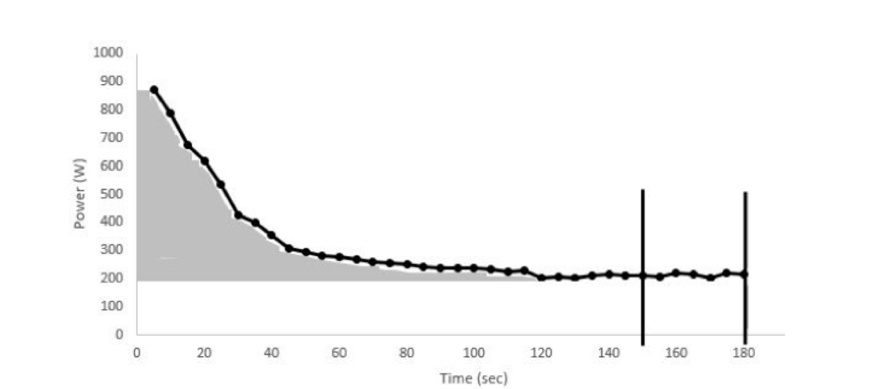
Figure 1. Schematic representation of the 3-min all-out critical power (CP3min) test response to estimate the critical power (CP) and anaerobic work capacity (AWC). The gray area under the curve represents the AWC and was estimated from the equation AWC = ([mean power (MP) (average power during first 150 seconds) – CP] x 150) / 100. The black vertical lines represent CP, which was the average power during the last 30 sec of the test.

