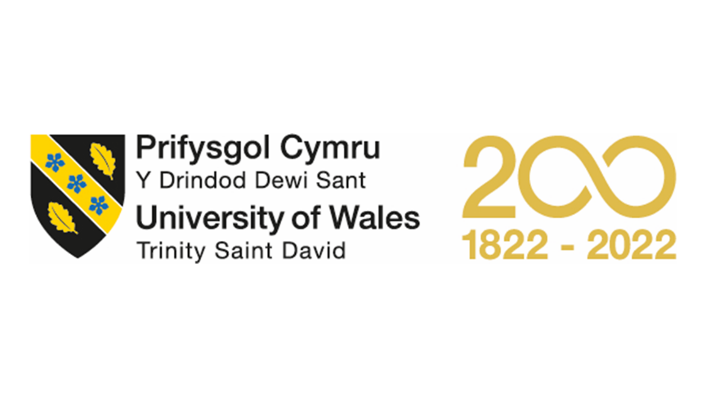
MBA – Master of Business Administration
Marketing Management
LCMB7001

Assessment – 2

Student Name: Honey Shinoy
Student ID: 2218830

Table of Contents

Table of Contents 2
List of Figures 4
1 Introduction to the organization 5
2 PESTEL analysis 5
2.1 Political Factors 5
2.2 Economic Factors 6
2.3 Social factors 7
2.4 Technological Factors 7
2.5 Environmental Factors 8
2.6 Legal factors 9
3 Porters 5 Forces model 9
3.1 Competitive Rivalry 9
3.2 Buyers’ bargaining power 9
3.3 Suppliers’ bargaining power 10
3.4 The threat of Substitutes 10
3.5 The threat of New Entrants 10
4 SWOT analysis 10
4.1 Strengths 11
4.2 Weaknesses 11
4.3 Opportunity 11
4.4 Threats 12
5 Marketing mix strategies 12
5.1 Product 12
5.2 Distribution 12
5.3 Promotion 13
5.4 Price 13
6 Recommendation 13
7 Conclusion 13
References 14

List of Figures
Figure 1: PESTEL analysis 5
Figure 2: Cosmetic industry in the UK 6
Figure 3: Inflation in the UK 7
Figure 4: Technology use in the UK 8
Figure 5: YouTube of Yardley London 8
Figure 6: Instagram of Yardley Figure 7: Facebook of Yardley 8
Figure 8: 4Ps of the marketing mix 12

Introduction to the organization
In 1932, Yardley Company was founded that is now celebrating 250 years of expertise in fragrance belonging to the personal care industry (Yardley Inserts, 2022). The company produces the world's leading purveyors of quality perfumes and soaps. Yardley has a wide range of beauty products and amazing perfumes with a variety of body and bath skin care, luxuries, & hair care products (PostAadmin, 2020). William Yardley and Samuel Cleaver are the founders, and its parent company is Wipro. Its main products are Perfumery and Toiletries, Soap bars, Fine fragrances, Talcum powder, Body wash, and Oral care. In fragrances, cosmetics, and related toiletry products, Yardley is a British personal care brand and is one of the oldest companies in the world (Yardley London, 2022).

PESTEL analysis
PESTEL analysis is utilized in macro environmental analysis mainly to examine and understand the external influence on the company that contains six factors as follows.
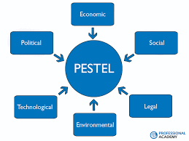
Figure 1: PESTEL analysais
(Source: David, 2022)

Political Factors
Political stability in England is good because it operates both the Dutch and British political systems that emphasize a good political environment. There are some confusion and debates over the UK's withdrawal from the EU (The Chartered Institute of Personnel and Development, 2022). Some argue that Brexit provides opportunities to explore the outer world while some argue that Brexit causes closed doors in international business. After Brexit, Yardley increases prices on some UK products. Yardley London Ltd is a company incorporated in Wales and England (Shaw, 2022).

Economic Factors
The Fragrances segment amounts to US$2.17bn in 2022 in the UK which would be expected to grow by 3.03% annually. The most generated revenue in the United States, when compared to global comparison, is US$8,366.00m in 2022 (Statista, 2022). By 8% as £1.47 billion, the fragrances market is expected to grow in 2022 (Statista, 2022). There are nearly 714 registered retailers in the UK. By 2019, the Cosmetics market in the United Kingdom market was worth more than 1.74 billion British pounds.
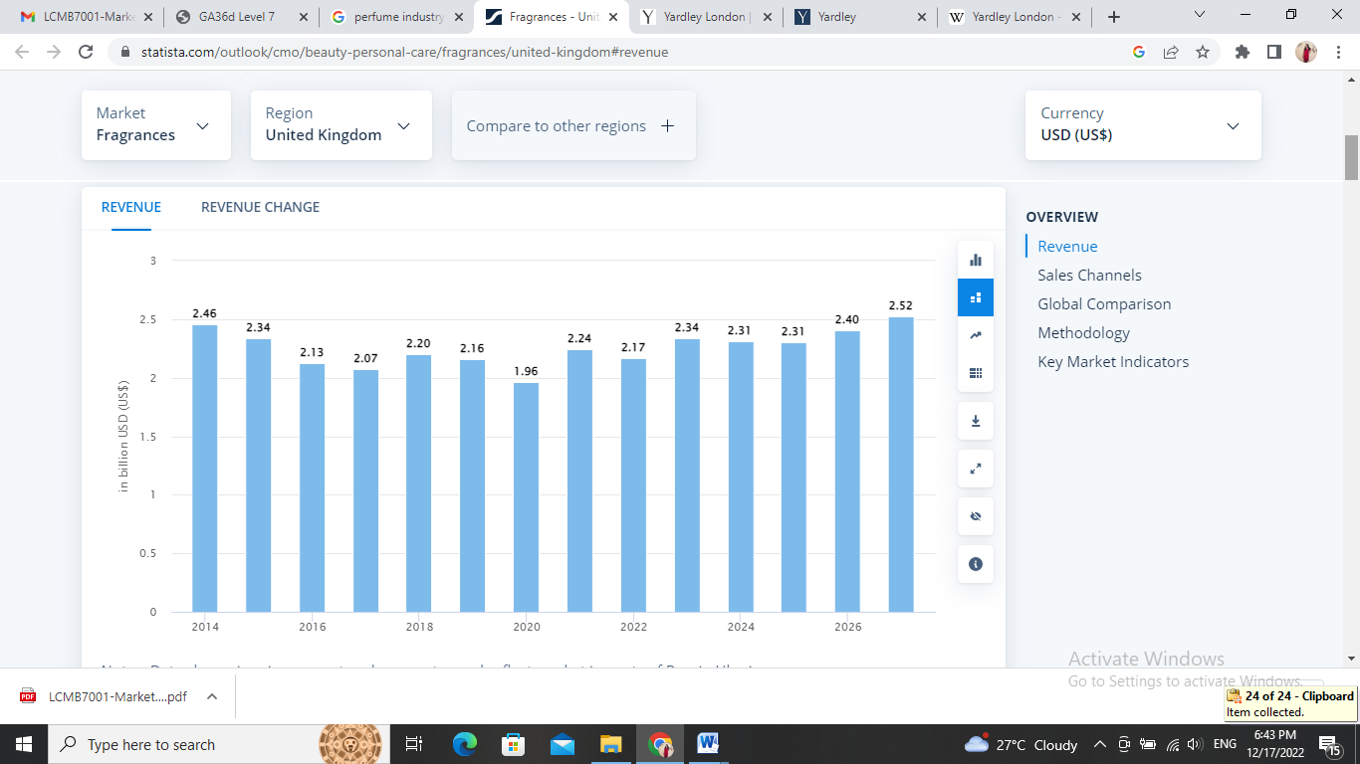
Figure 2: Cosmetic industry in the UK
(Source: Statista, 2022)
The 6th largest economy in the world is the UK that emphasizes UK people are financially stable. The ongoing corporation tax rate is 19% which would be grown by 25% from 2023 (Portes, 2022). In August, the annual inflation rate increased from 13.0% to 13.2% in September 2022 which means services and goods also increased.
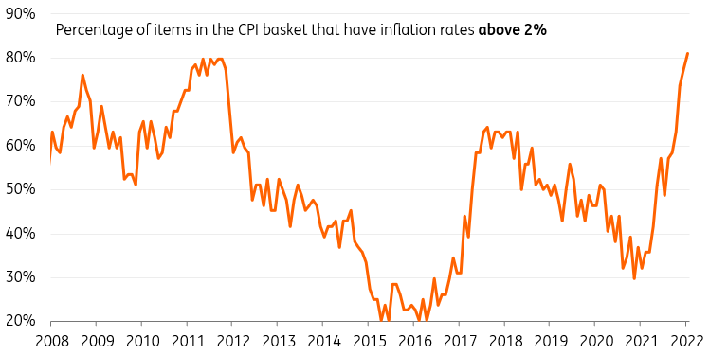
Figure 3: Inflation in the UK
(Source: Portes, 2022)

Social factors
The UK people are likely to purchase branded and quality products that have existed for years in the market. The UK is a multicultural country, and its population is 68.5 million. Different forms of products are launched to meet the needs and preferences of customers (BUSH, 2016). Yardley English Rose is one famous fragrance in UK society. British brands are famed for organic beauty over years.

Technological Factors
In the UK, there are 53 million active social media users including 3.7 million TikTok users, 40 million Facebook users, etc. which represents 77.9% of the UK population (Yadav, Chakraborty & Mittal, 2022).
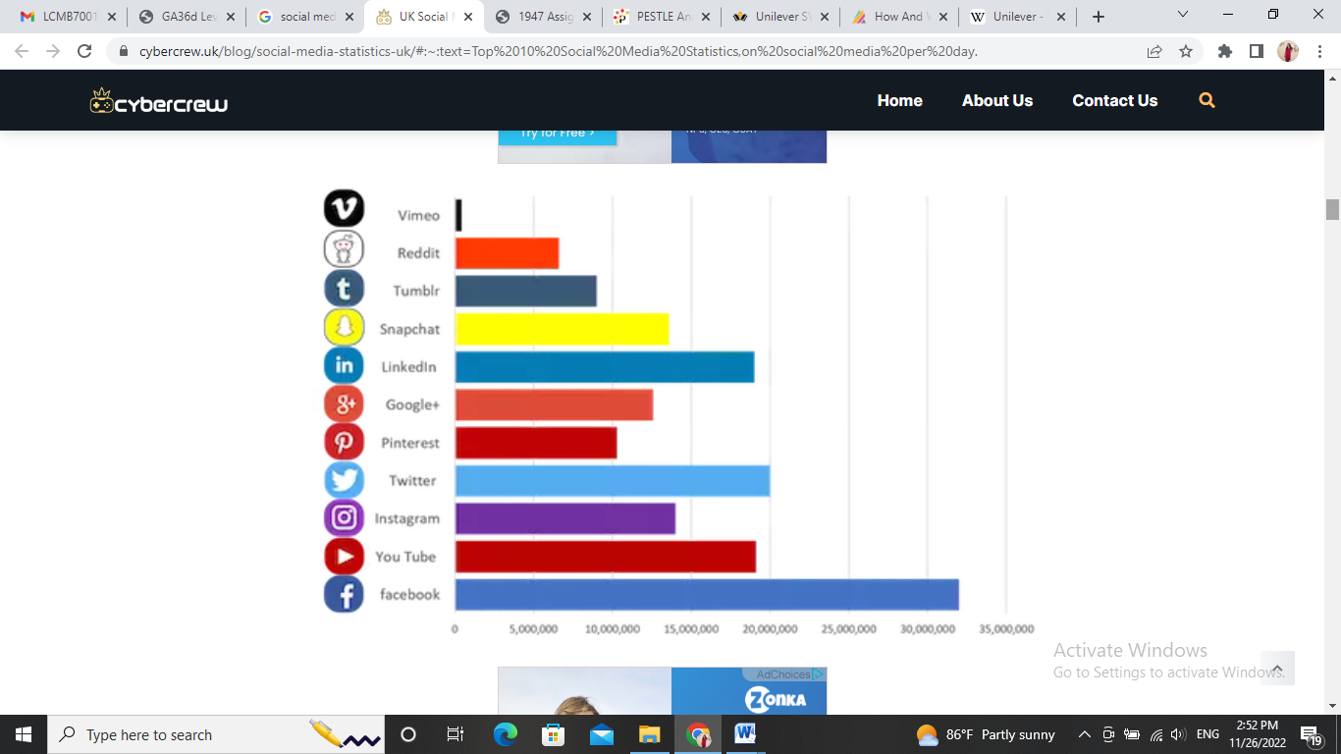
Figure 4: Technology use in the UK
(Source: Yadav, 2022)
Yardley London's YouTube has 1.49K subscribers, 199K Facebook followers, and 19K Instagram followers.
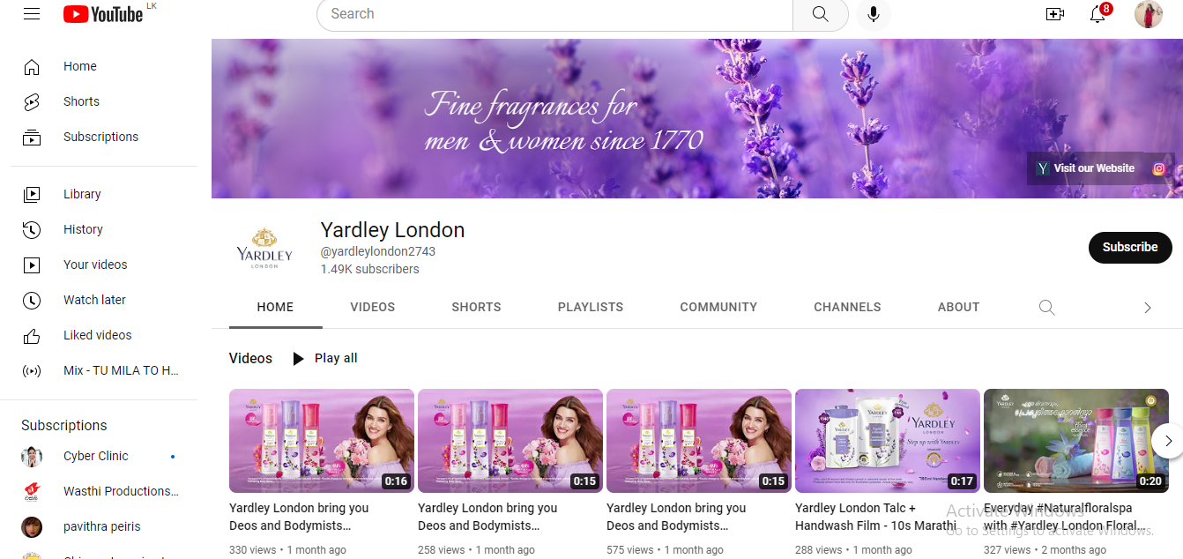
Figure 5: YouTube of Yardley London
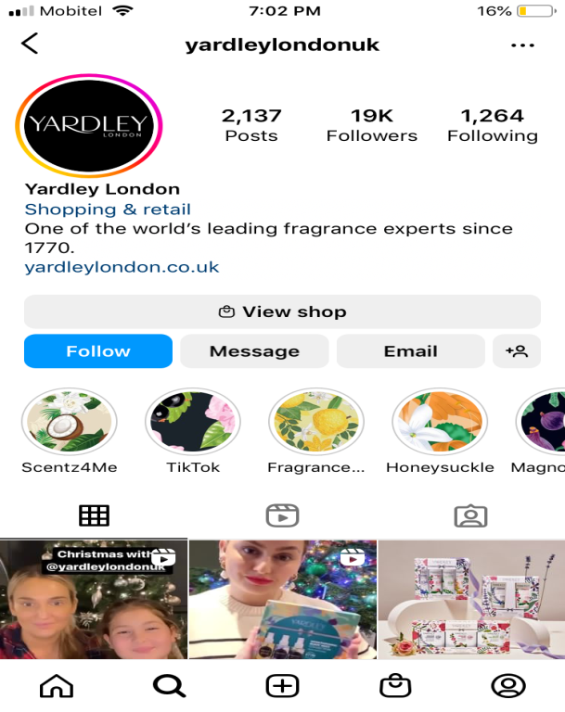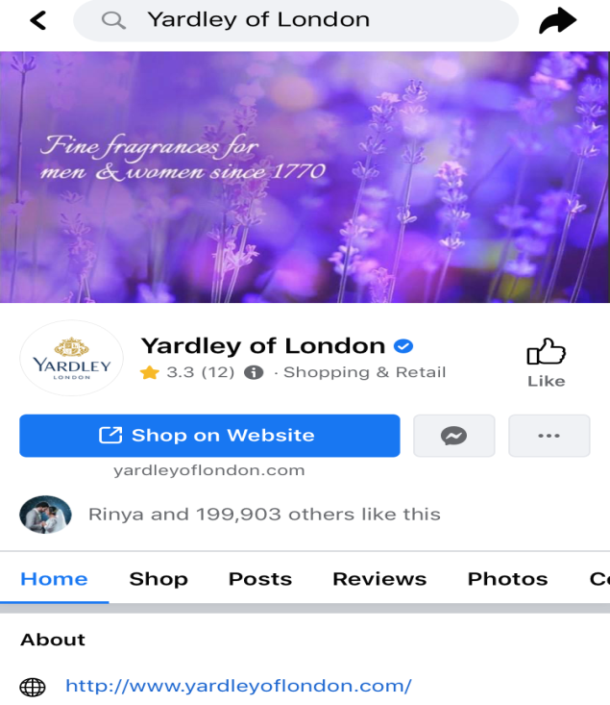
Figure 6: Instagram of Yardley Figure 7: Facebook of Yardley

Environmental Factors
To create environmental awareness, the newspapers, government, local councils, charities, and many others have taken a variety of initiatives. Yardley mostly uses organic products to manufacture perfume, cosmetics, and other products (Shaw, 2022). Sustainable and renewable resources are used by Yardley. The most pressing local concerns are flooding and air pollution.

Legal factors
The Employment Act 1996 protects the Rights of employees through Maternity and paternity leave, minimum wage, holiday pay, sick pay, etc. The Equality Act 2010 protects a person from any discrimination. Yardley is subject to the following terms and conditions and of the laws of England and Wales.

Porters 5 Forces model
To identify the environmental competition, Porter's Five Forces Framework is used as an analysis method which contains five forces as follows. The competitive position and strength of a business organization can be identified through this model.

Competitive Rivalry
There are nearly 714 registered retailers in the UK. Yardley London's competitors are HAKA, DECLEOR, Cadiveu, L'artisan Perfumer, Alphy & Becs, Prosody London Ltd, Arran Aromatics Ltd, and Scented Guru (Craft.co, 2022). Mainly due to low switching costs, Yardley London experiences tough competition which means there is a higher possibility of switching from one firm to another. Therefore, a high-priority force is a competitive rivalry in the company’s industrial environment.

Buyers’ bargaining power
Fragrance and cosmetic quality are highly taken into consideration by the consumers when compared to the Asian continent. As quality matters for the customer, the companies have to maintain the standard quality (Windsor & Berkshire, 2022). Mainly due to low switching costs, the consumers can look for other quality products hence buyers' bargaining power is also high. The people can be aware of the product details using the different platform through internet hence their information knowledge is higher (Windsor, 2022). The decision-making of a customer depends on the available details as well. But buyers’ purchasing power is reduced with inflation.

Suppliers’ bargaining power
Over 30 years of industry, the numbers of suppliers increased such as A&O, UK COSMETICS LTD, WS WHOLE SALES, TLCWHOLESALE, and SHAMA PHARMA LTD (Yardley Inserts, 2022). Through 848 potential providers in the raw material for fragrances, cosmetics, cosmetic raw materials, scented oil, and essences manufacturers (Yardley Inserts, 2022). The bargaining power of suppliers is high as 100% of the products are manufactured in the UK itself (Yardley London, 2022). But the UK can get raw material suppliers across the globe at low price levels. Wipro was owned by Yardley which has been known as an Indian multinational conglomerate since 2009 that emphasizes raw material suppliers can be get from India as well.

The threat of Substitutes
In the consumer goods industry, Yardley Company’s strength can be reduced by Substitutes. The consumers are enabled by low switching costs to use substitutes easily for products of Yardley (Yardley London, 2022). British people are likely to purchase branded perfume due to health concerns. Therefore, it is needed to have good quality products. When compared to Asian country people, the British people are not likely to use Ayurvedic products as they highly rely on branded products. Readily available markets are not available in the UK hence threat of substitutes is low in the UK.

The threat of New Entrants
In the consumer goods market, Yardley competes only with well-established firms that create a weak force of the threat of new entrants against Yardley. The advantage of high economies of scale is taken by Yardley which supports competitive pricing and high organizational efficiencies (Yardley London, 2022). As British people have concerns about branded products, new entrants cannot exit the market. Therefore, the threat of new entrance has a lower concern in the UK regarding Yardley.

SWOT analysis
For the purpose of helping an organization or a person identify Weaknesses, Strengths, Threats, and Opportunities related to project planning or business competition. SWOT analysis is considered a strategic management technique and strategic planning that is more of a situational analysis or situational assessment. To devise a successful strategy for the future, SWOT Analysis does the best now.

Strengths
Yardley London is considered a famous brand throughout the world that consists of quality soaps, fragrances, etc. Over 1,000 cosmetic lines are exported to 130 countries by Yardley (Bennett, 2022). The company has a wider and diversified range of products which makes a unique positioning toward changing consumer preferences in the world. With consumer preferences, Research and Development initiatives are widely funded in line to bring the market innovation and cutting-edge products (yardleylondon.co.uk, 2022). Over its top competitors HAKA, DECLEOR, Cadiveu, L'artisan Parfumeur, Alphy & Becs, Prosody London Ltd, Arran Aromatics Ltd, and Scented Guru, there is a separate and important competitive advantage in distribution channels being flexible in pricing (yardleylondon.co.uk, 2022). Over 24 million inserts in stock ready for immediate shipment are offered by the Company. Since 1946, Yardley Inserts LLC is known as a US-based manufacturer which has threaded and produced metal insert fasteners (Bennett, 2022). At Stratford, Manufacturing operations were built there and were also updated as a new research laboratory in 1950.

Weaknesses
Yardley London doesn’t provide adequate moisture to very dry skin. In addition, Yardley products are not rare and the competitors can easily follow and imitate the same products even though Yardley is branded and has existed for years (Bennett, 2022). In terms of fragrance, there are fewer verities as it is widely limited to floral. Its fragrance doesn't last a long time. Another weakness is the price is on the steeper side.

Opportunity
By combining perfumes with other products including Deodorant, and Talc, Yardley has opportunities to promote more to the young rural consumers. At a cheaper price, ready availability in the market is planning to grow with offers (Shaw, 2022). There are fewer varieties in the present market but that is planned to improve by using artificial intelligence, because, a new variation of floral fragrance can be adopted (Shaw, 2022). Yardley can engage in corporate social responsibility by providing beauty parlours and training centres increasing professionals. A positive brand image can be built in rural and semi-rural areas.

Threats
The competition in the growing market is increasing day by day. HAKA, DECLEOR, Cadiveu, L'artisan Parfumeur, Alphy & Becs, Prosody London Ltd, Arran Aromatics Ltd, and Scented Guru are the main competitors of Yardley (Shaw, 2022).

Marketing mix strategies
The marketing mix or 4Ps emphasizes a combination of business strategies mainly to capture the target market. A marketing mix is maintained by Yardley to address challenges in the global competition and market as a leading company in the Personal care industry (Skool Team, 2017).
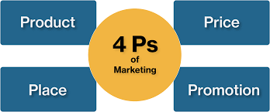
Figure 8: 4Ps of the marketing mix
(Source: Shaw, 2022)

Product
Yardley has a wide range of beauty products and amazing perfumes with a variety of body and bath skin care, luxuries, & hair care products. Yardley's business in the UK is acquired by Wipro Consumer Care. In 2005, Lorna mead Group acquired Yardley from Procter & Gamble (P&G) (Skool Team, 2017). Yardley brand is a premium brand with the products categorized under three main categories. Many natural fragrances are available such as Rose, Lavender, Lily, Bluebell, April Violets, Freesia, Dahlia, Daisy, Kiri, Jade, Polaire, Ink, Hermina, Citrus Wood, Rhodium, etc. Yardley’s signature scent is English Lavender (Skool Team, 2017).

Distribution
In different countries in the Middle East, Asia, Australia, the USA, Europe, and parts of Africa, Yardley is considered a global brand. In Yardley, KB Transport Solutions Ltd facilitates distribution services and warehouse storage (BUSH, 2016). Flexible, fast, and efficient palletized goods are delivered by the company. In Marston Green, Castle Brom & Sheldon, Yardley, Leaflet distribution offered Over 20 years of experience. Yardley’s product development-intensive growth strategy and generic strategy are significant (BUSH, 2016).

Promotion
Social media, television adverts, and print media adverts also play a significant role in promoting brands and products. Yardley London YouTube has 1.49K subscribers, 199K Facebook followers, and 19K Instagram followers. Yardley spends on its promotion with gold colour logo designing which signifies superiority, royalty, and luxury. Popular celebrities for their product endorsements are used by the brand (BUSH, 2016).

Price
There is no issue with the quality of raw materials by maintaining their products that are of high quality. In the middle and premium segments, the Yardley brand is targeted. For the products, the price charged is also higher than for other brands (Yardley London, 2022). To justify the standards and qualities of its Eau de Toilette, the premium price is charged.

Recommendation
It would be better if more raw materials can be founded in different parts of the world. It is needed to have an important concern on growing competitors because the outer world is manufacturing more similar products to target other countries of operation. It would be better if the perfume’s fragrance can be lasting longer than 8 hours. The author recommends taking raw materials at low cost from foreign countries to reduce company costs. Setting prices according to the region is important that helps in managing costs as well.

Conclusion
Under the fragrances, cosmetics, and related toiletries categories, Yardley of London is considered an international brand that sells different types of products holding two royal warrants in the United Kingdom. In fragrances, cosmetics, and related toiletry products, Yardley is a British personal care brand is one of the oldest companies in the world.

References
A. A. Shaw. PESTLE Analysis of UK. https://www.marketingtutor.net/pestle-analysis-of-uk/
Craft.co. 2022. Craft. https://craft.co/yardley-london-ltd/competitors
J. Bennett. 2022. Cosmetic and Skin. https://www.cosmeticsandskin.com/companies/yardley-1945.php
J. David. 2022. HowandWhat. https://howandwhat.net/pestel-analysis-uk/#:~:text=PESTEL%20analysis%20is%20a%20very,%2C%20Scotland%2C%20and%20Northern%20Ireland.
Portes, J., 2022. Immigration and the UK economy after Brexit. Oxford Review of Economic Policy, 38(1), pp.82-96.
PostAdmin. 2020. https://assignmenttutoronline.com/blog/analysing-the-marketing-plan-of-yardley-london/
Skool Team. 2017. Yardley Marketing Strategy & Marketing Mix. https://www.mbaskool.com/marketing-mix/products/17341-yardley.html
Statista. 2022. Fragrances - United Kingdom. https://www.statista.com/outlook/cmo/beauty-personal-care/fragrances/united-kingdom
T. BUSH. 2016. https://pestleanalysis.com/pest-analysis-of-the-uk/
The Chartered Institute of Personnel and Development. 2022. CIPD. https://www.cipd.co.uk/knowledge/strategy/organisational-development/pestle-analysis-factsheet#gref
Windsor and Berkshire. 2022. Yardley London. https://pipecandy.com/companies/yardley-london-ltd
Yardley Inserts. 2022. https://www.yardleyinserts.com/
Yardley London. 2022. https://yardleylondon.co.uk/
yardleylondon.co.uk. 2022. https://www.countryandtownhouse.com/brands-guide/yardley-london/

