Student name: Sharif Fathi
Module: Enterprise & Innovation Group Project
Module code: ACDA5003
Lecturer: James Williams
Assignment Title: EIGP 2 - Individual Report.

Table of Contents:
Pages | Numbers
‘Introduction’ section: | 2
Ideation | 3,4,5,6
Development (All*): | 7,8,9,10
Tech Start-Up: | 10, 11, 12
The Market and Competitors: | 12
Appendix: CPD Review: | 12
References | 13

‘Introduction’ section:
It has been asked to write a report about the new product business innovation plan. Our team will be covering the sections and tasks that we have been asked to do. Each one of us will be submitting their individual contribution and this report we will be talking about idea of this new product that we are building.
In this report we will be discussing and describing the design such the colours that we used for the product and the different layout design that we used through the software. One of the main things that will be focusing in this report is the requirements and how our product is different from others on the market.

We will be taking about the development of the prototype and there will be screenshots and text that describes the implementation process.
I will be talking about the trading name, legal classification and what each team members roles it is such as the things that they done during the development. We will be analysing the industry including relevant statistics. We need to find out if there is a market for our product?
we will be answering these questions in the report and the questions that we need to find out is such as finding who our competitors are, is there similar product and their price.

Ideation:
This new product that was developed by the group is car rental service, but this car rental services is not like the other rental services that is in the market. Our rental service is a third party service that invites car owners to provide us cars and we will provide the customers that will rent the cars from them through our third party service, we will take care of all the legal papers regarding car insurance, payments.

The design of the product is very simple and as you can see the it also has responsive layout. This website It allows the customer to see all the cars that is available for rent and if the car is not available, then it will not be on the home page.
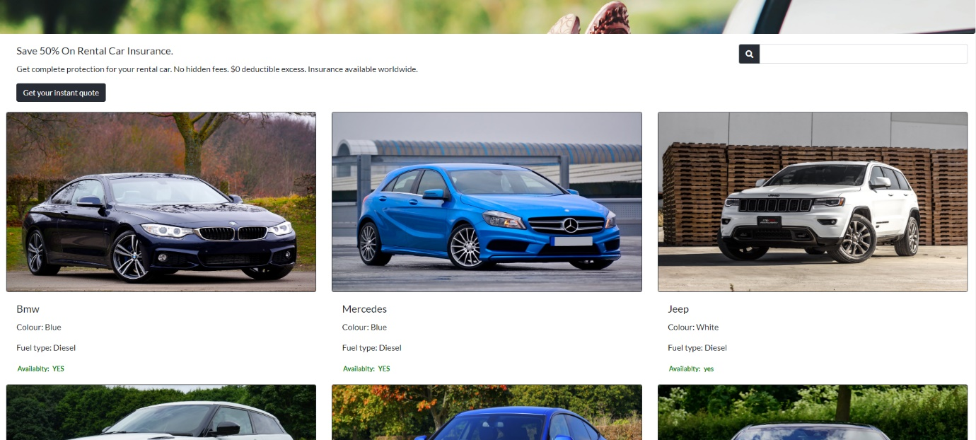

The customer can click on the car of their choice, but they I must be logged in, in order to rent the car, so the customer can leave the payment details.
Customers can see the comments from other customers, the price and more information about the car that they want rent. The customer can rent the car by leaving information such as the how long they want to keep the car and when they want to pick up.
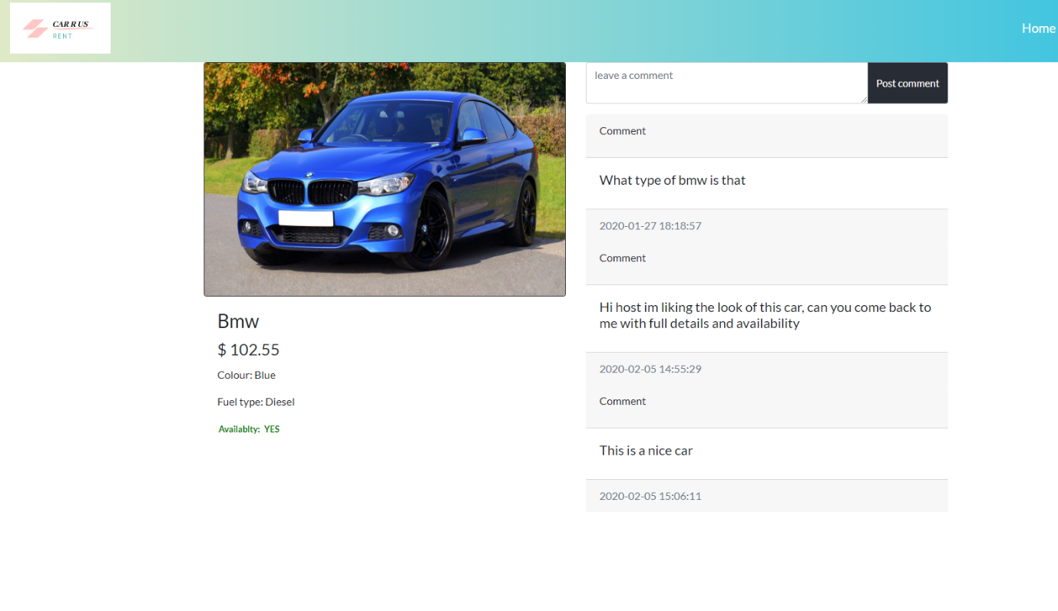

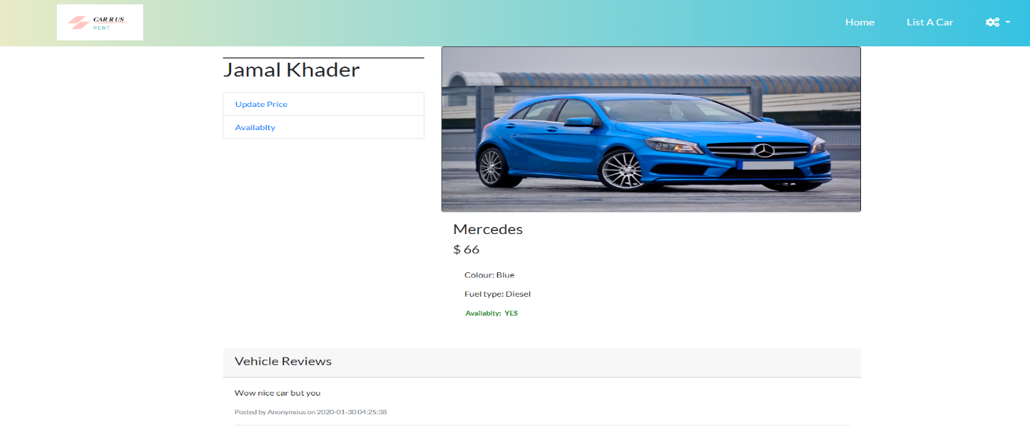
The owner has to login in order to use the website, after the owner logs in, they will be taken to this page, there is screen shot bellow.

The car owner can update the price and they can choose the price they like to rent their own car.
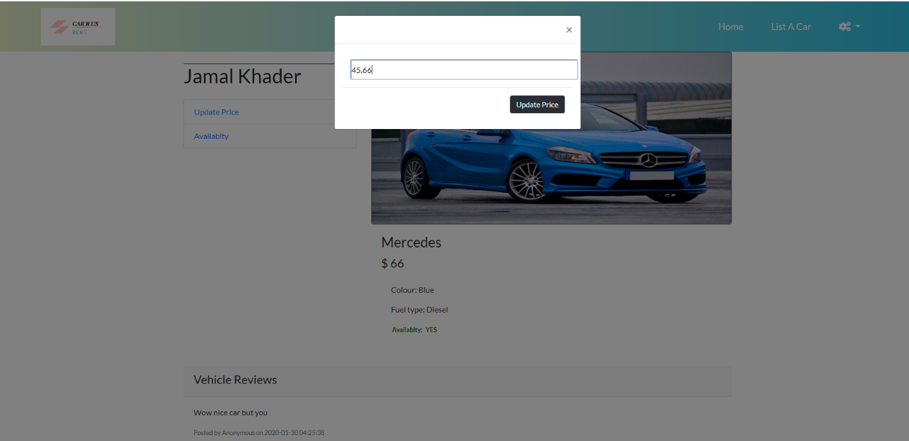
When the owners want to take their own car from the site, they need to use this form bellow and choose (yes or no).

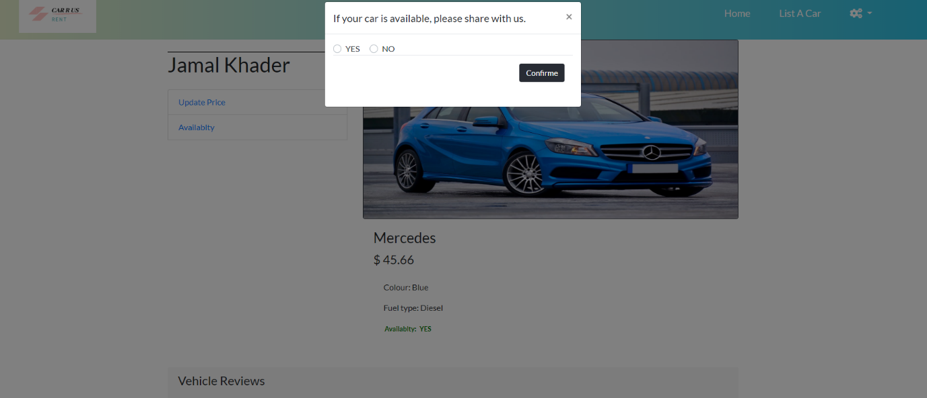

The website allows the user to list their own car by just filling this form bellow and that data will be going to the database.
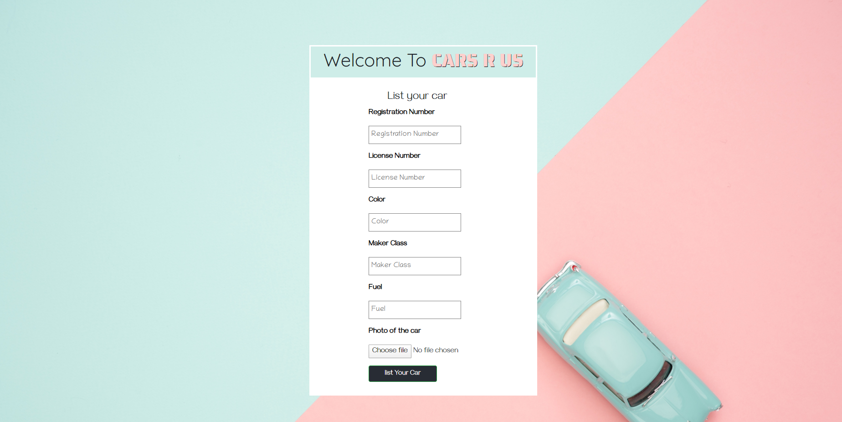

There are a lot of car rental services on the market at moment, but these other services they usually focus on people that coming to the country for holiday and they own the cars that they renting to the customers.

Our third-party services will change the idea of owning a car, because there are millions of people who own cars, those cars are just parked in front of their houses. Our software allows the car owners to share out their cars with other who don’t own cars.
This photo is from a website called autoevolution [1]

Development (All*):
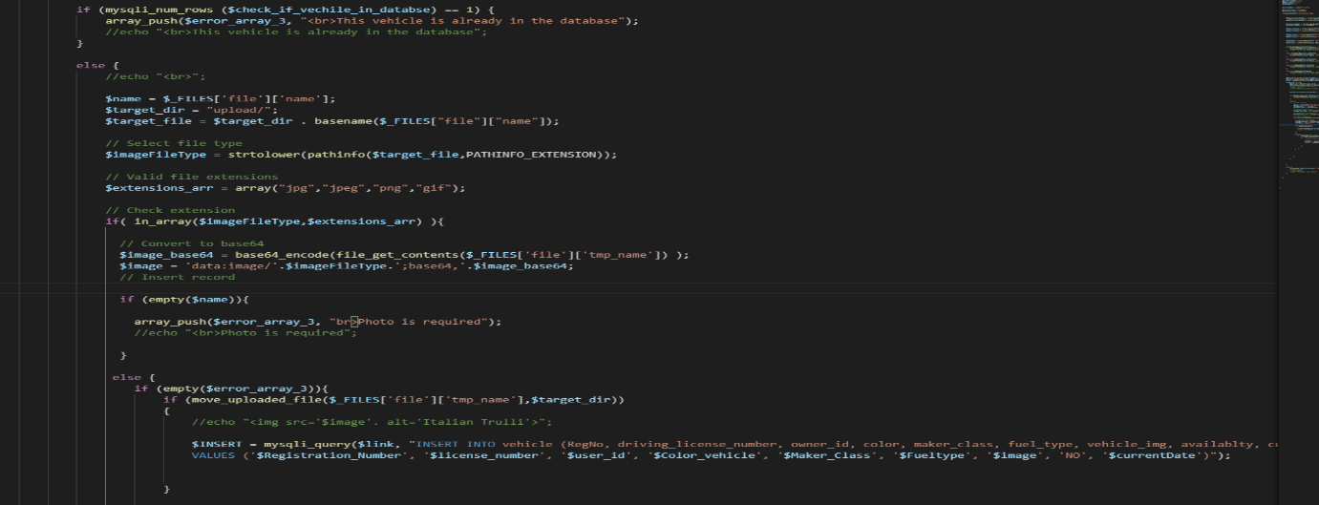
When the car owners list their cars, by filling the form that I talked about. Bellow there is a screenshot and that screenshot is the code that takes the user input such as Registration Number, basically all the information about the car that they want list. That data will go to the database.

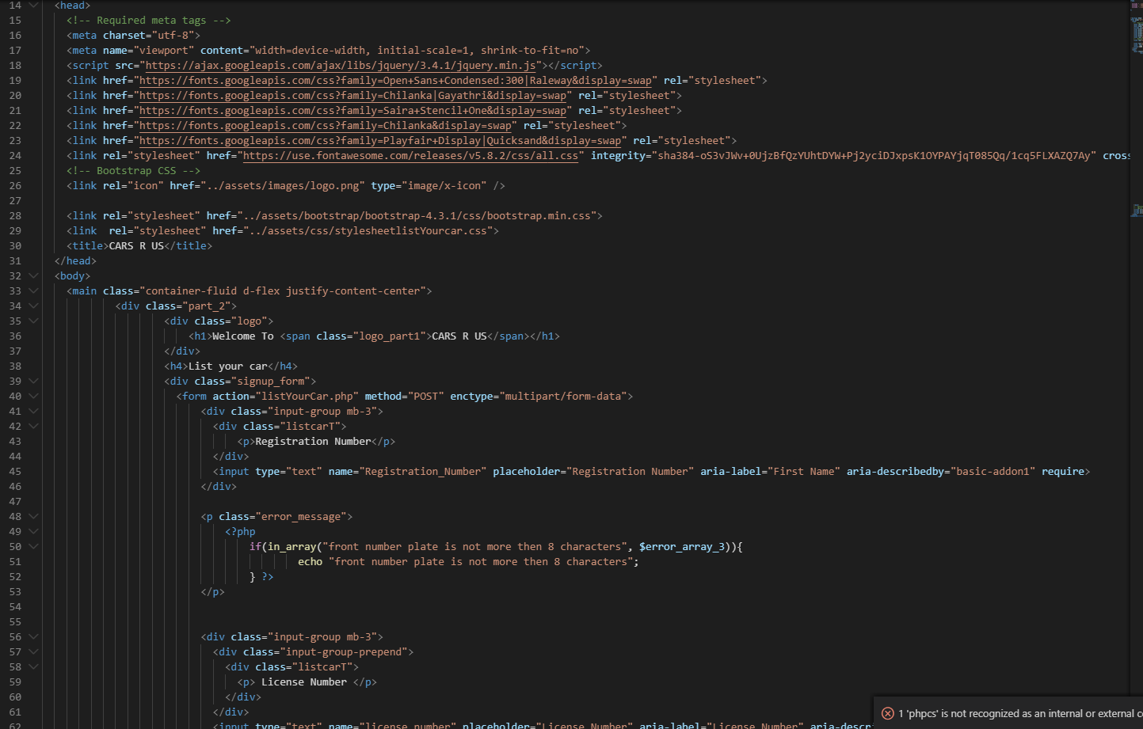
This is the frontend code, or everything you see this is the code that allows you to see the form.

Authentication is very important to our software. Our software can recognise when the user logs in to the software. But before logging, the user must have an account and if the user does not have an account, they must create new account.

So, our software has log in and sign up forms and customers have their own log in / sign up forms. The owners also have their own log in / sign up forms which allows them to access the software.

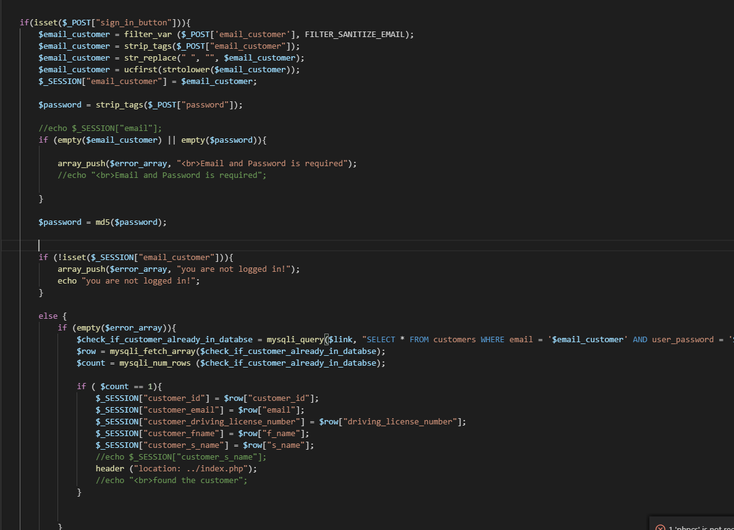
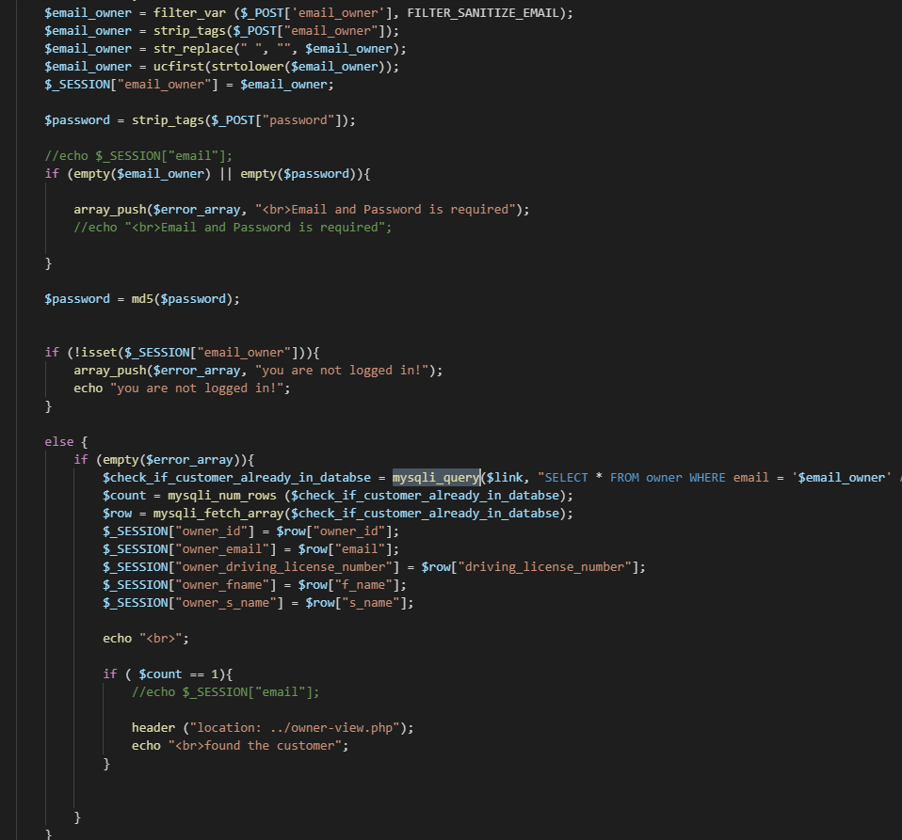
Bellow, there is the code that allows the user to log in and takes them to the home page.
The customers can leave comments and their comments can be feedback, that feedback can be positive or negative. as agency we can then think about how we are going to make the customers happy.
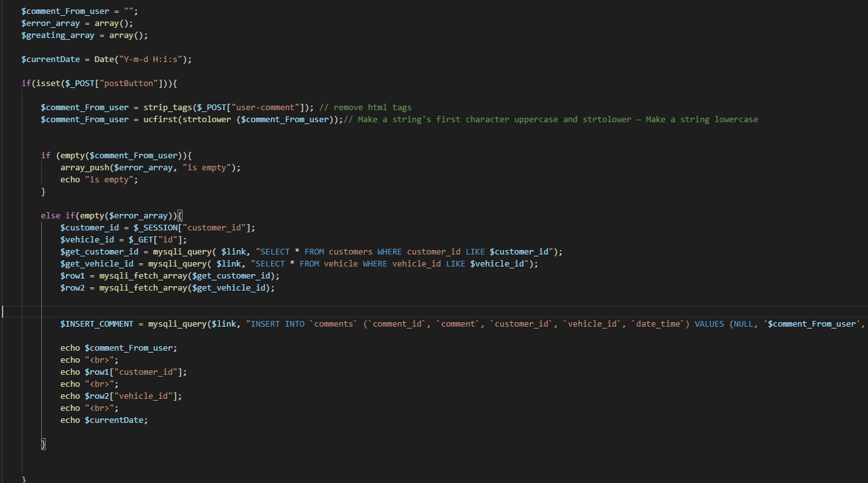
Here is the code that takes the comments and sends them to the database.

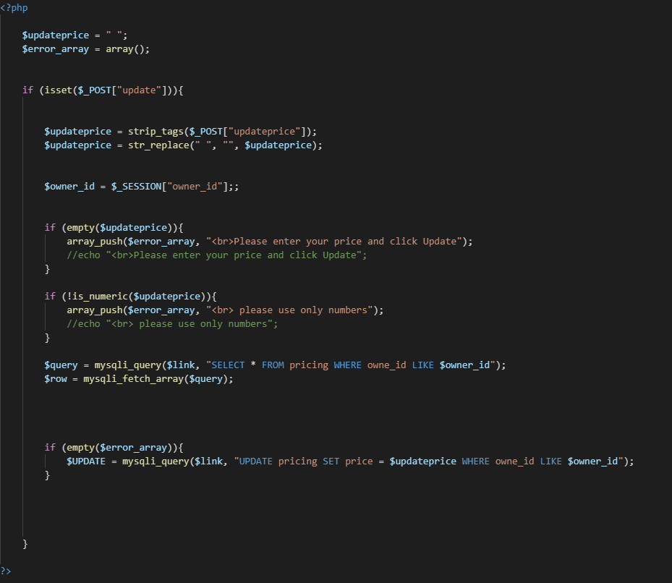
We allowed the car owners to update the price that they want to rent their own car and here is the code that allows them to update the price.
This code allows the owners to make their cars availably when they not using their cars and it also makes it unavailable if they want to take their cars off the site.
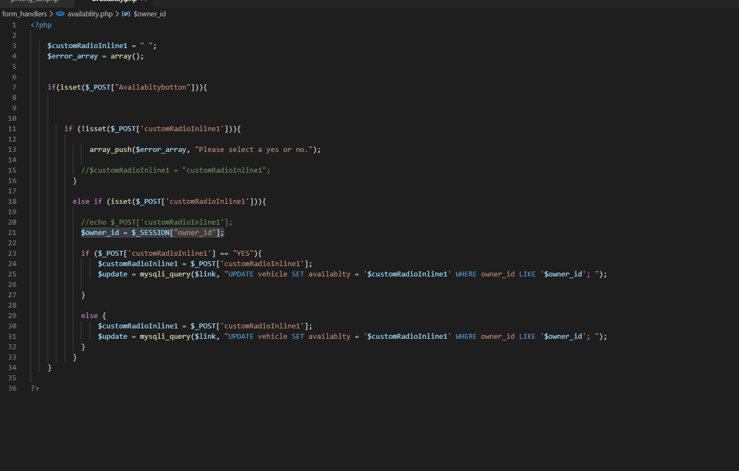

Tech Start-Up:
Our third-party service will need a trading name or trademark and we have talked about our trademark, it was hard choosing company name but after a lot of thinking, we have decided to call it CAR R US.

We developed a software that makes people life easier and this software is developed by me (Fathi) and (Abdi). Our third-party software will make money for the car’s owners, because they could just share with their cars with others that do not own cars.

My role in this project is to design the database and make sure that the database is well organised. After when I designed the logo, the second thing that I designed was the database and my team they were keep giving me feedback.
Here is a screenshot of the database, designed using Visio.
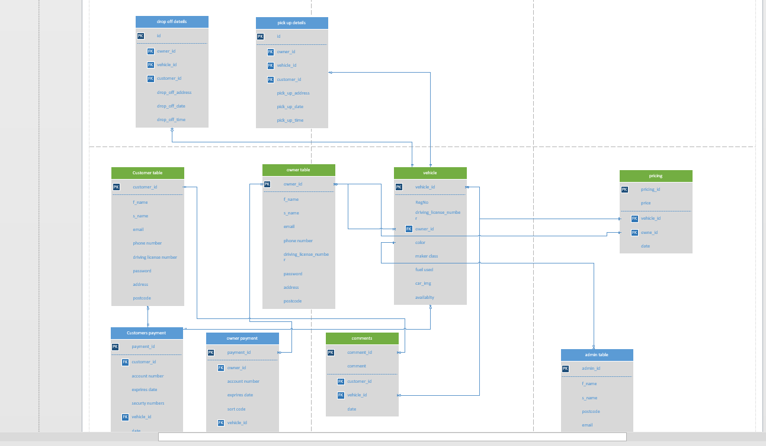

Here is our logo or trademark.


Before writing the frontend code, I had to design the pages because the website must look good and responsive choosing the right colours, fonts and layout.
My main job was to write the backend because after the frontend design, it was Abdi is job to code the frontend and my job was just to connect the database to the frontend. but is not just that easy, so I hard to debug the html CSS and add some JavaScript code that makes the website friendly for users.
Our mission is to make something that could make money and making our customers and the owners happy, so the website can have a lot of users because our product is the car owners, we must make sure that we keep them happy.

The Market and Competitors:
According to website called Mordor Intelligence [1], they say that car rental industry has gained popularity across the globe, owing online platforms that allows customer to book and rise in tourism around the world has help the car rental market.
North America & Europe are at first line of market and all the Asian countries are following. but America is leading the car rental market, owing car rental services and having customers that using their services and tourists in the country. boosts the usage of car rental in market.
some of the biggest companies that leading the market are:
- Avis Budget Group Inc.
- Sixt
- Hertz,
- Enterprise Holdings Inc.
- Europcar Group
When it comes to Europe, the competitor that we think we could face is Europcar Group, they allow customers to plan when they want pick up the car and went to return the car. some of their prices starts from £16 per day.
Appendix: CPD Review:
I have developed a lot of technical and employability skills, the main one that I developed is coding because is very important in the software engineering industry.
I have developed new skills such as teamwork, since software developers often work in teams and this helped me because my debugging skills improved.
The networking events helped me a lot, because they showed me what it takes to build a product that can make money.

References

[1] | autoevolution, [Online]. Available: https://s1.cdn.autoevolution.com/images/news/car-sharing-city-motoring-of-the-third-degree-9255_1.jpg. [Accessed 17 3 2020].
[2] | mordorintelligence, "mordorintelligence," [Online]. Available: https://www.mordorintelligence.com/industry-reports/car-rental-market. [Accessed 15 3 2020].

