This article can be found in the German history and religion section of an encyclopaedia such as Britannica and Wikipedia. Specifically found by searching the key words Concentration camp and World War Two. In this entry, Sachsenhausen concentration camp will be discussed with reference specifically to the history and its function as a living memorial to both the Soviet and Nazi occupation and use of the camp.
The Sachsenhausen camp was opened on the 12th of July 1936 on the edge of Orangeburg twenty-one miles north west of Berlin and is believed to be the second one ever built. (1) Originally, the camp was built in order to house political opponents such as journalists and communists to the Nazi regime. The camp opened whilst still being in the stages of construction with only twenty-one inmates who were given the task of completing the building work of the camp, whilst other prisoners began to arrive. Additionally, as the camp grew it began to be the place where many of the Schutzstaffel (ss) (2)
Camp layout.
Sachsenhausen concentration camp when completed included fifty barracks and was encased by an eight-foot electrified wall which when studies from above can be seen to represent an equilateral triangle which contained a semi-circle roll call area by the entrance to the main gate. The barracks could be seen to be lying behind the area in order to allow the machine gun -similar those which were used in World War one -to dominate the camp and instil fear in to the hearts of those who were prisoners of the camp.(3)
However, as the camp grew it was seen as necessary for more guard towers to be added to the camp in order to keep fear in the prisoner’s hearts. An infirmary could be seen in the southern angle of the camp and a camp prison in the eastern, whilst in the centre of the am a laundry and kitchen can be seen. (3)
Kristallnacht.
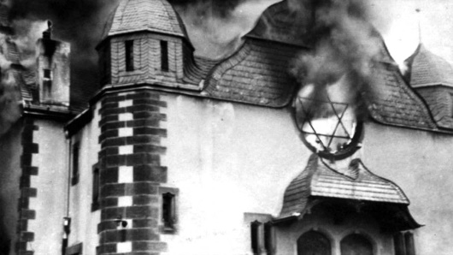
The biggest influx of inmates to the camp reportedly took place after the events of Kristallnacht on the 9th of November 1983 on the orders of Henrich Himmler where approximately 1.800 Jews were imprisoned. 6000 of these were sent to Sachsenhausen and within seven days 450 of those had been killed. Previously to the events of Kristallnacht food rations in the camp were adequate, however as winter drew nearer the food rations became smaller and inmates began to starve. (3)
Fig 1. Kristallnacht
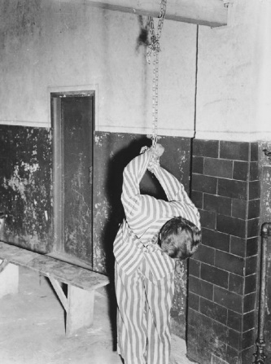
In the months following the events, many of the prisoners were permitted to leave the camp if they were able to procure a passage to emigration.(1) However, the camp soon became unable to hold the number of inmates being sent to them, therefore the camp was extended by the inclusion of a small rectangular section by the north east entrance to the camp outside of the perimeter walls. This section was later sectioned off in order to house special prisoners the regime wished to isolate. Today we know this to be the homosexuals who were believed to be sub human compared to the others in the camp. (4) In addition, it was recorded by some that this is where many of the torture techniques were established such as the Sachsenhausen salute and a technique which included tying a prisoner’s hands behind their back and then suspending them from the ceiling. This can be seen in figure 2 where the prisoners hands have been suspended by what appears to be a metal chain which in turn would dig in to the prisoner’s hands and cut off circulation. (4)
Fig 2 Torture techniques
Treatment of prisoners.
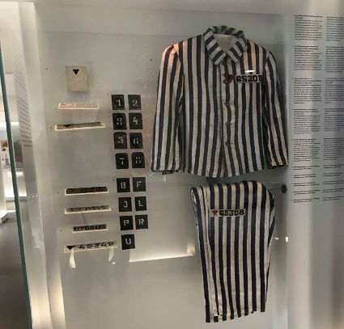
As previously mentioned, Sachsenhausen was seen as the example to all the other camps and its treatment of prisoners was no different. Each inmate had their own black and white striped uniform which adored his or her own prisoner number and a star. Each star was made of two triangles one white and the other of a significant colour depending on the reason they were at the camp. The red triangle was for communists and political prisoners, black for roma / gypsies, purple for Jehovah, green for common criminals and yellow for Jews. Red can be seen as the colour of the star adorning the trousers of the prisoner seen in figure 3, therefore it is reasonable to suggest that this person was either a political or communist figure. (5)
Fig. 3 Prisoner uniform
Many of the inmates were forced in to labour in this work camp especially with Heinkel an aircraft manufacturing company which used approximately six thousand of the inmates to develop the HE177. In addition, in 1938 the prisoners began to work in the worlds largest brickworks in preparation for Hitler’s dream of Germania. At the beginning of world war two the work ceased, however after the successful occupation of France in 1940 the work began again. (4)
Those who were forced to work in this particular work camp were named the “Punishment Commando” and were forced to march to and from the brickworks each day. However, 1941 a sub camp was built on the sight of the brick works. One information leaflet stated the camp was established for “the deliberate annihilation of certain prisoner’s groups. From July to September 1942, the systematically planned murders of some 180 to 200 homosexual prisoners were carried out in the Klinker satellite camp.” (6)
A third method of forced labour experienced by a vast majority of inmates at Sachsenhausen was the forced participation in Operation Bernard. This is reportedly believed that it was the largest recorded currency counterfeiting on record with over one billion in fake British notes. However, it is believed to this day that not all of the notes have been recovered. This operation was carried out with the aim of undermining the British and American economies in 1943. (7)
By 1944 Dr Wolfgang Wirth became involved with the politics of the camp particularly through his experiments with Sulfur Mustard. Around the time there had ben allegations of experimental drug testing. These were designed to be performance enhancing and durance boosting and consisted of a cocktail composed of drugs such as Cocaine and Oxycodone. Designed to be used for branches of the militia such as Luftwaffe and Wehrmacht these drugs were reportedly administered to prisoners of the camp whilst they tested out boots for the SS. However, there is very little evidence to support this claim, therefore it is impossible to determine its accuracy when considering the link to this particular camp. (8) Other more common medical experiments included castration, sterilization and the use of diseases such as hepatitis as well as HIV . Many died as a result of the experimentations, however those who survived post war suffered from numerous health issues. It is not known exactly how many of the prisoners were experimented upon, however it is believes that SS doctors had subjected over 100 prisoners in the camp to castration by the end of May 1941 (4)
Station z.
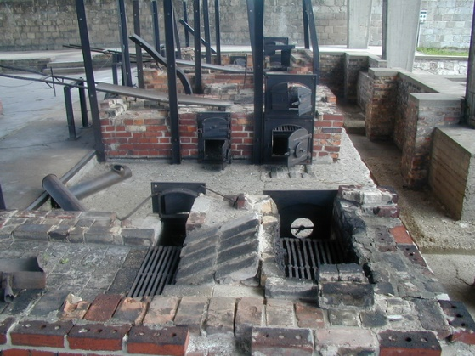
As the camp grew, new methods of killing some of the inmates began to arise. The recorded preferred method was by shooting. However, as the war effort intensified in Germany, more prisoners were sent to the camp, as a result on January 31st, 1942 inmates were forced to construct “Station z” in a portion of the industrial yard. This was built specifically for the extermination of some prisoners and on the 29th of May high ranking Nazi officials were invited to the sight to see its effectiveness. In order to do this ninety-six Jews were shot and their bodies placed in to furnaces which could hold up to eight people at a time. (9)
Its name was as recorded was intended to be comedic as the inmates had to enter the camp through watchtower A (The gate house) and would subsequently leave through station Z after being executed. (9)
In the following year a gas station was added to station Z and was intended to be used to “cleanse” the camp. However, its use was limited to special order only, therefore it is unknown exactly how many died by the use of this as the transport and death logs were either never recorded or destroyed during the evacuation. (9)
Fig. 4 Station Z
Liberation and forced evacuation.
By January 1945 it was recorded that the camp population had grown to approximately 65,00 prisoners. However with the advance of the red army during the spring of 1945 it was clear that Germany was going to lose the war, particularly after the United States joined the fight after the bombing of Pearl harbour in December 1941. The camp began preparations for the forced evacuation of the camp thus demanding 33,000 of the inmates embark on a North-east march. Prisoners were split in to groups of 400 and were intended to be placed on a ship which would then be sunk. However, as the march continued many fell and were unable to continue, therefore they were shot by SS soldiers to ensure their passing. As the march continued it was reported that many of the SS soldiers had fled along with some of the inmates who were able to escape to freedom. (4)
April 22nd 1945 is when the camp was liberated whilst containing 3000 inmates including 1400 women. Many of those who remained behind were to ill and starved to welcome the 47th unit of the red army and the 2nd Polish Infantry. However, many died after the liberation as they were still too malnourished and ill despite the medical attention received by the Allied Forces. (10)
Post World War Two.
By August of 1945 a Soviet camp names Special camp No.7 was moved inn to the facility of Sachsenhausen and held Nazi functionaries as well as political prisoners and inmates sentenced by the Soviet Military tribunal. By 1948 the camp had been re-named “Special camp one” and was one of the three biggest soviet camps in the Soviet occupied area until1950. (10)
By November 1947 all sixteen Nazi operatives were convicted for their crimes. Fourteen of which received a life sentence, whilst two others gained fifteen-year prison terms.
Its use as a memorial.
Planning for the use of Sachsenhausen as a memorial began in 1956 six years after the closing of the camp under soviet occupation and then officially opened in April 1961 with its first director being Christian Mahler a former inmate and senior police officer.
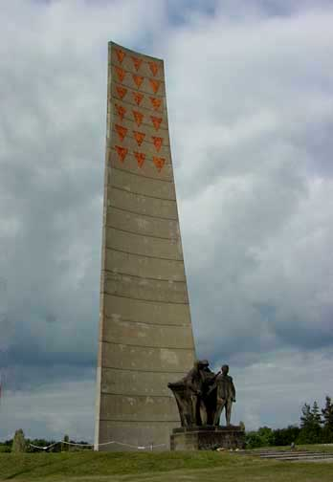
Much of the planning for the use of the camp involved the removal of a vast majority of the buildings and the construction of a statue in memorial now known as the Obelisk statue. This statue can be seen to hold eighteen red triangles representing those soviet prisoners which were held captive at the camp during world war two. This however is not the only memorial to those who suffered at the camp. (11)
In 2015 the camp was officially declared a memorial and museum with many of the buildings having been reconstructed such as the kitchens and gas chambers.
Fig 5
After the fall of the wall, the camp was entrusted to a fund who decided to open a museum on the sight, one of which can be seen in Guard Tower A and numerous others have been opened since in various areas around the camp. However, in 1990, mass graves were discovered on the camps sight linking to its soviet past. Therefore, a separate museum has since been opened to honour the soviet connections and use of the camp post world war two. In more recent years however, the camp came under attack from Neo-Nazi groups in 1992 but was the restored in 1997. Moreover, some of the damage caused by the attack has been left in order to serve as a reminder that the past cannot be forgotten and should not be repeated. (12)

Bibliography
Gas Chamber at Station Z Execution Site http://www.scrapbookpages.com/Sachsenhausen/ConcentrationCamp/GasChamber.html edn, ()
Gas Chamber at Station Z Execution Site http://www.scrapbookpages.com/Sachsenhausen/ConcentrationCamp/GasChamber.html edn, ()
Sachsenhausen, https://www.ushmm.org/wlc/en/article.php?ModuleId=10005538 edn, (100 Raoul Wallenberg Place, SW Washington, DC 20024-2126: United States Holocaust Memorial Museum, Washington, DC, )
Sachsenhausen (Oranienburg), https://www.jewishvirtuallibrary.org/history-and-overview-of-sachsenhausen-oranienburg-concentration-camp edn, (American-Israeli Cooperative Enterprise, 2018)
the World's Largest Brick Factory, http://www.scrapbookpages.com/Sachsenhausen/ConcentrationCamp/BrickFactory.html edn, (scrapbookpages.com, )
BIRGE AMONDSON, Visiting Sachsenhausen Concentration Camp, https://www.tripsavvy.com/sachsenhausen-concentration-camp-berlin-1519794 edn, (Tripsavvy, 2018)
Brandenburg Memorials Foundation, Breif History and Site Plan Schsenhausen Memorial and Museum, trans. by Richard Toovey (Brandenburg Memorial Foundation, 2017)
---'Sachsenhausen Memoial and Museum', in Sites of Remembrance 1933-1945, 5th edn (Germany: Die Beauftragte der Bundesregierung, 2016) 9 <www.orte-der-erinnerung.de>
Hugh B. Urban, New Age, Neopagan, and New Religious Movements: Alternative Spirituality in Contemporary America (California: California state press, 2013)
Jaron Verlag, 'Jewish Cemetries', in Culture, Religion, Daily Life Yesterday and Today, trans. by Bill Rebiger, , 2 vols (Berlin: Berlin Kompakt, 2014), pp. 88-89,90
NS Zwangsarbeit Dokumentationszentrum, Documentation Centre on Nzi Forced Labour, (Helga Lieser, Berlin: Der Beauftragte der Bundesregierung, 2013)
The Editors of Encyclopaedia Britannica, Sachsenhausen-Oranienburg, https://www.britannica.com/place/Sachsenhausen-concentration-camp-Germany edn, (Encyclopaedia Britannica, 2018)
United States Holocaust Memorial Museum, Washington, DC, Sachsenhausen: Conditions in the Camp, https://www.ushmm.org/wlc/en/article.php?ModuleId=10007775 edn, (United States Holocaust Memorial Museum, Washington, DC, )
---Sachsenhausen: Liberation and Postwar Trials, https://www.ushmm.org/wlc/en/article.php?ModuleId=10007776 edn, (United States Holocaust Memorial Museum, Washington, DC, )
Niven, Bill (2002). Facing the Nazi Past (1st ed.). Routledge. p. 11
Lebor, Adam; Boyes, Roger (2000). Surviving Hitler (1st ed.). Simon & Schuster. p. 230.
Florian Schmalz: Weapon research in Nazi Germany. The cooperation of the Kaiser Wilhelm companies, military and industry. Göttingen 2005, ISBN 3-89244-880-9.

