ACCA4023 Web Design written Assignment.

Ossian De’Ath
2520279
Computing
ACCA4023 Web Design.
22/10/2025

Table of Contents
Summary of the report. 3
Requirements. 3
Target Audience and Purpose. 3
Implementation and Validation. 4
Home Page. 4
Home Page Web Page. 4
Home Page Validation. 5
Ones to Watch Page. 6
Ones to Watch Page Web Page. 6
Ones to Watch Page Validation. 8
Fixtures Page. 10
Fixtures Page Web Page. 10
Fixtures Page Validation. 12
Team Information Page. 15
Team Information Page Web Page. 15
Team Information Page Validation. 16
Assessment.css Validation. 17
Evaluation. 18
General Evaluation: 18
Accessibility. [1] 18
SEO. [2] 18
Usability. [3] 18
Website Evaluation 19
Accessibility. [4] 19
Perceivability. 19
Operability and Understandable. 19
Robust. 20
SEO. [5] & [4] & [6] & [7] 20
Website Comparison. 20
Website 1 – Apple.com 21
Website 2 – Samsung.com 22
Conclusion. 22
References 23
Appendices 24
Assessment.css 24
Home_Page.html 41
Ones_to_Watch.html 44
Fixtures.html 48
Team_information.html 52

Summary of the report.
This report presents the design and development of my website which is focused on the 2026 Rugby Six Nations, this includes a team and player information. It outlines the designs I have used along with the processes used; structural decisions made and techniques implemented to meet certain criteria, based on things like Search engine optimisation and accessibility. The report will go in depth with the HTML and CSS code used, and validated, with the resolution, if the validation is showing errors, allowing me to stay in compliance with the WCAG 2.1 Criteria, which I use validation tools to confirm that my website is compliant. The report also evaluates key concepts such as, accessibility, usability, SEO, and more; it also compares two external websites using tools like the WAVE checker, and provides a critical assessment on both sites, identifying my preferred design, which is backed up by facts from WAVE.

Requirements.
I want the website to give information like where games will be played, which stadium belongs to which team, and highlight the success of each team in the tournament. This will educate the users on the history of the six nations and help them become engaged within future tournaments, therefor bringing more awareness to the game of rugby.

Target Audience and Purpose.
My Target audience would be people who are new to the world of rugby and want to learn more about big rugby sporting events, like the Six Nations, however, my actual audience could be anyone, someone with a lot of rugby knowledge or none at all. I have want my website to be accessible to all users as I want to spread awareness around the globe of rugby and the beauty of the game.

Implementation and Validation.

Home Page.

Home Page Web Page.
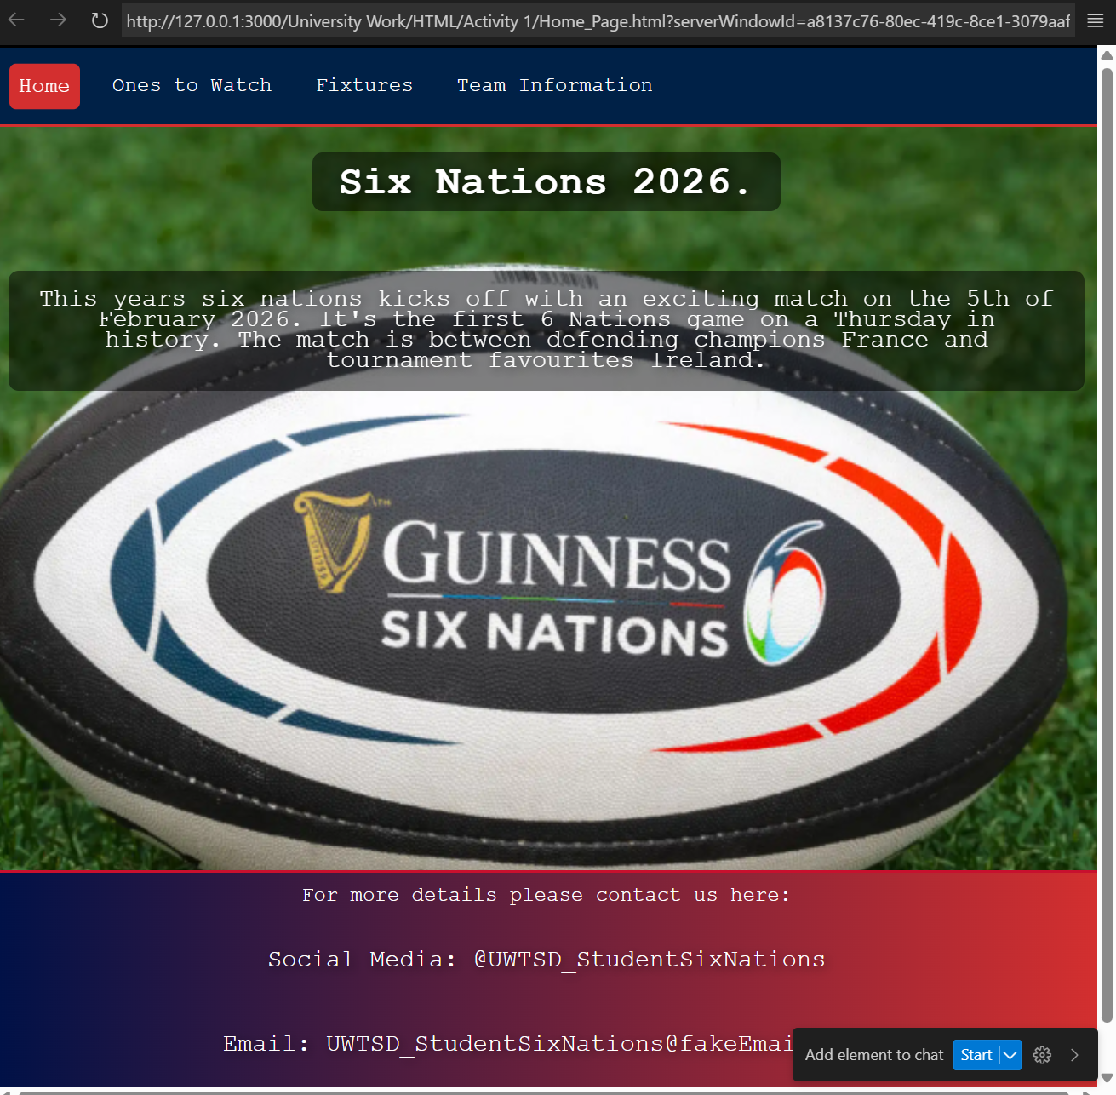
This is my home Page, Looking at this I have a background image with some text which talks about the website. It has the Navigation bar across the top which highlights red when you hover your mouse over it.

Home Page Validation.
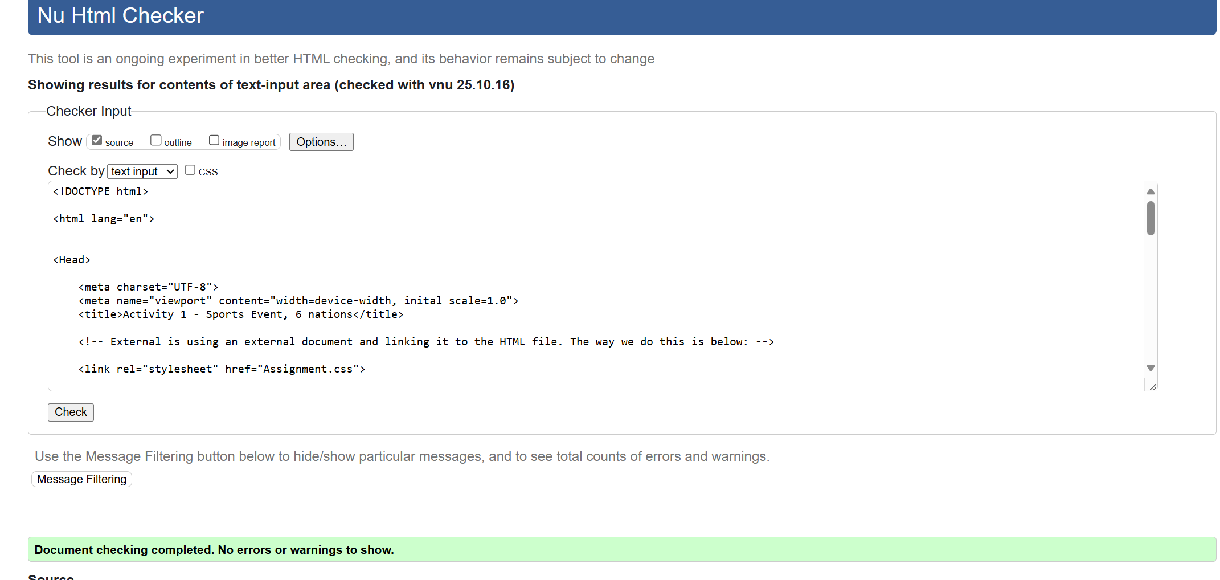

Ones to Watch Page.

Ones to Watch Page Web Page.
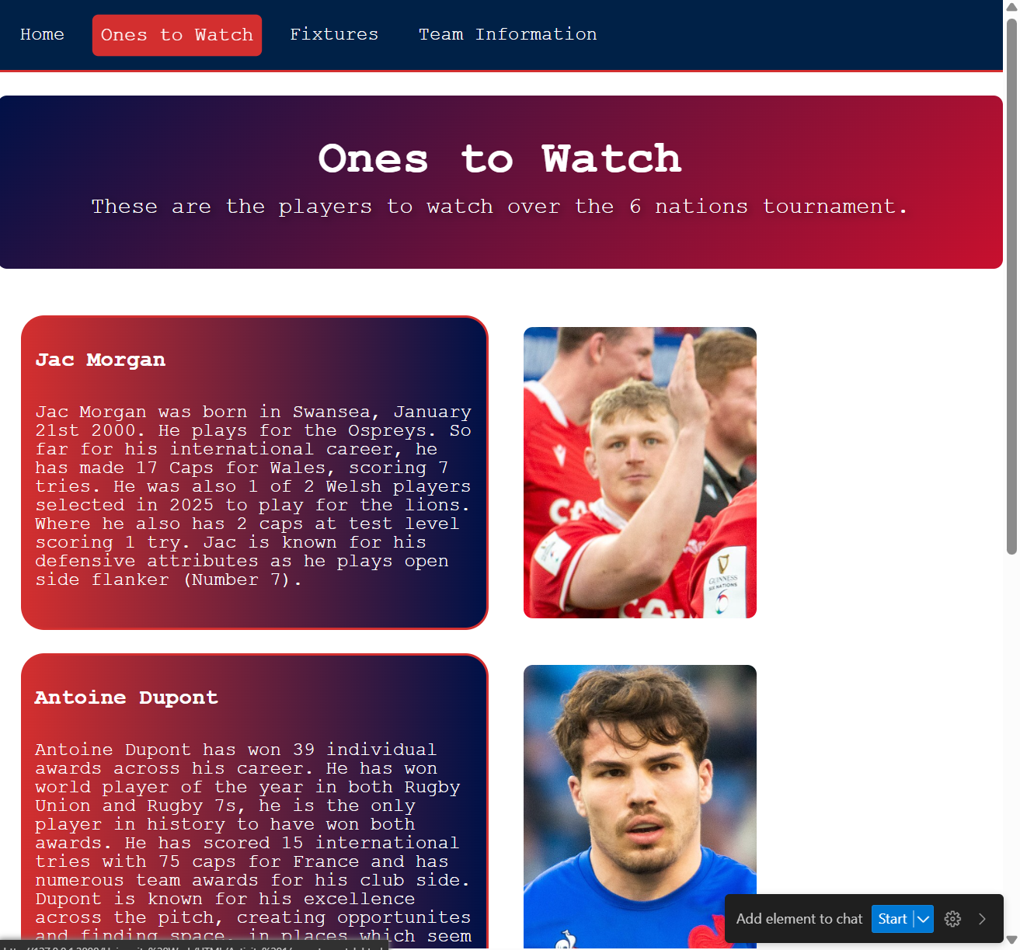
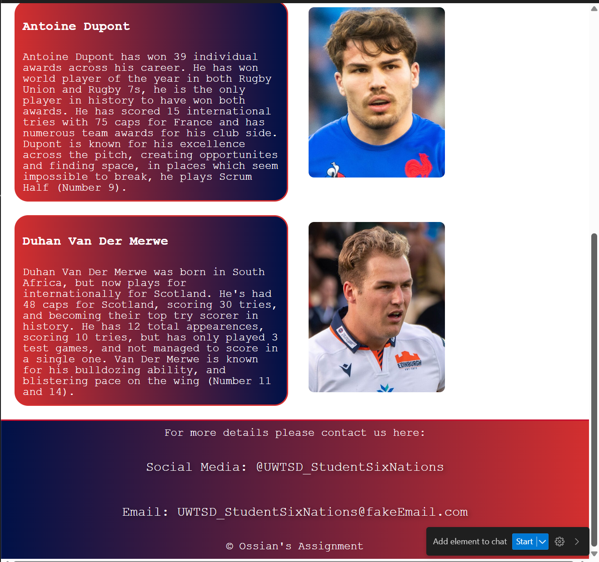
The above section also has the same navigation bar and style as the previous page. I have segmented the page into two columns. This is so I can have a column for text and information as seen on the left and images, or maps on the right.

Ones to Watch Page Validation.
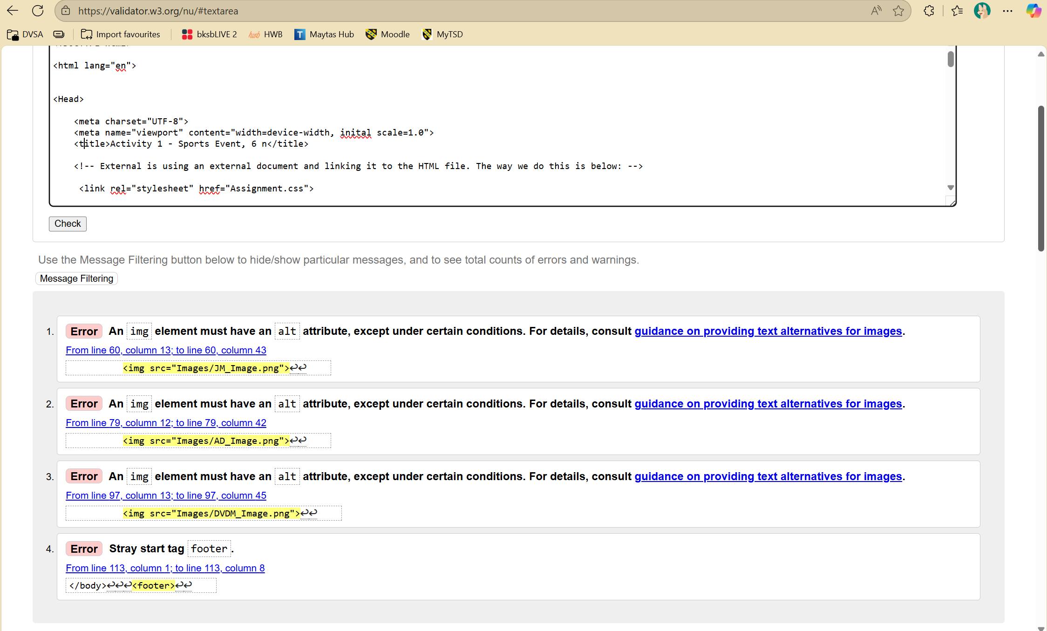
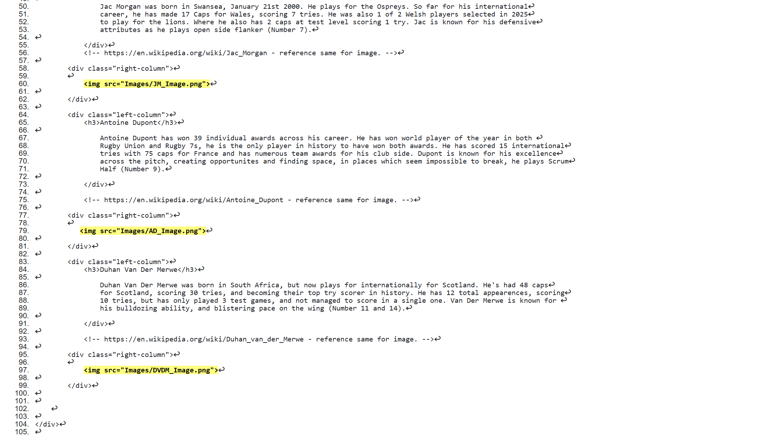
The html checker has highlighted 4 issues. I resolved this by putting the footer in the body, and adding the alt attribute to the img tag.
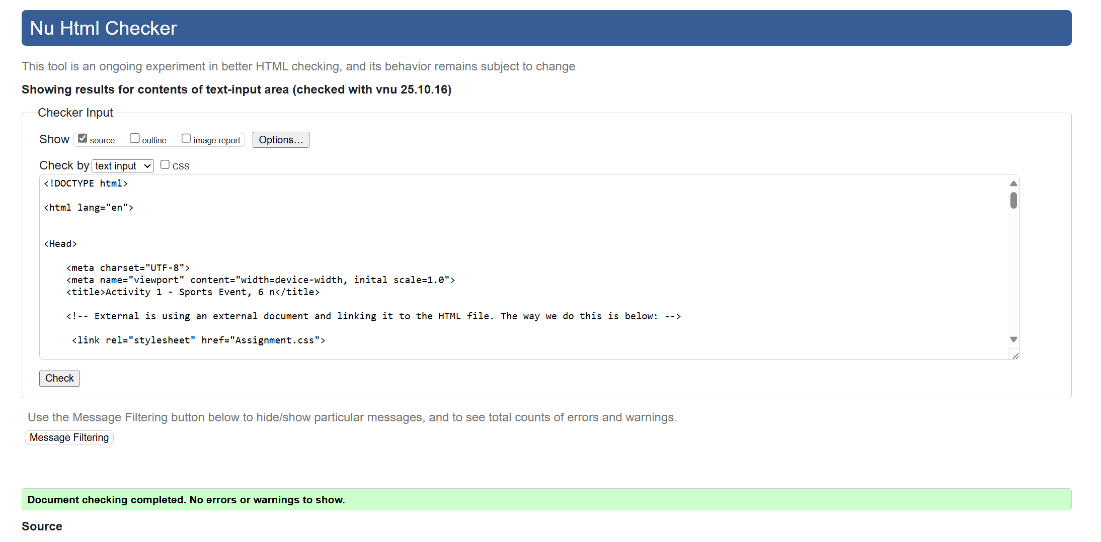
After making the adjustments I have cleared all errors within my HTML code.

Fixtures Page.

Fixtures Page Web Page.
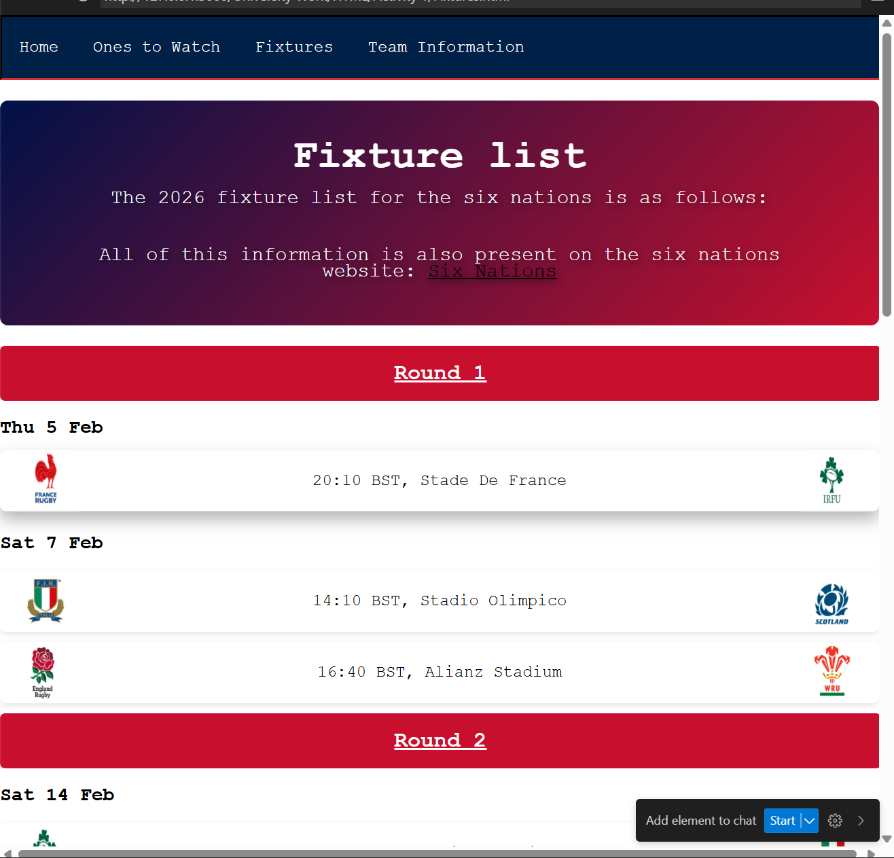
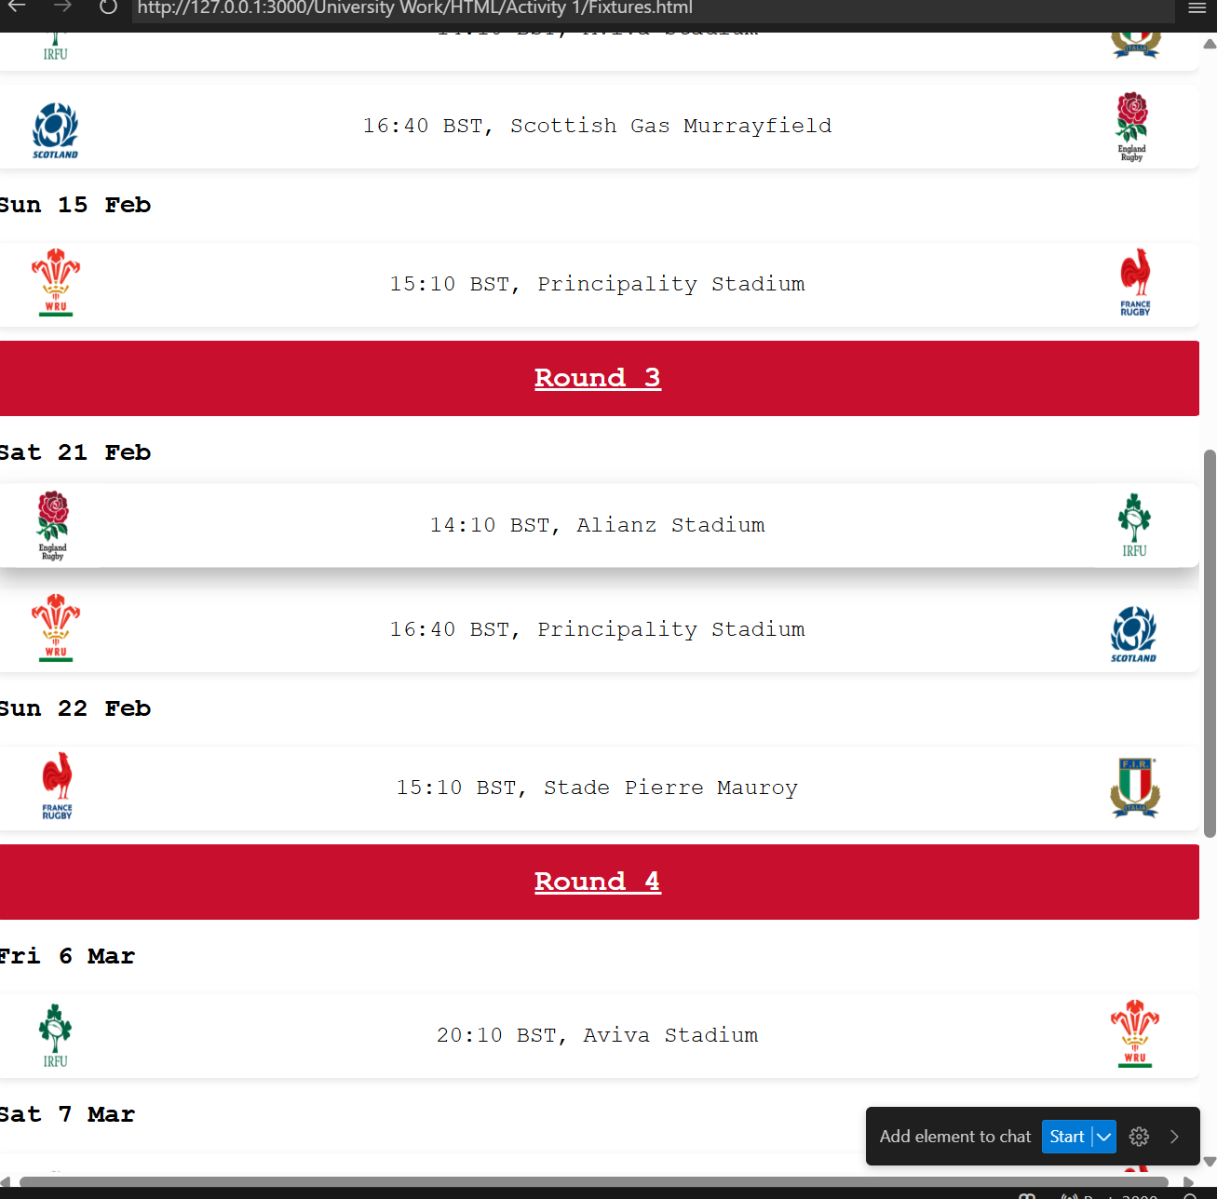
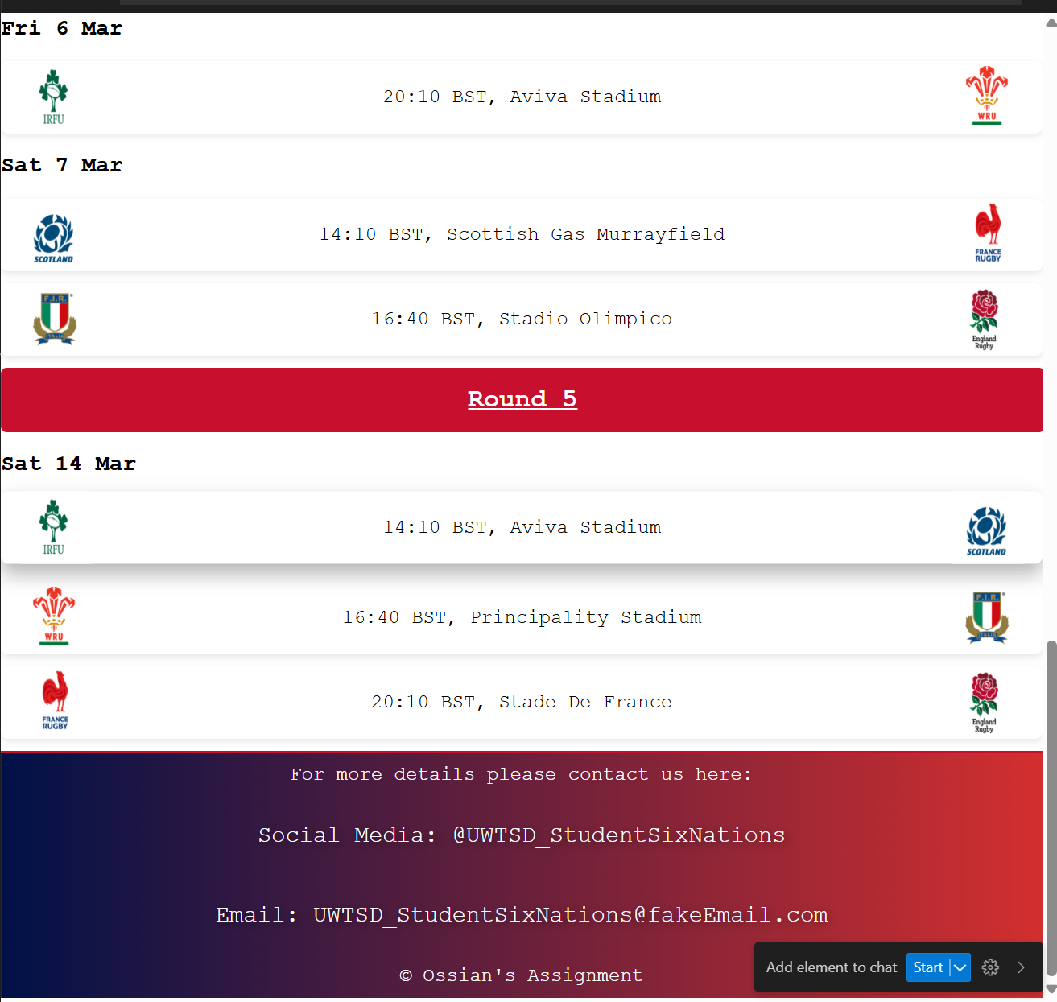
This page was designed to educate users of the website on the fixtures, and where each fixture is taking place, with the time and date of when they take place. I have also linked the six nations website so users can view this information directly from the source.

Fixtures Page Validation.

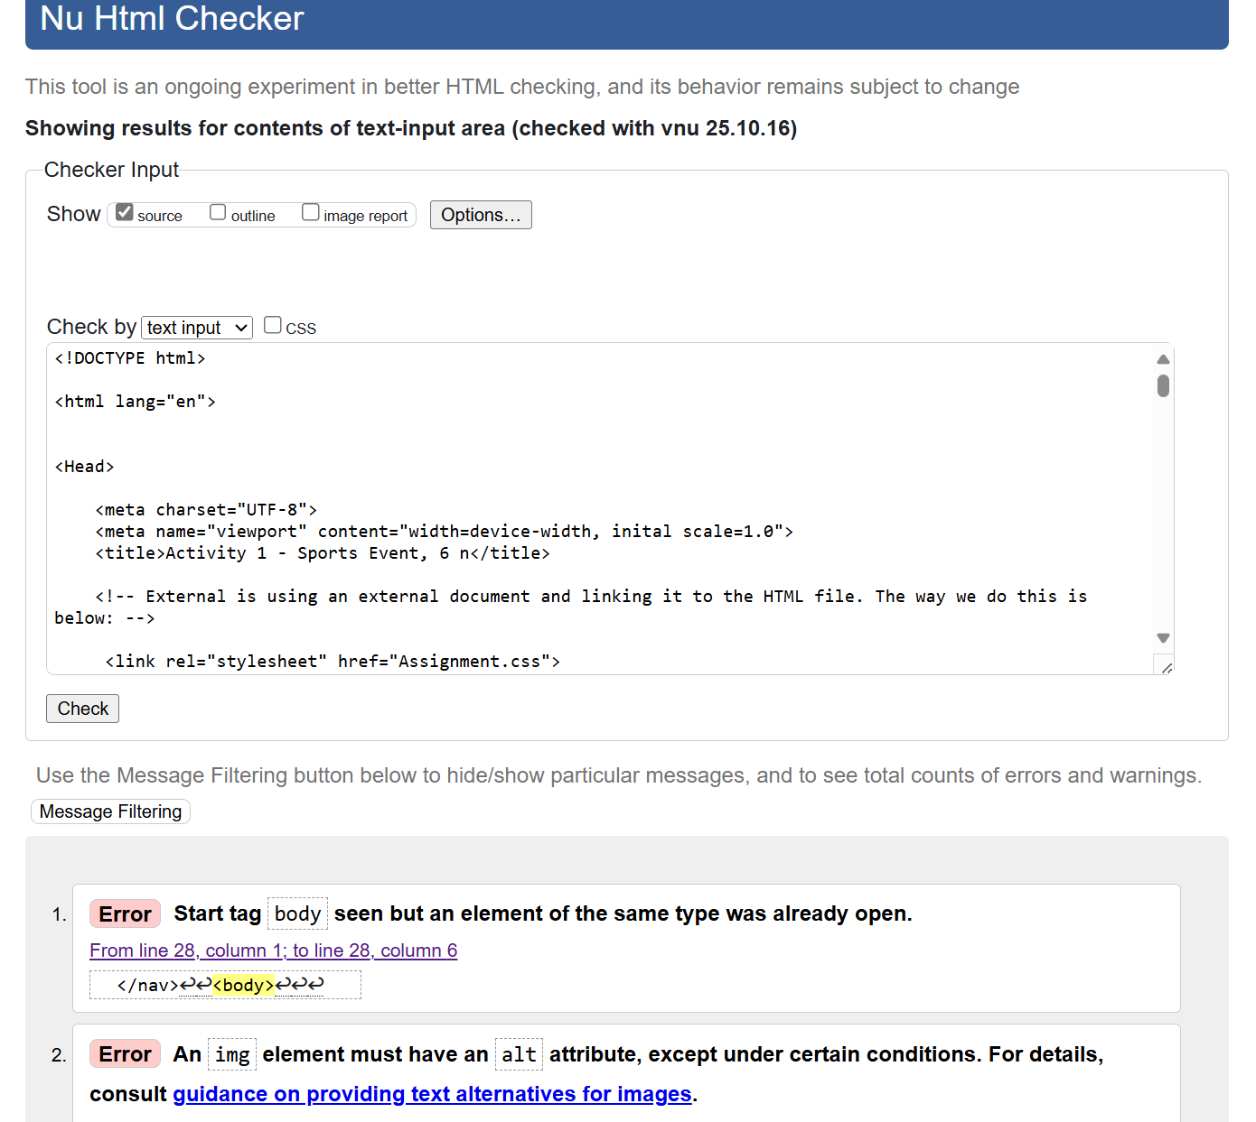
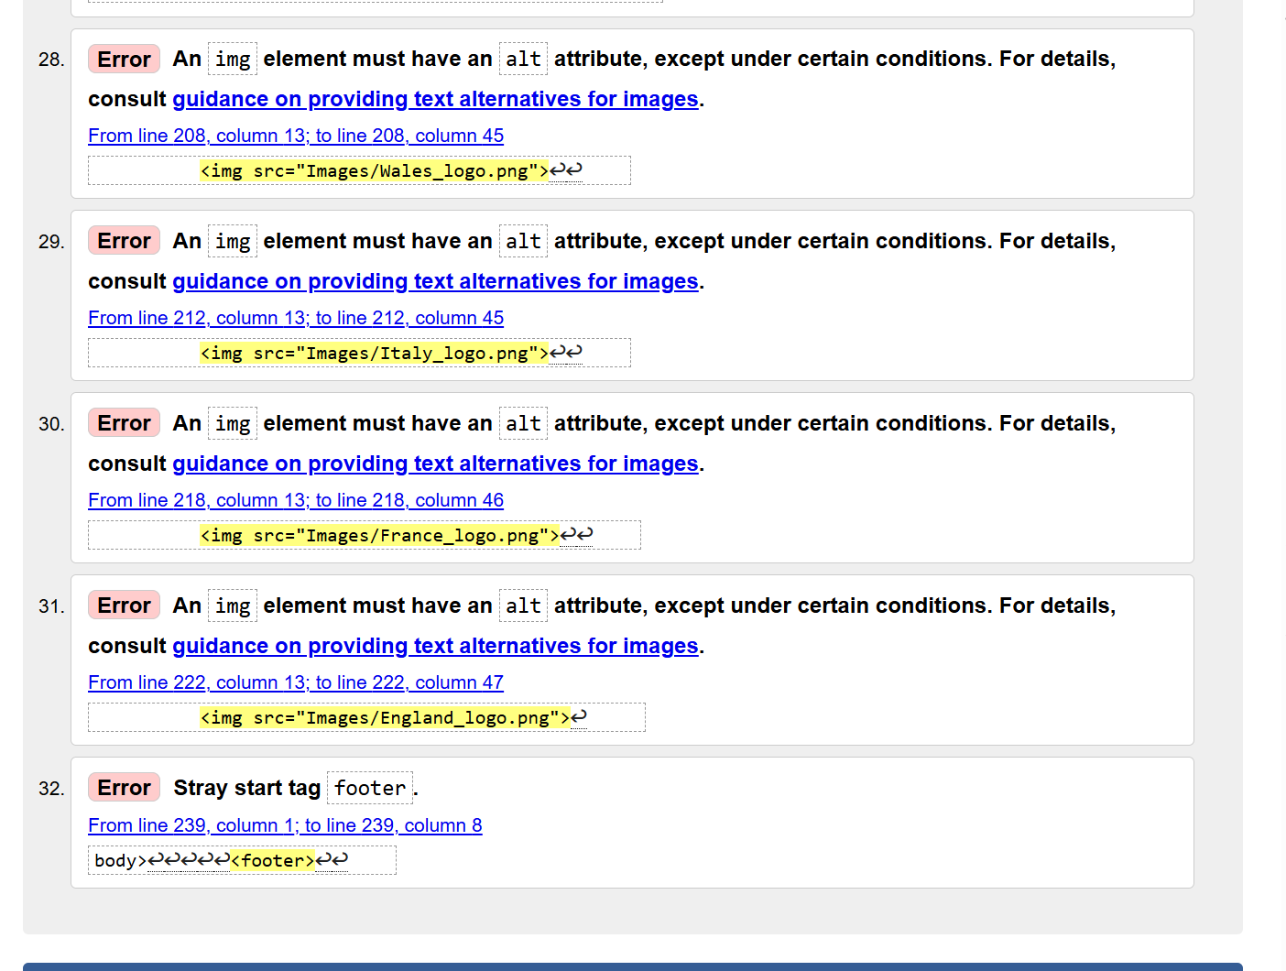
I have 32 errors on this page. Two of the errors came from the footer and nav bar not being in the body tag. And the others were to do with the img tag and not having the alt attribute.
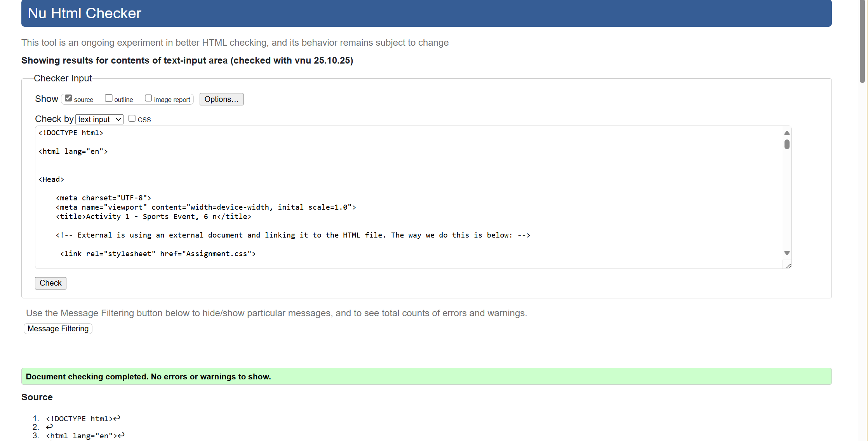

Team Information Page.

Team Information Page Web Page.
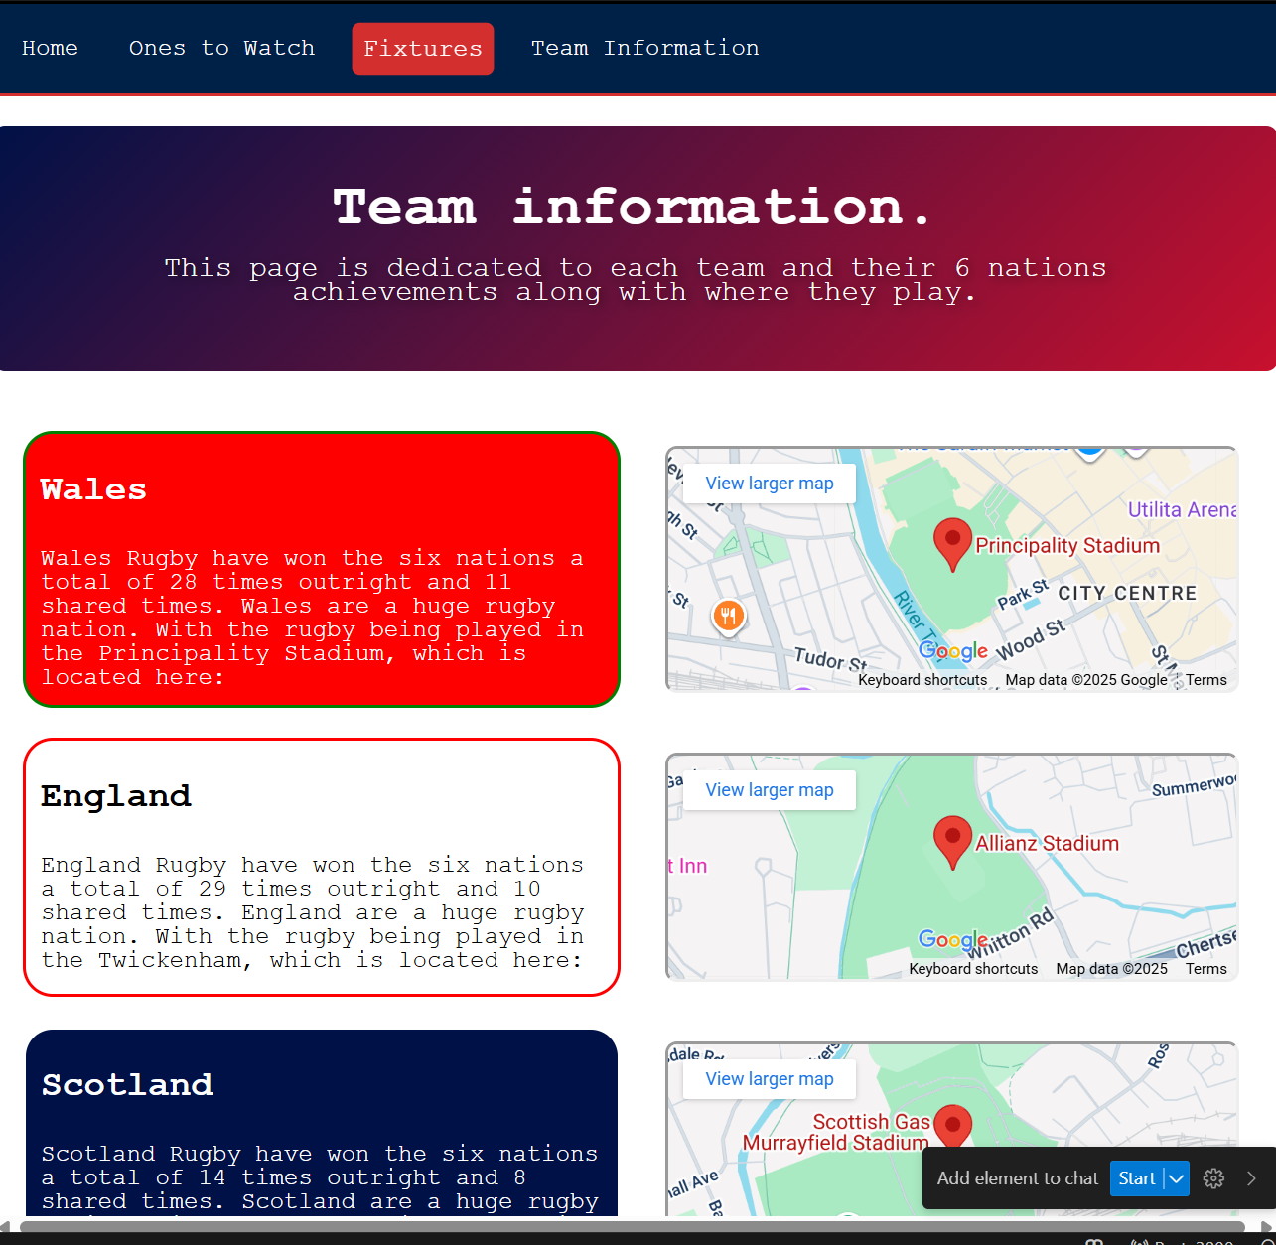
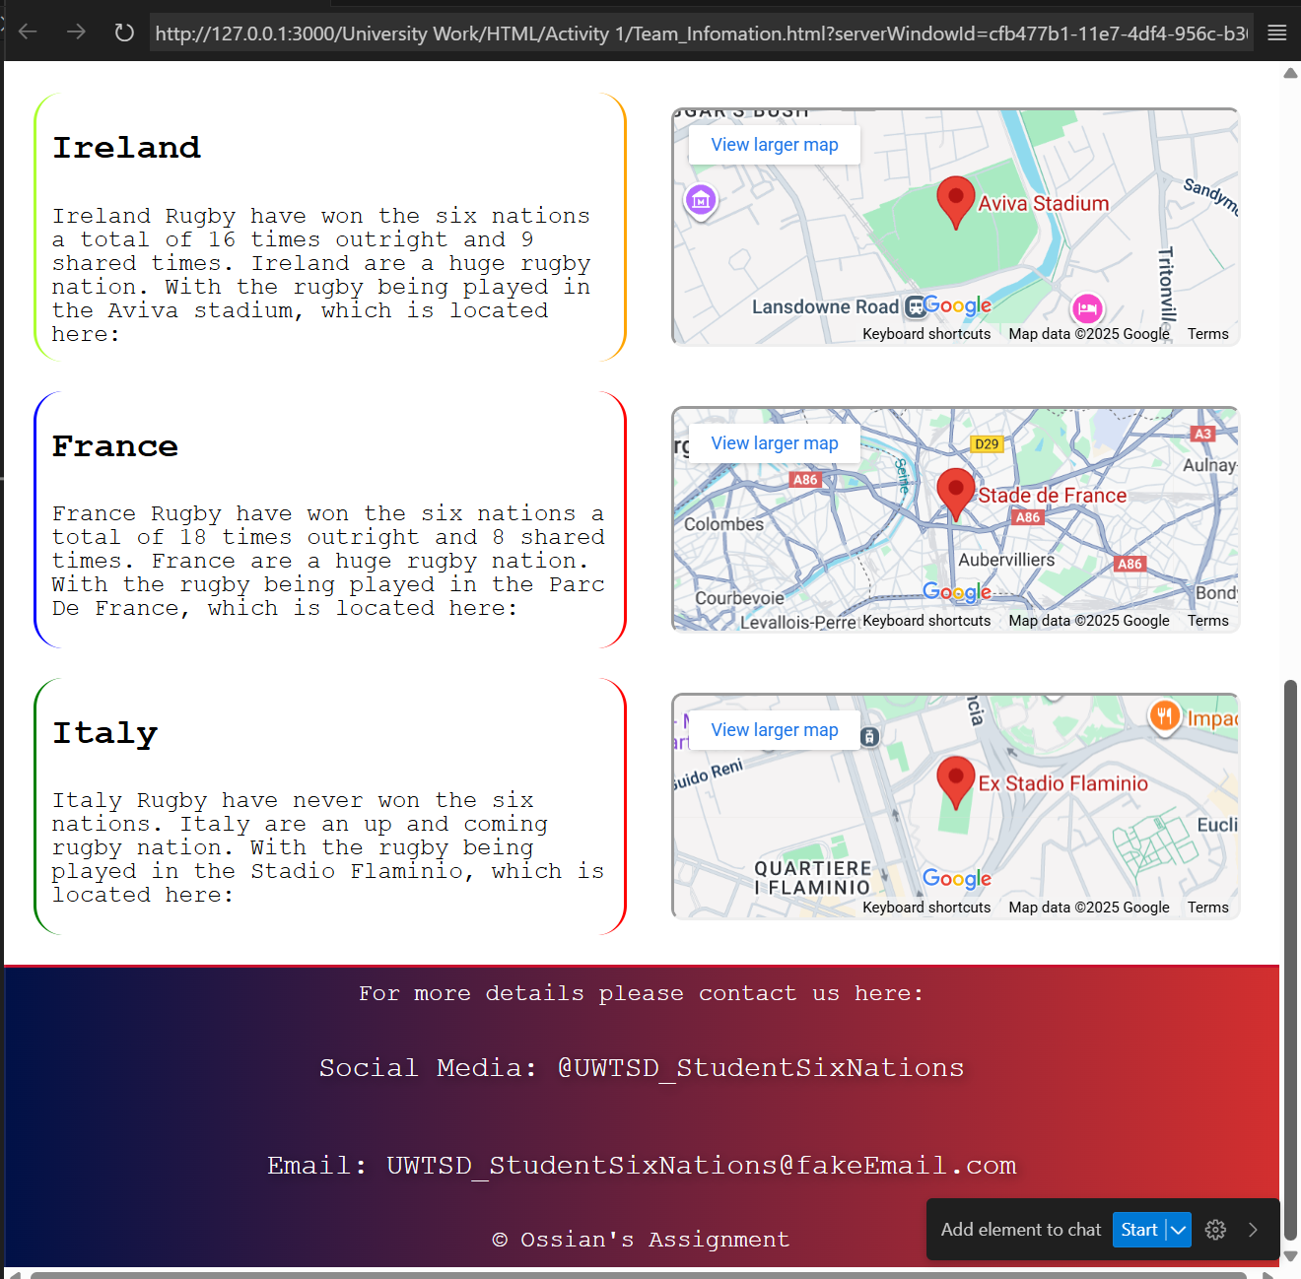
This is my team information page, it gives information about the teams competing inside of the six nations, and the information on the map as to where each stadium is located. I’ve added some visual features as well.

Team Information Page Validation.

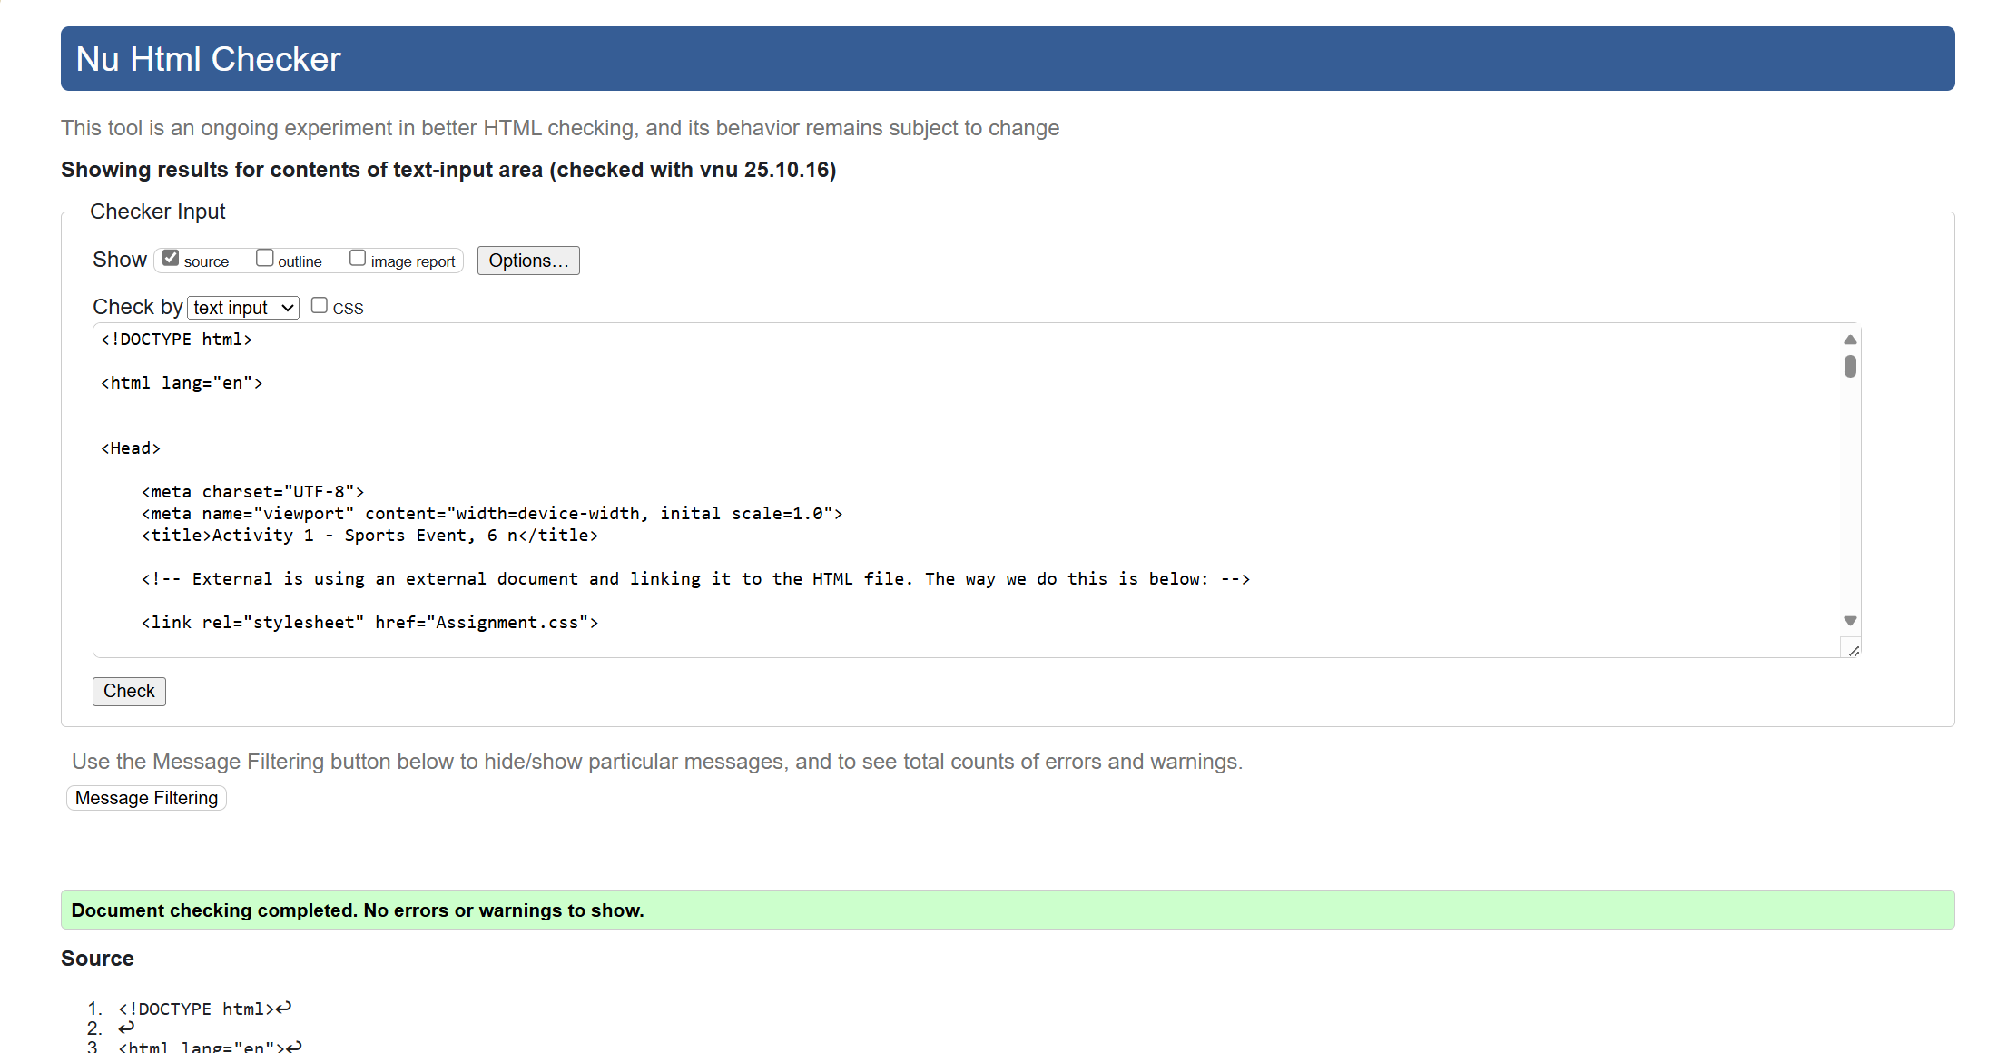

Assessment.css Validation.
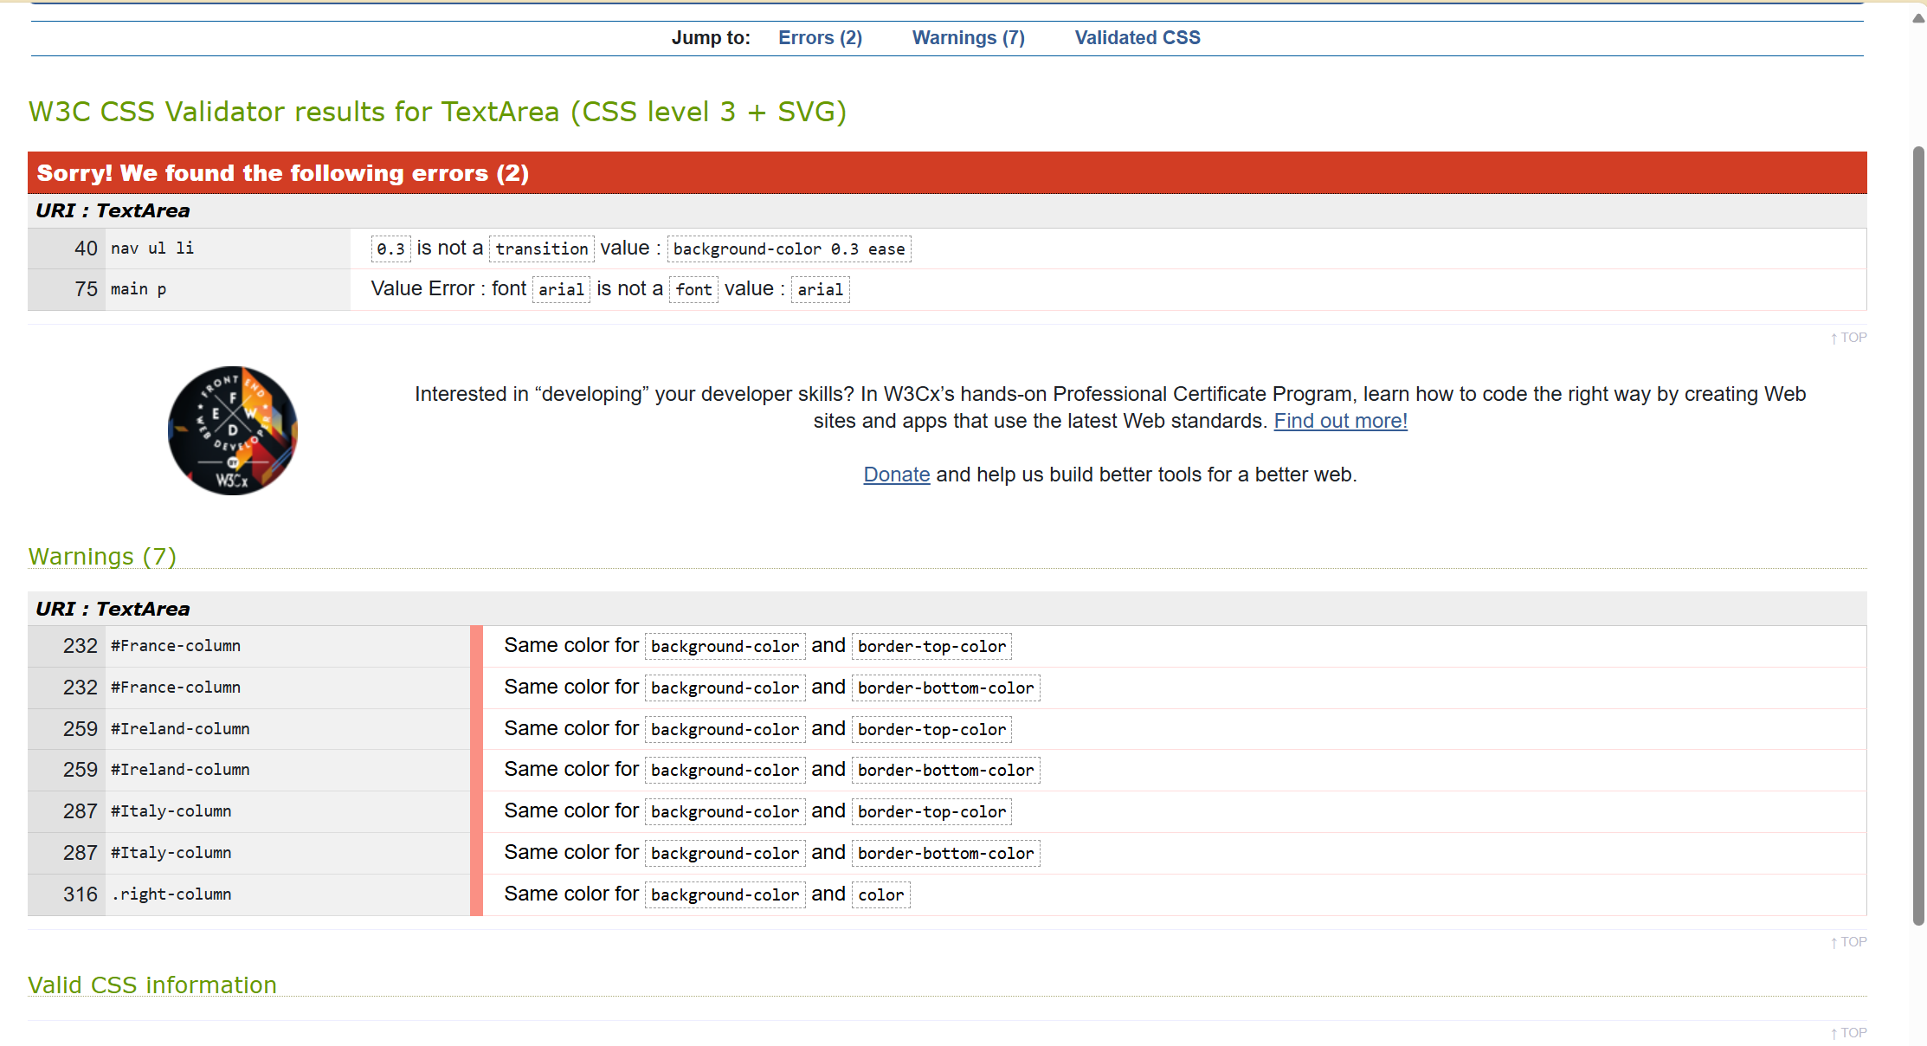
There are 2 errors and 7 warnings within my CSS.
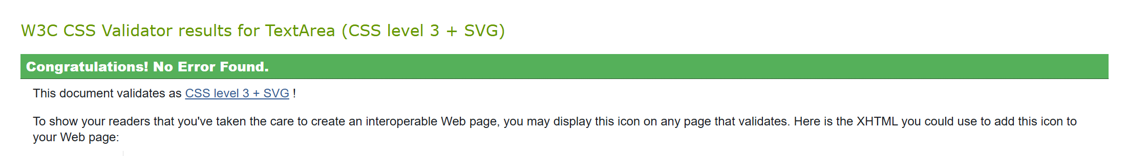
I removed the text colour on the right column div class, and then removed the lines of code which caused issues and nothing noticeable changed on my website, so there are no issues. The border top and bottom issues are risks I’ll accept as they are white and blend in with the background.

Evaluation.

General Evaluation:

Accessibility. [1]
Accessibility is now considered a core requirements, as previously it was treated as an afterthought. In recent years guidelines have been set in place to enforce accessibility into all websites, these guidelines consist of WCAG (versions 2.0- draft 3.0), other standards such as Section 508 (US) and EN 301 549 (EU) are there to enforce these accessibility requirements on everyone.

SEO. [2]
The use of SEO within the website is very important as studies show that when you use effective SEO techniques, things such as:
- Keyword Optimisation: will improve your click through rate by 20-40%.
- Traffic Growth: Up to 30% more traffic.
- Conversation Rates: improvements increased between 10-25%.
- Revenue Impact: Revenues increased by 25% and operational efficiency by 15%.
To reap the benefits of the above, you must look to:
- Optimise the site structures, by using things like clear navigation and a logical hierarchy.
- Prioritise a responsive design for all devices.
- Technical SEO essentials, including Clean urls, Meta tags, and schema markup, also ensure the site is secured with SSL certificates.
The user of the above techniques will allow for a more optimal use of SEO, allow for your website/company to get the benefits of SEO.

Usability. [3]
Usability is a key quality attribute when talking about web and software design, Usability is the ease of which a user can learn, operate and interpret outputs of a system. (IEEE Std.1061, 1992).
A lack of usability will lead to monetary loss, user dissatisfaction, and productivity issues. The only issue with usability is it is all subjective as there is no universal criteria for usability evaluation, and it is really dependent on the website and it’s user focus.
With the integration of usability in web design, it should be implanted as soon as possible within the design as this limits design problems you may face further down the line.

Website Evaluation

Accessibility. [4]
Looking at my website, I have tried to make it accessible to everyone. This is because I have included an alt attribute inside of my image tags, this is so screen readers can clearly define what each image is to visually impaired users. Using semantic HTML is a foundational step in making websites accessible for everyone. In additional to this, I have used tags like <header>, <nav>, < [3]main>, and <footer>. This will help assistive technologies navigate the content more efficiently. It also benefits all users by enhancing clarity, responsiveness and search engine visibility. By including the above tags and techniques it ensures that all users can have a fair and reliable experience when accessing my website. It allows for users to access the website even with disabilities, which will promote inclusivity, and equality to all.

Perceivability.
I believe that content in my web page, is clear and easy to understand. I have also provided an Alt tag within my images so images can be read by an text to speech reader for visually impaired. I have used colours for text which is either a darker or light colour depending on the background. By incorporating the above, I can help support the text to read features
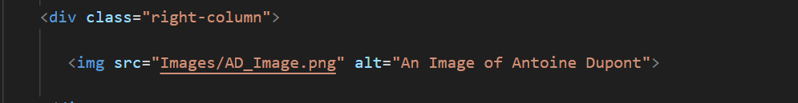
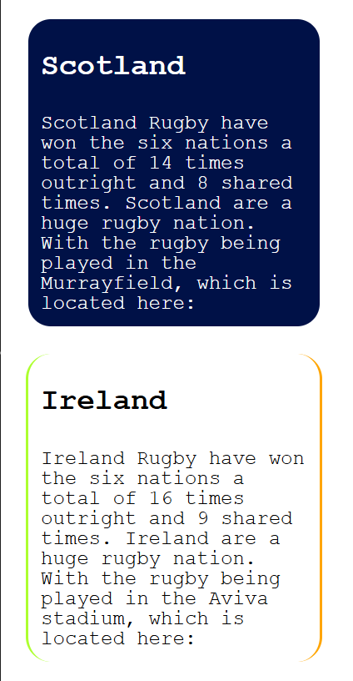

Operability and Understandable.
My website is designed to be easily operable because the Nav Bar is highlighted across the top of the page, and the buttons highlight when hovered over, clearly underlining what tab you are selecting. Just by looking at the page we can clearly define and see where the Nav bar is located, where the main content is located, and where the footer is located. This allows the user to select through the website.
I believe the content is understandable as fonts are not clashing for text and background, headers are clearly defined, along with the navigation bar. I’ve tried to use language which is easy to read and understand, I can confirm this myself as I suffer with dyslexia and I can clearly read all information, and understand every piece of text.

Robust.
Looking at the code checker above, I believe it is all okay in terms of no errors within the HTML code. For my code structure I have made sure that each section is clearly visible and tagged cleanly, so text to speech readers can clearly read and understand the html code.

SEO. [5] & [4] & [6] & [7]
SEO is the process of optimising a website so it ranks higher in the search engines results. To ensure your website is always at the top of the queue for SEO, you can use techniques like descriptive title tags, meta descriptions and include keywords within headings and content. Often SEO and accessibility overlap as semantic HTML helps both screen readers and search engines. Some usage of SEO inside of my website would be, descriptive title tags, and alt text within images. Below is the title tag, I’ve kept it short and simple as a fixture list usually is a short and simple search. I have also used things like H1 for headings, and key words within headings.
After researching some articles online, I have tried to optimise my website; I have used minimal SEO techniques within the title content, as previously my title used to just be Six Nations, which is okay, but it is minimalistic. So I have changed each title to represent what each page is used for, for example, below I have incorporated more information like Six Nations Fixture list 2026 in hopes that this will push my website to the front page of every search engine. I have also included features like detailed H1 headings, and some smaller H2, and even H3 headings to break down and segment the website clearly.
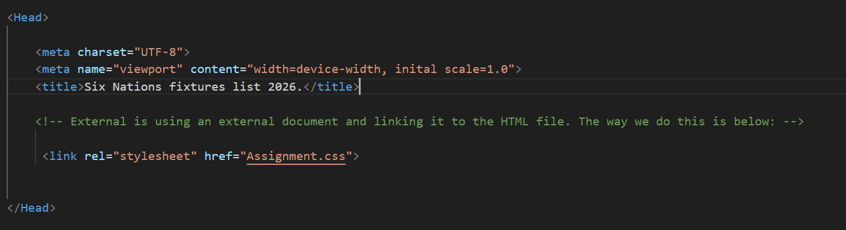
I have even looked at using ARIA Roles as they define the purpose of an element on a webpage and can help screen readers understand what part of the page does what, for example the <div> tag I have used within my navigation bar is given the role=”navigation”, this allows assistive technology to learn that this is the sites navigation bar.
Statistics show that websites with over 3,000 words tend to receive more traffic, social shares, and backlinks. While my site may not reach that word count, I’ve focused on quality content and keyword placement to improve discoverability. On average, websites contain around 1,400 words, personally I have aimed to meet or exceed that benchmark.

Website Comparison.

Website 1 – Apple.com
Area | Description
Usability | Clean, minimalistic layout. Intuitive navigation; with consistent fonts and spacing across the website.
Accessibility | WAVE shows good contrast and ARIA labels; with some minor issues with form labels. The website does comply with most of the WCAG 2.1 AA standards.
SEO | Well-structured titles, meta descriptions optimised with alt text present but limited on decorative images, with all headings being logical (h1-h3)
Mobile Friendliness | Responsive design with smooth scaling and fast loading times. The touch targets function great.
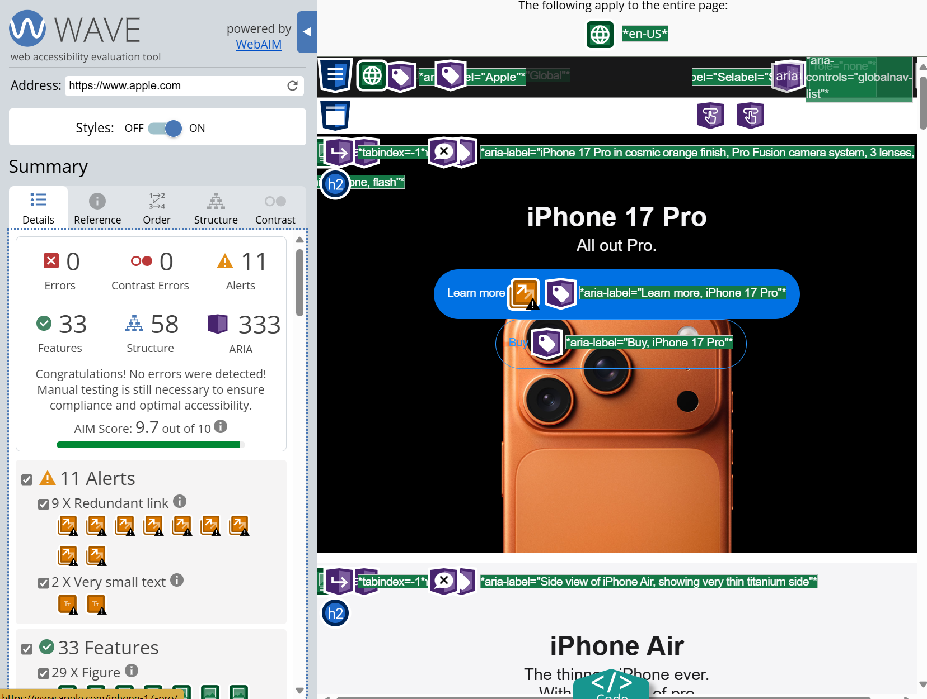

Website 2 – Samsung.com
Area | Description
Usability | Vibrant visuals, with the navigation being cluttered (in my opinion), the readability is effected as there are dense content blocks.
Accessibility | WAVE detects missing alt text on some images, ARIA roles present but inconsistent and partial WCAG 2.1 compliance.
SEO | Titles and meta tags are all optimised with some alt attributes missing on the promotional banners. The heading hierarchy is less consistent.
Mobile Friendliness | Quite responsive, but the bigger assets are slower to load, and some buttons seem too small to touch.
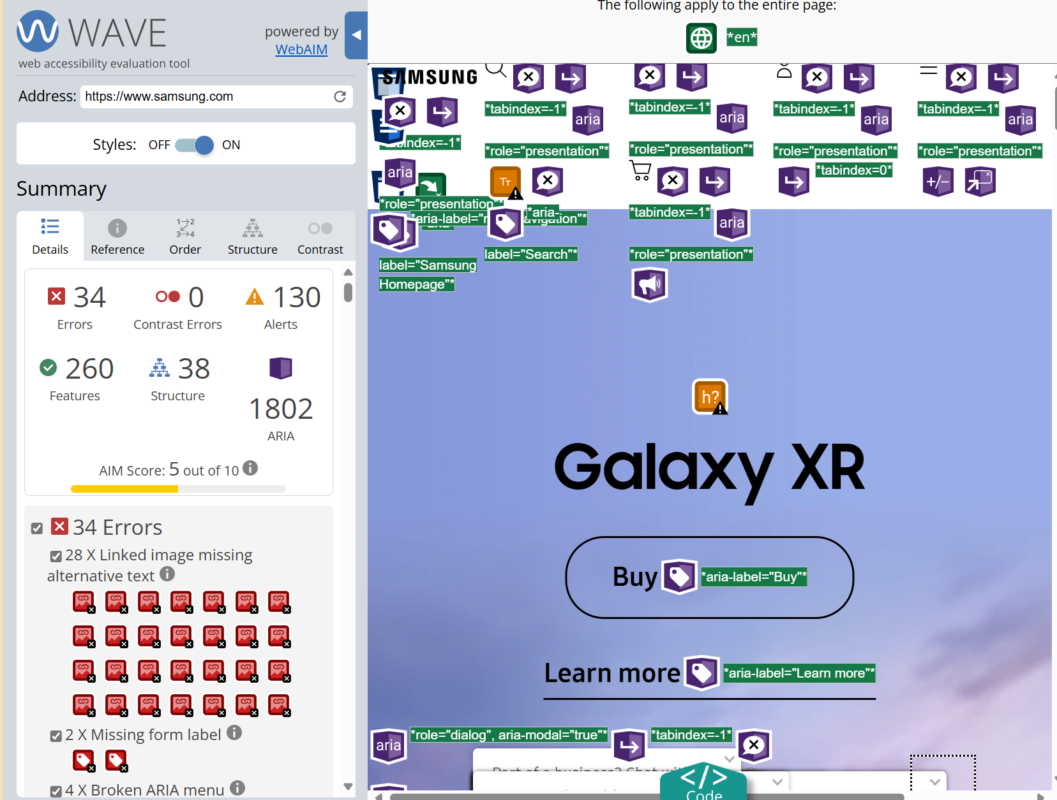

Conclusion.
In my opinion, Apple.com offers a better usability experience, along with accessibility and mobile performance, whereas Samsung.com exceeds in the visual engagement, but struggles with accessibility and speed. In my opinion, Apple.com is an overall better user experience, and seems to be more compliant as looking at the WAVE images of each websites home page, you can clearly see there are 34 errors within the Samsung website relating to Alternative text, whereas Apple’s homepage doesn’t seem to have any errors, meaning it is compliant with WGAC 2.1 standards.
When looking at both websites AIM score, you can see Apples AIM score is a 9.7 out of 10 whereas Samsung, is a 5 out of 10. Meaning Apple has more accessibility features, and things like a better contrast. Viewing the WAVE reports, I believe it supports my conclusion, that Apples home page is a nicer and more visually appealing experience, it also feels smoother and flows nicer when trying to navigate the site. Samsung have 34 errors on home page, which leads to the bad AIM score, I believe the errors all relate to there not being an ALT attribute on images in the homepage, meaning the website is less accessible by visually impaired users and screen readers.

References

[1] | C. S.-L. &. A. K. Jinat Ara, “Accessibility engineering in web evaluation process: a systematic literature review,” Springer Nature Link, 27 Janurary 2023. [Online]. Available: https://link.springer.com/article/10.1007/s10209-023-00967-2. [Accessed Monday November 2025].
[2] | G. S. R. N. Thango, “Systematic Review on SEO and Digital Marketing Strategies for Enhancing Retail SMEs' Performance,” Sciety, 24 October 2024. [Online]. Available: https://sciety.org/articles/activity/10.20944/preprints202410.1715.v1. [Accessed Monday 17th. November 2025].
[3] | A. M. &. S. K. Dubey, “Usability Evaluation Methods: A Literature Review,” Research Gate, Not Specified. Not Specified 2020. [Online]. Available: https://www.researchgate.net/publication/266874640_Usability_evaluation_methods_a_literature_review/fulltext/5444c1290cf2a6a049ab1f0f/Usability-evaluation-methods-a-literature-review.pdf. [Accessed Monday 17th November 2025].
[4] | Mozilla, “HTML: A Good Basis for Accessibility,” Mozilla, 29 April 2025. [Online]. Available: https://developer.mozilla.org/en-US/docs/Learn_web_development/Core/Accessibility/HTML. [Accessed 28 October 2025].
[5] | Search Engine Journal, “The State of SEO 2026: How to Survive,” Search Engine Journal, 15 (based on publication date) October 2025. [Online]. Available: https://www.searchenginejournal.com/the-state-of-seo-2026-how-to-survive/555368/. [Accessed 28 October 2025].
[6] | G. Jhean, “83 SEO Statistics for 2025 (Current & Verified),” AIOSEO, 22 Janurary 2025. [Online]. Available: https://aioseo.com/seo-statistics/. [Accessed 28 October 2025].
[7] | Mozilla Developer Network (MDN), “ARIA – Accessibility,” Mozilla Foundation, 28 October 2025. [Online]. Available: https://developer.mozilla.org/en-US/docs/Web/Accessibility/ARIA. [Accessed 28 October 2025].

Appendices
Before code is pasted in I had 2092 words, this includes the Table of Contents and References.

Assessment.css
/* Navigation Styles */

nav {

background-color:#002147;
width: 100%;
height: 60px;
display: flex;
align-items: center;
justify-content: flex-start;
padding: 0px;
border-bottom: #D32F2F;
border-style: solid;

}

nav ul {

display: flex;
margin: 0;
padding: 0;
list-style: none;

}

nav ul li{

display: inline-flex;
align-items: center;
justify-content: center;
height: 20px;
margin: 0 10px;
background-color: transparent;
border-spacing: 0px;
padding: 7px;
/* below allows you to have rounded boarders on the nav bar */
border-radius:5px;

}

/* below allows the nav bar to change colour on the button which has been hovered over */

nav ul li:hover{

background-color: #D32F2F;
transform: scale(1.05);

}

nav ul li a{

color: rgb(255, 255, 255);
text-decoration: none;

}

main {
flex: 1;
background-color: white;
padding: 0px;
}

main p{

font-size: 1.2rem;
margin: 10px;
font-family: Courier;
font: bold;

}

html, body {

height: 100%;
margin: 0;
flex-direction: column;
background-color: white;
color: black;
font-family: Courier;
font-size: 16px;
line-height: 1em;

}

p{

font-size: 1.2rem;
color: white;
text-shadow: 2px 2px 8px rgba(0, 0, 0, 0.7);
margin-top: 20px;
padding: 15px 20px;
border-radius: 8px;

}

#home-main{

/* Background image reference - helensbauer.pages.dev */
background: url(Images/SN_Ball.png) no-repeat center center/cover;
height: 70vh;
/* width: 100%; */
display: flex;
flex-direction: column;
align-items: center;
text-align: center;
position: relative;
background-attachment: fixed;
padding: 0px;

}

#home-main h2 {
font-size: 2rem;
color: white;
text-shadow: 2px 2px 8px rgba(0, 0, 0, 0.7);
margin-top: 20px;
background-color: rgba(0, 0, 0, 0.5);
padding: 15px 20px;
border-radius: 8px;
}

#home-main p {
font-size: 1.2rem;
color: white;
text-shadow: 2px 2px 8px rgba(0, 0, 0, 0.7);
margin-top: 20px;
background-color: rgba(0, 0, 0, 0.5);
padding: 15px 20px;
border-radius: 8px;
}

/* Main Content Layout */
.Main-content {
display: grid;
grid-template-columns: 1fr 1fr; /* Two columns */
gap: 20px;
padding: 20px;
}

/* Left Column (Text Column) */
.left-column {
display: flex;
flex-direction: column;
gap: 10px;
background: linear-gradient(90deg, #D32F2F, #001147);
color:white;
text-align: left;
padding: 10px;
border-radius: 20px;
border: #D32F2F solid 2px;
}

/* Individual Design for each team */

#Wales-column {
display: flex;
flex-direction: column;
gap: 10px;
background-color: red;
color:white;
text-align: left;
padding: 10px;
border-radius: 20px;
border: green solid 2px;

}

#Wales-column :hover{

transform: scale(1.01);

}

#England-column {
display: flex;
flex-direction: column;
gap: 10px;
background-color: white;
color:black;
text-align: left;
padding: 10px;
border-radius: 20px;
border: red solid 2px;
}

#England-column h2{

color:black;
}

#England-column :hover{

transform: scale(1.01);

}

#Scotland-column {
display: flex;
flex-direction: column;
gap: 10px;
background-color:#001147;
color:white;
text-align: left;
padding: 10px;
border-radius: 20px;
border: white solid 2px;
}

#Scotland-column :hover{

transform: scale(1.01);

}

#France-column {
display: flex;
flex-direction: column;
gap: 10px;
background-color: white;
color: black;
text-align: left;
padding: 10px;
border-radius: 20px;
border: solid 2px;
border-top: white;
border-bottom: white;
border-left: blue solid;
border-right: red solid;
}

#France-column h2{

color:black;
}

#France-column :hover{

transform: scale(1.01);

}

#Ireland-column {
display: flex;
flex-direction: column;
gap: 10px;
background-color: white;
color:black;
text-align: left;
padding: 10px;
border-radius: 20px;
border: solid 2px;
border-top: white;
border-bottom: white;
border-left: greenyellow solid 2px;
border-right: orange solid 2px;
}

#Ireland-column h2{

color:black;
}

#Ireland-column :hover{

transform: scale(1.01);

}

#Italy-column {
display: flex;
flex-direction: column;
gap: 10px;
background-color: white;
color:black;
text-align: left;
padding: 10px;
border-radius: 20px;
border: solid 2px;
border-top: white;
border-bottom: white;
border-left: green solid 2px;
border-right: red solid 2px;

}

#Italy-column h2{

color:black;
}

#Italy-column :hover{

transform: scale(1.01);

}

/* Right Column (Images/Maps Column) */
.right-column {
display: flex;
flex-direction: column;
gap: 10px;
background: white;
text-align: left;
padding: 10px;

}

.right-column img {
width: 200px;
height: 250px;
object-fit: cover;
border-radius: 8px;

}

.right-column iframe{

width: 100%;
height: 100%;
object-fit: cover;
border-radius: 8px;

}

.page-head {

background: linear-gradient(135deg, #001147, #c8102e); /* Team colors */
color: #fff;
padding: 20px 20px;
text-align: center;
border-radius: 8px;
margin-bottom: 20px;
margin-top: 20px;

}

.page-head h1 {

font-size: 2.5rem;
margin-bottom: 10px;
font-weight: bold;

}

.page-head a {
display: inline-block;
color: black;
text-decoration: underline;
transition: transform 0.3s ease;
}

.page-head a:hover {
transform: scale(1.05);
}

.fixture-head p {

font-size: 1.2rem;
opacity: 0.9;

}

.round-title {

display: block;
width: 100%;
text-align: center;
background: #c8102e;
color: white;
padding: 1px;
font-size: 0.9rem;
margin-bottom: 1px;
border-radius: 5px;

}

.fixture-row {

display: flex;
justify-content: space-between;
align-items: center;
background: white;
padding: 0px 15px;
margin-bottom: 10px;
border-radius: 6px;
box-shadow: 0 2px 6px rgba(0,0,0,0.1);

}

.fixture-row:hover {

transform: translateY(-5px);
box-shadow: 0 8px 16px rgba(0,0,0,0.3);

}

.fixture-row img {

width: 60px;
height: 60px;

}

.fixture-text {

flex: 1;
text-align: center;
font-size: 1rem;
color: #333;

}

footer {
background: linear-gradient(90deg, #001147, #D32F2F);
color: white;
text-align: center;
padding-top: 10px;
padding-bottom: 10px;
width: 100%;
border-top: 2px solid #c8102e;
}

Home_Page.html
<!DOCTYPE html>

<html lang="en">

<Head>

<meta charset="UTF-8">
<meta name="viewport" content="width=device-width, inital scale=1.0">
<title>Six Nations, Information website.</title>

<!-- External is using an external document and linking it to the HTML file. The way we do this is below: -->

<link rel="stylesheet" href="Assignment.css">

</Head>

<body>

<nav>
<ul>
<li><a href="Home_Page.html">Home</a></li>
<li><a href="ones_to_watch.html">Ones to Watch</a></li>
<li><a href="Fixtures.html">Fixtures</a></li>
<li><a href="Team_Infomation.html">Team Information</a></li>
</ul>
</nav>

<main>

<!-- Background image reference - helensbauer.pages.dev -->
<div id="home-main">

<h2>Six Nations 2026.</H2>

<p>

This years six nations kicks off with an exciting
match on the 5th of February 2026. It's the first
6 Nations game on a Thursday in history. The match
is between defending champions France and tournament
favourites Ireland.

</p>

</div>
</main>

<footer>

For more details please contact us here:

<p> Social Media: @UWTSD_StudentSixNations </p>
<p>Email: UWTSD_StudentSixNations@fakeEmail.com</p>

&copy; Ossian's Assignment

</footer>

</body>

</html>

Ones_to_Watch.html

<!DOCTYPE html>

<html lang="en">

<Head>

<meta charset="UTF-8">
<meta name="viewport" content="width=device-width, inital scale=1.0">
<title>Six Nations, players to watch.</title>

<!-- External is using an external document and linking it to the HTML file. The way we do this is below: -->

<link rel="stylesheet" href="Assignment.css">

</Head>

<body>

<nav>
<ul>
<li><a href="Home_Page.html">Home</a></li>
<li><a href="ones_to_watch.html">Ones to Watch</a></li>
<li><a href="Fixtures.html">Fixtures</a></li>
<li><a href="Team_Infomation.html">Team Information</a></li>
</ul>
</nav>

<main>

<div class="page-head">

<h1>Ones to Watch</h1>

<p>These are the players to watch over the 6 nations tournament.</p>

</div>
<div class="Main-content">

<div class="left-column">
<h3>Jac Morgan</h3>

Jac Morgan was born in Swansea, January 21st 2000. He plays for the Ospreys. So far for his international
career, he has made 17 Caps for Wales, scoring 7 tries. He was also 1 of 2 Welsh players selected in 2025
to play for the lions. Where he also has 2 caps at test level scoring 1 try. Jac is known for his defensive
attributes as he plays open side flanker (Number 7).

</div>
<!-- https://en.wikipedia.org/wiki/Jac_Morgan - reference same for image. -->

<div class="right-column">

<img src="Images/JM_Image.png" alt="An Image of Jac Morgan">

</div>

<div class="left-column">
<h3>Antoine Dupont</h3>

Antoine Dupont has won 39 individual awards across his career. He has won world player of the year in both
Rugby Union and Rugby 7s, he is the only player in history to have won both awards. He has scored 15 international
tries with 75 caps for France and has numerous team awards for his club side. Dupont is known for his excellence
across the pitch, creating opportunites and finding space, in places which seem impossible to break, he plays Scrum
Half (Number 9).

</div>

<!-- https://en.wikipedia.org/wiki/Antoine_Dupont - reference same for image. -->

<div class="right-column">

<img src="Images/AD_Image.png" alt="An Image of Antoine Dupont">

</div>

<div class="left-column">
<h3>Duhan Van Der Merwe</h3>

Duhan Van Der Merwe was born in South Africa, but now plays for internationally for Scotland. He's had 48 caps
for Scotland, scoring 30 tries, and becoming their top try scorer in history. He has 12 total appearences, scoring
10 tries, but has only played 3 test games, and not managed to score in a single one. Van Der Merwe is known for
his bulldozing ability, and blistering pace on the wing (Number 11 and 14).

</div>

<!-- https://en.wikipedia.org/wiki/Duhan_van_der_Merwe - reference same for image. -->

<div class="right-column">

<img src="Images/DVDM_Image.png" alt="An Image Duhan Van Der Merwe">

</div>

</div>

</main>

<footer>

For more details please contact us here:

<p> Social Media: @UWTSD_StudentSixNations </p>
<p>Email: UWTSD_StudentSixNations@fakeEmail.com</p>

&copy; Ossian's Assignment

</footer>
</body>

</html>

Fixtures.html
<!DOCTYPE html>

<html lang="en">

<Head>

<meta charset="UTF-8">
<meta name="viewport" content="width=device-width, inital scale=1.0">
<title>Six Nations, players to watch.</title>

<!-- External is using an external document and linking it to the HTML file. The way we do this is below: -->

<link rel="stylesheet" href="Assignment.css">

</Head>

<body>

<nav>
<ul>
<li><a href="Home_Page.html">Home</a></li>
<li><a href="ones_to_watch.html">Ones to Watch</a></li>
<li><a href="Fixtures.html">Fixtures</a></li>
<li><a href="Team_Infomation.html">Team Information</a></li>
</ul>
</nav>

<main>

<div class="page-head">

<h1>Ones to Watch</h1>

<p>These are the players to watch over the 6 nations tournament.</p>

</div>
<div class="Main-content">

<div class="left-column">
<h3>Jac Morgan</h3>

Jac Morgan was born in Swansea, January 21st 2000. He plays for the Ospreys. So far for his international
career, he has made 17 Caps for Wales, scoring 7 tries. He was also 1 of 2 Welsh players selected in 2025
to play for the lions. Where he also has 2 caps at test level scoring 1 try. Jac is known for his defensive
attributes as he plays open side flanker (Number 7).

</div>
<!-- https://en.wikipedia.org/wiki/Jac_Morgan - reference same for image. -->

<div class="right-column">

<img src="Images/JM_Image.png" alt="An Image of Jac Morgan">

</div>

<div class="left-column">
<h3>Antoine Dupont</h3>

Antoine Dupont has won 39 individual awards across his career. He has won world player of the year in both
Rugby Union and Rugby 7s, he is the only player in history to have won both awards. He has scored 15 international
tries with 75 caps for France and has numerous team awards for his club side. Dupont is known for his excellence
across the pitch, creating opportunites and finding space, in places which seem impossible to break, he plays Scrum
Half (Number 9).

</div>

<!-- https://en.wikipedia.org/wiki/Antoine_Dupont - reference same for image. -->

<div class="right-column">

<img src="Images/AD_Image.png" alt="An Image of Antoine Dupont">

</div>

<div class="left-column">
<h3>Duhan Van Der Merwe</h3>

Duhan Van Der Merwe was born in South Africa, but now plays for internationally for Scotland. He's had 48 caps
for Scotland, scoring 30 tries, and becoming their top try scorer in history. He has 12 total appearences, scoring
10 tries, but has only played 3 test games, and not managed to score in a single one. Van Der Merwe is known for
his bulldozing ability, and blistering pace on the wing (Number 11 and 14).

</div>

<!-- https://en.wikipedia.org/wiki/Duhan_van_der_Merwe - reference same for image. -->

<div class="right-column">

<img src="Images/DVDM_Image.png" alt="An Image Duhan Van Der Merwe">

</div>

</div>

</main>

<footer>

For more details please contact us here:

<p> Social Media: @UWTSD_StudentSixNations </p>
<p>Email: UWTSD_StudentSixNations@fakeEmail.com</p>

&copy; Ossian's Assignment

</footer>
</body>

</html>

Team_information.html
<!DOCTYPE html>

<html lang="en">

<Head>

<meta charset="UTF-8">
<meta name="viewport" content="width=device-width, inital scale=1.0">
<title>Six Nations, team information.</title>

<!-- External is using an external document and linking it to the HTML file. The way we do this is below: -->

<link rel="stylesheet" href="Assignment.css">

</Head>

<body>

<nav>
<ul>
<li><a href="Home_Page.html">Home</a></li>
<li><a href="ones_to_watch.html">Ones to Watch</a></li>
<li><a href="Fixtures.html">Fixtures</a></li>
<li><a href="Team_Infomation.html">Team Information</a></li>
</ul>
</nav>

<main>

<div class="page-head">

<h1>Team information.</h1>

<p>This page is dedicated to each team and their 6 nations achievements along with where they play.</p>

</div>

<div class="Main-content">

<div id="Wales-column">

<h2>Wales</h2>

Wales Rugby have won the six nations a total of 28 times outright and 11 shared times. Wales are a huge rugby
nation. With the rugby being played in the Principality Stadium, which is located here:

</div>

<div class="right-column">
<iframe src="https://www.google.com/maps/embed?pb=!1m18!1m12!1m3!1d2484.907519346474!2d-3.1852090233530497!3d51.478211812835205!2m3!1f0!2f0!3f0!3m2!1i1024!2i768!4f13.1!3m3!1m2!1s0x486e1cb1dfc6fd81%3A0x39e2d294964328e9!2sPrincipality%20Stadium!5e0!3m2!1sen!2suk!4v1760367846368!5m2!1sen!2suk"></iframe>
</div>

<div id="England-column">

<h2>England</h2>

England Rugby have won the six nations a total of 29 times outright and 10 shared times. England are a huge rugby
nation. With the rugby being played in the Twickenham, which is located here:

</div>

<div class="right-column">
<iframe src="https://www.google.com/maps/embed?pb=!1m18!1m12!1m3!1d2486.119676608834!2d-0.34408002335418175!3d51.455959114459944!2m3!1f0!2f0!3f0!3m2!1i1024!2i768!4f13.1!3m3!1m2!1s0x48760cedef6feaf3%3A0xa90e68c86cf99ca4!2sAllianz%20Stadium!5e0!3m2!1sen!2suk!4v1760367960453!5m2!1sen!2suk"></iframe>
</div>

<div id="Scotland-column">

<h2>Scotland</h2>

Scotland Rugby have won the six nations a total of 14 times outright and 8 shared times. Scotland are a huge rugby
nation. With the rugby being played in the Murrayfield, which is located here:

</div>

<div class="right-column">
<iframe src="https://www.google.com/maps/embed?pb=!1m18!1m12!1m3!1d2234.4092342153813!2d-3.2436151231108354!3d55.94227867738111!2m3!1f0!2f0!3f0!3m2!1i1024!2i768!4f13.1!3m3!1m2!1s0x4887c65417739d0d%3A0x8d2f9e9f766f3af5!2sScottish%20Gas%20Murrayfield%20Stadium!5e0!3m2!1sen!2suk!4v1760368117950!5m2!1sen!2suk"></iframe>
</div>

<div id="Ireland-column">

<h2>Ireland</h2>

Ireland Rugby have won the six nations a total of 16 times outright and 9 shared times. Ireland are a huge rugby
nation. With the rugby being played in the Aviva stadium, which is located here:

</div>

<div class="right-column">
<iframe src="https://www.google.com/maps/embed?pb=!1m18!1m12!1m3!1d2382.4513092022553!2d-6.230526423254165!3d53.33517697555919!2m3!1f0!2f0!3f0!3m2!1i1024!2i768!4f13.1!3m3!1m2!1s0x48670ec268eb8af9%3A0xe37e998e72032668!2sAviva%20Stadium!5e0!3m2!1sen!2suk!4v1760368349358!5m2!1sen!2suk" ></iframe>
</div>

<div id="France-column">

<h2>France</h2>

France Rugby have won the six nations a total of 18 times outright and 8 shared times. France are a huge rugby
nation. With the rugby being played in the Parc De France, which is located here:

</div>

<div class="right-column">
<iframe src="https://www.google.com/maps/embed?pb=!1m18!1m12!1m3!1d41979.17944184023!2d2.265342796835517!3d48.88301980477377!2m3!1f0!2f0!3f0!3m2!1i1024!2i768!4f13.1!3m3!1m2!1s0x47e66ebadd2263bf%3A0x70c04f7109156311!2sStade%20de%20France!5e0!3m2!1sen!2suk!4v1760368413803!5m2!1sen!2suk"></iframe>
</div>

<div id="Italy-column">

<h2>Italy</h2>

Italy Rugby have never won the six nations. Italy are an up and coming rugby
nation. With the rugby being played in the Stadio Flaminio, which is located here:

</div>

<div class="right-column">
<iframe src="https://www.google.com/maps/embed?pb=!1m18!1m12!1m3!1d2968.4110612480363!2d12.469744576185526!3d41.927017662349776!2m3!1f0!2f0!3f0!3m2!1i1024!2i768!4f13.1!3m3!1m2!1s0x132f614e6cb013a3%3A0x937bad5d72a2b1ca!2sEx%20Stadio%20Flaminio!5e0!3m2!1sen!2suk!4v1760368534560!5m2!1sen!2suk"></iframe>
</div>

</div>
</main>

<footer>

For more details please contact us here:

<p> Social Media: @UWTSD_StudentSixNations </p>
<p>Email: UWTSD_StudentSixNations@fakeEmail.com</p>

&copy; Ossian's Assignment

</footer>

</body>
</html>

