13th January 2025
Report with Gantt Chart
Advanced Project Management (ACBA 6010)
Luke Hunt (2220977)
Word Count: 1817 (without Gantt Chart)
Prepared for: Rhodri Thomas
1.0 - Table of Contents
2.0 – Introduction to Project 2
3.0 – Critical Resources 2
3.0.1 – Labour 2
3.0.2 – Project Management 3
3.0.3 – Health and Safety 5
3.0.4 – Time Management 5
3.0.5 – Specialist Skills 5
3.0.6 – Equipment Management 6
3.0.7. – Materials Management 6
3.0.8 – Financial Management 6
3.0.1 – Company Reputation 7
4.0 – Project Monitor and Control 8
5.0 – Delays and Delay Resolution 10
6.0 – Conclusion 11
7.0 - References 12
8.0 – Appendices 14
8.1 – Appendix 1 14
8.2 – Appendices 2 15

2.0 – Introduction to Project
The aim of this report is to identify, discuss and evaluate the resources which are critical to the construction project, Canolfan Gwili Centre, in Hendy Carmarthenshire. The report will focus on the critical resources for the project, how they are monitored and controlled, and how delays can be resolved. There will also be exploration of various resource management methods and what the most suited strategies will be for this project. Running parallel to this will be images of the Gantt chart for the project, indicating the stages and delays of the project. The project will require careful planning, resource management and monitoring to ensure a successful outcome.

3.0 – Critical Resources

3.0.1 – Labour

Human resources are fundamental to the success of construction projects like the Canolfan Gwili Centre. A skilled, coordinated workforce is vital for meeting goals, staying on schedule, within budget, and maintaining quality standards. Effective project management, however, goes beyond labour, involving the coordination of materials, time, specialised skills, costs, equipment, and knowledge to understand and mitigate risks (Schwartz, 2024). The availability of skilled labour, as identified in figure 2 on page 17 of the appendices, is crucial, as shortages or fluctuations can lead to delays and increased costs. To mitigate these risks, strategies such as quality assurance checks, incentives, and ongoing training are employed to maintain a skilled workforce and ensure the project stays on track.

3.0.2 – Project Management
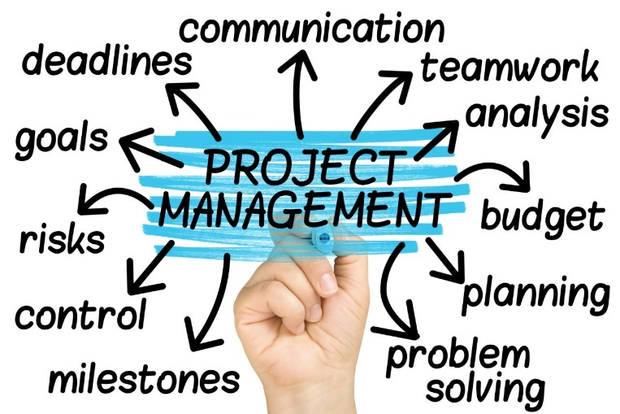
Effective project management is key to coordinating teams and tasks in order to meet project deadlines. The project manager oversees planning, scheduling, and budgeting to prevent delays and cost overruns. Clear communication, risk registers, performance indicators, and incentive-based contracts are crucial in helping to maintain project alignment, but knowledge retention within the workforce is just as crucial (March, 2017). A culture of continuous learning, mentoring, and professional development ensures that employees remain up to date with industry standards and technologies (BSI, RICS, HSE) etc. A strong company reputation further supports project success by attracting skilled workers and securing future business, based on high standards of quality, safety, and customer satisfaction. Strong management practices, including regular performance reviews, are essential to addressing issues quickly (Richard H. Clough, 2015). The images below help the PM identify the current state of the project and how critical resources are being handled. Figure 3 shows the critical path for the Canolfan Gwili Centre, while figure 4 shows the baseline of the current positioning of the project:
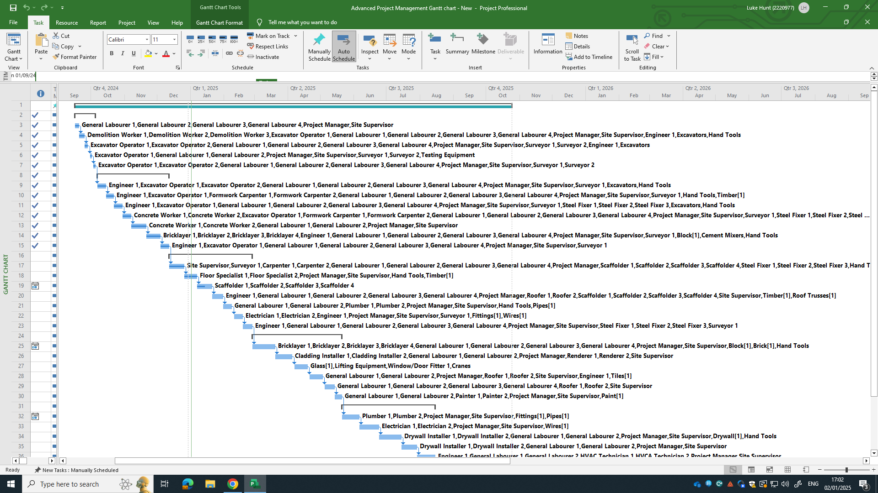
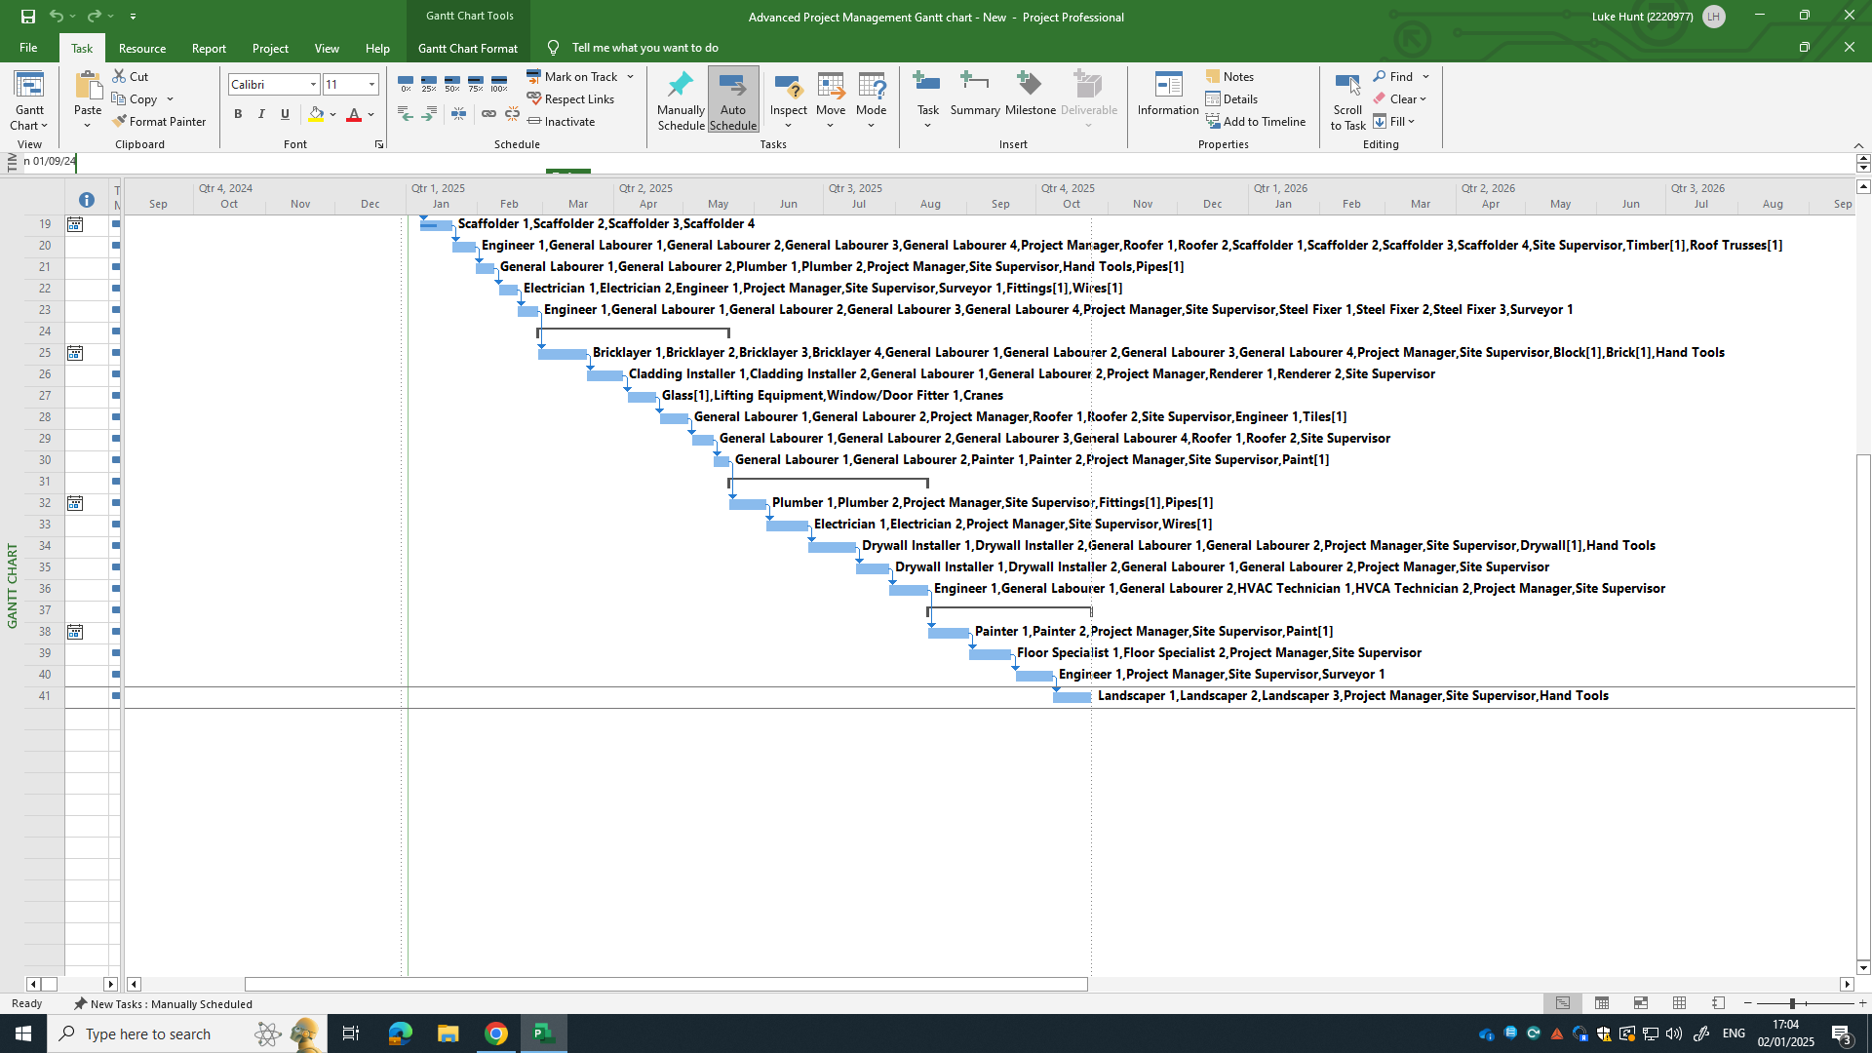
Figure 2 (Hunt, 2024)
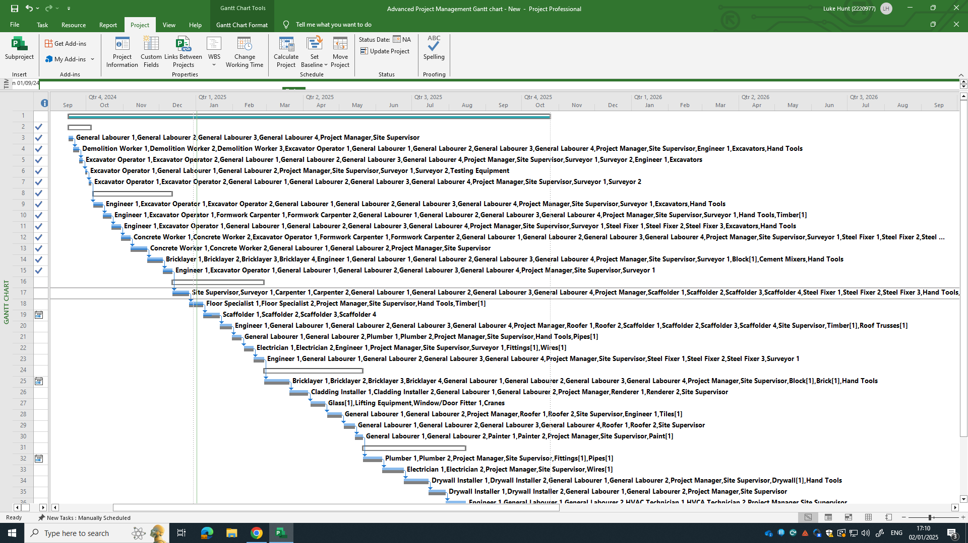
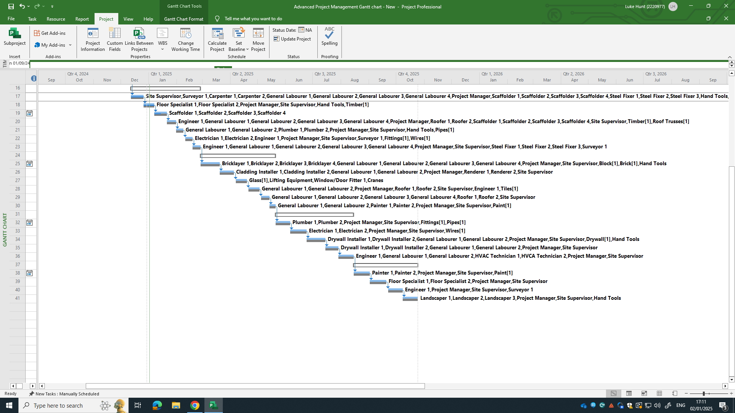
Figure 3 (Hunt, 2024)

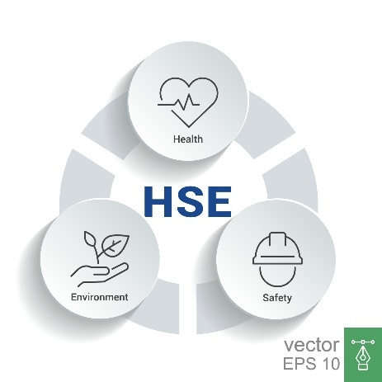
3.0.3 – Health and Safety
Health and Safety standards on site are paramount for maintaining critical resources throughout a project. Non-compliance with safety standards can lead to accidents, legal issues, and project delays. Thus, regular safety training, proactive inspections, and fostering a culture of safety awareness will help to minimise risks and enhance productivity throughout (Health and Safety Executive, 2024).

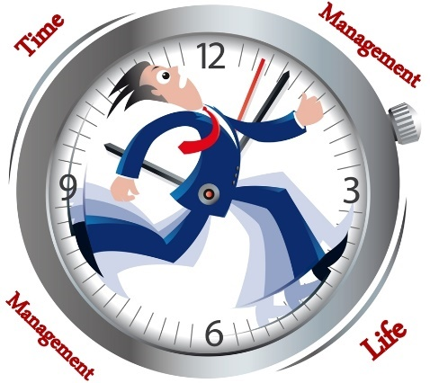
3.0.4 – Time Management
Time is a majorly critical resource for any project as it can have a both good and bad impacts on everything within a project. Delays, for example, can result from external factors like weather or internal issues like poor planning. In order to maintain effective time management, critical path methods, milestone tracking, and flexible planning, are essential. Regular progress reviews and incentive contracts will further ensure that timelines are adhered to (The constructor building idea, 2021).


3.0.5 – Specialist Skills
Procuring specialised skills, like HVAC or electrical systems, for site is another critical resource, linked to time management. Often in short supply, it is essential to address this early on as it can quickly lead to delays and increased costs (CITB, 2024). Early planning, targeted recruitment strategies, and training programs will help ensure the availability of necessary expertise.

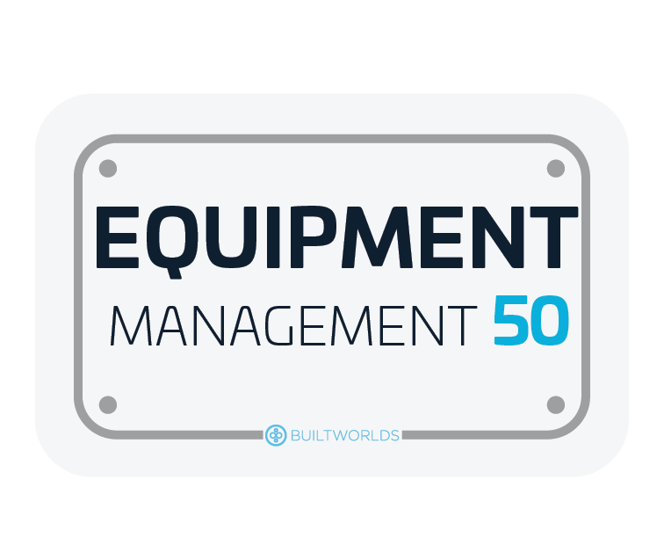
3.0.6 – Equipment Management
Managing and maintaining equipment on site is necessary for mitigating delays due to breakdowns. It’s important to consider whether machinery is to be purchased or hired, as this can absolutely impact the critical path. A well-maintained equipment strategy, including scheduled maintenance and contingency plans for breakdowns, ensures that machinery is available when needed. Regular maintenance and efficient scheduling will help to prevent unplanned downtime and optimise productivity (Lazar, 2023).

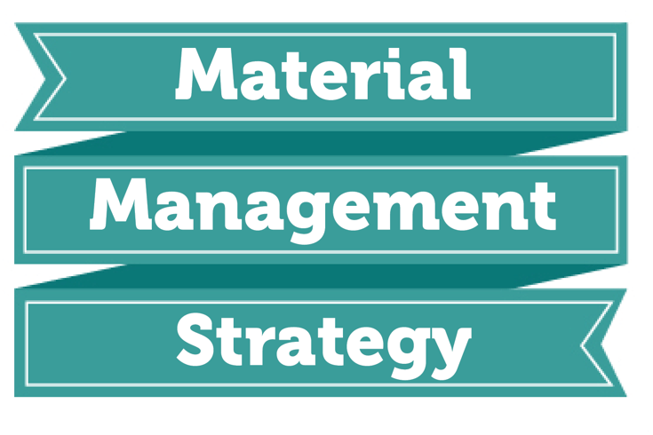
3.0.7. – Materials Management
Materials management is another critical resource that ensures a smooth construction process. Issues such as supply chain disruptions or fluctuating costs can cause delays. Therefore, a strong supply chain strategy, focusing on local suppliers and contingency plans, minimises such risks. Having efficient material management ensures that materials are available at the right time, within budget, and meet quality standards. Effective procurement planning, proper storage, and regular quality checks help to maintain material availability and compliance with regulations (Erickson, 2023).


3.0.8 – Financial Management
Financial Management is by far the most important resource available for any project. Keeping the project within budget and financially stable requires proper financial planning, including contingency budgets, and securing flexible funding. Regular financial reviews also allow for timely adjustments, ensuring financial feasibility throughout the project. Budget control, accurate cost forecasting, and cash flow management are fundamental considerations to avoid overspending and ensure the project runs smoothly (Farhadi, 2024).


3.0.1 – Company Reputation
Having a company that emits a good reputation shows both skilled workers and clients that the company’s standards reflect good quality, safety and client satisfaction. This helps achieve an element of trust and is crucial for enhancing and preserving a reputation. This will help with future business for other projects, thus supporting further the critical resources of this, and other projects (James, 2024).
As identified above, there are many factors that are to be considered for a construction project like the Canolfan Gwili Centre. There are critical resources that are fundamental to maintain a projects time, cost and quality and they are all interlinked. By addressing challenges such as labour shortages, material supply issues, and financial constraints proactively, the project remains on track, within budget, and meets quality standards. These factors are to be followed to ensure that the critical path of the Gwili Centre remains on target. Productive and effective Project management will allow for all of the above to be effectively coordinated and help to overcome potential barriers and ensures project success.

4.0 – Project Monitor and Control
Monitoring and controlling resources in construction projects is crucial to ensure efficiency, budget control, meet timelines, and maintain quality. For the Canolfan Gwili Centre project, overseeing human resources, materials, plant, and financial resources is essential to avoid inefficiencies, delays, and cost overruns. This section outlines strategies for managing these resources and emphasises the importance of timely interventions (Doyle, 2022). Figure 1 identifies the critical path, duration, dates, resources and cost. For the resource sheet, please refer to appendix 1.
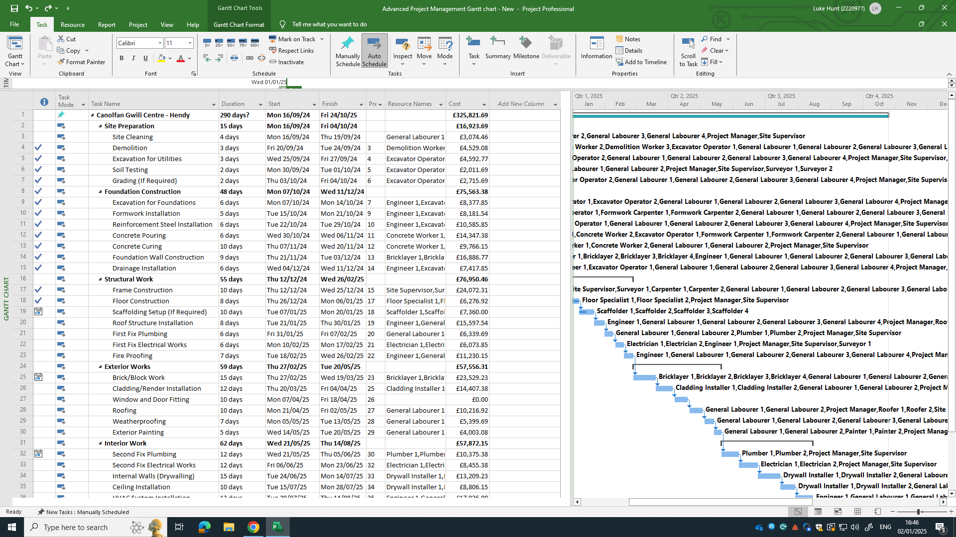
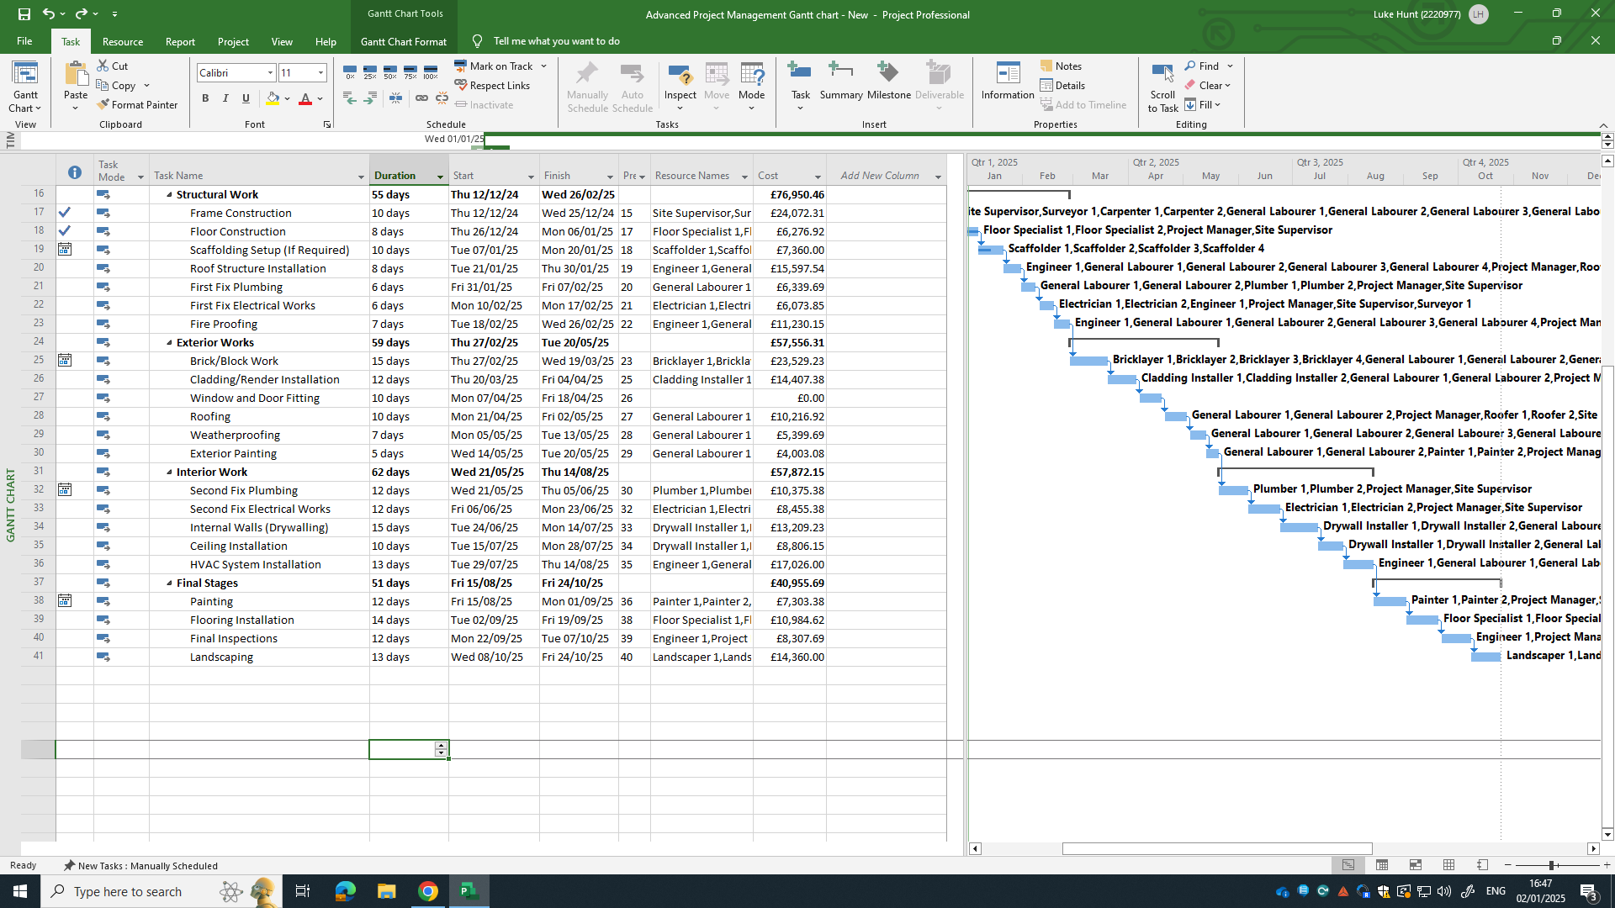
Figure 1 (Hunt, 2024)

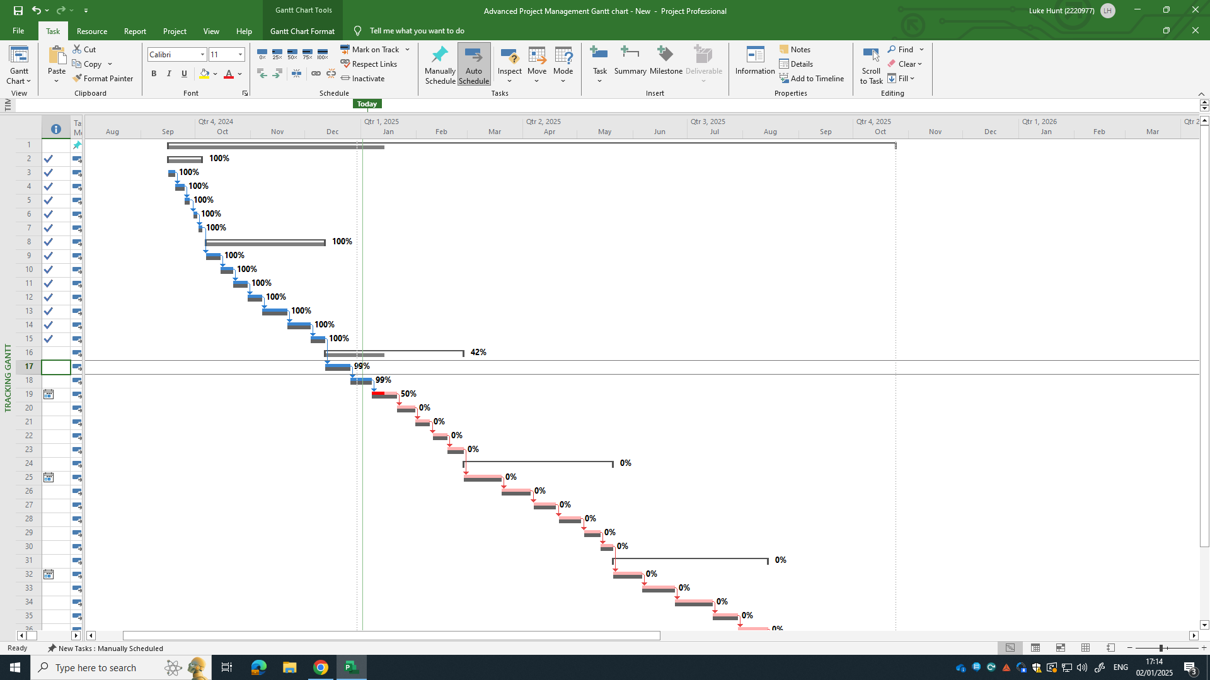
Figure 2 identifies the baseline for the project along with what sections are complete and what are not. All of this information collated can help to produce graphs on cost, based on risk and resources. This will help the project manager to identify and evaluate what the best decision is to make. Below are some key things to consider when monitoring and controlling the project:
Figure 2 (Hunt, 2024)
- Effective communication is essential in managing delays, ensuring transparency and encouraging collaboration among all stakeholders. Regular updates with contractors, clients, suppliers, and workers can help to better coordinate efforts and quickly adapt to changes. Without clear communication, these delays can escalate.
- Utilising the right contract provisions, such as the NEC contract’s risk registers and compensation event procedures, ensures that delays caused by unforeseen circumstances are managed efficiently. These tools enable early identification of risks and ensure delays are handled fairly (Tristancho, 2023).
- Furthermore, incentivisation is another tool that can motivate workers to recover lost time by offering bonuses or rewards for meeting specific performance targets. However, these incentives should be aligned with the project’s goals to remain cost-effective.
- By maintaining communication, adjusting schedules, reallocating resources, and leveraging contract provisions, the project manager can proactively address delays, minimising their impact and ensuring the successful completion of the project (Wiley-Blackwell, 2022)

5.0 – Delays and Delay Resolution
Delays are an inevitable aspect of most construction projects, but with the right strategies, they can be managed and resolved quickly to minimise their impact on the critical path. For the Canolfan Gwili Centre project, addressing delays shown in the Gantt Chart efficiently is central to staying on schedule. The following strategies outline key actions to resolve delays, including identifying causes, adjusting schedules, reallocating resources, maintaining communication, and utilising appropriate contract provisions. Figure 5 shows the roof structure installation delay that has cost 7 days, while the Windows and Doors fitting has been delayed by 10 days. There is now a clear shift from the baseline critical path, shown in red.
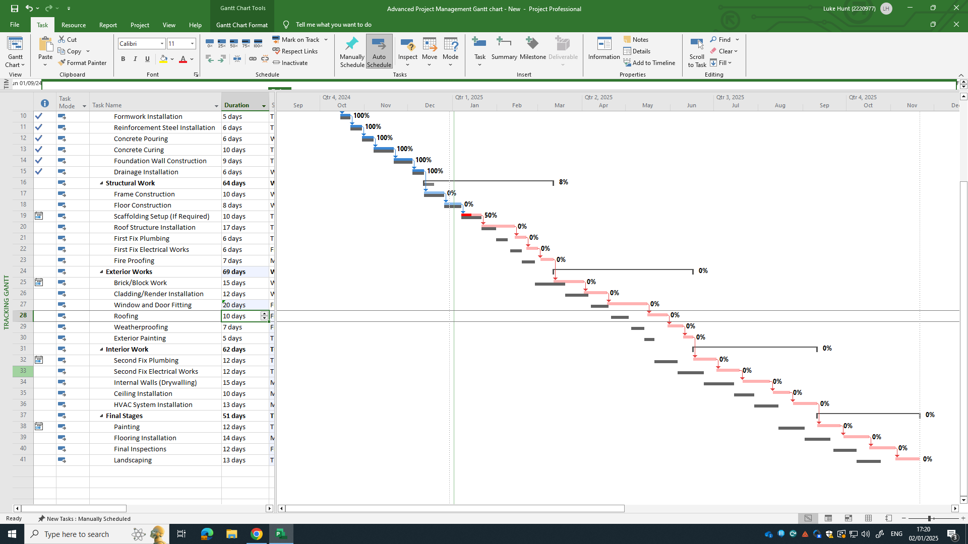
Figure 5 (Hunt, 2024)

The first step in resolving any delay is to identify its cause. In this case it is the roof structure installation and the windows and doors fittings. This could be from adverse weather conditions, supply chain disruptions, labour shortages, or equipment failures. A thorough analysis of the issue, and the impact of this, helps the project manager pinpoint the issue and decide on the most effective solution. Due to these delays, there now has to be an adjustment in the Gantt chart, and project, to try and bring back the time lost. Figure 6 below shows that during the structural stage of the project, which has been completed, was done so ahead of schedule (DesignHorizons Team, 2024).
In certain situations, reallocating resources may be necessary. This could involve bringing in additional labour or equipment to speed up delayed tasks. Ensuring resources are directed where they are needed most helps maintain productivity and reduces the potential for further delays. In the Gantt chart extra man hours were added to the structural Works, but also Second fix Plumbing was brought forward, ahead of the some of the completion of the exterior works, like exterior painting, and the window and door fittings. Figure 6 shows that these reallocations and adjustments has brought the project back to its critical path, and ahead of the end date. This will even allow for other delays, should there be any.
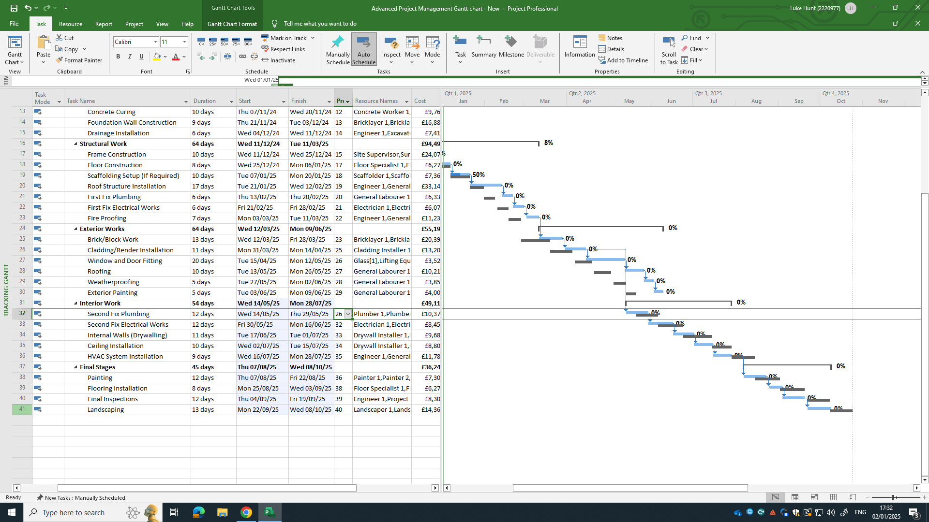
Figure 6 (Hunt, 2024)

6.0 – Conclusion
The Canolfan Gwili Centre project is a relatively small project. This might mean that some critical resources may be less available, and others, crucially more important. There are various methods of management that will allow the project to be monitored and controlled well enough that delays can be well mitigated. In the instance of the delay that has occurred, adjustments have been made in terms of reallocation of man hours, and activities that could be moved, that won’t affect the critical path or improve it. Although the end date has remained the same, the inner stages of the project have changed, and have relied on the need for extra hours to be works. I think incentivisation is a great way to maintain flow in the project. It may cost for bonuses etc but would be the lesser of two evils when compared to going over the deadline. Furthermore, communication is key to ensuring that everyone is aware of the changes and has the time to adapt, to allow the project to continue. Looking at utilising management methods like Maslow’s Hierarchy of needs (Cherry, 2024), would help to maintain a positive outlook for skilled workers, to help continue works. Effective project monitoring and control will lay the foundations for dealing with any delays and allow the project to fluctuate within the critical path.

- References
Cherry, K., 2024. Maslow's Hierarchy of Needs. [Online]
Available at: https://www.verywellmind.com/what-is-maslows-hierarchy-of-needs-4136760
[Accessed 2nd january 2024].
CITB, 2024. Over 250,000 extra construction workers required by 2028 to meet demand. [Online]
Available at: https://www.citb.co.uk/about-citb/news-events-and-blogs/over-250-000-extra-construction-workers-required-by-2028-to-meet-demand/
[Accessed 30th december 2024].
DesignHorizons Team, 2024. Effective Methods for Analyzing Construction Delays. [Online]
Available at: https://designhorizons.org/effective-methods-for-analyzing-construction-delays/
[Accessed 2nd january 2025].
Doyle, W., 2022. The Critical Path Method in Construction: A Comprehensive Guide. [Online]
Available at: https://www.gatherinsights.com/blog/the-critical-path-method-in-construction-a-comprehensive-guide
[Accessed 29th december 2024].
Erickson, C., 2023. What is Construction Materials Management?. [Online]
Available at: https://structshare.com/blog/what-is-construction-materials-management
[Accessed 30th december 2024].
Farhadi, F., 2024. Discover Essential Insights into Financial Management in Construction Projects. Learn about Key Components, Best Practices, Tools, and Future .... [Online]
Available at: https://neuroject.com/financial-management-in-construction/
[Accessed 30th december 2024].
Health and Safety Executive, 2024. HSE. [Online]
Available at: https://www.hse.gov.uk/construction/
[Accessed 30th December 2024].
Hunt, 2024. Project Gantt Chart. Carmarthen: Luke Hunt.
Hunt, 2024. Resource Sheet. Carmarthen: Luke Hunt.
Indeed, 2024. Excavator Driver. [Online]
Available at: Driver Excavator Work, jobs (with Salaries) | Indeed.com United Kingdom
[Accessed 30th december 2024].
James, W., 2024. How Does Brand Reputation Drive Construction Success?. [Online]
Available at: https://constructowiki.com/how-does-brand-reputation-drive-construction-success/
[Accessed 30th december 2024].
Lazar, A., 2023. Guide to Construction Equipment Management: Everything You Need to Know. [Online]
Available at: https://www.autodesk.com/blogs/construction/construction-equipment-management/
[Accessed 30th december 2024].
March, C., 2017. Construction Management Theory and Practice. 1st ed. Abington: Routledge.
Richard H. Clough, G. A. S. S. K. S. R. O. S. J. L. R., 2015. Construction Contracting: A Practical Guide to Company Management, 8th Edition. 8th ed. s.l.:s.n.
Schwartz, B., 2024. The Construction Resource Management Process Explained. [Online]
Available at: https://www.projectmanager.com/blog/construction-resource-management
[Accessed 29th december 2024].
The constructor building idea, 2021. The importance of effectiveness in construction. [Online]
Available at: https://theconstructor.org/others/the-importance-of-effective-time-management-in-construction/571072/
[Accessed 30th december 2024].
Wiley-Blackwell, 2022. Code of Practice for Project Management for the Built Environment, 6th Edition. 6th ed. s.l.:CIOB (The Chartered Institute of Building) .
AECOM, (Ed.). (2023). Spon's Architects' and Builders' Price Book 2024 (149th ed.). CRC Press. Available at: https://doi.org/10.1201/9781003428534

8.0 – Appendices

8.1 – Appendix 1
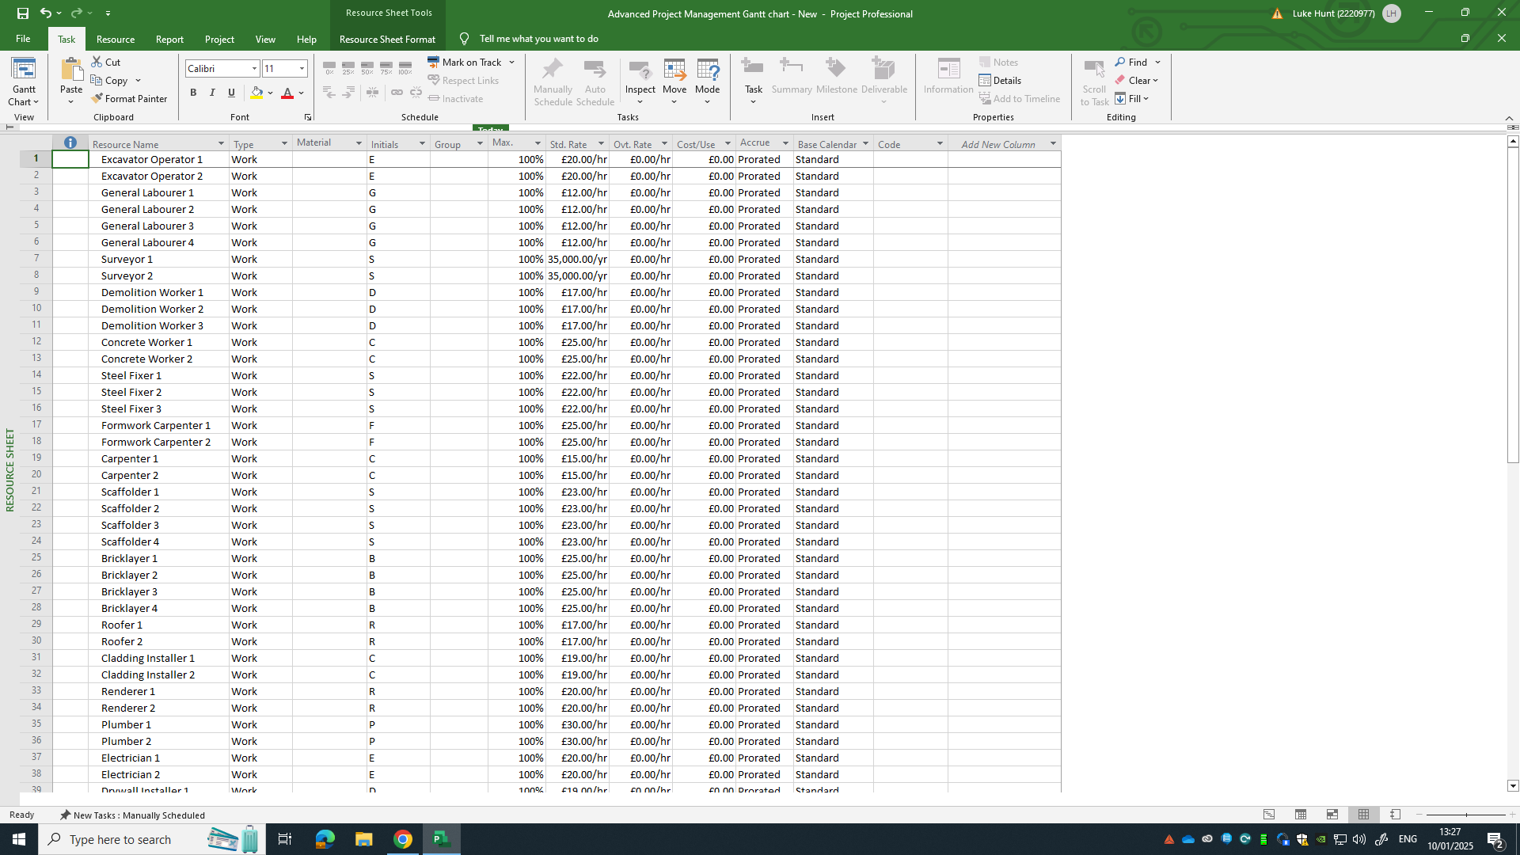
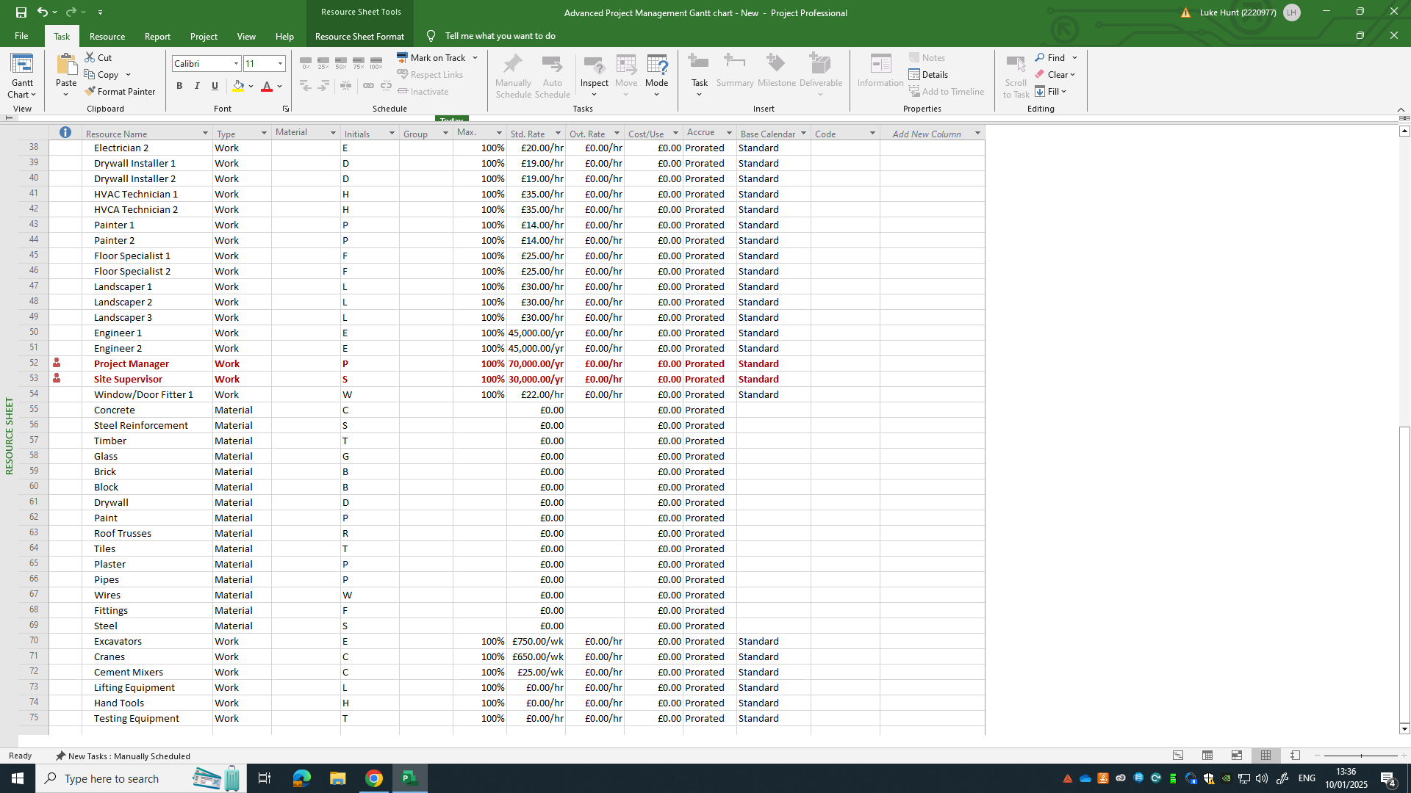
Figure 8 (Hunt, 2024)

8.2 – Appendices 2
Below are links for indeed hourly rates for labour, materials and machinery:
Erickson, C., 2023. What is Construction Materials Management?. [Online]
Available at: https://structshare.com/blog/what-is-construction-materials-management
[Accessed 30th december 2024].
Indeed, 2024. Jobs (with salaries). [Online]
Available at: Driver Excavator Work, jobs (with Salaries) | Indeed.com United Kingdom
[Accessed 29th December 2024].

Indeed, 2024. Jobs (with salaries). [Online]
Available at: Digital Surveyor Work, jobs (with Salaries) | Indeed.com United Kingdom [Accessed 29th December 2024].

Indeed, 2024. Jobs (with salaries). [Online]
Available at: General Labourer Work, jobs (with Salaries) | Indeed.com United Kingdom
[Accessed 29th December 2024].

Indeed, 2024. Jobs (with salaries). [Online]
Available at: Mason Work, jobs (with Salaries) | Indeed.com United Kingdom
[Accessed 29th December 2024].

Indeed, 2024. Jobs (with salaries). [Online]
Available at: https://uk.indeed.com/jobs?q=steel+fixer&l=&from=searchOnDesktopSerp&vjk=de24ad921fb
[Accessed 29th December 2024].

Indeed, 2024. Jobs (with salaries). [Online]
Available at: https://uk.indeed.com/jobs?q=hvac+technician&l=&from=searchOnDesktopSerp%2Cwhatautocomplete&vjk=1daf92c99
[Accessed 29th December 2024].

Indeed, 2024. Jobs (with salaries). [Online]
Available at: Painter Decorator Work, jobs (with Salaries) | Indeed.com United Kingdom
[Accessed 29th December 2024].

Indeed, 2024. Jobs (with salaries). [Online]
Available at: Drywall Work, jobs (with Salaries) | Indeed.com United Kingdom
[Accessed 29th December 2024].

Indeed, 2024. Jobs (with salaries). [Online]
Available at: Electrician Work, jobs (with Salaries) | Indeed.com United Kingdom
[Accessed 29th December 2024].

Indeed, 2024. Jobs (with salaries). [Online]
Available at: Cladding Work, jobs (with Salaries) | Indeed.com United Kingdom
[Accessed 29th December 2024].

Indeed, 2024. Jobs (with salaries). [Online]
Available at: Bricklayer Work, jobs (with Salaries) | Indeed.com United Kingdom
[Accessed 29th December 2024].

Indeed, 2024. Jobs (with salaries). [Online]
Available at: Scaffolder Work, jobs (with Salaries) | Indeed.com United Kingdom
[Accessed 29th December 2024].

Indeed, 2024. Jobs (with salaries). [Online]
Available at: Carpenter Work, jobs (with Salaries) | Indeed.com United Kingdom
[Accessed 29th December 2024].

Indeed, 2024. Jobs (with salaries). [Online]
Available at: Formwork Carpenter Jobs, Work (with Salaries) | Indeed.com United Kingdom
[Accessed 29th December 2024].

Indeed, 2024. Jobs (with salaries). [Online]
Available at: Concrete Finisher Jobs, Work (with Salaries) | Indeed.com United Kingdom
[Accessed 29th December 2024].

Indeed, 2024. Jobs (with salaries). [Online]
Available at: Digital Surveyor Work, jobs (with Salaries) | Indeed.com United Kingdom
[Accessed 29th December 2024].

Indeed, 2024. Jobs (with salaries). [Online]
Available at: Demolition Labourer Jobs, Work (with Salaries) | Indeed.com United Kingdom [Accessed 29th December 2024].
Indeed, 2024. Jobs (with salaries). [Online]
Available at:https://uk.indeed.com/jobs?q=floor%20layer&l=&from=searchOnDesktopSerp%2Cwhatautocomplete
[Accessed 29th December 2024].

Indeed, 2024. Jobs (with salaries). [Online]
Available at: Window Fitter Work, jobs (with Salaries) | Indeed.com United Kingdom
[Accessed 29th December 2024].

Indeed, 2024. Jobs (with salaries). [Online]
Available at: https://wedgewoodgroundworks.co.uk/machine-hire/
[Accessed 29th December 2024].

Indeed, 2024. Jobs (with salaries). [Online]
Available at: https://www.checkatrade.com/blog/cost-guides/crane-hire-cost/
[Accessed 29th December 2024].

Indeed, 2024. Jobs (with salaries). [Online]
Available at: Site Supervisor Work, jobs (with Salaries) | Indeed.com United Kingdom
[Accessed 29th December 2024].

Indeed, 2024. Jobs (with salaries). [Online]
Available at: https://uk.indeed.com/jobs?q=landscaper&l=&from=searchOnDesktopSerp%2Cwhatautocomplete
[Accessed 29th December 2024].

Indeed, 2024. Jobs (with salaries). [Online]
Available at: https://uk.indeed.com/jobs?q=site%20engineer&l=&from=searchOnDesktopSerp%2Cwhatautocomplete
[Accessed 29th December 2024].

Indeed, 2024. Jobs (with salaries). [Online]
Available at: Project Manager Work, jobs (with Salaries) | Indeed.com United Kingdom
[Accessed 29th December 2024].

Indeed, 2024. Jobs (with salaries). [Online]
Available at: Electrician Work, jobs (with Salaries) | Indeed.com United Kingdom
[Accessed 29th December 2024].

Indeed, 2024. Jobs (with salaries). [Online]
Available at: Plumber Work, jobs (with Salaries) | Indeed.com United Kingdom
[Accessed 29th December 2024].

