lclm4006 business plan
Programme Title :CertHe Business skills for the workplace

Zia-Ur-Rehman Tehzeeb (2438220)

Module Code: LCLM4006
Module Title: Enterprise and Entrepreneurship
Lecturer: Dr Ejike Udeogu
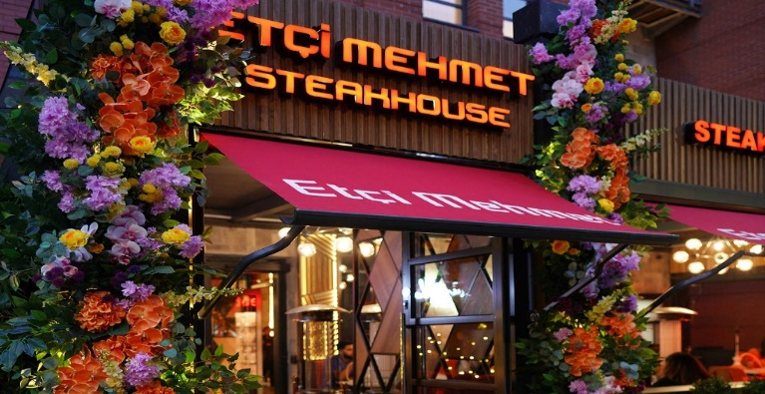

Executive Summary
Founded in Istanbul in 2012 by Mehmet and Mustafa (known as Baba).
Etci Mehmet is a well-known Turkish steakhouse that is famous for premium, halal – certified meats and dramatic fire show for entertainment. After starting In Turkey, the brand expanded into the UK with lively locations such as
Manchester, Birmingham, Liverpool and Leeds.

- High – Traffic Entertainment Hub: Birmingham City Centre a key destination where families come and do some shopping and having something to eat after their long day out.
- Accessibility & Parking: located in the Bullring shopping mall, the site offers parking essential for destination.
- Operational Capacity: The location offers necessary space for a high volume “show” dining experience.

USP’S:
- Location & Experience - offering a unique atmosphere for example, authentic rooftop, modern friendly areas.
- Digital integration & Delivery – utilising popular Turkish delivery apps to cater high demand for convenience foods.
Cash Projections:
- Market Growth -Food service is projected to grow from $14.55 billion to $16.52 billion between 2025 – 2026 (https://www.mordorinteligence.com/industry-reports)
- Cas Flow strategy – prioritising fast-moving items that manage inventory to avoid spoilage and maintain and handle cost surges.

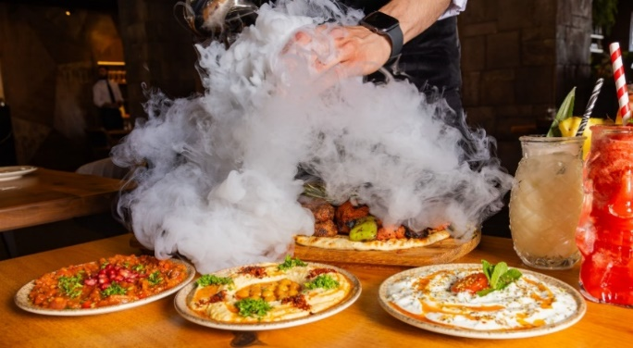

Contents
Executive Summary 1
Overview of the business 3
Legal format and management structure 4
PESTEL and Competitor analysis 5
Marketing strategies 6
Funding 7
Reference List 9

Overview of the business
Etci Mehmet is a Turkish restaurant that focuses on serving high – quality and traditional Turkish grilled meat dishes. The restaurant offers a wide range of authentic Turkish dining experiences full of flavour and freshness and setting out the highest standards when preparing meats.
key elements:
- Origins: The restaurant was established back in 2012 by Mustafa and Mehmet.
- Experience: Etci Mehmet is well known for its theatrical, lively dining experience that features flaming and high energy.
- Signature offerings: The menu features premium halal cuts such as Tomahawk and Ribeye for instance a 24-carat gold covered giving it a traditional wow look.
- Expansion: Following its success in Istanbul, the well-known brand expanded internationally in the UK, beginning with its first location in Manchester then moving swiftly into Birmingham and then Leeds.
- Atmosphere: Designed for family celebrations and very welcoming.

The rationale for Birmingham is supported by its status as one of the UK’S most diverse cities, massive night – time economy and rapidly expanding Turkish Cultural footprint.
There are around 127,644 Turkish – born residents across England and Wales as of 2021 (https://www.ons.gov.uk), Birmingham has a key hub for Turkish business and community growth.

Bustling Night Life:
Economic Impact: Nighttime economy in the UK has around 1.3 million jobs and approximately 10% of GDP in the West Midlands hospitality trade employees about 120,000 people making up one third of reginal workplace (https:/www.birmingham.gov.uk)

Legal format and management structure

This business will operate as a franchise by leading an immediate brand recognition and having a reduced risk of failure.
because it provides a passion and offers the independence of being one’s own boss while providing a space for social connection.
Etci Mehmet restaurant operates a private Limited company (Ltd) under the act 2006.
Key advantages of a legal format for a startup include:
- Limited Liability protection
- Access to Capital and credibility
- Funder Agreements and continuity
Etci Mehmet restaurant utilizes a functional management structure allowing restaurants to clear and taking responsibilities kitchen (back of house) and the dining area (front of house)
Management structure – Director overseas staff, including cashiers, team members and areas managers.
Head Chef – Leads the entire Kitchen
Bar Assistant – Makes soft drinks and Mocktails.
Waiter 1 – Serves food to the customers.
Waiter 2 – Asks how the food is and is there anything else they would like to order.

PESTEL and Competitor analysis
Top competitors of Etci Mehmet: Etci Mehmet has several competitors from both high – profile celebrity steakhouse and established high quality Turkish restaurants in the UK ideally from cities like Manchester, Liverpool and Leeds.
- Ribeye Steakhouse – known for offering premium steaks in similar locations.
- The Oakleaf Restaurant – competes in high end dining sector.
- Giuseppe – A restaurant that offers similar dining experiences.
- Other High-End Turkish / Steak Restaurants – similar locations in Manchester, Liverpool and Birmingham that provide halal and experiential dining.
Steakhouse industry:
Political factors are external government – driven influences, polices and laws that impact business operations.
- Halal Certification & regulations – varying regulations regarding halal sourcing and certification in different countries such as Turkey, UK and Saudi Arabia.
- Trade Restrictions/ import Tariffs – impacts the ability to source premium meats and products internationally.
- Political Stability in operations locations such as Turkey, UK, Saudi Arabia and Qatar.
Economic Factors is anything that has a bearing on the economy.
- Inflation and Rising meat costs
- Exchange Rate Volatility
- Consumer Disposable Income
Social Factors is elements that shape human interactions and societal structures including demographics and social institutions.
- Demands for Halal Fine Dining
- Cultural Preferences/ Dietary Trends
Technological Factors is something that’s based in science and applied to everyday life to solve problems.
- Social Media & Digital Marketing
- Online Reservations
- Food Preparations
Environmental Factors is external surroundings conditions, and influences – both natural and human made.
- Sustainable sourcing
- Waste Management
Legal Factors are laws and regulations and court decisions that business and individuals must follow.
- Health & Safety Compliance
- Licensing & Permits

Marketing strategies

Families and groups who are looking for shared, authentic dishes to tourists exploring cultural cuisine and looking for a welcoming atmosphere.
Key Customer profiles and preferences:
- Cultural Seekers / Tourists – interested in making full use of traditional dishes like steaks and baklava.
- Group / Family Diners – Enjoy shared dining experiences such as sharing Meze plates.
Locals / Business people – seeking quick lunch options or a relaxed dinner atmosphere.
Technologies & Platforms:
- Social Media & Content
- Reviews
- Online Reservations
- Digital Marketing
- Online ordering & delivery
- Loyalty points
- Website
Key strategies for Turkish Restaurant:
- Visual Appeal
- Influencers
- Unique Experiences

Funding

 | CASH FLOW
 |  | MONTH
 | Cash in | 1
 | Loan- start up capital | £5,000
 | Sales (total sales of product and/or services) | £800
 | Other | £290
 | Total cash in-flows (A) | £6,090
 |  | MONTH
 | Cash out-expenses | 1
 | Rent or premises costs | £900
 | Business rates for your business premises | £1,200
 | Utilities (gas, electricity, water) | £600
 | Insurance | £100
 | Telephone and internet | £120
 | Marketing and advertising expenses | £500
 | Vehicle running costs | £200
 | Equipment purchase or leasing | £1,000
 | Postage, printing, stationery | £100
 | Transport and delivery | £100
 | Professional fees (legal, accounting etc.) | £80
 | Cost of sales (Cost of product) | £800
 | Wages your own | £500
 | Staff wages | £800
 | Any other | £60
 | Any other | £50
 | Total cash out-flows (B) | £7,110
 | Your net cash flow (A-B) | £230

Reference List
Chaffey, D. and Ellis – Chadwick, F. (2022) Digital marketing. 8th edn. Harlow: Pearson.
Edwards, E. (2020) ‘The thingness of photographs’, in S. Bull (ed.) A companion to photography. Wiley – Blackwell, pp. 97 – 112.
Gerrards, S. et al. (2005) Environmental management systems. London: Routledge.
LaRochelle, J. M. and King, A. R. (2011) ‘Avoiding Plagiarism’, Hospital Pharmacy, 46(12), pp. 917 – 919.
Office for National Statistics (2023) Labour market overview, UK: November 2023. Available at: https://www.ons.gov.uk (Accessed: 25th February 2026).
Peston, R. (2012) why are we in this mess. London: Hodder & Stoughton.
Selman, P. (2012) ‘Learning to love the landscapes of Carbon – neutral development’, Landscape Research, 37(1), pp. 5 - 21.
World Health Organisation (2021) Global Health Reports. Available at: https://www.who.int (Accessed: 10th November 2024).

