Holiday Inn
Wakibur Rahman 1906346
Holiday Inn
6th December 2022
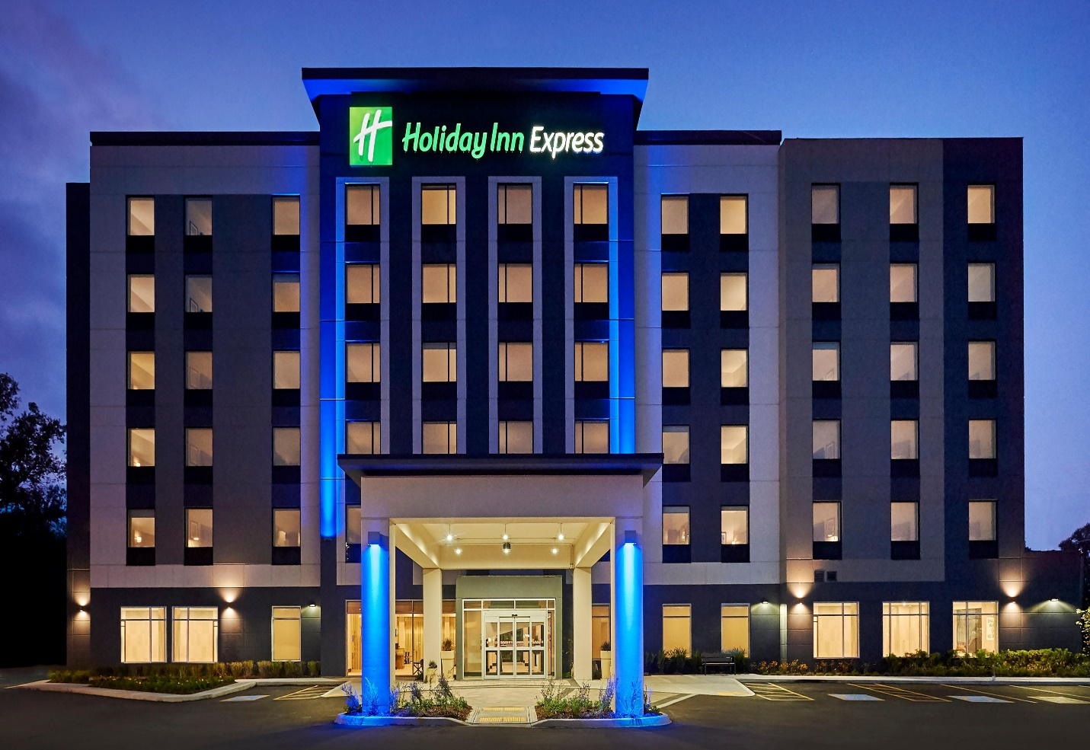

Executive summary
Holiday Inn is a reputable hotel brand that caters to business travelers by equipping them with the amenities they need in order to be productive while they are away from the office. The primary advantages offered by this hotel chain include: Excellent advertising helps people remember the brand and increases its exposure; there are 1200 hotels throughout the world; the parent firm has a strong brand; a diverse group of people choose hotels; and there are 100 million tourist nights each year, demonstrating that customers are satisfied. In additional to that, Holiday Inn has earned a poor rating in a number of different categories. First, Holiday Inn is now increasing its attempts to obtain a larger degree of market penetration in emerging nations. At the same time, the company faces a significant amount of competition, which has led to a small market share. In addition, a significant number of guests have voiced their dissatisfaction with the quality of service provided by this hotel. However, travelers are enthusiastic in seeing a range of new destinations and taking advantage of seasonal bargains that are unique to each country, which might raise the demand for Holiday Inn accommodations. In the meanwhile, hotels and the Somerston Capital fund are making large investments in Holiday Inn franchisees. In addition to this, the agreement with IHG has been extended for another 15 years beginning in 2018, beginning with the period that is now in effect. These concerns have been taken into consideration as potential significant elements that might lead to a growth in the company's market share in the market. It has been found that, several recent economic issues have created a complex situations for Holiday Inn as people are reducing their spending on luxury items. A greater rate of capital interest has made it difficult to collect funds, and a higher rate of inflation has led to a reduction in the residents' discretionary spending. As a result, fewer people are going on trips and tours because of the higher prices. As a consequence of this, it is predicted that there will be a reduction in the number of individuals’ tourists and visitors in the following days. People demand cheaper services in comparison to the price increase, but it is difficult for the management of the hotel to provide this. A more recent obstacle for Holiday Inn is that various individuals have different requirements, and because of the wide variety of requirements, it might be difficult for hotel management to meet everyone's wants. This is a newer problem for Holiday Inn.
This report has summarized that Holiday Inn London lacks of congenial atmosphere for visitors. Many guests have complained that the advertisement does not match their hotel experiences. The surroundings was woefully lacking in furnishings and creating continuous visitors’ dissatisfaction. Dust, trash, and inefficient waste management were everywhere. In addition to that, Hotel room interiors were disappointing. Customers complained that their rooms' basics were so unclean they couldn't use them. The rental home lacks a mirror, TV remote, mattresses, and air coolers, according to several tenants. However, most clients saw room price as a selling point. Lighting and air conditioning worked too. Considering these issues along with other problems, an action plan has been designed and solved four different issues mentioning approaches, objectives, tenure, and expected costs.

Contents
Introduction 5
Scope and analysis 6
SWOT Analysis 8
PESTLE analysis 9
Main body 11
Findings and result 18
Action plan 21
Recommendations 24
Conclusion 25
References 26

Introduction
The Holiday Inn name is the most well-known hotel chain in the world, with more than 1,200 locations. Holiday Inn is a trusted hotel chain that caters to business travelers by providing them with the facilities they require, as well as a welcoming environment where vacationers can unwind in style with access to on-site dining options, room service, private pools, fitness centers, and relaxing lounge areas. The Holiday Inn brand has been servicing visitors for decades, and the hotel's infor mal environment and features like meeting as well as on amenities, Kids Eat and Stay Free programmes, and KidSuites rooms have helped make it "America's Favorite Hotel." On the other hand, there have been some reports of problems with the hotel's service. This paper will single out one such grievance and examine it thoroughly before offering suggestions for resolving it. One of the complaints of a client collected from Moon et al (2020) is like ‘It was trashy. You won't receive what you see online. You're seeing a waterfront hotel online. You'll receive a waterfront motel. And not online. It's fake. The room and bathroom were poor. The whole area stunk. Each light is rusty and aged. I'm speechless when we arrive. The building's paint was deteriorating and the pool and other areas looked patched up. God awful Lawn chairs awful, lobby bad it’s not what you see on the photographs, and I told a manager that we need new towels and bed linens in our room. And tell him that online pictures aren't real and he must take them down. Many years ago, this motel closed. The guy or people that brought it didn't upgrade the construction or interior. It upset me a lot. It's a damn pity you're in a motel, not a hotel. We didn't come from NJ to be in a motel. Holiday Inn Express has a fantastic brand, but the hotel isn't up to par. Get his name. I don't like it and wouldn't suggest it’. So, it advisable that for Holiday Inn to focus on these issues to advance in the future. Every customer complaint must be taken into consideration. So, this consultancy report will analyze this comment and will develop action plan for Holiday Inn.

Scope and analysis
Holiday Inn has emerged as one of the most well-known and respected hotel chains in the world since it first opened its doors in 1952 (Kimes, 2001). Since then, over than a thousand hotels under the Holiday Inn brand have opened their doors throughout the globe. Whether they are in town for business or pleasure, guests at Holiday Inn Hotels & Resorts in London City get attentive service and a friendly atmosphere throughout their stay. The surroundings, services, and facilities provided by these hotels, which range from metropolitan areas to beach resorts, make it easier to work, relax, and interact with others regardless of whether an individual is hanging out with friends, family, coworkers, or customers. This hotel network now has 1182 properties with a total of 212534 guest rooms, while at the same times, it is planning to create an additional 241 hotels so that it may better serve clients all over the world (Smirl, 2016).
Every day, 325,000 people who are brilliant and enthusiastic about hospitality offer True Hospitality for Good in this company's hotels and communities located all over the globe. This hotel chain operates hotels in three separate capacities: as a franchisor, as a management, and both as an owner and a lessee of individual properties. It specializes on the mainstream, upmarket, and luxury areas of the hotel business, and it has a specialized portfolio of brands that are specifically customized to satisfy the requirements of visitors for various events and situations (Smirl, 2016). One of the most significant advantages that IHG has is its extensive worldwide network of hotel owners. The key to its success is pairing owners with the appropriate brands and markets, as well as collaborating with one another to make the most of our size and resources in order to generate high returns. This hotel places an emphasis on growing businesses at every stage, from gathering to talk about a brand-new concept to preparing every aspect of a hotel's administration to the launch of the hotel itself (Shuford, 2015). Once it is operational, it will provide hotel owners with world-class and brand-specific tools that will assist in driving hotel staff performance, greater visitor happiness, and higher revenue. In addition to this, it maintains a tight working relationship with the IHG Owners Association, which serves as a voice for the concerns of more than 4,500 hotel managers and owners throughout the globe.
The goal of producing outstanding, economy net rooms growth has not altered, and it will continue to be driven by continuous investments in improving what is offered to guests and owners and building this brand at volume in increased markets. This leads to a sustainable rise in working capital and earnings over the long run, which, if executed with discipline, may be reinvestment in our company or given to shareholders. What has changed is the way in which this brand executes on the strategy that has been created.
This includes what it targets, the behaviours that it champions, and the objective that leads this brand. It has examined what is most essential, not only to IHG's development, but how it grow, keeping in mind what it has learned from grappling with Covid-19 and preparing for a successful recovery over time. This has been done by listening to stakeholders and evaluating what is most important. As a result, its goals have shifted to place brands at the center of the company's operations, while also placing owners and visitors at the forefront of thoughts. This brand acknowledges the significant part that an advanced, well-invested digital strategy plays in ensuring that we live up to our increasing obligation to look out for the well-being of individuals and communities while also preserving the health of the planet.
This hotel network now operates over 6,000 hotels and 885,000 bedrooms in more than 100 different countries. Additionally, it has 17 distinct brands that cater to the various visitor demands that are present all over the globe. In addition, Holiday Inn has one of the biggest hotel loyalty programmes in the whole globe. According to a report, non-rooms income will account for 13% of total income in 2021 (Hultman et al, 2021). Food and beverage sales will account for 11% of this revenue, and the company will also have 9 Guest Contact Centers located across the globe, each of which will support 12 different languages. Through the IHG Way of Clean, this company is now reinventing cleanliness by using science-led standards and service metrics. Additionally, its branded websites are mobile friendly and provide over 158 different brand/language combinations, which are quite helpful for site visitors.

So, there is a question and that is, what factors drive these movements of Holiday Inn worldwide? SWOT and PESTLE have been explained below to understand this question.

SWOT Analysis
Strengths | Weaknesses
1. Excellent advertising boosts brand remember and exposure (Gursoy and Chi, 2020).  2. 1200 hotels globally  3. Parent company's brand is high  4. Choice of hotels  5. 100 million visitor nights every year displays consumer satisfaction. | 1. Continuing efforts to achieve a higher level of market penetration in developing countries (Gursoy and Chi, 2020)  2. An enormous number of rivals results in a little market share.  3. Huge number of customers’ complaints on service delivery
Opportunities | Threats
1. Tourists are interested in seeing a variety of new places.  2. Seasonal deals that are distinctive to each country  3. Hotels as well as the Somerston Capital fund are making significant investments in Holiday Inn franchisees (Smart et al, 2021).  4. The deal with IHG has been renewed for another 15 years commencing in 2018, starting with the current term. | 1. An increase in the hotel's overall operating expenses will have an indirect effect on room prices  2.A fall in the tourist business as a direct result of the global influenza epidemic and the continuing economic crisis in the world's main economies (Smart et al, 2021)  3. A fierce level of rivalry on a worldwide scale from both well-known and local hotels

The important strengths of Holiday Inn's business that offer the company a competitive edge in the market are the ones that make up Holiday Inn's strengths. The financial condition of a brand, the skilled workforce it employs, the one-of-a-kind quality of its products, and intangible assets such as brand value are all essential variables that contribute to its strengths.

However, continuing efforts to achieve a higher level of market penetration in developing countries, an enormous number of rivals’ results in a little market shares and huge number of customers’ complaints on service delivery are its major weaknesses. Hotels and the Somerston Capital fund are making substantial investments in Holiday Inn franchisees, but travelers want to experience a wide range of new destinations and take advantage of seasonal bargains that are unique to each country. In addition, the present period might be seen as a chance to attract additional guests since the arrangement with IHG has been extended for the next 15 years beginning in 2018.

PESTLE analysis
Political factors | Economic factors | Social factors
- Due to the worldwide economic turmoil, even the United Kingdom is also facing challenges and therefore, within a year, citizen of the country have seen three government (Jones and Comfort, 2020).  - Different government implement set different rules which create an ambivalent situation for Holiday Inn | - Higher interest rate of capital has made fund collection challenging  - Higher inflation has reduced extra spending of citizens (Sanabria-Díaz et al, 2021)  - Less people opt for visits and tours due to higher costs | - People want cheaper services compared to the price hike, but it is a difficult for the hotel management (Jones and Comfort, 2020)  - Different people demand different requirements and due to the variation on demands, it is challenging for hotel management to manage all their needs
Technological factors | Legal factors | Environmental factors
- Technology has supported better customer management  - Easy communication and booking systems  - Reduced customers complaints  - Advance bookings and reservation have become a supportive service for visitors and tourists (Rahimi and Gunlu, 2016) | - Strict implementation of consumer laws have reduced scope for the hotel management  - Customers have been given with the full rights although legal supports have not been increased for the industry (Sanabria-Díaz et al, 2021)  - Government has no allocation to support the industry by law. | - Increased costs due to extensive focus on waste management  - Committed to reduce carbon and greenhouse gas emissions (Rahimi and Gunlu, 2016)  - Efficient treatment plan installed in every hotel for better management

Main body
Based on the comments of client along with SWOT and PESTLE analysis, several issues have been found that are both good and limitations of Holiday Inn. However, the areas where Holiday Inn is now doing better should be improved more possible and at the same time, areas where there are significant lack of focus and improvement exist, must be taken into considerations to develop plans.
Realistic advertisement: Holiday Inn must keep an exact balance between what it show online and what really exist in the hotel. Reputation management is an important part of realistic advertisement and it can be done by ensuring that customer see the same thing online and offline (Jones and Comfort, 2020). Because it also creates credibility of the hotel service. Royalty programs and focusing on existing customer well can create a realistic vibe of the hotel among visitors and tourists. In the hotel sector, where customers may only stay with once, a loyalty programme is more important than ever before as a promotional tool. In a time when most of the customers use price comparison websites before booking a trip, this is more important than ever. It's important to keep in mind that lengthy programmes that require customers to collect stamps, etc., prove mostly harmful, as many failing hotels have discovered. Instead, Holiday Inn should highlight the advantages they will get throughout their current or future stay. Offers like a 30% discount on a second night's stay or complimentary meals during their stay are certain ways to attract customers who might otherwise only stay for one night, the average length of stay for leisure travelers. It is anticipated that personalization will prove to be particularly important in this context, as much as 55% of professionals working in the airline and travel business already investing with dependable outcomes (Rahimi and Gunlu, 2016). Even better, since the company's tailored work will be handled by software that is both easy and automated, there will be no increase in the amount of work that has to be done at any point. Instead, reference number software that delivers automatic single-use coupons directly to current consumer inboxes is sure to enhance conversions here by providing consumers with tailor-made perks that demonstrate Holiday Inn's concern for them as individuals.

As a matter of fact, 79% of customers currently claim that they will only react to discounts that are personalized in these ways, which will make this a major component of hospitality in the year 2020 (Jones and Comfort, 2020). Therefore, this may be another approach for Holiday Inn to take clients and demonstrate that it has their back and is devoted to providing the finest service possible.
Attractive and ready-to-serve environment: Always keep in mind that customers are evaluating both the hotel as a whole and what they are seeing from personally. If Holiday Inn want to get people's attention and leave a positive impression, it should put some effort into the building's construction, design, and interior decoration, as well as its overall cleanliness. Make an additional effort to ensure that the rooms management are renting out are not just beautiful but also pleasant and well-kept. Because they are paying for the hotel, guests expect nothing less than to be wowed by the accommodations, regardless of how far they have travelled to reach the hotel in search of a comfortable place to rest their heads (Camilleri, 2018). Secondly, guests will be pleasantly surprised by the addition of outside seating, which will come at a time when they are beginning to feel at ease in the hotel. Management have the option of setting up an outside restaurant and bar, or they can just create space for chairs and tables so that guests can kick back and take it easy while they are there. It is a good idea to make an investment in a gas patio heater for each seat so that they can warm up the outside area when it becomes cold or when it gets dark outside. Because of this, the management will be capable of making use of the patio throughout the whole year and will not be constrained by the weather in terms of when they can and cannot open it. Moreover, never undervalue the contribution that personnel makes to the successful operation of the hotel. Employ individuals that are skilled, affable, and knowledgeable about providing superior service to the clientele. It is important that the management should not be scared to clean place and get rid of the personnel that are bringing energy levels down and making visitors feel uncomfortable or irritated. If necessary, the management must take action to involve in the recruiting process, and should not keep in the dark regarding the individuals who are now representing hotel environment (Moon et al, 2020).

Development of brand value: It is essential for the success of the company that Holiday Inn develop a solid reputation. When guests hear the name of the hotel and its brand, they already know what to anticipate, from the kind of services that are accessible to the rewards programmes that are provided. Customers need to feel that they have an emotional and personal connection to the company in order for that relationship to be successful (Camilleri, 2018). Travelers may be made to feel more connected to a hotel brand via the utilization of personal anecdotes and experiences that others have had through experiential marketing. The management has to identify the characteristics and principles of the brand that are shared by the many assets so that they may be grouped together under one name. In additional to that, workers as well as all of the underlying personnel are required to exhibit the appropriate values and ethics. There are a lot of hotels that are using branding to emphasize their stance on social themes like diversity and sustainability. In relation to that, the management of the hotel is responsible for establishing an expectation for the quality of service provided.
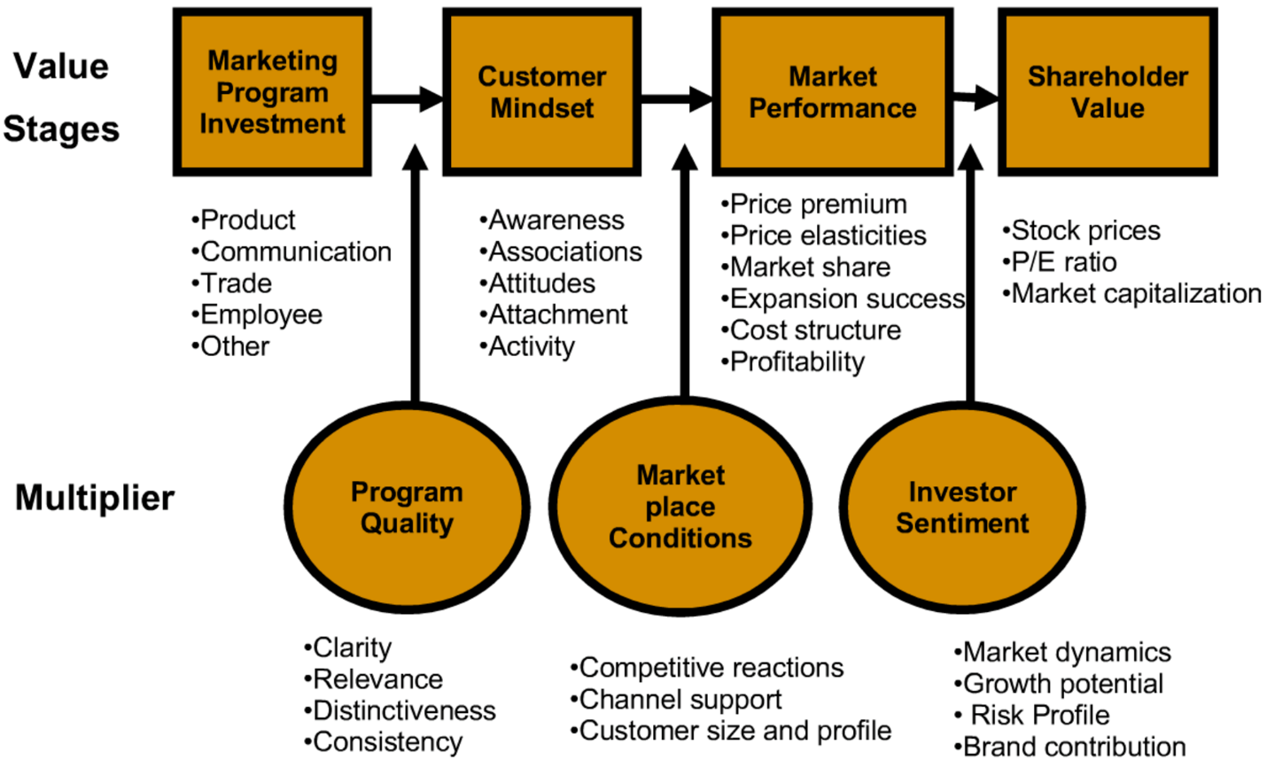
Figure-1: Brand value composition for Hotel Industry (Khalayleh and Al-Hawary, 2022)
In the end, it is necessary to develop brand promise by reiterating the hotel's objective and the strategies it plans to use in order to fulfil that mission. Because an enticing marketing slogan, name, or promise may make a hotel well-known in the area or perhaps worldwide. The finest hotels should expand its definition to include the idea of hospitality in addition to the standard amenities they provide, which may include the condition of the rooms, the facilities, or the level of service provided by staff members who have received enough training. Hotel chains are in the company of taking good care of people, and the staff of a hotel should strive to provide customers with an experience that is transformative (Khalayleh and Al-Hawary, 2022). This is because providing customers with an experience that is transformative creates a lifelong experience for a new customer, increasing the likelihood that they will select this hotel again in the future. When someone takes the time to care for another, it not only creates a feeling in that person but also strengthens the connection between those individuals, which in turn spreads that emotion. The real care shown to another person has the power to alter both their state of mind and their viewpoint. Successful hotel chains should actually cultivate hospitality and customer excellence - the fundamental ideas upon which they are formed - and incorporate it into their brand culture (Moon et al, 2020). Hospitality and customer excellence are the cornerstones of successful hotel brands. One brand that is responsible for the creation of life-changing experiences is The Peninsula, China. They do this by providing excellent hospitality.
Efficient workforce for better service delivery: If workers aren't given a specific objective to work toward, it's unreasonable for a company or organisation to expect them to be productive. Personnel will become less effective if the objective that they are working toward is not well defined and is not genuinely feasible. Therefore, Holiday Inn has to make an effort to ensure that the tasks its staff are assigned are as specific and concise as is feasible. The management has to make it clear to them precisely what it is that they anticipate from them, as well as the particular effects that this project will have on the hotel's reputation and its capacity to remain profitable. To do this, one strategy is to ensure that the objectives the management set are "SMART," which stands for specified, measurable, achievable, realistic, and timely.
Before delegating a work to an employee, the supervisor is required to determine whether or not it satisfies each of these criteria (Shuford, 2015).
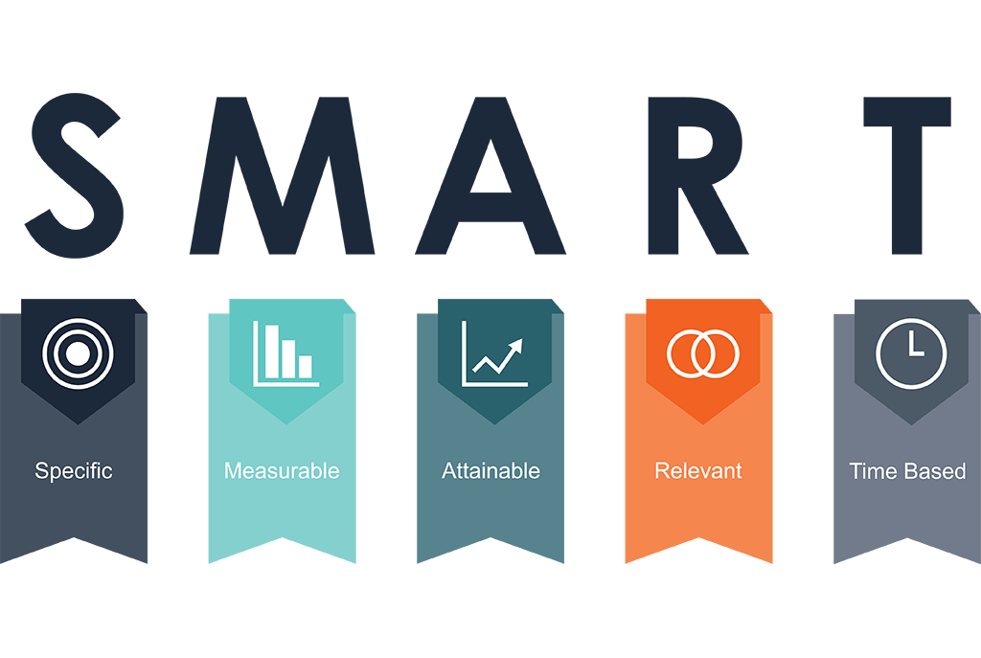
Figure-2: Setting SMART objective for employees will ensure engagement and dedication (Rutherford, 2021)
Cost minimizations: As costs of business operations including food items, salary of employees, and transportation have been increased, it is also necessary for Holiday Inn to ensure that its cost of operation is minimum. Through the use of a cost-benefit analysis, Holiday Inn is able to determine whether or not it is financially beneficial to pursue a given project or opportunity (Rutherford, 2021). Because it can determine whether the advantages of a task outweigh the costs — in other words, whether it has profit potential —, it provides a structure for businesses to make comparisons projects on a like-for-like basis, and it acts as a comprehensive method for deciding the most cost-effective direction to a desired outcome, such as Project A or Project B.
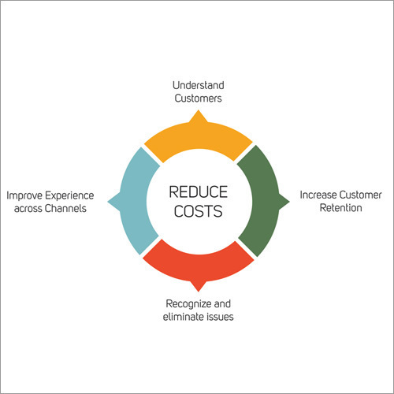
This makes it a useful tool for businesses that want to obtain cost efficiency because this can determine whether a project has profit potential. Whenever it comes to making the most of available funds, it is essential to intelligently match available resources with the appropriate tasks. The idea of operating a company in a manner that minimizes costs is one that almost every proprietor of a company is familiar with. One way for a firm to optimize profits is to reduce expenses as much as possible. Nevertheless, a significant number of businesses are unable of comprehending the fact that the variable, return on investment, is of the utmost significance in this equation (ROI) (Rutherford, 2021). To put it another way, it is not sufficient to just reduce expenditures. Because there are many scenarios in which a Holiday Inn may save funds in the short term but lose out on value - and funds - in the long term, businesses and hotels need to help ensure that those cutbacks are worth that which they save. This is because there are many scenarios in which a company may save money in the short term. When it comes to working with information technology services, company owners often run into this issue. When they examine at the cost for a certain service or product, they can come to the conclusion that it is out of their price range to purchase it. They make the option to go to something less expensive as a direct consequence of this, only to learn at a later time that this decision ultimately costs them more money than they had saved in the first place (Rutherford, 2021).
Figure-3: Cost minimization options available to Hotels (Khalayleh and Al-Hawary, 2022)
Impressing visitors and tourists: What people in one nation search for in a hotel may be quite different from what people in another country are looking for in a hotel because of cultural differences?
This may include things like the configuration of the sleeping areas, the components of the complementary meal, or the availability of various sorts of technology. The most important thing is to determine which of the hotel's facilities assist visitors would feel the most at ease while they are staying there (Camilleri, 2018). For instance, coffee is the beverage of choice in the morning in the United States, although many other cultures like drinking great tea. Even though most people are content with teas of average quality, possessing teas of superior quality as well as the equipment necessary to produce excellent tea might set the hotel apart from the competition. It would not even be that difficult to market something like this; all that management would need to do is make sure to put the names of high-quality tea brand names wherever they sell other facilities, and mention it every so often on social media (Rutherford, 2021). Another important aspect to consider is offering ways for overseas tourists to get in touch with their families back home. Some tourists coming from less developed nations may not have access to technologies such as Wi-Fi calling or communication programmes like Skype, despite the fact that many smartphones have these capabilities.
Either make international phone calls for them at no cost, or make sure they have access to alternative means to stay in touch with family and friends back home. Think about starting a programme where they may rent a tablet or laptop to use while they video chat with their families back at home. Many tourists see hotels as essentially interchangeable. They anticipate a comfortable bed, a peaceful night's sleep, access to a pool, and a limited continental breakfast at most. The hotels that really stand out, however, are the ones that accomplish something really remarkable. People will go to great lengths and invest more money on a one-of-a-kind event. This is why guests at a Disney Resort are ready to pay much more than guests at a comparable hotel in California or Florida. Holiday Inn may stand out by providing guests with an app for their smartphones that allows them to tailor their stay to their preferences. Give them the option to use it to order room service, arrange for cleanings at convenient times, and even adjust the temperature in their room before they return after exploring the area. Or maybe the management could provide additional meals than breakfast.
Do something that stands out and is interesting. The marketing department may then promote the product through many channels, including but not limited to social media, print advertisements, television commercials, and blog posts (Sousa et al, 2021). Filling those unoccupied rooms and ensuring the hotel's regular revenue may be accomplished by targeting the foreign tourist industry. Guests will choose the hotel above others if it caters to their needs and interests, maintains an informative blog, and staff members can communicate with them in their native tongue.

Findings and result
Areas | Descriptive | Rank (1-3)  - 3 Means best  - 2 Means better  - 1 Means good
Environment of the hotel | The atmosphere of the hotel at the Holiday Inn London falls short of expectations. A great number of clients have voiced their dissatisfaction with the campaign, claiming that their experiences at the hotel do not correspond to what was depicted in the advertisement (Sousa et al, 2021). It was painfully obvious that there was a severe lack of furniture in the environment. Dust and debris were scattered throughout, and there were no efficient waste management techniques in place. Cards containing advice on how to save water should be left for tourists to read in their rooms. Recycling is one way that Holiday Inn can begin to engage in the process of managing trash for the solid waste it generates. Additionally, composting is encouraged here at the company. Hotels may choose to install air filtration systems to improve their indoor air quality. | Good
Environment and decoration of hotel rooms | The interior design of the hotel rooms fell short of expectations. Customers have expressed their dissatisfaction, stating that they discovered essentials in their rooms to be extremely dirty, and that in some instances, they were unable to make use of those necessary. Some clients have complained that essential items such as a mirror, TV remote, beds, and air coolers are missing from the rental property (Moon et al, 2021). However, the cost of a room was a selling feature for customers, with the vast majority of them seeing cost as a positive aspect of the experience. In addition to that, the lighting and the air conditioning unit were both functioning properly. | Better
Attractive reception and guest management | The Hotel Front Office System was not operating as smoothly as it should have been. Even the décor was not made to be user-friendly, and the essential components of the check-in system were not there. The majority of the staff lacked the ability to communicate effectively, which made it difficult for them to effectively handle guests and tourists. It has been discovered that several of the staff members mumble. On the other hand, the reception area had comfortable seating arrangements for guests to use as they awaited the completion of their reservation (Rutherford, 2021). During this period, each guest was assisted by a hotel employee, which made it much simpler for guests to move their belongings about the hotel. | Better
Feedback collections | The hotel's performance and the quality of the services it provides may both benefit greatly from the input of guests. On the other hand, there was no feedback gathering method in the hotel. There was no letterbox or other mechanism set up for consumers to react with their concerns. The fact that guests who were unhappy with the level of service received at the hotel were unable to voice their complaints to the management contributed to a poor perception of the establishment (Sanabria-Díaz et al, 2021). This has also contributed to a decrease in the hotel's goodwill. | Good
Reality-based advertisement | The fact that Holiday Inn fails not live up to the expectations set by its advertisements is one of the chain's most glaring shortcomings. Things were presented in a misleading manner in advertisements, and as a result, a significant number of clients have voiced their unhappiness with the company. Holiday Inn's whole advertising strategy was a waste of money and did not provide the desired results (Sanabria-Díaz et al, 2021). Customers' inability to get necessary information might do irreparable harm to a company's reputation. However, the annual report reveals that the company has a sizable expenditure allocated to advertising. However, the hotel's aims, activities, and marketing methods for promoting itself and the services it offers are not typical of the business. | Good
Table-1: Summary of the findings

Action plan
Number | Problem | Solution | Desired outcomes | Time scale | Completion date | Budget
1 | Advertisement policy | -Employing professional agency  -Development and initiation of attractive advertising scheme  -Ensuring attractive advertisement to allure customers | -Higher number of visitors engagement  -Higher market share  -Attracting visitors from worldwide | 3 Months | February/2023 | £20000
2 | Poor design of front desk and hotel rooms | - Employing skilled and attractive workforce  -Ensuring better treatment and welcoming to visitors  -Installing necessary device for smooth communication | -To ensure a warm welcome to the visitors  -To create a positive and attractive vibe  -To make visitors to feel special | 2 Month | January/2023 | £10000
3 | Lack of skilled workforce | -Arrangement of training for workforce  -Keeping them under supervision  -Setting SMART goals for employees | -Better engagement of employees with visitors  -Better service delivery to visitors  -Better reporting of customers’ experience and better supporting visitors during the visiting time. | 4 Months | April/2023 | £10000
4 | Lack of research and development | -Development of a research team  -Classifying the duties and responsibilities of research team | -To understand the comment of visitors  -To undertake regular research on visitors’ feedback  -To develop strategies and working policies based on the report of research team. | 1 Month | December/2022 | £1000

Table-2: Action plan

Recommendations
Ensuring better ‘first impression’: Given the significance of a person's initial impression, it is critical to ensure that all of your employees present themselves in a professional manner. Customers will have an easier time locating the staff member they need to speak to for assistance if they are provided with uniforms to wear throughout their interactions with the company. When each person is dressed differently, there is no way to convey the same level of seriousness or professionalism as can be achieved via the use of uniforms (Sanabria-Díaz et al, 2021).
Attractive front office: The key elements of the physical arrangement of any front office department include a currency board, an electronic key board, a currency board, a bell desk, a property management, and an in house communication system (Moon et al, 2020). The front desk is also an important part of the physical setup of the front office. Because of these factors, the visitors' mental state and final choice will be positively affected.
Room decorations: The interior design of the hotel is responsible for conveying a great deal of information. A location that has been thoughtfully planned has the potential to attract the kinds of visitors that the administration wants to see on a regular basis. It is important to ensure that the features and services of the hotel are highlighted, as this will increase the likelihood that a guest will return and will help spread good word of mouth (Rahimi and Gunlu, 2016).
Improving reviews: The administration should take the time to reply to feedback on Google, TripAdvisor, and Facebook in order to improve the online reviews. They should continue to provide a wonderful experience for guests even after they have checked out, as well as urge previous guests to return. The management may maintain an active presence across several social media platforms (Rutherford, 2021). It need to be shown that a hotel is a live, breathing creature that contains components that are necessary for a possible guest.

Conclusion
Holiday Inn is one of the most popular hotel chain in the entire world. Recently several customers have complained regarding a variety of issues and this report has covered these issues and analysed to develop solutions. At the end, it has been found that, as a mother company Holiday Inn central has been successful to keep its reputations, however, Holiday Inn London was not successful to meet the demands and expectations of visitors. Decorations of front office, rooms, and workforces were not up to the standard like other international hotel chain maintain. Moreover, their advertising policies were the deadliest as a number of customers have complained that they have found a great difference between what they have seen in the advertisement and what they have witnessed. These issues are to be solved immediately according to the recommendations made on this report, otherwise this branch of Holiday Inn will lose its competitiveness gradually.

References
Camilleri, M.A., 2018. The tourism industry: An overview. Travel marketing, tourism economics and the airline product, pp.3-27.
Gursoy, D. and Chi, C.G., 2020. Effects of COVID-19 pandemic on hospitality industry: review of the current situations and a research agenda. Journal of Hospitality Marketing & Management, 29(5), pp.527-529.
Hultman, M., Papadopoulou, C., Oghazi, P. and Opoku, R., 2021. Branding the hotel industry: The effect of step-up versus step-down brand extensions. Journal of Business Research, 124, pp.560-570.
Jones, P. and Comfort, D., 2020. The COVID-19 crisis and sustainability in the hospitality industry. International journal of contemporary hospitality management.
Khalayleh, M. and Al-Hawary, S., 2022. The impact of digital content of marketing mix on marketing performance: An experimental study at five-star hotels in Jordan. International Journal of Data and Network Science, 6(4), pp.1023-1032.
Kimes, S.E., 2001. How product quality drives profitability: The experience at Holiday Inn. Cornell Hotel and Restaurant Administration Quarterly, 42(3), pp.25-28.
Moon, C., Batle, J. and Morales, M., 2020, March. Eco-innovation in the hotel industry: A review of seven hotels using the UNWTO 2030 sustainability guidelines. In International conference on tourism research (pp. 365-VI). Academic Conferences International Limited.
Rahimi, R. and Gunlu, E., 2016. Implementing customer relationship management (CRM) in hotel industry from organizational culture perspective: case of a chain hotel in the UK. International Journal of Contemporary Hospitality Management.
Rutherford, D.G., 2021. Hotel management and operations.
Sanabria-Díaz, J.M., Aguiar-Quintana, T. and Araujo-Cabrera, Y., 2021. Public strategies to rescue the hospitality industry following the impact of COVID-19: A case study of the European Union. International Journal of Hospitality Management, 97, p.102988.
Shuford, J., 2015. Hotel, motel, Holiday Inn and peer-to-peer rentals: the sharing economy, North Carolina, and the constitution. North Carolina Journal of Law & Technology, 16(5), p.301.
Smart, K., Ma, E., Qu, H. and Ding, L., 2021. COVID-19 impacts, coping strategies, and management reflection: A lodging industry case. International Journal of Hospitality Management, 94, p.102859.
Smirl, L., 2016. ‘Not Welcome at the Holiday Inn’: How a Sarajevan Hotel Influenced Geo-politics. Journal of Intervention and Statebuilding, 10(1), pp.32-55.
Sousa, B.B., Magalhães, F.C. and Soares, D.B., 2021. The role of relational marketing in specific contexts of tourism: A luxury hotel management perspective. In Building consumer-brand relationship in luxury brand management (pp. 223-243). IGI Global.
Yavas, U. and Babakus, E., 2003. What do guests look for in a hotel? A multi-attribute approach. Services Marketing Quarterly, 25(2), pp.1-9.

