Module: Knowledge and Information Management Skills for the Workplace.
Module Code: BMSW_5106
Student Name: ASHRAF ALI
Student Number: 1715408
Lecturers Name: Buddhi Pathak
Assignment Title: Case Study - ZOPA

Table of Contents
1. Introduction 1
2. Information system’s necessity for Zopa 1
3. Information systems implemented by Zopa 3
4. Reasons of Zopa’s structure composed of different functions and level and computer-based information system’s impact on supporting managers at each level and functions of Zopa operations 6
5. Knowledge management challenges for Zopa 8
6. Zopa’s approach and Porter’s generic competitive strategy 9
7. Recommendations to strengthen Zopa’s knowledge management practices 10
8. Impact of progress in information technology (IT) on knowledge management practice in Zopa 11
9. Implementation method of enterprise resource planning (ERP) systems in Zopa 13
10. Conclusion 15
11. Reference 16

1. Introduction
Information system (IS) is the coherent system that is network oriented where data collection, processing, storing and output related services are available and an IS usually is integrated system of hardware and software or applications (Geertman, 2012). Through proper usage of IS, not only scientific and research areas but also business and financial market related areas can get best output or results in terms of response time, information access and decision making.. Zopa is a peer to peer lending firm and it considers usage of IS as mandatory as its client management and core business activity actually depends on computer based IS. Hence this report will discuss Zopa’s IS usage, knowledge management KM) process, KM practices. Also contribution of IS to support porter’s competitive model or how enterprise resource planning can be implemented in Zopa will be discussed in this report.

2. Information system’s necessity for Zopa.
Informations system usually supports series of benefits where prompt data delivery, quick decisions making facility and other information usage perspectives are satisfied (Kim, 2015) and such system is crucial for Zopa for following reasons:
Real time information: Zopa’s main duty is to negotiate between two parties or clients about such an interest rate which causes both of the parties to enjoy a profitable deal. To ensure such rate, Zopa has to convince both the parties about a perfect interest rate and to meet this purpose, it has to place many real time data or subjective informations in front of the clients so that they can understand the situations and market trends as well as other fund management aspects. A trustworthy information system usually has the ability to find out real time data in front of user within seconds (Marnewick, 2016). As a result of this, Zopa is in need of a best compatible information system according to its negotiation based roles and consequentially it considers such system essential.
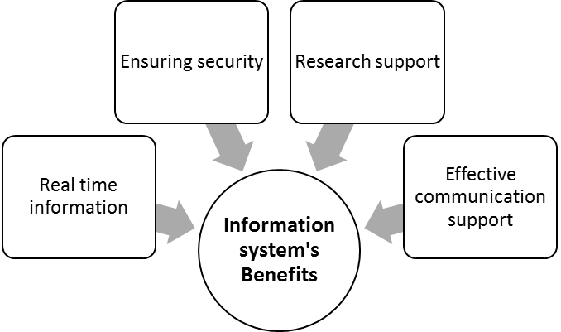
Figure 1: Information system's benefit
Source: (Kim, 2015)
Ensuring security: as this firm deals with clients’ financial informations, often clients may place or deliver some information which are very confidential, hence Zopa always is under pressure to keep those information private so that no other third parties can have any access to them. A good information system is designed considering the necessary security arrangements and firewall facilities (Azad, 2012). So, Zopa actually considers having a fine information system is essential to ensure best security for client information.
Research support: to convince the clients about any rate’s effectiveness, Zopa’s researcher have to show necessary justifications. To provide valid justifications, those researcher have to study market data and trends and researcher often need different processed or calculated numerical data also to prepare valid justification. A good information system has huge information storage facility and such system facilitates quicker information processing time (Galliers, 2014). Considering this, Zopa prioritizes on the importance of information system mandatorily.
Effective communication support: this firm depends on credit informations to judge the credibility of borrower parties. So, it has to communicate the outside parties for credibility related informations. Moreover inside communication i.e. communication between researchers and other decision making parties are very crucial for Zopa. A best featured information system ensures record keeping facility, flexibility, cost efficiency and effective as well as prompt communication service is one of the best delivered services of such system (Vom, 2014). To have the benefit for easy and prompt communication between different internal and outsider parties, this firm depends on a compatible information system matched with its needs.

3. Information systems implemented by Zopa
Several classifications are found within the area of informations system and different information system supports different types of purposes. According to the necessity of tasks, Zopa uses informations systems like:
Transaction Process Systems (TPS): the best user of this TPS is the manufacturer companies which have lots of operational data and process related to raw materials, stock, invoices and bills (Garcia, 2012). But as TPS offers better processing facilities of repetitive incurrence, Zopa uses this system to record the repetitive orders of very usual clients who orders to negotiate for their preferred interest rate always or frequently.
Management Information Systems (MIS): MIS usually serves to prepare structured report accumulated from TPS (Laudon and Laudon, 2015). Zopa also uses this MIS for collecting coherent information from TPS to prepare structured report which usually supports different purposes of various users including top managers.
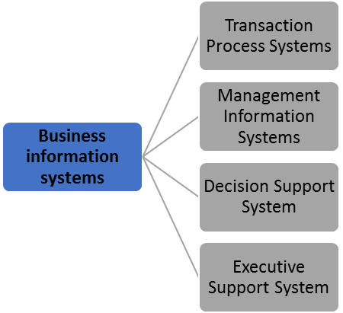
Figure 2: Business information systems
Source: (Laudon and Laudon, 2015)
Decision Support Systems (DSS): to reach a viable decision considering various alternatives, this system supports most (Alyoubi, 2015). Zopa has to calculate best rates for parties and to find out perfect interest rates, DSS is used here by the researchers.
Executive Support Systems (ESS): this is actually used by the executives to set strategic decision regarding business’s journey (Geertman, 2012). Zopa’s top level managers are the core user of ESS and they usually take help of this system to decide about actions which will necessary to generate competitive advantage. Also when long run vision supporting decisions are needed to be taken, executives and top personnel use this.
Zopa’s information systems and their implementation purposes are described and now it is the turn of discussing input, processing and output any of the systems. As Zopa is the negotiator of interest rate, discussion about DSS will be more appropriate:
Input: factors or data usually considered as input for this system. DSS considered input data as raw informations which needs further calculative processing (Linden, 2017). DSS can be linked with TPS or other information system to collect data as input. Actually DSS is designed in such a way that here both manual and computerized actions can be possible. Thus Zopa’s DSS is linked with server, storage and other information system to collect market data, numerical values etc. Even researchers of Zopa also provide input manually about clients’ data, if necessary.
Processing: processing of DSS is usually depends on the choice of user. DSS supports users with lots of spreadsheet and model usage. Thus after placing the inputs to the system, it is the choice of user to select the processing strategy and he/she can select any model or formula to get outcomes (Ni, 2012). Zopa’s researchers usually select the calculative formula that will find out effective interest rate based on clients’ situation and requirements.
Output: after processing, DSS provides transformed data that will be used as the final decisions or supportive materials to take final decision. For example, sometimes Zopa’s researcher places input data which generates outcomes or reports as market trend and then Zopa’s researcher suggest clients to act according to market trends. Or Zopa’s researcher sometimes place input which generates direct effective interest rate and they suggest clients to take that rate as optimal one.
As Zopa is P2P negotiator, it explicitly use the unique IS that matches with its functional duties perfectly. The actual system used by Zopa is financial management information system or FMIS (Zopa, 2020). For example, Zopa uses this FMIS to deal with persons interested to get direct services from Zopa. Example of usage of loan application will be helpful to point out the input-processing-output of this system used by Zopa and this is describes in below:
- When a person wants to take loan through Zopa, Zopa’s FMIS is designed to help him. Thus this person has to use online loan application form and this form is actually aligned with the FMIS. So when the person places his/her necessary information like age, income, preferred borrowing rate or other information asked by loan application form, these are taken as the input by the FMIS.
- After placing the information, those inputs are ready to be processed by the system. And in this processing stage, processing stage of FMIS also judges whether the interested person is suitable in terms of Zopa’s customer suitability criteria i.e. he/she is creditworthy or not. Actually FMIS is directly connected to a cloud computing server. So Zopa’s central processing unit of FMIS not only judges creditworthiness but also uses the informations in cloud server to identify the suitable lender against the interested borrower who has just use the loan application form and placed his/her information. This is the processing stage and here CPU of FMIS searches for matching lender who has suitable lending criteria and Zopa calls this whole processing stage as ‘soft searching’ (Howard, 2020)
- After processing, FMIS reaches in decision and this stage needs maximum three minutes to provide output. So if the person is judged as creditworthy and suitable lender is found against his/her demanded criteria, FMIS of Zopa provides output in the positive form and loan application form suggested the interested borrowers to precede further to make the deal with interested lender. But if the person’s creditworthiness is not satisfactory or suitable lender is not found against his/her criteria, Zopa’s FMIS simply provide output that ‘we are sorry, currently any interested lender against your demanded criteria is unavailable’.

4. Reasons of Zopa’s structure composed of different functions and level and computer-based information system’s impact on supporting managers at each level and functions of Zopa operations
Zopa’s business is related to peer to peer lending and its structure has composed to different function and level like Zopa’s functions is divided in three broader categories of borrowing, investing and saving and each of the broader category of function is again separated in different levels like following figure:
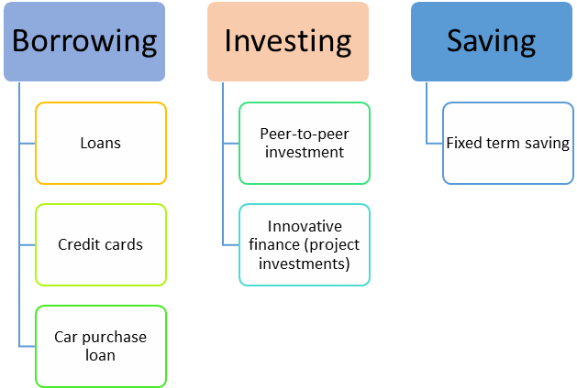
Figure 3: Zopa's offered services and levels
Source: (Zopa, 2020)
Zopa has designed the functions and level in such ways for following reasons:
- Composing different functions and level means more offerings are made to the clients and so there is an opportunity to serve more people with different requirements.
- Such divisions will increase diversifying options because if Zopa faces loss in borrowing function, the other two function will be probably profitable
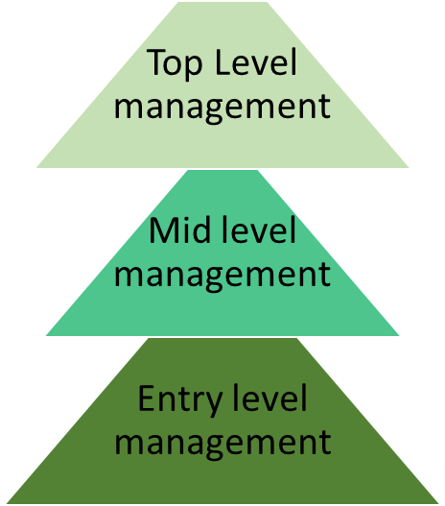
Figure 4: Zopa's level of management
Source: (Zopa, 2020)
Managers in Zopa get support from computer based IS at each level of functions. For example, Zopa’s entry level managers usually contribute to direct customer related matters and they are in such a position that they can deliver the perfect interest rate of a client within three minutes who wants a borrowing related service from Zopa and it is the contribution of IS. Even for car loan or other personal loans, Zopa can serve client with borrowed amount within 2 hours of application. This quick response time is the benefit of computer-based system. And Zopa’s saving related functions are also supported by computer based system. Zopa’s mid level managers are the supervisor of entry level managers and they receive feedbacks from them. Then Zopa’s mid level managers prepare report about organizational investment, borrowing and saving related performance and so they use (MIS) which is a part of IS. And top level mangers receive the report prepared by mid level managers and then top level managers use executive support system or ESS and they usually take help of this system to decide about actions which will necessary to generate strategic long term decisions about corporate policy. So reviewing all the contributions, it is now clear that Zopa’s managers are supported by computer-based system at each level of functions and operations.

5. Knowledge management challenges for Zopa
In the business perspective, Knowledge Management Challenges (KMC) are usually considered the barriers related to acquire and usage of knowledge that are essential for making decisions about business’s day to day activity and also important for making strategic long run visionary decisions (Holsapple, 2013). Currently Zopa is doing well in managing such challenges, but some potential threats can be found as potential KMC for Zopa like:
Prompt data access and technological adaptability challenge: today’s financial market is so fast that sometimes it is necessary to decide about steps within seconds considering the price/interest movements of financial assets in financial market (North, 2018). To decide about best rate, having real time data about financial market is mandatory. Zopa currently has prompt access of real time data, but it can face problem if it fails maintain such legacy i.e. its rivals collect data or facts at a greater speed than Zopa. For example, Zopa’s rival ‘Bondora’ has adopted a new technology which makes the lenders familiar with the borrowers more quickly. Thus Zopa faced threat of quicker data access and better technology adopted by the rival, and then Zopa reacted to its rival by adopting more powerful new 'Borrowing Power' tool where customers were allowed to take the same services even in Apple and Android without using Zopa’s website (Schraer, 2019). So it actually indicates that Zopa has faced knowledge management challenge in terms of prompt data access and technological adaptability which is then handled by using proper technological assistance. Thus it indicates Zopa can again face such problem if it fails to keep pace with updated technology adopted by the peers.
Security challenge: data security is considered as very essential for the firms because often firms face threat of strategic failure if their collected core data is leaked although they collect data promptly from authentic sources (Lyu, 2015). For example, Zopa has faced question about its login security very recently and it has to place cyber security certificate to convince the customers (Lemmon, 2019). Although here Zopa has been able to convince them, this incident shows that there is some point of security related weakness which makes some users to think Zopa’s service is weak in terms of data security. Thus This can be one of the worst potential threats for Zopa if their security system cannot ensure best data security in near future and not only showing cyber security certificate is enough, Zopa should focus on strong firewall and protection system that can actually make the customers convinced. .

6. Zopa’s approach and Porter’s generic competitive strategy
Zopa is smart strategic decision maker in terms of Porter’s generic competitive strategy. Porter’s strategy shows four strategic attempts where cost leadership stagey suggests a firm to serve with the lowest offered price within an industry and differentiation suggests firms to serve the whole industry with most premium quality services/products (Dhliwayo, 2012). On the other hand, cost focus strategy suggests a firm to serve the portion of an industry with lowest price while differentiation focus strategy suggest a firm to serve portion or segment of industry with premium quality products.
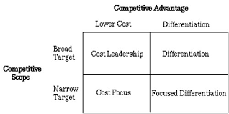
Figure 5: Porter's competitive strategy
Source: (Dhliwayo, 2012)
Now Zopa’s approach is incorporated with the cost focus strategy of porter’s model. This is because Zopa does not serve the whole industry rather its target customers are the persons who usually have been rejected from the banks. And Zopa always tries to ensure an affordable rate for both the negotiating clients. As Zopa serves portions of industry and it highly emphasizes on clients’ affordability while negotiating, it can be said that Zopa’s overall approach is incorporated with porters cost focus strategy.
Further discussion also says that the use of (IS) or (IT) has enabled Zopa to achieve a competitive advantage. Such advantage is achieved by Zopa in two ways like:
Quick information access: Zopa’s smart usage of information system always makes it informed about the lowest market rate. Thus when Zopa offers rate to clients, it can make its offered rate compatible with the market rate.
Quick response: due to information system, Zopa can receive quick credit check service of borrowers. As it can judge credibility in least time period, it can serve credible clients with very narrow time period. Also Zopa’s researcher can use DSS to find out optimal rate within very reasonable time period. Competitive advantage is the advantage that is gaied through offering customers with greater service, benefit or value than of rivals (Soltanizadeh, 2016). Since customers considers Zopa as a fine P2P negotiator for its quick response time and reasonable rate, such factors are sources of Zopa’s competitive advantage because those factors cause clients to prioritize Zopa over rivals.

7. Recommendations to strengthen Zopa’s knowledge management practices
Knowledge acquisition-retention-transfer perspective says that knowledge should be collected from authentic sources and a cross review or check is necessary to ensure the authenticity (Geisler, 2015). Such perspective also suggests retaining only the relevant data and focusing on analyzing them. And knowledge should be transferred in a collective way so that every related stakeholder of such knowledge can be benefited perfectly and can generate best optimal decision. Now some recommendation to strengthen Zopa’s knowledge management practices under knowledge acquisition-retention-transfer perspective will be given so that it can reduce the chances of being victim of KMC and those recommendations are:
Being up-to-date about competitors and technology: as knowledge securing - retention-transfer perspective highlights on authentic data input (Liebowitz, 2016) and Zopa has a potential challenge of prompt data access and technological adaptability, it should review the steps of rival about data acquisitions and always install and use the best up-to-date technology to ensure prompt data acquisition.
Ensuring relevancy: as knowledge securing-retention-transfer perspective highlights` on retaining and using only relevant data (Geisler, 2015) and Zopa has a potential knowledge contribution challenge, it should start to implement a shared knowledge usage facility under a centralized review system where every related parties can collaborate to each other about data miss usage.
Improving overall response time: reducing response time is the best way to support knowledge acquisition-retention-transfer perspective because response time actually include quick data security checking, quick data transfer to the team within organization and finally quick service delivery to the clients (Dalkir, 2017). Hence if Zopa can improve its overall response time, its data security challenge will be satisfied and also data or knowledge transfer perspective will be satisfied.

8. Impact of progress in information technology (IT) on knowledge management practice in Zopa
IT basically refers the usage of computer based system for business or research related purpose and supporting organizations with communicational improvement is a key area of IT. Day by day further IT development is creating new business opportunities for firms and knowledge management process in organization is also beneficiary of such progress. Zopa is also expecting progress in its KM practices by the progress in IT through following ways:
Establishing culture of KM: establishment of such culture is crucial. If an organization wants to establish this, it must employ a highly collaborative knowledge sharing and transferring system and process (Chang, 2015). If IT progress is enhanced, Zopa will have a better collaborative and communication based KM practices. Therefore IT progress will positively impact on KM practices in Zopa.
Practice of knowledge integration: not only establishing the culture of KM but also supporting knowledge integration is another best KM practices (Valmohammadi, 2015). Creating easy and prompt link between business data, conversations and projects are part of such integration. If IT progress is enhanced further in near future, such types of integration will take less time and generate better outcome. Zopa will be again a beneficiary of improvement in IT as such improvement will support its knowledge integration practice of KM process.
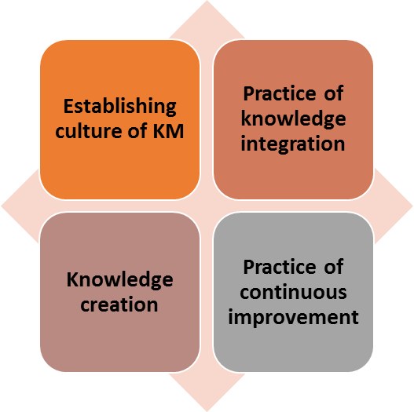
Figure 6: Knowledge management practices
Source: (Valmohammadi, 2015)
Knowledge creation: creating newer knowledge from existing knowledge and information is a practice of effective KM process (Chang, 2015). IT has substantial impact on creating easy access to information and data or raw information is the primary source of creating knowledge. Hence Zopa can expect of having a better knowledge creation opportunity under knowledge management process because progress in IT will cause easier informational access and this will be better knowledge creating opportunity.
Practice of continuous improvement: one of the effective KM practice suggests a KM process to improve continuously like this practice directs for having such a KM process which will generate better knowledge with gradual reduction of cost (Inkinen, 2016). As IT progress has strong chance to support Zopa with quick information access with reduced time period, it is expected that further IT progress may cause best KM practice of better information with reduce cost and then Zopa’s KM practices will be again supported by IT progress.

9. Implementation method of enterprise resource planning (ERP) systems in Zopa
ERP is a business activity related software system which enables a business firm to have better version of integrated use of business applications and ultimately such usage cause improved automation in business activity (Chiu, 2014). ERP actually is implemented through some steps and Zopa can follow those like:
Understand the goal of ERP establishment: ERP does not have direct relationship with increased monetary returns or customer gain (Ghobakhloo, 2019). Thus Zopa must identify the reason of implementing this. As ERP can support better automation, Zopa can think of implement this as a source of better process innovation.
Collaboration and expert support: ERP may require expert supervision to be implemented properly and existing employees may require better training to be familiar with ERP oriented process (Antero, 2015). So selecting and hiring proper professional as well as making the existing human resource as mentally prepared to accept the ERP requirement is necessary in Zopa.
Budget and data migration: ERP may require currents system’s data transformation (Chiu, 2014) and so Zopa must have necessary systematic capability to handle, transform and maintenance of data. Also budget is an issue here. Hence Zopa should design the ERP framework in such a way that real ERP establishment cost matches with budget.

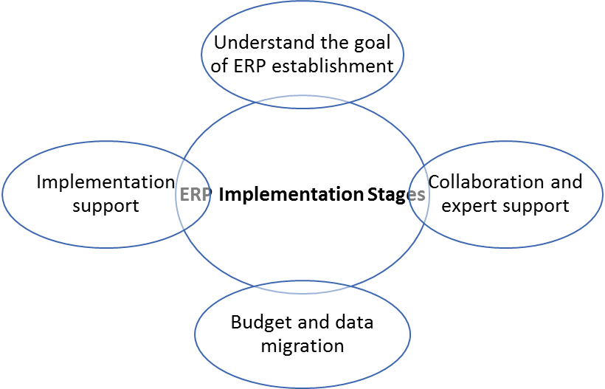
Figure 7: ERP implementation stages
Source: (Chiu, 2014)
Implementation support: when goal is set, employees are trained, experts are hired and data transformation is completed, ERP is ready to proceed further. This stage actually requires monitoring and updating. Therefore here Zopa should use techniques for necessary communication based and process oriented review arrangements.
ERP can support Zopa with various advantages like it can increase operational efficiency (Madanhire, 2016) and when ERP will cause process automation, Zopa will benefit such efficiency. ERP will ensure customized reporting for mangers and top executives. Improved security is another benefit of it. Zopa will benefit this because ERP will also help to protect data misuse and leakage in a systematic way. ERP also is associated with challenges. For example, ERP often behaves as change resistance way and so if Zopa wants to cause further transformation in existing ERP, it may face huge data migration and flexibility relates hassles. Also maintenance cost of ERP sometimes seems huge to be covered. Therefore Zopa should consider such factors crucially to have a smart and successful ERP.

10. Conclusion
Informations system (IS) usually supports business organizations with series of benefits and usage of such system is regarded as mandatory for Zopa as it creates direct support for conducting core business activity of borrowing, investing and saving. Zopa uses different IS like TPS, DSS, MIS and ESS. Although there are some potential knowledge management challenges of Zopa, proper usage of IS can make it easier to overcome those challenges. And knowledge management practices will be benefitted if Zopa uses better information technology. This report also has showed that Zopa is directly benefited by IS to follow Porter’s generic strategy. Finally ERP systems’ implementation is discussed and it is said that Zopa should consider the challenges of ERP if wants to enjoy highest benefit of ERP.

11. Reference
Alyoubi, B.A., 2015. Decision support system and knowledge-based strategic management. Procedia Computer Science, 65, pp.278-284.
Antero, M.C., 2015. A Multi-case Analysis of the Development of Enterprise Resource Planning Systems (ERP) Business Practices. Frederiksberg: Copenhagen Business School (CBS).
Azad, M.M., Amin, M.B. and Alauddin, M., 2012. Executive information system. International Journal of Computer Science and Network Security (IJCSNS), 12(5), p.106.
Chang, C.L.H. and Lin, T.C., 2015. The role of organizational culture in the knowledge management process. Journal of Knowledge management.
Chiu, Y.H., Claybaugh, C.C., Lea, B.R. and Yu, W.B., 2014. Enterprise resource planning.
Dalkir, K., 2017. Knowledge management in theory and practice. MIT press.
Dhliwayo, S., 2014. Entrepreneurship and competitive strategy: An integrative approach. The Journal of Entrepreneurship, 23(1), pp.115-135.
Galliers, R.D. and Leidner, D.E. eds., 2014. Strategic information management: challenges and strategies in managing information systems. Routledge.
Garcia, M.O., Braghetto, K.R., Pu, C. and Ferreira, J.E., 2012. An implementation of a transaction model for business process systems. Journal of Information and Data Management, 3(3), pp.271-271.
Geertman, S. and Stillwell, J. eds., 2012. Planning support systems in practice. Springer Science & Business Media.
Geisler, E. and Wickramasinghe, N., 2015. Principles of Knowledge Management: Theory, Practice, and Cases: Theory, Practice, and Cases. Routledge.
Ghobakhloo, M., Azar, A. and Tang, S.H., 2019. Business value of enterprise resource planning spending and scope. Kybernetes.
Holsapple, C. ed., 2013. Handbook on knowledge management 1: Knowledge matters (Vol. 1). Springer Science & Business Media.
Howard, L., 2020. Zopa Loans: Compare, Review And Apply For A Loan | Moneysupermarket. [online] Moneysupermarket.com. Available at: https://www.moneysupermarket.com/loans/zopa-loans/
Inkinen, H., 2016. Review of empirical research on knowledge management practices and firm performance. Journal of knowledge management.
Kim, Y.J., 2015. Convergence of Business Information System Process using Knowledge-based Method. Journal of the Korea Convergence Society, 6(4), pp.65-71.
Laudon, K.C. and Laudon, J.P., 2015. Management information systems (p. 143). Upper Saddle River: Pearson.
Lemmon, C., 2019. Is The Zopa Login Secure?. [online] 4thWay. Available at: https://www.4thway.co.uk/candid-opinion/is-zopa-login-secure/
Liebowitz, J. and Frank, M. eds., 2016. Knowledge management and e-learning. CRC press.
Linden, I., Liu, S. and Colot, C. eds., 2017. Decision Support Systems VII. Data, Information and Knowledge Visualization in Decision Support Systems: Third International Conference, ICDSST 2017, Namur, Belgium, May 29-31, 2017, Proceedings (Vol. 282). Springer.
Lyu, H. and Zhang, Z., 2015. Job quitters, information security awareness, and knowledge management strategies. Journal of Information Privacy and Security, 11(4), pp.189-210.
Madanhire, I. and Mbohwa, C., 2016. Enterprise resource planning (ERP) in improving operational efficiency: Case study. Procedia CIRP, 40, pp.225-229.
Marnewick, C., 2016. Benefits of information system projects: The tale of two countries. International Journal of Project Management, 34(4), pp.748-760.
Ni, J. and Jin, X., 2012. Decision support systems for effective maintenance operations. CIRP annals, 61(1), pp.411-414.
North, K. and Kumta, G., 2018. Knowledge management: Value creation through organizational learning. Springer.
Schraer, N., 2019. Zopa Launches New Credit-Scoring Tool. [online] MoneySavingExpert.com. Available at: https://www.moneysavingexpert.com/news/2019/10/zopa-launches-new-credit-scoring-tool-/
Soltanizadeh, S., Rasid, S.Z.A., Golshan, N.M. and Ismail, W.K.W., 2016. Business strategy, enterprise risk management and organizational performance. Management Research Review.
Valmohammadi, C. and Ahmadi, M., 2015. The impact of knowledge management practices on organizational performance. Journal of Enterprise Information Management.
Vom Brocke, J. and Rosemann, M. eds., 2014. Handbook on business process management 1: Introduction, methods, and information systems. Springer.
Zopa.com, 2020. [online] Available at: https://www.zopa.com/

