

B.Eng. (Hons) in Embedded Electronic Systems

ELECTRONICS II

Module: ACDA6001

Sean Upton 2410530

Word count 2641

Abstract

This report investigates two binary multipliers, the Wallace tree and the Brauns multiplayer. Comparing the differences between the different architectures. Both multipliers are 8x8 meaning that they can multiply two 8-bit values to create a 16-bit output. The architecture consists of AND gates with full and half adder.
For this VHDL and FPGA is used during the implementation. The study is to look at a multitude of factors including power consumption, processing speed and rescores usage. By comparing the designs, the key differences in the types of architecture are identified, this highlights the benefits of each type of multiplier for different scenarios.

Table of contents
Abstract 1
Table of contents 2
Introduction 4
Background research 4
Brauns and Wallace tree 5
Innovations 5
Applications and advantages of multipliers 5
flowchart/pseudocode showing the system operation. 7
Flowchart 7
Brauns code 8
Wallace tree code 9
Methodologies explaining the design process 9
Full adder 10
Half adder 10
Brauns 11
Wallace 11
Multipliers Block Diagram and Algorithms. 12
Brauns block diagram 13
Wallace tree block diagram 13
VHDL Codes (In Appendix Words are not countable for coding’s) 14
Timing diagrams and schematics of the designs 15
Timing and schematic of Brauns 16
Brauns longest path 16
Brauns synthesis 17
Brauns implementation 17
Timing and schematic of Wallace 18
Wallace tree longest path 18
Wallace tree synthesis 19
Wallace tree implementation 19
FGGA Design Screen dumps with Pin allocation. 21
Brauns FGGA 22
Wallace FGGA 23
Simulation results 25
Brauns simulations 26
Wallace tree simulations 27
Comparison, Analysis, and Interpretation of Results (use at least 4 samples) 29
Interpterion of Power utilization and LUTs 30
Power utilization of Brauns 31
Synthesis 31
Implementation 32
Power utilization of Wallace tree 33
Synthesis 33
Implementation 34
Details of testing and recommendations for future improvements 36
Testing 36
Brauns 37
4 x 5 37
1 x 1 37
AB x CD 38
Wallace tree 40
FF x FF 40
3B x 4B 41
2 x 2 41
Improvements 43
Conclusion 43
Appendix 47
Barun's code 47
Wallce tree code 61

Figure 1 Brauns (left) and Wallace flow chart (right) 9
Figure 2 full adder code 11
Figure 3 half adder code 11
Figure 4 Brauns table 12
Figure 5 Wallace table 12
Figure 6 methodology simulation 13
Figure 7 methodology hardware test 13
Figure 8 Brauns block diagram 14
Figure 9 Wallace tree diagram 15
Figure 10 Brauns longest path 17
Figure 11 Brauns longest delay 18
Figure 12 Brauns synthesised worst negative slack 18
Figure 13 Brauns implemented worst negative slack 18
Figure 14 Brauns schematic 18
Figure 15 Brauns RTL design 19
Figure 16 Wallace tree longest path 19
Figure 17 Wallace tree longest delay 20
Figure 18 Wallace tree synthesised worst negative slack 20
Figure 19 Wallace tree implemented worst negative slack 20
Figure 20 Wallace tree schematic 21
Figure 21 Wallace tree RTL design 21
Figure 22 Brauns floor plan 23
Figure 23 Brauns interconnection layout 24
Figure 24 Wallace floor plan 24
Figure 25 Wallace interconnected layout 25
Figure 26 Brauns 1x1 simulation 26
Figure 27 Brauns 4x5 simulation 27
Figure 28 Brauns AB x CD simulation 27
Figure 29 Wallace 2 x 2 simulation 28
Figure 30 Wallce 3B X 4B simulation 28
Figure 31 Wallace tree FF x FF simulation 29
Figure 32 Brauns synthesis LUT 31
Figure 33 Brauns synthesis utilization summery 32
Figure 34 Brauns synthesis power summery 32
Figure 35 Brauns implementation LUTs 32
Figure 36 Brauns implementation utilization summary 33
Figure 37 Brauns implementation power summery 33
Figure 38 Wallace synthesis LUTs 33
Figure 39 Wallace synthesis utilization summary 34
Figure 40 Wallace synthesis power summary 34
Figure 41 Wallace implementation LUTs 34
Figure 42 Wallace implementation utilization summary 35
Figure 43 Wallace implementation power summary 35
Figure 44 Brauns 4 x 4 hardware test 37
Figure 45 Brauns 4 x 4 simulation 37
Figure 46 Brauns 1 x 1 hardware test 38
Figure 47 Brauns 1 x 1 simulation 38
Figure 48 Brauns AB x CD hardware test 39
Figure 49 Brauns AB x CD simulation 39
Figure 50 Wallace FF x FF simulation 40
Figure 51 Wallace FF x FF hardware test 40
Figure 52 Wallace 3B x 4B simulation 41
Figure 53 Wallace 3B X 4B hardware test 41
Figure 54 Wallace 2 x 2 simulation 42
Figure 55 Wallace 2 x 2 hardware test 42

Introduction

Multiplication is an essential part of digital electronics, it is necessary in signal processing, image processing and VLSI systems [1]. This is why the architecture of the multiplayer is a necessary consideration, as it will determine the performance of the product. It is important that the design is optimised to allow the product to have high speed and a low power consumption.
The report focusses on two types of multiplayers, the Brauns multiplayer and the Wallace tree multiplayer. Although they both arrive at the same conclusion when it comes to multiplication, the way in which they do this differs. These differences can be seen in the performance of the multiplayers. The Brauns multiplayer is considered to be the simpler to implement of the two whereas the Wallace tree is considered to be faster [2]. This is to be analysed from the implementation using the VHDL software.
Using this software, the two multipliers will be simulated, this will allow insights into the timing constants, utilization and power consumption. These readings will be taken for both and analysed to give strength and limitations of both multiplayers.

Background research

Brauns and Wallace tree

Both multipliers were designed around the 1960s, the Wallace tree multiplier being the first with the Brauns to follow [3]. The Bruns was developed to offer a simpler design and ease of implementation. More recent developments focus on improving speed and reducing power consumption. The tree-based structures reduce delays by processing partial products in parallel rather than individually, this is the Wallace tree. The Brauns multiplier is an array multiplier, processing partial products row by row unlike the tree. This makes them simpler and easy to design.
There are key differences between both multiplayers. When looking at speed the Brauns is slower than the Wallce tree due to its simplistic architecture Brauns is slower. With that the Wallace tree is a come complex design so can take longer when in the design stage. This will result in the Brauns using more power and increased hardware usage. [4]
Innovations
Modern multiplayers offer more of a hybrid of the tree structure and the array. Taking features from both in an attempt to combine the speed of the tree and the simplices of the array. [5]
Research into multipliers focus on improving speed, efficiency and hardware utilization. Multipliers are used in various systems such as signal processing and artificial intelligence. A multiplier that is now widely used is the Vedic multiplier. This method reduces delays and power consumption. There are also the Approximate multipliers. This have proved to be less accurate than other multiplier but have major improvements in speed and efficiency [6].
The software to be used to implement and simulate the multipliers is Vivado. The software allows for the VHDL code to be written and can be installed into the Basys FPGA hardware.

Applications and advantages of multipliers

The use of multipliers is fundamental for digital systems; they offer a range of applications sue to their ability for fast and reliable multiplication [7]. The most prominent areas being in signal processing such as filtering and audio processing. They are used in computers for executing instructions and impact the machines overall performance. Communication systems utilize multipliers for encoding and data transmitting.
Modern technology realises on the use if multipliers. Their ability to perform at high speeds is necessary as it reduces the processing time. This is why the Wallace tree is better than the Brauns and is more common in complex systems. There is an advantage to there being many different types of architecture that can be used as the multiplier can be tailored to the desired use, if delays are not much of a concern for a simple system it may be more appropriate to use the Brauns or Approximate. They can also be scaled to handle different bit sizes meaning they can be used in simple project up to large complex systems.
More recently they are being used in artificial intelligence. AI relies on multipliers to prosses data, in neural networks there is constant data that needs to be processed to give an output in real time, due to this there needs to be an efficient multiplier with minimal delay [8].

flowchart/pseudocode showing the system operation.

The use of the flow chart and pseudocode is used to clearly demonstrate the sequence of operations and a simple overview of the system. Allowing for readers with a non-technical background to easier engage with the system.

Flowchart
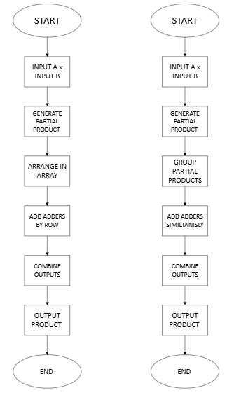
Figure 1 Brauns (left) and Wallace flow chart (right)
Brauns code
-Start
-Load A, Load B
-Generate partial products using AND gates
-Shift partial products based on position
-Add all partial products using array of adders
-Output 16-bit product
-End

Wallace tree code
-Start
-Load A, Load B
-Generate partial products using AND gates
-Group partial products and reduce them using adders
-Repeat reduction until only 2 rows remain
-Add final 2 rows
-Output final 16-bit product
-End

Methodologies explaining the design process

Both multipliers were designed using Xilin Vivado. Both implement half adder and full adders, this also needed to be designed so that they could be used in the implementation.
Full adder
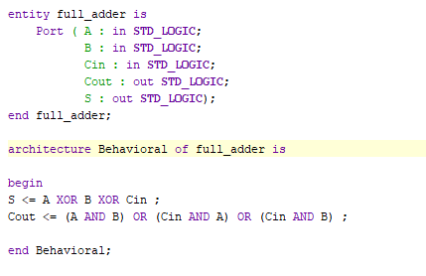
Figure 2 full adder code

Half adder
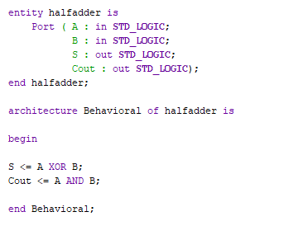
Figure 3 half adder code
A diagram is created which is utilised when designing. These then allow an easy reference when writing the code. It allows you to see the combinations of the input, sum, and the carries.

Brauns
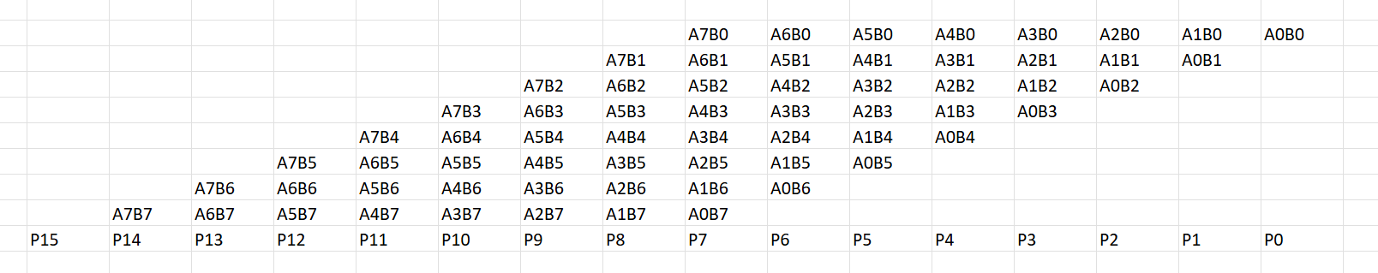
Figure 4 Brauns table

Wallace
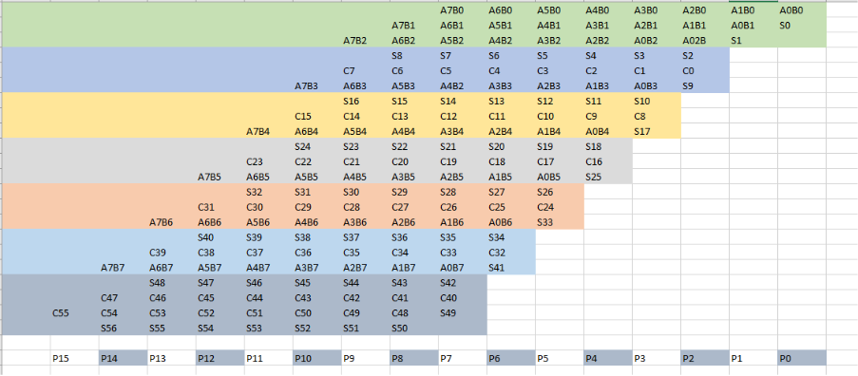
Figure 5 Wallace table
After both multipliers are complete simulation are done to test if they are given the correct results, the simulation is conducted using Vivado, the code is then uploaded to the Basys 3 board for hardware testing.

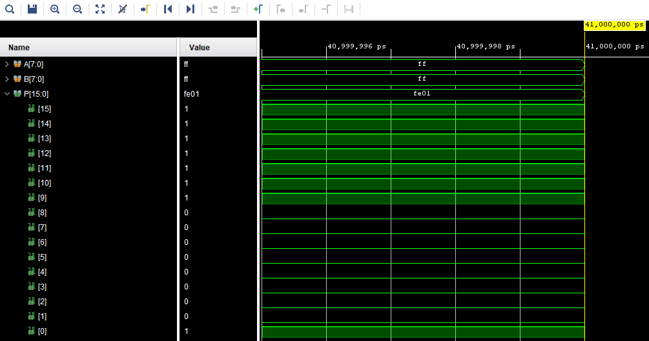
Figure 6 methodology simulation
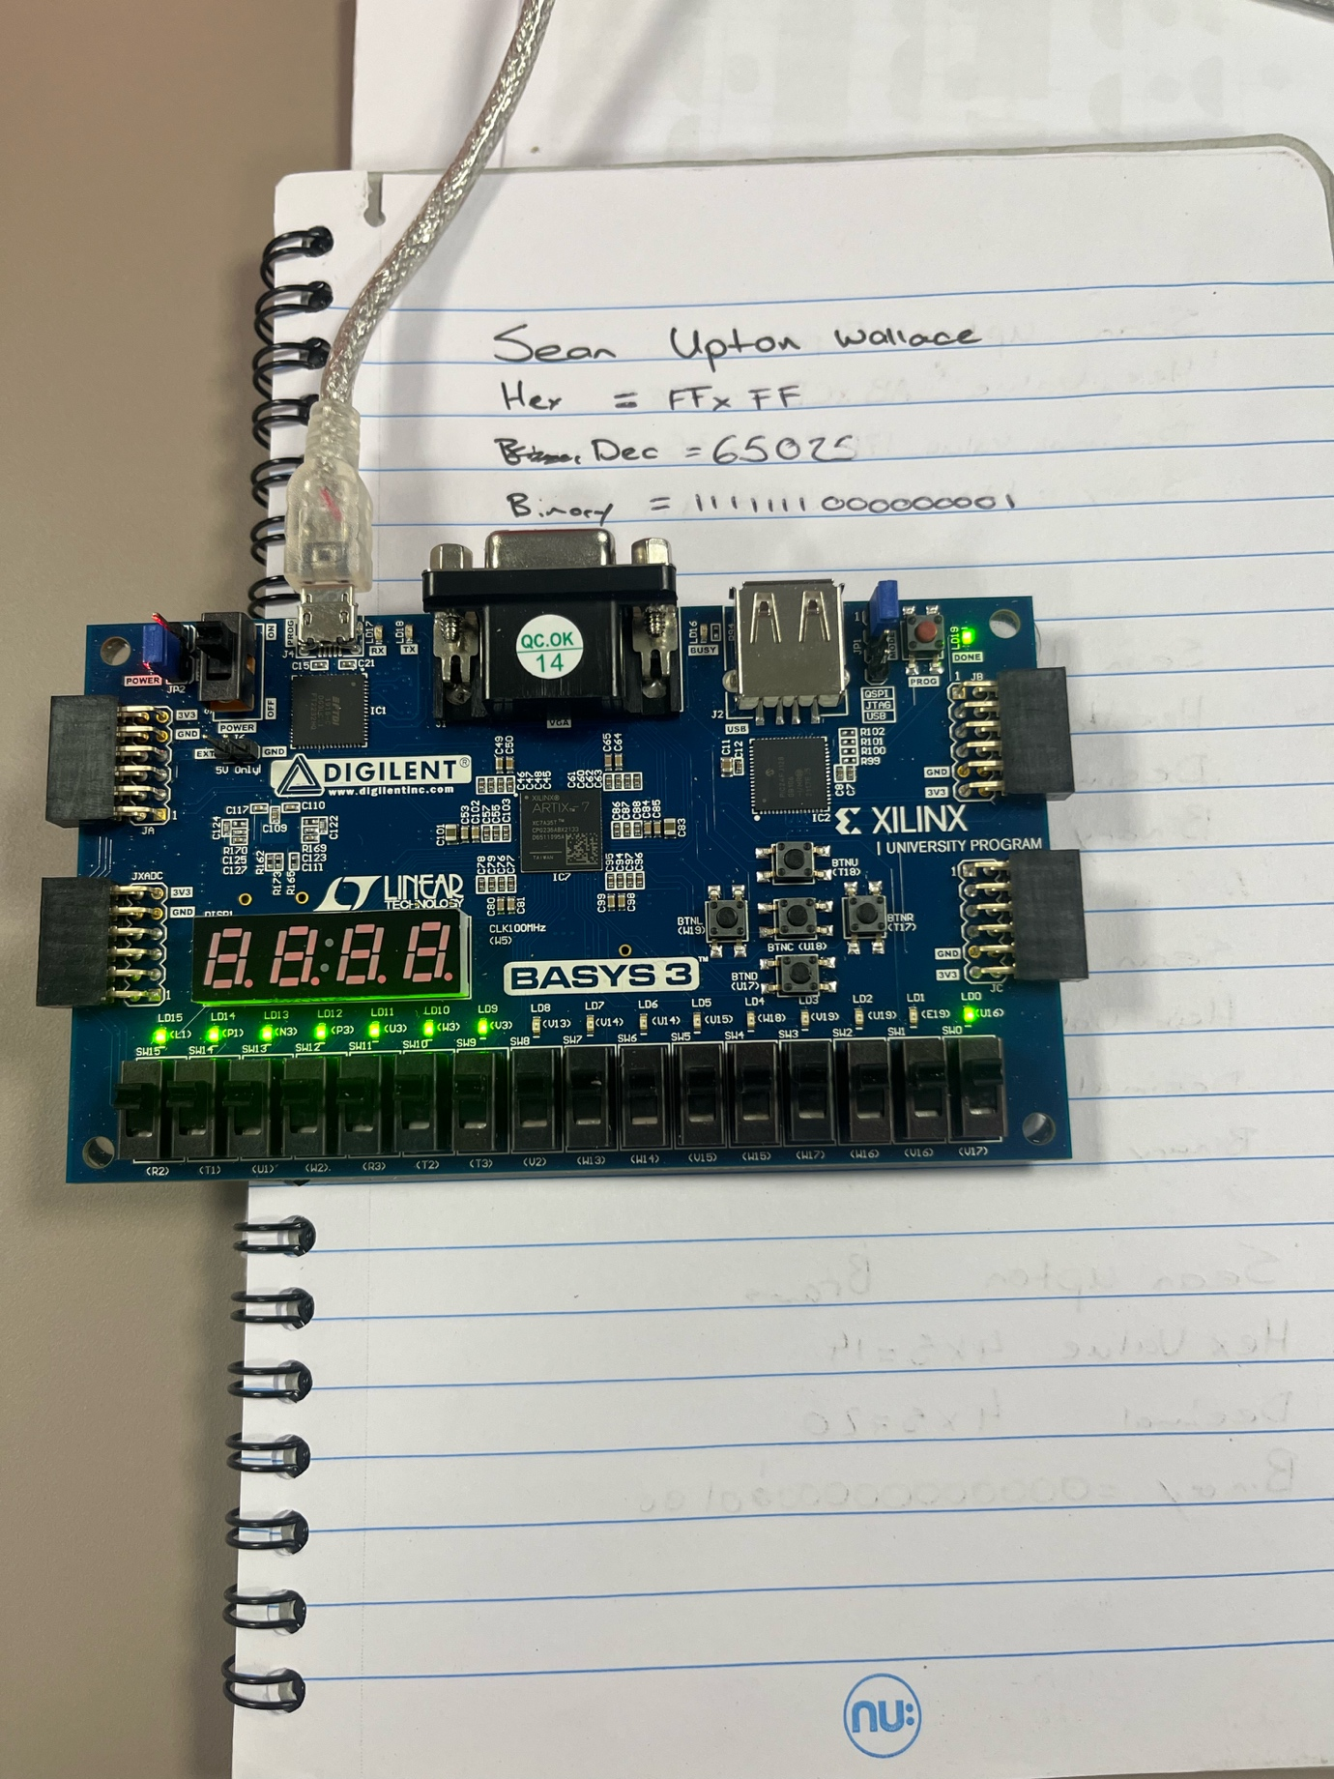
Figure 7 methodology hardware test

Multipliers Block Diagram and Algorithms.
To understand how both multipliers work the use of diagrams allows a representation of how it works. The structed then allows for accurate 8x8 multiplication.

Brauns block diagram
The Brauns uses AND gates alongside full and half adders. It is designed in an array structure. The half adders having two inputs and two outputs. The sum and the carry outputs are then used as inputs for further adders which will result in the multiplication of the 8-bit signals to 16 bits. This design is simpler to understand and design, but as a result of this it is slower.
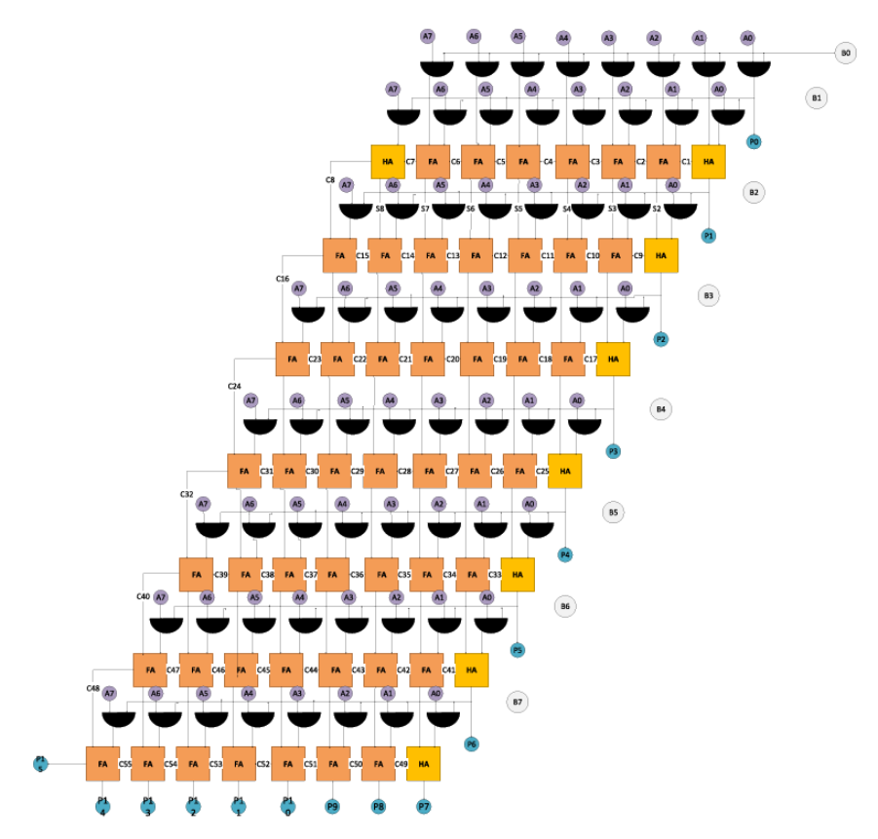
Figure 8 Brauns block diagram

Wallace tree block diagram
The Wallace tree is the faster of the two architectures; it achieves this by using parallel processing. This is adding multiple stages at once reducing partial products.
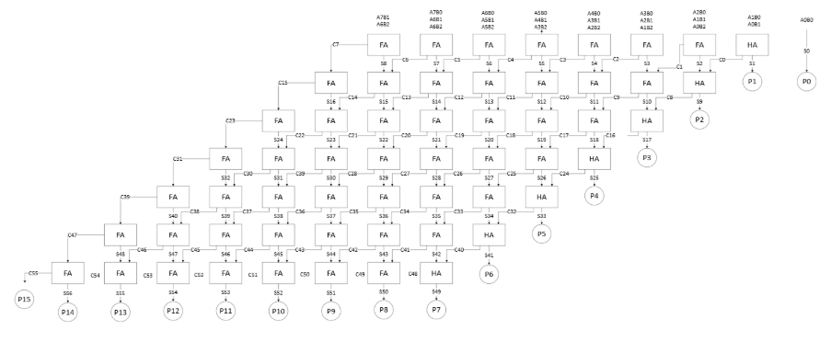
Figure 9 Wallace tree diagram

VHDL Codes (In Appendix Words are not countable for coding’s)

Both multipliers are designed using VHDL and utilize the half adder and the full adder, they then use their own specific architecture which code must be written and will be shown the appendix

Timing diagrams and schematics of the designs

Timing and schematic of Brauns

Brauns longest path

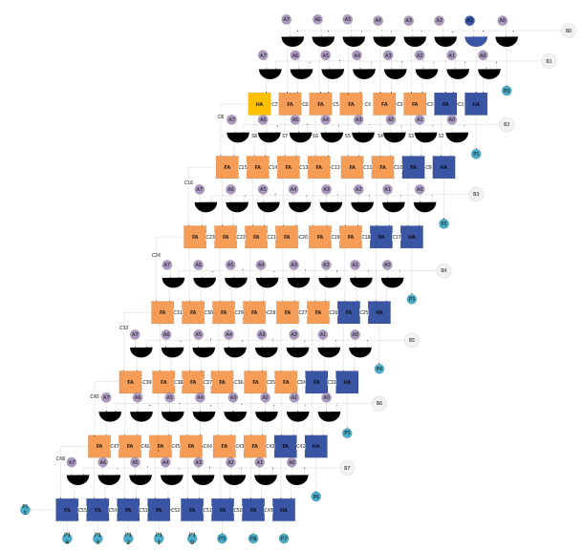
Figure 10 Brauns longest path
Once the longest path is identified the longest delay can be calculated. The multiplier is made up of AND gates, full adders and half adders. In the longest path there is 20 full/half adders and one and gate. The delay for an and gate is given to be 1ns and the delays for the adders in 2ns. Using this the delay can be calculated as
$longest delay = 1ns + 20\left(2ns\right) =41ns$
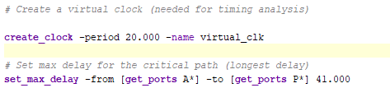
Figure 11 Brauns longest delay
When doing the synthesis, the worst negative slack is 25.084ns but when implementing the design, it gives a worst negative slack of 18.521ns.

Brauns synthesis
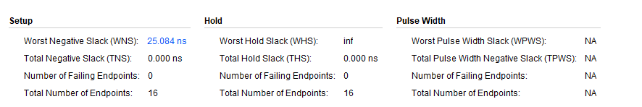
Figure 12 Brauns synthesised worst negative slack

Brauns implementation
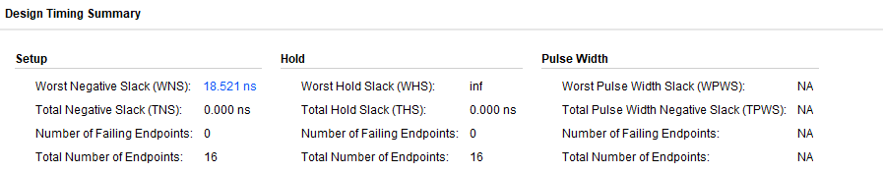
Figure 13 Brauns implemented worst negative slack
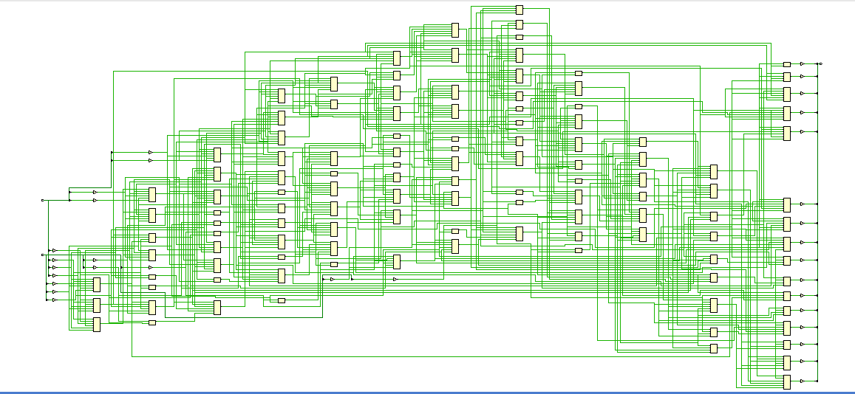
Figure 14 Brauns schematic
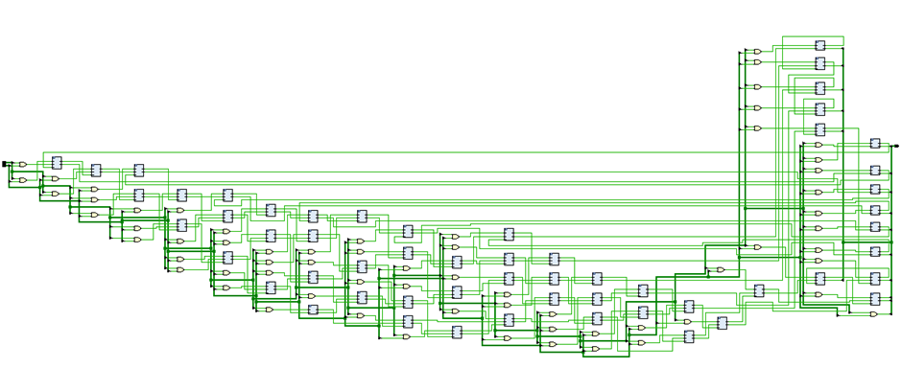
Figure 15 Brauns RTL design

Timing and schematic of Wallace

Wallace tree longest path
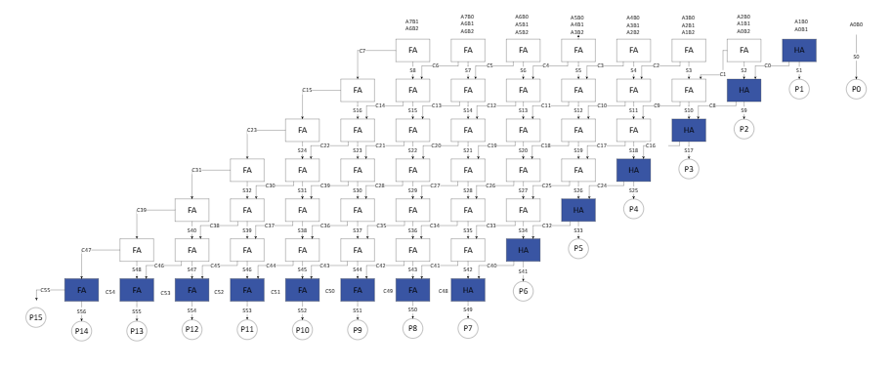
Figure 16 Wallace tree longest path
For the Wallace tree there are 14 adder stages, using this we can do the same calculation to find the longest delay.

$$longest delay = 1ns + 14\left(2ns\right) =29ns$$

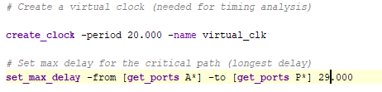
Figure 17 Wallace tree longest delay

Wallace tree synthesis
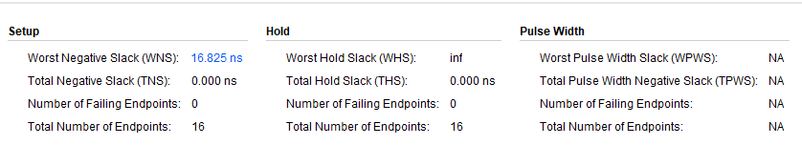
Figure 18 Wallace tree synthesised worst negative slack

Wallace tree implementation
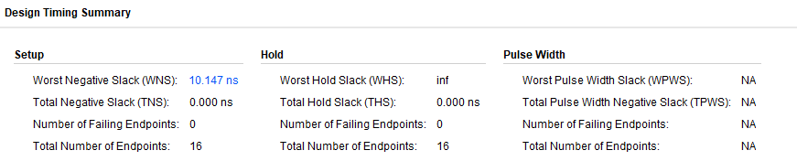
Figure 19 Wallace tree implemented worst negative slack
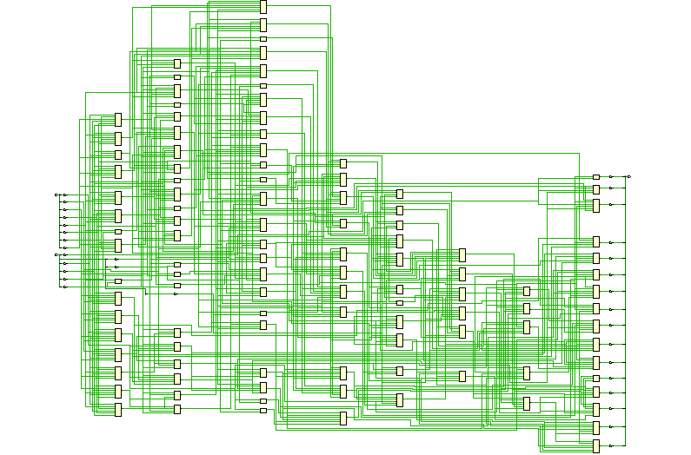
Figure 20 Wallace tree schematic
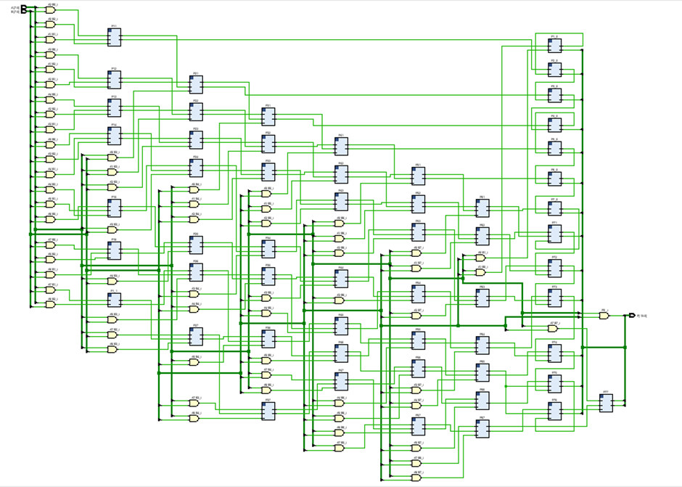
Figure 21 Wallace tree RTL design
From this it can be seen that the longest delays are higher for the Brauns, meaning that the Wallace tree is faster. This is the result that was to be expected.

FGGA Design Screen dumps with Pin allocation.

One the multipliers have been implemented a floorplan and interconnection layout are generated. This allows in incite to the internals of the hardware architecture.

Brauns FGGA
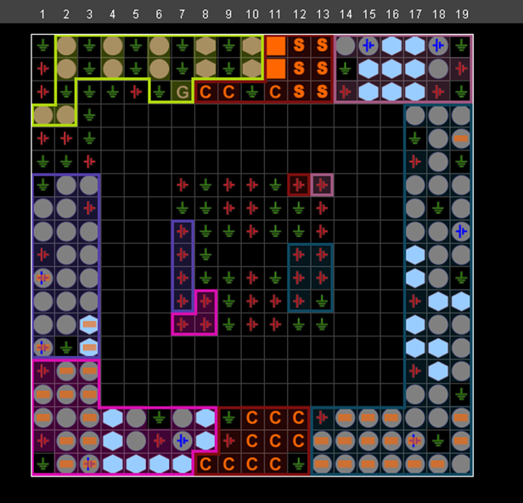
Figure 22 Brauns floor plan

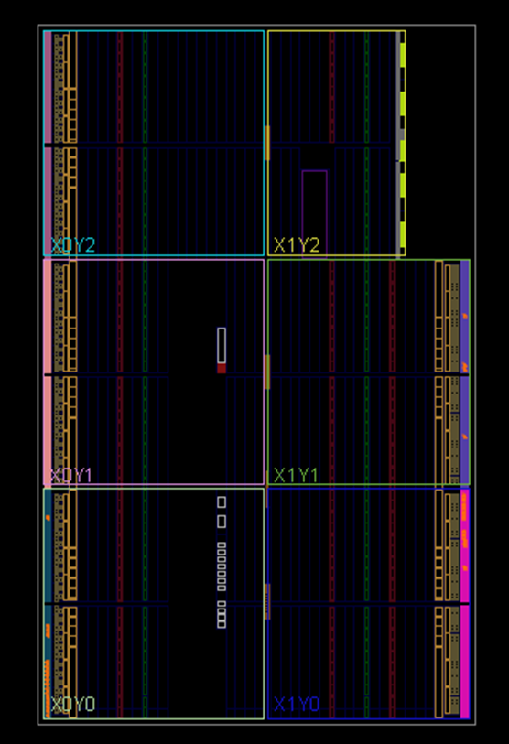
Figure 23 Brauns interconnection layout

Wallace FGGA
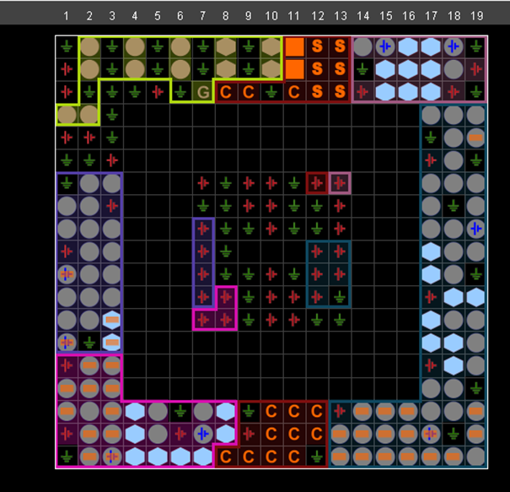
Figure 24 Wallace floor plan
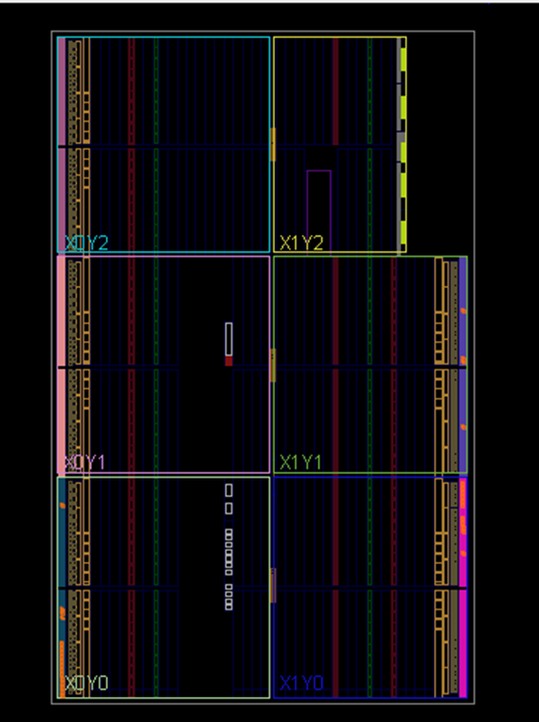
Figure 25 Wallace interconnected layout
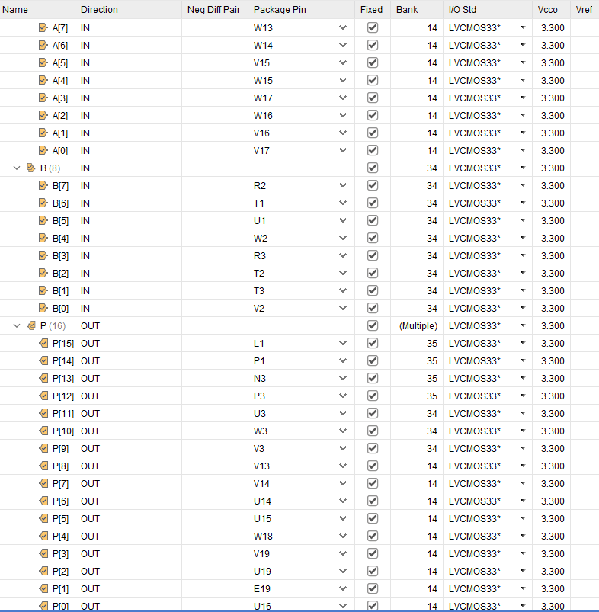
Figure 26 I/O layout
Using the Basys 3 board the input and output pins can be identified and mapped across to both multipliers, as they both have 16 inputs and 16 outputs the I/O pins are the same for both designs. The I/O std is to write that it should be 3.3V.

Simulation results

The simulation allows an insight to see if the multiplier is working as expected. The simulations are run using the Vivado software and is done for both the Wallace tree and the Brauns. Testing low figures as well as high figures to see the full range of both multipliers.

Brauns simulations
For the Brauns an initial test of 1 x 1 shows that the design is working correctly
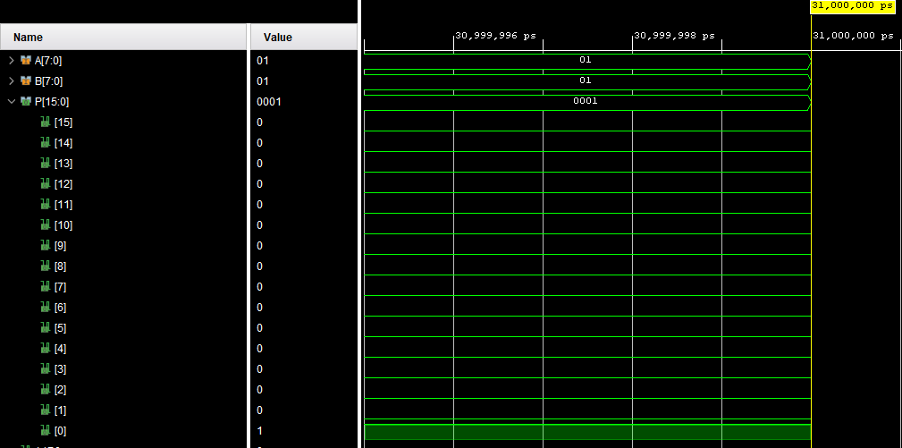
Figure 27 Brauns 1x1 simulation
Forcing the constant and running the simulation gives us the hex value of 0001 and the binary output of 0000000000000001 which is the correct result.
Next a more complex action doing 4 x 5 is simulated.
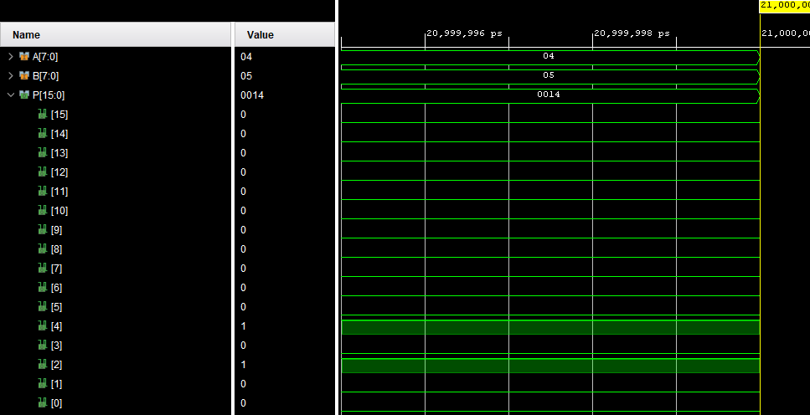
Figure 28 Brauns 4x5 simulation
This again gives the correct result showing 0014 in hex and giving a binary output of 0000000000010100 which is correct.
The final simulation for the Brauns is AB X CD this large number will allow a final check to see if it is working as intended.
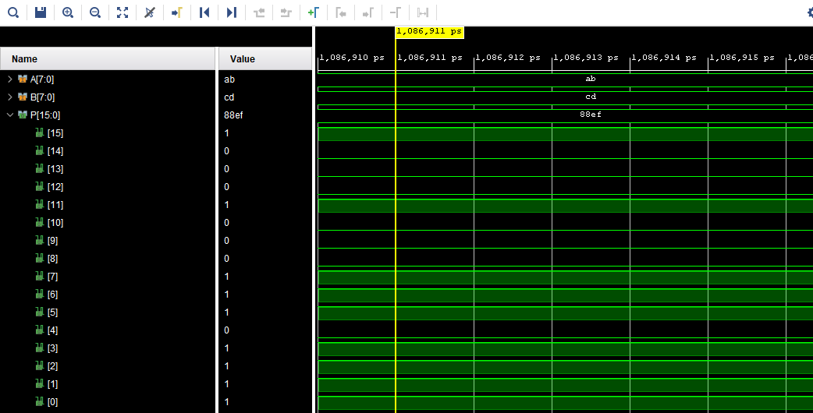
Figure 29 Brauns AB x CD simulation
This simulation gives a hex output of 88ef and a binary output of 1000100011101111 which is correct.

Wallace tree simulations
The first test for the Wallace tree is a simple 2x2 which will give an immediate indication if the design is working correctly.

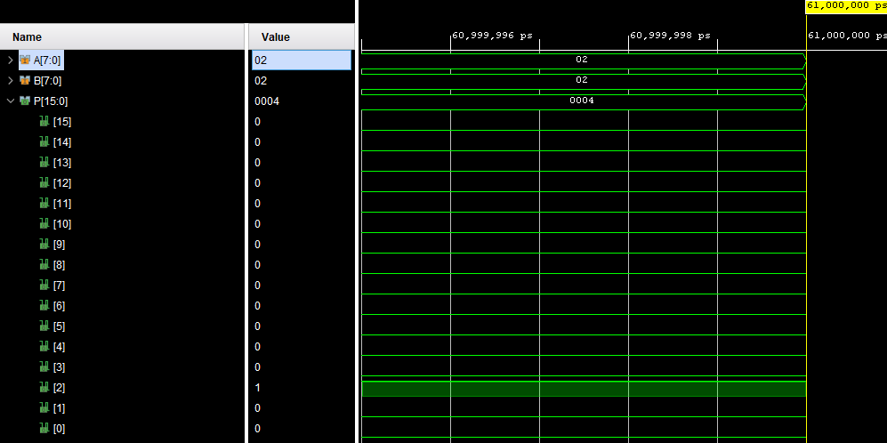
Figure 30 Wallace 2 x 2 simulation
This gives a hex result of 0004 which is correct and gives a binary output of 0000000000000100 which is as expected.
Next is 3b x 4b
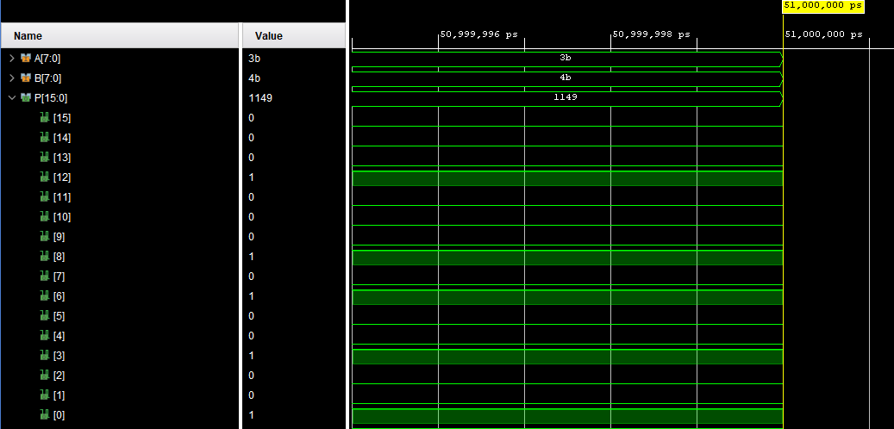
Figure 31 Wallce 3B X 4B simulation
This gives the hex value of 1149 and a binary of 0001000101001001.
The final test is FF x FF this will test the higher range of the multiplier
Figure 32 Wallace tree FF x FF simulation

This again shows the correct value of FE01 and a binary of 1111111000000001 which is correct.

Comparison, Analysis, and Interpretation of Results (use at least 4 samples)

To compare the results of both multipliers test reports from Vivado are used, they provide insights to how the architecture works with the hardware. Calculations are also preformed to find the minimum timing delay. This must be found as it directly affects the speed and efficiency of the multiplier. Four samples are used, this allows an accurate conclusion to be drawn. The results are only going to be looked at for the implementation to give a more accurate result.

The first point to consider is the worst negative slack. The Wallace tree has a worst negative slack of 10.147ns, the Brauns has a worst negative slack of 18.521ns. This value was to be expected as the Wallace tree is typically a faster multiplier.

Interpterion of Power utilization and LUTs

When designing it is important to know the power utilization of your design. This is important as higher utilization will result in the chip on the hardware's temperature to rise, use more power and limit the life span on the chip. The FPGA has a budget of how much power can be used and you want to limit usage as much as possible without effecting the prosses. The LUT represents how much hardware is used in the design.

The results of the implementation it can be seen that the Brauns uses 0.44% of LUT and the Wallace tree uses 0.41% meaning that the Wallace tree is slightly more efficient, but the difference is marginal. The I/O utilization is the same across both multipliers due to them sharing 16 inputs and 16 outputs. When looking at the power report it can be seen that the total on chip power is the same at 0.091W, but analysing the results shows that only 0.018W comes from the I/O and 0.072W from the devise, this shows that each design uses a very small amount of power.

Power utilization of Brauns

Synthesis
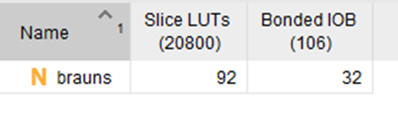
Figure 33 Brauns synthesis LUT

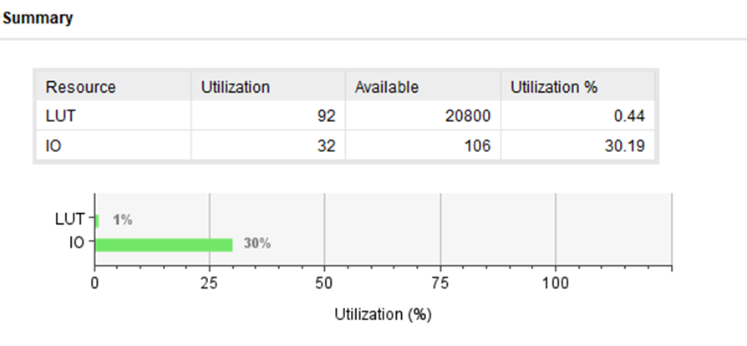
Figure 34 Brauns synthesis utilization summery

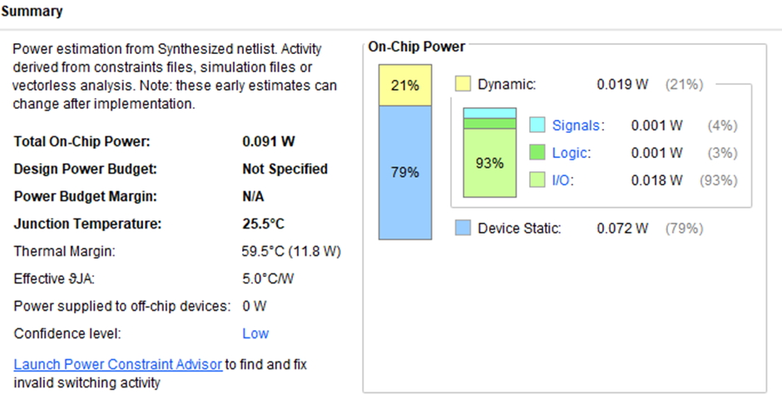
Figure 35 Brauns synthesis power summery

Implementation

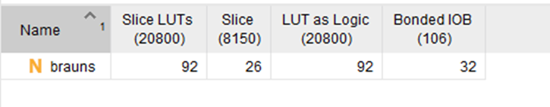
Figure 36 Brauns implementation LUTs

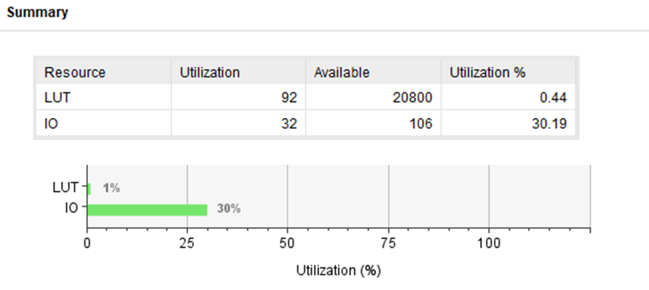
Figure 37 Brauns implementation utilization summary

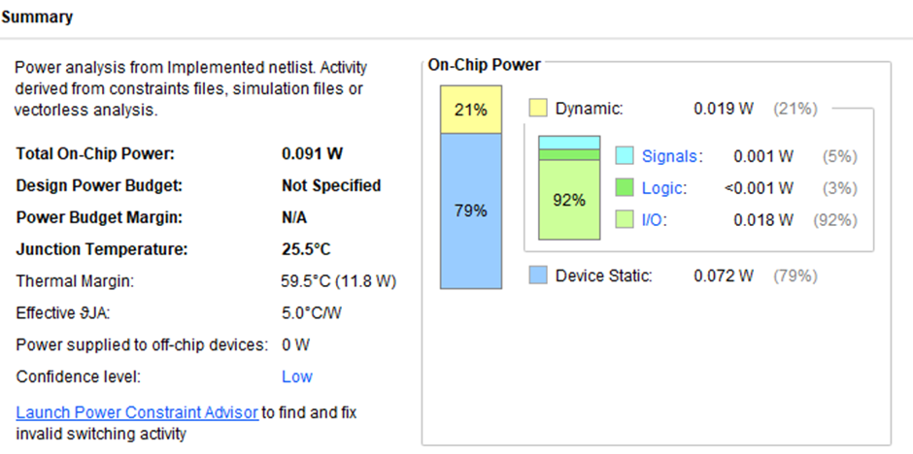
Figure 38 Brauns implementation power summery

Power utilization of Wallace tree

Synthesis
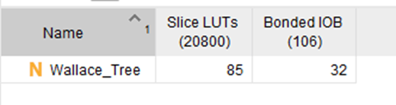
Figure 39 Wallace synthesis LUTs

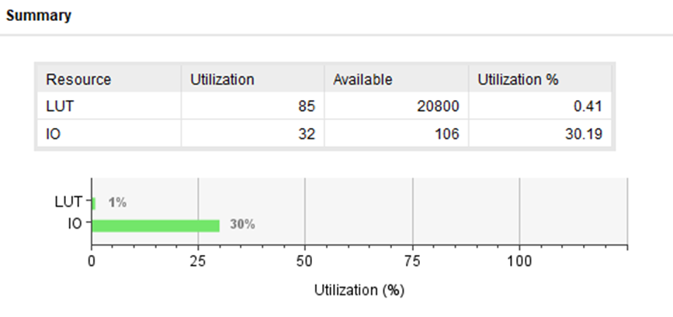
Figure 40 Wallace synthesis utilization summary

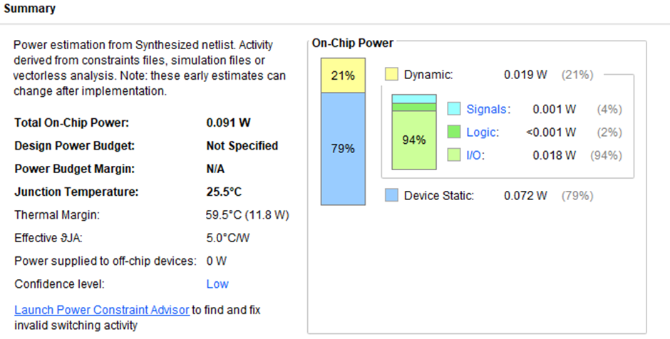
Figure 41 Wallace synthesis power summary

Implementation

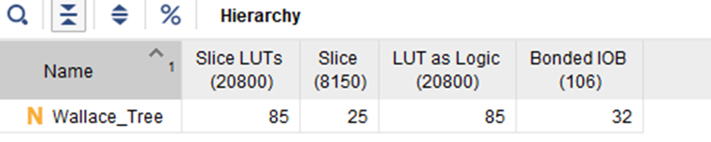
Figure 42 Wallace implementation LUTs

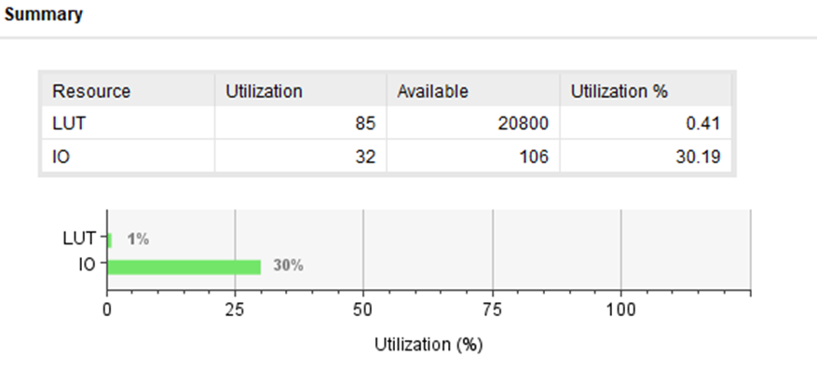
Figure 43 Wallace implementation utilization summary

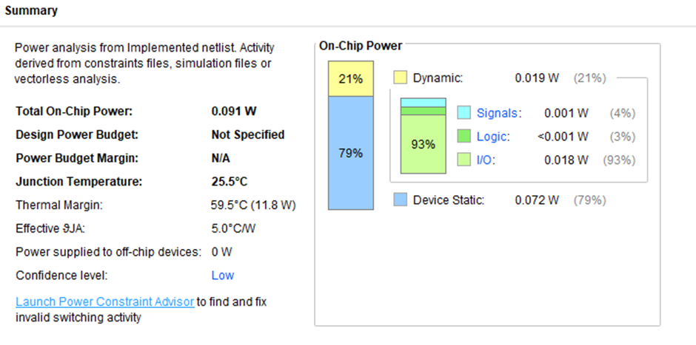
Figure 44 Wallace implementation power summary

Details of testing and recommendations for future improvements

Testing
The testing is done using the Vivado software as well as the Basys hardware. This is necessary to see if both designs operate as intended. Both multipliers have different architecture but give accurate results when simulated in the Vivado software as well as on the Basys hardware

When testing on the hardware the inputs are controlled by 16 switches, each switch represents a binary input. The first 8 switches represent A and the last 8 represent B. depending on the configuration of the switches will give outputs via the LEDs which are acting as the 16-bit binary output. Tests are compared against the simulated results that were preformed using vivado to see if the correct outputs are given.

Brauns

4 x 5
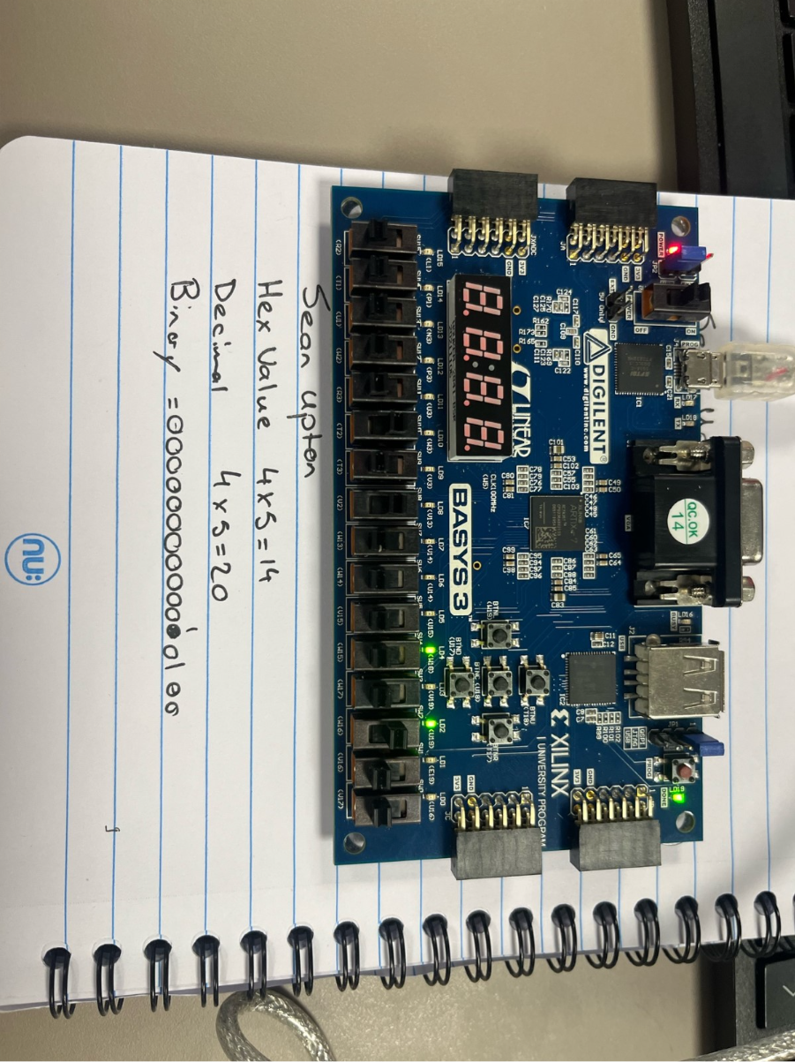
Figure 45 Brauns 4 x 4 hardware test
Figure 46 Brauns 4 x 4 simulation

1 x 1
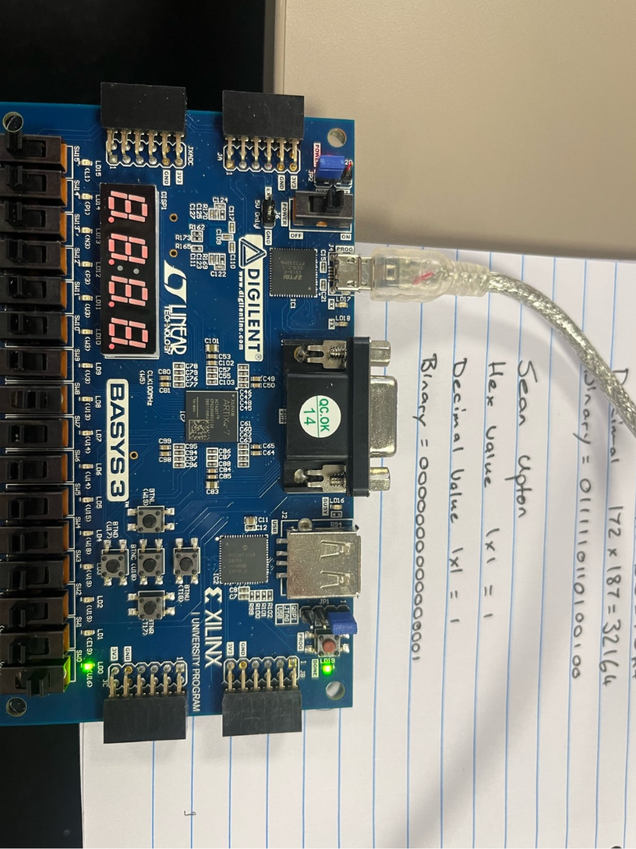
Figure 47 Brauns 1 x 1 hardware test
Figure 48 Brauns 1 x 1 simulation

AB x CD

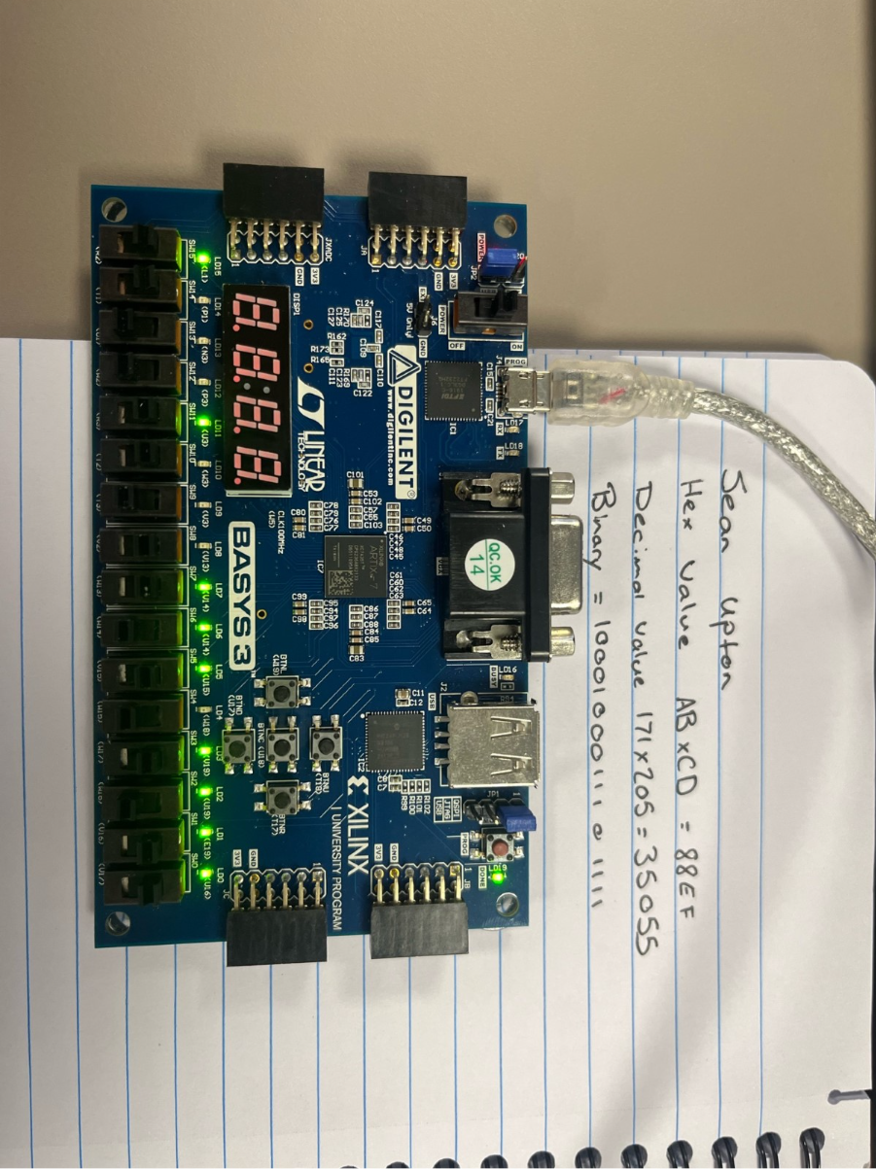
Figure 49 Brauns AB x CD hardware test
Figure 50 Brauns AB x CD simulation

Wallace tree

FF x FF

Figure 51 Wallace FF x FF simulation
Figure 52 Wallace FF x FF hardware test

3B x 4B
Figure 53 Wallace 3B x 4B simulation
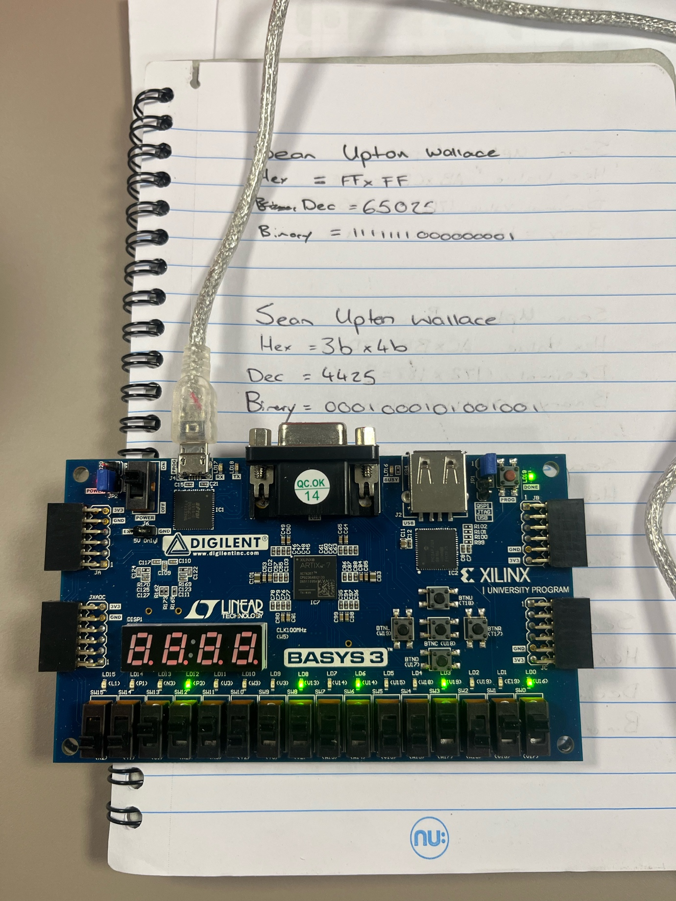
Figure 54 Wallace 3B X 4B hardware test

2 x 2
Figure 55 Wallace 2 x 2 simulation
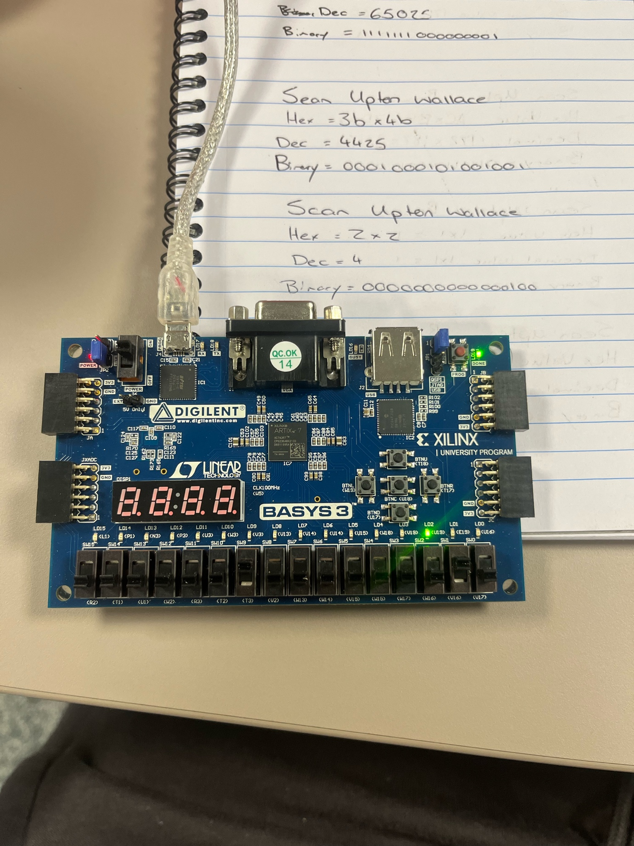
Figure 56 Wallace 2 x 2 hardware test

Improvements
The 8x8 multiplier does allow for large multiplication, there is also scope for expanding on the multipliers by adding additional stages there is scope to go to 16 x 16 bits and 32 x 32. To get a more accurate picture of efficiency and performance of multipliers, additional multipliers could have been tested such as the Vedic multiplier. To improve the delay pipelining could be introduced this would reduce the number of stages as multiplication is broken down into smaller steps.

Conclusion
The purpose of the research was to compare the performance of both the Brauns and Wallace tree multiplier through the use of simulation and analysis and find the measurable differences between the array and tree architecture. It was found that the Brauns multiplier is easier to implement due to its straightforward structure. But as a downside to this structure is that there is more of a delay due to increased steps. The Wallace tree is a more complex design but is able to achieve faster results due to it being able to reduce partial products in parallel.
Both multipliers are effective at multiplying 8x8 binary inputs, but the Wallce tree would be more advised to be used for applications that require better performance.

[1]
S. P. and A. A. Khan, “Comparison of Braun Multiplier and Wallace Multiplier Techniques in VLSI,” 2018 4th International Conference on Devices, Circuits and Systems (ICDCS), pp. 48–53, Mar. 2018, doi: https://doi.org/10.1109/icdcsyst.2018.8605173. Available: https://ieeexplore.ieee.org/document/8605173. [Accessed: Mar. 13, 2025]
[2]
D. V. N. Bharathi, “Review on Performance and Hardware Complexity of Multipliers,” Review on Performance and Hardware Complexity of Multipliers , vol. 15, no. 5, pp. 14–16, Sep. 2020, Available: https://d1wqtxts1xzle7.cloudfront.net/64829337/C1505011416-libre.pdf?1604306155=&response-content-disposition=inline%3B+filename%3DReview_on_Performance_and_Hardware_Compl.pdf&Expires=1776530125&Signature=ZK14qrnIXm30fQXccCq4oVQcyRIVYyB~tWKpBqM1b5IfS~5l3Af6fd7QiIP4krh3ZCSCVroVG46PEM-Tb9D~WSUyAZ~oxPiFkqXvfR3VO3hSVF3epHi~b4cLBeivfMUoRlLtkoOTLFPcKjcEBcWH6F~ZVSeJgaRkz0cWIuGo9NSpeL-pYr2HJezVD-lOFYEJvRvCBZBsI30dY2SCFYqaas6DbHIqbEPEqwXAc9PCjz8OlOdIGYH3jsVMEGKceCguteHmbTBuwx3MAVepJVkSuacOSunJATugZi7fD8adK21mZLN0clXVw4FzdvyNICWVVvScL8YHQpL9yIaKQOcgrg__&Key-Pair-Id=APKAJLOHF5GGSLRBV4ZA. [Accessed: Apr. 18, 2026]
[3]
K. A. C. Bickerstaff, M. Schulte, and E. E. Swartzlander, “Reduced area multipliers,” Dec. 2002, doi: https://doi.org/10.1109/asap.1993.397168
[4]
Yeshudas Muttu, Lokesh Kumar Bramhane, A. D. Rahulkar, and T. Veerakumar, “Implementation and Performance Analysis of 8-bit Digital Parallel Array Multipliers,” pp. 1–5, Nov. 2024, doi: https://doi.org/10.1109/ic-sit63503.2024.10862414
[5]
safia Bibi, “Design and analysis of hybrid tree multipliers for reduction of partial products,” informit, Jul. 01, 2018. Available: https://search.informit.org/doi/abs/10.3316/informit.677655289724938. [Accessed: Apr. 18, 2026]
[6]
S. P. and A. A. Khan, “Comparison of Braun Multiplier and Wallace Multiplier Techniques in VLSI,” 2018 4th International Conference on Devices, Circuits and Systems (ICDCS), pp. 48–53, Mar. 2018, doi: https://doi.org/10.1109/icdcsyst.2018.8605173. Available: https://ieeexplore.ieee.org/document/8605173
[7]
V. B. Biradar, P. G. Vishwas, C. S. Chetan, and B. S. Premananda, “Design and performance analysis of modified unsigned braun and signed Baugh-Wooley multiplier,” 2017 International Conference on Electrical, Electronics, Communication, Computer, and Optimization Techniques (ICEECCOT), Dec. 2017, doi: https://doi.org/10.1109/iceeccot.2017.8284612
[8]
A. Rosi, T. Suresh, MD. G. Babu, S. H. Ramakrishnan, M. Charan, and T. Vaishnavi, “High Performance Power Efficient Multiplier for AI Based Application,” 2025 11th International Conference on Communication and Signal Processing (ICCSP), pp. 1496–1500, Jun. 2025, doi: https://doi.org/10.1109/iccsp64183.2025.11088623. Available: https://ieeexplore.ieee.org/abstract/document/11088623. [Accessed: Apr. 18, 2026]

Appendix

Barun's code
library IEEE;
use IEEE.STD_LOGIC_1164.ALL;

-- Uncomment the following library declaration if using
-- arithmetic functions with Signed or Unsigned values
--use IEEE.NUMERIC_STD.ALL;

-- Uncomment the following library declaration if instantiating
-- any Xilinx leaf cells in this code.
--library UNISIM;
--use UNISIM.VComponents.all;

entity brauns is
Port ( A : in STD_LOGIC_VECTOR (7 downto 0);
B : in STD_LOGIC_VECTOR (7 downto 0);
P : out STD_LOGIC_VECTOR (15 downto 0));
end brauns;

architecture Behavioral of brauns is

signal A1B0 : std_logic;
signal A0B1 : std_logic;

signal A2B0 : std_logic;
signal A1B1 : std_logic;
signal A0B2 : std_logic;

signal A3B0 : std_logic;
signal A2B1 : std_logic;
signal A1B2 : std_logic;
signal A0B3 : std_logic;

signal A4B0 : std_logic;
signal A3B1 : std_logic;
signal A2B2 : std_logic;
signal A1B3 : std_logic;
signal A0B4 : std_logic;

signal A5B0 : std_logic;
signal A4B1 : std_logic;
signal A3B2 : std_logic;
signal A2B3 : std_logic;
signal A1B4 : std_logic;
signal A0B5 : std_logic;

signal A6B0 : std_logic;
signal A5B1 : std_logic;
signal A4B2 : std_logic;
signal A3B3 : std_logic;
signal A2B4 : std_logic;
signal A1B5 : std_logic;
signal A0B6 : std_logic;

signal A7B0 : std_logic;
signal A6B1 : std_logic;
signal A5B2 : std_logic;
signal A4B3 : std_logic;
signal A3B4 : std_logic;
signal A2B5 : std_logic;
signal A1B6 : std_logic;
signal A0B7 : std_logic;

signal A7B1 : std_logic;
signal A6B2 : std_logic;
signal A5B3 : std_logic;
signal A4B4 : std_logic;
signal A3B5 : std_logic;
signal A2B6 : std_logic;
signal A1B7 : std_logic;

signal A7B2 : std_logic;
signal A6B3 : std_logic;
signal A5B4 : std_logic;
signal A4B5 : std_logic;
signal A3B6 : std_logic;
signal A2B7 : std_logic;

signal A7B3 : std_logic;
signal A6B4 : std_logic;
signal A5B5 : std_logic;
signal A4B6 : std_logic;
signal A3B7 : std_logic;

signal A7B4 : std_logic;
signal A6B5 : std_logic;
signal A5B6 : std_logic;
signal A4B7 : std_logic;

signal A7B5 : std_logic;
signal A6B6 : std_logic;
signal A5B7 : std_logic;

signal A7B6 : std_logic;
signal A6B7 : std_logic;

signal A7B7 : std_logic;

signal C1 : std_logic;------p2
signal S2 : std_logic;

signal C2 : std_logic;------p3
signal S3 : std_logic;
signal C9 : std_logic;
signal S10 : std_logic;

signal C3 : std_logic;------p4
signal S4 : std_logic;
signal C10 : std_logic;
signal S11 : std_logic;
signal C17 : std_logic;
signal S18 : std_logic;

signal C4 : std_logic;------P5
signal S5 : std_logic;
signal C11 : std_logic;
signal S12 : std_logic;
signal C18 : std_logic;
signal S19 : std_logic;
signal C25 : std_logic;
signal S26 : std_logic;

signal C5 : std_logic;-----P6
signal S6 : std_logic;
signal C12 : std_logic;
signal S13 : std_logic;
signal C19 : std_logic;
signal S20 : std_logic;
signal C26 : std_logic;
signal S27 : std_logic;
signal C33 : std_logic;
signal S34 : std_logic;

signal C6 : std_logic;------P7
signal S7 : std_logic;
signal C13 : std_logic;
signal S14 : std_logic;
signal C20 : std_logic;
signal S21 : std_logic;
signal C27 : std_logic;
signal S28 : std_logic;
signal C34 : std_logic;
signal S35 : std_logic;
signal C41 : std_logic;
signal S42 : std_logic;

signal C7 : std_logic;------P8
signal S8 : std_logic;
signal C14 : std_logic;
signal S15 : std_logic;
signal C21 : std_logic;
signal S22 : std_logic;
signal C28 : std_logic;
signal S29 : std_logic;
signal C35 : std_logic;
signal S36 : std_logic;
signal C42 : std_logic;
signal S43 : std_logic;
signal C49 : std_logic;

signal C8 : std_logic;------P9
signal C15 : std_logic;
signal S16 : std_logic;
signal C22 : std_logic;
signal S23 : std_logic;
signal C29 : std_logic;
signal S30 : std_logic;
signal C36 : std_logic;
signal S37 : std_logic;
signal C43 : std_logic;
signal S44 : std_logic;
signal C50 : std_logic;

signal C16 : std_logic;------P10
signal C23 : std_logic;
signal S24 : std_logic;
signal C30 : std_logic;
signal S31 : std_logic;
signal C37 : std_logic;
signal S38 : std_logic;
signal C44 : std_logic;
signal S45 : std_logic;
signal C51 : std_logic;

signal C24 : std_logic;------P11
signal C31 : std_logic;
signal S32 : std_logic;
signal C38 : std_logic;
signal S39 : std_logic;
signal C45 : std_logic;
signal S46 : std_logic;
signal C52 : std_logic;

signal C32 : std_logic;------P12
signal C39 : std_logic;
signal S40 : std_logic;
signal C46 : std_logic;
signal S47 : std_logic;
signal C53 : std_logic;

signal C40 : std_logic;------P13
signal C47 : std_logic;
signal S48 : std_logic;
signal C54 : std_logic;

signal C48 : std_logic;------P14
signal C55 : std_logic;

signal C56 : std_logic;------P15

component full_adder
port (A : in STD_LOGIC;
B : in STD_LOGIC;
Cin : in STD_LOGIC;
S : out STD_LOGIC;
Cout : out STD_LOGIC);
end component;

component halfadder
port (A : in STD_LOGIC;
B : in STD_LOGIC;
S : out STD_LOGIC;
Cout : out STD_LOGIC);
end component;

begin
A1B0 <= A(1) and B(0) ;----row 2
A0B1 <= A(0) and B(1) ;

A2B0 <= A(2) and B(0) ;---row 3
A1B1 <= A(1) and B(1) ;
A0B2 <= A(0) and B(2) ;

A3B0 <= A(3) and B(0) ;---row 4
A2B1 <= A(2) and B(1) ;
A1B2 <= A(1) and B(2) ;
A0B3 <= A(0) and B(3) ;

A4B0 <= A(4) and B(0) ;---row 5
A3B1 <= A(3) and B(1) ;
A2B2 <= A(2) and B(2) ;
A1B3 <= A(1) and B(3) ;
A0B4 <= A(0) and B(4) ;

A5B0 <= A(5) and B(0) ;---row 6
A4B1 <= A(4) and B(1) ;
A3B2 <= A(3) and B(2) ;
A2B3 <= A(2) and B(3) ;
A1B4 <= A(1) and B(4) ;
A0B5 <= A(0) and B(5) ;

A6B0 <= A(6) and B(0) ;----row 7
A5B1 <= A(5) and B(1) ;
A4B2 <= A(4) and B(2) ;
A3B3 <= A(3) and B(3) ;
A2B4 <= A(2) and B(4) ;
A1B5 <= A(1) and B(5) ;
A0B6 <= A(0) and B(6) ;

A7B0 <= A(7) and B(0) ;----row 8
A6B1 <= A(6) and B(1) ;
A5B2 <= A(5) and B(2) ;
A4B3 <= A(4) and B(3) ;
A3B4 <= A(3) and B(4) ;
A2B5 <= A(2) and B(5) ;
A1B6 <= A(1) and B(6) ;
A0B7 <= A(0) and B(7) ;

A7B1 <= A(7) and B(1) ;----row 9
A6B2 <= A(6) and B(2) ;
A5B3 <= A(5) and B(3) ;
A4B4 <= A(4) and B(4) ;
A3B5 <= A(3) and B(5) ;
A2B6 <= A(2) and B(6) ;
A1B7 <= A(1) and B(7) ;

A7B2 <= A(7) and B(2) ;----row 10
A6B3 <= A(6) and B(3) ;
A5B4 <= A(5) and B(4) ;
A4B5 <= A(4) and B(5) ;
A3B6 <= A(3) and B(6) ;
A2B7 <= A(2) and B(7) ;

A7B3 <= A(7) and B(3) ;----row 11
A6B4 <= A(6) and B(4) ;
A5B5 <= A(5) and B(5) ;
A4B6 <= A(4) and B(6) ;
A3B7 <= A(3) and B(7) ;

A7B4 <= A(7) and B(4) ;----row 12
A6B5 <= A(6) and B(5) ;
A5B6 <= A(5) and B(6) ;
A4B7 <= A(4) and B(7) ;

A7B5 <= A(7) and B(5) ;----row 13
A6B6 <= A(6) and B(6) ;
A5B7 <= A(5) and B(7) ;

A7B6 <= A(7) and B(6) ;----row 14
A6B7 <= A(6) and B(7) ;

A7B7 <= A(7) and B(7) ;

P0 : P(0) <= A(0) and B(0) ;

----2
P1_0 : halfadder port map (A=>A1B0 , B=>A0B1 ,S=> P(1), Cout=>C1);

----3
P21 : full_adder port map (A=>A2B0 , B=>A1B1 , Cin=>C1, S=>S2, Cout=>C2);
P2_0 : halfadder port map (A=>A0B2 , B=>S2 , S=>P(2), Cout=>C9);

----4
P31 : full_adder port map (A=>A3B0 , B=>A2B1, Cin=>C2 , S=>S3 ,Cout=>C3);
P32 : full_adder port map (A=>A1B2, B=>S3 ,Cin=>C9, S=>S10 ,Cout=>C10);
P3_0 : halfadder port map (A=>A0B3, B=>S10 , S=>P(3),Cout=>C17);

----5
P41 : full_adder port map (A=>A4B0 , B=>A3B1, Cin=>C3 , S=>S4 ,Cout=>C4);
P42 : full_adder port map (A=>A2B2 , B=>S4, Cin=>C10 , S=>S11 ,Cout=>C11);
P43 : full_adder port map (A=>A1B3 , B=>S11, Cin=>C17 , S=>S18 ,Cout=>C18);
P4_0 : halfadder port map (A=>A0B4, B=>S18 , S=>P(4),Cout=>C25);

----6
P51 : full_adder port map (A=>A5B0 , B=>A4B1, Cin=>C4 , S=>S5 ,Cout=>C5);
P52 : full_adder port map (A=>A3B2 , B=>S5, Cin=>C11 , S=>S12 ,Cout=>C12);
P53 : full_adder port map (A=>A2B3 , B=>S12, Cin=>C18 , S=>S19 ,Cout=>C19);
P54 : full_adder port map (A=>A1B4 , B=>S19, Cin=>C25 , S=>S26 ,Cout=>C26);
P5_0 : halfadder port map (A=>A0B5, B=>S26 , S=>P(5),Cout=>C33);

----7
P61 : full_adder port map (A=>A6B0 , B=>A5B1, Cin=>C5 ,S=>S6 ,Cout=>C6);
P62 : full_adder port map (A=>A4B2 , B=>S6, Cin=>C12 , S=>S13 ,Cout=>C13);
P63 : full_adder port map (A=>A3B3 , B=>S13, Cin=>C19 , S=>S20 ,Cout=>C20);
P64 : full_adder port map (A=>A2B4 , B=>S20, Cin=>C26 , S=>S27 ,Cout=>C27);
P65 : full_adder port map (A=>A1B5 , B=>S27, Cin=>C33 , S=>S34 ,Cout=>C34);
P6_0 : halfadder port map (A=>A0B6 , B=>S34 , S=>P(6),Cout=>C41);

----8
P71 : full_adder port map (A=>A7B0 , B=>A6B1, Cin=>C6 , S=>S7 ,Cout=>C7);
P72 : full_adder port map (A=>A5B2 , B=>S7, Cin=>C13 , S=>S14 ,Cout=>C14);
P73 : full_adder port map (A=>A4B3 , B=>S14, Cin=>C20 , S=>S21 ,Cout=>C21);
P74 : full_adder port map (A=>A3B4 , B=>S21, Cin=>C27 , S=>S28 ,Cout=>C28);
P75 : full_adder port map (A=>A2B5 , B=>S28, Cin=>C34 , S=>S35 ,Cout=>C35);
P76 : full_adder port map (A=>A1B6 , B=>S35, Cin=>C41 , S=>S42 ,Cout=>C42);
P7_0 : halfadder port map (A=>A0B7 , B=>S42 , S=>P(7),Cout=>C49);

----9
P8_0 : halfadder port map (A=>A7B1, B=>C7 , S=>S8,Cout=>C8);
P81 : full_adder port map (A=>A6B2 , B=>S8, Cin=>C14 , S=>S15 ,Cout=>C15);
P82 : full_adder port map (A=>A5B3 , B=>S15, Cin=>C21 , S=>S22 ,Cout=>C22);
P83 : full_adder port map (A=>A4B4 , B=>S22, Cin=>C28 , S=>S29 ,Cout=>C29);
P84 : full_adder port map (A=>A3B5 , B=>S29, Cin=>C35 , S=>S36 ,Cout=>C36);
P85 : full_adder port map (A=>A2B6 , B=>S36, Cin=>C42 , S=>S43 ,Cout=>C43);
P86 : full_adder port map (A=>A1B7 , B=>S43, Cin=>C49 , S=>P(8) ,Cout=>C50);

----10
P91 : full_adder port map (A=>A7B2 , B=>C8, Cin=>C15 , S=>S16 ,Cout=>C16);
P92 : full_adder port map (A=>A6B3 , B=>S16, Cin=>C22 , S=>S23 ,Cout=>C23);
P93 : full_adder port map (A=>A5B4 , B=>S23, Cin=>C29 , S=>S30 ,Cout=>C30);
P94 : full_adder port map (A=>A4B5 , B=>S30, Cin=>C36 , S=>S37 ,Cout=>C37);
P95 : full_adder port map (A=>A3B6 , B=>S37, Cin=>C43 , S=>S44 ,Cout=>C44);
P96 : full_adder port map (A=>A2B7 , B=>S44, Cin=>C50 , S=>P(9) ,Cout=>C51);

----11
P101 : full_adder port map (A=>A7B3 , B=>C16, Cin=>C23 , S=>S24 ,Cout=>C24);
P102 : full_adder port map (A=>A6B4 , B=>S24, Cin=>C30 , S=>S31 ,Cout=>C31);
P103 : full_adder port map (A=>A5B5 , B=>S31, Cin=>C37 , S=>S38 ,Cout=>C38);
P104 : full_adder port map (A=>A4B6 , B=>S38, Cin=>C44 , S=>S45 ,Cout=>C45);
P105 : full_adder port map (A=>A3B7 , B=>S45, Cin=>C51 , S=>P(10) ,Cout=>C52);

----12
P111 : full_adder port map (A=>A7B4 , B=>C24, Cin=>C31 , S=>S32 ,Cout=>C32);
P112 : full_adder port map (A=>A6B5 , B=>S32, Cin=>C38 , S=>S39 ,Cout=>C39);
P113 : full_adder port map (A=>A5B6 , B=>S39, Cin=>C45 , S=>S46 ,Cout=>C46);
P114 : full_adder port map (A=>A4B7 , B=>S46, Cin=>C52 , S=>P(11) ,Cout=>C53);

----13
P121 : full_adder port map (A=>A7B5 , B=>C32, Cin=>C39 , S=>S40 ,Cout=>C40);
P122 : full_adder port map (A=>A6B6 , B=>S40, Cin=>C46 , S=>S47 ,Cout=>C47);
P123 : full_adder port map (A=>A5B7 , B=>S47, Cin=>C53 , S=>P(12) ,Cout=>C54);

----14
P131 : full_adder port map (A=>A7B6 , B=>C40, Cin=>C47 , S=>S48 ,Cout=>C48);
P142 : full_adder port map (A=>A6B7 , B=>S48, Cin=>C54 , S=>P(13) ,Cout=>C55);

----15
P141 : full_adder port map (A=>A7B7 , B=>C48 , Cin=>C55 , S=>P(14) ,Cout=>P(15));

end Behavioral;

Wallce tree code
library IEEE;
use IEEE.STD_LOGIC_1164.ALL;

-- Uncomment the following library declaration if using
-- arithmetic functions with Signed or Unsigned values
--use IEEE.NUMERIC_STD.ALL;

-- Uncomment the following library declaration if instantiating
-- any Xilinx leaf cells in this code.
--library UNISIM;
--use UNISIM.VComponents.all;

entity Wallace_Tree is
Port ( A : in STD_LOGIC_VECTOR (7 downto 0) ;
B : in STD_LOGIC_VECTOR (7 downto 0) ;
P : out STD_LOGIC_VECTOR (15 downto 0)) ;
end Wallace_Tree;

architecture Behavioral of Wallace_Tree is
component full_adder is
Port ( A : in STD_LOGIC;
B : in STD_LOGIC;
Cin : in STD_LOGIC;
S : out STD_LOGIC;
Cout : out STD_LOGIC);
end component;

component halfadder is
Port ( A : in STD_LOGIC;
B : in STD_LOGIC;
S : out STD_LOGIC;
Cout : out STD_LOGIC);
end component;

signal
S2,S3,S4,S5,S6,S7,S8,S10,S11,S12,S13,S14,S15,S16,S18,S19,S20,S21,S22,S23,S24,S26,S27,S28,S29,S30,S31,S32,S34,S35,S36,S37,S38,S39,S40,S42,S43,S44,S45,S46,S47,S48 : STD_LOGIC;
signal
C1,C2,C3,C4,C5,C6,C7,C8,C9,C10,C11,C12,C13,C14,C15,C16,C17,C18,C19,C20,C21,C22,C23,C24,C25,C26,C27,C28,C29,C30,C31,C32,C33,C34,C35,C36,C37,C38,C39,C40,C41,C42,C43,C44,C45,C46,C47,C48,C49,C50,C51,C52,C53,C54,C55 : STD_LOGIC;

signal A1B0 : STD_LOGIC;
signal A2B0 : STD_LOGIC;
signal A3B0 : STD_LOGIC;
signal A4B0 : STD_LOGIC;
signal A5B0 : STD_LOGIC;
signal A6B0 : STD_LOGIC;
signal A7B0 : STD_LOGIC;

signal A0B1 : STD_LOGIC;
signal A1B1 : STD_LOGIC;
signal A2B1 : STD_LOGIC;
signal A3B1 : STD_LOGIC;
signal A4B1 : STD_LOGIC;
signal A5B1 : STD_LOGIC;
signal A6B1 : STD_LOGIC;
signal A7B1 : STD_LOGIC;

signal A0B2 : STD_LOGIC;
signal A1B2 : STD_LOGIC;
signal A2B2 : STD_LOGIC;
signal A3B2 : STD_LOGIC;
signal A4B2 : STD_LOGIC;
signal A5B2 : STD_LOGIC;
signal A6B2 : STD_LOGIC;
signal A7B2 : STD_LOGIC;

signal A0B3 : STD_LOGIC;
signal A1B3 : STD_LOGIC;
signal A2B3 : STD_LOGIC;
signal A3B3 : STD_LOGIC;
signal A4B3 : STD_LOGIC;
signal A5B3 : STD_LOGIC;
signal A6B3 : STD_LOGIC;
signal A7B3 : STD_LOGIC;

signal A0B4 : STD_LOGIC;
signal A1B4 : STD_LOGIC;
signal A2B4 : STD_LOGIC;
signal A3B4 : STD_LOGIC;
signal A4B4 : STD_LOGIC;
signal A5B4 : STD_LOGIC;
signal A6B4 : STD_LOGIC;
signal A7B4 : STD_LOGIC;

signal A0B5 : STD_LOGIC;
signal A1B5 : STD_LOGIC;
signal A2B5 : STD_LOGIC;
signal A3B5 : STD_LOGIC;
signal A4B5 : STD_LOGIC;
signal A5B5 : STD_LOGIC;
signal A6B5 : STD_LOGIC;
signal A7B5 : STD_LOGIC;

signal A0B6 : STD_LOGIC;
signal A1B6 : STD_LOGIC;
signal A2B6 : STD_LOGIC;
signal A3B6 : STD_LOGIC;
signal A4B6 : STD_LOGIC;
signal A5B6 : STD_LOGIC;
signal A6B6 : STD_LOGIC;
signal A7B6 : STD_LOGIC;

signal A0B7 : STD_LOGIC;
signal A1B7 : STD_LOGIC;
signal A2B7 : STD_LOGIC;
signal A3B7 : STD_LOGIC;
signal A4B7 : STD_LOGIC;
signal A5B7 : STD_LOGIC;
signal A6B7 : STD_LOGIC;
signal A7B7 : STD_LOGIC;

begin
A1B0 <= A(1) and B(0);
A2B0 <= A(2) and B(0);
A3B0 <= A(3) and B(0);
A4B0 <= A(4) and B(0);
A5B0 <= A(5) and B(0);
A6B0 <= A(6) and B(0);
A7B0 <= A(7) and B(0);

A0B1 <= A(0) and B(1);
A1B1 <= A(1) and B(1);
A2B1 <= A(2) and B(1);
A3B1 <= A(3) and B(1);
A4B1 <= A(4) and B(1);
A5B1 <= A(5) and B(1);
A6B1 <= A(6) and B(1);
A7B1 <= A(7) and B(1);

A0B2 <= A(0) and B(2);
A1B2 <= A(1) and B(2);
A2B2 <= A(2) and B(2);
A3B2 <= A(3) and B(2);
A4B2 <= A(4) and B(2);
A5B2 <= A(5) and B(2);
A6B2 <= A(6) and B(2);
A7B2 <= A(7) and B(2);

A0B3 <= A(0) and B(3);
A1B3 <= A(1) and B(3);
A2B3 <= A(2) and B(3);
A3B3 <= A(3) and B(3);
A4B3 <= A(4) and B(3);
A5B3 <= A(5) and B(3);
A6B3 <= A(6) and B(3);
A7B3 <= A(7) and B(3);

A0B4 <= A(0) and B(4);
A1B4 <= A(1) and B(4);
A2B4 <= A(2) and B(4);
A3B4 <= A(3) and B(4);
A4B4 <= A(4) and B(4);
A5B4 <= A(5) and B(4);
A6B4 <= A(6) and B(4);
A7B4 <= A(7) and B(4);

A0B5 <= A(0) and B(5);
A1B5 <= A(1) and B(5);
A2B5 <= A(2) and B(5);
A3B5 <= A(3) and B(5);
A4B5 <= A(4) and B(5);
A5B5 <= A(5) and B(5);
A6B5 <= A(6) and B(5);
A7B5 <= A(7) and B(5);

A0B6 <= A(0) and B(6);
A1B6 <= A(1) and B(6);
A2B6 <= A(2) and B(6);
A3B6 <= A(3) and B(6);
A4B6 <= A(4) and B(6);
A5B6 <= A(5) and B(6);
A6B6 <= A(6) and B(6);
A7B6 <= A(7) and B(6);

A0B7 <= A(0) and B(7);
A1B7 <= A(1) and B(7);
A2B7 <= A(2) and B(7);
A3B7 <= A(3) and B(7);
A4B7 <= A(4) and B(7);
A5B7 <= A(5) and B(7);
A6B7 <= A(6) and B(7);
A7B7 <= A(7) and B(7);

--1
P0 : P(0) <= A(0) and B(0) ;

P1_0 : halfadder port map(A=>A1B0 , B=>A0B1, S=>P(1), Cout=>C1);
P11 : full_adder port map(A=>A2B0 , B=>A1B1, Cin=>A0B2, S=>S2, Cout=>C2);
P12 : full_adder port map(A=>A3B0 , B=>A2B1, Cin=>A1B2, S=>S3, Cout=>C3);
P13 : full_adder port map(A=>A4B0 , B=>A3B1, Cin=>A2B2, S=>S4, Cout=>C4);
P14 : full_adder port map(A=>A5B0 , B=>A4B1, Cin=>A3B2, S=>S5, Cout=>C5);
P15 : full_adder port map(A=>A6B0 , B=>A5B1, Cin=>A4B2, S=>S6, Cout=>C6);
P16 : full_adder port map(A=>A7B0 , B=>A6B1, Cin=>A5B2, S=>S7, Cout=>C7);
P1_1 : halfadder port map(A=>A7B1 , B=>A6B2, S=>S8, Cout=>C8);

--2
P2_0 : halfadder port map(A=>S2, B=>C1, S=>P(2), Cout=>C9);
P21 : full_adder port map(A=>S3, B=>C2, Cin=>A0B3, S=>S10, Cout=>C10);
P22 : full_adder port map(A=>S4, B=>C3, Cin=>A1B3, S=>S11, Cout=>C11);
P23 : full_adder port map(A=>S5, B=>C4, Cin=>A2B3, S=>S12, Cout=>C12);
P24 : full_adder port map(A=>S6, B=>C5, Cin=>A3B3, S=>S13, Cout=>C13);
P25 : full_adder port map(A=>S7, B=>C6, Cin=>A4B3, S=>S14, Cout=>C14);
P26 : full_adder port map(A=>S8, B=>C7, Cin=>A5B3, S=>S15, Cout=>C15);
P27 : full_adder port map(A=>A7B2, B=>C8, Cin=>A6B3, S=>S16, Cout=>C16);

--3
P3_0 : halfadder port map(A=>S10, B=>C9, S=>P(3), Cout=>C17);
P31 : full_adder port map(A=>S11, B=>C10, Cin=>A0B4, S=>S18, Cout=>C18);
P32 : full_adder port map(A=>S12, B=>C11, Cin=>A1B4, S=>S19, Cout=>C19);
P33 : full_adder port map(A=>S13, B=>C12, Cin=>A2B4, S=>S20, Cout=>C20);
P34 : full_adder port map(A=>S14, B=>C13, Cin=>A3B4, S=>S21, Cout=>C21);
P35 : full_adder port map(A=>S15, B=>C14, Cin=>A4B4, S=>S22, Cout=>C22);
P36 : full_adder port map(A=>S16, B=>C15, Cin=>A5B4, S=>S23, Cout=>C23);
P37 : full_adder port map(A=>A7B3, B=>C16, Cin=>A6B4, S=>S24, Cout=>C24);

--4
P4_0: halfadder port map(A=>S18, B=>C17, S=>P(4), Cout=>C25);
P41 : full_adder port map(A=>S19, B=>C18, Cin=>A0B5, S=>S26, Cout=>C26);
P42 : full_adder port map(A=>S20, B=>C19, Cin=>A1B5, S=>S27, Cout=>C27);
P43 : full_adder port map(A=>S21, B=>C20, Cin=>A2B5, S=>S28, Cout=>C28);
P44 : full_adder port map(A=>S22, B=>C21, Cin=>A3B5, S=>S29, Cout=>C29);
P45 : full_adder port map(A=>S23, B=>C22, Cin=>A4B5, S=>S30, Cout=>C30);
P46 : full_adder port map(A=>S24, B=>C23, Cin=>A5B5, S=>S31, Cout=>C31);
P47 : full_adder port map(A=>A7B4, B=>C24, Cin=>A6B5, S=>S32, Cout=>C32);

--5
P5_0 : halfadder port map(A=>S26, B=>C25, S=>P(5), Cout=>C33);
P51 : full_adder port map(A=>S27, B=>C26, Cin=>A0B6, S=>S34, Cout=>C34);
P52 : full_adder port map(A=>S28, B=>C27, Cin=>A1B6, S=>S35, Cout=>C35);
P53 : full_adder port map(A=>S29, B=>C28, Cin=>A2B6, S=>S36, Cout=>C36);
P54 : full_adder port map(A=>S30, B=>C29, Cin=>A3B6, S=>S37, Cout=>C37);
P55 : full_adder port map(A=>S31, B=>C30, Cin=>A4B6, S=>S38, Cout=>C38);
P56 : full_adder port map(A=>S32, B=>C31, Cin=>A5B6, S=>S39, Cout=>C39);
P57 : full_adder port map(A=>A7B5, B=>C32, Cin=>A6B6, S=>S40, Cout=>C40);

--6
P6_0 : halfadder port map(A=>S34, B=>C33, S=>P(6), Cout=>C41);
P61 : full_adder port map(A=>S35, B=>C34, Cin=>A0B7, S=>S42, Cout=>C42);
P62 : full_adder port map(A=>S36, B=>C35, Cin=>A1B7, S=>S43, Cout=>C43);
P63 : full_adder port map(A=>S37, B=>C36, Cin=>A2B7, S=>S44, Cout=>C44);
P64 : full_adder port map(A=>S38, B=>C37, Cin=>A3B7, S=>S45, Cout=>C45);
P65 : full_adder port map(A=>S39, B=>C38, Cin=>A4B7, S=>S46, Cout=>C46);
P66 : full_adder port map(A=>S40, B=>C39, Cin=>A5B7, S=>S47, Cout=>C47);
P67 : full_adder port map(A=>A7B6, B=>C40, Cin=>A6B7, S=>S48, Cout=>C48);

--7
P7_0 : halfadder port map(A=>S42, B=>C41, S=>P(7), Cout=>C49);
P71 : full_adder port map(A=>S43, B=>C42, Cin=>C49, S=>P(8), Cout=>C50);
P72 : full_adder port map(A=>S44, B=>C43, Cin=>C50, S=>P(9), Cout=>C51);
P73 : full_adder port map(A=>S45, B=>C44, Cin=>C51, S=>P(10), Cout=>C52);
P74 : full_adder port map(A=>S46, B=>C45, Cin=>C52, S=>P(11), Cout=>C53);
P75 : full_adder port map(A=>S47, B=>C46, Cin=>C53, S=>P(12), Cout=>C54);
P76 : full_adder port map(A=>S48, B=>C46, Cin=>C54, S=>P(13), Cout=>C55);
P77 : full_adder port map(A=>A7B7, B=>C48, Cin=>C55, S=>P(14), Cout=>P(15));

end Behavioral;

