Critical Thinking Report
Brindusa Elena Nechita
1905284
University of Wales
Trinity Saint David
18th December 2020

Table of contents

Executive Summary………………………………………………………………………………………3
Introduction…………………………………………………………………………………………..…….4
Findings…………………………………………………………………………………………………..5-11
Conclusions………………………………………………………………………………………………..11
Reference List………………………………………………………………………………………..11-12

Executive Summary

The present formal report will debate a critical analysis of one classic and one new management theory and will try to critically evaluate how the organisational example chosen has implemented them, how the theories impacted on its values, beliefs and attitudes and on its employees, leading to success.
Classical theories of approach to management have focused more on the formal aspects of the organization, especially on the organizational structures of enterprises (hierarchy, authority, division of labour), on the organization of production and on the control of activities. However, if we refer to the exponents of this classical school of management and especially to H. Fayol and F. W. Taylor, we must recognize that through their studies they have laid the foundation for modern management.
While the classical theories disregard the human factor of the employees, one of the new sociological theories developed, Elton Mayo’s management theory criticizes the principles of classical school, because ignoring human aspects prevents real growth of labour productivity. His theory paved the way of the new management systems that a great number of organisations successfully implement today.
The current concern is to unify in a coherent perspective the various accents on which the many existing schools of managerial thinking focus. This modern school of thought includes the importance to study the roles of the manager. Based on Hawthorne studies, this school of modern management theories is looking to include the results of current research in behavioural sciences and has given rise to a discipline called organizational behaviour. The focus is on managerial style, participatory management, teamwork, group dynamics, individual behaviour, motivation and communication.

Introduction

The organisation of choice that is about to be explored in this report on how management theories are implemented and what effect they have on the company’s values, beliefs and attitudes is Starbucks.
Starbucks has always been a place where you can find some of the best coffees in the world. Today, it's easy to have coffee at Starbucks whenever you want, but it wasn't the same in 1971 when you should have travelled to Seattle to do that.
The story of the Starbucks brand begins in 1971, when the first store opens in Seattle (USA). The people who opened the store were Jerry Baldwin, Zev Siegl and Gordon Bowker. (starbucks.com)
In 1982, Starbucks was joined by Howard Schultz, who also became the manager of the marketing department, dealing with the four stores that existed at the time in Seattle. In the 1990s, Starbucks stores began to expand, first in the United States, then around the world, in 1996 opening the first cafes outside North America, specifically in Japan and Singapore.
The Starbucks phenomenon continues into the 2000s. The company expands to more than 30 countries, with more than 6,000 locations. Today, Starbucks continues to have the same popularity, with the brand being present in more than 40 countries around the world and more than 14,000 locations, most of which are still in the United States. (starbucks.com)

Findings

The organisation’s value is to connect with customers thru the quality products they sell, the service they offer and the ambiance in their coffee shops, making each visit unique for each customer. They emphasize on making the coffee shops a neighbourhood gathering place as part of a daily routine. Employees are as important as the customers they serve and are being considered partners in the shared success.
‘OUR MISSION
To inspire and nurture the human spirit - one person, one cup and one neighbourhood at a time.’ (starbucks.com)
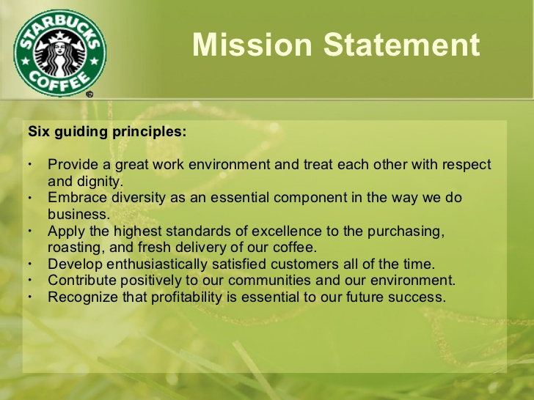
https://image.slidesharecdn.com/starbucks-danny-1217991083487419-9/95/starbucks-strategy-11-728.jpg?cb=1217965353
Starbucks implemented Taylor’s Theory throughout the organisation. They agree that the most important motivational factor for employees is the reward and recognition programme and they started from the operational level upwards. It all starts with providing employees training and developing, job security, better pay packages and certain benefits that can maximise their performance. Dissatisfaction in the workplace environment can lead to lack of motivation and low engagement, absenteeism, poor customer service and low productivity.
At the beginning of the 20th century, in his paper 'Scientific Management' (1911), Frederick Taylor presented some measures to improve the efficiency of individual workers and to run factories. He laid the foundations of scientific management based on the application of scientific principles in the management of labour and workers, taking a stand against waste and inefficiency. (business.com)
Taylor's main concern was supervisory management and he put a lot of emphasis on the efficiency of workers and managers at the operational level. Scientific management is only a mental revolution for both the employer and the employees, consisting of the following principles:
- Science instead of the basic principle: to improve the level of performance, the general rule being replaced by science.
- Harmony instead of discordance: there must be coordination of employee activities and not discordance.
- Cooperation, not individualism: there should be an environment of cooperation within the organisation of mutual interest.
- Developing each person at their highest efficiency: motivation must be ensured with the utmost efficiency for each member of the organization.
He suggested that each workstation should be divided into distinct tasks, and then managers should find the best ways for those tasks to be performed properly and the expected result to be achieved. He also issued the idea that it is necessary to carefully select and fit the most suitable person for each job, then training that person to perform their tasks as best as possible. Taylor also promoted and supported the idea according to which most people work to earn money and has concluded that the payment must be in accordance with the results obtained by each individual. (expertprogrammanagement.com)
This conclusion led him to propose a progressively agreed remuneration system, according to which employees receive a certain amount for each unit of product they obtain.
At the same time, Taylor looked at the effects of the progressive payment system to increase efficiency among employee groups. Although expectations were that the result would increase as a result of the pressure that faster workers would exert on slower workers to make them produce more, production remained constant, regardless of the 'standard' set by management.
Although Taylor's ideas were revolutionary and had a great impact on motivational practice, his view of motivation was quickly appreciated by other specialists as simplistic and narrow. They came up with the idea that people work not only to earn money and gradually it was observed that, although real and useful, this perspective was indeed too narrow, leaving out the social aspects of work and of the organisation. Others observed that instead of both organisation and employee to mutually benefit, the organisation was the only one benefiting, dehumanising the employee, not leaving room for creativity and autonomy. (www.shareyouressays.com)
According to psychologists, the theory has disadvantages as it mainly emphasizes on efficiency, disregards human factors and sees individuals as machinery, separation of planning and doing and dissatisfaction as in comparing one’s performance with a co-worker’s. It also has a micro approach as it can only be applied to factory like organisations. On a long term, this automated work method that turns humans in machinery can have psychological and neurological side-effects.
Looking at the methods of training their new employees, Starbucks starts with a 2-4 weeks session of intense and precise training program that most definite led to the company’s success. They have tailored such an efficient training program, learning about coffee history and company culture, providing the baristas with all the tools they need and teach them to deliver high quality products, consistency in coffee making products techniques, recipe memorisation, providing hands-on experiences from day one, all in order to give the ultimate customer experience. (www.gaebler.com)
Starbucks feels that the most important ingredient of their success (besides their speciality coffee) is the quality of the employees, therefore they allocated vast financial resources and time in training and obtaining the best employees available.
Following Taylor’s theory, Starbucks recently initiated a multi-quarter-stretching effort to help employees better connect with customers. To achieve this goal, Starbucks aims to simplify employee work and reduce the time they spend on tasks that don't address to customers. Some examples of such efforts include moving cleaning activities in post-hour and automating product planning and these efforts are already starting to make a difference.
Looking at the benefits and programs for all its employees, whether part of full-time, there are a few that are worth enumerating: multiple choices of health care, discounted shares and stocks for partners, paid time off, parental leave, 100% tuition coverage for bachelor degrees and partner assistance for those who may struggle from an illness, death in the family or natural disasters.
The new approach of the organisation that raised health care benefits led to attracting high quality employees and reduced the turnover rate and saved Starbucks important financial resources. (www.biu.ac.il)
There are a lot of perks for partners as well: in-store discounts and affiliate discounts, recognition programs, free tea/coffee mark out, on-site gym, day-care and dry-cleaning. (starbucks.com)
For effective management it is necessary to find a balance in terms of employee satisfaction, a balance that on the one hand does not allow the impairment of individual or collective performance due to acute dissatisfaction, and on the other hand, to stimulate performance by finding effective ways to increase employee satisfaction.
A modern theory that can perfectly fill in the gap that Taylor’s theory leaves, the impersonality of the work and the relationship with colleagues and direct managers, the sociological aspect of life of individuals within the organisation they work for and contribute to its success by being effective, is Mayo’s motivational theory. (expertprogrammanagement.com)
A landmark moment in the School of Human Relations is the research of George Elton Mayo at the Western Electric Company (USA) from 1924 to 1932 and by Fritz Roethlisberger. The initial purpose of their investigations was to study the relationship between working conditions and productivity. They found that in some work teams, the level of labour productivity was maintained even if environmental factors became unfavourable. Mayo concluded that the level of labour productivity was maintained due to psychosocial elements, such as the nature of the relationships regarding the framing of the work and the formation of groups and the level of information within the group.
Mayo, like Taylor, falls into the same trap: the absolutization of one type of motivation - Taylor' salary motivation, and with Mayo, the motivation of group affiliation. Mayo's conception drew attention to the need for more detailed study of human behavior and especially its motivation.
The man in his existence is guided by several motivational impulses. Through experiments at the Hawthorne plants (which belonged to Western Electric Company), carried out by Mayo and Fritz Roethlisberger, the concept of "economic man" was replaced by the concept of "social man" (man motivated by relations with his fellows).
The results of the experiments led to some relevant conclusions on the practice of management: the organization as a social system, the hawthorne effect (any unintended effect determined by the attention given to the subjects in an experiment), the quality of the driving climate. (expertprogrammanagement.com)
Sociological concerns continued, and psychosociological analyses showed that the relationships between people are extremely varied for at least two reasons: the work itself differs from one individual to another and the diversity of human motivations.
The worker's work depends on working conditions and may become unpleasant or may be an agreeable one. The motivations of individuals are extremely varied, they can be related to the nature of their aspirations, their personality, socio-educational context, working environment, cultural and income level.
Valuing the employee as much as the customer and meeting their working needs (an overall pleasant work atmosphere) makes Starbucks a very successful organisation that leaves room for very little improvement. Implementing these theories along with the company’s values and beliefs is benefiting the employees, the organisation and the customers, leading to maximised profit for the business and more pay and benefits for the employees (recognision programmes, equality in employment, training and progression, pension schemes). (ukessays.com)
The customer experience can also be improved with minor changes in the layouts of the coffee shops in two ways:
- Placing the coffee machines in such a way that the customer can actually see the barista making the coffee, leaving them with a long lasting impression on the act of making a coffee.
- Placing digital picture frames that would contain local customer photos would give a more personal note to every neighbourhood shop and give customers a feeling of belonginess.
Implementing a unique initiative, granting stock options to all employees, from top managers down to baristas, in proportion with their base pay, and involving them in the equity success of the company, proved itself to be an effective way to motivate employees to treat customers with an exceptional service, along with reducing costs. From this moment on, employees were considered and called partners which contributed to their dedication and loyalty towards the organisation. (www.biu.ac.il)
Richard Barrett's model is based on data from nearly 2,000,000 people across the globe. It is one of the most extensive sociological researches. Seven well-established levels can be distinguished in the development of personal consciousness. Each of these levels contains a particular category of needs that is inherent to the human condition. The seven existential needs are the main motivational forces of man, the ones that generate values – the most important things for each of us. (valuescentre.com)
Following them, 7 types of internal dialogues are born:

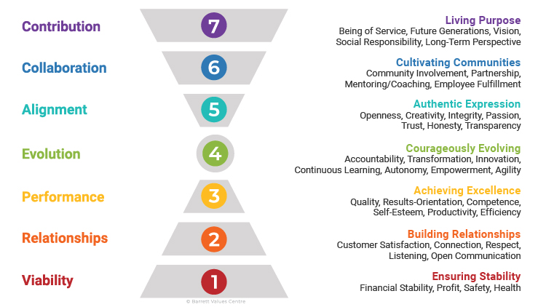
https://www.valuescentre.com/wp-content/uploads/2020/05/BarrettModel_Descriptions-1.jpg
Thru Barrett’s Model, an individual identifies and alings their personal needs and values to the ones of the organisation they work for or want to be a part of, there can only be success on both parties.

Conclusion

Acnowleging the merits of both theories and combining Taylor’s theory with Mayo’s, along with an individual’s values and beliefs that we can identify them as being the same as the company’s (respect for the employee as well as for the customer, emphasising on working smarter and not harder and allocating more time to the customers, giving the coffee shop ambiance warmth thru excellent service, their passion for coffee, the rewards and recognision programmes and health and care benefits, the opportunity to evolve, creating a sense of belonginessand inclusiveness), Starbucks becomes an ideal organisation to be a part of. It treats individuals with respect and fairness, it gives exact training and support and makes employees partners in the shared success.

Reference list

1.Taylor’s Motivation Theory – Scientific Management (2020) Available at: https://expertprogrammanagement.com/2018/05/taylors-scientific-management/ Accessed: 01st Dec 2020
2.Ghosh, P. Criticism of Scientific Management (Taylorism) – Essay Available at: https://www.shareyouressays.com/essays/criticism-of-scientific-management-taylorism-essay/120578 Accessed: 29th Nov 2020
3.Starbucks Training Program (2020) Available at: https://www.gaebler.com/Starbucks-Training-Program.htm#:~:text=Starbucks%20puts%20new%20employees%20through%20a%20strict%20training,focus%20exclusively%20on%20the%20mechanics%20of%20the%20position. Accessed: 2nd Dec 2020
4.Caramela, S. (2018) Management Theory Of Frederick Taylor Available at: https://www.business.com/articles/management-theory-of-frederick-taylor/#:~:text=Frederick%20Taylor%27s%20scientific%20management%20theory%2C%20also%20called%20the,mistake%2C%20employers%20should%20reward%20workers%20for%20increased%20productivity. Accessed: 27th Nov 2020
5.Benefits and perks (2020) Available at: https://www.starbucks.com/careers/working-at-starbucks/benefits-and-perks Accessed: 21st Nov 2020
6.Culture and value (2020) Available at: https://www.starbucks.com/careers/working-at-starbucks/culture-and-values Accessed 21st Nov 2020
7.Mayo’s Motivation Theory / Hawthorn effect (2018) Available at: https://expertprogrammanagement.com/2018/05/mayos-motivation-theory-hawthorn-effect/ Accessed: 2nd Dec 2020
8.Kukreja, S. (2019) Elton Mayo and his Key Theories Available at: https://www.managementstudyhq.com/elton-mayo-theories.html Accessed 5th Dec 2020
9.Overton, L. (2017) What is the most important factor in employee motivation? Available at: https://bizfluent.com/info-8190209-important-factor-employee-motivation.html Accessed: 15th Dec 2020
10.UKEssays (2018) Theories Of Motivation At Starbucks Management Essay Available at: https://www.ukessays.com/essays/management/theories-of-motivation-at-starbucks-management-essay.php Accessed 16th Dec 2020
11.Larson, R. C. (2008) Starbucks a strategic analysis Available at: https://www.biu.ac.il/soc/sb/stfhome/bijaoui/891/case/2009/starbuck08full.pdf Accessed 16th Dec 2020
12.https://image.slidesharecdn.com/starbucks-danny-1217991083487419-9/95/starbucks-strategy-11-728.jpg?cb=1217965353
13.https://www.valuescentre.com/wp-content/uploads/2020/05/BarrettModel_Descriptions-1.jpg

