Course title: Problem Solving and Decision Making
Course Lecturer: Magdalena Wronska
University of Wales Trinity Saint David
Student Name: Emole Lawrence Favour
Student Number: 1908220

Tables of Contents
Introduction 3
Experience 3
Scope 4
Limitation 5
Literature 6
Analysis of the Problems 7
PESTEL Analysis 7
SWOT Analysis 8
Fishbone Analysis 9
Proposing Solution 10
PMI Chart 10
Implementing solution 11
Communication Plan 12
Conclusion 12
Reference List 13

Introduction
The problem-solving concept is considered to be a very vital and important skill in any professional or social field. Problems solving is described to be our daily role by researchers and academics in our day to day live s we encounter a variety of decison that we need to make and issues and our choices and decison are based on solving an issue. Ever since the onset of Covid-19 there has been a lot of issues that cropped up in various industries and most of all as research has evidenced is that the Hotel industry has been one of the first to be crucially impacted (Nicola et al., 2020). For example, Travel Lodge Hotel profits plummeted from what used to, because of the restrictions, compliance and guidelines set by regulators and the government to safeguard people from the diseases. The hotel has its culture where it is often referred to be a place where people could gather and socialize in numbers and feast but since the enactment of the guidelines and compliance issues of covd-19 the number of people who are actually willing to go to an hotel has reduced and more people have opted to seek much safer way and not pre expose themselves to the disease and option of ordering and delivery was considered which though allowed for business continuity it did not rack in the same number of sales as it was before.

Experience
In my experience I believe that since covid-19 initial case was announced there was a growing panic in the country and in various industries this is because we understood what it meant if the cases happen to increase (Hao et al., 2020). Our fears soon came true and as time was moving the cases grew at an alarming rate and it was decided that proactive action need to be taken to ensure the safety of the people At the hotel we instituted measures to make sure we are compliant by introducing wearing of masks and urging our customers to wash their hands before entering the premises and this was working for some time before the health regulatory bodies and the government decided to and more stringent measure to protect the population and they introduced social distancing and this means for us to be able to continue with businesses we would need to make sure that we allow even lesser people customers in the hotel at a time to minimize the direct contact people have with each other and this also meant that some staff needed to belayed off as the hotel was not in apposition to support their payments with the kind of business it was having (Seetharaman, 2020). This I believed changed the whole hotel culture and dynamics which was more of a social place. Further, even with the compliance the hotel instituted a mandatory testing for its staff and unfortunately two of our staff were found to be asymptomatic and this meant that they needed to be quarantines and everyone who they were in contact with and this spiked in fare t some staff as some refused to come to work in fare of contamination and this further reduced the profit the hotel was receiving and with the lockdown being put in effect it completely shattered the hotel performance.

Scope
Looking through history it was evident that even in the past there were cases of infections illnesses that came up and disrupted the normal functioning of the society in various ways a variety of business were affected and people’s livelihood were impacted and one would think with a precedence existing countries would be ready for such an eventuality and this was evidenced as when corvid -19 began it was clear that countries business and governments were not necessarily ready for such a pandemic (Jiang and Wen, 2020). The pandemic covered a big scope mostly looking at the hotel and one of the majors is the impact in the Profits and performance. The hotel was hit directly given that the disease was very infections it was mostly spreading in placed where people largely gathered and directly interacted like in hotels and this was the initial thought of control by making sure people would not be allowed to gather like that in large number and this meant lesser people in the hotels and sing the hotels facilities one mostly because of fear and compliance. On the other hand, it was evident that the hotel culture was greatly changed and this was surprising as the scope stretched out this far and this was evident as the hotels resulted to online order and deliveries and this was not initially what was considered the hotel culture (Chang et al., 2020). Research revealed that the aim of hotel as to present a venue where people would feel at home away from home and enjoy their time while feasting and Covid-19 made this not possible and the hotel needed to find other supporting means to ensure business continuity.

Limitation
The hotel before the pandemic was being driven by increasing the disposable income, ne travel trends and incrasing the travelling business because of the imprving internent penetration and internenet bankng and onine presensce of the hotels as travel destinations. The hotel was being expanded with the growing global toursims before the outbreak. This was because reseauch reveled tha tehr was an increased nber of international tourasm arrivals that had continously risen and after the outbreak the major hit the hotel was the dramatic cancelation and decrease in the tours and travels which impacted on bookings and this was furher imapcted with the governments cesation of foreign visists nad locking down most of the other major set back as it slowed the hotel down (Qiu et al., 2020). At the hotel there were employees of which about eighty percent of them are paid hourly there was a drop in the amount of hours worked and this meant these employees ended up earning less and other laid off as there were less cutomers available in the hotels and the hotels was not in a position to retain all their workers and with complience issues of social disating it as regulated to be signifncaty lesser people in the hotel space.

Literature
Research evidenced that SARS was a phase in the world where most people, governments and businesses were not read and prepared for. The pandemic caused a total shut down and crumbling of various industries and business and some more than other were majorly affected and this like the hotel and hospitality industry (Huang et al., 2020). The cessation of movements and foreign travels was a starts where foreign tourism was not allowed and this went deep into the hotel performance as their client was majorly affected and left to rely on local travels this proved to be a challenge as researchers have evidenced that local tourism is not as effective as people tend to prefer something different that what they have locally. This has further been attributed to familiarity. This was a huge blow articles have revealed that since the outbreak was announced to be a pandemic the normal functioning of the hotel changed and when the mandatory compliance guidelines where set it was evident that most hotels were not prepared to handle the new normal (Sharma and Nicolau, 2020). Research has evidenced that and recommended that the governments actually considered the Covid-19 be part of society going forward and enact policies, guidelines and rules that will help in managing the disease just like any other infectious illness and allow continuity of business, schools and the economy as these areas have a received a significant hit since the outbreak of the diseases and I being announced as a pandemic.

Analysis of the Problems

PESTEL Analysis
The PESTEL Analysis is described to be one among the most essential tools that is applied in the management of organizations as it is defined to be an important asset in the analysis of the issues within an organization (Bartik et al, 2020). The major aim of the analysis is to present an essential asset for informative and evidenced based decision making. The analysis takes to consideration all the aspects and variable relevant to the organization and he issues to be decided upon. Some of them include:

Political
- Drafting and enforcement of laws and policies that will protect the hotel industry in such times as a key player in the economy Economic
- Leads to significant turnover rates because of layoffs because the hotels are not in a position to maintain their employees Social
- Societal change in how people interact
Technological
- Surveillance and monitoring of the Hotels to stay complaint to the laws safeguarding against Covid-19
Environmental
- Adverse working environment in the industry due to new enforced laws on compliance
Legal
- Equality acts that ensure that the industry is not discriminated against with the laws and policies of compliance.

SWOT Analysis
SWOT analysis as a complement to the PESTEL analysis is considered to be a framework which is applied in the evaluation and organization of a company or business in order to develop a strategic and informed plan. The framework considered both external and internal factors and attributes impacting the business and future potential.
Strength
Availabilities of infrastructure that supports continuity of the Hotel industry through online ordering and delivery
Weakness
Unsupportive policies and laws
Opportunity
Advancement in technology in the Industry making it possible for business continuity
Threats
Low quality care delivery and services due to the drastic change in the industry culture

Fishbone Analysis
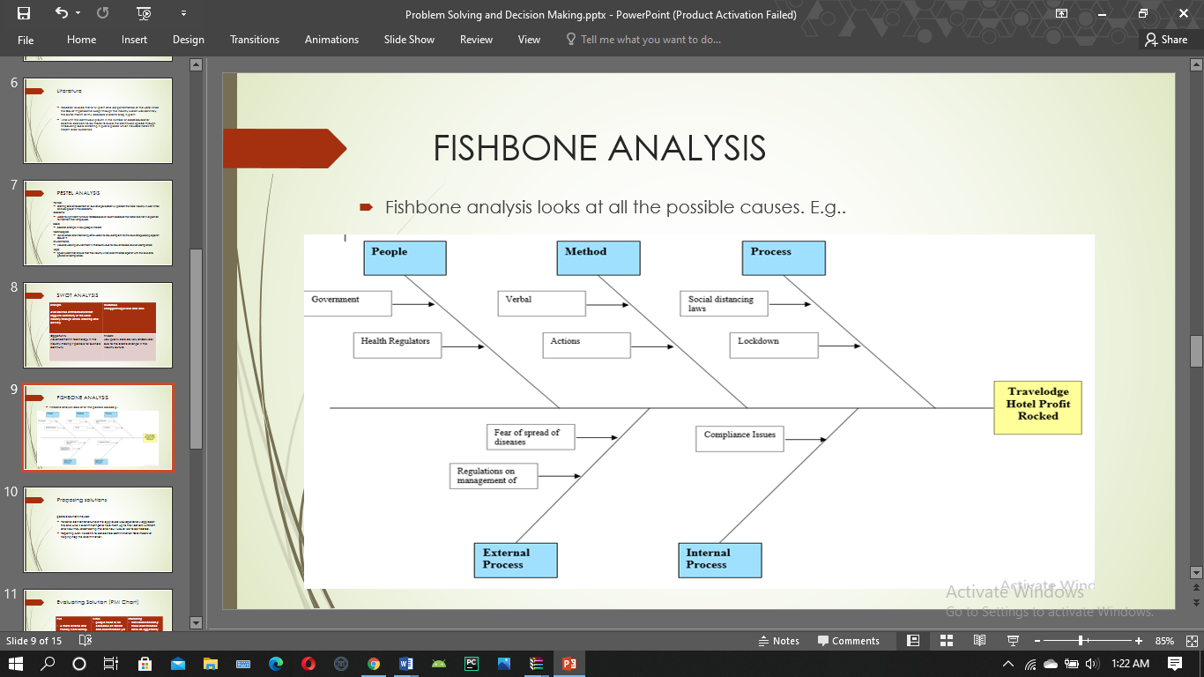
This type of analysis is considered to be important in the aim of offering a well detailed and defined structure in identification of the causes and their effect and impact. The fishbone analysis compared to the PESTEL and SWOT is considered a key tool as it helps one evaluate the underlying issues and make an informed decision which will benefit in improving the understanding and the issues in a structured manner and how well to approach them.

Proposing Solution
The pandemic has clearly been a drawback for the hotel however, there is still hope for business continuity as the hotel industry play an essential role in the economy (Baum et al., 2020). Therefore, it is proposed that to be able to help the hotel and the industry at large for the regulator bodies and the government to allow the hotel continue with their operation as long as the hotel has took into consideration the needed and set guidelines an polices around codid-19 compliance rule to stop the spread and this also lift the travel bans as long as one is tested negative for the disease can be allowed to travel and this will open up the hotel to more customers and business opportunities.

PMI Chart
This type of analysis is often introduced when discussing ideas and decisions and progress as it considered both positive and negative and also the neutral point to allow more room for deliberation for a more informed decision.

Plus  - Advancement in technology which supports business continuity in this time +20  +20 | Minus  - people need to comply by the covid-19 guidelines and reduces and impacts the Hotel culture which is big in promoting the Hotel industry -5  - Policies and Laws that limit the hotel business -5  -10 | Interesting  - Not only the Hotel industry has been impacted by the pandemic and other industries have there fire share of impact that they need to adjust to +5  +5

Implementing solution
Research has evidence that the hotel and the general industry and hotel business is at the mercy of the leaders and policymakers. It should be in their interest to still make sure the industry survives this pandemic because of the role it plays in the economy and his can be made possible through making a way through policy that will allow continuation of business as normal.

Communication Plan
The proposed implementation and the plan will be applied through the relevant stakeholders who we would report to.
Stakeholder | Power | Interest | Communication
James | Manager | 1 | Profit and Performance
Mary | Team Leader | 2 | Profit and Performance

Conclusion
It is evident the since the outbreak of the disease there has been a continuous downfall in the Hotel business as various pillars supporting the business received massive impact from the disease consequences and there is need for a pan to allow business continuity to sustain the hotel and the industry.

Reference List
Bartik, A.W., Bertrand, M., Lin, F., Rothstein, J. and Unrath, M., 2020. Measuring the labor market at the onset of the COVID-19 crisis (No. w27613). National Bureau of Economic Research.
Baum, T., Mooney, S.K., Robinson, R.N. and Solnet, D., 2020. COVID-19’s impact on the hospitality workforce–new crisis or amplification of the norm. International Journal of Contemporary Hospitality Management.
Chang, C.L., McAleer, M. and Ramos, V., 2020. A charter for sustainable tourism after COVID-19.
Hao, F., Xiao, Q. and Chon, K., 2020. COVID-19 and China’s Hotel Industry: Impacts, a Disaster Management Framework, and Post-Pandemic Agenda. International Journal of Hospitality Management, p.102636.
Huang, A., Makridis, C., Baker, M., Medeiros, M. and Guo, Z., 2020. Understanding the Impact of COVID-19 Intervention Policies on the Labor Market of the Hospitality and Retail Industries. Available at SSRN 3637766.
Jiang, Y. and Wen, J., 2020. Effects of COVID-19 on hotel marketing and management: a perspective article. International Journal of Contemporary Hospitality Management.
Nicola, M., Alsafi, Z., Sohrabi, C., Kerwan, A., Al-Jabir, A., Iosifidis, C., Agha, M. and Agha, R., 2020. The socio-economic implications of the coronavirus pandemic (COVID-19): A review. International journal of surgery (London, England), 78, p.185.
Qiu, R.T., Park, J., Li, S. and Song, H., 2020. Social costs of tourism during the COVID-19 pandemic. Annals of Tourism Research, p.102994.
Seetharaman, P., 2020. Business models shifts: Impact of Covid-19. International Journal of Information Management, 54, p.102173.
Sharma, A. and Nicolau, J.L., 2020. An open market valuation of the effects of COVID-19 on the travel and tourism industry. Annals of Tourism Research.

