Service Improvement Report: Analysis of Quality Failures at Mid Staffordshire NHS Foundation Trust

MSc Public Health and Social Care in Practice

Quality Assurance and Service Improvements
(LCHS7006)

Lecturer: Shepherd Ziko

Student Name: MOHAMMEDASHRAF PATEL

Student ID: 2432246

Introduction
Quality in healthcare implies the degree to which the health services contribute to the probability of the desired health outcomes as well as being compatible with the existing professional knowledge (Donabedian, 1988). The institute of medicine (2001) enumerates six dimensions of quality, namely, patient-centredness, efficiency, effectiveness, timeliness, equity, and safety. Quality assurance is made up of methodical institutional procedures aimed at observing, assessing and advancing excellence of medical support (World Health Organisation, 2006). Continuous quality improvement (CQI) is fundamental in social care and public health because it allows organisations to achieve a systematic improvement of service provision, lessen unwarranted occurrences, and promote organisational learning (Batalden and Davidoff, 2007). CQI structures aid healthcare systems to evolve according to emerging challenges and retain patient safety as the primary objective through the repetitive stages of evaluation, implementation, and review (Berwick, 1989).
Mid Staffordshire NHS Foundation Trust (2005-2009) is one of the most significant cases of quality failures in the current history of the modern healthcare system that resulted in the death of an estimated 400 to 1,200 preventable patients (Francis, 2013). There has been lack of proper provision of patients such as proper nutrition and hydration, cleanliness, timely attention and the Trust has been orienting on attaining Foundation Trust status and meeting the financial targets at the expense of patients care (Healthcare Commission, 2009). The Francis Report showed disastrous failures in clinical governance, leadership responsibility, organisational culture and regulatory control (Francis, 2013). Complaints of staff and family were carefully disregarded, and outside regulators could do nothing even after apparent warning signs such as high mortality rates (Walshe and Shortell, 2004).
Continuing the analysis of roots causes of the problem suggested as a result of the presentation by Component 1, where the systems-based safety models were used to name root causes, the Component 2 report will proceed with the further examination of the problem by applying quality improvement models such as the Swiss Cheese Model, Root Cause Analysis with the help of the Fishbone Diagram with the 5 Whys technique added, the Donabedian Model, and SWOT analysis. The Plan-Do-Study-Act (PDSA) methodology is then used to create evidence-based recommendations and prevent the repeat medical incident with the goal of ensuring a stopping mechanism of quality improvement.
Overview of Continuous Quality Improvement and the Mid Staffordshire Context
The reform pressures that were exercised over the NHS in the period between 2005 and 2009 underscored the performance targets, cost-efficiency and the aim of becoming a Foundation Trust (Walshe, 2010). Healthcare Commission (2009) disclosed that the standard mortality rates of the Hospital, Mid Staffordshire, were extremely high, exceeding the national standards, which revealed the failure of the system. Staffing deficits, which persisted during chronic stages, especially of qualified nurses, lowered the skill-mix ratios to unreasonable levels (Ball et al., 2014). Patients were characterised by lengthy emergency department wait times, lack of infection control leading to avoidable infections, and time wastage in infection and treatment diagnosis (Francis, 2013). The lack of awareness and action about waning standards was not realised in any of the governance structures, even after mortality data, staff, and patient complaints sounded warning bells (Dixon-Woods et al., 2013). To solve these failures, the organisation was in need of a complete overhaul in its organisational culture, values, behaviours and leadership (Mannion and Davies, 2018), yet the ingrained poor practices were not going to change (West et al., 2015).
Application of the Swiss Cheese Model: Understanding Multi-Layered System Failures
This Swiss Cheese Model of Reason (2000) depicts how accidents occur when failures are aligned in several defensive layers, including policies, management, supervision, training, equipment, etc. and templates defective or have holes within each. These are systemic failures; these are aligned to allow damage (Perneger, 2005). Defensive layers went dead at the same time at Mid Staffordshire. The culture in which targets were more important than the quality of care was imposed by leadership that was focused on financial performance and Foundation Trust status to the detriment of patient safety (Francis, 2013). s
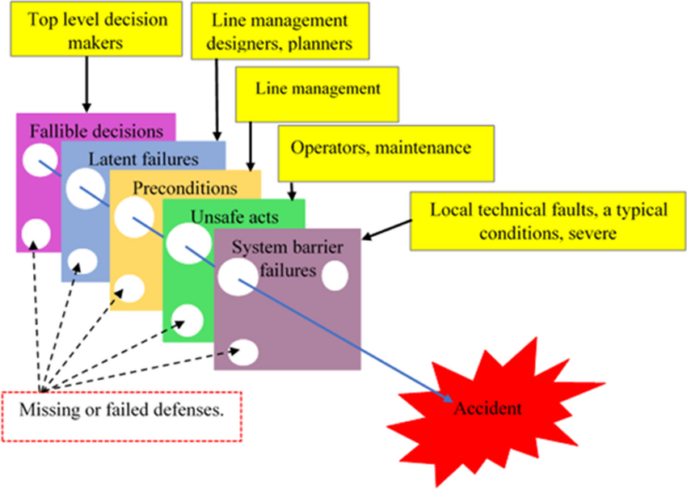
Figure 1. Swiss Cheese Model (visualisation of aligned defence failures). Source: ResearchGate / Fu et al.
There had been poor managerial control where the middle managers were not well-resourced and could not communicate issues (Walshe, 2010). The quality of supervision was poor because the senior nurses failed to maintain high standards in clinical practice due to their workloads (Ball et al., 2014). Unsafe practices became regularised, and understaffing at the chronic level allowed staff to compromise basic care (Maben et al., 2012), whereas frontline staff operated under time and resource constraints (Healthcare Commission, 2009). As the situation of the patients became worse, all the defensive layers were breached: they were late to recognise, did not report, did not have an appropriate response, and did not know about it at the board level. These simultaneous drawbacks were one of the examples that Reason (2000) presented in his thesis: disastrous consequences are the result of multiple system failures in concert.

Root Cause Analysis: Fishbone Diagram Application
Another systemic model of causes of quality problems is the Fishbone Diagram by Ishikawa (1985). The six main categories are applied to Mid Staffordshire, and these include people, processes, equipment, environment, management and policy.
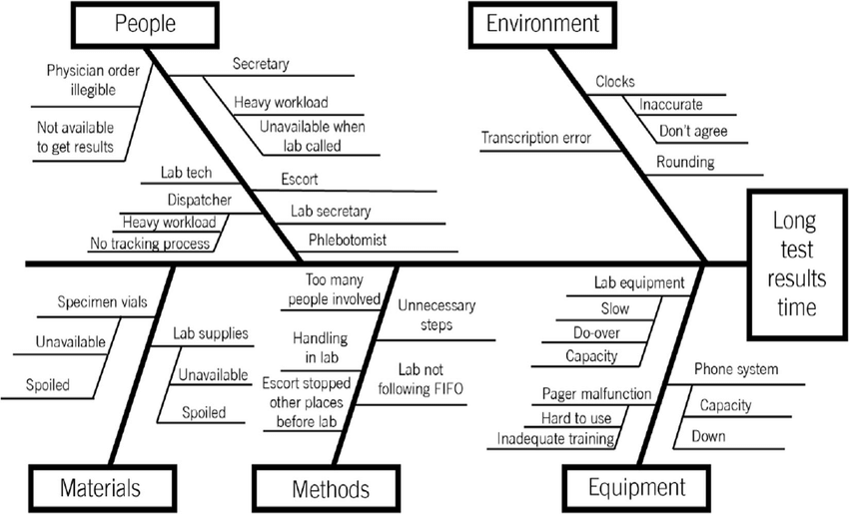
Figure 2. Fishbone (Ishikawa) diagram — example of categorising root causes in healthcare. Source: ResearchGate / Point of Care Foundation.
People factor. The number of the staffed nurses was lower than recommended, and it produced unsafe nurse-patient ratios (Ball et al., 2014). These outcomes were lack of training and development hence inadequate-trained staff; poor care was caused by low morale and turnover (Maben et al., 2012).
Process failures. Examples of process failures were ineffective incident reporting systems that promoted blame and inadequate clinical governance, and a lack of data analysis related to safety. The information loss at transfers was caused by communication failures, and the superficially conducted clinical audit did not encourage the application of the evidence-based practice (Dixon-Woods et al., 2013).
Management failures showed no consideration of safety, but leadership was focusing on the ambitions of Foundation Trusts. The executives and boards were not familiar with frontline conditions, as they were facing misleading performance reports, and middle managers did not have authority and resources (Francis, 2013).
Policy weaknesses. The shortcoming in policy lies in the performance structures encouraging financial and purposeful performance, as opposed to quality. There was lax regulatory regulation, and the autonomy of Foundation Trust decreased scrutiny, yet had no substantial self-regulation ability (Bevan and Hood, 2006). The Fishbone analysis puts an emphasis on the fact that interlinked human, organisational, and policy failures had a collective impact on the failure of the system and individual mistakes became accidents.
Deepening Analysis: The 5 Whys Framework
The Toyota Production System (Ohno, 1988) 5 Whys technique reveals root causes by repeatedly posing the question of why, to shift surface symptoms to root causes of the system (Serrat, 2017). Applied to the problem of the staffing crisis in Mid Staffordshire:
- Why were mortality rates elevated?
→ Due to the lack of nursing care provided to patients, such as failure to observe them and provide a timely response.
- Why was nursing care inadequate?
→ Since the ratios between nurses and patients were on the side of danger.
- Why are staffing ratios insufficient?
→ Due to the reduction of nursing posts in a bid to make financial savings towards attaining Foundation Trust status.
- Why did the Trust prioritise financial savings?
→ Since the regulatory systems encouraged financial excesses and aimed at adherence.
- Why did policy frameworks value finance over quality?
→ The fact that national reforms encouraged organisational freedom, market-type
- competition, which was not accompanied by quality guarantees (Walshe, 2010; Bevan and Hood, 2006).
This is a repeated examination of the corrupt interests of those in policy-making processes, which promoted financial performance at the cost of patient safety. Therefore, the general root cause consisted of not just local mismanagement but also the policy structure design. The 5 Whys show that quality improvement must be based on remedying structural causes and not the apparent symptoms (Nicolay et al., 2012).
Application of the Donabedian Model: Structure–Process–Outcome Analysis
According to Donabedian (1988) model, the quality of healthcare is assessed under three dimensions that are interrelated and these are the structure (resources and systems), process (care delivery) and outcome (results). It shows that the lack of a resource preconditions processes and, thus, patient outcomes (Ayanian and Markel, 2016).

Structural failures, including persistent understaffing of nurses that fell below recommended staffing levels, inefficient infrastructure and equipment that prevented infection control, inefficient IT systems that limited clinical communications, and fragmented governance that confused responsibility were structural failures that arose at Mid Staffordshire (Francis, 2013).

Any inadequacy in processes was visible in terms of provision of the fundamental nursing care(hydration, nutrition, hygiene, prevention of pressure ulcers) being inconsistently provided (Healthcare Commission, 2009). Clinical measurements were not standardised, and this delayed the deterioration of the patients to be delayed. There were mistakes and oversights in medical prescriptions, and no one communicated with each other, patients, and their families negatively, resulting in misunderstandings and delayed treatment (Berwick, 2013).

Results were dismal: the mortality rates were much higher than predicted, and the HSMRs were the highest in the country (Healthcare Commission, 2009). Nursing care and responsiveness towards staff were not satisfactory among patients. The high rate of infection and low morale of the staff indicated a poor organisational culture that was characterised by absenteeism and turnover (Maben et al., 2012). The framework by Donabedian thus explains the ways structural inadequacies were transpired through processes to deliver negative results, which further justifies systemic change.
SWOT Analysis: Strategic Evaluation
SWOT analysis provides strategic insight into the internal strengths and weaknesses as well as relationships of external opportunities and threats to quality improvement (Helms and Nixon, 2010).
Strengths
The Francis Report (2013), which reported in detail systemic failures and gave reform impetus, were a strength. Strong regulation was enhanced by the Care Quality Commission widened its scope and enhanced the enhancement infrastructure within the NHS (Berwick, 2013). Insurance required improvement of competence levels by professional organisations like the Royal College of Nursing (RCN, 2018), and real-time monitoring could be realised due to the use of technology to track patients and digital data dashboards.
Weaknesses
Among the weaknesses included the consistent workforce shortages that curtailed the compliance with staffing (RCN, 2021), NHS financial constraints hindering investment in quality, and the fatigue of reform (Buchanan et al., 2005). The entrenched organisational cultures that were resistant to change also functioned as an impediment to improvement.
Opportunities
There are also prospects in more patient and family roles in the care design, which makes user perspectives set priorities (Ocloo and Matthews, 2016). Monitoring, communication, and decision-making could be enhanced using digital integration. Sharing can be promoted through expanding the evidence-based improvement science (Dixon-Woods et al., 2012) and collaborative learning networks such as patient safety collaboratives (Health Foundation, 2014) to achieve shared innovation and capacity building in the NHS.

Threats
Among the threats are sustained pressure due to increasing demand, resource scarcity and shortage of workforce. Political instability could turn the emphasis of policies, resulting in a lack of uniformity. The high-profile failures that lead to blame cultures are the culture that prevents open learning (Wachter, 2012), whereas the systemic complexity of healthcare poses a challenge to the sustainability of improvements. The SWOT synthesis highlights the fact that, despite improvements in regulatory and professional frameworks, there are long-lasting workforce, financial and cultural obstacles. A sustainable change needs to focus on mitigating such structural limitations via combined policy, leadership, and workforce development plans in accordance with patient-centred values.
Recommendations
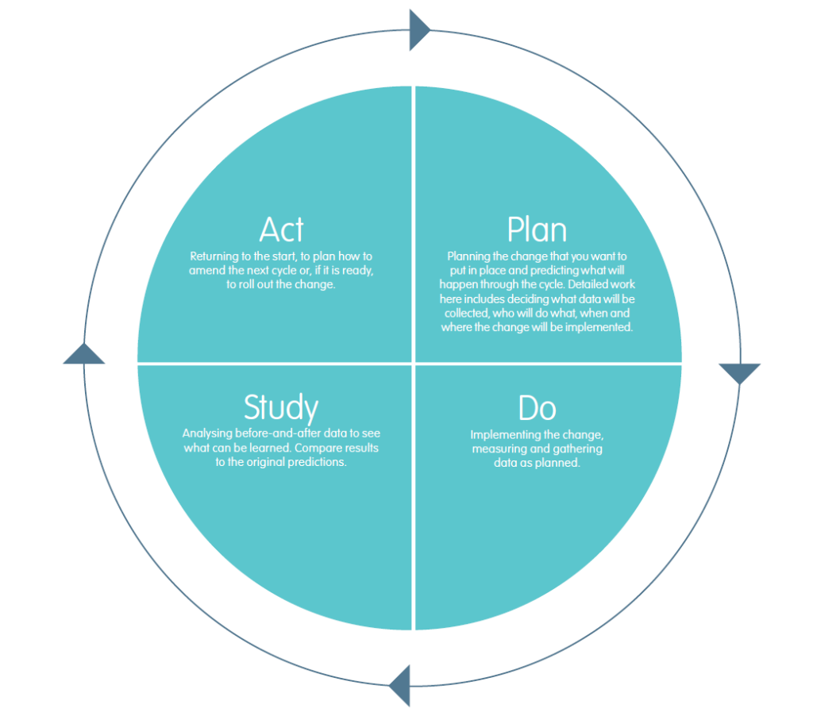
Figure 3. Plan–Do–Study–Act (PDSA) cycle — iterative quality improvement method. Source: Health Innovation West of England.

Recommendations: Applying the PDSA Framework for Quality Improvement
The Plan-Do-Study-Act (PDSA) approach - a globally accepted model of testing and implementing healthcare improvement through cyclic learning-based learning should be the background of evidence-based interventions to overcome systemic quality failures at Mid Staffordshire NHS Foundation Trust (Langley et al., 2009; Taylor et al., 2014).

Recommendation 1: Implement Robust Clinical Governance and Real-Time Quality Surveillance
Plan:
Instead, introduce a system of proper governance, and the main safety indicators (mortality, patient experience, staffing, incidents, as well as audits) are tracked in real time (Powell et al., 2014). Install an all-inclusive quality monitor, which will be accessible to managers, clinical teams, and executives. Governance of division structure: Board-level quality meetings: to offer strategic guidance of quality, weekly ward-level quality meetings: to converse incidences, monthly divisional meetings: to examine patterns (Institute for Healthcare Improvement, 2012). Tasks Specialist resources like data analysts and patient safety experts. Stated targets to be implemented over 50% The process of defining the quality issues, 95% completion of the agreed actions and the increase of the indicators which can be proved in six months.
Do:
Conduct testing of the system in two departments, Emergency and Medicine, over a period of twelve weeks. Data interpretation and root cause analysis: Train staff on data interpretation and root cause analysis. Hold weekly fifteen-minute huddles to analyse the data and give actions. Conduct monthly divisional meetings to review four-week trends and report back to board committees, with quality being subject to scrutiny as much as finance is.
Study:
Assess the level of governance effectiveness by comparing the level of timeliness in identifying issues, the rate of action completion, and improvement of the indicator using statistical process control (Benneyan et al., 2003). Hold staff surveys and focus groups on whether the structures of governance encourage learning and improvement. Examine the minutes of the review boards to determine the quality of discussions and supervision.
Act:
Optimise government with knowledge, replicate effective solutions at organisation-wide levels in six months. Develop yearly governance maturity evaluations and non-stop review circles to remain responsive and support long-term betterment (Berwick, 2013).

Recommendation 2: Establish Evidence-Based Safe Staffing and Workforce Development
Plan:
Create personnel models and planned staffing that were NICE (2014) compliant and reflected the staffing needs (based on individual acuity). Develop workforce policies that include recruitment, retention, and flexible deployment as well as professional development that will improve clinical, leadership and improvement skills (West et al., 2015). Conducting financial modelling to determine investment requirements and success measures, safety indicators, patient experience, staff satisfaction, and turnover.
Do:
Introduce safe staffing in the high-acuity units at a time - Emergency, Acute Medicine, Critical Care. Use agency assistance in the recruitment, but without compromising. Implement daily on-the-job staffing monitoring through the Safer Nursing Care Tool with evident back-escalation when the ratios drop below the norms (Ball et al., 2014). Offer new nurse induction, preceptorship, clinical supervision and learning protection. By creating career paths that are well defined, through leadership development programmes.
Study:
Follow the impact by use of safety and care quality measurement-falls, pressure ulcers, medication errors, infection rates, and Response times. Indirectly measure workload, development, and support provided by an organisation through staff surveys and measure workforce stability through absence and turnover statistics. Use statistical process control to determine the reason behind the true improvement or merely due to chance (Benneyan et al., 2003). Collect qualitative data regarding workload and career development by use of focus groups.
Act:
Evidence-based adjustments of the staffing models, which integrate sustainable establishments of high-quality care, consistently. Make workforce development a strategic choice through visible career systems, leadership development, and dynamic oversight to tackle the issue of the workforce ahead of a crisis (West et al., 2015).

Recommendation 3: Foster a Positive Safety Culture and Meaningful Patient Partnership
Plan:
Introduce a culture change initiative that will encompass values, behaviours and leadership to enhance psychological safety, openness and accountability (Mannion and Davies, 2018). Ascertain explicit safety anticipations and integrate patient and family visions in the service model. Construct counselling boards to add to the administration and enhancement of quality. Win executive approval of transparency and visible leadership of quality and safety.
Do:
Introduce staff involvement programs- forums, listening sessions and reporting confidences- to enable the staff to express grievances. Make executives and senior clinicians do leadership walk-rounds to show that they are serious about this and to learn by experience (Frankel et al., 2008). Established patient and family advisory groups on planning and policy formulation and enhancement projects. Patient stories should be incorporated into board meetings to make data more personal and to maintain a patient-centred focus. Incorporate the introduction of recognition programmes for staff contributions to safety and improvement.
Study:
Measure change in culture with the validated measures, like; Safety Attitudes Questionnaire, monitoring of teamwork, openness, and leadership commitment to safety (Sexton et al., 2006). Measures patient partnership by rates of participation, qualitative response and developmental impact of patient involvement. Surveillance of psychological safety through reporting behaviour and disposition to speak up. Assess the culture on an annual basis to mark a point of progress and intervention goals.
Act:
Transform culture by sustaining change through constant reinforcement, observable leadership, and adaptive partnership strategies based on the evaluation outcomes. Discuss cultural barriers in a systematic manner, understanding that a drastic change in culture can only be achieved after years of work. Integrate cultural ideals and patient collaboration into the system of governance and operational decision-making, which builds strength against external forces that jeopardise quality (Dixon-Woods et al., 2013).
Using PDSA cycle can be applied to implement the improvement iteratively, in a structured way, focusing on the improvement of the governance, workforce, and culture, which are the most involved areas in the Mid Staffordshire failures. Data-driven learning, low-risk staffing, and authentic patient partnership can make the NHS a resilient system that is dedicated to continuous improvement and patient-centred care.

Conclusion
The Mid Staffordshire NHS Foundation Trust scandal is a deep-seated failure in quality assurance with disastrous outcomes for patients and families, with the outcome of the scandal disclosing important flaws in the system's regulation, leadership, and governance of healthcare. The Swiss Cheese Model has been used to examine the failure of multiple protective layers, which coincided to establish an environment that allowed unnecessary damage to take place, starting at the board-level control to management systems and into the frontline services being delivered to patients. The Fishbone Diagram of root cause analysis determined contributory factors in the areas of people, processes, management, and policy, and the 5 Whys method of root cause analysis revealed the underlying problems in policy structure that favoured financial over patient safety. The Donabedian Model was used to demonstrate the causal pathways of structural inadequacies into process failures to epic patient outcomes. The SWOT analysis has discovered the challenges as well as the opportunities to achieve sustainable improvement.

The evidence-based guidelines designed by PDSA methodology mitigate all these root causes: firms have made strong clinical governance with real-time quality monitoring, safe staffing with evidence-based practice using systematic workforce development, and positive safety cultures with meaningful patient relationships. To implement it successfully, the executive should be committed to it, relatively well resourced, and understand that cultural change cannot happen in brief efforts but only under long-term commitment.

The teachings of Mid Staffordshire are not limited to one organisation; in the bigger picture, all NHS organisations need to realise that becoming efficient and providing caring care do not need to be in opposition with each other, proper regulation is essential, and patient safety remains the priority of the organisation. The principles of the Francis Report (2013) that need to be incorporated into future quality assurance are transparency, candour, patients first, and openness, which must permeate the healthcare systems. It is only with long-term adherence to such values that the healthcare organisations in question can avoid the repeat of such a disastrous failure and, consequently, fulfil their core responsibility of delivering safe, effective, patient-centred care.

References
Ayanian, J.Z. and Markel, H. (2016) ‘Donabedian’s lasting framework for health care quality’, New England Journal of Medicine, 375(3), pp. 205–207.
Ball, J.E., Murrells, T., Rafferty, A.M., Morrow, E. and Griffiths, P. (2014) ‘“Care left undone” during nursing shifts: Associations with workload and perceived quality of care’, BMJ Quality & Safety, 23(2), pp. 116–125.
Batalden, P.B. and Davidoff, F. (2007) ‘What is “quality improvement” and how can it transform healthcare?’, Quality and Safety in Health Care, 16(1), pp. 2–3.
Benneyan, J.C., Lloyd, R.C. and Plsek, P.E. (2003) ‘Statistical process control as a tool for research and healthcare improvement’, Quality and Safety in Health Care, 12(6), pp. 458–464.
Berwick, D.M. (1989) ‘Continuous improvement as an ideal in health care’, New England Journal of Medicine, 320(1), pp. 53–56.
Berwick, D. (2013) A promise to learn – a commitment to act: Improving the safety of patients in England. London: Department of Health.
Bevan, G. and Hood, C. (2006) ‘What’s measured is what matters: Targets and gaming in the English public health care system’, Public Administration, 84(3), pp. 517–538.
Buchanan, D., Fitzgerald, L., Ketley, D., Gollop, R., Jones, J.L., Lamont, S.S., Neath, A. and Whitby, E. (2005) ‘No going back: A review of the literature on sustaining organisational change’, International Journal of Management Reviews, 7(3), pp. 189–205.
Dixon-Woods, M., McNicol, S. and Martin, G. (2012) ‘Ten challenges in improving quality in healthcare: Lessons from the Health Foundation’s programme evaluations and relevant literature’, BMJ Quality & Safety, 21(10), pp. 876–884.
Dixon-Woods, M., Baker, R., Charles, K., Dawson, J., Jerzembek, G., Martin, G., McCarthy, I., McKee, L., Minion, J., Ozieranski, P. and Willars, J. (2013) ‘Culture and behaviour in the English National Health Service: Overview of lessons from a large multimethod study’, BMJ Quality & Safety, 23(2), pp. 106–115.
Donabedian, A. (1988) ‘The quality of care: How can it be assessed?’, JAMA, 260(12), pp. 1743–1748.
Francis, R. (2013) Report of the Mid Staffordshire NHS Foundation Trust Public Inquiry. London: The Stationery Office.
Frankel, A., Grillo, S.P., Pittman, M., Thomas, E.J., Horowitz, L., Page, M. and Sexton, B. (2008) ‘Revealing and resolving patient safety defects: The impact of leadership WalkRounds on frontline caregiver assessments of patient safety’, Health Services Research, 43(6), pp. 2050–2066.
Health Foundation (2014) Spreading improvement ideas: Tips from the Closing the Gap through Clinical Communities programme. London: The Health Foundation.
Healthcare Commission (2009) Investigation into Mid Staffordshire NHS Foundation Trust. London: Commission for Healthcare Audit and Inspection.
Helms, M.M. and Nixon, J. (2010) ‘Exploring SWOT analysis – where are we now? A review of academic research from the last decade,’ Journal of Strategy and Management, 3(3), pp. 215–251.
Institute for Healthcare Improvement (2012). Daily huddles. Cambridge, MA: Institute for Healthcare Improvement.
Institute of Medicine (2001) Crossing the quality chasm: A new health system for the 21st century. Washington, DC: National Academy Press.
Ishikawa, K. (1985). What is total quality control? The Japanese way. Englewood Cliffs, NJ: Prentice-Hall.
Langley, G.J., Moen, R.D., Nolan, K.M., Nolan, T.W., Norman, C.L. and Provost, L.P. (2009). The improvement guide: A practical approach to enhancing organisational performance. 2nd edn. San Francisco: Jossey-Bass.
Maben, J., Peccei, R., Adams, M., Robert, G., Richardson, A., Murrells, T. and Morrow, E. (2012) Patients’ experiences of care and the influence of staff motivation, affect and wellbeing. Final report. Southampton: NIHR Service Delivery and Organisation Programme.
Mannion, R. and Davies, H. (2018) ‘Understanding organisational culture for healthcare quality improvement’, BMJ, 363, k4907.
National Institute for Health and Care Excellence (2014). Safe staffing for nursing in adult inpatient wards in acute hospitals. NICE guideline [SG1]. London: NICE.
Nicolay, C.R., Purkayastha, S., Greenhalgh, A., Benn, J., Chaturvedi, S., Phillips, N. and Darzi, A. (2012) ‘Systematic review of the application of quality improvement methodologies from the manufacturing industry to surgical healthcare’, British Journal of Surgery, 99(3), pp. 324–335.
Ocloo, J. and Matthews, R. (2016) ‘From tokenism to empowerment: Progressing patient and public involvement in healthcare improvement’, BMJ Quality & Safety, 25(8), pp. 626–632.
Ohno, T. (1988). Toyota production system: Beyond large-scale production. Cambridge, MA: Productivity Press.
Perneger, T.V. (2005) ‘The Swiss cheese model of safety incidents: Are there holes in the metaphor?’, BMC Health Services Research, 5, p. 71.
Powell, A.E., Rushmer, R.K. and Davies, H.T. (2014). A systematic narrative review of quality improvement models in health care. Edinburgh: NHS Quality Improvement Scotland.
Reason, J. (2000) ‘Human error: Models and management’, BMJ, 320(7237), pp. 768–770.
Reason, J., Carthey, J. and de Leval, M.R. (2001) ‘Diagnosing “vulnerable system syndrome”: An essential prerequisite to effective risk management’, Quality in Health Care, 10(Suppl 2), pp. ii21–ii25.
Royal College of Nursing (2018) RCN standards for clinical governance. London: Royal College of Nursing.
Royal College of Nursing (2021) Employment survey 2021. London: Royal College of Nursing.
Serrat, O. (2017) ‘The five whys technique’, in Knowledge solutions. Singapore: Springer, pp. 307–310.
Sexton, J.B., Helmreich, R.L., Neilands, T.B., Rowan, K., Vella, K., Boyden, J., Roberts, P.R. and Thomas, E.J. (2006) ‘The Safety Attitudes Questionnaire: Psychometric properties, benchmarking data, and emerging research’, BMC Health Services Research, 6, p. 44.
Taylor, M.J., McNicholas, C., Nicolay, C., Darzi, A., Bell, D. and Reed, J.E. (2014) ‘Systematic review of the application of the Plan–Do–Study–Act method to improve quality in healthcare’, BMJ Quality & Safety, 23(4), pp. 290–298.
Wachter, R.M. (2012). Understanding patient safety. 2nd edn. New York: McGraw-Hill Medical.
Walshe, K. (2010) ‘Reorganisation of the NHS in England’, BMJ, 341, c3843.
Walshe, K. and Shortell, S.M. (2004) ‘When things go wrong: How health care organisations deal with major failures’, Health Affairs, 23(3), pp. 103–111.
West, M., Armit, K., Loewenthal, L., Eckert, R., West, T. and Lee, A. (2015) Leadership and leadership development in health care: The evidence base. London: Faculty of Medical Leadership and Management, The King’s Fund and Centre for Creative Leadership.
World Health Organisation (2006) Quality of care: A process for making strategic choices in health systems. Geneva: World Health Organisation.

