The Event Experience

MAX02104 – The Events Industry

Name: Joseph Deakin

Student Number: 1706611
Executive Summary

Throughout this report relating to the events industry and the overall event experience, the annual music event, Creamfields, will be used to produce a review of the event which can later be presented to the management team of this organisation along with a checklist for event consumer evaluation which will then be used for observational research. The report will include a description of the chosen event and will include relevant sub-headings to support the review of the event. This includes identifying the target market of this event and how they can be identified and the factors that influence their consumer satisfaction and what factors may also lead to consumers being dissatisfied. Recommendations can then be made to help improve the numerous factors that come with organising a large-scale event and the running operation of the event.

Contents Page

Executive Summary………………………………………………………………………...0
Introduction…………………………………………………………………………………..1
Main Findings………………………………………………………………………………..2
- Event Background…………………………………………………………………..2
- The Event Consumer……………………………………………………………….2
- Event Motives………………………………………………………………………..3
- Event Satisfaction Checklist………………………………………………………..4
- Key Elements Influencing Consumer Satisfaction & Experience……………....5
Conclusion……………………………………………………………………………………6
Bibliography……………………………………………………………………………….....7
Appendix……………………………………………………………………………………...8

- Introduction

The aim of the following report is to produce a review of the annual music festival – Creamfields. Throughout this report readers can expect the review to include details of the event such as a description of the event in relation to the scale of the event and industry context. The typical event consumer will also be identified as will the reasons behind why the typical consumer attends the event, particularly when the event is attended by the same consumer each time the event is held. Readers can also expect a satisfaction checklist which enables further review of both the organisation and delivery of the specified event. The various elements which influence consumer satisfaction and experience will also be discussed.
The report is also to be presented to the management team of the event including a checklist which has been produced for event consumer evaluation which can later be used for observational research which may later help further development of the event in the future. The main findings of this report will confirm reasons behind the running of the event and why consumers choose to attend the event as if it is an annual holiday.

- Main Findings

Throughout this section the main findings of the report will be discussed as will any background information surrounding the event – Creamfields. The history of the event will be produced as will information about the ‘typical’ event consumer and who they are and what it is that attracts the consumer to this large-scale event and how it does that. Motivators will be discussed and reasons behind these motivators that attracts such a large audience. A satisfaction checklist will also be produced to enable further review of this organisation and delivery of the event. Finally, key elements relating to consumer satisfaction and overall experience will be discussed.

2.1 Event Background

Creamfields is an annual music festival which has been running for the past two decades as of this year, marking this year the twentieth anniversary. The event takes place over the same weekend every year lasting no more than four days and has been expanding and improving ever since the first Creamfields took place twenty years ago. Creamfields is also known as “Tourism Event of The Year” (VisitLiverpool, 2016) with attendance numbers starting at 25,000 in 1998 when the first Creamfields took place to numbers increasing to 70,000 plus as of 2017 which means the development of the event has had to improve by adding new stages across the site for performers and expanding the campsite capacity to cater for the rise in event attendees. (Creamfields, 2016).
Creamfields is a major dance festival which continues to push the boundaries of outdoor event production going from a one-day event to a long four-day event meaning the introduction to the camping aspect of the festival. Not only is standard camping available but also what is known as ‘Dreamfields’ which is luxury camping, for a higher price, which has been set up prior to festival-goers arrival meaning they have to carry less as it’s all ready and set up for them. Along with bronze, silver and gold camping which includes benefits such as real toilets and hot running showers. Today, Creamfields is the UK’s leading outdoor music festival and this is due to the incredible line up of artists that perform at the event across the weekend with some artists performing almost every year meaning there’s plenty opportunity for the festival-goers to witness their favourite acts in person.

2.2 The Event Consumer

The typical event consumer and target market for the event can easily be identified as young adults. The event is an eighteen plus event only with ID being required upon entry to the event to prove one’s age and to show they are eligible to purchase alcohol on site. Consumers attending Creamfields travel not only domestically across the United Kingdom but also travel internationally just to witness the four-day dance music event. To fully determine the target market for Creamfields the process of market segmentation is to be carried out. Market segmentation can be divided into numerous categories of a range of factors as to why consumers choose to attend the event. Factors can include psychographic factors which involves the consumers personality characteristics and their interest in the event and more so the interest of the large set of performances by world known artists, which are to be made during the event. Other factors can include geographic factors and where the event is to take place, in this case Daresbury, located near both major cities Liverpool and Manchester which both have fantastic transport links making the event easier to get to for those not from the surrounding areas. (Lee & Beeler et al (2009), cited in Tkaczynski, A. and Rundle-Thiele, S. (2011, P. 426-434) say that events such as these music festivals bring numerous social and financial benefits to local communities and it has been argued that events like this can increase local tourism demand and therefore improving the identity of the local community – bringing in more event consumers willing to spend money on and at these events.

2.3 Event Motives

There are many motivations as to why people participate in different events and it is important to outline these motivators so that the information can be used to support decision making for further promotional activity and consumer satisfaction. There is so much importance behind the range of motives that impacts upon event attendance and in this instance, Creamfields, a large outdoor music festival provides a range of motivators for event attendees. Motives can be separated into four categories according to McDonnell et al (1999) cited in Shone & Parry (2011, P. 27). This includes social motives, organisational motives, physiological motives and personal motives. Examples of these motives include wanting to share social experiences with others. Organisation motives may include the need to make a profit. Physiological motives for Creamfields may include wanting to be entertained which is what the artists are there to do. More importantly are the personal motives which include fulfilment of ambitions and wanting to attend the event to seeking out new experiences.
There are many other determinants for causing consumers to want to participate in events. Creamfields tickets go on sale almost straight after the event has ended then sales for the following year begin a few weeks later, leaving plenty of decision time for potential consumers (Shone & Parry, 2011, P. 150). Consumers tend to travel in groups of three or more when attending a music event such as Creamfields. As there is plenty of time to decide on whether to attend the event, tickets are available to be purchased in full price of roughly £250 for a standard ticket for four days or a deposit scheme is also offered where as little as £20 can be paid and a further £47 each month from then until the balance is paid off. This is to make the event not seem as expensive by not denting the consumers bank account and should there be any issues meaning event attendees can no longer attend – they haven’t paid full price but can still get what they paid for back by ensuring they pay a cheap cancellation fee when booking tickets, which is done online through companies such as Ticketmaster who liaison with Creamfields.
As the event happens once a year, consumers tend to repeat purchase tickets if the previous event experience has been memorable and because there is familiarity in the event and the enjoyment that is associated with it, particularly as Creamfields is an annual event and a year is to be waited before the event. (Shone & Parry, 2011, P. 150). Other event motives include Maslow’s hierarchy of needs as shown in appendix 1.0 with the attendance of attendees at Creamfields relating to the self-esteem aspect and their psychological needs and to feel part of something by being at the event surrounded by other festival-goers who share similar interests as one another.

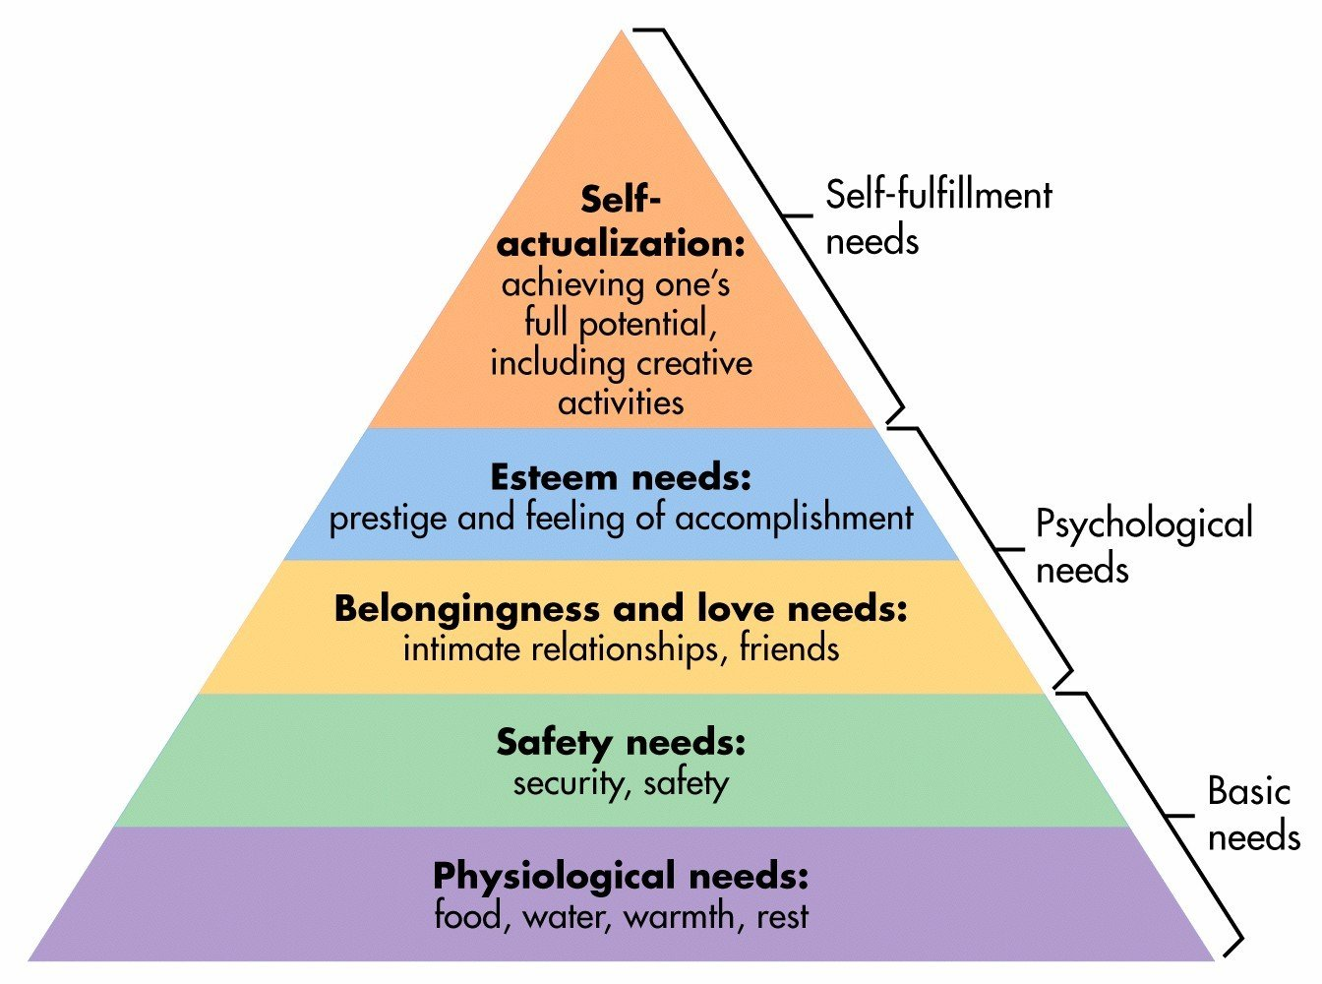

Appendix 1.0: Maslow’s Hierarchy of Needs

2.4 Event Satisfaction Checklist

The following checklist will enable a review of Creamfields’ organisation and delivery of the annual event:
- Advertisement for event
- Artists/DJ’s
- Bars
- Bathrooms (Portaloo’s)
- Insurance
- Local Services E.g. Police/Ambulance service
- Liaison with food caterers and other stalls
- Site Layout e.g. queue to enter site/campsites/stage locations
- Security
- Staff/Volunteers for bar work/supervising event/clean up
- Tents e.g. emergency tents, phone charging tents, camping tents for sale in case of emergencies
- Water taps across site
- Wristbands for entry to event and wristbands to say age has been verified
- Wristbands for pre-booked amenities such as hot showers and real toilets

The checklist shows the most essential elements to ensuring the smooth running of the event each year and everything that needs to be considered before the event can open its gates to the public. It takes a lot of time to plan and create an event of this scale where there are hundreds of thousands of attendees.

2.5 Key Elements Influencing Consumer Satisfaction & Experience

There can be many key elements that influence the consumer satisfaction and experience when it comes to any kind of event. Creamfields being a major outdoor music event with large numbers of attendees means there are more elements that determine consumer satisfaction and the overall consumer experience. The artists performances and the range of artists there across the four-day period is one of the main key elements that influences customer satisfaction. When artists don’t show it leads to dissatisfaction leaving consumers concerned on what their contribution of payment towards the event has gone towards. For outdoor events other elements may include the weather for the duration of the event, which is why outdoor music festivals are held in the summer and commonly at the same time each year. If elements like these aren’t met to the consumers standard, then it dampens the overall experience which can have a knock-on effect of them not wanting to attend this event again or any other event that falls into the same category – major outdoor music festivals.

- Conclusion

Too conclude this report, it has shown that Creamfields is the most popular, major, outdoor dance festival here in the UK but also receives a high impact from international consumers who travel here to witness and experience the annual event. Creamfields is proof that with the right direction any size event can expand to the size that Creamfields has expanded from and from a day event to an event taking place over numerous days with event attendees expanding by the thousands. It is also apparent of the motivators that encourage the target market to attend the event whether it’s social motivators or physiological. Other determinants include consumers wanting to share these experiences with friends and to feel part of something in an atmosphere where people are surrounded by other people who share similar tastes in music and that’s all they must focus on from the start of the event to the end. There is also a lot of organising of an event of this scale and that it takes time to organise making it work better and making it more enjoyable being an annual event which encourages consumers to attend as it only makes the one appearance every single year.

- Bibliography

Creamfields 2018. (2017). Creamfields 2016 in Review — Creamfields 2018. Available at: http://www.creamfields.com/creamfields-2016 [Accessed 28 Oct. 2017].

McDonnell et al (1999) cited in Shone, A & Parry, B (2011) Successful Event Management, a Practical Handbook Chapter Eight, pp. 27. [Accessed 1 Nov. 2017].

Shone, A, and Parry, B (2011) Successful Event Management, a Practical Handbook Chapter Eight, pp. 150. [Accessed 29 Oct. 2017].

Simply Psychology. (2017). Maslow's Hierarchy of Needs. Available at: https://www.simplypsychology.org/maslow.html [Accessed 1 Nov. 2017].

Tkaczynski, A. and Rundle-Thiele, S. (2011). Event segmentation: A review and research agenda. Tourism Management, 32(2), pp.426-434. [Accessed 1 Nov. 2017].

Visitliverpool.com. (2017). Creamfields 2018 - Festival in Daresbury, Cheshire - Visit Liverpool. Available at: https://www.visitliverpool.com/whats-on/creamfields-2018-p390241 [Accessed 28 Oct. 2017].

- Appendix

1.0: Maslow’s Hierarchy of Needs

