Steffan Pryce-Griffiths (1902720)
1902720@student.uwtsd.ac.uk
SPG Constructions
A report summary on our management procedure route and specific quality management / assurances in place to meet the client’s quality requirements for the University Student Accommodation.
Sa1 University student accomdation
Pre-Quality Questionnaire
Appendix
  - Introduction
  - Traditional Procurement
  - Iron Triangle
  - Traditional procurement communication process
Project / Site Manager managing various tasks
Traditional Procurement Quality flow chart
2. Quality Management Systems
2.1 Below documents that generate Quality Management systems within SPG Constructions
3. Quality Assurance
3.1 Why is Quality Assurance so important?
3.2 Quality Assurance methodology
3.3 Role of BIM in Quality Assurance / Standards
4. Aftersales procedure method
4.1 The benefits of BIM during the after-sale process
4.2 Pre-Quality Questionnaire Summary

1.1 Introduction

This report documents the communication and quality benefits of a traditional procurement route for the project. How it will successfully deliver a project and how the use quality management systems in place that will focus on the client’s quality requirements for the University Student Accommodation. The Contractor will be providing the project and delivery process through BIM. This BIM software will include the client brief and date within the model, including a “3D model such as physical coordination, BIM can bring together data at the required level of detail” which is vital for our client. Accessibility of the project will be available to the client and the consultant team.

1.2 Traditional procurement

The traditional procurement “route is seen as most efficient and suitable” (CIOB, 2011) as it allows the clients to design the project to the standard and quality, they believe is satisfactory. The majority of the risk lays with the client, which is beneficial for both parties on this project. In the means of the client maintains the control of the quality. The contractor role is the execution of the project, “responsibility for co-ordination of subcontract packages lies firmly with the contractor” This procurement system allows all parties “knowing where they stand, and who has responsibility for what” (CIOB, 2011).

The planning and thought process of the project has been prepared by the client and the client architect- potentially longer duration but possibly could be lower with the reduce chances of errors, higher quality and total cost certainty of the project.
A fully formed design will be created by the client’s architect to allow the contractor to follow the specification and quality requirements from start to finish on the project. Client acknowledges that the contractor can accomplish the project to their design and standard.

1.3 Iron Triangle

The use of the iron triangle “illustrates the relationship between three primary forces in a project” (Jenkins, 2010). Time is the delivery duration of the project, cost symbolises the resources or money available and “quality represents the fit-to-purpose that the project must achieve to be a success” (Jenkins, 2010) apart from health & safety. Therefore health & safety should never be put to jeopardy to achieve the primary forces.

One factor is typically fixed which allows us to vary in proportion the other two to an agreeable standard between the client and contractor of the end product, the contractor will deliver the project and the timescale required to succeed.

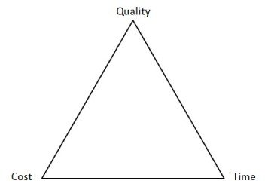
In our project situation, quality is the client key factor. Working on a fixed level of quality will determine the clients project will be achieve their quality requirements and specifications. The project cost “will largely dependent upon the time available, longer duration fewer people” (Jenkins, 2010) needed.

Health & Safety

1.4 Traditional procurement communication process

To achieve a successful project, effective project management is required. The use of BIM supports the contractor project manager “rather than diminishing the role of the project manager, BIM actually enhances and sharpens it” (RICS, 2017) and creates a smooth delivery / communication process between the client, consultant team and main contractor. All the construction professionals within the project can “work in an integrated environment at any stage of the delivery process” (RICS, 2017). Figure 2 shows how the “information relates to each other and influence the content of other types of information during the construction process”. BIM creates a trouble-free delivery of the information throughout the process.
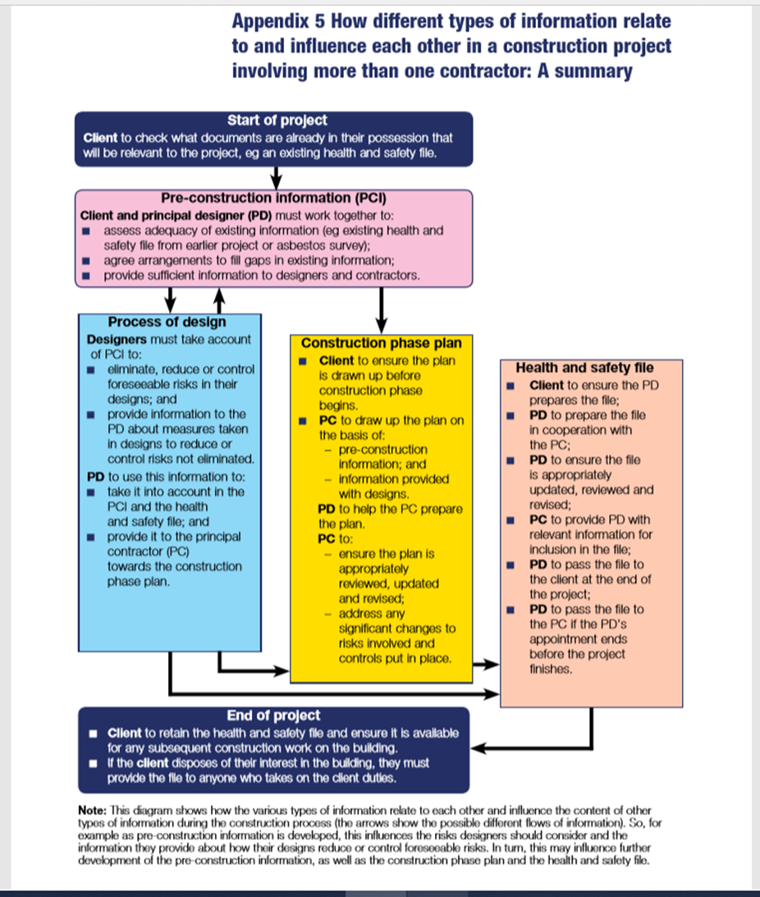

Delivering the project through BIM assists the project manager to bring “together a disparate group of experts and integrating their knowledge into a buildable design that meets cost, quality, safety, sustainability, and schedule objectives and requirements, and generates value for the project sponsor, project team members, and end-users” (RICS, 2017). SPG Constructions can certified project success with how effective our project managers and team can deliver a project through BIM, “fundamental enabler for effective integration” (RICS, 2017). It is an important declaration that all project managers and members of SPG Construction understand the application and use of it to deliver the client project.

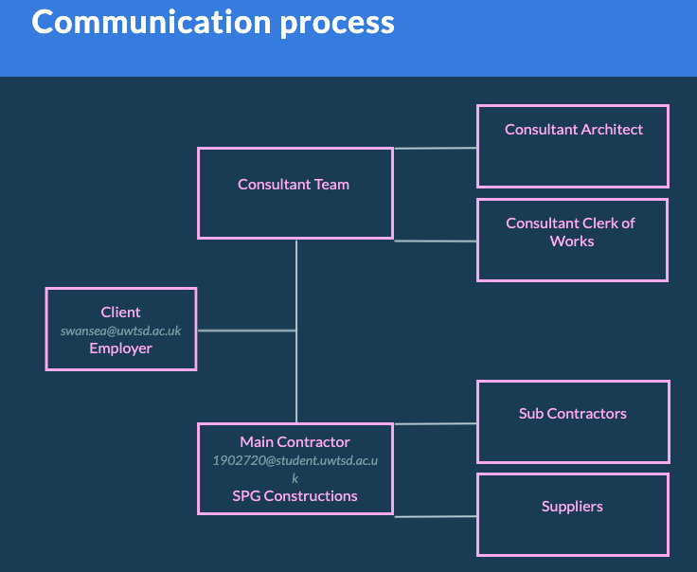
Figure 3: Communication process between the client, consultant team and SPG Construction.

Tasks | Project / Site manager managing various parties & tasks
1 | Responsible to the Construction Director/Manager for all aspects of the project including the attainment of the required quality, safety programme, profitability, co-ordination of site works and effectiveness of the site quality system.
2 | Prepare and issue the Project Management Plan, including regular review and revision as necessary.
3 | Establish site administrative procedures to include all forms, use and distribution.
4 | Provide single point of contact for the Client.
5 | Formulate and agree main contract programmes.
6 | Set the agenda for the construction process and the design/information co-ordination to achieve that process.
7 | Set up quality procedures and ensure that these are implemented.
8 | Formulate and present progress reporting structure, both internally and to the Client.
9 | Ensure competence of subcontractors in compliance prior to appointment.
10 | Ensure Site Diary is kept..
11 | Implement change procedures in line with contractual requirements.
12 | Organise an initial countdown meeting with client/design team.
13 | Monitor countdown process.
14 | Review countdown checklist at regular intervals up to completion, during client progress meetings and subcontractor meetings.
15 | Monitor and carry out snagging process as defined on countdown manual
16 | Ensure project completion checklist is completed.
17 | Ensure handover meeting is carried
18 | Oversee preparation of O&M manuals.
19 | Set up and monitor handover schedules, keys, spares and certificates.
20 | Lead post-handover review meetings.
21 | Complete relevant Project Data Capture Sheet
22 | Manage, in overall terms, site Health and Safety Policy, security and fire policies
23 | Prepare a construction Health and Safety plan from the information supplied by the CDM Co-ordinator in the pre-construction safety plan
24 | Establish the location of underground services and overhead power lines in conjunction with the CDM Coordinator where reasonably practical
25 | Ensure that the Health and Safety plan is updated and reviewed throughout the duration of the contract and that the plan and revisions are brought to the attention of subcontractors
26 | Ensure compliance with the company fire prevention procedure
27 | Prepare Health and Safety File and O&M information.

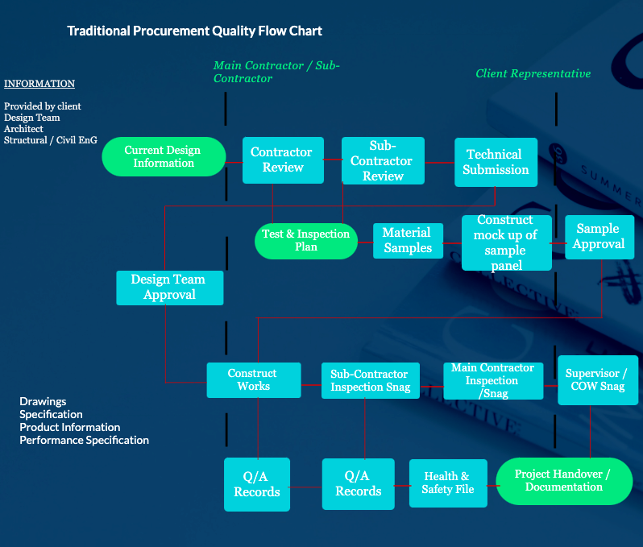
2. Quality Management Systems
This project will be managed in accordance with the Quality Management System certificated by British Standards Institute (BSI) and meeting the requirements of BS EN ISO 9001.
SPG Construction Quality Management System is employed to guarantee our client “quality planning quality assurance and quality control” of the University Accommodation. The quality management systems facilitate to accomplish objectives and standards in the construction industry and our client’s expectation of quality. It ensures that SPG Construction can successfully complete the client project within “the constraints given, such as, specified period and at minimum possible cost”. Quality being the central target for the client with the Student Accommodation project, an agreement between the client and SPG Construction to understand an acceptable balance of cost and time to achieve a successful project.

2.1 Below, documents that generate Quality Management Systems withing SPG Constructions.

Client Brief / Specification
- Brief states the project is a Traditional project - Client employs the Design Team. SPG not responsible for the design. Client & his Team are.
- Client brief / not SPG’s issue. SPG can do a design review and offer advice to the Client design team on any issues identified.
- Vital the client constructs a brief which includes all quality requirements and specification of the project.
- Design brief is one of the “most powerful project management tools” (Heaton, 2020), allows SPG Construction identify the scope, magnitude and fundamental details to meet the client design.
- A good quality client brief helps avoid barriers occurring early on and can potentially quicken design / development process.
Design review
- Frequent design review meetings amongst the client, consultant team and SPG Construction will improve the quality of the design, helping our client to secure high-quality design.
- Meeting consisting of construction professionals, “offers advice and judgement of an understanding of a good design”. A highly efficient design review adds more value than just quality.
- Design process helps distinguish potential risks and costs delays in the planning to save time and money.
- Valuable design review gives SPG Construction, consultant team and clients design teams “confidence that they have had the best possible independent advice on design quality”.

Drawing register
An important system to segregate the latest drawings from superseded drawings.
- Reduces time to retrieve required files and drawings.
- Reduces storage space and stores all drawings in the same area for the project.
- Able to collaborate drawings across the project.
- Provides information to user on activities on a particular date and time
- Reduces errors on the project, always working on update drawings.

Quality Communication
- Weekly meetings / updates schedule with SPG Construction and the clerk of the works of the client.
- Clerk of the works can communicate between the client and SPG Constructions to minimise conflict and achieve our client’s quality requirement.
- Project / site managers communicate to sub-contractors to establish that material and workmanship meet the client’s criteria.
- Completion dates and deliveries will be recorded to avoid any delays. SPG Construction can create custom reports in Microsoft project or Excel to share with the clients the progress.
Series of quality checklists
- specified material delivered
- Samples / Sample panel approval
- installed in accordance with manufacturer’s recommendations
- check whether operatives have had relevant /correct training for the product being installed.
- Agree S/C quality check procedure - May need ‘Hold Points’ (work can’t proceed) until check undertaken where works subsequently covered up and can’t be inspected. Q/A may include photographic evidence.
- When S/C Q/A offers inspection documentation top SPG works inspected by SPG and either counter sign s/c document or produce document to confirm inspection and offer to clerk of works for inspection / sign off.

PROJECT COMPLETION INSPECTIONS
- Sign off that all client raised snags addressed
- Safety certificates in place. Fire Alarm, Sprinkler system, Lift commission, design team sign-off, Fire officer / Building Control Certificate of Occupation.
- Certificates of Test and commission for all systems installed, Electrical Mechanical, building management systems, Drains CCTV survey.

3. Quality Assurance

Quality requirements are identified through quality assurance for the Student Accommodation project. “Existing quality documents can be relevant to the quality requirement of the project”. Outcome of this project will be a success to our clients due to the critical quality assurance process SPG Constructions implement.

3.1 Why is Quality Assurance so important?
All construction project consists of some form of risk, a valuable quality assurance process is “essential in preventing problems with a build and reducing risk”. The result of quality assurances is identifying quality issues in advance to any activity being completed, this prevents any re-work or delays in the program. SPG Construction know the importance of identifying quality issues to steer away from painful defect-liability periods for the client or building failing years after completion.
3.2 Quality Assurance methodology

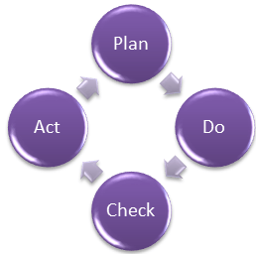
- Plan – Plan and establish related quality issues to determine the procedures to deliver a high-quality end product for our client.
- Do - Advance testing of Processes and do changes where required in the processes.
- Check – Observing the processes, alter processes and investigation if they truly meet the quality requirement / standards of our clients.
- Act – Procedures implemented to achieve improvements in our processes to provide quality assurance for our client. https://www.guru99.com/all-about-quality-assurance.html
3.3 Role of BIM in Quality Assurance / Standards
Conventionally, QA process is manual comprising a lot of paperwork, which results in a complicated and technical process to successfully accomplish. SPG Construction, construction team have received BIM project & construction training courses for specific BIM projects such as student accommodation project.
BIM specifies quality information to form a real structure, the height, thickness, material and it’s texture. By allowing various disciplines access on details of our project components; quality of material used and controlled procedures in a single BIM Model”. Communication operates efficiently between disciplines and simplifies workflow to reach our clients desired quality.

- Improved collaboration and control among project stakeholders.
- Improved project quality.
- Faster delivery of projects.
- Cost effective method.
- Reduce wasting of resources.
- Maximum revenue and new business opportunities

Regulations
ISO 9000 / 9001 consists of quality management principles and how focuses on client requirements. SPG Construction will use ISO 9000 / 9001 to provide quality management and to ensure our client “gets consistent, good-quality products and services, which in turn brings many business benefits”. Frequent checks are carried out to certify our systems works. Internal audits are checked by SPG Construction. Alternatively, invitation is available for the client to audit the quality system themselves.
Standards
Kitemark materials (BS EN ISO 17067)


The components and the materials used on the Student Accommodation will comply “with a particular British Standard are marked with British Standard kitemark” (Chudley, 2017, pg.77) with the Correct BS number.

The symbol assures our clients that the products are tested to “accordance with recommendations set out in the specific standard” (Chudley, 2017, pg.77). The standard are not legal requirements but satisfy provision to our client specification of quality.

Workmanship (BS 8000-0:2014) (Quality Control)
SPG Construction drive this standard to all Sub-Contractors to promote quality control. It’s important that human factor of quality workmanship is fulfilled to meet the client’s quality requirements and to provide a safe yet quality finish to any workmanship they may be involved in.

4. After sale procedure

Handover pack

Health & Safety File

As Build Drawings

Building Manuals (basic handbook)

Keys & Labelled (spares)

Equipment Spares / Service Tools

Client Identifies Problem

Client notifies contractor of problem

Defect response / time to establish problem
(depending severity)

Contractor establishes the correct Sub-contractor
(Agreement on timescale)

Sub-contractor completes issue

Client / contractor signs off

Defect issue

Log defect correction
(For Quality Plan)

4.1 The benefits of BIM during the after-sale process

SPG Construction supports the use of BIM in the soft-landing process, communicating to our client how to visualise and understand “how the asset will work in use during the design and construction stages”. Virtual presentation on how different system of the building works with user instruction manual. An overall understanding of the building to our client. The defect process ran through BIM can certainly make it easier for SPG Construction and our client to communicate problems with the project and recognise corrections with updates on the platform.

4.2 Pre-Quality Questionnaire Summary

The report has explained the reasoning for using traditional procurement to our client. To give our clients the full responsibility in the design and quality requirements required for the build, allows the client to communicate to it’s consultant team consisting of clerk of works to work and architect to create the project to the client design and quality requirements. The consultant team will communicate with SPG Construction throughout the whole building process, therefore both parties can execute the client brief. The benefits of project delivery through BIM are immeasurable from improving quality of the build, improving collaboration of disciplines to being cost effective method. This ensures SPG Constructions can successfully manage this project to the quality management / assurance of the client and that communication between organisation is prominent to gain the trust of our client.

Reference:

- Autodesk (n.d.). Construction Quality Checklists & Issues | Autodesk BIM 360. [online] BIM 360. Available at: https://www.autodesk.co.uk/bim-360/construction-management-software/quality-control-in-construction/construction-quality-checklist/ [Accessed 13 Jan. 2021]
- BIM Services (2019). Role of BIM standards in Quality Assurance. [online] BIM Blog. Available at: https://www.bimservicesindia.com/blog/role-of-bim-standards-in-quality-assurance/#:~:text=Quality%20Assurance%20(QA)%20is%20a [Accessed 13 Jan. 2021].
- Blundell, S. (2019). Understanding and applying BIM to construction projects. [online] Planning, BIM & Construction Today. Available at: https://www.pbctoday.co.uk/news/bim-news/understanding-bim/54890/ [Accessed 13 Jan. 2021].
- Chudley, R. (2017). Building Construction Handbook. Roy Chudley, p.pg.77.
- CIOB (2011). A REPORT EXPLORING PROCUREMENT IN THE CONSTRUCTION INDUSTRY. Available at: https://www.ciob.org/sites/default/files/CIOB%20research%20-%20Procurement%20in%20the%20Construction%20Industry%202010_1.pdf [Accessed 8 Jan. 2021].
- Coventry University (n.d.). Traditional procurement. Future Learn. Available at: https://www.futurelearn.com/info/courses/contract-management-and-procurement/0/steps/75144 [Accessed 13 Jan. 2021].
- Design Review (2013). Design Review Principles and Practice. [online] Available at: https://www.designcouncil.org.uk/sites/default/files/asset/document/DC%20Cabe%20Design%20Review%2013_W_0.pdf [Accessed 13 Jan. 2021].
- engineeringmanagementinstitute (2018). BIM as an Effective Tool in Project Management. [online] Engineering Management Institute. Available at: https://engineeringmanagementinstitute.org/bim-effective-tool-project-management/#:~:text=BIM%20facilitates%20IPD%3A [Accessed 13 Jan. 2021].
- Heaton, S. (2020). How to Write a Design Brief to Keep Your Web Design Projects On Track. [online] Shopify. Available at: https://www.shopify.com/partners/blog/100022086-how-to-write-a-design-brief-to-keep-your-web-design-projects-on-track [Accessed 13 Jan. 2021].
- HSE (2015). The Construction (Design and Management). [online] Available at: https://www.hse.gov.uk/pubns/priced/l153.pdf [Accessed 13 Jan. 2021].
- ISO (2015). ISO 9000 family – Quality management. [online] ISO. Available at: https://www.iso.org/iso-9001-quality-management.html [Accessed 13 Jan. 2021].
- Jenkins, N. (2010). A Project Management Primer: Basic Principles - Scope Triangle. [online] Project Smart. Available at: https://www.projectsmart.co.uk/project-management-scope-triangle.php [Accessed 8 Jan. 2021].
- QDMS Solutions (n.d.). Drawing Register. [online] www.qdmssolutions.com. Available at: http://www.qdmssolutions.com/knowledgebase/drawing-register.htm#:~:text=A%20Drawing%20register%20acts%20as [Accessed 13 Jan. 2021].
- RICS (2017). Insight Insight Building Information Modelling for Project Managers rics.org/insights. [online] Available at: https://www.rics.org/globalassets/rics-website/media/knowledge/research/insights/bim-for-project-managers-rics.pdf [Accessed 8 Jan. 2021].

